HFBR-0501 Series
Versatile Link
The Versatile Fiber Optic Connection

Data Sheet

Description
The Versatile Link series is a complete family of fiber optic link components for applications requiring a low cost solution. The HFBR-0501 series includes transmitters, receivers, connectors and cable specified for easy design. This series of components is ideal for solving problems with voltage isolation/insulation, EMI/RFI immunity or data security. The optical link design is simplified by the logic compatible receivers and complete specifications for each component. The key optical and electrical parameters of links configured with the HFBR-0501 family are fully guaranteed from 0° to
70°C.

A wide variety of package configurations and connectors provide the designer with numerous mechanical solutions to meet application requirements. The transmitter and receiver components have been designed for use in high volume/low cost assembly processes such as auto insertion and wave soldering.

Transmitters incorporate a 660 nm LED. Receivers include a monolithic dc coupled, digital IC receiver with open collector Schottky output transistor. An internal pullup resistor is available for use in the HFBR-25X1/2/4 receivers. A shield has been integrated into the receiver IC to provide additional, localized noise immunity.

Internal optics have been optimized for use with 1 mm diameter plastic optical fiber. Versatile Link specifications incorporate all connector interface losses. Therefore, optical calculations for common link applications are simplified.
Features
• Low cost fiber optic components
• Enhanced digital links dc-5 MBd
• Extended distance links up to 120 m at 40 kBd
• Low current link: 6 mA peak supply current
• Horizontal and vertical mounting
• Interlocking feature
• High noise immunity
• Easy connectoring Simplex, Duplex, and Latching connectors
• Flame retardant
• Transmitters incorporate a 660 nm Red LED for easy visibility
• Compatible with standard TTL circuitry

Applications
• Reduction of lightning/voltage transient susceptibility
• Motor controller triggering
• Data communications and local area networks
• Electromagnetic Compatibility (EMC) for regulated systems: FCC, VDE, CSA, etc.
• Tempest-secure data processing equipment
• Isolation in test and measurement instruments
• Error free signalling for industrial and manufacturing equipment
• Automotive communications and control networks
• Noise immune communication in audio and video equipment

HFBR-0501 Series Part Number Guide

HFBR X5XX

1 = Transmitter
2 = Receiver

5 = 600 nm Transmitter and
Receiver Products 1 = 5 MBd High Performance Link
2 = 1 MBd High Performance Link
3 = 40 kBd Low Current/Extended Distance Link
2 = Horizontal Package 4 = 1 MBd Standard Link
3 = Vertical Package 6 = 155 MBd Receiver
7 = 155 MBd Transmitter
8 = 10 MBd High Performance Link

Link Selection Guide
(Links specified from 0 to 70°C, for plastic optical fiber unless specified.)

Signal Rate | Distance (m) 25°C | Distance (m) | Transmitter | Receiver
40 kBd | 120 | 110 | HFBR-1523 | HFBR-2523
1 MBd | 20 | 10 | HFBR-1524 | HFBR-2524
1 MBd | 55 | 45 | HFBR-1522 | HFBR-2522
5 Mbd | 30 | 20 | HFBR-1521 | HFBR-2521

Evaluation Kit
HFBR-0501 1 MBd Versatile Link:
This kit contains: HFBR-1524 Tx, HFBR-2524 Rx, polishing kit, 3 styles of plastic connectors, Bulkhead feedthrough, 5 meters of 1 mm diameter plastic cable, lapping film and grit paper, and HFBR-0501 data sheet.

Application Literature
Application Note 1035 (Versatile Link)

Package and Handling Information
The compact Versatile Link package is made of a flame retardant VALOX® UL 94 V-0 material (UL file # E121562) and uses the same pad layout as a standard, eight pin dual-in-line package. Vertical and horizontal mountable parts are available. These low profile Versatile Link packages are stackable and are enclosed to provide a dust resistant seal. Snap action simplex, simplex latching, duplex, and duplex latching connectors are offered with simplex or duplex cables.
Package Orientation
Performance and pinouts for the vertical and horizontal packages are identical. To provide additional attachment support for the vertical Versatile Link housing, the designer has the option of using a self-tapping screw through a printed circuit board into a mounting hole at the bottom of the package. For most applications this is not necessary.

Package Housing Color
Versatile Link components and simplex connectors are color coded to eliminate confusion when making connections. Receivers are blue and transmitters are gray, except for the HFBR-15X3 transmitter, which is black.

VALOX® is a registered trademark of the General Electric Corporation.

2

Handling
Versatile Link components are auto-insertable. When wave soldering is performed with Versatile Link components, the optical port plug should be left in to prevent contamination of the port. Do not use reflow
Recommended Chemicals for Cleaning/Degreasing Alcohols: methyl, isopropyl, isobutyl. Aliphatics: hexane, heptane, Other: soap solution, naphtha.

solder processes (i.e., infrared reflow or vapor-phase reflow). Nonhalogenated water soluble fluxes (i.e., 0% chloride), not rosin based fluxes, are recom-

CAUTION This bag contains MOISTURE-SENSITIVE DEVICES
Level
4

mended for use with Versatile Link components.

Versatile Link components are moisture sensitive devices and are shipped in a moisture sealed bag. If the components are exposed to air for an extended period of time, they may require a baking step before the soldering process. Refer to the special labeling on the shipping tube for details.
1. Shelf life in sealed bag: 12 months at < 40°C and < 90% Relative
Humidity (RH).

2. After this bag is opened, devices that will be subjected to wave soldering, or equivalent processing (solder temperature < 260°C for
10 sec) must be:
a) Mounted within 72 hours at factory conditions of ≤ 30°C/60% RH. b) Stored at ≤ 20% RH.

3. Devices require baking, before mounting, if:
a) Desiccant changes to PINK. b) If 2a or 2b are not met.
4. If baking is required, devices may be baked outside of tube for 20 hours at 75°C.

Bag Seal Date:
(If blank, see barcode label)

Note: LEVEL defined by EIA JEDEC Standard J-STD-020

Do not use partially halogenated hydrocarbons such as
1,1.1 trichloroethane, ketones such as MEK, acetone,
chloroform, ethyl acetate, methylene dichloride, phenol,
methylene chloride, or N-methylpyrolldone. Also, Avago
does not recommend the use of cleaners that use
halogenated hydrocarbons because of their potential
environmental harm.

Mechanical Dimensions
Horizontal Modules Vertical Modules

2.0 (0.080)

18.8 (0.740)
6.8 (0.270)

10.2 (0.400)
5.1 (0.200)

7.6 (0.30)

0.64 (0.025)

77.7.61 (0(0.3.3005))

4.2 (0.165)

18.8
0.740

7.62 (0.300)
3.81 (0.150) MAX.
3.56 (0.140) MIN.

0.51

1.27 (0.050)

(0.020)
2.5 (0.100)

0.64 (0.025) DIA.

2.8 (0.109)
1.85 (0.073)

3

Versatile Link Printed Board Layout Dimensions
Horizontal Module Vertical Module

2.54 (0.100)
7.62 (0.300)

1.01 (0.040) DIA.

TOP VIEW
4 3 2 1

7.62 (0.300)

5 6

1.85 MIN. (0.073)

PCB EDGE

DIMENSIONS IN MILLIMETERS (INCHES).

Interlocked (Stacked) Assemblies (refer to Figure 1) Horizontal packages may be stacked by placing units with pins facing upward. Initially engage the inter- locking mechanism by sliding the L bracket body from
above into the L slot body of the lower package. Use a
straight edge, such as a ruler, to bring all stacked units
into uniform alignment. This technique prevents
potential harm that could occur to fingers and hands of
assemblers from the package pins. Stacked horizontal
packages can be disengaged if necessary. Repeated
stacking and unstacking causes no damage to individual
units.

To stack vertical packages, hold one unit in each hand, with the pins facing away and the optical ports on the bottom. Slide the L bracket unit into the L slot unit. The straight edge used for horizontal package alignment is not needed.

Stacking Horizontal Modules
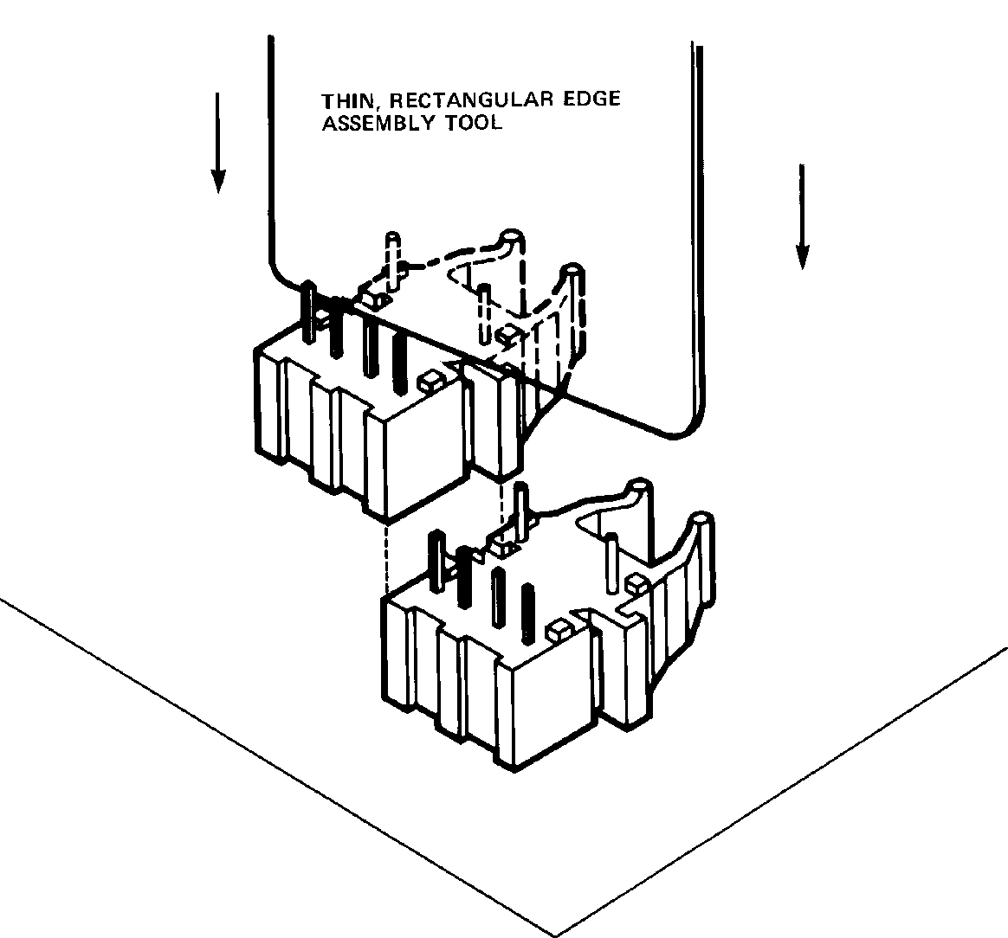

Figure 1. Interlocked (stacked) horizontal or vertical packages
Stacking Vertical Modules

4

5 MBd Link (HFBR-15X1/25X1)
System Performance 0 to 70°C unless otherwise specified.

 |  | Parameter | Symbol | Min. | Typ. | Max. | Units | Conditions | Ref.
 | High | Data Rate |  | dc |  | 5 | MBd | BER ≤10-9, PRBS:27-1
Performance
5 MBd
 |  | Link Distance  (Standard Cable) |  | 19  27 | 48 |  | m m | IFdc = 60 mA  IFdc = 60 mA, 25°C | Fig. 3  Note 3
 |  | Link Distance  (Improved Cable) |  | 22  27 | 53 |  | m m | IFdc = 60 mA  IFdc = 60 mA, 25°C | Fig. 4  Note 3
 |  | Propagation  Delay | tPLH  tPHL |  | 80  50 | 140  140 | ns ns | RL = 560 Ω, CL = 30 pF  fiber length = 0.5 m  -21.6 ≤PR ≤-9.5 dBm | Fig. 5, 8  Notes 1, 2
 |  | Pulse Width  Distortion tPLH-tPHL | tD |  | 30 |  | ns | PR = -15 dBm  RL = 560 Ω, CL = 30 pF | Fig. 5, 7

Notes:
1. The propagation delay for one metre of cable is typically 5 ns.
2. Typical propagation delay is measured at PR = -15 dBm.
3. Estimated typical link life expectancy at 40°C exceeds 10 years at 60 mA.

Figure 2. Typical 5 MBd interface circuit

100
100

50
I F – FORWARD CURRENT (mA)
40
OVERDRIVE
30
UNDERDRIVE
20

10
50
I F – FORWARD CURRENT (mA)
40
OVERDRIVE
30

UNDERDRIVE
20

10

0°C–70°C
25°C
5
0 10 20 30 40 50

0°C–70°C
25°C
5
0 10 20 30 40 50 60

– CABLE LENGTH – METRES

– CABLE LENGTH – METRES

Figure 3. Guaranteed system performance with standard cable (HFBR-15X1/25X1)
Figure 4. Guaranteed system performance with improved cable (HFBR-15X1/25X1)

5

Figure 5. 5 MBd propagation delay test circuit

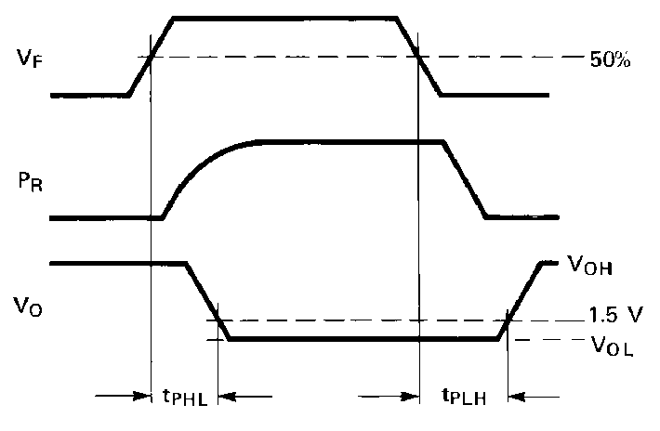

Figure 6. Propagation delay test waveforms

500
500

400
tD – PULSE WIDTH DISTORTION – ns

300

HFBR-15X2/25X2
HFBR-15X4/25X4

70°C

25°C
0°C

400

300

200
200

100

0

HFBR-15X1/25X1

70°C
25°C
0°C
100

0
tp – PROPAGATION DELAY – ns

-25
-20 -15
-10 -5 0
-25
-20 -15
-10 -5 0
 |  |  |  |  |  | tp | LH
HFBR-15X2/25X2
HFBR-15X4/25X4
 |  |  |  |  |  | tp | LH
 |  | HFB | R-15 | X1/2 | 5X1
 |  |  |  |  |  | tp | HL

PR – INPUT OPTICAL POWER – dBm

PR – INPUT OPTICAL POWER – dBm

Figure 7. Typical link pulse width distortion vs. optical power
Figure 8. Typical link propagation delay vs. optical power

6

HFBR-15X1 Transmitter

ANODE 1
CATHODE 2
N.C. 3
N.C. 4
8 DO NOT CONNECT

5 DO NOT CONNECT

Pin # Function
1 Anode
2 Cathode
3 Open
4 Open
5 Do not connect
8 Do not connect

Note: Pins 5 and 8 are for mounting and retaining purposes only. Do not electrically connect these pins.

Absolute Maximum Ratings
Parameter Symbol Min. Max. Units Reference
Storage Temperature TS –40 +85 °C Operating Temperature TA –40 +85 °C
Lead Soldering Cycle Temp. 260 °C Note 1
Time 10 sec
Forward Input Current IFPK 1000 mA Note 2, 3
IFdc 80
Reverse Input Voltage VBR 5 V

Notes:
1. 1.6 mm below seating plane.
2. Recommended operating range between 10 and 750 mA.
3. 1 μs pulse, 20 μs period.

All HFBR-15XX LED transmitters are classified as IEC 825-1 Accessible Emission Limit (AEL) Class 1 based upon the current proposed draft scheduled to go into effect on January 1, 1997. AEL Class 1 LED devices are considered eye safe. Contact your local Avago sales representative for more information.

7

Transmitter Electrical/Optical Characteristics 0°C to 70°C unless otherwise specified.

Parameter | Symbol | Min. | Typ.[5] | Max. | Units | Conditions | Ref.
Transmitter Output  Optical Power | PT | -16.5 |  | -7.6 | dBm | IFdc = 60 mA | Notes 1, 2
Transmitter Output  Optical Power | PT | -14.3 |  | -8.0 | dBm | IFdc = 60 mA, 25°C | Notes 1, 2
Output Optical Power  Temperature Coefficient | ∆PT /∆T |  | -0.85 |  | %/°C
Peak Emission  Wavelength | ⎣PK |  | 660 |  | nm
Forward Voltage | VF | 1.45 | 1.67 | 2.02 | V | IFdc = 60 mA
Forward Voltage  Temperature Coefficient | ∆VF /∆T |  | -1.37 |  | mV/°C |  | Fig. 9
Effective Diameter | D |  | 1 |  | mm
Numerical Aperture | NA |  | 0.5
Reverse Input Breakdown  Voltage | VBR | 5.0 | 11.0 |  | V | IFdc = 10 ∝A, TA = 25°C
Diode Capacitance | CO |  | 86 |  | pF | VF = 0, f = MHz
Rise Time | tr |  | 80 |  | ns | 10% to 90%, | Note 3
Fall Time | tf |  | 40 |  | ns
 |  |  |  |  |  | IF = 60 mA

Notes:
1. Measured at the end of 0.5 m standard fiber optic cable with large area detector.
2. Optical power, P (dBm) = 10 Log [P(μW)/1000 μW].
3. Rise and fall times are measured with a voltage pulse driving the transmitter and a series connected 50 Ω load. A wide bandwidth optical to electrical waveform analyzer, terminated to a 50 Ω input of a wide bandwidth oscilloscope, is used for this response time measurement.

1.8 5

0
1.7
VF – FORWARD VOLTAGE – V

1.6
0°C

25°C

1.5
70°C

-15

1.4
2 10

100
-20
PT – NORMALIZED OUTPUT POWER – dB
2 10

100

IFdc – TRANSMITTER DRIVE CURRENT (mA)

IFdc – TRANSMITTER DRIVE CURRENT (mA)

Figure 9. Typical forward voltage vs. drive current Figure 10. Normalized typical output power vs. drive current

8

HFBR-25X1 Receiver

DO NOT CONNECT 5

DO NOT CONNECT 8

1000 Ω

4 RL
3 VCC
2 GROUND
1 VO
Pin # Function
1 VO
2 Ground
3 VCC
4 RL
5 Do not connect
8 Do not connect

Note: Pins 5 and 8 are for mounting and retaining purposes only. Do not electrically connect these pins.

Absolute Maximum Ratings

Parameter |  | Symbol | Min. | Max. | Units | Reference
Storage Temperature |  | TS | –40 | +85 | °C
Operating Temperature |  | TA | –40 | +85 | °C
Lead Soldering Cycle | Temp. |  |  | 260 | °C | Note 1
 | Time |  |  | 10 | sec
Supply Voltage |  | VCC | –0.5 | 7 | V | Note 2
Output Collector Current |  | IOAV |  | 25 | mA
Output Collector Power Dissipation |  | POD |  | 40 | mW
Output Voltage |  | VO | –0.5 | 18 | V
Pull-up Voltage |  | VP | –5 | VCC | V
Fan Out (TTL) |  | N |  | 5

Notes:
1. 1.6 mm below seating plane.
2. It is essential that a bypass capacitor 0.01 μF be connected from pin 2 to pin 3 of the receiver. Total lead length between both ends of the capacitor and the pins should not exceed 20 mm.

Receiver Electrical/Optical Characteristics
0°C to 70°C, 4.75 V ≤VCC ≤5.25 V unless otherwise specified

Parameter | Symbol | Min. | Typ. | Max. | Units | Conditions | Ref.
Input Optical Power  Level for Logic “0” | PR(L) | –21.6 |  | –9.5 | dBm | VOL = 0.5 V IOL = 8 mA | Notes 1,  2, 4
 |  | –21.6 |  | –8.7 |  | VOL = 0.5 V  IOL = 8 mA, 25°C
Input Optical Power  Level for Logic “1” | PR(H) |  |  | –43 | dBm | VOL = 5.25 V IOH ≤250 ∝A | Note 1
High Level Output Current | IOH |  | 5 | 250 | ∝A | VO = 18 V, PR = 0 | Note 3
Low Level Output Current | VOL |  | 0.4 | 0.5 | V | IOL = 8 mA, PR = PR(L)MIN | Note 3
High Level Supply  Current | ICCH |  | 3.5 | 6.3 | mA | VCC = 5.25 V, PR = 0 | Note 3
Low Level Supply Current | ICCL |  | 6.2 | 10 | mA | VCC = 5.25 V  PR = -12.5 dBm | Note 3
Effective Diameter | D |  | 1 |  | mm
Numerical Aperture | NA |  | 0.5
Internal Pull-up Resistor | RL | 680 | 1000 | 1700 | Ω

Notes:
1. Optical flux, P (dBm) = 10 Log [P (μW)/1000 μW].
2. Measured at the end of the fiber optic cable with large area detector.
3. RL is open.
4. Pulsed LED operation at IF > 80 mA will cause increased link tPLH propagation delay time. This extended tPLH time contributes to increased pulse width distortion of the receiver output signal.

9

1 MBd Link
(High Performance HFBR-15X2/25X2, Standard HFBR-15X4/25X4)
System Performance Under recommended operating conditions unless otherwise specified.

 |  | Parameter | Symbol | Min. | Typ. | Max. | Units | Conditions | Ref.
 | High | Data Rate |  | dc |  | 1 | MBd | BER ≤10-9, PRBS:27-1
Performance  1 MBd |  | Link Distance  (Standard Cable) |  | 39  47 | 70 |  | m m | IFdc = 60 mA  IFdc = 60 mA, 25°C | Fig. 14  Notes 1,  3, 4
 |  | Link Distance  (Improved Cable) |  | 45  56 | 78 |  | m m | IFdc = 60 mA  IFdc = 60 mA, 25°C | Fig. 15  Notes 1,  3, 4
 |  | Propagation  Delay | tPLH  tPHL |  | 180  100 | 250  140 | ns ns | RL = 560 Ω, CL = 30 pF I = 0.5 metre  PR = -24 dBm | Fig. 16, 18  Notes 2, 4
 |  | Pulse Width  Distortion tPLH-tPHL | tD |  | 80 |  | ns | PR = -24 dBm  RL = 560 Ω, CL = 30 pF | Fig. 16, 17  Note 4

 | Parameter | Symbol | Min. | Typ. | Max. | Units | Conditions | Ref.
Standard | Data Rate |  | dc |  | 1 | MBd | BER ≤10-9, PRBS:27-1
1 MBd | Link Distance  (Standard Cable) |  | 8  17 | 43 |  | m m | IFdc = 60 mA  IFdc = 60 mA, 25°C | Fig. 12  Notes 1,  3, 4
1 MBd | Link Distance  (Improved Cable) |  | 10  19 | 48 |  | m m | IFdc = 60 mA  IFdc = 60 mA, 25°C | Fig. 13  Notes 1,  3, 4
1 MBd | Propagation  Delay | tPLH  tPHL |  | 180  100 | 250  140 | ns ns | RL = 560 Ω, CL = 30 pF I = 0.5 metre  PR = -20 dBm | Fig. 16, 18  Notes 2, 4
1 MBd | Pulse Width  Distortion tPLH-tPHL | tD |  | 80 |  | ns | PR = -20 dBm  RL = 560 Ω, CL = 30 pF | Fig. 16, 17  Note 4

Notes:
1. For IFPK > 80 mA, the duty factor must be such as to keep IFdc ≤80 mA. In addition, for IFPK > 80 mA, the following rules for pulse width apply: IFPK ≤160 mA: Pulse width ≤1 ms
IFPK > 160 mA: Pulse width ≤1 μS, period ≥20 μS.
2. The propagation delay for one meter of cable is typically 5 ns.
3. Estimated typical link life expectancy at 40°C exceeds 10 years at 60 mA.
4. Pulsed LED operation at IFPK > 80 mA will cause increased link tPLH propagation delay time. This extended tPLH time contributes to increased pulse width distortion of the receiver output signal.

10

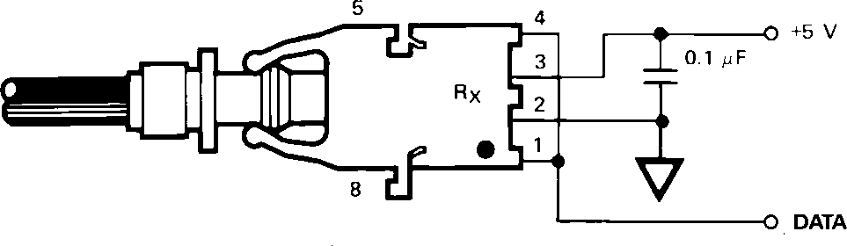

Figure 11. Required 1 MBd interface circuit

The HFBR-25X2 receiver can not be overdriven when using the required interface circuit shown in Figure 11.

100
90
80
I F – FORWARD CURRENT (mA)
70
60
100
90
80
I F – FORWARD CURRENT (mA)
70
60

50 50

40 40

30 30

HFBR-15X4/25X4

20
0 5 10 15 20 25
HFBR-15X4/25X4
0°C–70°C
25°C

20
0 10
0°C–70°C
25°C
20 30

– CABLE LENGTH – METRES

– CABLE LENGTH – METRES

Figure 12. Guaranteed system performance for the HFBR-15X4/25X4 Link with standard cable
Figure 13. Guaranteed system performance for the HFBR-15X4/25X4 Link with improved cable

100

50
40
30

20
100

50
40
30

20

UNDERDRIVE

UNDERDRIVE

10 10
IF – FORWARD CURRENT (mA)
IF – FORWARD CURRENT (mA)

0°C–70°C
25°C
5
0 10 20 30 40 50

0°C–70°C
25°C
5
0 10 20 30 40 50 60

– CABLE LENGTH – METRES

– CABLE LENGTH – METRES

Figure 14. Guaranteed system performance for the HFBR-15X2/25X2 Link with standard cable
Figure 15. Guaranteed system performance for the HFBR-15X2/25X2 Link with improved cable

11

Figure 16. 1 MBd propagation delay test circuit

500
500

400
tD – PULSE WIDTH DISTORTION – ns

300

HFBR-15X2/25X2
HFBR-15X4/25X4

70°C

25°C
0°C

400
tp – PROPAGATION DELAY – ns

300

200
200

100

0

HFBR-15X1/25X1

70°C
25°C
0°C
100

0

-25
-20 -15
-10 -5 0
-25
-20 -15
-10 -5 0
 |  |  |  |  |  | tp | LH
HFBR-15X2/25X2
HFBR-15X4/25X4
 |  |  |  |  |  | tp | LH
 |  | HFB | R-15 | X1/2 | 5X1
 |  |  |  |  |  | tp | HL

PR – INPUT OPTICAL POWER – dBm

PR – INPUT OPTICAL POWER – dBm

Figure 17. Pulse width distortion vs. optical power
Figure 18. Typical link propagation delay vs. optical power

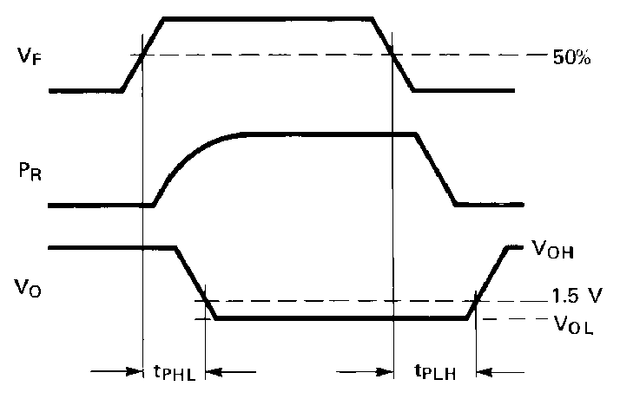

Figure 19. Propagation delay test waveforms

12

HFBR-15X2/15X4 Transmitters

8 DO NOT CONNECT

Pin # Function
1 Anode
2 Cathode

ANODE 1
3 Open

CATHODE 2
N.C. 3
N.C. 4

5 DO NOT CONNECT

4 Open
5 Do not connect
8 Do not connect

Absolute Maximum Ratings

Note: Pins 5 and 8 are for mounting and retaining purposes only. Do not electrically connect these pins.

Parameter |  | Symbol | Min. | Max. | Units | Reference
Storage Temperature |  | TS | –40 | +85 | °C
Operating Temperature |  | TA | –40 | +85 | °C
Lead Soldering Cycle | Temp. |  |  | 260 | °C | Note 1
Lead Soldering Cycle | Time |  |  | 10 | sec
Forward Input Current |  | IFPK |  | 1000 | mA | Note 2, 3
 |  | IFdc |  | 80
Reverse Input Voltage |  | VBR |  | 5 | V

Notes:
1. 1.6 mm below seating plane.
2. Recommended operating range between 10 and 750 mA.
3. 1 μs pulse, 20 μs period.

All HFBR-15XX LED transmitters are classified as IEC 825-1 Accessible Emission Limit (AEL) Class 1 based upon the current proposed draft scheduled to go into effect on January 1, 1997. AEL Class 1 LED devices are considered eye safe. Contact your Avago sales representative for more information.

Transmitter Electrical/Optical Characteristics 0°C to 70°C unless otherwise specified. For forward voltage and output power vs. drive current graphs.

IF = 60 mA
Parameter |  | Symbol | Min. | Typ. | Max. | Units | Conditions | Ref.
Transmitter  Output | HFBR-15X2 | PT | –13.6  –11.2 |  | –4.5  –5.1 | dBm | IFdc = 60 mA  IFdc = 60 mA, 25°C
Optical  Power | HFBR-15X4 | PT | –17.8  –15.5 |  | –4.5  –5.1 | dBm | IFdc = 60 mA  IFdc = 60 mA, 25°C
Output Optical Power  Temperature Coefficient |  | ∆PT /∆T |  | –0.85 |  | %/°C
Peak Emission Wavelength |  | ⎣PK |  | 660 |  | nm
Forward Voltage |  | VF | 1.45 | 1.67 | 2.02 | V | IFdc = 60 mA
Forward Voltage  Temperature Coefficient |  | ∆VF /∆T |  | –1.37 |  | mV/°C |  | Fig. 11
Effective Diameter |  | DT |  | 1 |  | mm
Numerical Aperture |  | NA |  | 0.5
Reverse Input Breakdown  Voltage |  | VBR | 5.0 | 11.0 |  | V | IFdc = 10 ∝A, TA = 25°C
Diode Capacitance |  | CO |  | 86 |  | pF | VF = 0, f = 1 MHz
Rise Time |  | tr |  | 80 |  | ns | 10% to 90%, | Note 1
Fall Time |  | tf |  | 40 |  | ns

Note:
1. Rise and fall times are measured with a voltage pulse driving the transmitter and a series connected 50 Ω load. A wide bandwidth optical to electrical waveform analyzer, terminated to a 50 Ω input of a wide bandwidth oscilloscope, is used for this response time measurement.

13

HFBR-25X2/25X4 Receivers

DO NOT CONNECT 5

DO NOT CONNECT 8

1000 Ω

4 RL
3 VCC
2 GROUND
1 VO

Pin # Function
1 VO
2 Ground
3 VCC
4 RL
5 Do not connect
8 Do not connect

Absolute Maximum Ratings
Note: Pins 5 and 8 are for mounting and retaining purposes only. Do not electrically connect these pins.

Parameter |  | Symbol | Min. | Max. | Units | Reference
Storage Temperature |  | TS | –40 | +85 | °C
Operating Temperature |  | TA | –40 | +85 | °C
Lead Soldering Cycle | Temp. |  |  | 260 | °C | Note 1
 | Time |  |  | 10 | sec
Supply Voltage |  | VCC | –0.5 | 7 | V | Note 2
Output Collector Current |  | IOAV |  | 25 | mA
Output Collector Power Dissipation |  | POD |  | 40 | mW
Output Voltage |  | VO | –0.5 | 18 | V
Pull-up Voltage |  | VP | –5 | VCC | V
Fan Out (TTL) |  | N |  | 5

Notes:
1. 1.6 mm below seating plane.
2. It is essential that a bypass capacitor 0.01 μF be connected from pin 2 to pin 3 of the receiver. Total lead length between both ends of the capacitor and the pins should not exceed 20 mm.

Receiver Electrical/Optical Characteristics 0°C to 70°C, 4.75 V ≤VCC ≤5.25 V unless otherwise specified.

Parameter |  | Symbol | Min. | Typ. | Max. | Units | Conditions | Ref.
Receiver  Optical Input | HFBR-2522 | PR(L) | –24 |  |  | dBm | VOL = 0 V IOL = 8 mA | Notes 1, 2, 3
Power Level  Logic 0 | HFBR-2524 |  | –20 |  |  |  |  | Note 4
Optical Input Power  Level Logic 1 |  | PR(H) |  |  | -43 | dBm | VOH = 5.25 V IOH = ≤250 ∝A
High Level Output Current |  | IOH |  | 5 | 250 | ∝A | VO = 18 V, PR = 0 | Note 5
Low Level Output Voltage |  | VOL |  | 0.4 | 0.5 | V | IOL = 8 mA  PR = PR(L)MIN | Note 5
High Level Supply Current |  | ICCH |  | 3.5 | 6.3 | mA | VCC = 5.25 V, PR = 0 | Note 5
Low Level Supply Current |  | ICCL |  | 6.2 | 10 | mA | VCC = 5.25 V,  PR = -12.5 dBm | Note 5
Effective Diameter |  | D |  | 1 |  | mm
Numerical Aperture |  | NA |  | 0.5
Internal Pull-up Resistor |  | RL | 680 | 1000 | 1700 | Ω

Notes:
1. Measured at the end of the fiber optic cable with large area detector.
2. Pulsed LED operation at IF > 80 mA will cause increased link tPLH propagation delay time. This extended tPLH time contributes to increased pulse width distortion of the receiver output signal.
3. The LED drive circuit of Figure 11 is required for 1 MBd operation of the HFBR-25X2/25X4.
4. Optical flux, P (dBm) = 10 Log [P(μW)/1000 μW].
5. RL is open.

14

40 kBd Link
System Performance Under recommended operating conditions unless otherwise specified.

Parameter | Symbol | Min. | Typ. | Max. | Units | Conditions | Ref.
Data Rate |  | dc |  | 40 | kBd | BER ≤10-9, PRBS: 27 - 1
Link Distance  (Standard Cable) |  | 13  94 | 41  138 |  | m m | IFdc = 2 mA IFdc = 60 mA | Fig. 21  Note 1
Link Distance  (Improved Cable) |  | 15  111 | 45  154 |  | m m | IFdc = 2 mA IFdc = 60 mA | Fig. 22  Note 1
Propagation  Delay | tPLH  tPHL |  | 4  2.5 |  | ∝s  ∝s | RL = 3.3 kΩ, CL = 30 pF PR = -25 dBm, 1 m fiber | Fig. 22, 25  Note 2
Pulse Width  Distortion tPLH-tPHL | tD |  |  | 7 | ∝s | -39 ≤PR≤- 14 dBm  RL = 3.3 kΩ, CL = 30 pF | Fig. 23, 24

Notes:
1. Estimated typical link life expectancy at 40°C exceeds 10 years at 60 mA.
2. The propagation delay for one metre of cable is typically 5 ns.

Figure 20. Typical 40 kBd interface circuit

120
100
80
60
40
I F – FORWARD CURRENT (mA)
120
100
80
60
I F – FORWARD CURRENT (mA)
40

20
20

10

6 10

HFBR-15X3/25X3

2
0°C–70°C
25°C
1

6
HFBR-15X3/25X3
4
0°C–70°C
25°C
2

0 10 20 30 40 50 60
70 80 90 100
0 10 20 30 40 50
60 70 80 90 100 110

– CABLE LENGTH – METRES

– CABLE LENGTH – METRES

Figure 21. Guaranteed system performance with standard cable
Figure 22. Guaranteed system performance with improved cable

15

Figure 23. 40 kBd propagation delay test circuit

6 8

5 7
t D – PULSE WIDTH DISTORTION – µs
6
4
5

3 4
t P – PROPAGATION DELAY – µs

3
2
2
1
1

0
-40

-34

-28

-22 -16

-10

0
-40

-34

-28

-22 -16

-10
tPLH
tPHL

PR – INPUT OPTICAL POWER, dBm

PR – INPUT OPTICAL POWER, dBm

Figure 24. Typical link pulse width distortion vs. optical power
Figure 25. Typical link propagation delay vs. optical power

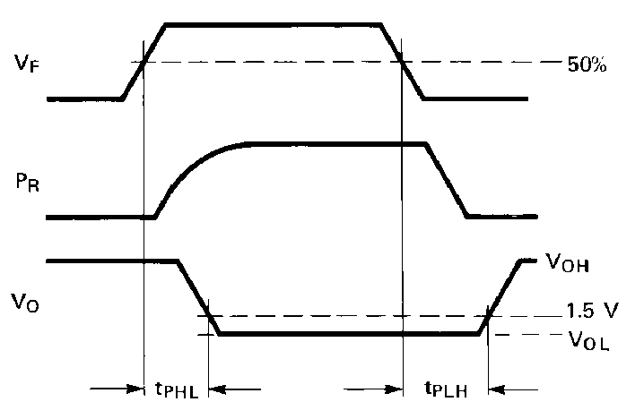

Figure 26. Propagation delay test waveforms

16

HFBR-15X3 Transmitter

ANODE 1
CATHODE 2
N.C. 3
N.C. 4

8 DO NOT CONNECT

5 DO NOT CONNECT

Pin # Function
1 Anode
2 Cathode
3 Open
4 Open
5 Do not connect
8 Do not connect

Absolute Maximum Ratings
Note: Pins 5 and 8 are for mounting and retaining purposes only. Do not electrically connect these pins.

Parameter |  | Symbol | Min. | Max. | Units | Reference
Storage Temperature |  | TS | –40 | +85 | °C
Operating Temperature |  | TA | –40 | +85 | °C
Lead Soldering Cycle | Temp. |  |  | 260 | °C | Note 1
Lead Soldering Cycle | Time |  |  | 10 | sec
Forward Input Current |  | IFPK |  | 1000 | mA | Note 2, 3
 |  | IFdc |  | 80 | mA
Reverse Input Voltage |  | VBR |  | 5 | V

Notes:
1. 1.6 mm below seating plane.
2. Recommended operating range between 10 and 750 mA.
3. 1 μs pulse, 20 μs period.

All HFBR-15XX LED transmitters are classified as IEC 825-1 Accessible Emission Limit (AEL) Class 1 based upon the current proposed draft scheduled to go into effect on January 1, 1997. AEL Class 1 LED devices are considered eye safe. Contact your Avago sales representative for more information.

Transmitter Electrical/Optical Characteristics 0°C to 70°C unless otherwise specified. For forward voltage and output power vs. drive current graphs.

IF = 60 mA
Parameter | Symbol | Min. | Typ. | Max. | Units | Conditions | Ref.
Transmitter Output  Optical Power | PT | –11.2  –13.6  –35.5 |  | –5.1  –4.5 | dBm | IFdc = 60 mA, 25°C  IFdc = 60 mA  IFdc = 2 mA, 0-70°C | Notes 3, 4  Fig. 9, 10
Output Optical Power  Temperature Coefficient | ∆PT /∆T |  | –0.85 |  | %/°C
Peak Emission  Wavelength | ⎣PK |  | 660 |  | nm
Forward Voltage | VF | 1.45 | 1.67 | 2.02 | V | IFdc = 60 mA
Forward Voltage  Temperature Coefficient | ∆VF /∆T |  | –1.37 |  | mV/°C |  | Fig. 18
Effective Diameter | D |  | 1 |  | mm
Numerical Aperture | NA |  | 0.5
Reverse Input Breakdown  Voltage | VBR | 5.0 | 11.0 |  | V | IFdc = 10 ∝A, TA = 25°C
Diode Capacitance | CO |  | 86 |  | pF | VF = 0, f = 1 MHz
Rise Time | tr |  | 80 |  | ns | 10% to 90%, | Note 1
Fall Time | tf |  | 40

Note:
1. Rise and fall times are measured with a voltage pulse driving the transmitter and a series connected 50 Ω load. A wide bandwidth optical to electrical waveform analyzer, terminated to a 50 Ω input of a wide bandwidth oscilloscope, is used for this response time measurement.

17

HFBR-25X3 Receiver

DO NOT CONNECT 5

DO NOT CONNECT 8

4 VCC
3 OPEN
2 GROUND
1 VO

Pin # Function
1 VO
2 Ground
3 Open
4 VCC
5 Do not connect
8 Do not connect

Note: Pins 5 and 8 are for mounting and retaining purposes only. Do not electrically connect these pins.

Absolute Maximum Ratings

Parameter |  | Symbol | Min. | Max. | Units | Reference
Storage Temperature |  | TS | –40 | +85 | °C
Operating Temperature |  | TA | –40 | +85 | °C
Lead Soldering Cycle | Temp. |  |  | 260 | °C | Note 1
 | Time |  |  | 10 | sec
Supply Voltage |  | VCC | –0.5 | 7 | V | Note 2
Average Output Collector Current |  | IO | –1 | 5 | mA
Output Collector Power Dissipation |  | POD |  | 25 | mW
Output Voltage |  | VO | –0.5 | 7 | V

Notes:
1. 1.6 mm below seating plane.
2. It is essential that a bypass capacitor 0.01 μF be connected from pin 2 to pin 3 of the receiver.

Receiver Electrical/Optical Characteristics 0°C to 70°C, 4.5 V ≤VCC ≤5.5 V unless otherwise specified.

Parameter | Symbol | Min. | Typ. | Max. | Units | Conditions | Ref.
Input Optical Power | PR(L) | –39 |  | –13.7 | dBm | VO = VOL, IOL = 3.2 mA | Notes 1,  2, 3
Level Logic 0 |  | –39 |  | –13.3 | dBm | VO = VOL,  IOH = 8 mA, 25°C | Notes 1,  2, 3
Input Optical Power  Level Logic 1 | PR(H) |  |  | –53 | dBm | VOH = 5.5 V IOH = ≤40 ∝A | Note 3
High Level Output Voltage | VOH | 2.4 |  |  | V | IO = - 40 ∝A, PR = 0 ∝W
Low Level Output Voltage | VOL |  |  | 0.4 | V | IOL = 3.2 mA PR = PR(L)MIN | Note 4
High Level Supply Current | ICCH |  | 1.2 | 1.9 | mA | VCC = 5.5 V, PR = 0 ∝W
Low Level Supply Current | ICCL |  | 2.9 | 3.7 | mA | VCC = 5.5 V,  PR = PRL (MIN) | Note 4
Effective Diameter | D |  | 1 |  | mm
Numerical Aperture | NA |  | 0.5

Notes:
1. Measured at the end of the fiber optic cable with large area detector.
2. Optical flux, P (dBm) = 10 Log P(μW)/1000 μW.
3. Because of the very high sensitivity of the HFBR-25X3, the digital output may switch in response to ambient light levels when a cable is not occupying the receiver optical port. The designer should take care to filter out signals from this source if they pose a hazard to the system.
4. Including current in 3.3 k pull-up resistor.

18

For product information and a complete list of distributors, please go to our website: www.avagotech.com

Avago, Avago Technologies, and the A logo are trademarks of Avago Technologies Limited in the United States and other countries. Data subject to change. Copyright © 2008 Avago Technologies Limited. All rights reserved. Obsoletes 5968-1712E
5988-1765EN January 30, 2008

