Versatile Link
The Versatile Fiber Optic
Connection

Technical Data

HFBR-0501 Series

Features
• Low Cost Fiber Optic
Components
• Enhanced Digital Links dc-5 MBd
• Extended Distance Links up to 120 m at 40 kBd
• Low Current Link: 6 mA Peak Supply Current
• Horizontal and Vertical
Mounting
• Interlocking Feature
• High Noise Immunity
• Easy Connectoring Simplex, Duplex, and Latching Connectors
• Flame Retardant
• Transmitters Incorporate a
660 nm Red LED for Easy
Visibility
• Compatible with Standard
TTL Circuitry

Applications
• Reduction of Lightning/Volt- age Transient Susceptibility
• Motor Controller Triggering
• Data Communications and
Local Area Networks
• Electromagnetic Compatibility (EMC) for Regulated Systems: FCC, VDE, CSA, etc.
• Tempest-Secure Data
Processing Equipment
• Isolation in Test and
Measurement Instruments
• Error Free Signalling for Industrial and Manufactur- ing Equipment
• Automotive Communications and Control Networks
• Noise Immune Communica- tion in Audio and Video Equipment

Description
The Versatile Link series is a complete family of fiber optic link components for applications requiring a low cost solution. The HFBR-0501 series includes trans- mitters, receivers, connectors and cable specified for easy design. This series of components is ideal for solving problems with voltage isolation/insulation, EMI/RFI immunity or data security. The optical link design is simplified
by the logic compatible receivers and complete specifications for each component. The key optical and electrical parameters of links configured with the HFBR-0501 family are fully guaranteed from
0 to 70 C.

A wide variety of package config- urations and connectors provide the designer with numerous mechanical solutions to meet application requirements. The

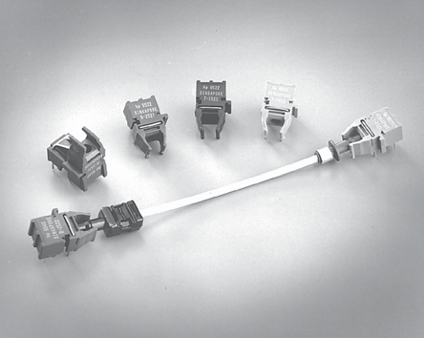

transmitter and receiver compo- nents have been designed for use in high volume/low cost assembly processes such as auto insertion and wave soldering.

Transmitters incorporate a 660 nm LED. Receivers include a monolithic dc coupled, digital IC receiver with open collector Schottky output transistor. An internal pullup resistor is avail- able for use in the HFBR-25X1/2/
4 receivers. A shield has been integrated into the receiver IC to provide additional, localized noise immunity.

Internal optics have been optim- ized for use with 1 mm diameter plastic optical fiber. Versatile Link specifications incorporate all connector interface losses.
Therefore, optical calculations for common link applications are simplified.

2

HFBR-0501 Series Part Number Guide

HFBR X5XX

1 = Transmitter
2 = Receiver

5 = 600 nm Transmitter and
Receiver Products 1 = 5 MBd High Performance Link
2 = 1 MBd High Performance Link
3 = 40 kBd Low Current/Extended Distance Link
2 = Horizontal Package 4 = 1 MBd Standard Link
3 = Vertical Package 6 = 155 MBd Receiver
7 = 155 MBd Transmitter
8 = 10 MBd High Performance Link

Link Selection Guide
(Links specified from 0 to 70 C, for plastic optical fiber unless specified.)

Signal Rate | Distance (m) 25 C | Distance (m) | Transmitter | Receiver
40 kBd | 120 | 110 | HFBR-1523 | HFBR-2523
1 MBd | 20 | 10 | HFBR-1524 | HFBR-2524
1 MBd | 55 | 45 | HFBR-1522 | HFBR-2522
5 Mbd | 30 | 20 | HFBR-1521 | HFBR-2521

Evaluation Kit
HFBR-0501 1 MBd Versatile Link:
This kit contains: HFBR-1524 Tx, HFBR-2524 Rx, polishing kit, 3 styles of plastic connectors, Bulkhead feedthrough, 5 meters of 1 mm diameter plastic cable, lapping film and grit paper, and HFBR-0501 data sheet.

Application Literature
Application Note 1035 (Versatile Link)

Package and Handling
Information
The compact Versatile Link pack- age is made of a flame retardant VALOX® UL 94 V-0 material
(UL file # E121562) and uses the same pad layout as a standard, eight pin dual-in-line package. Vertical and horizontal mountable parts are available. These low profile Versatile Link packages
are stackable and are enclosed to

provide a dust resistant seal. Snap action simplex, simplex latching, duplex, and duplex latching connectors are offered with simplex or duplex cables.

Package Orientation Performance and pinouts for the vertical and horizontal packages
are identical. To provide addi-
tional attachment support for the vertical Versatile Link housing,

the designer has the option of using a self-tapping screw through a printed circuit board into a mounting hole at the bottom of the package. For most applications this is not necessary.

Package Housing Color Versatile Link components and simplex connectors are color
coded to eliminate confusion

VALOX® is a registered trademark of the General Electric Corporation.

3

when making connections. Receivers are blue and transmit- ters are gray, except for the
HFBR-15X3 transmitter, which is black.

Handling
Versatile Link components are auto-insertable. When wave soldering is performed with Versatile Link components, the
Versatile Link components are moisture sensitive devices and are shipped in a moisture sealed bag. If the components are exposed to air for an extended period of time, they may require a baking step before the solder- ing process. Refer to the special labeling on the shipping tube for details.
Recommended Chemicals for
Cleaning/Degreasing Alcohols: methyl, isopropyl, isobutyl. Aliphatics: hexane,
heptane, Other: soap solution,
naphtha.

Do not use partially halogenated hydrocarbons such as 1,1.1 trichloroethane, ketones such as MEK, acetone, chloroform, ethyl

optical port plug should be left in to prevent contamination of the port. Do not use reflow solder
CAUTION This bag contains MOISTURE-SENSITIVE DEVICES
Level
4
acetate, methylene dichloride, phenol, methylene chloride, or N- methylpyrolldone. Also, Agilent

processes (i.e., infrared reflow or vapor-phase reflow). Nonhalogenated water soluble fluxes (i.e., 0% chloride), not rosin based fluxes, are recom- mended for use with Versatile Link components.
1. Shelf life in sealed bag: 12 months at < 40 C and < 90% Relative
Humidity (RH).

2. After this bag is opened, devices that will be subjected to wave soldering, or equivalent processing (solder temperature < 260 C for
10 sec) must be:
a) Mounted within 72 hours at factory conditions of 30 C/60% RH. b) Stored at 20% RH.

3. Devices require baking, before mounting, if:
a) Desiccant changes to PINK. b) If 2a or 2b are not met.

4. If baking is required, devices may be baked outside of tube for 20 hours at 75 C.

Bag Seal Date: (If blank, see barcode label)

Note: LEVEL defined by EIA JEDEC Standard J-STD-020
does not recommend the use of cleaners that use halogenated hydrocarbons because of their potential environmental harm.

Mechanical Dimensions
Horizontal Modules Vertical Modules

2.0 (0.080)

18.8 (0.740)
6.8 (0.270)

10.2 (0.400)
5.1 (0.200)

7.6 (0.30)

0.64 (0.025)

77.7.61 (0(0.3.3005))

4.2 (0.165)

18.8
0.740

7.62 (0.300)
3.81 (0.150) MAX.
3.56 (0.140) MIN.

0.51

1.27 (0.050)

(0.020)
2.5 (0.100)

0.64 (0.025) DIA.

2.8 (0.109)
1.85 (0.073)

4

Versatile Link Printed Board Layout Dimensions
Horizontal Module Vertical Module

2.54 (0.100)
7.62 (0.300)

1.01 (0.040) DIA.

TOP VIEW
4 3 2 1

7.62 (0.300)

5 6 PCB EDGE

1.85 MIN. (0.073)

DIMENSIONS IN MILLIMETERS (INCHES).

Interlocked (Stacked) Assemblies (refer to Figure 1)
Horizontal packages may be stacked by placing units with pins facing upward. Initially engage
the interlocking mechanism by sliding the L bracket body from above into the L slot body of the lower package. Use a straight
edge, such as a ruler, to bring all stacked units into uniform alignment. This technique prevents potential harm that could occur to fingers and hands of assemblers from the package
pins. Stacked horizontal packages can be disengaged if necessary. Repeated stacking and unstack- ing causes no damage to individual units.
To stack vertical packages, hold one unit in each hand, with the pins facing away and the optical ports on the bottom. Slide the L bracket unit into the L slot unit. The straight edge used for horizontal package alignment is not needed.

Stacking Horizontal Modules
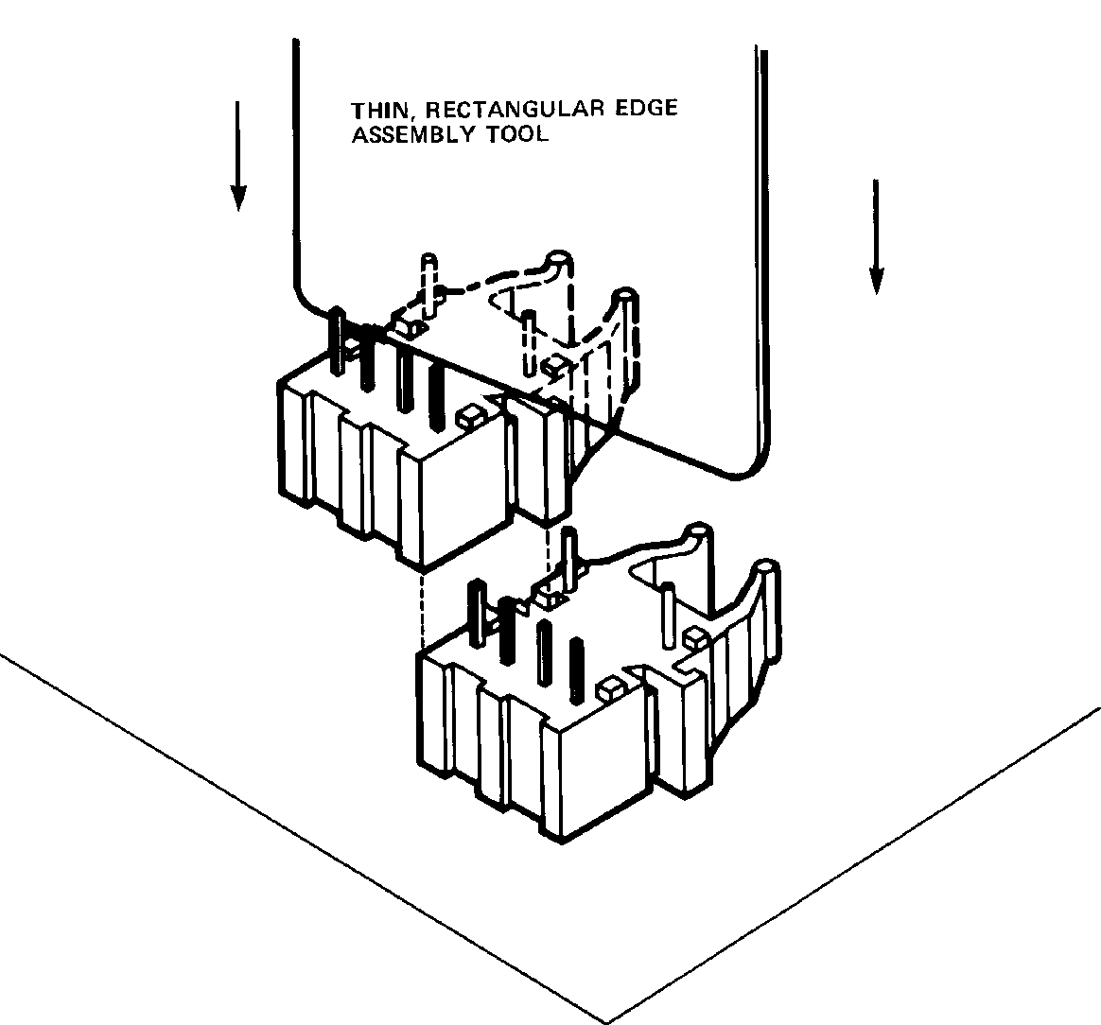

Figure 1. Interlocked (Stacked) Horizontal or Vertical Packages.
Stacking Vertical Modules

5

5 MBd Link (HFBR-15X1/25X1)
System Performance 0 to 70 C unless otherwise specified.

 | Parameter | Symbol | Min. | Typ. | Max. | Units | Conditions | Ref.
High  Performance  5 MBd | Data Rate |  | dc |  | 5 | MBd | BER 10-9, PRBS:27-1
High  Performance  5 MBd | Link Distance  (Standard Cable) |  | 19  27 | 48 |  | m m | IFdc = 60 mA  IFdc = 60 mA, 25 C | Fig. 3  Note 3
High  Performance  5 MBd | Link Distance  (Improved Cable) |  | 22  27 | 53 |  | m m | IFdc = 60 mA  IFdc = 60 mA, 25 C | Fig. 4  Note 3
High  Performance  5 MBd | Propagation  Delay | tPLH  tPHL |  | 80  50 | 140  140 | ns ns | RL = 560 , CL = 30 pF  fiber length = 0.5 m  -21.6 PR -9.5 dBm | Fig. 5, 8  Notes 1, 2
High  Performance  5 MBd | Pulse Width  Distortion tPLH-tPHL | tD |  | 30 |  | ns | PR = -15 dBm  RL = 560 , CL = 30 pF | Fig. 5, 7
Notes:
1. The propagation delay for one metre of cable is typically 5 ns.
2. Typical propagation delay is measured at PR = -15 dBm.
3. Estimated typical link life expectancy at 40 C exceeds 10 years at 60 mA.

Figure 2. Typical 5 MBd Interface Circuit.

10 10

50 50
I F – FORWARD CURRENT (mA)
I F – FORWARD CURRENT (mA)

OVERDRIVE
30
UNDERDRIVE
20

10

OVERDRIVE
30

UNDERDRIVE
20

10

0°C–70°C
25°C
5
0 10 20 30 40 50

0°C–70°C
25°C
5
0 10 20 30 40 50 60

– CABLE LENGTH – METRES

– CABLE LENGTH – METRES

Figure 3. Guaranteed System Performance with Standard
Cable (HFBR-15X1/25X1).
Figure 4. Guaranteed System Performance with Improved
Cable (HFBR-15X1/25X1).

6

Figure 5. 5 MBd Propagation Delay Test Circuit.

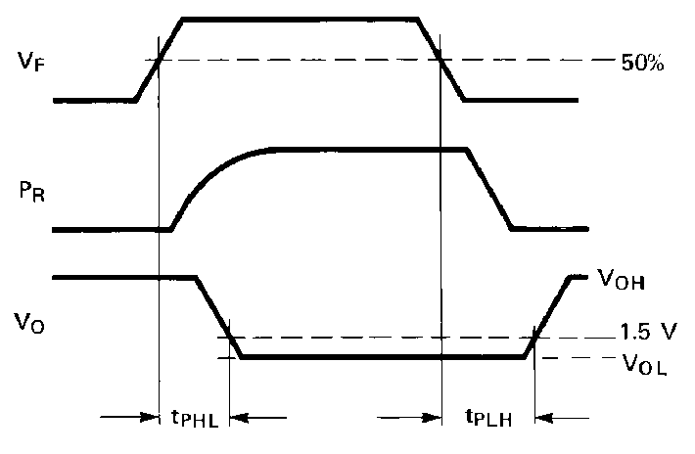

Figure 6. Propagation Delay Test Waveforms.

500
500
 |  |  |  |  |  | tp | LH
HFBR-15X2/25X2
HFBR-15X4/25X4
 |  |  |  |  |  | tp | LH
 |  | HFB | R-15 | X1/2 | 5X1
 |  |  |  |  |  | tp | HL

400
tD – PULSE WIDTH DISTORTION – ns

300

HFBR-15X2/25X2
HFBR-15X4/25X4

70°C

25°C
0°C

400
tp – PROPAGATION DELAY – ns

300

200
200

100

0

HFBR-15X1/25X1

70°C
25°C
0°C
100

0

-25
-20 -15
-10 -5 0
-25
-20 -15
-10 -5 0

PR – INPUT OPTICAL POWER – dBm

PR – INPUT OPTICAL POWER – dBm

Figure 7. Typical Link Pulse Width Distortion vs. Optical Power.
Figure 8. Typical Link Propagation Delay vs. Optical Power.

7
Pin # | Function
1 | Anode
2 | Cathode
3 | Open
4 | Open
5 | Do not connect
8 | Do not connect

HFBR-15X1 Transmitter

ANODE 1
CATHODE 2
N.C. 3
4
8 DO NOT CONNECT

N.C.

5 DO NOT CONNECT

Note: Pins 5 and 8 are for mounting and retaining purposes only. Do not electrically connect these pins.

Absolute Maximum Ratings

Parameter |  | Symbol | Min. | Max. | Units | Reference
Storage Temperature |  | TS | –40 | +85 | C
Operating Temperature |  | TA | –40 | +85 | C
Lead Soldering Cycle | Temp. |  |  | 260 | C | Note 1
Lead Soldering Cycle | Time |  |  | 10 | sec | Note 1
Forward Input Current |  | IFPK |  | 1000 | mA | Note 2, 3
 |  | IFdc |  | 80 | mA
Reverse Input Voltage |  | VBR |  | 5 | V

Notes:
1. 1.6 mm below seating plane.
2. Recommended operating range between 10 and 750 mA.
3. 1 s pulse, 20 s period.

All HFBR-15XX LED transmitters are classified as IEC 825-1 Accessible Emission Limit (AEL) Class 1 based upon the current proposed draft scheduled to go into effect on January 1, 1997. AEL Class 1 LED devices are considered eye safe. Contact your local Agilent sales representative for more information.

8

Transmitter Electrical/Optical Characteristics 0 C to 70 C unless otherwise specified.

Parameter | Symbol | Min. | Typ.[5] | Max. | Units | Conditions | Ref.
Transmitter Output | PT | -16.5 |  | -7.6 | dBm | IFdc = 60 mA | Notes 1, 2
Optical Power |  | -14.3 |  | -8.0 | dBm | IFdc = 60 mA, 25 C
Output Optical Power  Temperature Coefficient | PT / T |  | -0.85 |  | %/ C
Peak Emission  Wavelength | PK |  | 660 |  | nm
Forward Voltage | VF | 1.45 | 1.67 | 2.02 | V | IFdc = 60 mA
Forward Voltage  Temperature Coefficient | VF/ T |  | -1.37 |  | mV/ C |  | Fig. 9
Effective Diameter | D |  | 1 |  | mm
Numerical Aperture | NA |  | 0.5
Reverse Input Breakdown  Voltage | VBR | 5.0 | 11.0 |  | V | IFdc = 10 A, TA = 25 C
Diode Capacitance | CO |  | 86 |  | pF | VF = 0, f = MHz
Rise Time | tr |  | 80 |  | ns | 10% to 90%, | Note 3
Fall Time | tf |  | 40 |  | ns | IF = 60 mA

Notes:
1. Measured at the end of 0.5 m standard fiber optic cable with large area detector.
2. Optical power, P (dBm) = 10 Log [P( W)/1000 W].
3. Rise and fall times are measured with a voltage pulse driving the transmitter and a series connected 50 load. A wide bandwidth optical to electrical waveform analyzer, terminated to a 50 input of a wide bandwidth oscilloscope, is used for this response time measurement.

1.8 5

0
1.7
VF – FORWARD VOLTAGE – V

1.6
0°C

25°C

1.5
70°C

-15

1.4
2 10

100
-20
PT – NORMALIZED OUTPUT POWER – dB
2 10

100

IFdc – TRANSMITTER DRIVE CURRENT (mA)

IFdc – TRANSMITTER DRIVE CURRENT (mA)

Figure 9. Typical Forward Voltage vs. Drive Current. Figure 10. Normalized Typical Output Power vs. Drive
Current.

9
Pin # | Function
1 | VO
2 | Ground
3 | VCC
4 | RL
5 | Do not connect
8 | Do not connect

HFBR-25X1 Receiver

DO NOT CONNECT 5

DO NOT CONNECT 8

1000

4 RL
3 VCC
2 GROUND
1 VO

Absolute Maximum Ratings

Note: Pins 5 and 8 are for mounting and retaining purposes only. Do not electrically connect these pins.

Parameter |  | Symbol | Min. | Max. | Units | Reference
Storage Temperature |  | TS | –40 | +85 | C
Operating Temperature |  | TA | –40 | +85 | C
Lead Soldering Cycle | Temp. |  |  | 260 | C | Note 1
 | Time |  |  | 10 | sec | Note 1
Supply Voltage |  | VCC | –0.5 | 7 | V | Note 2
Output Collector Current |  | IOAV |  | 25 | mA
Output Collector Power Dissipation |  | POD |  | 40 | mW
Output Voltage |  | VO | –0.5 | 18 | V
Pull-up Voltage |  | VP | –5 | VCC | V
Fan Out (TTL) |  | N |  | 5
Notes:
1. 1.6 mm below seating plane.
2. It is essential that a bypass capacitor 0.01 F be connected from pin 2 to pin 3 of the receiver. Total lead length between both ends of the capacitor and the pins should not exceed 20 mm.

Receiver Electrical/Optical Characteristics
0 C to 70 C, 4.75 V VCC 5.25 V unless otherwise specified

Parameter | Symbol | Min. | Typ. | Max. | Units | Conditions | Ref.
Input Optical Power  Level for Logic “0” | PR(L) | –21.6 |  | –9.5 | dBm | VOL = 0.5 V IOL = 8 mA | Notes 1,  2, 4
Input Optical Power  Level for Logic “0” | PR(L) | –21.6 |  | –8.7 | dBm | VOL = 0.5 V  IOL = 8 mA, 25 C | Notes 1,  2, 4
Input Optical Power  Level for Logic “1” | PR(H) |  |  | –43 | dBm | VOL = 5.25 V IOH 250 A | Note 1
High Level Output Current | IOH |  | 5 | 250 | A | VO = 18 V, PR = 0 | Note 3
Low Level Output Current | VOL |  | 0.4 | 0.5 | V | IOL = 8 mA, PR = PR(L)MIN | Note 3
High Level Supply  Current | ICCH |  | 3.5 | 6.3 | mA | VCC = 5.25 V, PR = 0 | Note 3
Low Level Supply Current | ICCL |  | 6.2 | 10 | mA | VCC = 5.25 V  PR = -12.5 dBm | Note 3
Effective Diameter | D |  | 1 |  | mm
Numerical Aperture | NA |  | 0.5
Internal Pull-up Resistor | RL | 680 | 1000 | 1700

Notes:
1. Optical flux, P (dBm) = 10 Log [P ( W)/1000 W].
2. Measured at the end of the fiber optic cable with large area detector.
3. RL is open.
4. Pulsed LED operation at IF > 80 mA will cause increased link tPLH propagation delay time. This extended tPLH time contributes to
increased pulse width distortion of the receiver output signal.

10

1 MBd Link
(High Performance HFBR-15X2/25X2, Standard HFBR-15X4/25X4)
System Performance Under recommended operating conditions unless otherwise specified.

 | Parameter | Symbol | Min. | Typ. | Max. | Units | Conditions | Ref.
High  Performance  1 MBd | Data Rate |  | dc |  | 1 | MBd | BER 10-9, PRBS:27-1
High  Performance  1 MBd | Link Distance  (Standard Cable) |  | 39  47 | 70 |  | m m | IFdc = 60 mA  IFdc = 60 mA, 25 C | Fig. 14  Notes 1,  3, 4
High  Performance  1 MBd | Link Distance  (Improved Cable) |  | 45  56 | 78 |  | m m | IFdc = 60 mA  IFdc = 60 mA, 25 C | Fig. 15  Notes 1,  3, 4
High  Performance  1 MBd | Propagation  Delay | tPLH  tPHL |  | 180  100 | 250  140 | ns ns | RL = 560 , CL = 30 pF I = 0.5 metre  PR = -24 dBm | Fig. 16, 18  Notes 2, 4
High  Performance  1 MBd | Pulse Width  Distortion tPLH-tPHL | tD |  | 80 |  | ns | PR = -24 dBm  RL = 560 , CL = 30 pF | Fig. 16, 17  Note 4

 | Parameter | Symbol | Min. | Typ. | Max. | Units | Conditions | Ref.
Standard | Data Rate |  | dc |  | 1 | MBd | BER 10-9, PRBS:27-1
1 MBd | Link Distance  (Standard Cable) |  | 8  17 | 43 |  | m m | IFdc = 60 mA  IFdc = 60 mA, 25 C | Fig. 12  Notes 1,  3, 4
1 MBd | Link Distance  (Improved Cable) |  | 10  19 | 48 |  | m m | IFdc = 60 mA  IFdc = 60 mA, 25 C | Fig. 13  Notes 1,  3, 4
1 MBd | Propagation  Delay | tPLH  tPHL |  | 180  100 | 250  140 | ns ns | RL = 560 , CL = 30 pF I = 0.5 metre  PR = -20 dBm | Fig. 16, 18  Notes 2, 4
1 MBd | Pulse Width  Distortion tPLH-tPHL | tD |  | 80 |  | ns | PR = -20 dBm  RL = 560 , CL = 30 pF | Fig. 16, 17  Note 4
Notes:
1. For IFPK > 80 mA, the duty factor must be such as to keep IFdc 80 mA. In addition, for IFPK > 80 mA, the following rules for pulse width apply:
IFPK 160 mA: Pulse width 1 ms
IFPK > 160 mA: Pulse width 1 S, period 20 S.
2. The propagation delay for one meter of cable is typically 5 ns.
3. Estimated typical link life expectancy at 40 C exceeds 10 years at 60 mA.
4. Pulsed LED operation at IFPK > 80 mA will cause increased link tPLH propagation delay time. This extended tPLH time contributes to increased pulse width distortion of the receiver output signal.

11

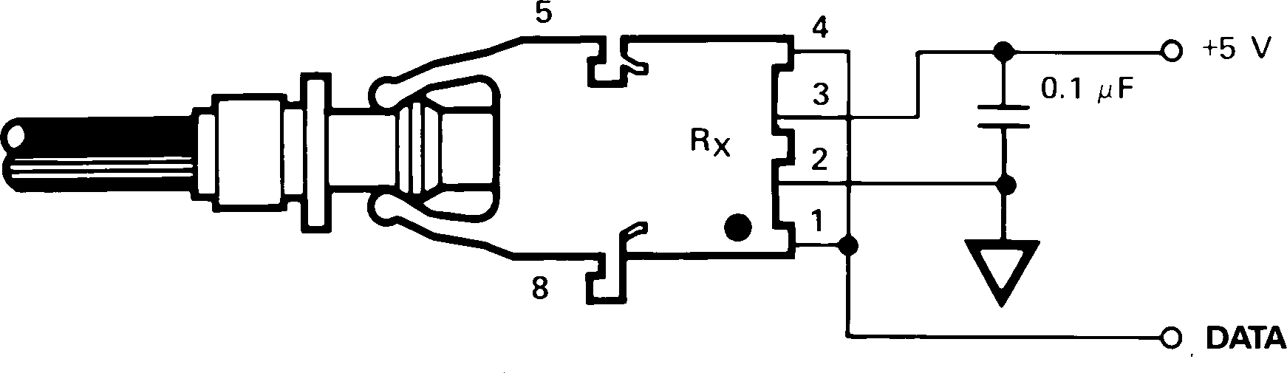

Figure 11. Required 1 MBd Interface Circuit.

The HFBR-25X2 receiver can not be overdriven when using the required interface circuit shown in Figure 11.

10 10
HFBR-15X4/25X4
0°C–70°C
25°C

90 90
80 80
I F – FORWARD CURRENT (mA)
I F – FORWARD CURRENT (mA)
70 70
60 60

50 50

40 40

30 30

HFBR-15X4/25X4

20
0 5 10 15

20 25

20
0 10
0°C–70°C
25°C
20 30

– CABLE LENGTH – METRES

– CABLE LENGTH – METRES

Figure 12. Guaranteed System Performance for the
HFBR-15X4/25X4 Link with Standard Cable.
Figure 13. Guaranteed System Performance for the
HFBR-15X4/25X4 Link with Improved Cable.

100

50
40
30

20
100

50
40
30

20

UNDERDRIVE

UNDERDRIVE

10 10
IF – FORWARD CURRENT (mA)
IF – FORWARD CURRENT (mA)

0°C–70°C
25°C
5
0 10 20 30 40 50

0°C–70°C
25°C
5
0 10 20 30 40 50 60

– CABLE LENGTH – METRES

– CABLE LENGTH – METRES

Figure 14. Guaranteed System Performance for the
HFBR-15X2/25X2 Link with Standard Cable.
Figure 15. Guaranteed System Performance for the
HFBR-15X2/25X2 Link with Improved Cable.

12

Figure 16. 1 MBd Propagation Delay Test Circuit.

500
500

400
tD – PULSE WIDTH DISTORTION – ns

300

HFBR-15X2/25X2
tp – PROPAGATION DELAY – ns
HFBR-15X4/25X4

70°C

25°C
0°C

400

300

200
200

100

0

HFBR-15X1/25X1

70°C
25°C
0°C
100

0
 |  |  |  |  |  | tp | LH
HFBR-15X2/25X2
HFBR-15X4/25X4
 |  |  |  |  |  | tp | LH
 |  | HFB | R-15 | X1/2 | 5X1
 |  |  |  |  |  | tp | HL

-25
-20 -15
-10 -5 0
-25
-20 -15
-10 -5 0

PR – INPUT OPTICAL POWER – dBm

PR – INPUT OPTICAL POWER – dBm

Figure 17. Pulse Width Distortion vs. Optical Power.
Figure 18. Typical Link Propagation
Delay vs. Optical Power.

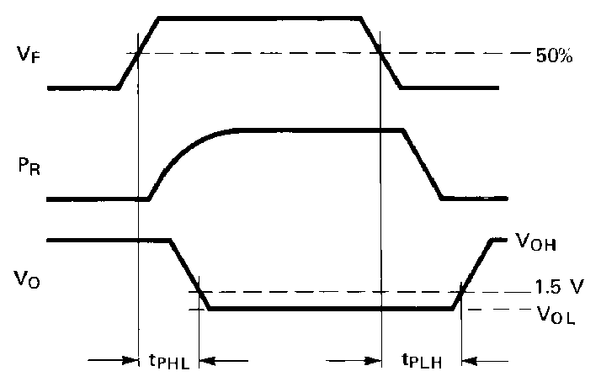

Figure 19. Propagation Delay Test
Waveforms.

13
Pin # | Function
1 | Anode
2 | Cathode
3 | Open
4 | Open
5 | Do not connect
8 | Do not connect

HFBR-15X2/15X4 Transmitters

ANODE 1
CATHODE 2
N.C. 3
N.C. 4
8 DO NOT CONNECT

5 DO NOT CONNECT

Note: Pins 5 and 8 are for mounting and retaining purposes only. Do not

Absolute Maximum Ratings
electrically connect these pins.

Parameter |  | Symbol | Min. | Max. | Units | Reference
Storage Temperature |  | TS | –40 | +85 | C
Operating Temperature |  | TA | –40 | +85 | C
Lead Soldering Cycle | Temp. |  |  | 260 | C | Note 1
Lead Soldering Cycle | Time |  |  | 10 | sec | Note 1
Forward Input Current |  | IFPK |  | 1000 | mA | Note 2, 3
 |  | IFdc |  | 80
Reverse Input Voltage |  | VBR |  | 5 | V

Notes:
1. 1.6 mm below seating plane.
2. Recommended operating range between 10 and 750 mA.
3. 1 s pulse, 20 s period.

All HFBR-15XX LED transmitters are classified as IEC 825-1 Accessible Emission Limit (AEL) Class 1 based upon the current proposed draft scheduled to go into effect on January 1, 1997. AEL Class 1 LED devices are considered eye safe. Contact your Agilent sales representative for more information.

Transmitter Electrical/Optical Characteristics 0 C to 70 C unless otherwise specified. For forward voltage and output power vs. drive current graphs.

Parameter |  | Symbol | Min. | Typ. | Max. | Units | Conditions | Ref.
Transmitter  Output | HFBR-15X2 | PT | –13.6  –11.2 |  | –4.5  –5.1 | dBm | IFdc = 60 mA  IFdc = 60 mA, 25 C
Optical  Power | HFBR-15X4 | PT | –17.8  –15.5 |  | –4.5  –5.1 | dBm | IFdc = 60 mA  IFdc = 60 mA, 25 C
Output Optical Power  Temperature Coefficient |  | PT/ T |  | –0.85 |  | %/ C
Peak Emission Wavelength |  | PK |  | 660 |  | nm
Forward Voltage |  | VF | 1.45 | 1.67 | 2.02 | V | IFdc = 60 mA
Forward Voltage  Temperature Coefficient |  | VF/ T |  | –1.37 |  | mV/ C |  | Fig. 11
Effective Diameter |  | DT |  | 1 |  | mm
Numerical Aperture |  | NA |  | 0.5
Reverse Input Breakdown  Voltage |  | VBR | 5.0 | 11.0 |  | V | IFdc = 10 A, TA = 25 C
Diode Capacitance |  | CO |  | 86 |  | pF | VF = 0, f = 1 MHz
Rise Time |  | tr |  | 80 |  | ns | 10% to 90%, | Note 1
Fall Time |  | tf |  | 40 |  | ns | IF = 60 mA

Note:
1. Rise and fall times are measured with a voltage pulse driving the transmitter and a series connected 50 load. A wide bandwidth optical to electrical waveform analyzer, terminated to a 50 input of a wide bandwidth oscilloscope, is used for this response time measurement.

14
Pin # | Function
1 | VO
2 | Ground
3 | VCC
4 | RL
5 | Do not connect
8 | Do not connect

HFBR-25X2/25X4 Receivers

DO NOT CONNECT 5

DO NOT CONNECT 8

1000

4 RL
3 VCC
2 GROUND
1 VO

Absolute Maximum Ratings
Note: Pins 5 and 8 are for mounting and retaining purposes only. Do not electrically connect these pins.

Parameter |  | Symbol | Min. | Max. | Units | Reference
Storage Temperature |  | TS | –40 | +85 | C
Operating Temperature |  | TA | –40 | +85 | C
Lead Soldering Cycle | Temp. |  |  | 260 | C | Note 1
 | Time |  |  | 10 | sec | Note 1
Supply Voltage |  | VCC | –0.5 | 7 | V | Note 2
Output Collector Current |  | IOAV |  | 25 | mA
Output Collector Power Dissipation |  | POD |  | 40 | mW
Output Voltage |  | VO | –0.5 | 18 | V
Pull-up Voltage |  | VP | –5 | VCC | V
Fan Out (TTL) |  | N |  | 5
Notes:
1. 1.6 mm below seating plane.
2. It is essential that a bypass capacitor 0.01 F be connected from pin 2 to pin 3 of the receiver. Total lead length between both ends
of the capacitor and the pins should not exceed 20 mm.

Receiver Electrical/Optical Characteristics 0 C to 70 C, 4.75 V VCC 5.25 V unless otherwise specified.

Parameter |  | Symbol | Min. | Typ. | Max. | Units | Conditions | Ref.
Receiver  Optical Input | HFBR-2522 | PR(L) | –24 |  |  | dBm | VOL = 0 V IOL = 8 mA | Notes 1, 2, 3
Power Level  Logic 0 | HFBR-2524 |  | –20 |  |  |  |  | Note 4
Optical Input Power  Level Logic 1 |  | PR(H) |  |  | -43 | dBm | VOH = 5.25 V IOH = 250 A | Note 4
High Level Output Current |  | IOH |  | 5 | 250 | A | VO = 18 V, PR = 0 | Note 5
Low Level Output Voltage |  | VOL |  | 0.4 | 0.5 | V | IOL = 8 mA PR = PR(L)MIN | Note 5
High Level Supply Current |  | ICCH |  | 3.5 | 6.3 | mA | VCC = 5.25 V, PR = 0 | Note 5
Low Level Supply Current |  | ICCL |  | 6.2 | 10 | mA | VCC = 5.25 V,  PR = -12.5 dBm | Note 5
Effective Diameter |  | D |  | 1 |  | mm
Numerical Aperture |  | NA |  | 0.5
Internal Pull-up Resistor |  | RL | 680 | 1000 | 1700
Notes:
1. Measured at the end of the fiber optic cable with large area detector.
2. Pulsed LED operation at IF > 80 mA will cause increased link tPLH propagation delay time. This extended tPLH time contributes to increased pulse width distortion of the receiver output signal.
3. The LED drive circuit of Figure 11 is required for 1 MBd operation of the HFBR-25X2/25X4.
4. Optical flux, P (dBm) = 10 Log [P( W)/1000 W].
5. RL is open.

15

40 kBd Link
System Performance Under recommended operating conditions unless otherwise specified.

Parameter | Symbol | Min. | Typ. | Max. | Units | Conditions | Ref.
Data Rate |  | dc |  | 40 | kBd | BER 10-9, PRBS: 27 - 1
Link Distance  (Standard Cable) |  | 13  94 | 41  138 |  | m m | IFdc = 2 mA IFdc = 60 mA | Fig. 21  Note 1
Link Distance  (Improved Cable) |  | 15  111 | 45  154 |  | m m | IFdc = 2 mA IFdc = 60 mA | Fig. 22  Note 1
Propagation  Delay | tPLH  tPHL |  | 4  2.5 |  | s s | RL = 3.3 k , CL = 30 pF PR = -25 dBm, 1 m fiber | Fig. 22, 25  Note 2
Pulse Width  Distortion tPLH-tPHL | tD |  |  | 7 | s | -39 PR - 14 dBm  RL = 3.3 k , CL = 30 pF | Fig. 23, 24
Notes:
1. Estimated typical link life expectancy at 40 C exceeds 10 years at 60 mA.
2. The propagation delay for one metre of cable is typically 5 ns.

Figure 20. Typical 40 kBd Interface Circuit.

12 12
10 10
80 80
60 60
I F – FORWARD CURRENT (mA)
I F – FORWARD CURRENT (mA)
40 40

20
20

10

6 10

HFBR-15X3/25X3

2
0°C–70°C
25°C
1

6
4
0°C–70°C
25°C
2

0 10 20 30 40 50 60
70 80 90 100
0 10 20 30 40 50
60 70 80 90 100 110

– CABLE LENGTH – METRES

– CABLE LENGTH – METRES

Figure 21. Guaranteed System Performance with
Standard Cable.
Figure 22. Guaranteed System Performance with Improved
Cable.

16

Figure 23. 40 kBd Propagation Delay Test Circuit.

6 8

7
5
t D – PULSE WIDTH DISTORTION – µs
6
4
5

3 4
t P – PROPAGATION DELAY – µs

3
2
2
1
1

0
-40

-34

-28

-22 -16

-10

0
-40

-34

-28

-22 -16

-10
tPLH
tPHL

PR – INPUT OPTICAL POWER, dBm

PR – INPUT OPTICAL POWER, dBm

Figure 24. Typical Link Pulse Width Distortion vs. Optical Power.
Figure 25. Typical Link Propagation Delay vs. Optical
Power.

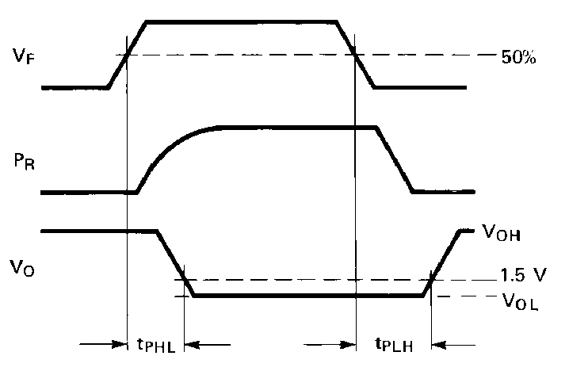

Figure 26. Propagation Delay Test Waveforms.

17
Pin # | Function
1 | Anode
2 | Cathode
3 | Open
4 | Open
5 | Do not connect
8 | Do not connect

HFBR-15X3 Transmitter

ANODE 1
CATHODE 2
N.C. 3
N.C. 4
8 DO NOT CONNECT

5 DO NOT CONNECT

Absolute Maximum Ratings
Note: Pins 5 and 8 are for mounting and retaining purposes only. Do not electrically connect these pins.

Parameter |  | Symbol | Min. | Max. | Units | Reference
Storage Temperature |  | TS | –40 | +85 | C
Operating Temperature |  | TA | –40 | +85 | C
Lead Soldering Cycle | Temp. |  |  | 260 | C | Note 1
Lead Soldering Cycle | Time |  |  | 10 | sec | Note 1
Forward Input Current |  | IFPK |  | 1000 | mA | Note 2, 3
 |  | IFdc |  | 80 | mA
Reverse Input Voltage |  | VBR |  | 5 | V

Notes:
1. 1.6 mm below seating plane.
2. Recommended operating range between 10 and 750 mA.
3. 1 s pulse, 20 s period.

All HFBR-15XX LED transmitters are classified as IEC 825-1 Accessible Emission Limit (AEL) Class 1 based upon the current proposed draft scheduled to go into effect on January 1, 1997. AEL Class 1 LED devices are considered eye safe. Contact your Agilent sales representative for more information.

Transmitter Electrical/Optical Characteristics 0 C to 70 C unless otherwise specified. For forward voltage and output power vs. drive current graphs.

Parameter | Symbol | Min. | Typ. | Max. | Units | Conditions | Ref.
Transmitter Output  Optical Power | PT | –11.2  –13.6  –35.5 |  | –5.1  –4.5 | dBm | IFdc = 60 mA, 25 C IFdc = 60 mA  IFdc = 2 mA, 0-70 C | Notes 3, 4  Fig. 9, 10
Output Optical Power  Temperature Coefficient | PT/ T |  | –0.85 |  | %/ C
Peak Emission  Wavelength | PK |  | 660 |  | nm
Forward Voltage | VF | 1.45 | 1.67 | 2.02 | V | IFdc = 60 mA
Forward Voltage  Temperature Coefficient | VF/ T |  | –1.37 |  | mV/ C |  | Fig. 18
Effective Diameter | D |  | 1 |  | mm
Numerical Aperture | NA |  | 0.5
Reverse Input Breakdown  Voltage | VBR | 5.0 | 11.0 |  | V | IFdc = 10 A, TA = 25 C
Diode Capacitance | CO |  | 86 |  | pF | VF = 0, f = 1 MHz
Rise Time | tr |  | 80 |  | ns | 10% to 90%, | Note 1
Fall Time | tf |  | 40 |  |  | IF = 60 mA

Note:
1. Rise and fall times are measured with a voltage pulse driving the transmitter and a series connected 50 load. A wide bandwidth optical to electrical waveform analyzer, terminated to a 50 input of a wide bandwidth oscilloscope, is used for this response time measurement.

18
Pin # | Function
1 | VO
2 | Ground
3 | Open
4 | VCC
5 | Do not connect
8 | Do not connect

HFBR-25X3 Receiver

DO NOT CONNECT 5

DO NOT CONNECT 8

4 VCC
3 OPEN
2 GROUND
1 VO

Absolute Maximum Ratings
Note: Pins 5 and 8 are for mounting and retaining purposes only. Do not electrically connect these pins.

Parameter |  | Symbol | Min. | Max. | Units | Reference
Storage Temperature |  | TS | –40 | +85 | C
Operating Temperature |  | TA | –40 | +85 | C
Lead Soldering Cycle | Temp. |  |  | 260 | C | Note 1
 | Time |  |  | 10 | sec | Note 1
Supply Voltage |  | VCC | –0.5 | 7 | V | Note 2
Average Output Collector Current |  | IO | –1 | 5 | mA
Output Collector Power Dissipation |  | POD |  | 25 | mW
Output Voltage |  | VO | –0.5 | 7 | V
Notes:
1. 1.6 mm below seating plane.
2. It is essential that a bypass capacitor 0.01 F be connected from pin 2 to pin 3 of the receiver.

Receiver Electrical/Optical Characteristics 0 C to 70 C, 4.5 V VCC 5.5 V unless otherwise specified.

Parameter | Symbol | Min. | Typ. | Max. | Units | Conditions | Ref.
Input Optical Power | PR(L) | –39 |  | –13.7 | dBm | VO = VOL, IOL = 3.2 mA | Notes 1,  2, 3
Level Logic 0 |  | –39 |  | –13.3 |  | VO = VOL,  IOH = 8 mA, 25 C | Notes 1,  2, 3
Input Optical Power  Level Logic 1 | PR(H) |  |  | –53 | dBm | VOH = 5.5 V IOH = 40 A | Note 3
High Level Output Voltage | VOH | 2.4 |  |  | V | IO = - 40 A, PR = 0 W
Low Level Output Voltage | VOL |  |  | 0.4 | V | IOL = 3.2 mA PR = PR(L)MIN | Note 4
High Level Supply Current | ICCH |  | 1.2 | 1.9 | mA | VCC = 5.5 V, PR = 0 W
Low Level Supply Current | ICCL |  | 2.9 | 3.7 | mA | VCC = 5.5 V,  PR = PRL (MIN) | Note 4
Effective Diameter | D |  | 1 |  | mm
Numerical Aperture | NA |  | 0.5

Notes:
1. Measured at the end of the fiber optic cable with large area detector.
2. Optical flux, P (dBm) = 10 Log P( W)/1000 W.
3. Because of the very high sensitivity of the HFBR-25X3, the digital output may switch in response to ambient light levels when a cable is not occupying the receiver optical port. The designer should take care to filter out signals from this source if they pose a hazard to the system.
4. Including current in 3.3 k pull-up resistor.

www.semiconductor.agilent.com
Data subject to change.
Copyright © 2001 Agilent Technologies, Inc. June 12, 2001
Obsoletes 5968-1712E
5988-1765EN

