HFBR-RXXYYYZ Series (POF) HFBR-EXXYYYZ Series (POF)
Plastic Optical Fiber Cable and Accessories
for Versatile Link

Data Sheet

Cable Description
The HFBR-R/EXXYYYZ series of plastic fiber optic cables are constructed of a single step-index fiber sheathed in a black polyethylene jacket. The duplex fiber consists of two simplex fibers joined with a zipcord web.

Standard attenuation and extra low loss POF cables are identical except for attenuation specifications. Polyethylene jackets on all plastic fiber cables comply with UL VW-1 flame retardant specification (UL file # E89328).

Cables are available in unconnectored or connectored options. Refer to the Ordering Guide for part number information.

500

400
αR – ATTENUATION – dB/km
Features
• Compatible with Avago Versatile Link family of connectors and fiber optic components
• 1 mm diameter Plastic Optical Fiber (POF) in two grades: low cost standard POF with 0.22 dB/m typical attenuation, or high performance extra low loss POF with 0.19 dB/m typical attenuation

Applications
• Industrial data links for factory automation and plant control
• Intra-system links; board-to-board, rack-to-rack
• Telecommunications switching systems
• Computer-to-peripheral data links, PC bus extension
• Proprietary LANs
• Digitized video
• Medical instruments
• Reduction of lightning and voltage transient susceptibility
• High voltage isolation

300

200

100
620

640

660

680

700

λ – WAVELENGTH – nm

Figure 1. Typical POF attenuation vs. wavelength.

Plastic Optical Fiber Specifications: HFBR-R/EXXYYYZ Absolute Maximum Ratings

Parameter |  | Symbol | Min. | Max. | Unit | Note
Storage and Operating Temperature |  | TS,O | -55 | +85 | °C
Recommended Operating Temperature |  | TO | -40 | +85 | °C
Installation Temperature |  | TI | -20 | +70 | °C | 1
Short Term Tensile | Single Channel | FT |  | 50 | N | 2
Force | Dual Channel | FT |  | 100 | N
Short Term Bend Radius |  | r | 25 |  | mm | 3, 4
Long Term Bend Radius |  | r | 35 |  | mm
Long Term Tensile Load |  | FT |  | 1 | N
Flexing |  |  |  | 1000 | Cycles | 4

Mechanical/Optical Characteristics, TA = -40 to +85°C unless otherwise specified.

Parameter Symbol Min. Typ.[5] Max. Unit Condition
Cable Standard Cable, αO 0.15 0.22 0.27 dB/m Source is HFBR-15XXZ Attenuation Type "R" (660 mm LED, 0.5 NA)
Extra Low Loss, 0.15 0.19 0.23 = 50 meters
Type "E"
Reference Standard Cable, αR 0.12 0.19 0.24 dB/m Source is 650 nm, Attenuation Type "R" 0.5 NA monochrometer,
Extra Low Loss, 0.12 0.16 0.19 = 50 meters
Type "E" Note 7, Figure 1
Numerical Aperture NA 0.46 0.47 0.50 >2 meters
Diameter, Core and Cladding DC 0.94 1.00 1.06 mm
Diameter, Jacket DJ 2.13 2.20 2.27 mm Simplex Cable
Propagation Delay Constant l/v 5.0 ns/m Note 6
Mass per Unit Length/Channel 5.3 g/m Without Connectors Cable Leakage Current IL 12 nA 50 kV, = 0.3 meters Refractive Index Core n 1.492
Cladding 1.417

Notes:
1. Installation temperature is the range over which the cable can be bent and pulled without damage. Below -20°C the cable becomes brittle and should not be subjected to mechanical stress.
2. Short Term Tensile Force is for less than 30 minutes.
3. Short Term Bend Radius is for less than 1 hour nonoperating.
4. 90° bend on 25 mm radius mandrel. Bend radius is the radius of the mandrel around which the cable is bent.
5. Typical data are at 25°C.
6. Propagation delay constant is the reciprocal of the group velocity for propagation delay of optical power. Group velocity is v=c/n where c is the velocity of light in free space (3xl08 m/s) and n is the effective core index of refraction.
7. Note that αR rises at the rate of about 0.0067 dB/°C, where the thermal rise refers to the LED temperature changes above 25°C. Please refer to
Figure 1 which shows the typical plastic optical fiber attenuation versus wavelength at 25°C.

2

Plastic Fiber Connector Styles
Connector Description
Four connector styles are available for termination of plastic optical fiber: simplex, simplex latching, duplex and duplex latching. All connectors provide a snap-in action when mated to Versatile Link components. Simplex connectors are color coded to facilitate identification of trans- mitter and receiver connections. Duplex connectors are keyed so that proper orientation is ensured during insertion. If the POF cable/ connector will be used at extreme operating temperatures or experience frequent and wide temperature cycling effects, the cable/connector attachment can
be strengthened with an RTV adhesive (see Plastic Connector- ing Instructions for more detail). The connectors are made of a flame retardant VALOX UL94 V-0 material (UL file # E121562).

SIMPLEX CONNECTOR STYLES HFBR-4501Z/4511Z – Simplex

, HFBR-4525Z

The simplex connector provides a quick and stable connection for applications that require a component-to-connector retention force of 8 Newtons (1.8 lb.).
These connectors are available in gray (HFBR-4501Z) or blue (HFBR-4511Z).
HFBR-4503Z/4513Z – Simplex Latching

HFBR-4525Z

The simplex latching connector is designed for rugged applications requiring a greater retention force
— 80 Newtons ( 18 lb.) — than provided by a simplex nonlatching connector. When inserting the simplex latching connector into a module, the connector latch mechanism should be aligned with the top surface of the horizontal modules, or with the tall vertical side of the vertical modules. Misalignment of an inserted latching connector into either module will not result in a positive latch. The connector is released
by depressing the rear section of the connector lever, and then pulling the connector assembly away from the module housing.

The simplex latching connector is available in gray (HFBR-4503Z) or blue (HFBR-4513Z).

DUPLEX CONNECTOR STYLES HFBR-4506Z – Duplex

HFBR-4526Z

Duplex connectors provide con- venient duplex cable termination and are keyed to prevent incorrect insertion into duplex configured modules. The duplex connector is compatible with dual combina- tions of horizontal or vertical Versatile Link components (e.g., two horizontal transmitters, two vertical receivers, a horizontal transmitter with a horizontal receiver, etc.). The duplex non-
latching connector is available in parchment, off-white (HFBR-
4506Z).

HFBR-4516Z – Duplex Latching

HFBR-4526Z

The duplex latching connector is designed for rugged applications requiring greater retention force than the nonlatching duplex con- nector. When inserting the duplex latching connector into a module, the connector latch mechanism should be aligned with the top surface of the dual combination of horizontal or vertical Versatile Link components. The duplex latching connector is available in gray (HFBR-4516Z).

,
Feedthrough/Splice
HFBR-4505Z/4515Z Bulkhead Adapter

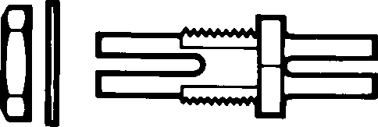

The HFBR-4505Z/4515Z adapter mates two simplex connectors for panel/bulkhead feedthrough of HFBR-4501Z/4511Z terminated plastic fiber cable. Maximum panel thickness is 4.1 mm (0.16 inch). This adapter can serve as a cable
in-line splice using two simplex connectors. The adapters are available in gray (HFBR-4505Z) and blue (HFBR-4515Z). This
adapter is not compatible with POF duplex, POF simplex latching, or HCS connectors.

3

Plastic Optical Fiber Connector Absolute Maximum Ratings

HFBR-4505Z/4515Z Adapter
Parameter | Symbol | Min. | Max. | Unit | Note
Storage and Operating Temperature | TS,O | -40 | 85 | °C | 1
Recommended Operating Temperature | TO | -40 | 85 | °C | 1
Installation Temperature | Tl | 0 | 70 | °C | 1
Nut Torque | TN |  | 0.7 | N-m | 2
 |  |  | 100 | OzF-in.

Notes:
1. Storage and Operating Temperatures refer to the ranges over which the connectors can be used when not subjected to mechanical stress. Installation Temperature refers to the ranges over which connectors may be installed onto the fiber and over which connectors can be connected and disconnected from transmitter and receiver modules.
2. Recommended nut torque is 0.57 N-m.

Plastic Optical Fiber Connector Mechanical/Optical Characteristics
TA = -40 to +85°C, Unless Otherwise Specified.
Parameter Part Number Symbol Min. Typ.[1] Max. Units Temp. °C Note
Retention Force, Simplex, FR-C 7 8 N +25 2
Connector to HFBR-4501Z/4511Z 3 -40 to +85

Versatile Link Transmitters and Receivers
Simplex Latching, 47 80 +25
HFBR-4503Z/4513Z 11 -40 to +85
Duplex, 7 12 +25
HFBR-4506Z 4 -40 to +85
Duplex Latching, 50 80 +25
HFBR-4516Z 15 -40 to +85
Tensile Force, Simplex, FT 8.5 22 N 3
Connector to Cable HFBR-4501Z/4511Z
Simplex Latching, 8.5 22
HFBR-4503Z/4513Z
Duplex, HFBR-4506Z 14 35
Duplex Latching, 14 35
HFBR-4516Z
Adapter Connector HFBR-4505Z/4515Z with αCC 0.7 1.5 2.8 dB 25 4, 5 to Connector Loss HFBR-4501Z/4511Z
Retention Force HFBR-4505Z/4515Z with FR-B 7 8 N Connector to Adapter HFBR-4501Z/4511Z
Insertion Force, Simplex, FI 8 30 N 6

Connector to Versatile
Link Transmitters and
Receivers

Notes:
1. Typical data are at +25°C.
HFBR-4501Z/4511Z
Simplex Latching, 16 35
HFBR-4503Z/4513Z
Duplex, HFBR-4506Z 13 46
Duplex Latching 22 51
HFBR-4516Z
2. No perceivable reduction in retention force was observed after 2000 insertions. Retention force of non-latching connectors is lower at elevated temperatures. Latching connectors are recommended for applications where a high retention force at high temperatures is desired.
3. For applications where frequent temperature cycling over temperature extremes is expected, please contact Avago Technologies for alternate connectoring techniques.
4. Minimum and maximum limit for αCC for 0°C to +70°C temperature range. Typical value of αCC is at +25°C.
5. Factory polish or field polish per recommended procedure.
6. Destructive insertion force was typically at 178 N (40 lb.).

4

Step-by-Step Plastic Cable
Connectoring Instructions
The following step-by-step guide describes how to terminate plastic fiber optic cable. It is ideal for both field and factory installation. Connectors can be easily installed on cable ends with wire strippers, cutters and a crimping tool.

Finishing the cable is accom- plished with the Avago
HFBR-4593Z Polishing Kit, consisting of a Polishing Fixture,
600 grit abrasive paper and 3 μm
pink lapping film (3M Company, OC3-14). The connector can be used immediately after polishing.

Materials needed for plastic fiber termination are:
1. Avago Plastic Optical Fiber Cable (Example: HFBR- RUS500Z, HFBR-RUD500Z, HFBR-EUS500Z, or HFBR- EUD500Z)
2. Industrial Razor Blade or Wire
Cutters
3. 16 Gauge Latching Wire Strippers (Example: Ideal StripmasterTM type 45-092).
4. HFBR-4597Z Crimping Tool
5. HFBR-4593Z Polishing Kit
6. One of the following connectors:
a) HFBR-4501Z/4503Z Gray Simplex/Simplex Latching Connector and HFBR-4525Z Simplex Crimp Ring
b) HFBR-4511Z/4513Z Blue Simplex/Simplex Latching Connector and HFBR-4525Z Simplex Crimp Ring
c) HFBR-4506Z Parchment
(off-white) Duplex
Connector and HFBR-4526Z Duplex Crimp Ring
d) HFBR-4516Z Gray Latching Duplex Connector and HFBR-4526Z Duplex Crimp Ring

Step 1
The zip cord structure of the duplex cable permits easy separation of the channels. The channels should be separated a minimum of 100 mm (4 in) to a maximum of 150 mm (6 in) back from the ends to permit connectoring and polishing.

After cutting the cable to the desired length, strip off approxi- mately 7 mm (0.3 in.) of the outer jacket with the 16 gauge wire strippers. Excess webbing on the duplex cable may have to be trimmed to allow the simplex or simplex latching connector to
slide over the cable.

When using the duplex connector and duplex cable, the separated duplex cable must be stripped to equal lengths on each cable. This allows easy and proper seating of the cable into the duplex connector.

Step 2
Place the crimp ring and connec- tor over the end of the cable; the fiber should protrude about 3 mm (0.12 in.) through the end of the connector. Carefully position the ring so that it is entirely on the connector with the rim of the crimp ring flush with the connec- tor, leaving a small space between the crimp ring and the flange. Then crimp the ring in place with the crimping tool. One crimp tool is used for all POF connector crimping requirements.

For applications with extreme temperature operation or frequent temperature cycling, improved connector to cable attachment
can be achieved with the use of an RTV (GE Company, RTV-128 or Dow Corning 3145-RTV)
adhesive. The RTV is placed into the connector prior to insertion of the fiber and the fiber is crimped normally. The connector can be polished after the RTV has cured and is then ready for use.

Note: By convention, place the gray connector on the trans- mitter cable end and the blue connector on the receiver cable end to maintain color coding (different color connectors are mechanically identical).

Simplex connector crimp rings cannot be used with duplex con- nectors and duplex connector crimp rings cannot be used
with simplex connectors because of size differences. The simplex crimp has a dull luster appear- ance; the duplex ring is glossy and has a thinner wall.

5

Step 3
Any excess fiber protruding from the connector end may be cut off; however, the trimmed fiber
should extend at least 1.5 mm
(0.06 in) from the connector end.

Insert the connector fully into the polishing fixture with the trimmed fiber protruding from the bottom of the fixture. This plastic polish- ing fixture can be used to polish two simplex connectors or simplex latching connectors simultane- ously, or one duplex connector.

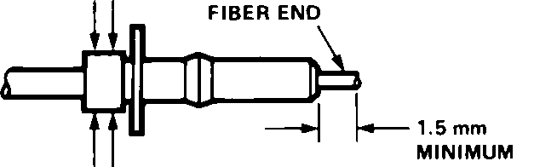

Note: The four dots on the bottom of the polishing fixture are wear indicators. Replace the polishing fixture when any
dot is no longer visible. Typically, the polishing fixture can be used 10 times; 10 duplex connectors or 20 simplex connectors, two at a time.

Place the 600 grit abrasive paper on a flat smooth surface, pressing down on the connector, polish the fiber and the connector using a figure eight pattern of strokes
until the connector is flush with the bottom of the polishing fixture. Wipe the connector and fixture with a clean cloth or tissue.

Step 4
Place the flush connector and polishing fixture on the dull side of the 3 μm pink lapping film and continue to polish the fiber and connector for approximately 25 strokes. The fiber end should be flat, smooth and clean.

This cable is now ready for use.
Note: Use of the pink lapping film fine polishing step results in approximately 2 dB improvement in coupling performance of either a transmitter-receiver link or a bulkhead/splice over a 600 grit polish alone. This fine polish is comparable to the Avago
factory polish. The fine polishing step may be omitted where an extra 2 dB of optical power is not essential, as with short link lengths. Proper polishing of the tip of the fiber/ connector face results in a tip diameter between 2.5 mm (0.098 in.) minimum and 3.2 mm (0.126 in.) maximum..

HFBR-4593Z Polishing Kit

6

Ordering Guide for POF Connectors and Accessories
Plastic Optical Fiber Connectors
HFBR-4501Z Gray Simplex Connector/Crimp Ring
HFBR-4511Z Blue Simplex Connector/Crimp Ring
HFBR-4503Z Gray Simplex Latching Connector with Crimp Ring HFBR-4513Z Blue Simplex Latching Connector with Crimp Ring HFBR-4506Z Parchment Duplex Connector with Crimp Ring HFBR-4516Z Gray Duplex Latching Connector with Crimp Ring HFBR-4505Z Gray Adapter (Bulkhead/Feedthrough)
HFBR-4515Z Blue Adapter (Bulkhead/Feedthrough)

Plastic Optical Fiber Accessories
HFBR-4522Z 500 HFBR-0500Z Products Port Plugs
HFBR-4525Z 1000 Simplex Crimp Rings
HFBR-4526Z 500 Duplex Crimp Rings
HFBR-4593Z Polishing Kit (one polishing tool, two pieces 600 grit abrasive paper, and two pieces 3 μm pink lapping film)
HFBR-4597Z Plastic Fiber Crimping Tool

Ordering Guide for POF Cable
For Example:
HFBR-RUD500Z is a Standard Attenuation, Unconnectored, Duplex, 500 meter cable.

HFBR-RLS001Z is a Standard Attenuation, Latching Simplex Connectored, Simplex, 1 meter cable.
HFBR-RMD010Z is a Standard Attenuation, Standard Duplex Connectored, Duplex, 10 meter cable.

HFBR-RMD100Z is a Standard Attenuation, Standard Duplex Connectored, Duplex, 100 meter cable.
Cable Length Tolerances: The plastic cable length tolerances are: +10%/-0%.

NOTE: By convention, pre- connectored simplex POF cables have gray and blue colored connectors on the opposite ends of the same fiber; although oppositely colored, the connectors are mechanically
identical. Duplex POF cables with duplex connectors use color- coded markings on the duplex fiber cable to differentiate between the channel.
HFBR- Z

Cable Code
R = Standard Attenuation POF E = Extra Low Loss POF

Connector Code
U = Unconnectored
N = Standard Simplex Connectors L = Latching Simplex Connectors M = Standard Duplex Connectors T = Latching Duplex Connectors
RoHS Compliant
Length Code (measured from tip of connector to tip of connector) Maximum 500 meters (not in 1 meter
increments).
See www.avagotech.com/fiber/cables e.g., 015 = 15 meters

Channel Code
S = Simplex Cable
D = Duplex Zipcord Cable

Note: Not all possible combinations reflect available part numbers. Please contact your local
Avago representative for a list of current available cable part numbers.

7

Connector Applications
Attachment to Avago Versatile Link Fiber Optic Components

Bulkhead Feedthrough or Panel Mounting for HFBR-4501Z/4511Z Simplex Connectors
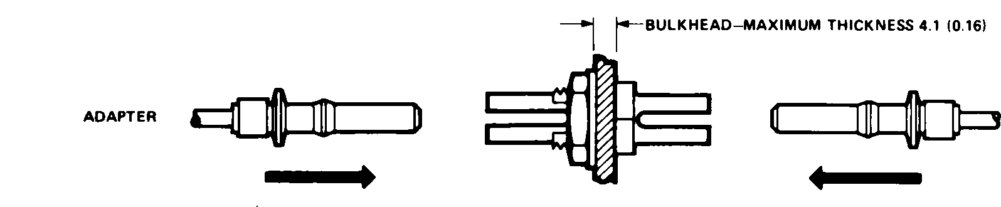

Versatile Link Mechanical Dimensions
All dimensions in mm (inches).
All dimensions ± 0.25 mm unless otherwise specified.

Fiber Optic Cable Dimensions

1.0 POF (0.039)

0.230
HCS (0.009)

HFBR-4505Z (Gray)/4515Z (Blue) Adapters
Panel Mounting – Bulkhead Feedthrough

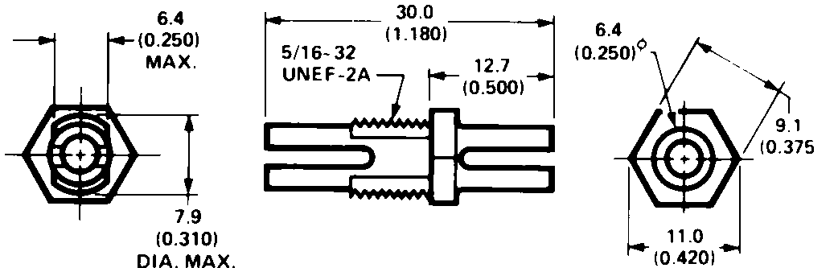

Bulkhead Feedthrough with Two HFBR-4501Z/4511Z Connectors

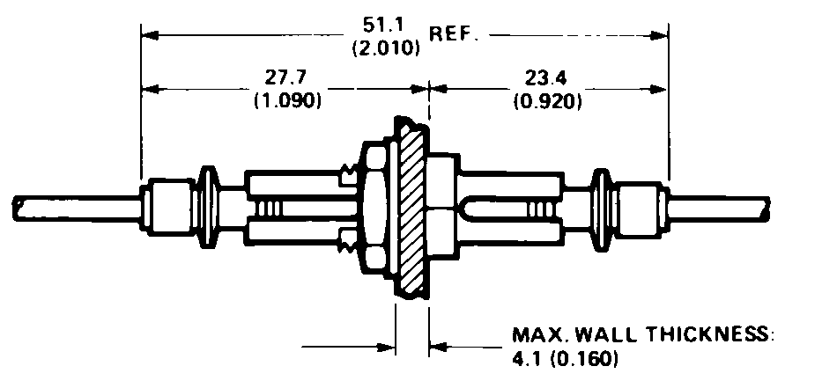

Versatile Link Mechanical Dimensions, continued

HFBR-4516Z (Parchment) Duplex Latching Connector
HFBR-4506Z (Parchment) Duplex Connector

HFBR-4503Z (Gray)/4513Z (Blue) Simplex Latching
Connector

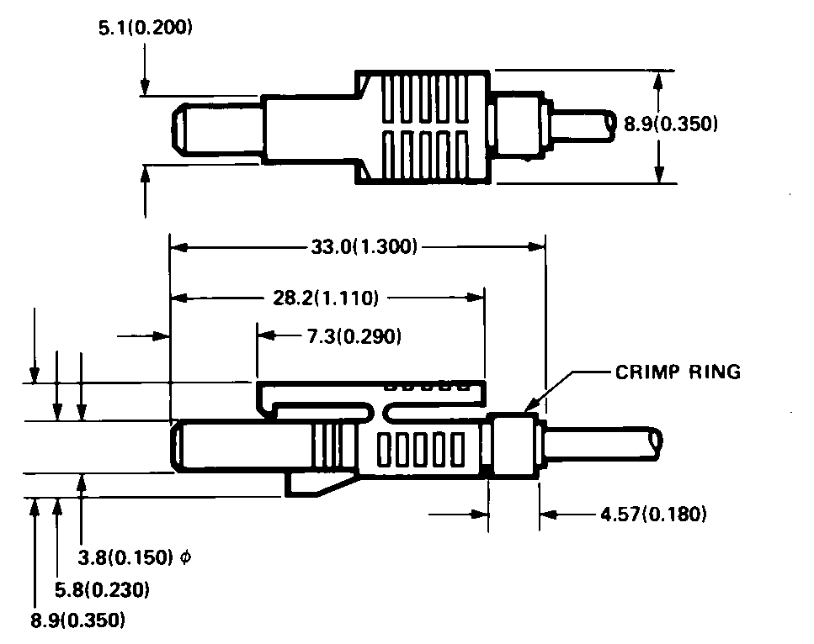

10
HFBR-4501Z (Gray)/4511Z (Blue) Simplex Connector

For product information and a complete list of distributors, please go to our website: www.avagotech.com

Avago, Avago Technologies, and the A logo are trademarks of Avago Technologies Limited in the United States and other countries. Data subject to change. Copyright © 2006 Avago Technologies Limited. All rights reserved.
AV01-0150EN May 14, 2006

