Freescale Semiconductor

+ 10 kPa On-Chip Temperature Compensated and Calibrated Silicon Pressure Sensors

The MPX2010 series silicon piezoresistive pressure sensors provide a very accurate and linear voltage output directly proportional to the applied pressure. These sensors house a single monolithic silicon die with the strain gauge and thin film resistor network integrated. The sensor is laser trimmed for precise span, offset calibration and temperature compensation.
Features
• Temperature Compensated over 0°C to + 85°C
• Ratiometric to Supply Voltage
• Differential and Gauge Options
• Available in Easy-to-Use Tape & Reel

MPX2010
Rev 13, 10/2008

MPX2010
Series
0 to 10 kPa (0 to 1.45 psi)
25 mV Full Scale
(Typical)

Application Examples

• Respiratory Diagnostics
• Air Movement Control
• Controllers
• Pressure Switching

ORDERING INFORMATION
Device Name | Package  Options | Case  No. | # of Ports |  |  | Pressure Type |  |  | Device Marking
Device Name | Package  Options | Case  No. | None | Single | Dual | Gauge | Differential | Absolute | Device Marking
Small Outline Package (MPXV2010 Series)
MPXV2010GP | Tray | 1369 |  | • |  | • |  |  | MPXV2010GP
MPXV2010DP | Tray | 1351 |  |  | • |  | • |  | MPXV2010DP
Unibody Package (MPX2010 Series)
MPX2010D | Tray | 344 | • |  |  |  | • |  | MPX2010D
MPX2010DP | Tray | 344C |  |  | • |  | • |  | MPX2010DP
MPX2010GP | Tray | 344B |  | • |  | • |  |  | MPX2010GP
MPX2010GS | Tray | 344E |  | • |  | • |  |  | MPX2010D
MPX2010GSX | Tray | 344F |  | • |  | • |  |  | MPX2010D
MPAK Package (MPXM2010 Series)
MPXM2010D | Rail | 1320 | • |  |  |  | • |  | MPXM2010D
MPXM2010DT1 | Tape and Reel | 1320 | • |  |  |  | • |  | MPXM2010D
MPXM2010GS | Rail | 1320A |  | • |  | • |  |  | MPXM2010GS
MPXM2010GST1 | Tape and Reel | 1320A |  | • |  | • |  |  | MPXM2010GS

SMALL OUTLINE PACKAGES
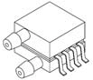

MPAK PACKAGES
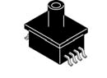

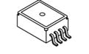

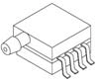

MPXV2010GP CASE 1369-01
MPXV2010DP CASE 1351-01
MPXM2010D/DT1
CASE 1320-02
MPXM2010GS/GST1
CASE 1320A-02


UNIBODY PACKAGES
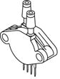

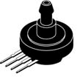

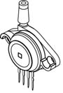

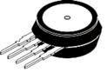

MPX2010D CASE 344-15
MPX2010GP CASE 344B-01
MPX2010DP CASE 344C-01
MPX2010GS CASE 344E-01
MPX2010GSX CASE 344F-01

© Freescale Semiconductor, Inc., 2005-2008. All rights reserved.


Table 1. Operating Characteristics (VS = 10 VDC, TA = 25°C unless otherwise noted, P1 > P2)

Characteristic | Symbol | Min | Typ | Max | Units
Pressure Range(1) | POP | 0 | — | 10 | kPa
Supply Voltage(2) | VS | — | 10 | 16 | VDC
Supply Current | IO | — | 6.0 | — | mAdc
Full Scale Span(3) | VFSS | 24 | 25 | 26 | mV
Offset(4) | VOFF | –1.0 | — | 1.0 | mV
Sensitivity | ΔV/ΔΡ | — | 2.5 | — | mV/kPa
Linearity | — | –1.0 | — | 1.0 | %VFSS
Pressure Hysteresis (0 to 10 kPa) | — | — | ±0.1 | — | %VFSS
Temperature Hysteresis (–40°C to +125°C) | — | — | ±0.5 | — | %VFSS
Temperature Coefficient on Full Scale Span | TCVFSS | –1.0 | — | 1.0 | %VFSS
Temperature Coefficient on Offset | TCVOFF | –1.0 | — | 1.0 | mV
Input Impedance | ZIN | 1300 | — | 2550 | Ω
Output Impedance | ZOUT | 1400 | — | 3000 | Ω
Response Time(5) (10% to 90%) | tR | — | 1.0 | — | ms
Warm-Up Time | — | — | 20 | — | ms
Offset Stability(6) | — | — | ± 0.5 | — | %VFSS
1. 1.0 kPa (kiloPascal) equals 0.145 psi.
2. Device is ratiometric within this specified excitation range. Operating the device at a different range may induce additional error due to device self-heating.
3. Full Scale Span (VFSS) is defined as the algebraic difference between the output voltage at full rated pressure and the output voltage at the minimum rated pressure.
4. Offset (VOFF) is defined as the output voltage at the minimum rated pressure.
5. Response Time is defined as the time for the incremental change in the output to go from 10% to 90% of its final value when subjected to a specified step change in pressure.
6. Offset stability is the product's output deviation when subjected to 1000 hours of Pulsed Pressure, Temperature Cycling with Bias Test.

MPX2010
Maximum Ratings

Table 2. Maximum Ratings(1)

Rating | Symbol | Value | Unit
Maximum Pressure (P1 > P2) | PMAX | 75 | kPa
Burst Pressure (P1 > P2) | PBURST | 100 | kPa
Storage Temperature | TSTG | –40 to +125 | °C
Operating Temperature | TA | – 40 to +125 | °C
1. Exposure beyond the specified limits may cause permanent damage or degradation to the device.

Voltage Output versus Applied Differential Pressure

The output voltage of the differential or gauge sensor increases with increasing pressure applied to the pressure side (P1) relative to the vacuum side (P2). Similarly, output voltage increases as increasing vacuum is applied to the vacuum side (P2) relative to the pressure side (P1).
Figure 1. shows a block diagram of the internal circuitry on the stand-alone pressure sensor chip.

VS
3

Sensing
Element
Thin Film Temperature Compensation and Calibration Circuitry
2
+VOUT

4
–VOUT

1

GND
Figure 1. Temperature Compensated and Calibrated
Pressure Sensor Schematic

MPX2010

On-Chip Temperature Compensation and Calibration

Figure 2. shows the output characteristics of the MPX2010 series at 25°C. The output is directly proportional to the differential pressure and is essentially a straight line.
The effects of temperature on full scale span and offset are very small and are shown under Operating Characteristics.
This performance over temperature is achieved by having
both the shear stress strain gauge and the thin-film resistor circuitry on the same silicon diaphragm. Each chip is dynamically laser trimmed for precise span and offset calibration and temperature compensation.
Figure 3. illustrates the differential/gauge die in the basic
chip carrier (Case 344). A silicone gel isolates the die surface and wire bonds from the environment, while allowing the pressure signal to be transmitted to the silicon diaphragm.
The MPX2010 series pressure sensor operating
characteristics and internal reliability and qualification tests are based on use of dry air as the pressure media. Media other than dry air may have adverse effects on sensor
performance and long term reliability. Contact the factory for information regarding media compatibility in your application.

LINEARITY
Linearity refers to how well a transducer's output follows the equation: Vout = Voff + sensitivity x P over the operating pressure range. There are two basic methods for calculating
nonlinearity: (1) end point straight line fit (see Figure 4.) or (2) a least squares best line fit. While a least squares fit gives the “best case” linearity error (lower numerical value), the calculations required are burdensome.
Conversely, an end point fit will give the “worst case” error (often more desirable in error budget calculations) and the calculations are more straightforward for the user. Freescale’s specified pressure sensor linearities are based on the end point straight line method measured at the midrange pressure.

30 VS = 10 Vdc
TA = 25°C
25 P1 > P2
20
15 MAX
Output (mVdc)

10

5

TYP

MIN

Span Range (Typical)

0
–5

Offset

kPa
PSI
2.5
0.362
5
0.725
7.5
1.09
10
1.45
(Typical)

Figure 2. Output vs. Pressure Differential

Wire Bond

Silicone
Die Coat Die
P1

Stainless Steel
Relative Voltage Output
Metal Cover

Epoxy
Case

Least Squares Fit

Exaggerated Performance Curve
Least Square Deviation

Straight Line
Deviation

Lead Frame RTV Die
Bond
End Point Straight
Line Fit

P2

Offset

0 50 100
Pressure (% Full Scale)

Figure 3. Unibody Package: Cross Sectional Diagram
(not to scale)
Figure 4. Linearity Specification Comparison

MPX2010

PRESSURE (P1)/VACUUM (P2) SIDE IDENTIFICATION TABLE

Freescale designates the two sides of the pressure sensor as the Pressure (P1) side and the Vacuum (P2) side. The Pressure (P1) side is the side containing silicone gel which isolates the die from the environment. The pressure sensor is designed to operate with positive differential pressure applied, P1 > P2.
The Pressure (P1) side may be identified by using the following table.

Table 3. Pressure (P1) Side Delineation
Part Number | Case  Type | Pressure (P1) Side Identifier
MPX2010D | 344 | Stainless Steel Cap
MPX2010DP | 344C | Side with Part Marking
MPX2010GP | 344B | Side with Port Attached
MPX2010GS | 344E | Side with Port Attached
MPX2010GSX | 344F | Side with Port Attached
MPXV2010GP | 1369 | Side with Port Attached
MPXV2010DP | 1351 | Side with Part Marking
MPXM2010D/DTI | 1320 | Side with Part Marking
MPXM2010GS/GSTI | 1320A | Side with Port Attached

MPX2010

PACKAGE DIMENSIONS

C
R

M
1 2 3 4
NOTES:
1. DIMENSIONINGANDTOLERANCINGPERASME Y14.5M, 1994.
2. CONTROLLINGDIMENSION: INCH.
3. DIMENSION-A- ISINCLUSIVEOFTHEMOLD STOPRING. MOLDSTOPRINGNOTTOEXCEED
Z 16.00 (0.630).
DIM | INCHES |  | MILLIMETERS
DIM | MIN | MAX | MIN | MAX
A | 0.595 | 0.630 | 15.11 | 16.00
B | 0.514 | 0.534 | 13.06 | 13.56
C | 0.200 | 0.220 | 5.08 | 5.59
D | 0.016 | 0.020 | 0.41 | 0.51
F | 0.048 | 0.064 | 1.22 | 1.63
G | 0.100 BSC |  | 2.54 BSC
J | 0.014 | 0.016 | 0.36 | 0.40
L | 0.695 | 0.725 | 17.65 | 18.42
M | 30˚ NOM |  | 30˚ NOM
N | 0.475 | 0.495 | 12.07 | 12.57
R | 0.430 | 0.450 | 10.92 | 11.43
Y | 0.048 | 0.052 | 1.22 | 1.32
Z | 0.106 | 0.118 | 2.68 | 3.00

B -A-

PIN 1
-T-
SEATING PLANE
J
F
N
1 2 3 4 L

G F
Y

D 4 PL
STYLE1: STYLE2: STYLE3:
PIN1. GROUND PIN1. V CC PIN1. GND
2. + OUTPUT 2. - SUPPLY 2. -VOUT
3. + SUPPLY 3. + SUPPLY 3. VS
4. - OUTPUT 4. GROUND 4. +VOUT
 |  | 0.136 (0.005) M | T | A M

DAMBAR TRIM ZONE: THIS IS INCLUDED WITHIN DIM. "F" 8 PL

CASE 344-15
ISSUE AA UNIBODY PACKAGE

SEATING PLANE

-T-

R
-A- U
L
H
NOTES:
1. DIMENSIONINGANDTOLERANCINGPERANSI Y14.5M, 1982.
2. CONTROLLINGDIMENSION: INCH.
DIM | INCHES |  | MILLIMETERS
DIM | MIN | MAX | MIN | MAX
A | 1.145 | 1.175 | 29.08 | 29.85
B | 0.685 | 0.715 | 17.40 | 18.16
C | 0.305 | 0.325 | 7.75 | 8.26
D | 0.016 | 0.020 | 0.41 | 0.51
F | 0.048 | 0.064 | 1.22 | 1.63
G | 0.100 BSC |  | 2.54 BSC
H | 0.182 | 0.194 | 4.62 | 4.93
J | 0.014 | 0.016 | 0.36 | 0.41
K | 0.695 | 0.725 | 17.65 | 18.42
L | 0.290 | 0.300 | 7.37 | 7.62
N | 0.420 | 0.440 | 10.67 | 11.18
P | 0.153 | 0.159 | 3.89 | 4.04
Q | 0.153 | 0.159 | 3.89 | 4.04
R | 0.230 | 0.250 | 5.84 | 6.35
S | 0.220 | 0.240 | 5.59 | 6.10
U | 0.910 BSC |  | 23.11 BSC

N PORT #1
POSITIVE PRESSURE (P1)

B

-Q-

-P- J
C

0.25 (0.010) M
PIN 1 K
T Q S S F
G

D 4 PL
0.13 (0.005) M

T S S Q S
STYLE1:
PIN1. GROUND
2. + OUTPUT
3. + SUPPLY
4. - OUTPUT

CASE 344B-01
ISSUE B UNIBODY PACKAGE

MPX2010

PACKAGE DIMENSIONS

V R
PORT #2

PORT #1
-A- U
W L
H
NOTES:
1. DIMENSIONINGANDTOLERANCINGPERANSI Y14.5M, 1982.
2. CONTROLLINGDIMENSION: INCH.
DIM | INCHES |  | MILLIMETERS
DIM | MIN | MAX | MIN | MAX
A | 1.145 | 1.175 | 29.08 | 29.85
B | 0.685 | 0.715 | 17.40 | 18.16
C | 0.405 | 0.435 | 10.29 | 11.05
D | 0.016 | 0.020 | 0.41 | 0.51
F | 0.048 | 0.064 | 1.22 | 1.63
G | 0.100 BSC |  | 2.54 BSC
H | 0.182 | 0.194 | 4.62 | 4.93
J | 0.014 | 0.016 | 0.36 | 0.41
K | 0.695 | 0.725 | 17.65 | 18.42
L | 0.290 | 0.300 | 7.37 | 7.62
N | 0.420 | 0.440 | 10.67 | 11.18
P | 0.153 | 0.159 | 3.89 | 4.04
Q | 0.153 | 0.159 | 3.89 | 4.04
R | 0.063 | 0.083 | 1.60 | 2.11
S | 0.220 | 0.240 | 5.59 | 6.10
U | 0.910 BSC |  | 23.11 BSC
V | 0.248 | 0.278 | 6.30 | 7.06
W | 0.310 | 0.330 | 7.87 | 8.38

PORT #2
VACUUM
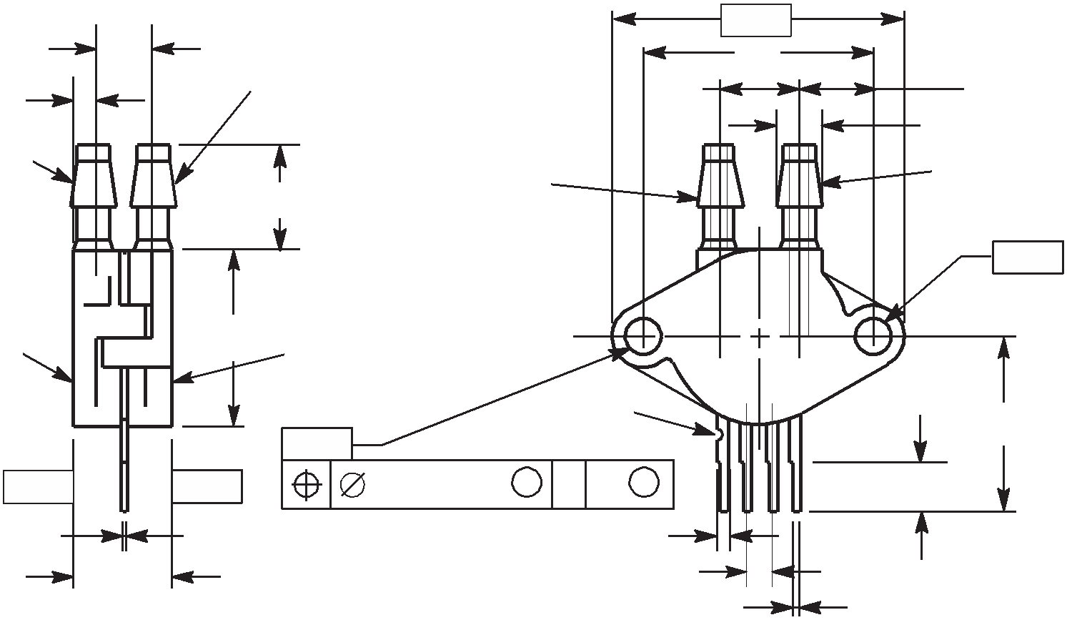

PORT #1
POSITIVE PRESSURE

N (P2) (P1)

-Q-

SEATING PLANE
B SEATING PLANE

-P- K

-T- -T-
J
C
0.25 (0.010) M
T Q S S F
G

D 4 PL

 |  | 0.13 (0.005) M | T | S S | Q S

STYLE1:
PIN1. GROUND
2. + OUTPUT
3. + SUPPLY
4. - OUTPUT

CASE 344C-01
ISSUE B UNIBODY PACKAGE

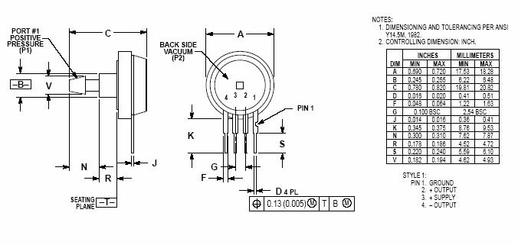

CASE 344E-01
ISSUE B UNIBODY PACKAGE

MPX2010

-T- C
E

A
-Q- U

NOTES:
1. DIMENSIONINGANDTOLERANCINGPERANSI Y14.5M, 1982.
2. CONTROLLINGDIMENSION: INCH.
DIM | INCHES |  | MILLIMETERS
DIM | MIN | MAX | MIN | MAX
A | 1.080 | 1.120 | 27.43 | 28.45
B | 0.740 | 0.760 | 18.80 | 19.30
C | 0.630 | 0.650 | 16.00 | 16.51
D | 0.016 | 0.020 | 0.41 | 0.51
E | 0.160 | 0.180 | 4.06 | 4.57
F | 0.048 | 0.064 | 1.22 | 1.63
G | 0.100 BSC |  | 2.54 BSC
J | 0.014 | 0.016 | 0.36 | 0.41
K | 0.220 | 0.240 | 5.59 | 6.10
N | 0.070 | 0.080 | 1.78 | 2.03
P | 0.150 | 0.160 | 3.81 | 4.06
Q | 0.150 | 0.160 | 3.81 | 4.06
R | 0.440 | 0.460 | 11.18 | 11.68
S | 0.695 | 0.725 | 17.65 | 18.42
U | 0.840 | 0.860 | 21.34 | 21.84
V | 0.182 | 0.194 | 4.62 | 4.92

V N B

PORT #1
POSITIVE PRESSURE
(P1)

-P-

0.25 (0.010) M

T Q M

4 3 2 1

R

PIN 1

S K

J F

D 4 PL
0.13 (0.005) M

G

T P S Q S

STYLE1:
PIN1. GROUND
2. V(+) OUT
3. VSUPPLY
4. V(-) OUT

CASE 344F-01
ISSUE B UNIBODY PACKAGE

MPX2010

PAGE 1 OF 2

CASE1351-01
ISSUE A
SMALL OUTLINE PACKAGE

MPX2010

PAGE 2 OF 2

CASE1351-01
ISSUE A
SMALL OUTLINE PACKAGE

MPX2010

PAGE 1 OF 2

CASE 1369-01
ISSUE B
SMALL OUTLINE PACKAGE

MPX2010

PAGE 2 OF 2

CASE 1369-01
ISSUE B
SMALL OUTLINE PACKAGE

MPX2010

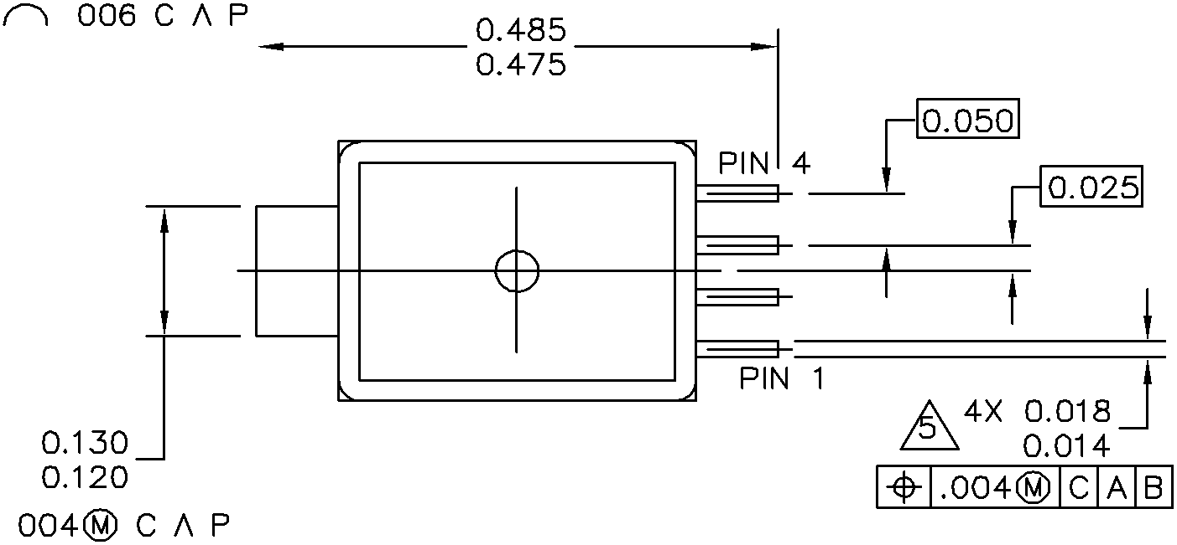

CASE 1320-02
ISSUE B MPAK

MPX2010

CASE 1320-02
ISSUE A MPAK

MPX2010

PIN 4

PIN 1

CASE 1320A-02
ISSUE A MPAK

MPX2010

CASE 1320-02
ISSUE A MPAK

MPX2010

How to Reach Us:

Home Page:
www.freescale.com

Web Support:
http://www.freescale.com/support

USA/Europe or Locations Not Listed:
Freescale Semiconductor, Inc. Technical Information Center, EL516
2100 East Elliot Road
Tempe, Arizona 85284
1-800-521-6274 or +1-480-768-2130 www.freescale.com/support

Europe, Middle East, and Africa: Freescale Halbleiter Deutschland GmbH Technical Information Center Schatzbogen 7
81829 Muenchen, Germany
+44 1296 380 456 (English)
+46 8 52200080 (English)
+49 89 92103 559 (German)
+33 1 69 35 48 48 (French)
www.freescale.com/support

Japan:
Freescale Semiconductor Japan Ltd. Headquarters
ARCO Tower 15F
1-8-1, Shimo-Meguro, Meguro-ku, Tokyo 153-0064
Japan
0120 191014 or +81 3 5437 9125 support.japan@freescale.com

Asia/Pacific:
Freescale Semiconductor China Ltd. Exchange Building 23F
No. 118 Jianguo Road Chaoyang District Beijing 100022
China
+86 010 5879 8000 support.asia@freescale.com

For Literature Requests Only:
Freescale Semiconductor Literature Distribution Center
P.O. Box 5405
Denver, Colorado 80217
1-800-441-2447 or +1-303-675-2140
Fax: +1-303-675-2150
LDCForFreescaleSemiconductor@hibbertgroup.com

MPX2010
Rev. 13
10/2008

Information in this document is provided solely to enable system and software implementers to use Freescale Semiconductor products. There are no express or implied copyright licenses granted hereunder to design or fabricate any integrated circuits or integrated circuits based on the information in this document.

Freescale Semiconductor reserves the right to make changes without further notice to any products herein. Freescale Semiconductor makes no warranty, representation or guarantee regarding the suitability of its products for any particular purpose, nor does Freescale Semiconductor assume any liability arising out of the application or use of any product or circuit, and specifically disclaims any and all liability, including without limitation consequential or incidental damages. “Typical” parameters that may be provided in Freescale Semiconductor data sheets and/or specifications can and do vary in different applications and actual performance may vary over time. All operating parameters, including “Typicals”, must be validated for each customer application by customer’s technical experts. Freescale Semiconductor does not convey any license under its patent rights nor the rights of others. Freescale Semiconductor products are not designed, intended, or authorized for use as components in systems intended for surgical implant into the body, or other applications intended to support or sustain life, or for any other application in which the failure of the Freescale Semiconductor product could create a situation where personal injury or death may occur. Should Buyer purchase or use Freescale Semiconductor products for any such unintended or unauthorized application, Buyer shall indemnify and hold Freescale Semiconductor and its officers, employees, subsidiaries, affiliates, and distributors harmless against all claims, costs, damages, and expenses, and reasonable attorney fees arising out of, directly or indirectly, any claim of personal injury or death associated with such unintended or unauthorized use, even if such claim alleges that Freescale Semiconductor was negligent regarding the design or manufacture of the part.

Freescale™ and the Freescale logo are trademarks of Freescale Semiconductor, Inc. All other product or service names are the property of their respective owners.


© Freescale Semiconductor, Inc. 2008. All rights reserved.

