Freescale Semiconductor

Media Resistant, Integrated Silicon Pressure Sensor for Manifold Absolute Pressure, Altimeter or Barometer Applications On-Chip Signal Conditioned, Temperature Compensated and Calibrated

The MPX4115A series is designed to sense absolute air pressure in altimeter or barometer (BAP) applications. Freescale's BAP sensor integrates on-chip, bipolar op amp circuitry and thin film resistor networks to provide a high level analog output signal and temperature compensation. The small form factor and high reliability of on-chip integration makes the Freescale BAP sensor a logical and economical choice for application designers.

Features

• 1.5% Maximum Error Over 0° to 85°C
• Ideally Suited for Microprocessor Interfacing or Microcontroller-Based Systems
• Temperature Compensated Over - 40°C to +125°C

MPX4115A Rev 5, 1/2009

MPX4115A Series
INTEGRATED PRESSURE SENSOR
15 to 115 kPa (2.2 to 16.7 psi)
0.2 to 4.8 V Output

Application Examples

• Altimeter
• Barometer
• Aviation Altimeters
• Industrial Controls
• Engine Control
• Weather Stations and Weather
Reporting Devices

• Durable Epoxy Unibody Element or Thermoplastic (PPS) Surface Mount Package
• Available as Standard Fluorosilicone Gel (MPXA4115A, MPX4115A) or Media Resistant Gel (MPXAZ4115A)

ORDERING INFORMATION
Device Name | Package  Options | Case  No. | # of Ports |  |  | Pressure Type |  |  | Device Marking
Device Name | Package  Options | Case  No. | None | Single | Dual | Gauge | Differential | Absolute | Device Marking
Unibody Package (MPX4115A Series)
MPX4115A | Tray | 867-08 | • |  |  |  |  | • | MPX4115A
MPX4115AP | Tray | 867B-04 |  | • |  |  |  | • | MPX4115AP
MPX4115AS | Tray | 867E-03 |  | • |  |  |  | • | MPX4115A
Small Outline Package (Media Resistant Gel) (MPXAZ4115A Series)
MPXAZ4115A6U | Rails | 482 | • |  |  |  |  | • | MPXAZ4115A
MPXAZ4115AC6U | Rails | 482A |  | • |  |  |  | • | MPXAZ4115A
MPXAZ4115A6T1 | Tape and Reel | 482 | • |  |  |  |  | • | MPXAZ4115A
Small Outline Package (MPXA4115A Series)
MPXA4115AC6U | Rails | 482A |  | • |  |  |  | • | MPXA4115A
MPXA4115AP | Tray | 1369-01 |  | • |  |  |  | • | MPXA4115AP
MPXA4115A6T1 | Tape and Reel | 482 | • |  |  |  |  | • | MPXA4115A
MPXA4115A6U | Rails | 482 | • |  |  |  |  | • | MPXA4115A

© Freescale Semiconductor, Inc., 2006-2009. All rights reserved.


UNIBODY PACKAGES
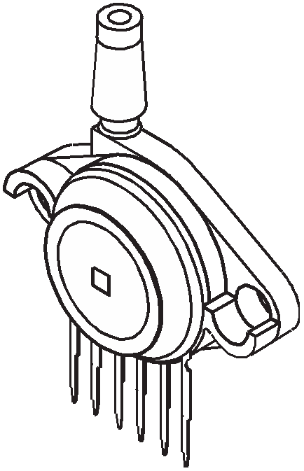

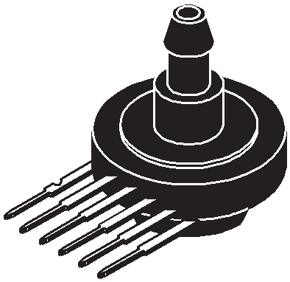

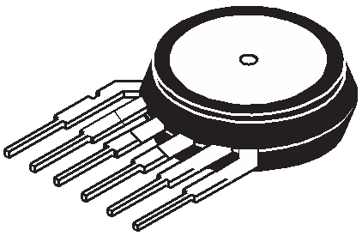

MPX4115A CASE 867-08
MPX4115AP CASE 867B-04
MPX4115AS CASE 867E-03

SMALL OUTLINE PACKAGES
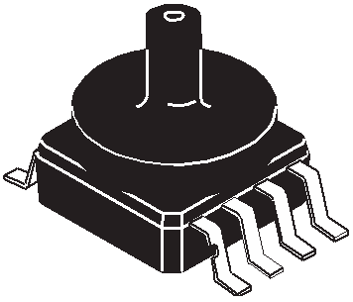

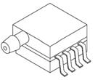

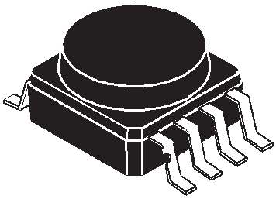

MPXAZ4115A6U/T1
MPXA4115A6U/T1
CASE 482-01
MPXAZ4115AC6U MPXA4115AC6U CASE 482A-01
MPXA4115AP CASE 1369-01

MPX4115A

Operating Characteristics

Table 1. Operating Characteristics (VS = 5.1 Vdc, TA = 25°C unless otherwise noted, P1 > P2. Decoupling circuit shown in
Figure 3 required to meet electrical specifications.)

Characteristic | Symbol | Min | Typ | Max | Unit
Pressure Range(1) | POP | 15 | — | 115 | kPa
Supply Voltage(2) | VS | 4.85 | 5.1 | 5.35 | Vdc
Supply Current | Io | — | 7.0 | 10 | mAdc
Minimum Pressure Offset (0 to 85°C)  @ VS = 5.1 Volts(3) | Voff | 0.135 | 0.204 | 0.273 | Vdc
Full Scale Output (0 to 85°C)  @ VS = 5.1 Volts(4) | VFSO | 4.725 | 4.794 | 4.863 | Vdc
Full Scale Span (0 to 85°C)  @ VS = 5.1 Volts(5) | VFSS | 4.521 | 4.59 | 4.659 | Vdc
Accuracy(6) (0 to 85°C) | — | — | — | ± 1.5 | %VFSS
Sensitivity | V/P | — | 46 | — | mV/kPa
Response Time(7) | tR | — | 1.0 | — | ms
Output Source Current at Full Scale Output | lo+ | — | 0.1 | — | mAdc
Warm-Up Time(8) | — | — | 20 | — | mSec
Offset Stability(9) | — | — | ± 0.5 | — | %VFSS
1. 1.0 kPa (kiloPascal) equals 0.145 psi.
2. Device is ratiometric within this specified excitation range.
3. Offset (Voff) is defined as the output voltage at the minimum rated pressure.
4. Full Scale Output (VFSO) is defined as the output voltage at the maximum or full rated pressure.
5. Full Scale Span (VFSS) is defined as the algebraic difference between the output voltage at full rated pressure and the output voltage at the minimum rated pressure.
6. Accuracy (error budget) consists of the following:
Linearity: Output deviation from a straight line relationship with pressure over the specified pressure range.
Temperature Hysteresis: Output deviation at any temperature within the operating temperature range, after the temperature is cycled to and from the minimum or maximum operating temperature points, with zero differential pressure applied.
Pressure Hysteresis: Output deviation at any pressure within the specified range, when this pressure is cycled to and from the minimum or maximum rated pressure, at 25°C.
TcSpan: Output deviation over the temperature range of 0 to 85°C, relative to 25°C.
TcOffset: Output deviation with minimum rated pressure applied, over the temperature range of 0 to 85°C, relative to 25°C. Variation from Nominal: The variation from nominal values, for Offset or Full Scale Span, as a percent of VFSS, at 25°C.
7. Response Time is defined as the time for the incremental change in the output to go from 10% to 90% of its final value when subjected to a specified step change in pressure.
8. Warm-up Time is defined as the time required for the product to meet the specified output voltage after the Pressure has been stabilized.
9. Offset Stability is the product's output deviation when subjected to 1000 hours of Pulsed Pressure, Temperature Cycling with Bias Test.

MPX4115A
Maximum Ratings

Table 2. MAXIMUM RATINGS(1)

Rating | Symbol | Value | Unit
Maximum Pressure (P1 > P2) | PMAX | 400 | kPa
Storage Temperature | Tstg | - 40 to +125 | °C
Operating Temperature | TA | - 40 to +125 | °C
1. Exposure beyond the specified limits may cause permanent damage or degradation to the device.

Figure 1 shows a block diagram of the internal circuitry integrated on a pressure sensor chip.

3 (Unibody)
VS 2 (Small Outline Package)

Sensing
Element
Thin Film Temperature Compensation and
Gain Stage #1
Gain Stage #2 and Ground
Reference
Shift Circuitry

VOUT

1 (Unibody)
4 (Small Outline Package)

GND

2 (Unibody)
3 (Small Outline Package)
Pins 4, 5, and 6 are NO CONNECTS
for unibody package devices.

Pins 1, 5, 6, 7, and 8 are NO CONNECTS
for small outline package devices.

Figure 1. Fully Integrated Pressure Sensor Schematic for Unibody Package and Small Outline Package

MPX4115A

On-chip Temperature Compensation and Calibration

Figure 2 illustrates an absolute sensing chip in the basic chip carrier (Case 867) and the small outline chip carrier (Case 482). A fluorosilicone gel isolates the die surface and wire bonds from the environment, while allowing the pressure signal to be transmitted to the sensor diaphragm. The MPX4115A series pressure sensor operating characteristics, and internal reliability and qualification tests are based on use of dry air as the pressure media. Media, other than dry air, may have adverse effects on sensor performance and long- term reliability. Contact the factory for information regarding media compatibility in your application.

Figure 3 shows the recommended decoupling circuit for interfacing the output of the integrated sensor to the A/D input of a microprocessor or microcontroller. Proper decoupling of the power supply is recommended.
Figure 4 shows the sensor output signal relative to pressure input. Typical, minimum, and maximum output curves are shown for operation over a temperature range of
0° to 85°C using the decoupling circuit shown in Figure 3. (The output will saturate outside of the specified pressure range.)

Fluoro Silicone
Gel Die Coat

Wire Bond

Die

P1

Stainless Steel
Metal Cover

Epoxy Plastic
Case
Fluoro Silicone
Gel Die Coat
P1
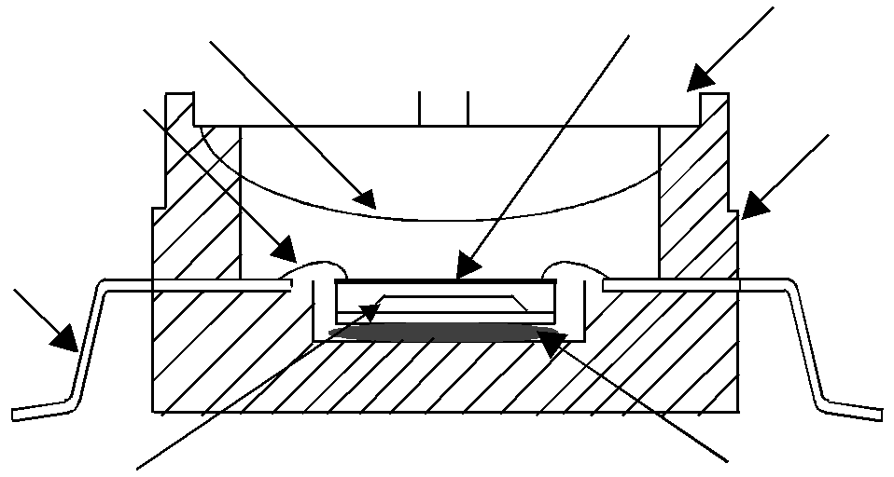

Wire Bond
Die
Stainless Steel
Steel Cap

Thermoplastic
Case

Lead Frame

Lead Frame

Sealed Vacuum Reference

Absolute Element
P2

Die
Bond

Sealed Vacuum Reference

Absolute Element

Die
Bond

Figure 2. Cross-Sectional Diagram (not to scale)

+5.1 V

Vout
Vs
Output

IPS

1.0 μF 0.01 μF
GND
470 pF

Figure 3. Recommended Power Supply Decoupling and Output Filtering
(For output filtering recommendations, refer to Application Note AN1646.)

5.0
4.5

4.0

3.5
3.0
Output (Volts)

2.5

2.0
1.5
1.0
0.5

0

TRANSFER FUNCTION:
Vout = Vs* (.009*P-.095) ± Error
VS = 5.1 Vdc
TEMP = 0 to 85°C

MIN

MAX

TYP

Pressure (ref. to sealed vacuum) in kPa
5
10
15
20
25
30
35
40
45
50
55
60
65
70
75
80
85
90
95
100
105
110
115
120
Figure 4. Output versus Absolute Pressure

MPX4115A

Transfer Function (MPX4115A)

Nominal Transfer Value: Vout = VS (P x 0.009 - 0.095)
± (Pressure Error x Temp. Factor x 0.009 x VS) VS = 5.1 V ± 0.25 Vdc

Temperature Error Band

MPX4115A Series

4.0

Temperature Error Factor
3.0

2.0

1.0

0.0
Temp Multiplier
- 40 3
0 to 85 1
+125 3

-40 -20 0 20 40 60

80 100

120

140

Temperature in °C

NOTE: The Temperature Multiplier is a linear response from 0°C to-40°C and from 85°C to 125°C.

Pressure Error Band

3.0

2.0
Pressure Error (kPa)
Error Limits for Pressure

1.0

0.0

-1.0

20 40 60 80 100 120

Pressure (in kPa)

-2.0

-3.0

Pressure Error (Max)
15 to 115 (kPa) ± 1.5 (kPa)

MPX4115A

PRESSURE (P1)/VACUUM (P2) SIDE IDENTIFICATION TABLE

The two sides of the pressure sensor are designated as the Pressure (P1) side and the Vacuum (P2) side. The Pressure (P1) side is the side containing fluorosilicone gel, which protects the die from harsh media. The MPX pressure
sensor is designed to operate with positive differential pressure applied, P1 > P2.
The Pressure (P1) side may be identified by using the following table:

Part Number | Case Type | Pressure (P1) Side Identifier
MPX4115A | 867 | Stainless Steel Cap
MPX4115AP | 867B | Side with Part Marking
MPX4115AS | 867E | Side with Port Attached
MPXAZ4115A6U/T1, MPXA4115A6U/T1 | 482 | Side with Part Marking
MPXAZ4115AC6U, MPXA4115AC6U | 482A | Side with Port Attached
MPXA4115AP | 1369 | Side with Port Attached

INFORMATION FOR USING THE SMALL OUTLINE PACKAGE (CASE 482)

MINIMUM RECOMMENDED FOOTPRINT FOR SURFACE MOUNTED APPLICATIONS

Surface mount board layout is a critical portion of the total design. The footprint for the surface mount packages must be the correct size to ensure proper solder connection interface between the board and the package. With the correct

footprint, the packages will self align when subjected to a solder reflow process. It is always recommended to design boards with a solder mask layer to avoid bridging and shorting between solder pads.

0.660
16.76
0.100 TYP 8X
2.54

0.060 TYP 8X
1.52

0.300
7.62

0.100 TYP 8X
2.54
inch
mm SCALE 2:1

Figure 5. SOP Footprint (Case 482)

MPX4115A

PACKAGE DIMENSIONS

5

-B-

8
-A-

D 8 PL
 |  | 0.25 (0.010) M | T | B S | A S

4

G
1

NOTES:
1. DIMENSIONINGANDTOLERANCINGPERANSI
Y14.5M, 1982.
2. CONTROLLINGDIMENSION: INCH.
3. DIMENSIONAANDBDONOTINCLUDEMOLD PROTRUSION.
4. MAXIMUMMOLDPROTRUSION0.15 (0.006).
5. ALLVERTICAL SURFACES5˚TYPICAL DRAFT.
DIM | INCHES |  | MILLIMETERS
DIM | MIN | MAX | MIN | MAX
A | 0.415 | 0.425 | 10.54 | 10.79
B | 0.415 | 0.425 | 10.54 | 10.79
C | 0.212 | 0.230 | 5.38 | 5.84
D | 0.038 | 0.042 | 0.96 | 1.07
G | 0.100 BSC |  | 2.54 BSC
H | 0.002 | 0.010 | 0.05 | 0.25
J | 0.009 | 0.011 | 0.23 | 0.28
K | 0.061 | 0.071 | 1.55 | 1.80
M | 0˚ | 7˚ | 0˚ | 7˚
N | 0.405 | 0.415 | 10.29 | 10.54
S | 0.709 | 0.725 | 18.01 | 18.41

S

N

C J

PIN 1 IDENTIFIER
K M
H
-T-

SEATING PLANE

CASE 482-01
ISSUE O
SMALL OUTLINE PACKAGE

5

N -B-

8
-A-

D 8 PL
 |  | 0.25 (0.010) M | T | B S | A S

4

G
1

NOTES:
1. DIMENSIONINGANDTOLERANCINGPERANSI Y14.5M, 1982.
2. CONTROLLINGDIMENSION: INCH.
3. DIMENSIONAANDBDONOTINCLUDEMOLD PROTRUSION.
4. MAXIMUMMOLDPROTRUSION0.15 (0.006).
5. ALLVERTICAL SURFACES5˚TYPICAL DRAFT.
DIM | INCHES |  | MILLIMETERS
DIM | MIN | MAX | MIN | MAX
A | 0.415 | 0.425 | 10.54 | 10.79
B | 0.415 | 0.425 | 10.54 | 10.79
C | 0.500 | 0.520 | 12.70 | 13.21
D | 0.038 | 0.042 | 0.96 | 1.07
G | 0.100 BSC |  | 2.54 BSC
H | 0.002 | 0.010 | 0.05 | 0.25
J | 0.009 | 0.011 | 0.23 | 0.28
K | 0.061 | 0.071 | 1.55 | 1.80
M | 0˚ | 7˚ | 0˚ | 7˚
N | 0.444 | 0.448 | 11.28 | 11.38
S | 0.709 | 0.725 | 18.01 | 18.41
V | 0.245 | 0.255 | 6.22 | 6.48
W | 0.115 | 0.125 | 2.92 | 3.17

S
W

V

C

J

PIN 1 IDENTIFIER
K M
H
-T-

SEATING PLANE

CASE 482A-01
ISSUE A
SMALL OUTLINE PACKAGE

MPX4115A

C

M

B -A-

SEATING

PIN 1

R

1 2 3 4 5 6

POSITIVE PRESSURE (P1)

N
L

NOTES:
1. DIMENSIONINGANDTOLERANCINGPER ANSI Y14.5M, 1982.
2. CONTROLLINGDIMENSION: INCH.
3. DIMENSION-A- ISINCLUSIVEOFTHEMOLD STOPRING. MOLDSTOPRINGNOTTOEXCEED
16.00 (0.630).
DIM | INCHES |  | MILLIMETERS
DIM | MIN | MAX | MIN | MAX
A | 0.595 | 0.630 | 15.11 | 16.00
B | 0.514 | 0.534 | 13.06 | 13.56
C | 0.200 | 0.220 | 5.08 | 5.59
D | 0.027 | 0.033 | 0.68 | 0.84
F | 0.048 | 0.064 | 1.22 | 1.63
G | 0.100 BSC |  | 2.54 BSC
J | 0.014 | 0.016 | 0.36 | 0.40
L | 0.695 | 0.725 | 17.65 | 18.42
M | 30˚ NOM |  | 30˚ NOM
N | 0.475 | 0.495 | 12.07 | 12.57
R | 0.430 | 0.450 | 10.92 | 11.43
S | 0.090 | 0.105 | 2.29 | 2.66

PLANE -T-

J
S F

G D 6 PL
 |  | 0.136 (0.005) M | T | A M

STYLE1:
PIN1. VOUT
2. GROUND
3. VCC
4. V1
5. V2
6. VEX
STYLE2:
PIN1. OPEN
2. GROUND
3. -VOUT
4. VSUPPLY
5. +VOUT
6. OPEN
STYLE3:
PIN1. OPEN
2. GROUND
3. +VOUT
4. +VSUPPLY
5. -VOUT
6. OPEN

CASE 867-08
ISSUE N BASIC ELEMENT

MPX4115A

NOTES:
A
C 1. DIMENSIONINGANDTOLERANCINGPERANSI
Y14.5M, 1982.
2. CONTROLLINGDIMENSION: INCH.
DIM | INCHES |  | MILLIMETERS
DIM | MIN | MAX | MIN | MAX
A | 0.690 | 0.720 | 17.53 | 18.28
B | 0.245 | 0.255 | 6.22 | 6.48
C | 0.780 | 0.820 | 19.81 | 20.82
D | 0.027 | 0.033 | 0.69 | 0.84
E | 0.178 | 0.186 | 4.52 | 4.72
F | 0.048 | 0.064 | 1.22 | 1.63
G | 0.100 BSC |  | 2.54 BSC
J | 0.014 | 0.016 | 0.36 | 0.41
K | 0.345 | 0.375 | 8.76 | 9.53
N | 0.300 | 0.310 | 7.62 | 7.87
S | 0.220 | 0.240 | 5.59 | 6.10
V | 0.182 | 0.194 | 4.62 | 4.93

-B- V

PIN 1

PORT #1
POSITIVE PRESSURE
(P1)
6 5 4 3 2 1

K
S

J G
N E F

-T-

D 6 PL
 |  | 0.13 (0.005) M | T | B M

STYLE1:
PIN1. V OUT
2. GROUND
3. V CC
4. V1
5. V2
6. V EX

CASE 867E-O3
ISSUE D
STOVE PIPE PORT (AS)

MPX4115A

PAGE 1 OF 2

CASE 867B-04
ISSUE G PORTED (AP)

MPX4115A

PAGE 2 OF 2

CASE 867B-04
ISSUE G PORTED (AP)

MPX4115A
PACKAGE DIMENSIONS

2 PLACES 4 TIPS
0.008 (0.20) C A B

A E

e
5 4

D

e/2

GAGE PLANE

.014 (0.35) θ

L A1
DETAIL G

8

F

B E1
1

8X b
 |  | 0.004 (0.1) M | C | A | B

NOTES:
1. CONTROLLINGDIMENSION: INCH.
2. INTERPRETDIMENSIONSANDTOLERANCESPER ASMEY14.5M, 1994.
3. DIMENSIONS"D" AND"E1" DONOTINCLUDE MOLDFLASHORPROTRUSIONS. MOLDFLASHOR PROTRUSIONSSHALL NOTEXCEED0.006 (0.152) PERSIDE.
4. DIMENSION"b" DOESNOTINCLUDEDAMBAR PROTRUSION. ALLOWABLEDAMBAR PROTRUSIONSHALL BE0.008 (0.203) MAXIMUM.
DIM | INCHES |  | MILLIMETERS
DIM | MIN | MAX | MIN | MAX
A | 0.300 | 0.330 | 7.11 | 7.62
A1 | 0.002 | 0.010 | 0.05 | 0.25
b | 0.038 | 0.042 | 0.96 | 1.07
D | 0.465 | 0.485 | 11.81 | 12.32
E | 0.717 BSC |  | 18.21 BSC
E1 | 0.465 | 0.485 | 11.81 | 12.32
e | 0.100 BSC |  | 2.54 BSC
F | 0.245 | 0.255 | 6.22 | 6.47
K | 0.120 | 0.130 | 3.05 | 3.30
L | 0.061 | 0.071 | 1.55 | 1.80
M | 0.270 | 0.290 | 6.86 | 7.36
N | 0.080 | 0.090 | 2.03 | 2.28
P | 0.009 | 0.011 | 0.23 | 0.28
T | 0.115 | 0.125 | 2.92 | 3.17
θ | 0˚ | 7˚ | 0˚ | 7˚

∅ T N
K

A M

8X
P
DETAIL G
0.004 (0.1)

SEATING

C PLANE

CASE 1369-01
ISSUE O
SMALL OUTLINE PACKAGE

MPX4115A

How to Reach Us:

Home Page:
www.freescale.com

Web Support:
http://www.freescale.com/support

USA/Europe or Locations Not Listed:
Freescale Semiconductor, Inc. Technical Information Center, EL516
2100 East Elliot Road
Tempe, Arizona 85284
1-800-521-6274 or +1-480-768-2130 www.freescale.com/support

Europe, Middle East, and Africa: Freescale Halbleiter Deutschland GmbH Technical Information Center Schatzbogen 7
81829 Muenchen, Germany
+44 1296 380 456 (English)
+46 8 52200080 (English)
+49 89 92103 559 (German)
+33 1 69 35 48 48 (French)
www.freescale.com/support

Japan:
Freescale Semiconductor Japan Ltd. Headquarters
ARCO Tower 15F
1-8-1, Shimo-Meguro, Meguro-ku, Tokyo 153-0064
Japan
0120 191014 or +81 3 5437 9125 support.japan@freescale.com

Asia/Pacific:
Freescale Semiconductor China Ltd. Exchange Building 23F
No. 118 Jianguo Road Chaoyang District Beijing 100022
China
+86 010 5879 8000 support.asia@freescale.com

For Literature Requests Only:
Freescale Semiconductor Literature Distribution Center
P.O. Box 5405
Denver, Colorado 80217
1-800-441-2447 or +1-303-675-2140
Fax: +1-303-675-2150
LDCForFreescaleSemiconductor@hibbertgroup.com

MPX4115A Rev. 5
1/2009

Information in this document is provided solely to enable system and software implementers to use Freescale Semiconductor products. There are no express or implied copyright licenses granted hereunder to design or fabricate any integrated circuits or integrated circuits based on the information in this document.

Freescale Semiconductor reserves the right to make changes without further notice to any products herein. Freescale Semiconductor makes no warranty, representation or guarantee regarding the suitability of its products for any particular purpose, nor does Freescale Semiconductor assume any liability arising out of the application or use of any product or circuit, and specifically disclaims any and all liability, including without limitation consequential or incidental damages. “Typical” parameters that may be provided in Freescale Semiconductor data sheets and/or specifications can and do vary in different applications and actual performance may vary over time. All operating parameters, including “Typicals”, must be validated for each customer application by customer’s technical experts. Freescale Semiconductor does not convey any license under its patent rights nor the rights of others. Freescale Semiconductor products are not designed, intended, or authorized for use as components in systems intended for surgical implant into the body, or other applications intended to support or sustain life, or for any other application in which the failure of the Freescale Semiconductor product could create a situation where personal injury or death may occur. Should Buyer purchase or use Freescale Semiconductor products for any such unintended or unauthorized application, Buyer shall indemnify and hold Freescale Semiconductor and its officers, employees, subsidiaries, affiliates, and distributors harmless against all claims, costs, damages, and expenses, and reasonable attorney fees arising out of, directly or indirectly, any claim of personal injury or death associated with such unintended or unauthorized use, even if such claim alleges that Freescale Semiconductor was negligent regarding the design or manufacture of the part.

Freescale™ and the Freescale logo are trademarks of Freescale Semiconductor, Inc. All other product or service names are the property of their respective owners.


© Freescale Semiconductor, Inc. 2009. All rights reserved.

