Freescale Semiconductor
Technical Data

Integrated Silicon Pressure Sensor On-Chip Signal Conditioned, Temperature Compensated and Calibrated
The MPX5010/MPXV5010G series piezoresistive transducers are state-of- the-art monolithic silicon pressure sensors designed for a wide range of applications, but particularly those employing a microcontroller or microprocessor with A/D inputs. This transducer combines advanced micromachining techniques, thin-film metallization, and bipolar processing to provide an accurate, high level analog output signal that is proportional to the applied pressure.
Features
ﾕ 5.0% Maximum Error over 0° to 85°C
ﾕ Ideally Suited for Microprocessor or Microcontroller-Based Systems
ﾕ Durable Epoxy Unibody and Thermoplastic (PPS) Surface Mount Package
ﾕ Temperature Compensated over ﾖ40° to +125°C ﾕ Patented Silicon Shear Stress Strain Gauge
ﾕ Available in Differential and Gauge Configurations
ﾕ Available in Surface Mount (SMT) or Through-hole (DIP) Configurations
Application Examples
ﾕ Hospital Beds
ﾕ HVAC
ﾕ Respiratory Systems
ﾕ Process Control
ORDERING INFORMATION
Device Type | Options | Case No. | MPX Series  Order No. | Packing Options | Device Marking
SMALL OUTLINE PACKAGE (MPXV5010G SERIES)
Basic Elements | Gauge, Element Only, SMT | 482 | MPXV5010G6U | Rails | MPXV5010G
Basic Elements | Gauge, Element Only, DIP | 482B | MPXV5010G7U | Rails | MPXV5010G
Ported Elements | Gauge, Axial Port, SMT | 482A | MPXV5010GC6U | Rails | MPXV5010G
Ported Elements | Gauge, Axial Port, DIP | 482C | MPXV5010GC7U | Rails | MPXV5010G
Ported Elements | Gauge, Axial Port, SMT | 482A | MPXV5010GC6T1 | Tape & Reel | MPXV5010G
Ported Elements | Gauge, Side Port, SMT | 1369 | MPXV5010GP | Trays | MPXV5010G
Ported Elements | Gauge, Dual Port, SMT | 1351 | MPXV5010DP | Trays | MPXV5010G
UNIBODY PACKAGE (MPX2202 SERIES)
Basic Element | Differential | 867 | MPX5010D | ﾗ | MPXV5010D
Ported Elements | Differential, Gauge | 867C | MPX5010DP | ﾗ | MPXV5010DP
Ported Elements | Gauge | 867B | MPX5010GP | ﾗ | MPXV5010GP
Ported Elements | Gauge, Axial | 867E | MPX5010GS | ﾗ | MPXV5010D
Ported Elements | Gauge, Axial PC Mount | 867F | MPX5010GSX | ﾗ | MPXV5010D

MPX5010
Rev 11, 01/2007
MPX5010 MPXV5010G SERIES
INTEGRATED PRESSURE SENSOR
0 to 10 kPa (0 to 1.45 psi)
0.2 to 4.7 V OUTPUT
SMALL OUTLINE PACKAGE

MPXV5010G6U MPXV5010GC6U/C6T1
CASE 482-01 CASE 482A-01

J

MPXV5010G7U MPXV5010GC7U CASE 482B-03 CASE 482C-03

MPXV5010GP MPXV5010DP CASE 1369-01 CASE 1351-01

UNIBODY PACKAGE PIN NUMBERS(1)
1 | Vout | 4 | N/C
2 | Gnd | 5 | N/C
3 | VS | 6 | N/C
1. Pins 4, 5, and 6 are internal device connections. Do not connect to external circuitry or ground. Pin 1 is noted by the notch in the lead.
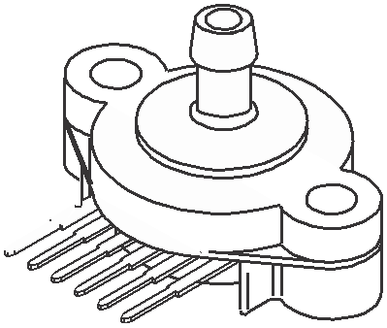

SMALL OUTLINE PACKAGE PIN NUMBERS(1)
1 | N/C | 5 | N/C
2 | VS | 6 | N/C
3 | Gnd | 7 | N/C
4 | Vout | 8 | N/C

UNIBODY PACKAGES
1. Pins 1, 5, 6, 7, and 8 are internal device connections. Do not connect to external circuitry or ground. Pin 1 is noted by the notch in the lead.

MPX5010D CASE 867-08
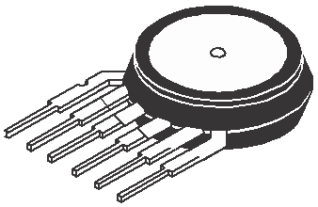

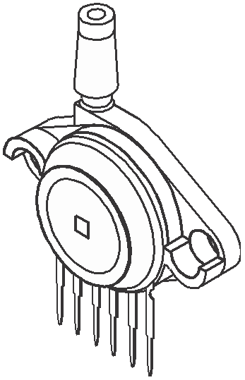

MPX5010GP CASE 867B-04

MPX5010DP CASE 867C-05

MPX5010GS CASE 867E-03


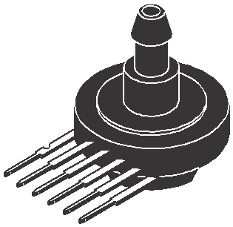

MPX5010GSX CASE 867F-03

ﾩ Freescale Semiconductor, Inc., 2007. All rights reserved.

VS

Sensing
Element
Thin Film Temperature Compensation and
Gain Stage #1
Gain Stage #2 and
Ground Reference Shift Circuitry

Vout

GND
Pins 1 and 5 through 8 are NO CONNECTS
for surface mount package
Pins 4, 5, and 6 are NO CONNECTS for unibody package

Figure 1. Fully Integrated Pressure Sensor Schematic

Table 1. Maximum Ratings(1)

Rating | Symbol | Value | Unit
Maximum Pressure (P1 > P2) | Pmax | 75 | kPa
Storage Temperature | Tstg | ﾖ40 to +125 | °C
Operating Temperature | TA | ﾖ40 to +125 | °C
1. Exposure beyond the specified limits may cause permanent damage or degradation to the device.

MPX5010

Table 2. Operating Characteristics (VS = 5.0 Vdc, TA = 25ﾰC unless otherwise noted, P1 > P2. Decoupling circuit shown in Figure 3 required to meet specification.)

Characteristic | Symbol | Min | Typ | Max | Unit
Pressure Range(1) | POP | 0 | ﾗ | 10 | kPa
Supply Voltage(2) | VS | 4.75 | 5.0 | 5.25 | Vdc
Supply Current | Io | ﾗ | 5.0 | 10 | mAdc
Minimum Pressure Offset(3) (0 to 85°C)  @ VS = 5.0 Volts | Voff | 0 | 0.2 | 0.425 | Vdc
Full Scale Output(4) (0 to 85°C)  @ VS = 5.0 Volts | VFSO | 4.475 | 4.7 | 4.925 | Vdc
Full Scale Span(5) (0 to 85°C)  @ VS = 5.0 Volts | VFSS | 4.275 | 4.5 | 4.725 | Vdc
Accuracy(6) (0 to 85°C) | ﾗ | ﾗ | ﾗ | ±5.0 | %VFSS
Sensitivity | V/P | ﾗ | 450 | ﾗ- | mV/kPa
Response Time(7) | tR | ﾗ | 1.0 | ﾗ- | ms
Output Source Current at Full Scale Output | IO+ | ﾗ | 0.1 | ﾗ- | mAdc
Warm-Up Time(8) | ﾗ | ﾗ | 20 | ﾗ- | ms
Offset Stability(9) | ﾗ | ﾗ | ± 0.5 | ﾗ- | %VFSS
1. 1.0 kPa (kiloPascal) equals 0.145 psi.
2. Device is ratiometric within this specified excitation range.
3. Offset (Voff) is defined as the output voltage at the minimum rated pressure.
4. Full Scale Output (VFSO) is defined as the output voltage at the maximum or full rated pressure.
5. Full Scale Span (VFSS) is defined as the algebraic difference between the output voltage at full rated pressure and the output voltage at the
minimum rated pressure.
6. Accuracy (error budget) consists of the following:
ﾕ Linearity: Output deviation from a straight line relationship with pressure over the specified pressure range.
ﾕ Temperature Hysteresis: Output deviation at any temperature within the operating temperature range, after the temperature is cycled to
and from the minimum or maximum operating temperature points, with zero differential pressure applied.
ﾕ Pressure Hysteresis: Output deviation at any pressure within the specified range, when this pressure is cycled to and from the
minimum or maximum rated pressure, at 25°C.
ﾕ TcSpan: Output deviation over the temperature range of 0° to 85°C, relative to 25°C.
ﾕ TcOffset: Output deviation with minimum rated pressure applied, over the temperature range of 0° to 85°C, relative to
25°C.
ﾕ Variation from Nominal: The variation from nominal values, for Offset or Full Scale Span, as a percent of VFSS, at 25°C.
7. Response Time is defined as the time for the incremental change in the output to go from 10% to 90% of its final value when subjected to
a specified step change in pressure.
8. Warm-up Time is defined as the time required for the product to meet the specified output voltage after the Pressure has been stabilized.
9. Offset Stability is the product's output deviation when subjected to 1000 hours of Pulsed Pressure, Temperature Cycling with Bias Test.

Table 3. Mechanical Characteristics

Characteristics | Typ | Unit
Weight, Basic Element (Case 867) | 4.0 | grams
Weight, Basic Element (Case 482) | 1.5 | grams

MPX5010
ON-CHIP TEMPERATURE COMPENSATION, CALIBRATION AND SIGNAL CONDITIONING

The performance over temperature is achieved by integrating the shear-stress strain gauge, temperature compensation, calibration and signal conditioning circuitry onto a single monolithic chip.
Figure 2 illustrates the Differential or Gauge configuration in the basic chip carrier (Case 482). A fluorosilicone gel isolates the die surface and wire bonds from the environment, while allowing the pressure signal to be transmitted to the sensor diaphragm.
The MPX5010 and MPXV5010G series pressure sensor
operating characteristics, and internal reliability and qualification tests are based on use of dry air as the pressure media. Media, other than dry air, may have adverse effects on
sensor performance and long-term reliability. Contact the factory for information regarding media compatibility in your application.
Figure 3 shows the recommended decoupling circuit for
interfacing the integrated sensor to the A/D input of a microprocessor or microcontroller. Proper decoupling of the power supply is recommended.
Figure 4 shows the sensor output signal relative to
pressure input. Typical, minimum, and maximum output
curves are shown for operation over a temperature range of
0° to 85°C using the decoupling circuit shown in Figure 3. The
output will saturate outside of the specified pressure range.

Fluoro Silicone
Gel Die Coat

Die
Stainless
Steel Cap

+5 V

Lead

P1

Wire Bond

Thermoplastic
Case

Vout
Vs

OUTPUT

Frame
IPS

1.0 μF 0.01 μF

GND

470 pF

P2
Differential Sensing
Element

Die Bond

Figure 2. Cross-Sectional Diagram SOP (not to scale)
Figure 3. Recommended Power Supply Decoupling and Output Filtering
(For additional output filtering, please refer to
Application Note AN1646.)

5.0

4.5

4.0
3.5
3.0

2.5

2.0
Output (V)
1.5
1.0
0.5

Transfer Function:
Vout = VS*(0.09*P+0.04) ﾱ ERROR VS = 5.0 Vdc
TEMP = 0 to 85ﾰC

MAX

MIN

TYPICAL

0 0 1 2 3 4 5 6 7 8 9
Differential Pressure (kPa)

10 11

Figure 4. Output versus Pressure Differential

MPX5010

Transfer Function (MPX5010, MPXV5010G)

Nominal Transfer Value: Vout = VS x (0.09 x P + 0.04)
ﾱ (Pressure Error x Temp. Factor x 0.09 x VS) VS = 5.0 V ± 0.25 Vdc

Temperature Error Band

MPX5010, MPXV5010G SERIES

4.0

Temperature Error Factor
3.0

2.0

1.0

0.0
Temp Multiplier
ﾖ40 3
0 to 85 1
+125 3

ﾖ40 ﾖ20 0 20 40 60 80

Temperature in ﾰC

100

120

140

NOTE: The Temperature Multiplier is a linear response from 0ﾰ to ﾖ40ﾰC and from 85ﾰ to 125ﾰC.

Pressure Error Band

Error
 | 0.5
 | 0.4
 | 0.3
 | 0.2
Pressure | 0.1

(kPa)

0 ﾖ0.1 ﾖ0.2 ﾖ0.3 ﾖ0.4
ﾖ0.5

0 1 2 3 4 5 6 7 8 9 10

Pressure (kPa)

Pressure Error (Max)
0 to 10 (kPa) ﾱ0.5 (kPa)

MPX5010

PRESSURE (P1)/VACUUM (P2) SIDE IDENTIFICATION TABLE

Freescale designates the two sides of the pressure sensor as the Pressure (P1) side and the Vacuum (P2) side. The Pressure (P1) side is the side containing fluorosilicone gel which protects the die from harsh media. The MPX pressure
sensor is designed to operate with positive differential
pressure applied, P1 > P2.
The Pressure (P1) side may be identified by using the
table below:

Part Number | Case Type | Pressure (P1) Side Identifier
MPX5010D | 867 | Stainless Steel Cap
MPX5010DP | 867C | Side with Part Marking
MPX5010GP | 867B | Side with Port Attached
MPX5010GS | 867E | Side with Port Attached
MPX5010GSX | 867F | Side with Port Attached
MPXV5010G6U | 482 | Stainless Steel Cap
MPXV5010G7U | 482B | Stainless Steel Cap
MPXV5010GC6U/T1 | 482A | Side with Port Attached
MPXV5010GC7U | 482C | Side with Port Attached
MPXV5010GP | 1369 | Side with Port Attached
MPXV5010DP | 1351 | Side with Part Marking

MINIMUM RECOMMENDED FOOTPRINT FOR SURFACE MOUNTED APPLICATIONS

Surface mount board layout is a critical portion of the total design. The footprint for the surface mount packages must be the correct size to ensure proper solder connection interface between the board and the package. With the correct
footprint, the packages will self align when subjected to a solder reflow process. It is always recommended to design boards with a solder mask layer to avoid bridging and shorting between solder pads.

0.660
16.76
0.100 TYP 8X
2.54

0.060 TYP 8X
1.52

0.300
7.62

0.100 TYP 8X
2.54
inch
mm SCALE 2:1

Figure 5. SOP Footprint (Case 482)

MPX5010

5

-B-

8
-A-

D 8 PL
 |  | 0.25 (0.010) M | T | B S | A S

4

G
1

NOTES:
1. DIMENSIONINGANDTOLERANCINGPERANSI
Y14.5M, 1982.
2. CONTROLLINGDIMENSION: INCH.
3. DIMENSIONAANDBDONOTINCLUDEMOLD PROTRUSION.
4. MAXIMUMMOLDPROTRUSION0.15 (0.006).
5. ALLVERTICAL SURFACES5˚TYPICAL DRAFT.
DIM | INCHES |  | MILLIMETERS
DIM | MIN | MAX | MIN | MAX
A | 0.415 | 0.425 | 10.54 | 10.79
B | 0.415 | 0.425 | 10.54 | 10.79
C | 0.212 | 0.230 | 5.38 | 5.84
D | 0.038 | 0.042 | 0.96 | 1.07
G | 0.100 BSC |  | 2.54 BSC
H | 0.002 | 0.010 | 0.05 | 0.25
J | 0.009 | 0.011 | 0.23 | 0.28
K | 0.061 | 0.071 | 1.55 | 1.80
M | 0˚ | 7˚ | 0˚ | 7˚
N | 0.405 | 0.415 | 10.29 | 10.54
S | 0.709 | 0.725 | 18.01 | 18.41

S

N

C J

PIN 1 IDENTIFIER
K M
H
-T-

SEATING PLANE

CASE 482-01
ISSUE O
SMALL OUTLINE PACKAGE

5

N -B-

8
-A-

D 8 PL
 |  | 0.25 (0.010) M | T | B S | A S

4

G
1

NOTES:
1. DIMENSIONINGANDTOLERANCINGPERANSI Y14.5M, 1982.
2. CONTROLLINGDIMENSION: INCH.
3. DIMENSIONAANDBDONOTINCLUDEMOLD PROTRUSION.
4. MAXIMUMMOLDPROTRUSION0.15 (0.006).
5. ALLVERTICAL SURFACES5˚TYPICAL DRAFT.
DIM | INCHES |  | MILLIMETERS
DIM | MIN | MAX | MIN | MAX
A | 0.415 | 0.425 | 10.54 | 10.79
B | 0.415 | 0.425 | 10.54 | 10.79
C | 0.500 | 0.520 | 12.70 | 13.21
D | 0.038 | 0.042 | 0.96 | 1.07
G | 0.100 BSC |  | 2.54 BSC
H | 0.002 | 0.010 | 0.05 | 0.25
J | 0.009 | 0.011 | 0.23 | 0.28
K | 0.061 | 0.071 | 1.55 | 1.80
M | 0˚ | 7˚ | 0˚ | 7˚
N | 0.444 | 0.448 | 11.28 | 11.38
S | 0.709 | 0.725 | 18.01 | 18.41
V | 0.245 | 0.255 | 6.22 | 6.48
W | 0.115 | 0.125 | 2.92 | 3.17

S
W

V

C

J

PIN 1 IDENTIFIER
K M
H
-T-

SEATING PLANE

CASE 482A-01
ISSUE A
SMALL OUTLINE PACKAGE

MPX5010

5

-B-

8
-A-

4

G
D 8 PL
 |  | 0.25 (0.010) M | T | B S | A S

1

NOTES:
1. DIMENSIONINGANDTOLERANCINGPER ANSI Y14.5M, 1982.
2. CONTROLLINGDIMENSION: INCH.
3. DIMENSIONAANDBDONOTINCLUDE MOLDPROTRUSION.
4. MAXIMUMMOLDPROTRUSION0.15 (0.006).
5. ALL VERTICAL SURFACES5˚ TYPICAL DRAFT.
6. DIMENSIONSTOCENTEROFLEADWHEN FORMEDPARALLEL.
DIM | INCHES |  | MILLIMETERS
DIM | MIN | MAX | MIN | MAX
A | 0.415 | 0.425 | 10.54 | 10.79
B | 0.415 | 0.425 | 10.54 | 10.79
C | 0.210 | 0.220 | 5.33 | 5.59
D | 0.026 | 0.034 | 0.66 | 0.864
G | 0.100 BSC |  | 2.54 BSC
J | 0.009 | 0.011 | 0.23 | 0.28
K | 0.100 | 0.120 | 2.54 | 3.05
M | 0˚ | 15˚ | 0˚ | 15˚
N | 0.405 | 0.415 | 10.29 | 10.54
S | 0.540 | 0.560 | 13.72 | 14.22

DETAIL X S

N PIN 1 IDENTIFIER

C

M
J DETAIL X

-T- K

SEATING PLANE

CASE 482B-03
ISSUE B
SMALL OUTLINE PACKAGE

5

N -B-

8

-A-

4

G
1

S

DETAIL X W
D 8 PL
 |  | 0.25 (0.010) M | T | B S | A S

NOTES:
1. DIMENSIONINGANDTOLERANCINGPER ANSI Y14.5M, 1982.
2. CONTROLLINGDIMENSION: INCH.
3. DIMENSIONAANDBDONOTINCLUDE MOLDPROTRUSION.
4. MAXIMUMMOLDPROTRUSION0.15 (0.006).
5. ALL VERTICAL SURFACES5˚ TYPICAL DRAFT.
6. DIMENSIONSTOCENTEROFLEADWHEN FORMEDPARALLEL.
DIM | INCHES |  | MILLIMETERS
DIM | MIN | MAX | MIN | MAX
A | 0.415 | 0.425 | 10.54 | 10.79
B | 0.415 | 0.425 | 10.54 | 10.79
C | 0.500 | 0.520 | 12.70 | 13.21
D | 0.026 | 0.034 | 0.66 | 0.864
G | 0.100 BSC |  | 2.54 BSC
J | 0.009 | 0.011 | 0.23 | 0.28
K | 0.100 | 0.120 | 2.54 | 3.05
M | 0˚ | 15˚ | 0˚ | 15˚
N | 0.444 | 0.448 | 11.28 | 11.38
S | 0.540 | 0.560 | 13.72 | 14.22
V | 0.245 | 0.255 | 6.22 | 6.48
W | 0.115 | 0.125 | 2.92 | 3.17

V PIN 1
IDENTIFIER
C

M
J DETAIL X
-T- K
SEATING PLANE

CASE 482C-03
ISSUE B
SMALL OUTLINE PACKAGE

MPX5010

C

M

B -A-

SEATING

PIN 1

R

1 2 3 4 5 6

POSITIVE PRESSURE (P1)

N
L

NOTES:
1. DIMENSIONINGANDTOLERANCINGPER ANSI Y14.5M, 1982.
2. CONTROLLINGDIMENSION: INCH.
3. DIMENSION-A- ISINCLUSIVEOFTHEMOLD STOPRING. MOLDSTOPRINGNOTTOEXCEED
16.00 (0.630).
DIM | INCHES |  | MILLIMETERS
DIM | MIN | MAX | MIN | MAX
A | 0.595 | 0.630 | 15.11 | 16.00
B | 0.514 | 0.534 | 13.06 | 13.56
C | 0.200 | 0.220 | 5.08 | 5.59
D | 0.027 | 0.033 | 0.68 | 0.84
F | 0.048 | 0.064 | 1.22 | 1.63
G | 0.100 BSC |  | 2.54 BSC
J | 0.014 | 0.016 | 0.36 | 0.40
L | 0.695 | 0.725 | 17.65 | 18.42
M | 30˚ NOM |  | 30˚ NOM
N | 0.475 | 0.495 | 12.07 | 12.57
R | 0.430 | 0.450 | 10.92 | 11.43
S | 0.090 | 0.105 | 2.29 | 2.66

PLANE -T-

J
S F

G D 6 PL
 |  | 0.136 (0.005) M | T | A M

STYLE1:
PIN1. VOUT
2. GROUND
3. VCC
4. V1
5. V2
6. VEX
STYLE2:
PIN1. OPEN
2. GROUND
3. -VOUT
4. VSUPPLY
5. +VOUT
6. OPEN
STYLE3:
PIN1. OPEN
2. GROUND
3. +VOUT
4. +VSUPPLY
5. -VOUT
6. OPEN

CASE 867-08
ISSUE N UNIBODY PACKAGE

MPX5010

PAGE 1 OF 2

CASE 867B-04
ISSUE G UNIBODY PACKAGE

MPX5010

PAGE 2 OF 2

CASE 867B-04
ISSUE G UNIBODY PACKAGE

MPX5010

P X
 |  | 0.25 (0.010) M | T | Q M

R

PORT #1
PRESSURE
(P1) N

PORT #2
VACUUM (P2)
B

C

PIN 1
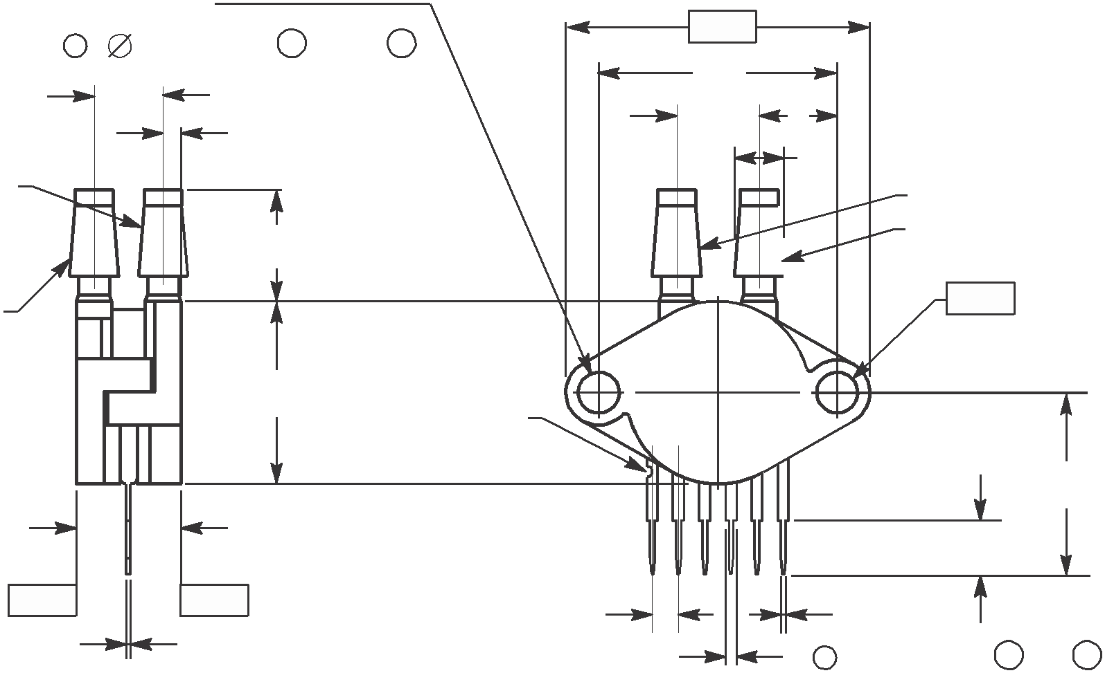

-A- U
W L

1 2 3 4 5 6
NOTES:
1. DIMENSIONINGANDTOLERANCINGPER ASMEY14.5M, 1994.
2. CONTROLLINGDIMENSION: INCH.
DIM
DIM | MIN | MAX | MIN | MAX
B | 0.685 | 0.715 | 17.40 | 18.16
D | 0.027 | 0.033 | 0.68 | 0.84
F | 0.048 | 0.064 | 1.22 | 1.63
G | 0.100 BSC |  | 2.54 BSC
J | 0.014 | 0.016 | 0.36 | 0.41
K | 0.695 | 0.725 | 17.65 | 18.42
L | 0.290 | 0.300 | 7.37 | 7.62
N | 0.420 | 0.440 | 10.67 | 11.18
P | 0.153 | 0.159 | 3.89 | 4.04
Q | 0.153 | 0.159 | 3.89 | 4.04
R | 0.063 | 0.083 | 1.60 | 2.11
S | 0.220 | 0.240 | 5.59 | 6.10
U | 0.910 BSC |  | 23.11 BSC
V | 0.182 | 0.194 | 4.62 | 4.93
W | 0.310 | 0.330 | 7.87 | 8.38
X | 0.248 | 0.278 | 6.30 | 7.06

PORT #2 VACUUM (P2) PORT #1 POSITIVE
PRESSURE (P1)

-Q-

K S

SEATING PLANE

-T- -T- J
SEATING PLANE

G D 6 PL
 |  | 0.13 (0.005) M | A M

F

STYLE1:
PIN1. V OUT
2. GROUND
3. V CC
4. V1
5. V2
6. VEX

CASE 867C-05
ISSUE F UNIBODY PACKAGE
A

NOTES:
C 1. DIMENSIONINGANDTOLERANCINGPERANSI
Y14.5M, 1982.
2. CONTROLLINGDIMENSION: INCH.
DIM | INCHES |  | MILLIMETERS
DIM | MIN | MAX | MIN | MAX
A | 0.690 | 0.720 | 17.53 | 18.28
B | 0.245 | 0.255 | 6.22 | 6.48
C | 0.780 | 0.820 | 19.81 | 20.82
D | 0.027 | 0.033 | 0.69 | 0.84
E | 0.178 | 0.186 | 4.52 | 4.72
F | 0.048 | 0.064 | 1.22 | 1.63
G | 0.100 BSC |  | 2.54 BSC
J | 0.014 | 0.016 | 0.36 | 0.41
K | 0.345 | 0.375 | 8.76 | 9.53
N | 0.300 | 0.310 | 7.62 | 7.87
S | 0.220 | 0.240 | 5.59 | 6.10
V | 0.182 | 0.194 | 4.62 | 4.93

-B- V

PIN 1

PORT #1
POSITIVE PRESSURE
(P1)
6 5 4 3 2 1

K
S

J G
N E F

-T-

D 6 PL
 |  | 0.13 (0.005) M | T | B M

STYLE1:
PIN1. V OUT
2. GROUND
3. V CC
4. V1
5. V2
6. V EX

CASE 867E-03
ISSUE D UNIBODY PACKAGE

MPX5010

-T- C
E

A
U -Q-

NOTES:
1. DIMENSIONINGANDTOLERANCINGPER ANSI Y14.5M, 1982.
2. CONTROLLINGDIMENSION: INCH.
DIM | INCHES |  | MILLIMETERS
DIM | MIN | MAX | MIN | MAX
A | 1.080 | 1.120 | 27.43 | 28.45
B | 0.740 | 0.760 | 18.80 | 19.30
C | 0.630 | 0.650 | 16.00 | 16.51
D | 0.027 | 0.033 | 0.68 | 0.84
E | 0.160 | 0.180 | 4.06 | 4.57
F | 0.048 | 0.064 | 1.22 | 1.63
G | 0.100 BSC |  | 2.54 BSC
J | 0.014 | 0.016 | 0.36 | 0.41
K | 0.220 | 0.240 | 5.59 | 6.10
N | 0.070 | 0.080 | 1.78 | 2.03
P | 0.150 | 0.160 | 3.81 | 4.06
Q | 0.150 | 0.160 | 3.81 | 4.06
R | 0.440 | 0.460 | 11.18 | 11.68
S | 0.695 | 0.725 | 17.65 | 18.42
U | 0.840 | 0.860 | 21.34 | 21.84
V | 0.182 | 0.194 | 4.62 | 4.93

V

PORT #1

PRESSURE (P1)

-P-

0.25 (0.010) M

T Q M

6 5 4 3 2 1
N
B

R
PIN 1

S K

J D 6 PL
 |  | 0.13 (0.005) M | T | P S | Q S

G

F

STYLE1:
PIN1. V OUT
2. GROUND
3. VCC
4. V1
5. V2
6. VEX

CASE 867F-03
ISSUE D UNIBODY PACKAGE

MPX5010

PAGE 1 OF 2

CASE 1351-01
ISSUE A
SMALL OUTLINE PACKAGE

MPX5010

PAGE 2 OF 2

CASE 1351-01
ISSUE A
SMALL OUTLINE PACKAGE

MPX5010

PAGE 1 OF 2

CASE 1369-01
ISSUE B
SMALL OUTLINE PACKAGE

MPX5010

PAGE 2 OF 2

CASE 1369-01
ISSUE B
SMALL OUTLINE PACKAGE

MPX5010

How to Reach Us:

Home Page:
www.freescale.com

Web Support:
http://www.freescale.com/support

USA/Europe or Locations Not Listed:
Freescale Semiconductor, Inc. Technical Information Center, EL516
2100 East Elliot Road
Tempe, Arizona 85284
+1-800-521-6274 or +1-480-768-2130 www.freescale.com/support

Europe, Middle East, and Africa: Freescale Halbleiter Deutschland GmbH Technical Information Center Schatzbogen 7
81829 Muenchen, Germany
+44 1296 380 456 (English)
+46 8 52200080 (English)
+49 89 92103 559 (German)
+33 1 69 35 48 48 (French)
www.freescale.com/support

Japan:
Freescale Semiconductor Japan Ltd. Headquarters
ARCO Tower 15F
1-8-1, Shimo-Meguro, Meguro-ku, Tokyo 153-0064
Japan
0120 191014 or +81 3 5437 9125 support.japan@freescale.com

Asia/Pacific:
Freescale Semiconductor Hong Kong Ltd. Technical Information Center
2 Dai King Street
Tai Po Industrial Estate
Tai Po, N.T., Hong Kong
+800 2666 8080 support.asia@freescale.com

For Literature Requests Only:
Freescale Semiconductor Literature Distribution Center
P.O. Box 5405
Denver, Colorado 80217
1-800-441-2447 or 303-675-2140
Fax: 303-675-2150
LDCForFreescaleSemiconductor@hibbertgroup.com

Information in this document is provided solely to enable system and software implementers to use Freescale Semiconductor products. There are no express or implied copyright licenses granted hereunder to design or fabricate any integrated circuits or integrated circuits based on the information in this document.

Freescale Semiconductor reserves the right to make changes without further notice to any products herein. Freescale Semiconductor makes no warranty, representation or guarantee regarding the suitability of its products for any particular purpose, nor does Freescale Semiconductor assume any liability arising out of the application or use of any product or circuit, and specifically disclaims any and all liability, including without limitation consequential or incidental damages. ﾓTypicalﾔ parameters that may be provided in Freescale Semiconductor data sheets and/or specifications can and do vary in different applications and actual performance may vary over time. All operating parameters, including ﾓTypicalsﾔ, must be validated for each customer application by customerﾒs technical experts. Freescale Semiconductor does not convey any license under its patent rights nor the rights of others. Freescale Semiconductor products are not designed, intended, or authorized for use as components in systems intended for surgical implant into the body, or other applications intended to support or sustain life, or for any other application in which the failure of the Freescale Semiconductor product could create a situation where personal injury or death may occur. Should Buyer purchase or use Freescale Semiconductor products for any such unintended or unauthorized application, Buyer shall indemnify and hold Freescale Semiconductor and its officers, employees, subsidiaries, affiliates, and distributors harmless against all claims, costs, damages, and expenses, and reasonable attorney fees arising out of, directly or indirectly, any claim of personal injury or death associated with such unintended or unauthorized use, even if such claim alleges that Freescale Semiconductor was negligent regarding the design or manufacture of the part.

Freescaleﾙ and the Freescale logo are trademarks of Freescale Semiconductor, Inc. All other product or service names are the property of their respective owners.

ﾩ Freescale Semiconductor, Inc. 2007. All rights reserved.

MPX5010
Rev. 11
01/2007

