Freescale Semiconductor

50 kPa Uncompensated
Silicon Pressure Sensors

The MPX53 series silicon piezoresistive pressure sensors provide a very accurate and linear voltage output, directly proportional to the applied pressure. These standard, low cost, uncompensated sensors permit manufacturers to design and add their own external temperature compensating and signal conditioning networks. Compensation techniques are simplified because of the predictability of Freescale's single element strain gauge design.

Features

• Low Cost
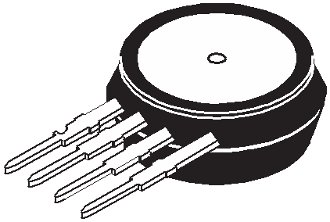

• Patented Silicon Shear Stress Strain Gauge Design
• Ratiometric to Supply Voltage
• Easy to Use Chip Carrier Package Options
• 60 mV Span (Typical)
• Differential and Gauge Options

MPX53
Rev 7, 05/2009

MPX53
Series

0 to 50 kPa (0 to 7.25 psi)
60 mV Full Scale Span
(Typical)

Application Examples

• Air Movement Control
• Environmental Control Systems
• Level Indicators
• Leak Detection
• Medical Instrumentation
• Industrial Controls
• Pneumatic Control Systems
• Robotics
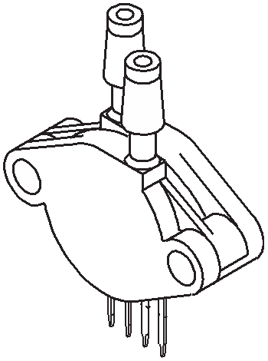

Marking
ORDERING INFORMATION
Device Name | Package  Options | Case  No. | # of Ports |  |  | Pressure Type |  |  | Device
Device Name | Package  Options | Case  No. | None | Single | Dual | Gauge | Differential | Absolute | Device
Unibody Package (MPX53 Series)
MPX53D | Tape & Reel | 344 | • |  |  |  | • |  | MPX53D
MPX53DP | Rail | 344C |  |  | • |  | • |  | MPX53DP
MPX53GP | Rail | 344B |  | • |  | • |  |  | MPX53GP
Small Outline Package (MPXV53G Series)
MPXV53GC7U | Rail | 482C |  | • |  | • |  |  | MPXV53G

SMALL OUTLINE PACKAGE
UNIBODY PACKAGES

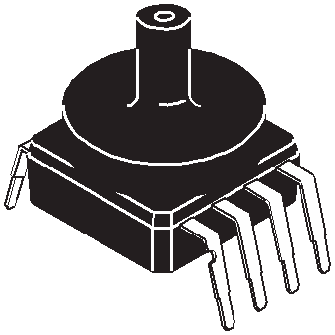

MPXV53GC7U CASE 482C-03
MPX53D CASE 344-15

MPX53GP CASE 344B-01


MPX53DP CASE 344C-01

© Freescale Semiconductor, Inc., 2007-2009. All rights reserved.
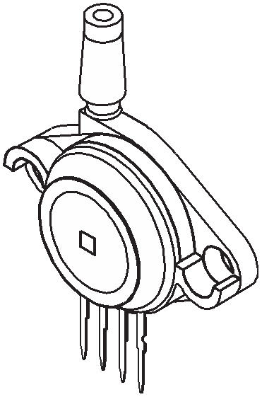

Operating Characteristics

Table 1. Operating Characteristics (VS = 3.0 Vdc, TA = 25°C unless otherwise noted, P1 > P2)

Characteristic | Symbol | Min | Typ | Max | Units
Pressure Range(1) | POP | 0 | — | 50 | kPa
Supply Voltage(2) | VS | — | 3.0 | 6.0 | VDC
Supply Current | IO | — | 6.0 | — | mAdc
Full Scale Span(3) | VFSS | 45 | 60 | 90 | mV
Offset(4) | VOFF | 0 | 20 | 35 | mV
Sensitivity | ΔV/ΔΡ | — | 1.2 | — | mV/kPa
Linearity | — | –0.6 | — | 0.4 | %VFSS
Pressure Hysteresis (0 to 50 kPa) | — | — | ±0.1 | — | %VFSS
Temperature Hysteresis | — | — | ±0.5 | — | %VFSS
Temperature Coefficient of Full Scale Span | TCVFSS | –0.22 | — | -0.16 | %VFSS/°C
Temperature Coefficient of Offset | TCVOFF | — | ±15 | — | µV/°C
Temperature Coefficient of Resistance | TCR | 0.21 | — | 0.27 | %ZIN/°C
Input Impedance | ZIN | 355 | — | 505 | Ω
Output Impedance | ZOUT | 750 | — | 1875 | Ω
Response Time(5) (10% to 90%) | tR | — | 1.0 | — | ms
Warm-Up Time(6) | — | — | 20 | — | ms
Offset Stability(7) | — | — | ±0.5 | — | %VFSS
1. 1.0 kPa (kiloPascal) equals 0.145 psi.
2. Device is ratiometric within this specified excitation range. Operating the device above the specified excitation range may induce additional error due to device self-heating.
3. Full Scale Span (VFSS) is defined as the algebraic difference between the output voltage at full rated pressure and the output voltage at the minimum rated pressure.
4. Offset (VOFF) is defined as the output voltage at the minimum rated pressure.
5. Response Time is defined as the time for the incremental change in the output to go from 10% to 90% of its final value when subjected to a specified step change in pressure.
6. Warm-up Time is defined as the time required for the product to meet the specified output voltage after the pressure is stabilized.
7. Offset stability is the product’s output deviation when subjected to 1000 hours of Pulsed Pressure, Temperature Cycling with Bias Test.

MPX53
Maximum Ratings

Table 2. Maximum Ratings(1)

Rating | Symbol | Value | Unit
Maximum Pressure (P1 > P2) | PMAX | 175 | kPa
Burst Pressure (P1 > P2) | PBurst | 200 | kPa
Storage Temperature | TSTG | –40 to +125 | °C
Operating Temperature | TA | – 40 to +125 | °C
1. Exposure beyond the specified limits may cause permanent damage or degradation to the device.

Figure 1 shows a schematic of the internal circuitry on the stand-alone pressure sensor chip.

3
+VS

Sensor
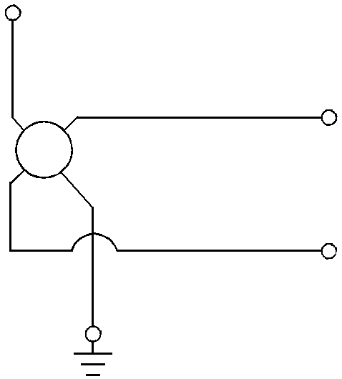

2
+VOUT

4
-VOUT

1

GND

Figure 1. Uncompensated Pressure Sensor Schematic

Voltage Output versus Applied Differential Pressure

The differential voltage output of the sensor is directly proportional to the differential pressure (P1) relative to the vacuum side (P2). Similarly, output voltage increases as
increasing vacuum is applied to the vacuum side (P2) relative to the pressure side (P1).

MPX53

Temperature Compensation

Figure 2 shows the typical output characteristics of the
MPX53 series over temperature.
The piezoresistive pressure sensor element is a semiconductor device which gives an electrical output signal proportional to the pressure applied to the device. This device uses a unique transverse voltage diffused semiconductor strain gauge which is sensitive to stresses produced in a thin silicon diaphragm by the applied pressure.
Because this strain gauge is an integral part of the silicon diaphragm, there are no temperature effects due to differences in the thermal expansion of the strain gauge and the diaphragm, as are often encountered in bonded strain gauge pressure sensors. However, the properties of the strain gauge itself are temperature dependent, requiring that the device be temperature compensated if it is to be used over an extensive temperature range.
Temperature compensation and offset calibration can be achieved rather simply with additional resistive components, or by designing your system using the MPX2053 series sensors.
Several approaches to external temperature
compensation over –40 to +125°C and 0 to + 80°C are presented in Freescale Application Note, AN840.

100

LINEARITY
Linearity refers to how well a transducer's output follows the equation: Vout = Voff + (sensitivity x P) over the operating pressure range (see Figure 3). There are two basic methods
for calculating nonlinearity: (1) end point straight line fit or
(2) a least squares best line fit. While a least squares fit gives the “best case” linearity error (lower numerical value), the calculations required are burdensome.
Conversely, an end point fit will give the “worst case” error (often more desirable in error budget calculations) and the calculations are more straightforward for the user. Freescale’s specified pressure sensor linearities are based on the end point straight line method measured at the midrange pressure.
Figure 4 illustrates the differential or gauge configuration in the unibody chip carrier (Case 344). A silicone gel isolates the die surface and wire bonds from the environment, while allowing the pressure signal to be transmitted to the silicon diaphragm.
The MPX53 series pressure sensor operating characteristics and internal reliability and qualification tests are based on use of dry air as the pressure media. Media other than dry air may have adverse effects on sensor performance and long term reliability. Refer to application note AN3728, for more information regarding media compatibility.

90 MPX53
80 VS = 3 Vdc
70 P1 > P2
60
Output (mVdc)
50
40
30
20
10
0

–40°C
+25°C

+ 125ºC

Span Range (Typ)

Offset
(Typ)

PSI
kPa
0 1 2 3 4 5 6 7 8
0 10 20 30 40 50
Pressure Differential
Figure 2. Output vs. Pressure Differential

90

80

70
60 Actual

50

40
Output (mVdc)

Linearity

Span
(VFSS)

Wire Bond

Silicone
Die Coat Die
P1

Stainless Steel
Metal Cover

Epoxy
Case

30 Theoretical

Lead Frame RTV Die
Bond

20

10

0
0 Pressure (kPa)
P2
Offset
(VOFF)

MAX POP

Figure 3. Linearity Specification Comparison Figure 4. Unibody Package — Cross-Sectional Diagram
(Not to Scale)

MPX53

PRESSURE (P1)/VACUUM (P2) SIDE IDENTIFICATION TABLE
Freescale designates the two sides of the pressure sensor as the Pressure (P1) side and the Vacuum (P2) side. The Pressure (P1) side is the side containing silicone gel which isolates the die from the environment. The Freescale MPX pressure sensor is designed to operate with positive differential pressure applied, P1 > P2.
Part Number | Case Type | Pressure (P1) Side  Identifier
MPX53D | 344 | Stainless Steep Cap
MPX53DP | 344C | Side with Port Marking
MPX53GP | 344B | Side with Port Attached
MPXV53 Series | 482C | Side with Port Attached

The Pressure (P1) side may be identified by using the following table.

MPX53
PACKAGE DIMENSIONS

C
R

M
1 2 3 4
NOTES:
1. DIMENSIONINGANDTOLERANCINGPERASME Y14.5M, 1994.
2. CONTROLLINGDIMENSION: INCH.
3. DIMENSION-A- ISINCLUSIVEOFTHEMOLD STOPRING. MOLDSTOPRINGNOTTOEXCEED
Z 16.00 (0.630).
DIM | INCHES |  | MILLIMETERS
DIM | MIN | MAX | MIN | MAX
A | 0.595 | 0.630 | 15.11 | 16.00
B | 0.514 | 0.534 | 13.06 | 13.56
C | 0.200 | 0.220 | 5.08 | 5.59
D | 0.016 | 0.020 | 0.41 | 0.51
F | 0.048 | 0.064 | 1.22 | 1.63
G | 0.100 BSC |  | 2.54 BSC
J | 0.014 | 0.016 | 0.36 | 0.40
L | 0.695 | 0.725 | 17.65 | 18.42
M | 30˚ NOM |  | 30˚ NOM
N | 0.475 | 0.495 | 12.07 | 12.57
R | 0.430 | 0.450 | 10.92 | 11.43
Y | 0.048 | 0.052 | 1.22 | 1.32
Z | 0.106 | 0.118 | 2.68 | 3.00

B -A-

PIN 1
-T-
SEATING PLANE
J
F
N
1 2 3 4 L

G F
Y

D 4 PL
 |  | 0.136 (0.005) M | T | A M

DAMBAR TRIM ZONE: THIS IS INCLUDED WITHIN DIM. "F" 8 PL

CASE 344-15
ISSUE AA UNIBODY PACKAGE

SEATING PLANE

-T-

R
-A- U
L
H
NOTES:
1. DIMENSIONINGANDTOLERANCINGPERANSI Y14.5M, 1982.
2. CONTROLLINGDIMENSION: INCH.
DIM | INCHES |  | MILLIMETERS
DIM | MIN | MAX | MIN | MAX
A | 1.145 | 1.175 | 29.08 | 29.85
B | 0.685 | 0.715 | 17.40 | 18.16
C | 0.305 | 0.325 | 7.75 | 8.26
D | 0.016 | 0.020 | 0.41 | 0.51
F | 0.048 | 0.064 | 1.22 | 1.63
G | 0.100 BSC |  | 2.54 BSC
H | 0.182 | 0.194 | 4.62 | 4.93
J | 0.014 | 0.016 | 0.36 | 0.41
K | 0.695 | 0.725 | 17.65 | 18.42
L | 0.290 | 0.300 | 7.37 | 7.62
N | 0.420 | 0.440 | 10.67 | 11.18
P | 0.153 | 0.159 | 3.89 | 4.04
Q | 0.153 | 0.159 | 3.89 | 4.04
R | 0.230 | 0.250 | 5.84 | 6.35
S | 0.220 | 0.240 | 5.59 | 6.10
U | 0.910 BSC |  | 23.11 BSC

N PORT #1
POSITIVE PRESSURE (P1)

B

-Q-

-P- J
C

0.25 (0.010) M
PIN 1 K
T Q S S F
G

D 4 PL
0.13 (0.005) M

T S S Q S

STYLE1:
PIN1. GROUND
2. + OUTPUT
3. + SUPPLY
4 - OUTPUT

CASE 344B-01
ISSUE B UNIBODY PACKAGE

MPX53

PACKAGE DIMENSIONS

V R
PORT #2

PORT #1
-A- U
W L
H
NOTES:
1. DIMENSIONINGANDTOLERANCINGPERANSI Y14.5M, 1982.
2. CONTROLLINGDIMENSION: INCH.
DIM | INCHES |  | MILLIMETERS
DIM | MIN | MAX | MIN | MAX
A | 1.145 | 1.175 | 29.08 | 29.85
B | 0.685 | 0.715 | 17.40 | 18.16
C | 0.405 | 0.435 | 10.29 | 11.05
D | 0.016 | 0.020 | 0.41 | 0.51
F | 0.048 | 0.064 | 1.22 | 1.63
G | 0.100 BSC |  | 2.54 BSC
H | 0.182 | 0.194 | 4.62 | 4.93
J | 0.014 | 0.016 | 0.36 | 0.41
K | 0.695 | 0.725 | 17.65 | 18.42
L | 0.290 | 0.300 | 7.37 | 7.62
N | 0.420 | 0.440 | 10.67 | 11.18
P | 0.153 | 0.159 | 3.89 | 4.04
Q | 0.153 | 0.159 | 3.89 | 4.04
R | 0.063 | 0.083 | 1.60 | 2.11
S | 0.220 | 0.240 | 5.59 | 6.10
U | 0.910 BSC |  | 23.11 BSC
V | 0.248 | 0.278 | 6.30 | 7.06
W | 0.310 | 0.330 | 7.87 | 8.38

PORT #2
VACUUM
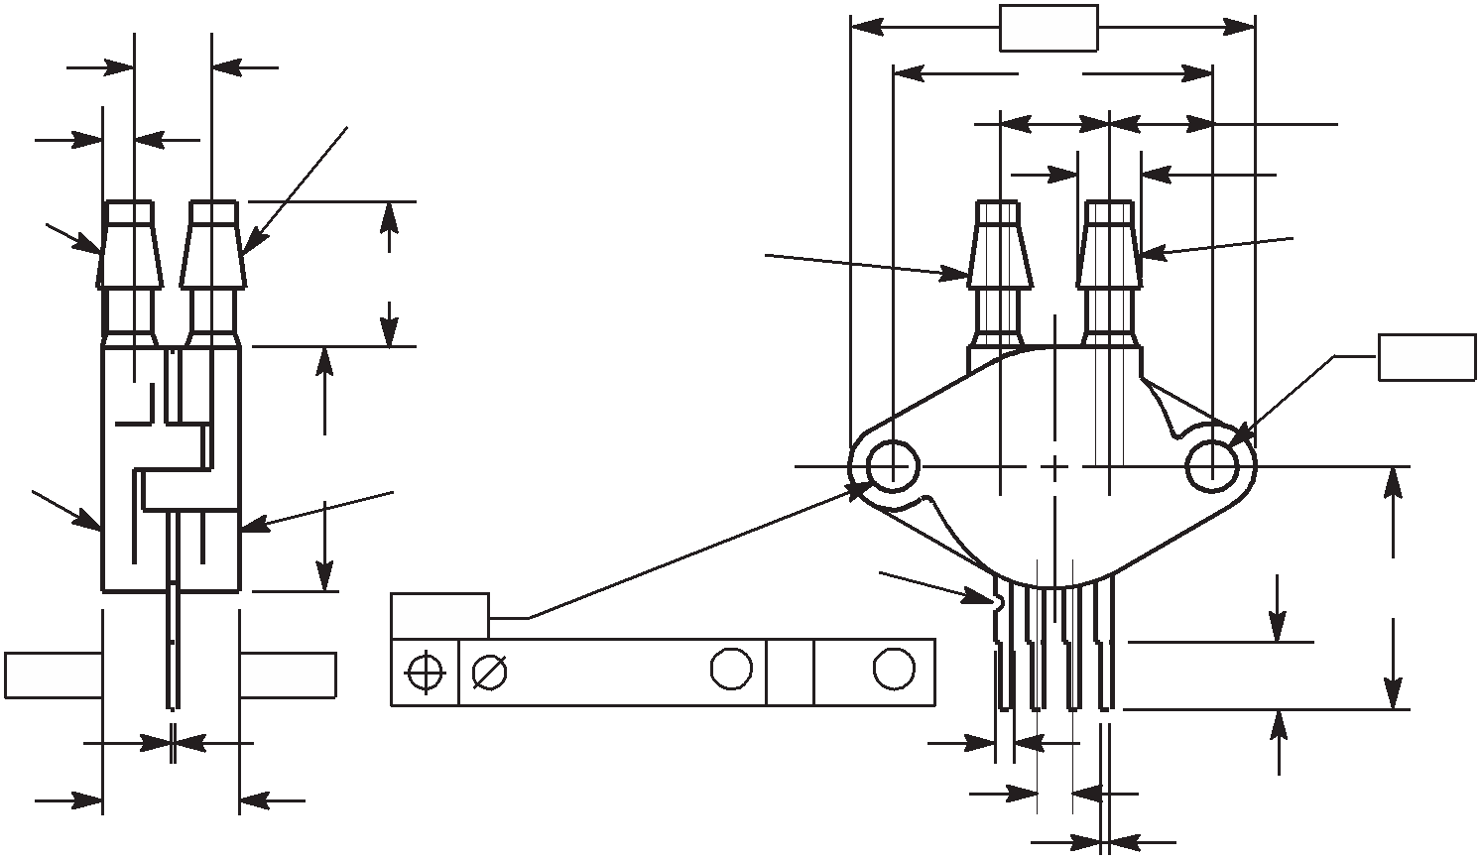

PORT #1
POSITIVE PRESSURE

N (P2) (P1)

-Q-

SEATING PLANE
B SEATING PLANE

-P- K

-T- -T-
J
C
0.25 (0.010) M
T Q S S F
G

D 4 PL

 |  | 0.13 (0.005) M | T | S S | Q S

CASE 344C-01
STYLE1:
PIN1. GROUND
ISSUE B UNIBODY PACKAGE

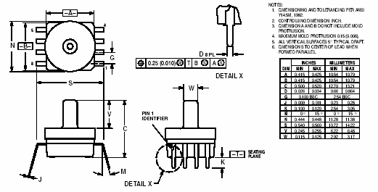

CASE 482C-03
ISSUE B
SMALL OUTLINE PACKAGE

MPX53

How to Reach Us:

Home Page:
www.freescale.com

Web Support:
http://www.freescale.com/support

USA/Europe or Locations Not Listed:
Freescale Semiconductor, Inc. Technical Information Center, EL516
2100 East Elliot Road
Tempe, Arizona 85284
1-800-521-6274 or +1-480-768-2130 www.freescale.com/support

Europe, Middle East, and Africa: Freescale Halbleiter Deutschland GmbH Technical Information Center Schatzbogen 7
81829 Muenchen, Germany
+44 1296 380 456 (English)
+46 8 52200080 (English)
+49 89 92103 559 (German)
+33 1 69 35 48 48 (French)
www.freescale.com/support

Japan:
Freescale Semiconductor Japan Ltd. Headquarters
ARCO Tower 15F
1-8-1, Shimo-Meguro, Meguro-ku, Tokyo 153-0064
Japan
0120 191014 or +81 3 5437 9125 support.japan@freescale.com

Asia/Pacific:
Freescale Semiconductor China Ltd. Exchange Building 23F
No. 118 Jianguo Road Chaoyang District Beijing 100022
China
+86 010 5879 8000 support.asia@freescale.com

For Literature Requests Only:
Freescale Semiconductor Literature Distribution Center
1-800-441-2447 or +1-303-675-2140
Fax: +1-303-675-2150
LDCForFreescaleSemiconductor@hibbertgroup.com

Information in this document is provided solely to enable system and software implementers to use Freescale Semiconductor products. There are no express or implied copyright licenses granted hereunder to design or fabricate any integrated circuits or integrated circuits based on the information in this document.

Freescale Semiconductor reserves the right to make changes without further notice to any products herein. Freescale Semiconductor makes no warranty, representation or guarantee regarding the suitability of its products for any particular purpose, nor does Freescale Semiconductor assume any liability arising out of the application or use of any product or circuit, and specifically disclaims any and all liability, including without limitation consequential or incidental damages. “Typical” parameters that may be provided in Freescale Semiconductor data sheets and/or specifications can and do vary in different applications and actual performance may vary over time. All operating parameters, including “Typicals”, must be validated for each customer application by customer’s technical experts. Freescale Semiconductor does not convey any license under its patent rights nor the rights of others. Freescale Semiconductor products are not designed, intended, or authorized for use as components in systems intended for surgical implant into the body, or other applications intended to support or sustain life, or for any other application in which the failure of the Freescale Semiconductor product could create a situation where personal injury or death may occur. Should Buyer purchase or use Freescale Semiconductor products for any such unintended or unauthorized application, Buyer shall indemnify and hold Freescale Semiconductor and its officers, employees, subsidiaries, affiliates, and distributors harmless against all claims, costs, damages, and expenses, and reasonable attorney fees arising out of, directly or indirectly, any claim of personal injury or death associated with such unintended or unauthorized use, even if such claim alleges that Freescale Semiconductor was negligent regarding the design or manufacture of the part.

Freescale™ and the Freescale logo are trademarks of Freescale Semiconductor, Inc. All other product or service names are the property of their respective owners.


© Freescale Semiconductor, Inc. 2009. All rights reserved.

MPX53
Rev. 7
05/2009

