36V Low Cost High Side
Current Sense in a SOT-23

FEATURES

■ Gain Conﬁgurable with Two Resistors
■ Low Offset Voltage: 250μV Maximum
■ Output Current: 1mA Maximum
■ Supply Range: 2.7V to 36V, 44V Absolute Maximum
■ Low Input Bias Current: 40nA Maximum
■ PSRR: 106dB Minimum
■ Low Supply Current: 65μA Typical, V+ = 12V
■ Operating Temperature Range: –40°C to 125°C
■ Low Proﬁle (1mm) ThinSOTTM Package

APPLICATIONS

■ Current Shunt Measurement
■ Battery Monitoring
■ Power Management
■ Motor Control
■ Lamp Monitoring
■ Overcurrent and Fault Detection
DESCRIPTION

The LT®6106 is a versatile high side current sense ampli- ﬁer. Design ﬂexibility is provided by the excellent device characteristics: 250μV maximum offset and 40nA maxi- mum input bias current. Gain for each device is set by two resistors and allows for accuracy better than 1%.

The LT6106 monitors current via the voltage across an external sense resistor (shunt resistor). Internal circuitry converts input voltage to output current, allowing for a small sense signal on a high common mode voltage to be translated into a ground referenced signal. The low DC offset allows for monitoring very small sense voltages. As a result, a small valued shunt resistor can be used, which minimizes the power loss in the shunt.

The wide 2.7V to 44V input voltage range, high accuracy and wide operating temperature range make the LT6106 ideal for automotive, industrial and power management applications. The very low power supply current of the LT6106 also makes it suitable for low power and battery operated applications.

, LT, LTC and LTM are registered trademarks of Linear Technology Corporation. ThinSOT is a trademark of Linear Technology Corporation. All other trademarks are the property of their respective owners.

TYPICAL APPLICATION

3V to 36V, 5A Current Sense with AV = 10

3V TO 36V

Measurement Accuracy vs Load Current

0.6

0.4
LIMIT OVER TEMPERATURE

0.02Ω

LOAD

100Ω

+IN

V–
–IN V+

0.2

0

–0.2

–0.4
ACCURACY (% OF FULL SCALE)

–0.6

TYPICAL PART AT TA = 25°C

LIMIT OVER TEMPERATURE

OUT

VOUT

–0.8

–1.0

–1.2

5A FULL SCALE RSENSE = 0.02Ω AV = 10

RIN = 100Ω ROUT = 1k
V+ = 3V

LT6106
200mV/A
0 1 2
3 4 5

1k LOAD CURRENT (A)

6106 TA01a
6106 TA01b

6106fa

ABSOLUTE MAXIMUM RATINGS
(Note 1)
Supply Voltage (V+ to V–)..........................................44V

PIN CONFIGURATION

TOP VIEW

Input Voltage (+IN to V–) ............................................ V+
(–IN to V–) ............................................ V+ Input Current........................................................–10mA Output Short-Circuit Duration .......................... Indeﬁnite

OUT 1
V– 2
–IN 3

S5 PACKAGE

5 V+

4 +IN

Operating Temperature Range (Note 4)
LT6106C............................................... –40°C to 85°C LT6106H ............................................ –40°C to 125°C
Speciﬁed Temperature Range (Note 4) LT6106C................................................... 0°C to 70°C LT6106H ............................................ –40°C to 125°C
Storage Temperature Range................... –65°C to 150°C Lead Temperature (Soldering, 10 sec) .................. 300°C
5-LEAD PLASTIC TSOT-23
TJMAX = 150°C, ⎝JA = 250°C/W

ORDER INFORMATION
Lead Free Finish

TAPE AND REEL (MINI) | TAPE AND REEL | PART MARKING* | PACKAGE DESCRIPTION | TEMPERATURE RANGE
LT6106CS5#TRMPBF | LT6106CS5#TRPBF | LTCWK | 5-Lead Plastic TSOT-23 | 0°C to 70°C
LT6106HS5#TRMPBF | LT6106HS5#TRPBF | LTCWK | 5-Lead Plastic TSOT-23 | –40°C to 125°C
TRM = 500 pieces. *Temperature grades are identiﬁed by a label on the shipping container. Consult LTC Marketing for parts speciﬁed with wider operating temperature ranges.
Consult LTC Marketing for information on lead based ﬁnish parts.
For more information on lead free part marking, go to: http://www.linear.com/leadfree/
For more information on tape and reel speciﬁcations, go to: http://www.linear.com/tapeandreel/

ELECTRICAL CHARACTERISTICS

The ● denotes the speciﬁcations which apply over the full speciﬁed

operating temperature range, otherwise speciﬁcations are at TA = 25°C. V+ = 12V, V+ = VSENSE+, RIN = 100Ω, ROUT = 10k, Gain = 100 unless otherwise noted. (Note 6)

SYMBOL | PARAMETER | CONDITIONS |  | MIN TYP MAX | UNITS
V+ | Supply Voltage Range |  | ● | 2.7 36 | V
VOS | Input Offset Voltage | VSENSE = 5mV | ● | 150 250  350 | μV  μV
ΔVOS/ΔT | Input Offset Voltage Drift | VSENSE = 5mV | ● | 1 | μV/°C
IB | Input Bias Current (+IN) | V+ = 12V, 36V | ● | 40  65 | nA  nA
IOS | Input Offset Current | V+ = 12V, 36V |  | 1 | nA
IOUT | Maximum Output Current | (Note 2) | ● | 1 | mA
PSRR | Power Supply Rejection Ratio | V+ = 2.7V to 36V, VSENSE = 5mV | ● | 106 | dB
VSENSE(MAX) | Input Sense Voltage Full Scale | RIN = 500Ω (Notes 2, 7) | ● | 0.5 | V
AV Error | Gain Error (Note 3) | VSENSE = 500mV, RIN = 500Ω, ROUT = 10k, V+ = 12.5V | ● | –0.65 –0.25 0 | %
AV Error | Gain Error (Note 3) | VSENSE = 500mV, RIN = 500Ω, ROUT = 10k, V+ = 36V | ● | –0.45 –0.14 0.1 | %
VOUT(HIGH) | Output Swing High  (Referred to V+) | VSENSE = 120mV | ● | 1.2  1.4 | V V
6106fa

ELECTRICAL CHARACTERISTICS The ● denotes the speciﬁcations which apply over the full speciﬁed operating temperature range, otherwise speciﬁcations are at TA = 25°C. V+ = 12V, V+ = VSENSE+, RIN = 100Ω, ROUT = 10k, Gain = 100 unless otherwise noted.

SYMBOL | PARAMETER | CONDITIONS |  | MIN TYP MAX | UNITS
 | Minimum Output Voltage  (Note 5) | VSENSE = 0mV, RIN = 100Ω, ROUT = 10k | ● | 12 45  65 | mV  mV
 | Minimum Output Voltage  (Note 5) | VSENSE = 0mV, RIN = 500Ω, ROUT = 10k, V+ = 12V, 36V | ● | 7 16  22 | mV  mV
BW | Signal Bandwidth (–3dB) | IOUT = 1mA, RIN = 100Ω, ROUT = 5k |  | 200 | kHz
tr | Input Step Response (to 50% of  Output Step) | ΔVSENSE = 100mV Step, RIN = 100Ω, ROUT = 5k, Rising Edge |  | 3.5 | μs
IS | Supply Current | V+ = 2.7V, IOUT = 0μA, (VSENSE = –5mV) | ● | 60 85  115 | μA
IS | Supply Current | V+ = 12V, IOUT = 0μA, (VSENSE = –5mV) | ● | 65 95  120 | μA
IS | Supply Current | V+ = 36V, IOUT = 0μA, (VSENSE = –5mV) | ● | 70 100  130 | μA

Note 1: Stresses beyond those listed under Absolute Maximum Ratings may cause permanent damage to the device. Exposure to any Absolute Maximum Rating condition for extended periods may affect device reliability and lifetime. In addition to the Absolute Maximum Ratings, the output current of the LT6106 must be limited to insure that the power dissipation in the LT6106 does not allow the die temperature to exceed
150°C. See the applications information section “Power Dissipation
Considerations” for further information.
Note 2: Guaranteed by the gain error test.
Note 3: Gain error refers to the contribution of the LT6106 internal circuitry and does not include errors in the external gain setting resistors.
Note 4: The LT6106C is guaranteed functional over the operating temperature range of –40°C to 85°C. The LT6106C is designed,
characterized and expected to meet speciﬁed performance from –40°C to
85°C but is not tested or QA sampled at these temperatures. The LT6106H
is guaranteed to meet speciﬁed performance from –40°C to 125°C. Note 5: The LT6106 output is an open collector current source. The minimum output voltage scales directly with the ratio ROUT/10k.
Note 6: VSENSE+ is the voltage at the high side of the sense resistor,
RSENSE. See Figure 1.
Note 7: VSENSE (MAX) is the maximum sense voltage for which the Electrical Characteristics will apply. Higher voltages can affect performance but will not damage the part provided that the output current of the LT6106 does not exceed the allowable power dissipation as described in Note 1.

TYPICAL PERFORMANCE CHARACTERISTICS

VOS Distribution

16 V+ = 12V
Input Offset Voltage vs
Supply Voltage

60
CHANGE IN INPUT OFFSET VOLTAGE (μV)
Input Offset Voltage vs
Temperature

VSENSE = 5mV ROUT = 10k

VSENSE = 5mV
14 RIN = 100Ω
ROUT = 10k
12 1068 UNITS
PERCENT OF UNITS (%)

10

8

6

4

2

0

50
40
30
20
10
0
–10
–20
–30
–40
–50
–60
–70
VSENSE = 5mV RIN = 100Ω ROUT = 10k TYPICAL UNITS

300

200

100

0

–100
INPUT OFFSET VOLTAGE (μV)

–200

–300

–400
V+ = 12V
RIN = 100Ω
AV = 100
TYPICAL UNITS

–200
–120 –40 0 40
120
200
0 5 10
15 20 25
30 35 40
–55
–25 5 35 65 95
125

INPUT OFFSET VOLTAGE (μV)
SUPPLY VOLTAGE (V)
TEMPERATURE (°C)

6106 G23

6106 G02

6106 G03

6106fa

TYPICAL PERFORMANCE CHARACTERISTICS

0
–0.05

Gain Error vs Temperature

120
110
POWER SUPPLY REJECTION RATIO (dB)
Power Supply Rejection Ratio vs Frequency

V+ = 12.5V
AV = 20
POWER SUPPLY REJECTION RATIO (dB)

120
110
Power Supply Rejection Ratio vs Frequency
V+ = 12.5V
AV = 20

–0.10
V+ = 36V
100

RIN = 100Ω
100
RIN
= 500Ω

–0.15
–0.20
GAIN ERROR (%)
–0.25
–0.30
–0.35
–0.40
–0.45
–0.50
–0.55
–0.60

VOUT = 1V IOUT = 1mA ROUT = 1k TYPICAL UNIT
V+ = 12V V+ = 5V

V+ = 2.7V
90
80
70
60
50
40
30
20 VOUT = 0.5V
10 VOUT = 1V VOUT = 2V
0
ROUT = 2k
90
80
70
60
50
40
30
20 VOUT = 2.5V
10 VOUT = 5V VOUT = 10V
0
ROUT = 10k

–45 –25 –5 15
35 55 75 95 115 130
100 1k
10k 100k 1M
100 1k
10k 100k 1M

TEMPERATURE (°C)

6106 G04
FREQUENCY (Hz)

6106 G08
FREQUENCY (Hz)

6106 G06

Gain Error Distribution
24
V+ = 12.5V
22 VSENSE = 500mV
20 RIN = 500Ω
18 ROUT = 10k
PERCENT OF UNITS (%)
11,072 UNITS
16 TA = 25°C
14
12
10
8
6
4
2
0

45
40
35
30
25
20
15
GAIN (dB)
10
5
0
–5
–10
–15
–20
–25
–30
Gain vs Frequency

VOUT = 10V
VOUT = 2.5V

V+ = 12.5V AV = 100
RIN = 100Ω
ROUT = 10k

45
40
35
30
25
20
15
10
GAIN (dB)
5
0
–5
–10
–15
–20
–25
–30
Gain vs Frequency

VOUT = 10V VOUT = 2.5V

V+ = 12.5V AV = 20
RIN = 500Ω
ROUT = 10k

–0.60
–0.48 –0.36
–0.24 –0.12 0
1k 10k
100k 1M 10M
1k 10k
100k 1M 10M

GAIN ERROR (%)

6106 G24
FREQUENCY (Hz)

6106 G09
FREQUENCY (Hz)

6106 G14

Input Bias Current vs Supply
Voltage

VSENSE = 5mV
19 RIN = 100Ω
18
INPUT BIAS CURRENT (nA)

17

16

15

14

13
TA = –40°C
12 TA = 25°C

VSENSE
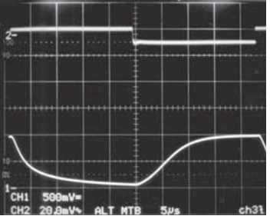

20mV/DIV

500mV/DIV
0V
Step Response 0mV to 10mV (RIN = 100Ω)

6106 G1

VSENSE
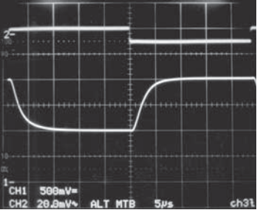

20mV/DIV

VOUT
500mV/DIV

0V
Step Response 10mV to 20mV (RIN = 100Ω)

11 TA = 70°C
TA = 125°C
10
AV = 100
VOUT = 0V TO 1V
ROUT = 10k
5μs/DIV
AV = 100
VOUT = 1V TO 2V
ROUT = 10k
5μs/DIV

0 5 10 15
20 25
30 35 40
45 50
V+ = 12V
V+ = 12V

SUPPLY VOLTAGE (V)

6106 G05

6106fa

TYPICAL PERFORMANCE CHARACTERISTICS

VSENSE
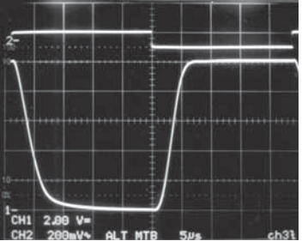

200mV/DIV

VOUT
2V/DIV

0V
Step Response 0mV to 100mV (RIN = 100Ω)

VSENSE
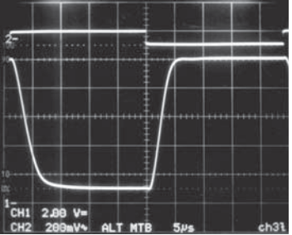

200mV/DIV

VOUT
2V/DIV

0V
Step Response 10mV to 100mV (RIN = 100Ω)

VSENSE
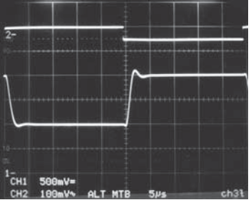

100mV/DIV

VOUT
500mV/DIV

0V
Step Response 50mV to 100mV (RIN = 500Ω)

AV = 100
VOUT = 0V TO 10V
ROUT = 10k
V+ = 12V
5⎧s/DIV
6106 G1
AV = 100
VOUT = 1V TO 10V
ROUT = 10k
V+ = 12V
5μs/DIV
6106 G1
AV = 20
VOUT = 1V TO 2V
ROUT = 10k
V+ = 12V
5μs/DIV
6106 G1

VSENSE
100mV/DIV

VOUT
500mV/DIV
0V
Step Response 0mV to 50mV (RIN = 500Ω)

VSENSE
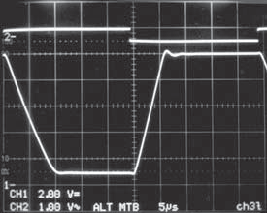

1V/DIV

VOUT
2V/DIV

0V
Step Response 50mV to 500mV (RIN = 500Ω)

VSENSE
1V/DIV

VOUT
2V/DIV

0V
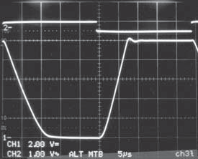

Step Response 0mV to 500mV (RIN = 500Ω)

AV = 20
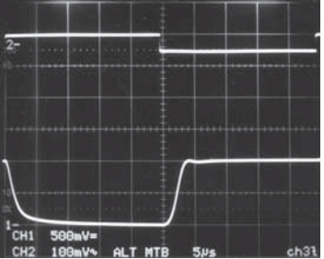

VOUT = 0V TO 1V
ROUT = 10k
V+ = 12V
5μs/DIV
6106 G1
AV = 20
VOUT = 1V TO 10V
ROUT = 10k
V+ = 12V
5μs/DIV
6106 G1
AV = 20
VOUT = 0V TO 10V
ROUT = 10k
V+ = 12V
5μs/DIV
6106 G1

11.10
V+ = 12V AV = 100
RIN = 100Ω
ROUT = 10k
VSENSE = 120mV

11.05

11.00

10.95

10.90
OUTPUT VOLTAGE (V)

10.85

10.80
Output Voltage Swing vs
Temperature

1100
1000
900
800
700
VOUT (mV)
600
500
400
300
200
100
0
Output Voltage vs Input Sense
Voltage (0mV ≤ VSENSE ≤ 10mV)
V+ = 12V
AV = 100
RIN = 100Ω
ROUT = 10k

220
200
180
160
140
VOUT (mV)
120
100
80
60
40
20
0
Output Voltage vs Input Sense
Voltage (0mV ≤ VSENSE ≤ 10mV)
V+ = 12V
AV = 20
RIN = 500Ω
ROUT = 10k

–50
–25 0
25 50
75 100 125
0 1 2
3 4 5 6 7
8 9 10
0 1 2
3 4 5 6 7
8 9 10

TEMPERATURE (°C)
VSENSE (mV)
VSENSE (mV)

6106 G07
6106 G19
6106 G20

6106fa

TYPICAL PERFORMANCE CHARACTERISTICS

Output Voltage vs Input Sense
Voltage (0mV ≤ VSENSE ≤ 200mV)
12
Output Voltage vs Input Sense
Voltage (0mV ≤ VSENSE ≤ 1V)
V+ = 12V AV = 20
RIN = 500Ω
ROUT = 10k

12

120

Supply Current vs Supply Voltage

10 10
100

8 8 80

6 6 60
VOUT (V)
VOUT (V)
SUPPLY CURRENT (μA)
V+ = 12V AV = 100
RIN = 100Ω
ROUT = 10k

4 4 40

2 2 20

TA = –40°C
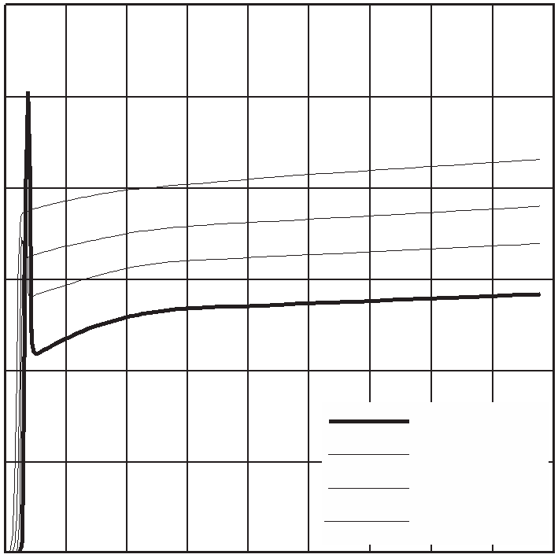

TA = 25°C
TA = 70°C
TA = 125°C

0 20 40
60 80 100 120 140 160 180 200
0 100 200 300 400 500 600 700 800 900 1000

0 5 10 15

20 25

30 35 40 45

VSENSE (mV)

PIN FUNCTIONS

6106 G21
VSENSE (mV)

6106 G22
SUPPLY VOLTAGE (V)

6106 G01

OUT (Pin 1): Current Output. OUT will source a current that is proportional to the sense voltage into an external resistor.
V– (Pin 2): Normally Connected to Ground.

–IN (Pin 3): The internal sense ampliﬁer will drive –IN to the same potential as +IN. A resistor (RIN) tied from V+ to –IN sets the output current IOUT = VSENSE/RIN. VSENSE is the voltage developed across RSENSE.

+IN (Pin 4): Must be tied to the system load end of the sense resistor, either directly or through a resistor.

V+ (Pin 5): Positive Supply Pin. The V+ pin should be con- nected directly to either side of the sense resistor, RSENSE. Supply current is drawn through this pin. The circuit may be conﬁgured so that the LT6106 supply current is or is not monitored along with the system load current. To monitor only the system load current, connect V+ to the more positive side of the sense resistor. To monitor the total current, including that of the LT6106, connect V+ to the more negative side of the sense resistor.

BLOCK DIAGRAM

ILOAD

L O A D

VSENSE

RSENSE

RIN

3

4

–IN

+IN

14k

14k

VBATTERY

5
V+

OUT
V– 1

IOUT

V = V • ROUT OUT SENSE R

2
6106 F01
IN
ROUT

Figure 1. LT6106 Block Diagram and Typical Connection

6106fa

APPLICATIONS INFORMATION
Introduction

The LT6106 high side current sense ampliﬁer (Figure 1) pro- vides accurate monitoring of current through a user-selected sense resistor. The sense voltage is ampliﬁed by a user- selected gain and level shifted from the positive power sup- ply to a ground-referred output. The output signal is analog and may be used as is, or processed with an output ﬁlter.

Theory of Operation

An internal sense ampliﬁer loop forces –IN to have the same potential as +IN. Connecting an external resistor, RIN, between –IN and V+ forces a potential across RIN that is the same as the sense voltage across RSENSE. A corresponding current, VSENSE/RIN, will ﬂow through RIN. The high impedance inputs of the sense ampliﬁer will not conduct this current, so it will ﬂow through an internal PNP to the output pin as IOUT.

The output current can be transformed into a voltage by adding a resistor from OUT to V–. The output voltage is then VO = V– + IOUT • ROUT.

Table 1. Useful Gain Conﬁgurations

GAIN | RIN | ROUT | VSENSE at VOUT = 5V | IOUT at VOUT = 5V
20 | 499Ω | 10k | 250mV | 500μA
50 | 200Ω | 10k | 100mV | 500μA
100 | 100Ω | 10k | 50mV | 500μA
GAIN | RIN | ROUT | VSENSE at VOUT = 2.5V | IOUT at VOUT = 2.5V
20 | 249Ω | 5k | 125mV | 500μA
50 | 100Ω | 5k | 50mV | 500μA
100 | 50Ω | 5k | 25mV | 500μA

Selection of External Current Sense Resistor

The external sense resistor, RSENSE, has a signiﬁcant ef- fect on the function of a current sensing system and must be chosen with care.

First, the power dissipation in the resistor should be con- sidered. The system load current will cause both heat and voltage loss in RSENSE. As a result, the sense resistor should be as small as possible while still providing the input dynamic range required by the measurement. Note that input dynamic range is the difference between the maximum input signal and the minimum accurately mea- sured signal, and is limited primarily by input DC offset of the internal ampliﬁer of the LT6106. In addition, RSENSE

must be small enough that VSENSE does not exceed the maximum input voltage speciﬁed by the LT6106, even un- der peak load conditions. As an example, an application may require that the maximum sense voltage be 100mV. If this application is expected to draw 2A at peak load, RSENSE should be no more than 50mΩ.

Once the maximum RSENSE value is determined, the mini- mum sense resistor value will be set by the resolution or dynamic range required. The minimum signal that can be accurately represented by this sense ampliﬁer is limited by the input offset. As an example, the LT6106 has a typical input offset of 150μV. If the minimum current is 20mA, a sense resistor of 7.5mΩ will set VSENSE to 150μV. This is the same value as the input offset. A larger sense resis- tor will reduce the error due to offset by increasing the sense voltage for a given load current. Choosing a 50mΩ RSENSE will maximize the dynamic range and provide a system that has 100mV across the sense resistor at peak load (2A), while input offset causes an error equivalent to only 3mA of load current. Peak dissipation is 200mW. If a
5mΩ sense resistor is employed, then the effective current error is 30mA, while the peak sense voltage is reduced to
10mV at 2A, dissipating only 20mW.

The low offset and corresponding large dynamic range of the LT6106 make it more ﬂexible than other solutions in this respect. The 150μV typical offset gives 60dB of dy- namic range for a sense voltage that is limited to 150mV maximum, and over 70dB of dynamic range if the rated input maximum of 0.5V is allowed.

Sense Resistor Connection

Kelvin connection of the –IN and +IN inputs to the sense resistor should be used in all but the lowest power appli- cations. Solder connections and PC board interconnec- tions that carry high current can cause signiﬁcant error in measurement due to their relatively large resistances. One 10mm × 10mm square trace of one-ounce copper is approximately 0.5mΩ. A 1mV error can be caused by as little as 2A ﬂowing through this small interconnect. This will cause a 1% error in a 100mV signal. A 10A load cur- rent in the same interconnect will cause a 5% error for the same 100mV signal. By isolating the sense traces from the high current paths, this error can be reduced by orders of

6106fa

APPLICATIONS INFORMATION magnitude. A sense resistor with integrated Kelvin sense terminals will give the best results. Figure 2 illustrates the
recommended method.

V+

RIN

This approach can be helpful in cases where occasional bursts of high currents can be ignored.

Care should be taken when designing the board layout for RIN, especially for small RIN values. All trace and inter- connect resistances will increase the effective RIN value, causing a gain error.

RSENSE

LOAD

+IN V–

LT6106

–IN V+

OUT

6106 F02

ROUT

VOUT

Selection of External Output Resistor, ROUT
The output resistor, ROUT, determines how the output cur- rent is converted to voltage. VOUT is simply IOUT • ROUT.

In choosing an output resistor, the maximum output volt- age must ﬁrst be considered. If the following circuit is a buffer or ADC with limited input range, then ROUT must be chosen so that IOUT(MAX) • ROUT is less than the allowed

Figure 2. Kelvin Input Connection Preserves Accuracy with
Large Load Currents

Selection of External Input Resistor, RIN
RIN should be chosen to allow the required resolution while limiting the output current to 1mA. In addition, the maximum value for RIN is 500Ω. By setting RIN such that the largest expected sense voltage gives IOUT = 1mA, then the maximum output dynamic range is available. Output dynamic range is limited by both the maximum allowed output current and the maximum allowed output voltage, as well as the minimum practical output signal. If less
maximum input range of this circuit.

In addition, the output impedance is determined by ROUT. If the circuit to be driven has high enough input impedance, then almost any useful output impedance will be accept- able. However, if the driven circuit has relatively low input impedance, or draws spikes of current such as an ADC might do, then a lower ROUT value may be required in order to preserve the accuracy of the output. As an example, if the input impedance of the driven circuit is 100 times ROUT, then the accuracy of VOUT will be reduced by 1% since:
ROUT • RIN(DRIVEN)

V = I •

dynamic range is required, then RIN can be increased
accordingly, reducing the maximum output current and
power dissipation. If low sense currents must be resolved
OUT OUT
ROUT + RIN(DRIVEN)

100

accurately in a system that has a very wide dynamic range, a smaller RIN than the maximum current spec allows may be used if the maximum current is limited in another way, such as with a Schottky diode across RSENSE (Figure 3). This will reduce the high current measurement accuracy by limiting the result, while increasing the low current measurement resolution.

V+

RSENSE
= IOUT • ROUT • 101 = 0.99 • IOUT • ROUT

Error Sources

The current sense system uses an ampliﬁer and resistors to apply gain and level shift the result. The output is then dependent on the characteristics of the ampliﬁer, such as gain and input offset, as well as resistor matching.

Ideally, the circuit output is:

VOUT = VSENSE • OUT ; VSENSE = RSENSE • ISENSE
R

LOAD

6106 F03
DSENSE
RIN

In this case, the only error is due to resistor mismatch,

Figure 3. Shunt Diode Limits Maximum Input Voltage to Allow
Better Low Input Resolution Without Overranging
which provides an error in gain only. However, offset volt- age and bias current cause additional errors.

6106fa

APPLICATIONS INFORMATION Output Error Due to the Ampliﬁer DC Offset Voltage, VOS
R
R

V+

RSENSE
R

–
IN
+
IN +IN

–IN

EOUT(VOS)
= VOS
• OUT
RIN

LOAD
V– V+

The DC offset voltage of the ampliﬁer adds directly to the
value of the sense voltage, VSENSE. This is the dominant error of the system and it limits the low end of the dynamic range. The paragraph “Selection of External Current Sense Resistor” provides details.

LT6106

R + = R – – R

OUT

6106 F04

ROUT

VOUT

IN IN
SENSE

Output Error Due to the Bias Currents, IB+ and IB–
+

Figure 4. Second Input R Minimizes Error Due to Input Bias Current

The bias current IB
ﬂows into the positive input of the
Minimum Output Voltage

internal op amp. IB– ﬂows into the negative input.

⎛ RSENSE – ⎞

The curves of the Output Voltage vs Input Sense Voltage show the behavior of the LT6106 with low input sense volt-

EOUT(IBIAS) = ROUT ⎜IB + •
– IB ⎟
ages. When V
= 0V, the output voltage will always

⎝ RIN ⎠

be slightly
SENSE
positive, the

result of input offset voltages and

Assuming IB+ ≅ I –
B
= IBIAS, and RSENSE << RIN then:
of a small amount of quiescent current (0.7μA to 1.2μA)
ﬂowing through the output device. The minimum output

EOUT(IBIAS) ≅ –ROUT • IBIAS
It is convenient to refer the error to the input: EIN(IBIAS) ≅ –RIN • IBIAS
For instance if IBIAS is 60nA and RIN is 1k, the input referred error is 60μV. Note that in applications where RSENSE ≅ RIN, IB+ causes a voltage offset in RSENSE that cancels the
–
voltage in the Electrical Characteristics table include both these effects.

Power Dissipation Considerations

The power dissipated by the LT6106 will cause a small increase in the die temperature. This rise in junction tem- perature can be calculated if the output current and the

error due to IB
and EOUT(IBIAS) ≅ 0mV. In most applica-
supply current are known.

tions, RSENSE << RIN, the bias current error can be similarly
+

The power dissipated in the LT6106 due to the output

reduced if an external resistor RIN
= (RIN – RSENSE) is

connected as shown in Figure 4. Under both conditions:
EIN(IBIAS) = ±RIN • IOS; where IOS = IB+ – IB–
signal is:

POUT = (VIN

– – VOUT

) • IOUT

If the offset current, IOS, of the LT6106 ampliﬁer is 6nA,
Since VIN
– ≅ V+, POUT
≅ (V+ – VOUT
) • IOUT

the 60μV error above is reduced to 6μV.

Adding RIN+ as described will maximize the dynamic range of the circuit. For less sensitive designs, RIN+ is not necessary.

Output Error Due to Gain Error

The LT6106 exhibits a typical gain error of –0.25% at 1mA output current. The primary source of gain error is due to the ﬁnite gain to the PNP output transistor, which results in a small percentage of the current in RIN not appearing in the output load ROUT.
The power dissipated due to the quiescent supply current is:
PQ = IS • (V+ – V–)
The total power dissipated is the output dissipation plus the quiescent dissipation:

PTOTAL = POUT + PQ
The junction temperature is given by: TJ = TA + ⎝JA • PTOTAL
At the maximum operating supply voltage of 36V and the
maximum guaranteed output current of 1mA, the total
6106fa

APPLICATIONS INFORMATION

power dissipation is 41mW. This amount of power dis- sipation will result in a 10°C rise in junction temperature above the ambient temperature.

It is important to note that the LT6106 has been designed to provide at least 1mA to the output when required, and can deliver more depending on the conditions. Care must be taken to limit the maximum output current by proper choice of sense resistor and RIN– and, if input fault con- ditions exist, external clamps.

Output Filtering

The output voltage, VOUT, is simply IOUT • ZOUT. This makes ﬁltering straightforward. Any circuit may be used which generates the required ZOUT to get the desired ﬁlter re- sponse. For example, a capacitor in parallel with ROUT will give a lowpass response. This will reduce unwanted noise from the output, and may also be useful as a charge reservoir to keep the output steady while driving a switch- ing circuit such as a MUX or ADC. This output capacitor in parallel with an output resistor will create a pole in the output response at:

normal operation, VSENSE should not exceed 500mV (see VSENSE(MAX) under Electrical Characteristics). This ad- ditional constraint can be stated as V+ – (+IN) ≤ 500mV. Referring to Figure 5, feedback will force the voltages at the inputs –IN and +IN to be equal to (VS – VSENSE). Connecting V+ to the load side of the shunt results in equal voltages at +IN, –IN and V+. Connecting V+ to the supply end of the shunt results in the voltages at +IN and –IN to be VSENSE below V+.

If the V+ pin is connected to the supply side of the shunt resistor the supply current drawn by the LT6106 is not included in the monitored current. If the V+ pin is con- nected to the load side of the shunt resistor (Figure 5), the supply current drawn by the LT6106 is included in the monitored current. It should be noted that in either conﬁguration, the output current of the LT6106 will not be monitored since it is drawn through the RIN resistor connected to the positive side of the shunt. Contract the factory for operation of the LT6106 with a V+ outside of the recommended operating range.

f–3dB =

1
2 • • ROUT • COUT
VS

RSENSE
RIN

+IN

–IN

Useful Equations

Input Voltage: VSENSE = ISENSE • RSENSE
LOAD
V V
–
+

Voltage Gain:

VOUT
VSENSE

= ROUT
RIN

LT6106

OUT

6106 F05

VOUT
ROUT

I R
Current Gain: OUT = SENSE

ISENSE

I
RIN

1
Figure 5. LT6106 Supply Current Monitored with the Load

Reverse Supply Protection

Transconductance: OUT =
VSENSE

V

RIN

R

Some applications may be tested with reverse-polarity supplies due to an expectation of the type of fault during

Transimpedance:
OUT = R
ISENSE SENSE
• OUT
RIN
operation. The LT6106 is not protected internally from ex-
ternal reversal of supply polarity. To prevent damage that may occur during this condition, a Schottky diode should

Power Supply Connection

For normal operation, the V+ pin should be connected to either side of the sense resistor. Either connection will meet the constraint that +IN ≤ V+ and –IN ≤ V+. During
be added in series with V– (Figure 6). This will limit the reverse current through the LT6106. Note that this diode will limit the low voltage performance of the LT6106 by effectively reducing the supply voltage to the part by VD.
6106fa

APPLICATIONS INFORMATION

In addition, if the output of the LT6106 is wired to a de- vice that will effectively short it to high voltage (such as through an ESD protection clamp) during a reverse sup- ply condition, the LT6106’s output should be connected through a resistor or Schottky diode (Figure 7).

Demo Board

Demo board DC1240 is available for evaluation of the
LT6106.
RSENSE

Response Time

The photos in the Typical Performance Characteristics show the response of the LT6106 to a variety of input conditions and values of RIN. The photos show that if the output cur- rent is very low or zero and an input transient occurs, there will be an increased delay before the output voltage begins changing while internal nodes are being charged.

RSENSE

+IN L V–
O
A D

D1

LT6106

–IN V+

OUT

R1
100Ω

R2
4.99k

VBATT
+IN L V–
O
A D

D1

LT6106

–IN V+

OUT
R1
100Ω

R3
1k

R2
4.99k
VBATT

ADC

6106 F07

6106 F06

Figure 6. Schottky Diode Prevents Damage During Supply Reversal

Figure 7. Additional Resistor R3 Protects Output
During Supply Reversal

PACKAGE DESCRIPTION

MAX

REF
S5 Package
5-Lead Plastic TSOT-23

(NOTE 4)

1.22 REF

3.85 MAX 2.62 REF
1.4 MIN
(NOTE 4)

PIN ONE

0.20 BSC

DATUM ‘A’
RECOMMENDED SOLDER PAD LAYOUT PER IPC CALCULATOR

0.95 BSC

0.80 – 0.90

1.00 MAX
0.30 – 0.45 TYP
5 PLCS (NOTE 3)

0.01 – 0.10

0.30 – 0.50 REF

0.09 – 0.20

1.90 BSC

NOTE:
1. DIMENSIONS ARE IN MILLIMETERS
2. DRAWING NOT TO SCALE
3. DIMENSIONS ARE INCLUSIVE OF PLATING
(NOTE 3) S5 TSOT-23 0302 REV B
4. DIMENSIONS ARE EXCLUSIVE OF MOLD FLASH AND METAL BURR
5. MOLD FLASH SHALL NOT EXCEED 0.254mm
6. JEDEC PACKAGE REFERENCE IS MO-193

6106fa
11

Information furnished by Linear Technology Corporation is believed to be accurate and reliable. However, no responsibility is assumed for its use. Linear Technology Corporation makes no representa-
.
tion that the interconnection of its circuits as described herein will not infringe on existing patent rights

TYPICAL APPLICATION

Simple 400V Current Monitor

ISENSE
DANGER! Lethal Potentials Present — Use Caution

VSENSE

400V

+IN
RSENSE

–IN
RIN
100Ω

L V–
O
A D
V+ DANGER!!
HIGH VOLTAGE!!

LT6106
OUT
12V CMPZ12L

M1 BAT46

M1 AND M2 ARE FQD3P50
ROUT
VOUT
M2
ROUT 2M
4.99k

VOUT = RIN • VSENSE = 49.9 VSENSE

6106 TA02

RELATED PARTS

PART NUMBER | DESCRIPTION | COMMENTS
LT1787 | Precision Bidirectional, High Side Current Sense Ampliﬁer | 75μV VOS, 60V, 60μA Operation
LT6100 | Gain-Selectable High Side Current Sense Ampliﬁer | 4.1V to 48V, Pin-Selectable Gain: 10, 12.5, 20, 25, 40, 50V/V
LTC®6101/LTC6101HV | High Voltage, High Side, Precision Current Sense Ampliﬁers | 4V to 60V/5V to 100V, Gain Conﬁgurable, SOT-23
LTC6103 | Dual High Side, Precision Current Sense Ampliﬁer | 4V to 60V, Gain Conﬁgurable 8-Pin MSOP
LTC6104 | Bidirectional High Side, Precision Current Sense Ampliﬁer | 4V to 60V, Gain Conﬁgurable 8-Pin MSOP

Linear Technology Corporation
12
1630 McCarthy Blvd., Milpitas, CA 95035-7417
6106fa

LT 0807 REV A • PRINTED IN USA

(408) 432-1900
● FAX: (408) 434-0507
● www.linear.com © LINEAR TECHNOLOGY CORPORATION 2007

