

LM337L
3-Terminal Adjustable Regulator
June 2005
LM337L 3-Terminal Adjustable Regulator

General Description
The LM337L is an adjustable 3-terminal negative voltage regulator capable of supplying 100mA over a 1.2V to 37V output range. It is exceptionally easy to use and requires only two external resistors to set the output voltage. Further- more, both line and load regulation are better than standard fixed regulators. Also, the LM337L is packaged in a standard TO-92 transistor package which is easy to use.
In addition to higher performance than fixed regulators, the LM337L offers full overload protection. Included on the chip are current limit, thermal overload protection and safe area protection. All overload protection circuitry remains fully func- tional even if the adjustment terminal is disconnected.
Normally, only a single 1µF solid tantalum output capacitor is needed unless the device is situated more than 6 inches from the input filter capacitors, in which case an input bypass is needed. A larger output capacitor can be added to improve transient response. The adjustment terminal can be by- passed to achieve very high ripple rejection ratios which are difficult to achieve with standard 3-terminal regulators.
Besides replacing fixed regulators, the LM337L is useful in a wide variety of other applications. Since the regulator is “floating” and sees only the input-to-output differential volt- age, supplies of several hundred volts can be regulated as long as the maximum input-to-output differential is not ex- ceeded.
Also, it makes an especially simple adjustable switching regulator, a programmable output regulator, or by connecting
a fixed resistor between the adjustment and output, the LM337L can be used as a precision current regulator. Sup- plies with electronic shutdown can be achieved by clamping the adjustment terminal to ground which programs the out- put to 1.2V where most loads draw little current.
The LM337L is available in a standard TO-92 transistor package, SO-8 surface mount package, and in our new 12 mil diameter bump micro SMD package. The LM337L is rated for operation over a −25˚C to +125˚C range.
For applications requiring greater output current in excess of
0.5A and 1.5A, see LM137 series data sheets. For the positive complement, see series LM117 and LM317L data sheets.

Features
n Adjustable output down to 1.2V
n Guaranteed 100mA output current
n Line regulation typically 0.01%/V
n Load regulation typically 0.1%
n Current limit constant with temperature
n Eliminates the need to stock many voltages
n Standard 3-lead transistor package
n 80 dB ripple rejection
n Output is short circuit protected
n Available in the 6-Bump micro SMD package
n See AN-1112 for micro SMD considerations

Typical Application

1.2V-25V Adjustable Regulator

00913403

© 2005 National Semiconductor Corporation DS009134 www.national.com

Connection Diagrams

3-Pin TO92 8-Pin SOIC

00913401 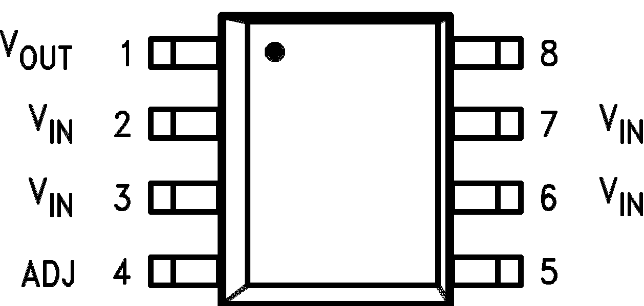
Bottom View 00913402
Top View

6-Bump micro SMD micro SMD Laser mark

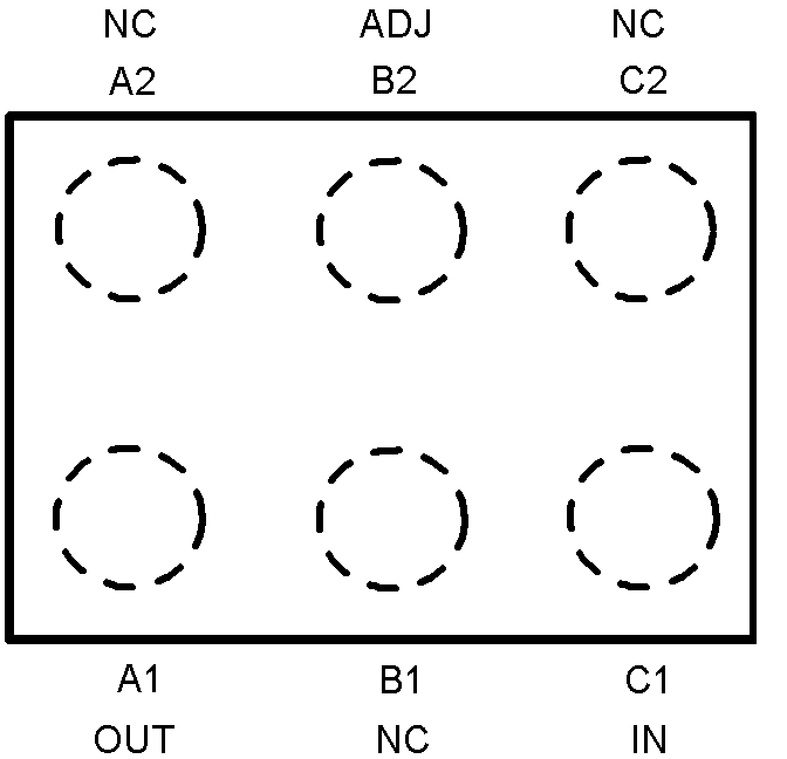 00913407
00913408

Ordering Information
Package | Part Number | Package Marking | Transport Media | NSC Drawing
3-Pin TO92 | LM337LZ | LM337LZ | 1800 per Bag | Z03A
8-Pin SOIC | LM337LM | LM337LM | Rails | M08A
8-Pin SOIC | LM337LMX | LM337LM | 2.5k Units Tape and Reel | M08A
6-Bump micro SMD | LM337LBL | PA | 250 Units Tape and Reel | BLA06FNB
6-Bump micro SMD | LM337LBLX | PA | 3k Units Tape and Reel | BLA06FNB

www.national.com 2
LM337L

Absolute Maximum Ratings (Note 1) Storage Temperature −55˚C to +150˚C
If Military/Aerospace specified devices are required, Lead Temperature
please contact the National Semiconductor Sales Office/ (Soldering, 10 sec.) 300˚C
Distributors for availability and specifications. Plastic Package (Soldering 4 sec.) 260˚C
Power Dissipation Internally Limited ESD Rating 1.5kV (Note 5) Input–Output Voltage Differential 40V
Operating Junction
Temperature Range −25˚C to +125˚C

Electrical Characteristics (Note 2)
Parameter | Conditions | Min | Typ | Max | Units
Line Regulation | TA = 25˚C, 3V ≤ |VIN − VOUT| ≤ 40V, (Note 3) |  | 0.01 | 0.04 | %/V
Load Regulation | TA = 25˚C, 5mA ≤ IOUT ≤ IMAX, (Note 3) |  | 0.1 | 0.5 | %
Thermal Regulation | TA = 25˚C, 10ms Pulse |  | 0.04 | 0.2 | %/W
Adjustment Pin Current |  |  | 50 | 100 | µA
Adjustment Pin Current Change | 5mA ≤ IL ≤ 100mA  3V ≤ |VIN − VOUT| ≤ 40V |  | 0.2 | 5 | µA
Reference Voltage | 3V ≤ |VIN − VOUT| ≤ 40V, (Note 4)  10mA ≤ IOUT ≤ 100mA, P ≤ 625mW | 1.20 | 1.25 | 1.30 | V
Line Regulation | 3V ≤ |VIN − VOUT| ≤ 40V, (Note 3) |  | 0.02 | 0.07 | %/V
Load Regulation | 5mA ≤ IOUT ≤ 100mA, (Note 3) |  | 0.3 | 1.5 | %
Temperature Stability | TMIN ≤ Tj ≤ TMAX |  | 0.65 |  | %
Minimum Load Current | |VIN − VOUT| ≤ 40V  3V ≤ |VIN − VOUT| ≤ 15V |  | 3.5  2.2 | 5  3.5 | mA  mA
Current Limit | 3V ≤ |VIN − VOUT| ≤ 13V  |VIN − VOUT| = 40V | 100  25 | 200  50 | 320  120 | mA  mA
Rms Output Noise, % of VOUT | TA = 25˚C, 10Hz ≤ f ≤ 10kHz |  | 0.003 |  | %
Ripple Rejection Ratio | VOUT = −10V, F = 120 Hz, CADJ = 0  CADJ = 10µF | 66 | 65  80 |  | dB  dB
Long-Term Stability | TA = 125˚C |  | 0.3 | 1 | %
Note 1: “Absolute Maximum Ratings” indicate limits beyond which damage to the device may occur. Operating Ratings indicate conditions for which the device is functional, but do not guarantee specific performance limits.
Note 2: Unless otherwise specified, these specifications apply −25˚C ≤ TJ ≤ + 125˚C for the LM337L; |VIN − VOUT| = 5V and IOUT = 40mA. Although power dissipation is internally limited, these specifications are applicable for power dissipations up to 625 mW. IMAX is 100mA.
Note 3: Regulation is measured at constant junction temperature, using pulse testing with a low duty cycle. Changes in output voltage due to heating effects are covered under the specification for thermal regulation.
Note 4: Thermal resistance of the TO-92 package is 180˚C/W junction to ambient with 0.4" leads from a PC board and 160˚C/W junction to ambient with 0.125" lead length to PC board. The M package θJA is 180˚C/W in still air. The 6-Bump micro SMD package θJA is 290˚C/W in still air.
Note 5: Human body model, 1.5kΩ in series with 100pF.

3 www.national.com
LM337L

Typical Applications
LM337L

1.2V-25V Adjustable Regulator

Regulator with Trimmable Output Voltage

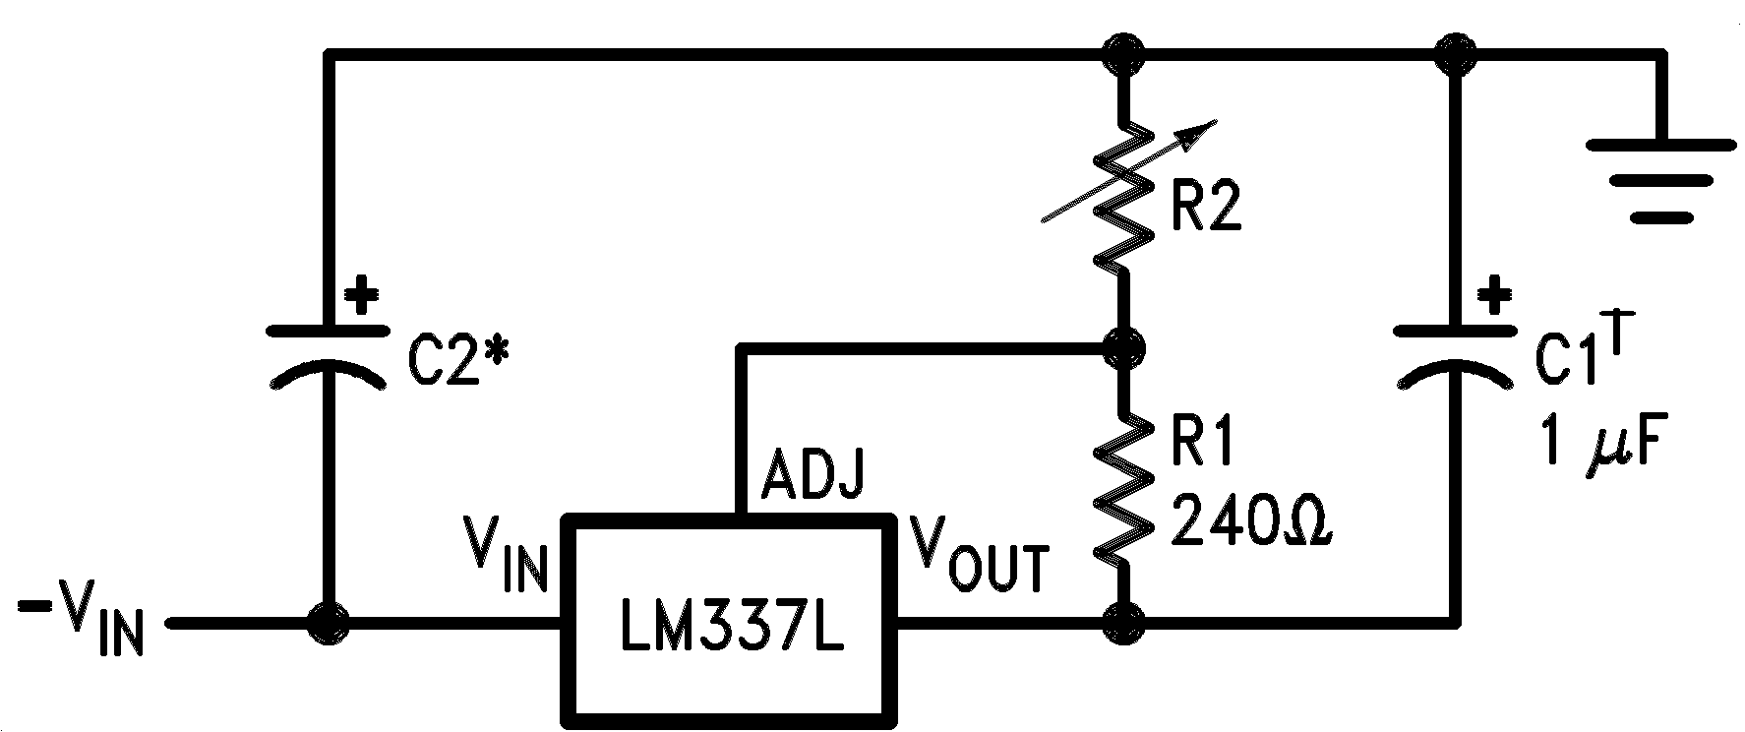

Full output current not available at high input-output voltages
00913403

Trim Procedure:

00913404

†C1 = 1µF solid tantalum or 10µF aluminum electrolytic required for stability
*C2 = 1µF solid tantalum is required only if regulator is more than 4" from power supply filter capacitor
— If VOUT is −23.08V or bigger, cut out R3 (if smaller, don’t cut it out).
— Then if VOUT is −22.47V or bigger, cut out R4 (if smaller, don’t).
— Then if VOUT is −22.16V or bigger, cut out R5 (if smaller, don’t).
This will trim the output to well within 1% of −22.00 VDC, without any of the expense or trouble of a trim pot (see LB-46). Of course, this technique can be used at any output voltage level.

www.national.com 4

Physical Dimensions inches (millimeters)
LM337L
unless otherwise noted

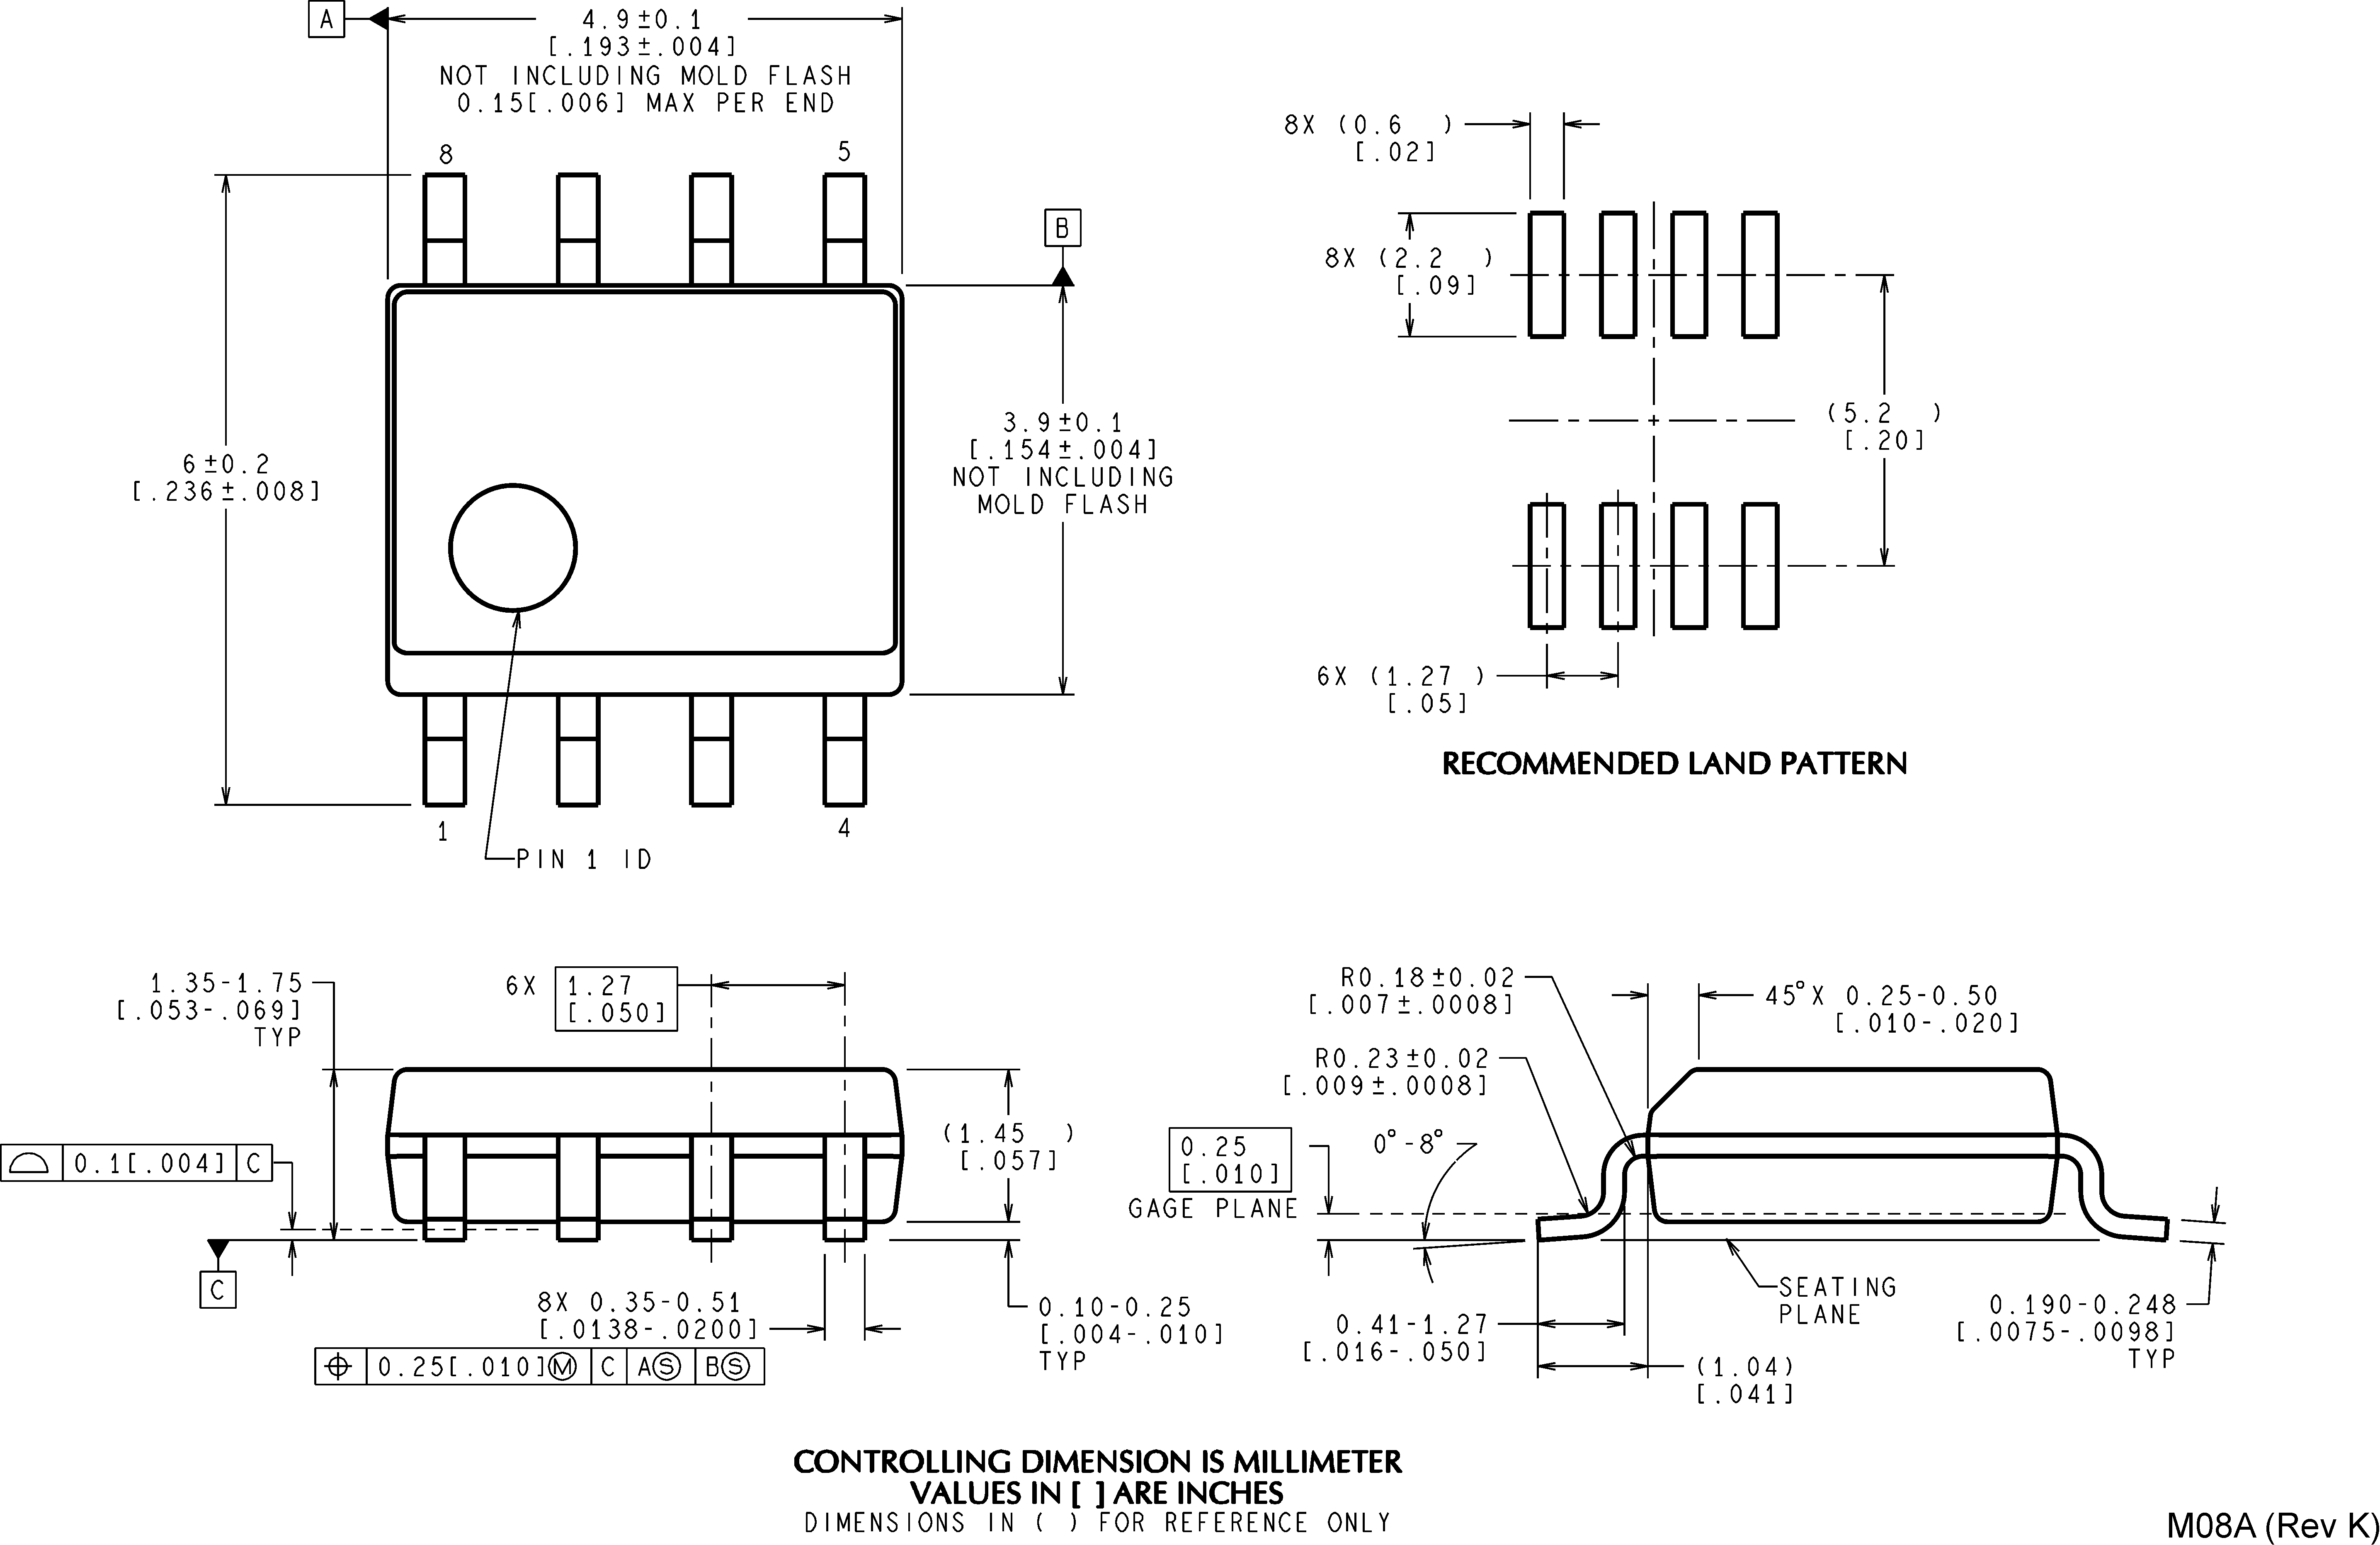

8-Pin SOIC
NS Package Number M08A

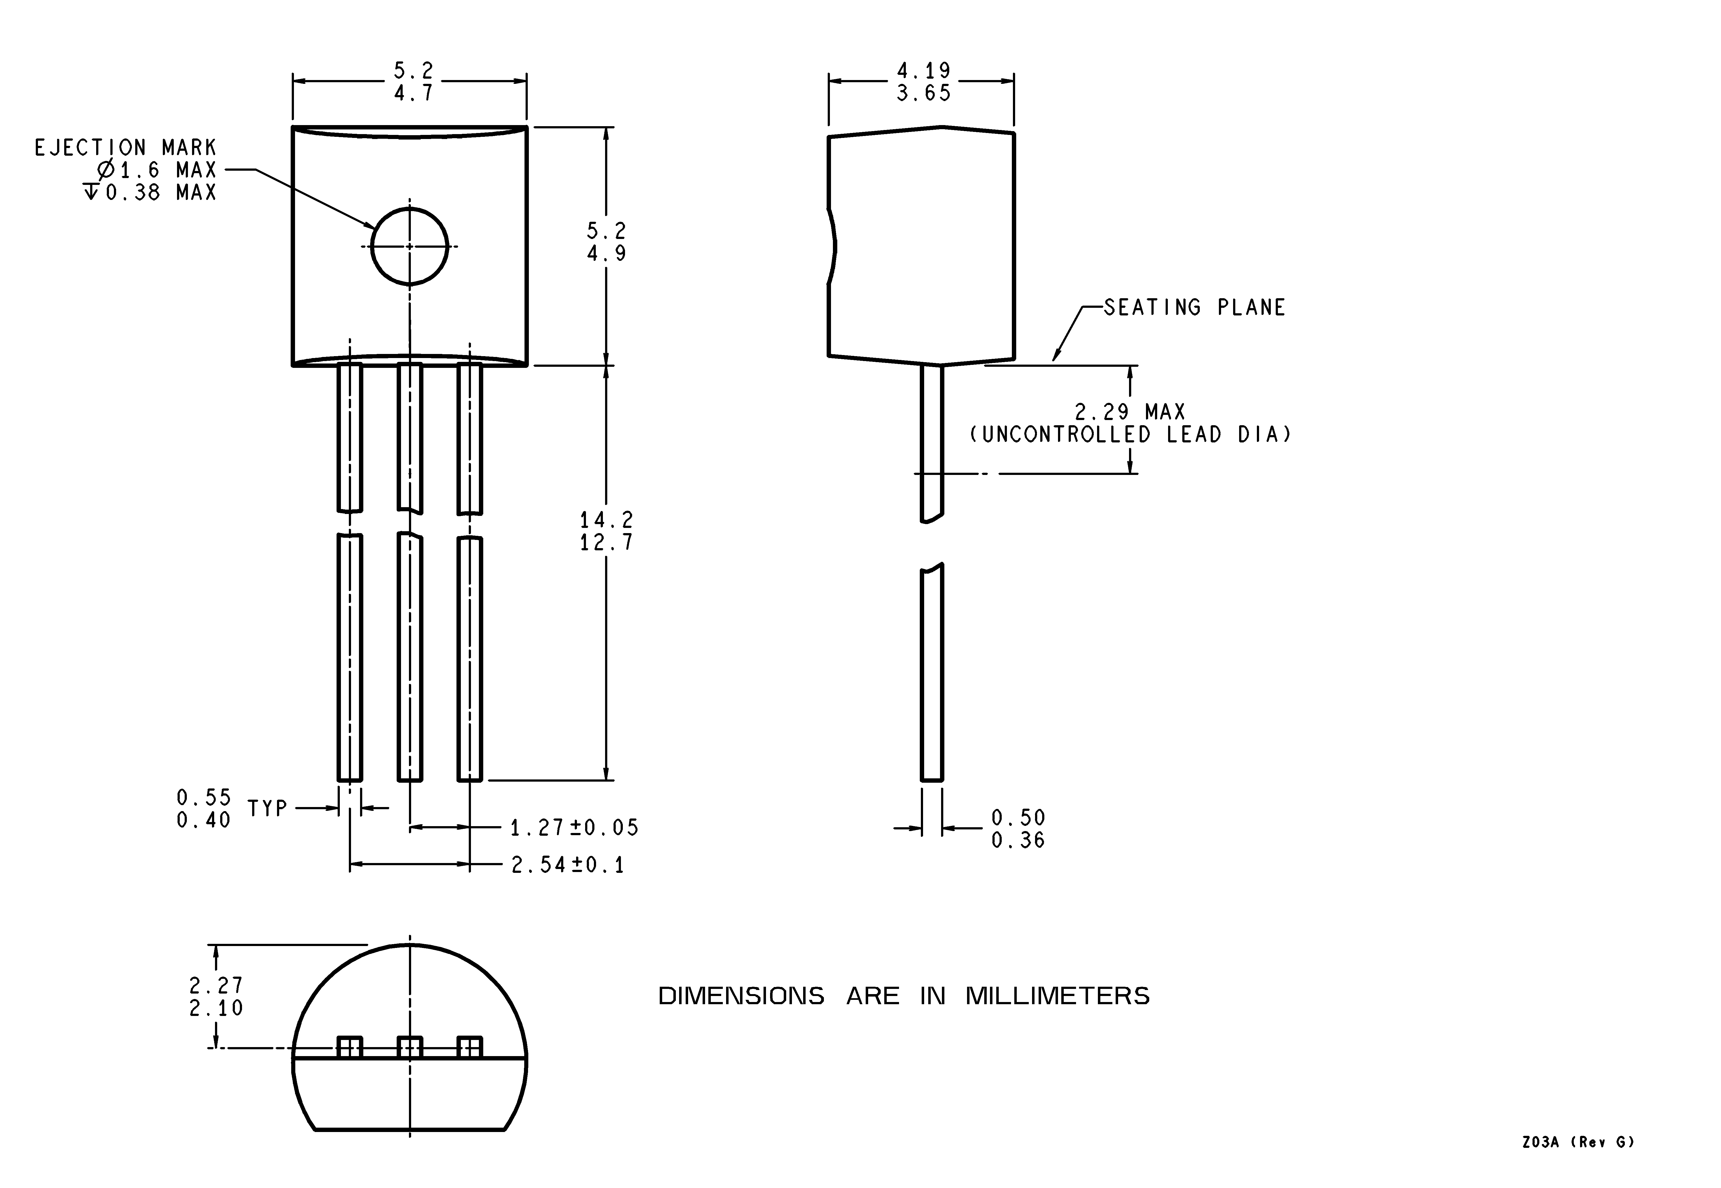

3-Pin TO-92 (Z)
NS Package Number Z03A

5 www.national.com

LM337L 3-Terminal Adjustable Regulator
Physical Dimensions inches (millimeters) unless otherwise noted (Continued)

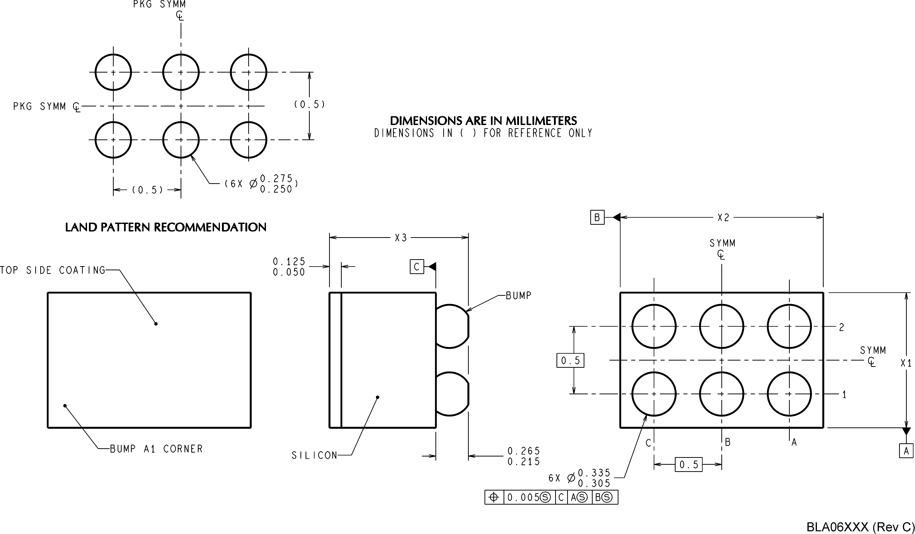

NOTES: UNLESS OTHERWISE SPECIFIED
1. EPOXY COATING.
2. 63Sn/37Pb EUTECTIC BUMP.
3. RECOMMEND NON-SOLDER MASK DEFINED LANDING PAD.
4. PIN A1 IS ESTABLISHED BY LOWER LEFT CORNER WITH RESPECT TO TEXT ORIENTATION. REMAINING PINS ARE NUMBERED COUNTERCLOCKWISE.
5. XXX IN DRAWING NUMBER REPRESENTS PACKAGE SIZE VARIATION WHERE X1 IS PACKAGE WIDTH. X2 IS PACKAGE LENGTH AND X3 IS PACKAGE HEIGHT (SEE TABLE, SHEET 2). EXAMPLE: BLA06AFA HAS WIDTH = 1006. LENGTH = 1641, HEIGHT = 795.
6. REFERENCE JEDEC REGISTRATION MO-211, VARIATION BC.
6-Bump micro SMD
NS Package Number BLA06FNB
X1 = 1133µm X2 = 1819µm X3 = 945µm
National does not assume any responsibility for use of any circuitry described, no circuit patent licenses are implied and National reserves the right at any time without notice to change said circuitry and specifications.
For the most current product information visit us at www.national.com.
LIFE SUPPORT POLICY
NATIONAL’S PRODUCTS ARE NOT AUTHORIZED FOR USE AS CRITICAL COMPONENTS IN LIFE SUPPORT DEVICES OR SYSTEMS WITHOUT THE EXPRESS WRITTEN APPROVAL OF THE PRESIDENT AND GENERAL COUNSEL OF NATIONAL SEMICONDUCTOR CORPORATION. As used herein:
1. Life support devices or systems are devices or systems 2. A critical component is any component of a life support which, (a) are intended for surgical implant into the body, or device or system whose failure to perform can be reasonably (b) support or sustain life, and whose failure to perform when expected to cause the failure of the life support device or properly used in accordance with instructions for use system, or to affect its safety or effectiveness.
provided in the labeling, can be reasonably expected to result in a significant injury to the user.
BANNED SUBSTANCE COMPLIANCE
National Semiconductor manufactures products and uses packing materials that meet the provisions of the Customer Products Stewardship Specification (CSP-9-111C2) and the Banned Substances and Materials of Interest Specification (CSP-9-111S2) and contain no ‘‘Banned Substances’’ as defined in CSP-9-111S2.
Leadfree products are RoHS compliant.
National Semiconductor National Semiconductor National Semiconductor National Semiconductor Americas Customer Europe Customer Support Center Asia Pacific Customer Japan Customer Support Center Support Center Fax: +49 (0) 180-530 85 86 Support Center Fax: 81-3-5639-7507
Email: new.feedback@nsc.com Email: europe.support@nsc.com Email: ap.support@nsc.com Email: jpn.feedback@nsc.com
Tel: 1-800-272-9959 Deutsch Tel: +49 (0) 69 9508 6208
English Tel: +44 (0) 870 24 0 2171
Français Tel: +33 (0) 1 41 91 8790

www.national.com
Tel: 81-3-5639-7560
LM337L 3-Terminal Adjustable Regulator

