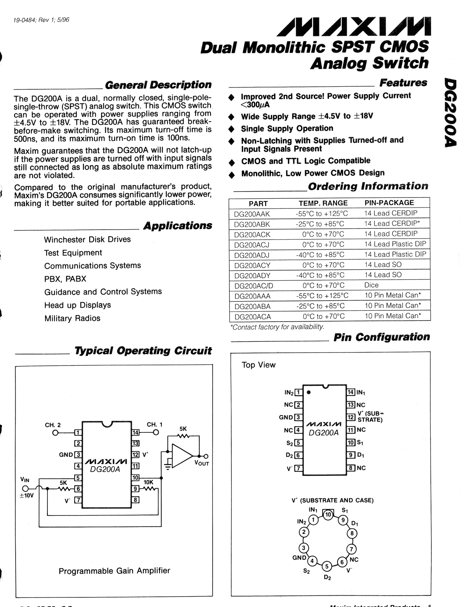
Maxim Integrated Products 1

For pricing, delivery, and ordering information, please contact Maxim/Dallas Direct! at
1-888-629-4642, or visit Maxim’s website at www.maxim-ic.com.

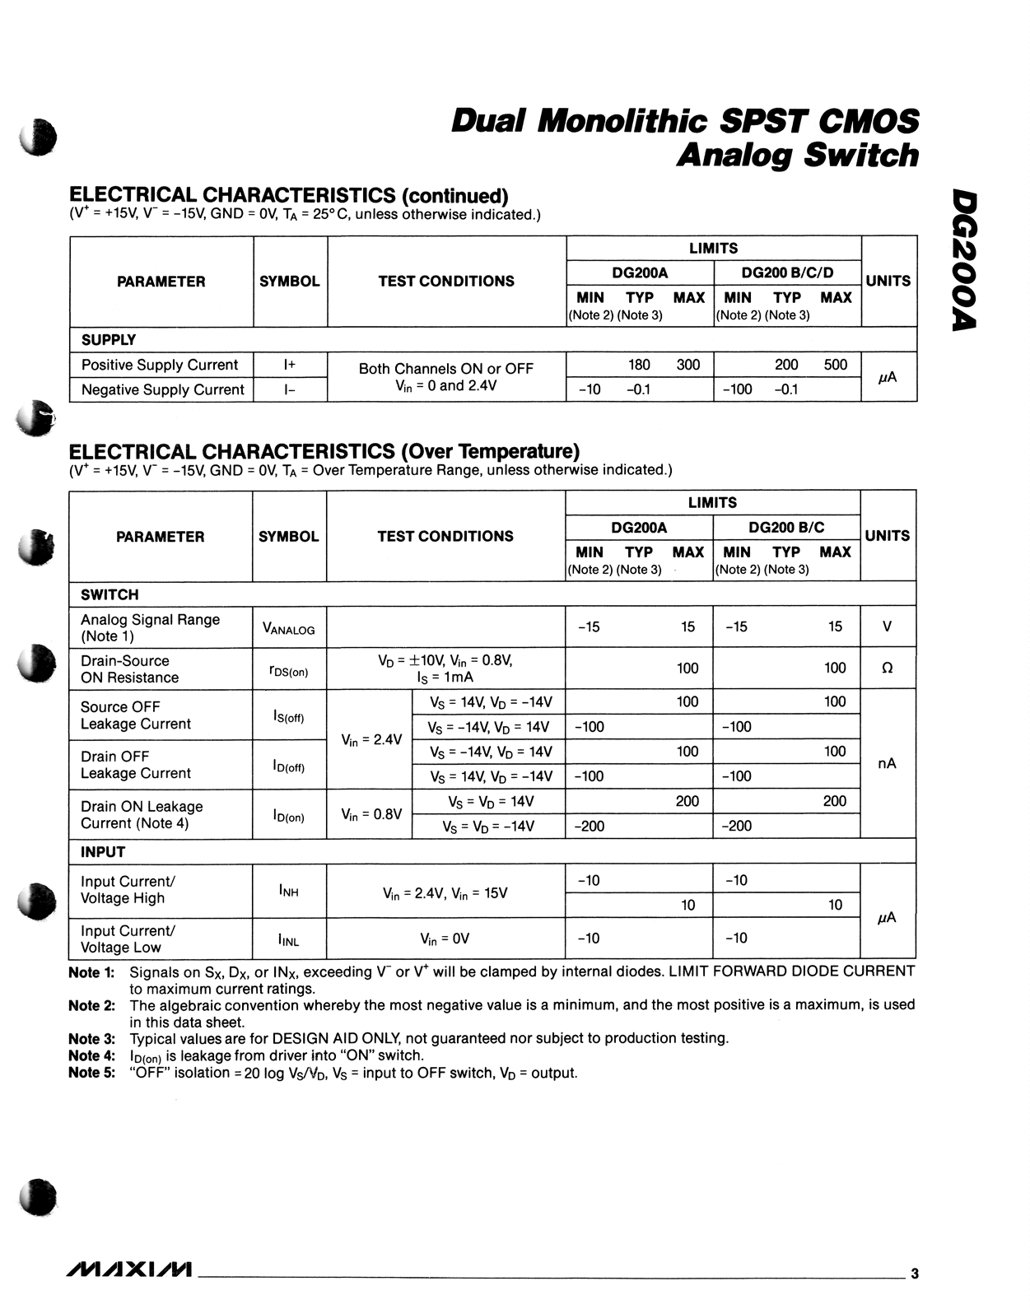

Package Information (The package drawing(s) in this data sheet may not reflect the most current specifications. For the latest package outline information go to www.maxim-ic.com/packages.)

