DS1973
4Kb EEPROM iButton®

SPECIAL FEATURES
ƒ 4096 bits Electrically Erasable Programmable
Read Only Memory (EEPROM)
ƒ Overdrive mode boosts communication speed
to 142kbps
ƒ 256-bit scratchpad ensures integrity of data
transfer
ƒ Memory partitioned into 256-bit pages for
packetizing data
ƒ Reduces control, address, data and power to a
single data pin
ƒ 8-bit family code specifies DS1973
communication requirements to reader
ƒ Reads and writes over a wide voltage range of
2.8V to 6.0V from -40°C to +85°C

F3 MicroCan

F5 MicroCan

iButton and 1-Wire are registered trademarks of Dallas Semiconductor.
COMMON iButton FEATURES
ƒ Unique, factory-lasered and tested 64-bit
registration number (8-bit family code +
48-bit serial number + 8-bit CRC tester) assures absolute identity because no two parts are alike
ƒ Multidrop controller for MicroLAN
ƒ Digital identification and information by
momentary contact
ƒ Chip-based data carrier compactly stores
information
ƒ Data can be accessed while affixed to object
ƒ Economically communicates to bus master
with a single digital signal at 16.3kbps
ƒ Standard 16mm diameter and 1-Wire®
protocol ensure compatibility with iButton family
ƒ Button shape is self-aligning with cup-
shaped probes
ƒ Durable stainless steel case engraved with
registration number withstands harsh environments
ƒ Easily affixed with self-stick adhesive
backing, latched by its flange, or locked with a ring pressed onto its rim
ƒ Presence detector acknowledges when reader
first applies voltage
ƒ Designed to meet UL#913 (4th Edit.);
Intrinsically Safe Apparatus, Under Entity Concept for use in Class I, Division 1, Group A, B, C and D Locations , contact Dallas Semiconductor for certification schedule

ORDERING INFORMATION DS1973-F3 F3 MicroCan DS1973-F5 F5 MicroCan

EXAMPLES OF ACCESSORIES DS9096P Self-Stick Adhesive Pad DS9101 Multi-Purpose Clip DS9093RA Mounting Lock Ring DS9093A Snap-In Fob
DS9092 iButton Probe

1 of 3 REV: 071508

iButton DESCRIPTION
The DS1973 4Kb EEPROM iButton is a rugged read/write data carrier that identifies and stores relevant information about the product or person to which it is attached. This information can be accessed with minimal hardware, for example a single port pin of a micro-controller. The DS1973 consists of a factory- lasered registration number that includes a unique 48-bit serial number, an 8-bit CRC, and an 8-bit Family Code (23H) plus 4096 bits of EEPROM. The power to program and read the DS1973 is derived entirely from the 1-Wire communication line. The memory is organized as sixteen pages of 256 bits each. The 64-bit registration number provides a guaranteed unique identity which allows for absolute traceability. Data is transferred serially via the 1-Wire protocol which requires only a single data lead and a ground return. The durable MicroCan package is highly resistant to harsh environments such as dirt, moisture, and shock. Its compact button-shaped profile is self-aligning with cup-shaped receptacles, allowing the DS1973 to be used easily by human operators or automatic equipment. Accessories permit the DS1973 to be mounted on printed circuit boards, plastic key fobs, photo-ID badges, ID bracelets, and many other objects. Applications include work-in-progress tracking, electronic travelers, access control and storage of calibration constants.

OVERVIEW
The block diagram in Figure 1 shows the relationships between the major control and memory sections of the DS1973. The DS1973 has three main data components: 1) 64-bit lasered ROM, 2) 256-bit scratchpad, and 3) 4096-bit EEPROM. The bus master must first provide one of the ROM function commands before the memory functions become accessible. All data is read and written least significant bit first.

The DS1973 contains the same memory chip as the DS2433. For a full description of the logical behavior, please refer to the DS2433 data sheet.

DS1973 BLOCK DIAGRAM Figure 1

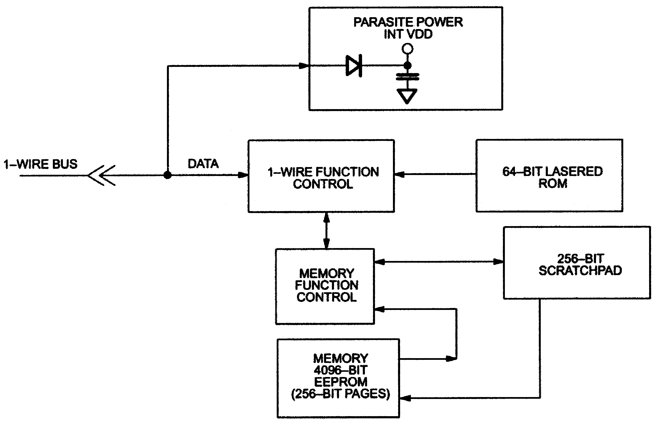

2 of 3
REVISION HISTORY
REVISION DATE | DESCRIPTION | PAGES CHANGED
071508 | Updated the F3 MicroCan and F5 MicroCan face brands with the latest  per PCN H020201. | 1

3 of 3

Maxim/Dallas Semiconductor cannot assume responsibility for use of any circuitry other than circuitry entirely embodied in a Maxim/Dallas Semiconductor product. No circuit patent licenses are implied. Maxim/Dallas Semiconductor reserves the right to change the circuitry and specifications without notice at any time.
M a x i m In tegra t ed P r oduc ts , 1 2 0 S a n Ga brie l D r iv e , Sun ny vale , CA 94 086 40 8 - 7 3 7 - 76 00
© 2008 Maxim Integrated Products
The Maxim logo is a registered trademark of Maxim Integrated Products, Inc. The Dallas logo is a registered trademark of Dallas Semiconductor Corporation.

