January 2005
ADC121S101/ADC101S101/ADC081S101 1MSPS, 12-/10-/8-Bit A/D Converters in SOT-23 & LLP

ADC121S101/ADC101S101/ADC081S101
1MSPS, 12-/10-/8-Bit A/D Converters in SOT-23 & LLP

General Description
The ADC121S101, ADC101S101, and ADC081S101 are low power, monolithic CMOS 12-, 10- and 8-bit analog-to-digital converters that operate at 1 MSPS. Each device is based on a successive approximation register architecture with inter- nal track-and-hold. The serial interface is compatible with several standards, such as SPI™, QSPI™, MICROWIRE™, and many common DSP serial interfaces.
The ADC121S101/101S101/081S101 uses the supply volt- age as a reference. This enables the devices to operate with a full-scale input range of 0 to VDD. The conversion rate is determined from the serial clock (SCLK) speed. These con- verters offer a shutdown mode, which can be used to trade throughput for power consumption. The ADC121S101/
101S101/081S101 are operated with a single supply that can range from +2.7V to +5.25V. Normal power consumption during continuous conversion, using a +3V or +5V supply, is
2 mW or 10 mW, respectively. The power down feature, which is enabled by a chip select (CS) pin, reduces the power consumption to under 5 µW using a +5V supply. All three converters are available in a 6-lead SOT-23 package, which provides an extremely small footprint for applications where space is a critical consideration. The ADC081S101 is also available in a 6-lead LLP package. These products are designed for operation over the industrial temperature range of −40˚C to +85˚C, with some parameters specified to
+125˚C for the ADC121S101.
Features
n Variable power management
n Packaged in 6-lead SOT-23 (ADC081S101 also available in a 6-Lead LLP package)
n Power supply used as reference
n Single +2.7V to +5.25V supply operation
n SPI™/QSPI™/MICROWIRE™/DSP compatible

Key Specifications
n Resolution with no Missing Codes 12/10/8 bits n Conversion Rate 1 MSPS n DNL (ADC121S101) +0.5, -0.3 LSB (typ) n INL (ADC121S101) ± 0.4 LSB (typ) n Power Consumption
— 3V Supply 2 mW (typ)
— 5V Supply 10 mW (typ)

Applications
n Automotive Navigation
n FA/ATM Equipment
n Portable Systems
n Medical Instruments
n Mobile Communications
n Instrumentation and Control Systems

Connection Diagram

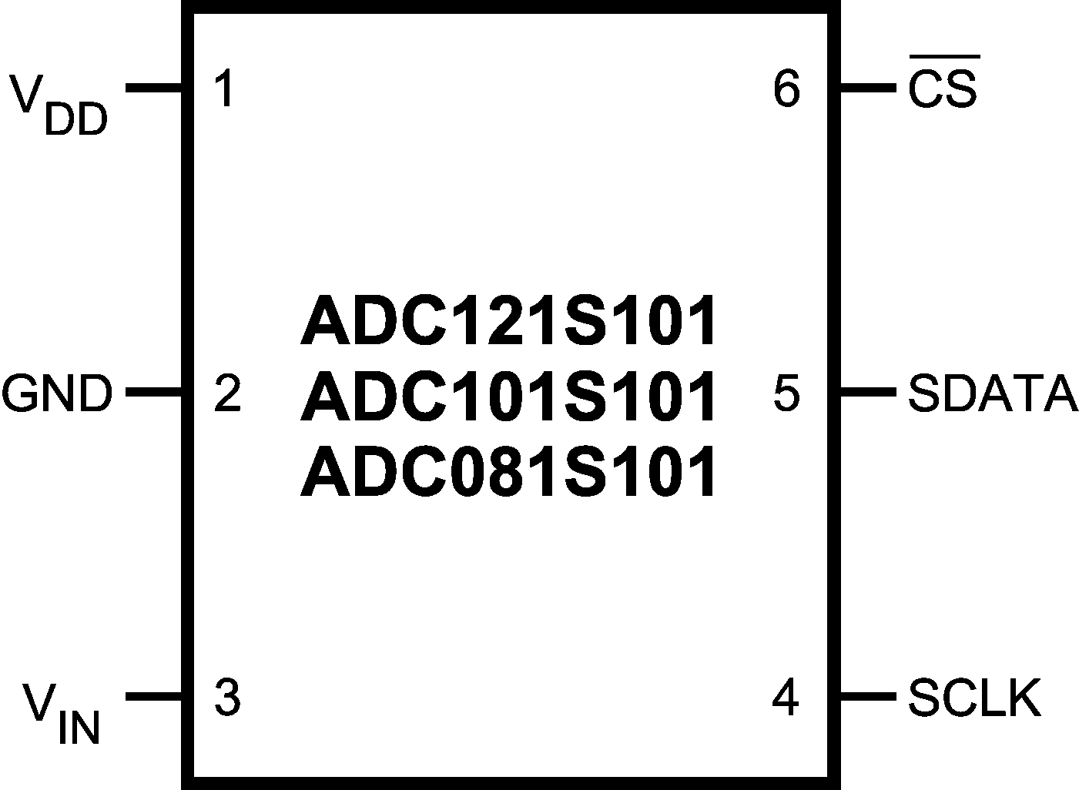
20110201

MICROWIRE™ is a trademark of National Semiconductor Corporation. TRI-STATE® is a trademark of National Semiconductor Corporation. QSPI™ and SPI™ are trademarks of Motorola, Inc.

© 2005 National Semiconductor Corporation DS201102 www.national.com

Ordering Information

Pin Descriptions
Pin No. | Symbol | Description
ANALOG I/O
3 | VIN | Analog input. This signal can range from 0V to VDD.
DIGITAL I/O
4 | SCLK | Digital clock input. The range of frequencies for this input is 10 kHz to 20 MHz, with guaranteed performance at 20 MHz. This clock directly controls the conversion and readout processes.
5 | SDATA | Digital data output. The output words are clocked out of this pin by the SCLK pin.
6 | CS | Chip select. A conversion process begins on the falling edge of CS.
POWER SUPPLY
1 | VDD | Positive supply pin. These pins should be connected to a quiet +2.7V to +5.25V source and bypassed to GND with 0.1 µF and 1 µF monolithic capacitors located within 1 cm of the power pin. The ADC121S101/101S101/081S101 uses this power supply as a reference, so it should be thoroughly bypassed.
2 | GND | The ground return for the supply.
Block Diagram

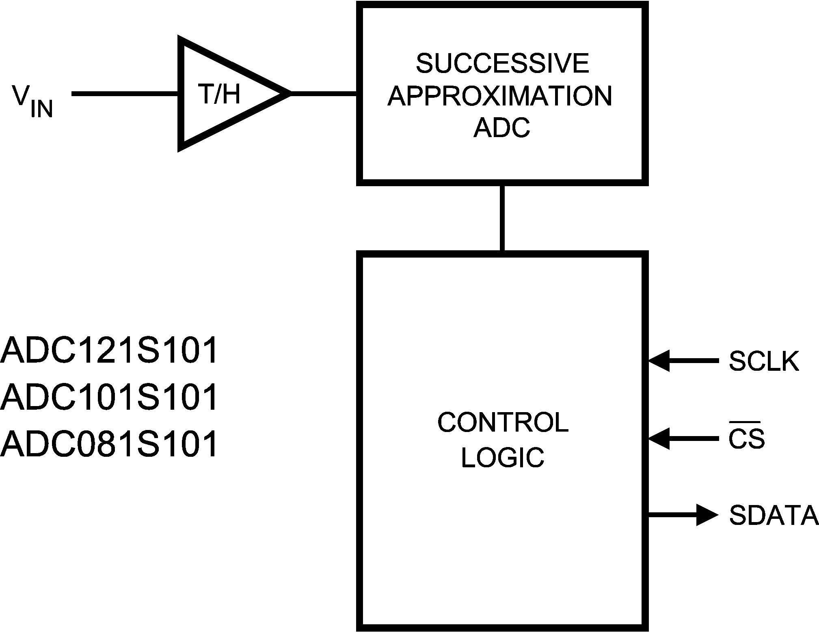
20110218

www.national.com 2
ADC121S101/ADC101S101/ADC081S101
Order Code | Temperature  Range | Description | Top Mark
ADC121S101CIMF | −40˚C to  +125˚C | 6-Lead SOT-23 Package | X01C
ADC101S101CIMF | −40˚C to +85˚C | 6-Lead SOT-23 Package | X02C
ADC081S101CIMF | −40˚C to +85˚C | 6-Lead SOT-23 Package | X03C
ADC121S101CIMFX | −40˚C to  +125˚C | 6-Lead SOT-23 Package, Tape & Reel | X01C
ADC101S101CIMFX | −40˚C to +85˚C | 6-Lead SOT-23 Package, Tape & Reel | X02C
ADC081S101CIMFX | −40˚C to +85˚C | 6-Lead SOT-23 Package, Tape & Reel | X03C
ADC081S101CISDX | −40˚C to +85˚C | 6-Lead LLP Package, Tape & Reel | X3C
ADC081S101CISD | −40˚C to +85˚C | 6-Lead LLP Package, Tape & Partial Reel | X3C
ADC121S101EVAL |  | SOT-23 Evaluation Board
ADC101S101EVAL |  | SOT-23 Evaluation Board
ADC081S101EVAL |  | SOT-23 Evaluation Board

Absolute Maximum Ratings Operating Ratings (Note 2) (Notes 1, 2) Operating Temperature Range
If Military/Aerospace specified devices are required, ADC121S101 −40˚C ≤ TA ≤ +125˚C
please contact the National Semiconductor Sales Office/ ADC101S101 & ADC081S101 −40˚C ≤ TA ≤ +85˚C
Distributors for availability and specifications. V Supply Voltage +2.7V to +5.25V
DD
Supply Voltage VDD −0.3V to +6.5V Digital Input Pins Voltage Range
Voltage on Any Analog Pin to GND −0.3V to VDD +0.3V (Note 6) +2.7V to +5.25V Voltage on Any Digital Pin to GND -0.3V to 6.5V
Input Current at Any Pin (Note 5) ±10 mA Package Thermal Resistance
ESD Susceptibility
Human Body Model 3500V Machine Model 200V Soldering Temperature, Infrared,
10 seconds 215˚C
Junction Temperature +150˚C Storage Temperature −65˚C to +150˚C Soldering process must comply with National Semiconductor’s Reflow Temperature Profile
specifications. Refer to www.national.com/packaging.
(Note 4)

ADC121S101 Converter Electrical Characteristics
The following specifications apply for VDD = +2.7V to 5.25V, fSCLK = 20 MHz, fSAMPLE = 1 MSPS unless otherwise noted. Bold- face limits apply for TA = −40˚C to +85˚C: all other limits TA = 25˚C, unless otherwise noted.
Symbol | Parameter | Conditions | Typical | Limits | Units
STATIC CONVERTER CHARACTERISTICS (VDD = 2.7V to 3.6V)
 | Resolution with No Missing Codes | −40˚C ≤ TA ≤ 125˚C |  | 12 | Bits
INL | Integral Non-Linearity | −40˚C ≤ TA ≤ 85˚C | ±0.4 | ±1 | LSB (max)
INL | Integral Non-Linearity | TA = 125˚C |  | +1  -1.1 | LSB (min) LSB (max)
DNL | Differential Non-Linearity | −40˚C ≤ TA ≤ 85˚C | +0.5  -0.3 | +1  -0.9 | LSB (max) LSB (min)
DNL | Differential Non-Linearity | TA = 125˚C |  | ±1 | LSB (max)
VOFF | Offset Error | −40˚C ≤ TA ≤ 125˚C | ±0.1 | ±1.2 | LSB (max)
GE | Gain Error | −40˚C ≤ TA ≤ 125˚C | ±0.2 | ±1.2 | LSB (max)
DYNAMIC CONVERTER CHARACTERISTICS (fIN = 100 kHz, -0.02 dBFS sine wave unless otherwise noted)
SINAD | Signal-to-Noise Plus Distortion Ratio | −40˚C ≤ TA ≤ 125˚C | 72 | 70 | dB (min)
SNR | Signal-to-Noise Ratio | −40˚C ≤ TA ≤ 85˚C | 72.5 | 70.8 | dB (min)
SNR | Signal-to-Noise Ratio | TA = 125˚C |  | 70.6 | dB (min)
THD | Total Harmonic Distortion |  | -80 |  | dB
SFDR | Spurious-Free Dynamic Range |  | 82 |  | dB
IMD | Intermodulation Distortion, Second  Order Terms | fa = 103.5 kHz, fb = 113.5 kHz | -78 |  | dB
IMD | Intermodulation Distortion, Third  Order Terms | fa = 103.5 kHz, fb = 113.5 kHz | -78 |  | dB
FPBW | -3 dB Full Power Bandwidth | +5V Supply | 11 |  | MHz
FPBW | -3 dB Full Power Bandwidth | +3V Supply | 8 |  | MHz
POWER SUPPLY CHARACTERISTICS
VDD | Supply Voltage | −40˚C ≤ TA ≤ 125˚C |  | 2.7  5.25 | V (min)  V (max)

3 www.national.com
ADC121S101/ADC101S101/ADC081S101
Package | θJA
6-Lead SOT-23 | 265˚C / W
6-Lead LLP | 94˚C / W

ADC121S101 Converter Electrical Characteristics (Continued)
The following specifications apply for VDD = +2.7V to 5.25V, fSCLK = 20 MHz, fSAMPLE = 1 MSPS unless otherwise noted. Bold- face limits apply for TA = −40˚C to +85˚C: all other limits TA = 25˚C, unless otherwise noted.
Symbol | Parameter | Conditions | Typical | Limits | Units
POWER SUPPLY CHARACTERISTICS
IDD | Normal Mode (Static) | VDD = +4.75V to +5.25V, SCLK On or Off | 2 |  | mA
IDD | Normal Mode (Static) | VDD = +2.7V to +3.6V, SCLK On or Off | 1 |  | mA
IDD | Normal Mode (Operational) | VDD = +4.75V to +5.25V, fSAMPLE = 1 MSPS | 2.0 | 3.2 | mA (max)
IDD | Normal Mode (Operational) | VDD = +2.7V to +3.6V, fSAMPLE = 1 MSPS | 0.6 | 1.5 | mA (max)
IDD | Shutdown Mode | VDD = +5V, SCLK Off | 0.5 |  | µA
IDD | Shutdown Mode | VDD = +5V, SCLK On | 60 |  | µA
PD | Power Consumption, Normal Mode  (Operational) | VDD = +5V, fSAMPLE = 1 MSPS | 10 | 16 | mW (max)
PD | Power Consumption, Normal Mode  (Operational) | VDD = +3V, fSAMPLE = 1 MSPS | 2 | 4.5 | mW (max)
PD | Power Consumption, Shutdown Mode | VDD = +5V, SCLK Off | 2.5 |  | µW
PD | Power Consumption, Shutdown Mode | VDD = +3V, SCLK Off | 1.5 |  | µW
ANALOG INPUT CHARACTERISTICS
VIN | Input Range |  | 0 to VDD |  | V
IDCL | DC Leakage Current |  |  | ±1 | µA (max)
CINA | Input Capacitance (Note 3) |  | 30 |  | pF
DIGITAL INPUT CHARACTERISTICS
VIH | Input High Voltage |  |  | 2.4 | V (min)
VIL | Input Low Voltage | VDD = +5V |  | 0.8 | V (max)
VIL | Input Low Voltage | VDD = +3V |  | 0.4 | V (max)
IIN | Input Current | VIN = 0V or VDD | ±10 nA | ±1 | µA (max)
CIND | Input Capacitance (Note 3) |  | 2 | 4 | pF (max)
DIGITAL OUTPUT CHARACTERISTICS
VOH | Output High Voltage | ISOURCE = 200 µA,  VDD = +2.7V to +5.25V |  | VDD −0.2 | V (min)
VOL | Output Low Voltage | ISINK = 200 µA |  | 0.4 | V (max)
IOL | TRI-STATE Leakage Current |  |  | ±10 | µA (max)
COUT | TRI-STATE Output Capacitance |  | 2 | 4 | pF (max)
 | Output Coding |  | Straight (Natural) Binary
AC ELECTRICAL CHARACTERISTICS
fSCLK | Clock Frequency |  |  | 20 | MHz (max)
DC | SCLK Duty Cycle |  |  | 40  60 | % (min)  % (max)
tTH | Track/Hold Acquisition Time |  |  | 400 | ns (max)
fRATE | Throughput Rate | See Serial Interface Section |  | 1 | MSPS (max)
tAD | Aperture Delay |  | 3 |  | ns
tAJ | Aperture Jitter |  | 30 |  | ps

www.national.com 4
ADC121S101/ADC101S101/ADC081S101

ADC101S101 Converter Electrical Characteristics
The following specifications apply for VDD = +2.7V to 5.25V, fSCLK = 20 MHz, fSAMPLE = 1 MSPS unless otherwise noted. Bold- face limits apply for TA = −40˚C to +85˚C: all other limits TA = 25˚C, unless otherwise noted.
Symbol | Parameter | Conditions | Typical | Limits | Units
STATIC CONVERTER CHARACTERISTICS
 | Resolution with No Missing Codes |  |  | 10 | Bits
INL | Integral Non-Linearity |  | ±0.2 | ±0.7 | LSB (max)
DNL | Differential Non-Linearity |  | +0.3  -0.2 | ±0.7 | LSB (max) LSB (max)
VOFF | Offset Error |  | ±0.1 | ±0.7 | LSB (max)
GE | Gain Error |  | ±0.2 | ±1 | LSB (max)
DYNAMIC CONVERTER CHARACTERISTICS
SINAD | Signal-to-Noise Plus Distortion Ratio | fIN = 100 kHz | 61.7 | 61 | dBFS (min)
SNR | Signal-to-Noise Ratio | fIN = 100 kHz | 62 |  | dB
THD | Total Harmonic Distortion | fIN = 100 kHz | -77 | -73 | dB (max)
SFDR | Spurious-Free Dynamic Range | fIN = 100 kHz | 78 | 74 | dB (min)
IMD | Intermodulation Distortion, Second  Order Terms | fa = 103.5 kHz, fb = 113.5 kHz | -78 |  | dB
IMD | Intermodulation Distortion, Third  Order Terms | fa = 103.5 kHz, fb = 113.5 kHz | -78 |  | dB
FPBW | -3 dB Full Power Bandwidth | +5V Supply | 11 |  | MHz
FPBW | -3 dB Full Power Bandwidth | +3V Supply | 8 |  | MHz
POWER SUPPLY CHARACTERISTICS
VDD | Supply Voltage |  |  | 2.7  5.25 | V (min) V (max)
IDD | Normal Mode (Static) | VDD = +4.75V to +5.25V, SCLK On or Off | 2 |  | mA
IDD | Normal Mode (Static) | VDD = +2.7V to +3.6V, SCLK On or Off | 1 |  | mA
IDD | Normal Mode (Operational) | VDD = +4.75V to +5.25V, fSAMPLE = 1 MSPS | 2.0 | 3.2 | mA (max)
IDD | Normal Mode (Operational) | VDD = +2.7V to +3.6V, fSAMPLE = 1 MSPS | 0.6 | 1.5 | mA (max)
IDD | Shutdown Mode | VDD = +5V, SCLK Off | 0.5 |  | µA (max)
IDD | Shutdown Mode | VDD = +5V, SCLK On | 60 |  | µA (max)
PD | Power Consumption, Normal Mode  (Operational) | VDD = +5V, fSAMPLE = 1 MSPS | 10 | 16 | mW (max)
PD | Power Consumption, Normal Mode  (Operational) | VDD = +3V, fSAMPLE = 1 MSPS | 2 | 4.5 | mW (max)
PD | Power Consumption, Shutdown Mode | VDD = +5V, SCLK Off | 2.5 |  | µW (max)
PD | Power Consumption, Shutdown Mode | VDD = +3V, SCLK Off | 1.5 |  | µW (max)
ANALOG INPUT CHARACTERISTICS
VIN | Input Range |  | 0 to VDD |  | V
IDCL | DC Leakage Current |  |  | ±1 | µA (max)
CINA | Input Capacitance (Note 3) |  | 30 |  | pF
DIGITAL INPUT CHARACTERISTICS
VIH | Input High Voltage |  |  | 2.4 | V (min)
VIL | Input Low Voltage | VDD = +5V |  | 0.8 | V (max)
VIL | Input Low Voltage | VDD = +3V |  | 0.4 | V (max)
IIN | Input Current | VIN = 0V or VDD | ±10 nA | ±1 | µA (max)
CIND | Input Capacitance (Note 3) |  | 2 | 4 | pF (max)
DIGITAL OUTPUT CHARACTERISTICS
VOH | Output High Voltage | ISOURCE = 200 µA,  VDD = +2.7V to +5.25V |  | VDD −0.2 | V (min)

5 www.national.com
ADC121S101/ADC101S101/ADC081S101

ADC101S101 Converter Electrical Characteristics (Continued)
The following specifications apply for VDD = +2.7V to 5.25V, fSCLK = 20 MHz, fSAMPLE = 1 MSPS unless otherwise noted. Bold- face limits apply for TA = −40˚C to +85˚C: all other limits TA = 25˚C, unless otherwise noted.
Symbol | Parameter | Conditions | Typical | Limits | Units
DIGITAL OUTPUT CHARACTERISTICS
VOL | Output Low Voltage | ISINK = 200 µA |  | 0.4 | V (max)
IOL | TRI-STATE Leakage Current |  |  | ±10 | µA (max)
COUT | TRI-STATE Output Capacitance  (Note 3) |  | 2 | 4 | pF (max)
 | Output Coding |  | Straight (Natural) Binary
AC ELECTRICAL CHARACTERISTICS
fSCLK | Clock Frequency |  |  | 20 | MHz (max)
DC | SCLK Duty Cycle |  |  | 40  60 | % (min)  % (max)
tTH | Track/Hold Acquisition Time |  |  | 400 | ns (max)
fRATE | Throughput Rate | See Serial Interface Section |  | 1 | MSPS (max)
tAD | Aperture Delay |  | 3 |  | ns
tAJ | Aperture Jitter |  | 30 |  | ps

www.national.com 6
ADC121S101/ADC101S101/ADC081S101

ADC081S101 Converter Electrical Characteristics
The following specifications apply for VDD = +2.7V to 5.25V, fSCLK = 20 MHz, fSAMPLE = 1 MSPS unless otherwise noted. Bold- face limits apply for TA = −40˚C to +85˚C: all other limits TA = 25˚C, unless otherwise noted.
Symbol | Parameter | Conditions |  | Typical | Limits | Units
STATIC CONVERTER CHARACTERISTICS
 | Resolution with No Missing Codes |  |  |  | 8 | Bits
INL | Integral Non-Linearity |  |  | ±0.05 | ±0.3 | LSB (max)
DNL | Differential Non-Linearity |  |  | ±0.07 | ±0.3 | LSB (max)
VOFF | Offset Error |  |  | ±0.03 | ±0.3 | LSB (max)
GE | Gain Error |  |  | ±0.08 | ±0.4 | LSB (max)
 | Total Unadjusted Error |  |  | ±0.07 | ±0.3 | LSB (max)
DYNAMIC CONVERTER CHARACTERISTICS
SINAD | Signal-to-Noise Plus Distortion Ratio | fIN = 100 kHz |  | 49.7 | 49 | dB (min)
SNR | Signal-to-Noise Ratio | fIN = 100 kHz |  | 49.7 |  | dB
THD | Total Harmonic Distortion | fIN = 100 kHz |  | -77 | -65 | dB (max)
SFDR | Spurious-Free Dynamic Range | fIN = 100 kHz |  | 69 | 65 | dB (min)
IMD | Intermodulation Distortion, Second  Order Terms | fa = 103.5 kHz, fb = 113.5 kHz |  | -68 |  | dB
IMD | Intermodulation Distortion, Third  Order Terms | fa = 103.5 kHz, fb = 113.5 kHz |  | -68 |  | dB
FPBW | -3 dB Full Power Bandwidth | +5V Supply |  | 11 |  | MHz
FPBW | -3 dB Full Power Bandwidth | +3V Supply |  | 8 |  | MHz
POWER SUPPLY CHARACTERISTICS
VDD | Supply Voltage |  |  |  | 2.7  5.25 | V (min) V (max)
IDD | Normal Mode (Static) | VDD = +4.75V to +5.25V, SCLK On or Off |  | 2 |  | mA
IDD | Normal Mode (Static) | VDD = +2.7V to +3.6V, SCLK On or Off |  | 1 |  | mA
IDD | Normal Mode (Operational) | VDD = +4.75V to +5.25V, fSAMPLE = 1 MSPS | SOT-23 | 2.0 | 3.2 | mA (max)
IDD | Normal Mode (Operational) | VDD = +4.75V to +5.25V, fSAMPLE = 1 MSPS | LLP | 2.0 | 2.6 | mA (max)
IDD | Normal Mode (Operational) | VDD = +2.7V to +3.6V, fSAMPLE = 1 MSPS | SOT-23 | 0.6 | 1.5 | mA (max)
IDD | Normal Mode (Operational) | VDD = +2.7V to +3.6V, fSAMPLE = 1 MSPS | LLP | 0.6 | 1.1 | mA (max)
IDD | Shutdown Mode | VDD = +5V, SCLK Off |  | 0.5 |  | µA (max)
IDD | Shutdown Mode | VDD = +5V, SCLK On |  | 60 |  | µA (max)
PD | Power Consumption, Normal Mode  (Operational) | VDD = +5V, fSAMPLE = 1  MSPS | SOT-23 | 10 | 16 | mW (max)
PD | Power Consumption, Normal Mode  (Operational) | VDD = +5V, fSAMPLE = 1  MSPS | LLP | 10 | 13 | mW (max)
PD | Power Consumption, Normal Mode  (Operational) | VDD = +3V, fSAMPLE = 1 MSPS |  | 2 | 4.5 | mW (max)
PD | Power Consumption, Shutdown Mode | VDD = +5V, SCLK Off |  | 2.5 |  | µW (max)
PD | Power Consumption, Shutdown Mode | VDD = +3V, SCLK Off |  | 1.5 |  | µW (max)
ANALOG INPUT CHARACTERISTICS
VIN | Input Range |  |  | 0 to VDD |  | V
IDCL | DC Leakage Current |  |  |  | ±1 | µA (max)
CINA | Input Capacitance |  |  | 30 |  | pF
DIGITAL INPUT CHARACTERISTICS
VIH | Input High Voltage |  |  |  | 2.4 | V (min)
VIL | Input Low Voltage | VDD = +5V |  |  | 0.8 | V (max)
VIL | Input Low Voltage | VDD = +3V |  |  | 0.4 | V (max)
IIN | Digital Input Current | VIN = 0V or VDD |  | ±10 nA | ±1 | µA (max)
CIND | Input Capacitance(Note 3) |  |  | 2 | 4 | pF (max)

7 www.national.com
ADC121S101/ADC101S101/ADC081S101

ADC081S101 Converter Electrical Characteristics (Continued)
The following specifications apply for VDD = +2.7V to 5.25V, fSCLK = 20 MHz, fSAMPLE = 1 MSPS unless otherwise noted. Bold- face limits apply for TA = −40˚C to +85˚C: all other limits TA = 25˚C, unless otherwise noted.
Symbol | Parameter | Conditions | Typical | Limits | Units
DIGITAL OUTPUT CHARACTERISTICS
VOH | Output High Voltage | ISOURCE = 200 µA,  VDD = +2.7V to +5.25V |  | VDD − 0.2 | V (min)
VOL | Output Low Voltage | ISINK = 200 µA |  | 0.4 | V (max)
IOL | TRI-STATE Leakage Current |  |  | ±10 | µA (max)
COUT | TRI-STATE Output Capacitance  (Note 3) |  | 2 | 4 | pF (max)
 | Output Coding |  | Straight (Natural) Binary
AC ELECTRICAL CHARACTERISTICS
fSCLK | Clock Frequency |  |  | 20 | MHz (max)
DC | SCLK Duty Cycle |  |  | 40  60 | % (min)  % (max)
tTH | Track/Hold Acquisition Time |  |  | 400 | ns (max)
fRATE | Throughput Rate | See Applications Section |  | 1 | MSPS (min)
tAD | Aperture Delay |  | 3 |  | ns
tAJ | Aperture Jitter |  | 30 |  | ps

www.national.com 8
ADC121S101/ADC101S101/ADC081S101

ADC121S101/ADC101S101/ADC081S101 Timing Specifications
The following specifications apply for VDD = +2.7V to 5.25V, fSCLK = 20 MHz, Boldface limits apply for TA = −40˚C to +85˚C:
all other limits TA = 25˚C, unless otherwise noted. (Note 11)
Symbol | Parameter | Conditions | Typical | Limits | Units
tCONVERT |  |  | 16 x tSCLK
tQUIET | (Note 7) |  |  | 50 | ns (min)
t1 | Minimum CS Pulse Width |  |  | 10 | ns (min)
t2 | CS to SCLK Setup Time |  |  | 10 | ns (min)
t3 | Delay from CS Until SDATA TRI-STATE® Disabled (Note 8) |  |  | 20 | ns (max)
t4 | Data Access Time after SCLK Falling  Edge(Note 9) | VDD = +2.7 to +3.6 |  | 40 | ns (max)
t4 | Data Access Time after SCLK Falling  Edge(Note 9) | VDD = +4.75 to +5.25 |  | 20 | ns (max)
t5 | SCLK Low Pulse Width |  |  | 0.4 x  tSCLK | ns (min)
t6 | SCLK High Pulse Width |  |  | 0.4 x  tSCLK | ns (min)
t7 | SCLK to Data Valid Hold Time | VDD = +2.7 to +3.6 |  | 7 | ns (min)
t7 | SCLK to Data Valid Hold Time | VDD = +4.75 to +5.25 |  | 5 | ns (min)
t8 | SCLK Falling Edge to SDATA High  Impedance (Note 10) | VDD = +2.7 to +3.6 |  | 25  6 | ns (max)  ns (min)
t8 | SCLK Falling Edge to SDATA High  Impedance (Note 10) | VDD = +4.75 to +5.25 |  | 25  5 | ns (max)  ns (min)
tPOWER-UP | Power-Up Time from Full  Power-Down |  | 1 |  | µs
Note 1: Absolute maximum ratings are limiting values, to be applied individually, and beyond which the serviceability of the circuit may be impaired. Functional operability under any of these conditions is not implied. Exposure to maximum ratings for extended periods may affect device reliability.
Note 2: All voltages are measured with respect to GND = 0V, unless otherwise specified
Note 3: Specification limit guaranteed by design.
Note 4: See the section titled "Surface Mount" found in a current National Semiconductor Linear Databook for other methods of soldering suface mount devices.
Note 5: Except power supply pins.
Note 6: Independent of supply voltage.
Note 7: Minimum Quiet Time Required Between Bus Relinquish and Start of Next Conversion
Note 8: Measured with the load circuit shown above, and defined as the time taken by the output to cross 1.0V.
Note 9: Measured with the load circuit shown above, and defined as the time taken by the output to cross 1.0V or 2.0V.
Note 10: t8 is derived from the time taken by the outputs to change by 0.5V with the loading circuit shown above. The measured number is then adjusted to remove the effects of charging or discharging the 25pF capacitor. This means t8 is the true bus relinquish time, independent of the bus loading.
Note 11: All input signals are specified as tr = tf = 5 ns (10% to 90% VDD) and timed from 1.6V.

9 www.national.com
ADC121S101/ADC101S101/ADC081S101

Specification Definitions
APERTURE DELAY is the time after the falling edge of CS
to when the input signal is acquired or held for conversion.
APERTURE JITTER (APERTURE UNCERTAINTY) is the variation in aperture delay from sample to sample. Aperture jitter manifests itself as noise in the output.
DIFFERENTIAL NON-LINEARITY (DNL) is the measure of the maximum deviation from the ideal step size of 1 LSB.
DUTY CYCLE is the ratio of the time that a repetitive digital waveform is high to the total time of one period. The speci- fication here refers to the SCLK.
EFFECTIVE NUMBER OF BITS (ENOB, or EFFECTIVE BITS) is another method of specifying Signal-to-Noise and Distortion or SINAD. ENOB is defined as (SINAD - 1.76) /
6.02 and says that the converter is equivalent to a perfect
ADC of this (ENOB) number of bits.
FULL POWER BANDWIDTH is a measure of the frequency at which the reconstructed output fundamental drops 3 dB below its low frequency value for a full scale input.
ADC121S101/ADC101S101/ADC081S101
GAIN ERROR is the deviation of the last code transition (111...110) to (111...111) from the ideal (VREF - 1.5 LSB for ADC121S101 and ADC101S101, VREF - 1 LSB for ADC081S101), after adjusting for offset error.
INTEGRAL NON-LINEARITY (INL) is a measure of the deviation of each individual code from a line drawn from negative full scale (1⁄2 LSB below the first code transition) through positive full scale (1⁄2 LSB above the last code transition). The deviation of any given code from this straight line is measured from the center of that code value.
INTERMODULATION DISTORTION (IMD) is the creation of additional spectral components as a result of two sinusoidal frequencies being applied to the ADC input at the same time. It is defined as the ratio of the power in the either the two second order or all four third order intermodulation products to the sum of the power in both of the original frequencies. IMD is usually expressed in dBFS.
MISSING CODES are those output codes that will never appear at the ADC outputs. The ADC121S101/101S101/
081S101 is guaranteed not to have any missing codes.
OFFSET ERROR is the deviation of the first code transition (000...000) to (000...001) from the ideal (i.e. GND + 0.5 LSB for the ADC121S101 and ADC101S101, and GND + 1 LSB for the ADC081S101).
SIGNAL TO NOISE RATIO (SNR) is the ratio, expressed in dB, of the rms value of the input signal to the rms value of the sum of all other spectral components below one-half the sampling frequency, not including harmonics or dc.
SIGNAL TO NOISE PLUS DISTORTION (S/N+D or SINAD) Is the ratio, expressed in dB, of the rms value of the input signal to the rms value of all of the other spectral compo- nents below half the clock frequency, including harmonics but excluding dc.
SPURIOUS FREE DYNAMIC RANGE (SFDR) is the differ- ence, expressed in dB, between the rms values of the input signal and the peak spurious signal, where a spurious signal is any signal present in the output spectrum that is not present at the input.
TOTAL HARMONIC DISTORTION (THD) is the ratio, ex- pressed in dBc, of the rms total of the first five harmonic levels at the output to the level of the fundamental at the output. THD is calculated as

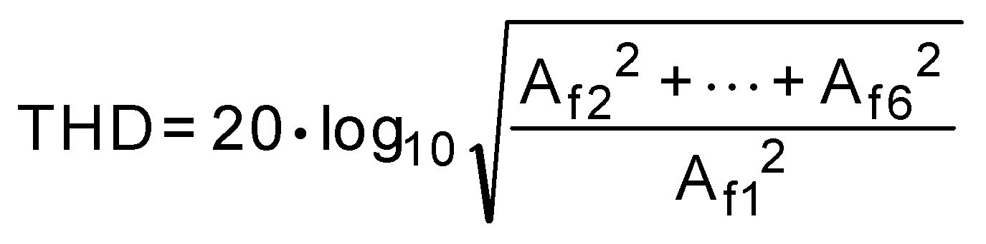

where Af1 is the RMS power of the fundamental (output)
frequency and Af2 through Af6 are the RMS power in the first
5 harmonic frequencies.
TOTAL UNADJUSTED ERROR is the worst deviation found from the ideal transfer function. As such, it is a comprehen- sive specification which includes full scale error, linearity error, and offset error.

www.national.com 10

Timing Diagrams

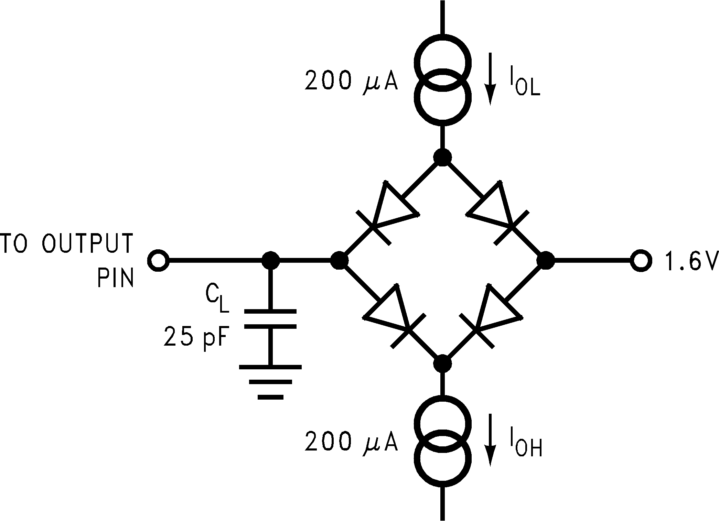
20110208
ADC121S101/ADC101S101/ADC081S101

FIGURE 1. Timing Test Circuit

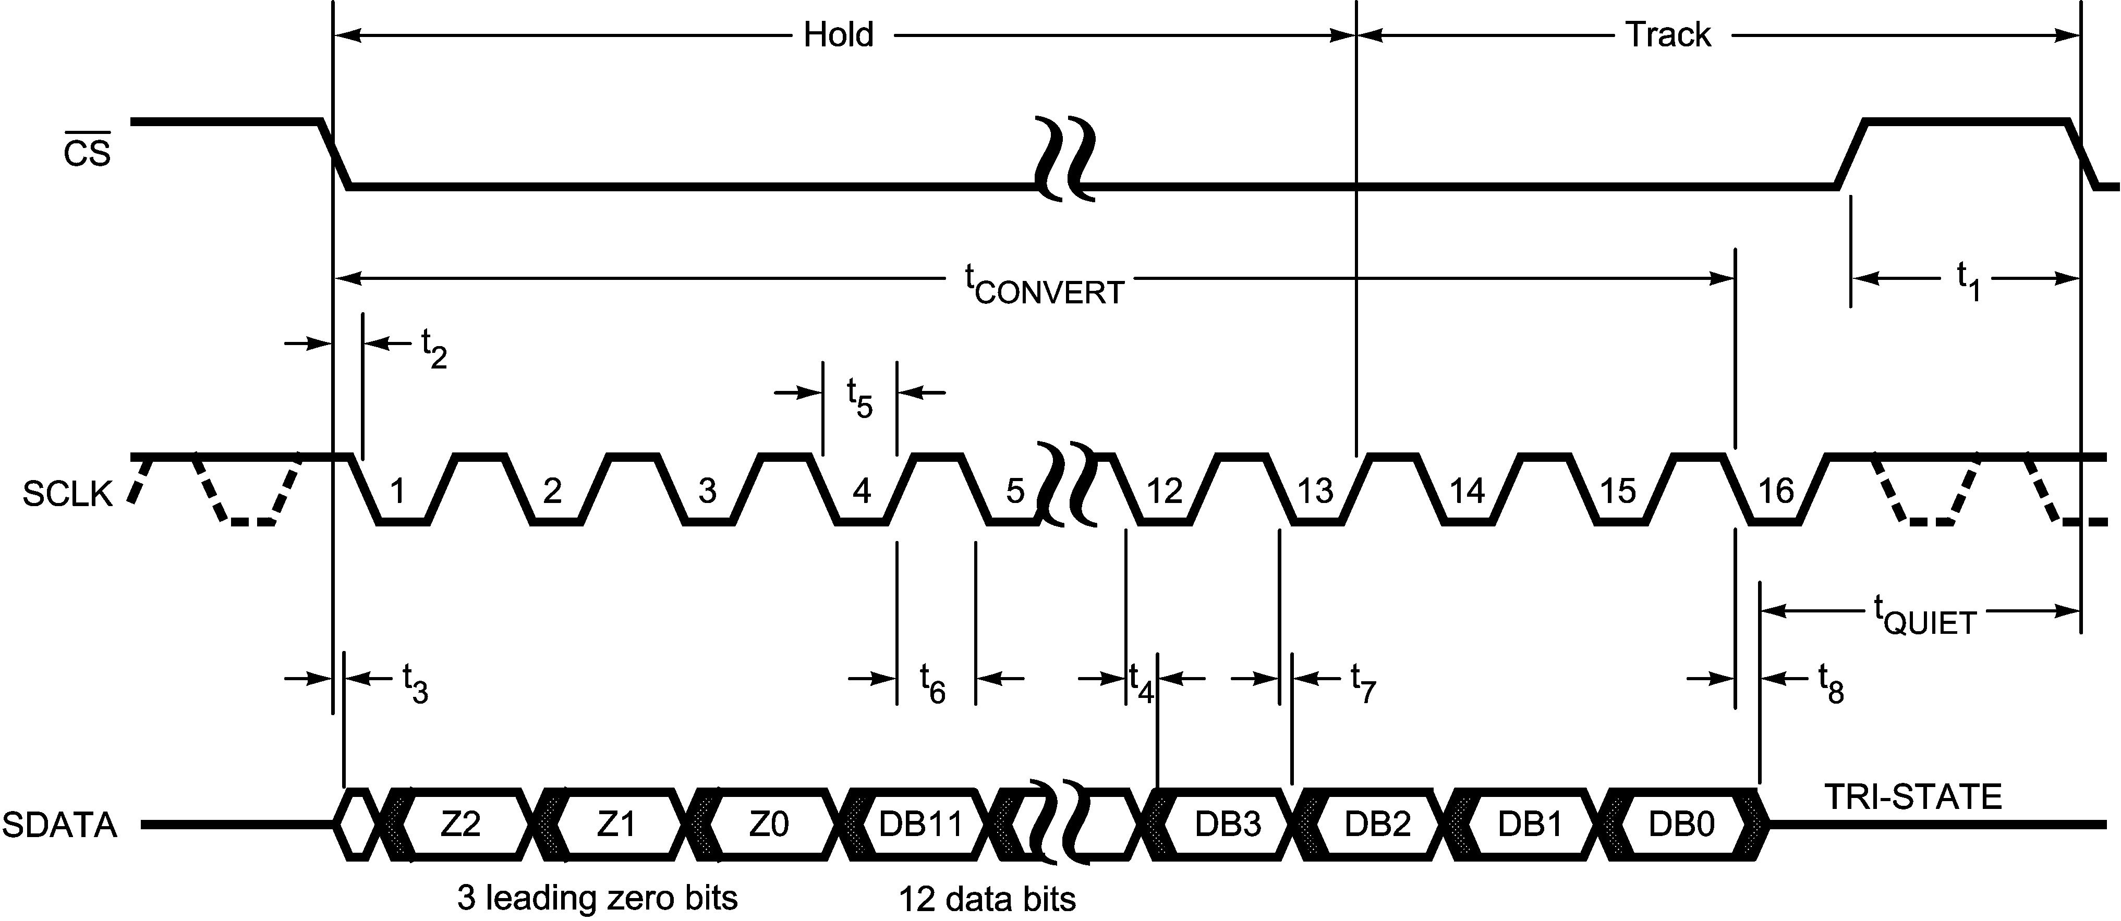
20110202

FIGURE 2. ADC121S101 Serial Interface Timing Diagram

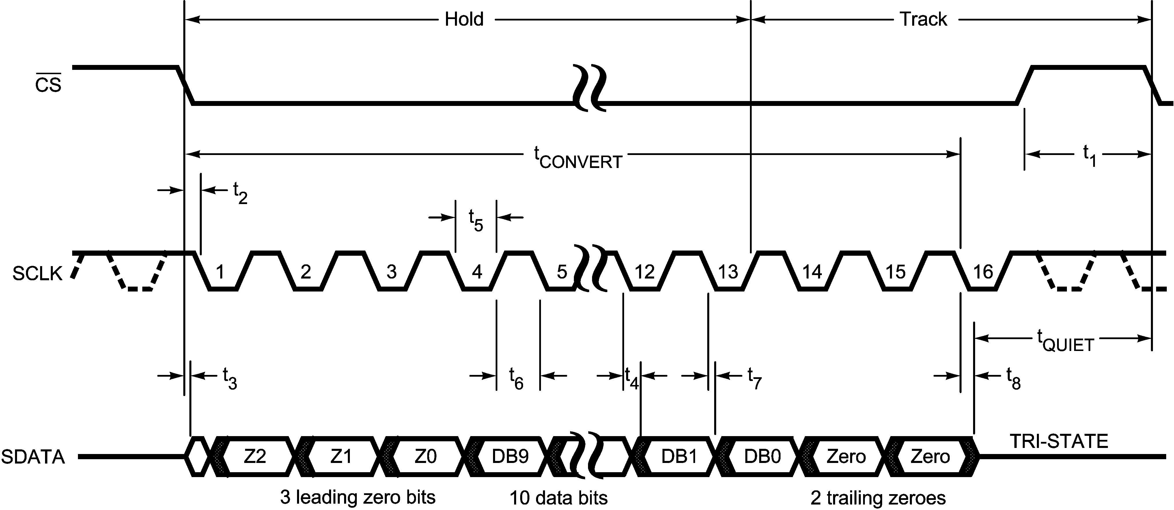
20110203

FIGURE 3. ADC101S101 Serial Interface Timing Diagram

11 www.national.com

Timing Diagrams (Continued)
ADC121S101/ADC101S101/ADC081S101

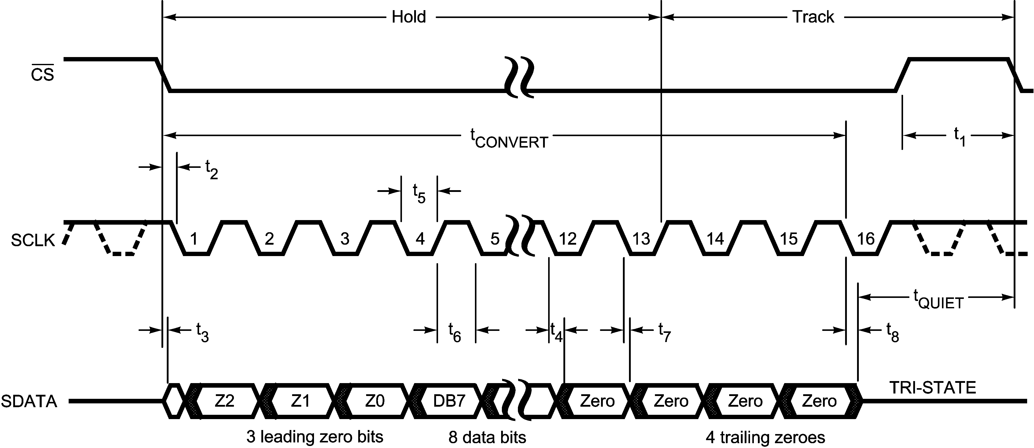
20110204

FIGURE 4. ADC081S101 Serial Interface Timing Diagram

www.national.com 12

Typical Performance Characteristics TA = +25˚C, VDD = 3V, fSAMPLE = 1 MSPS, fSCLK = 20 MHz, fIN = 100 kHz unless otherwise stated.
ADC121S101/ADC101S101/ADC081S101
ADC121S101

ADC121S101 DNL ADC121S101 INL

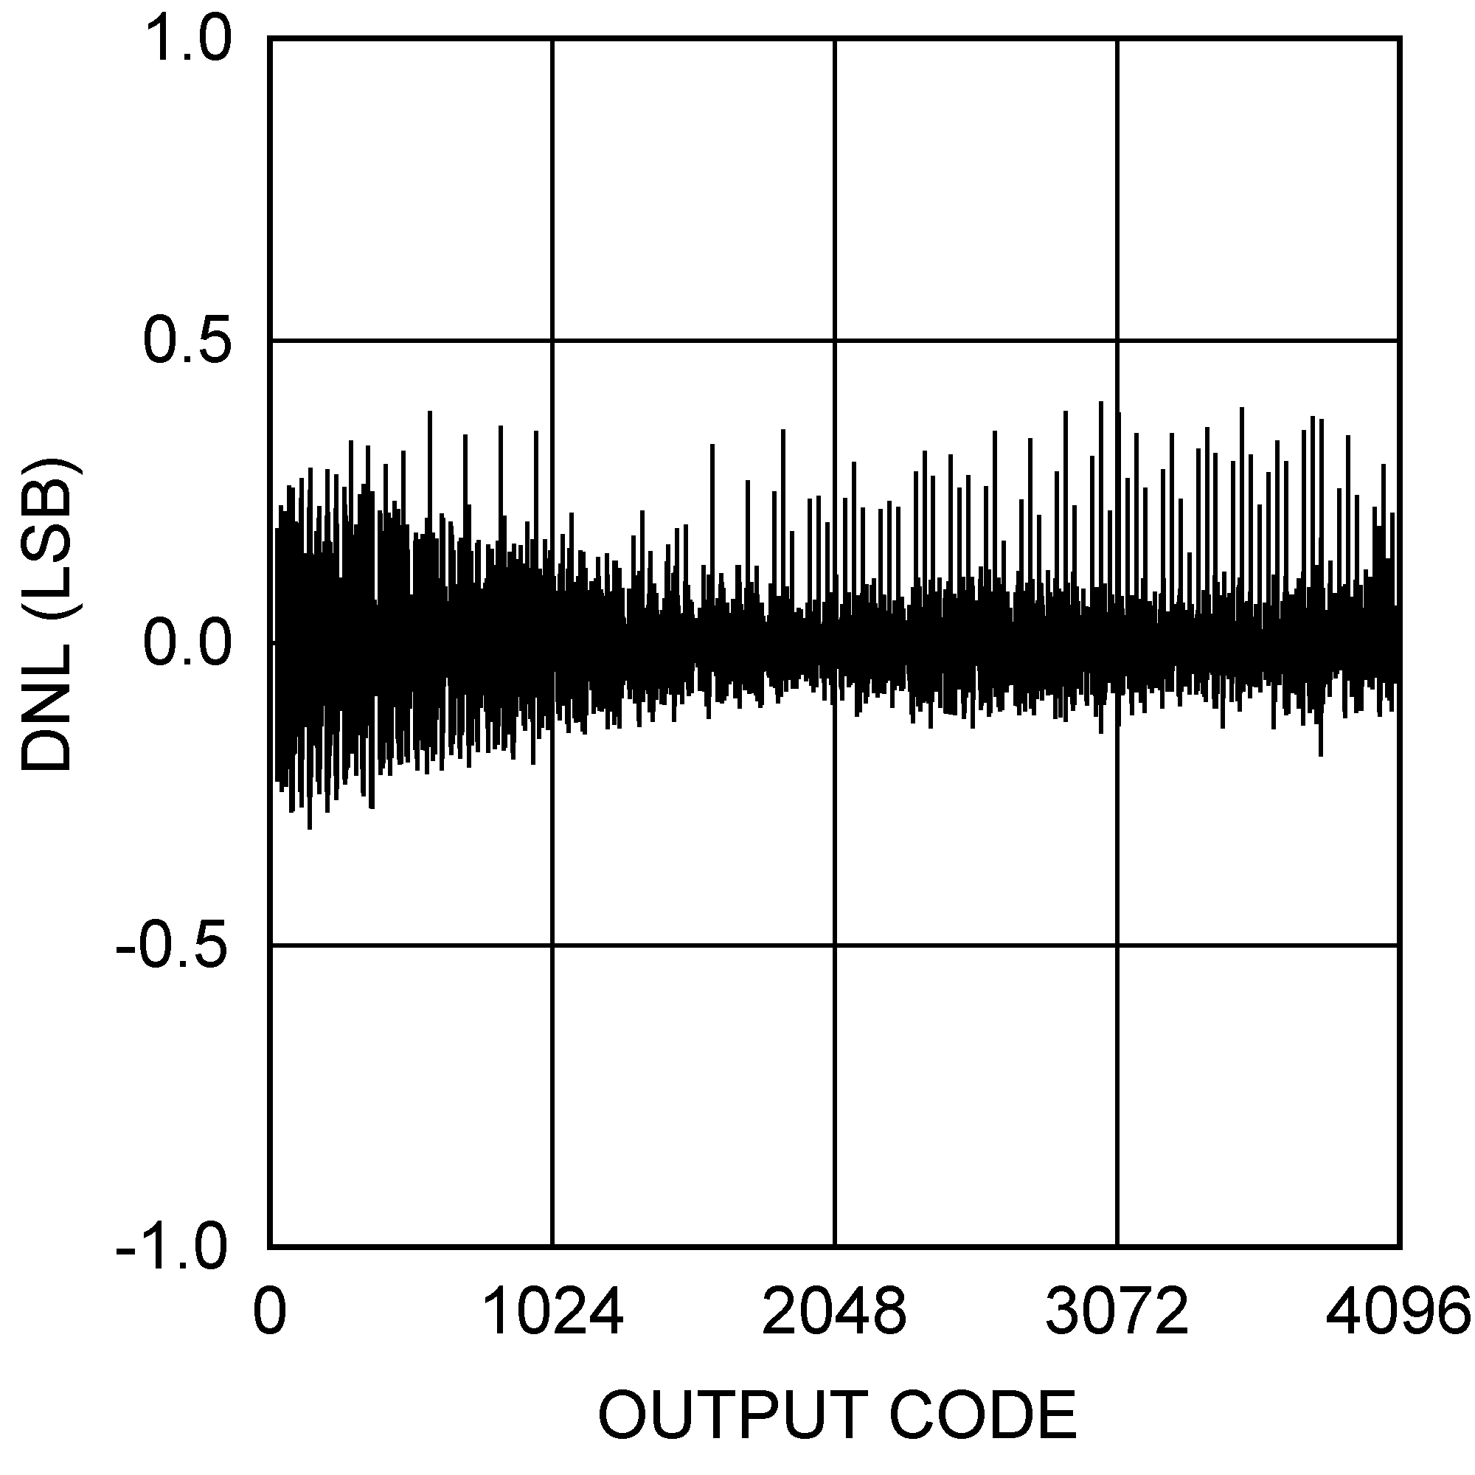
20110206 20110205

ADC121S101 Spectral Response @ 100 kHz Input ADC121S101 THD vs. Source Impedance

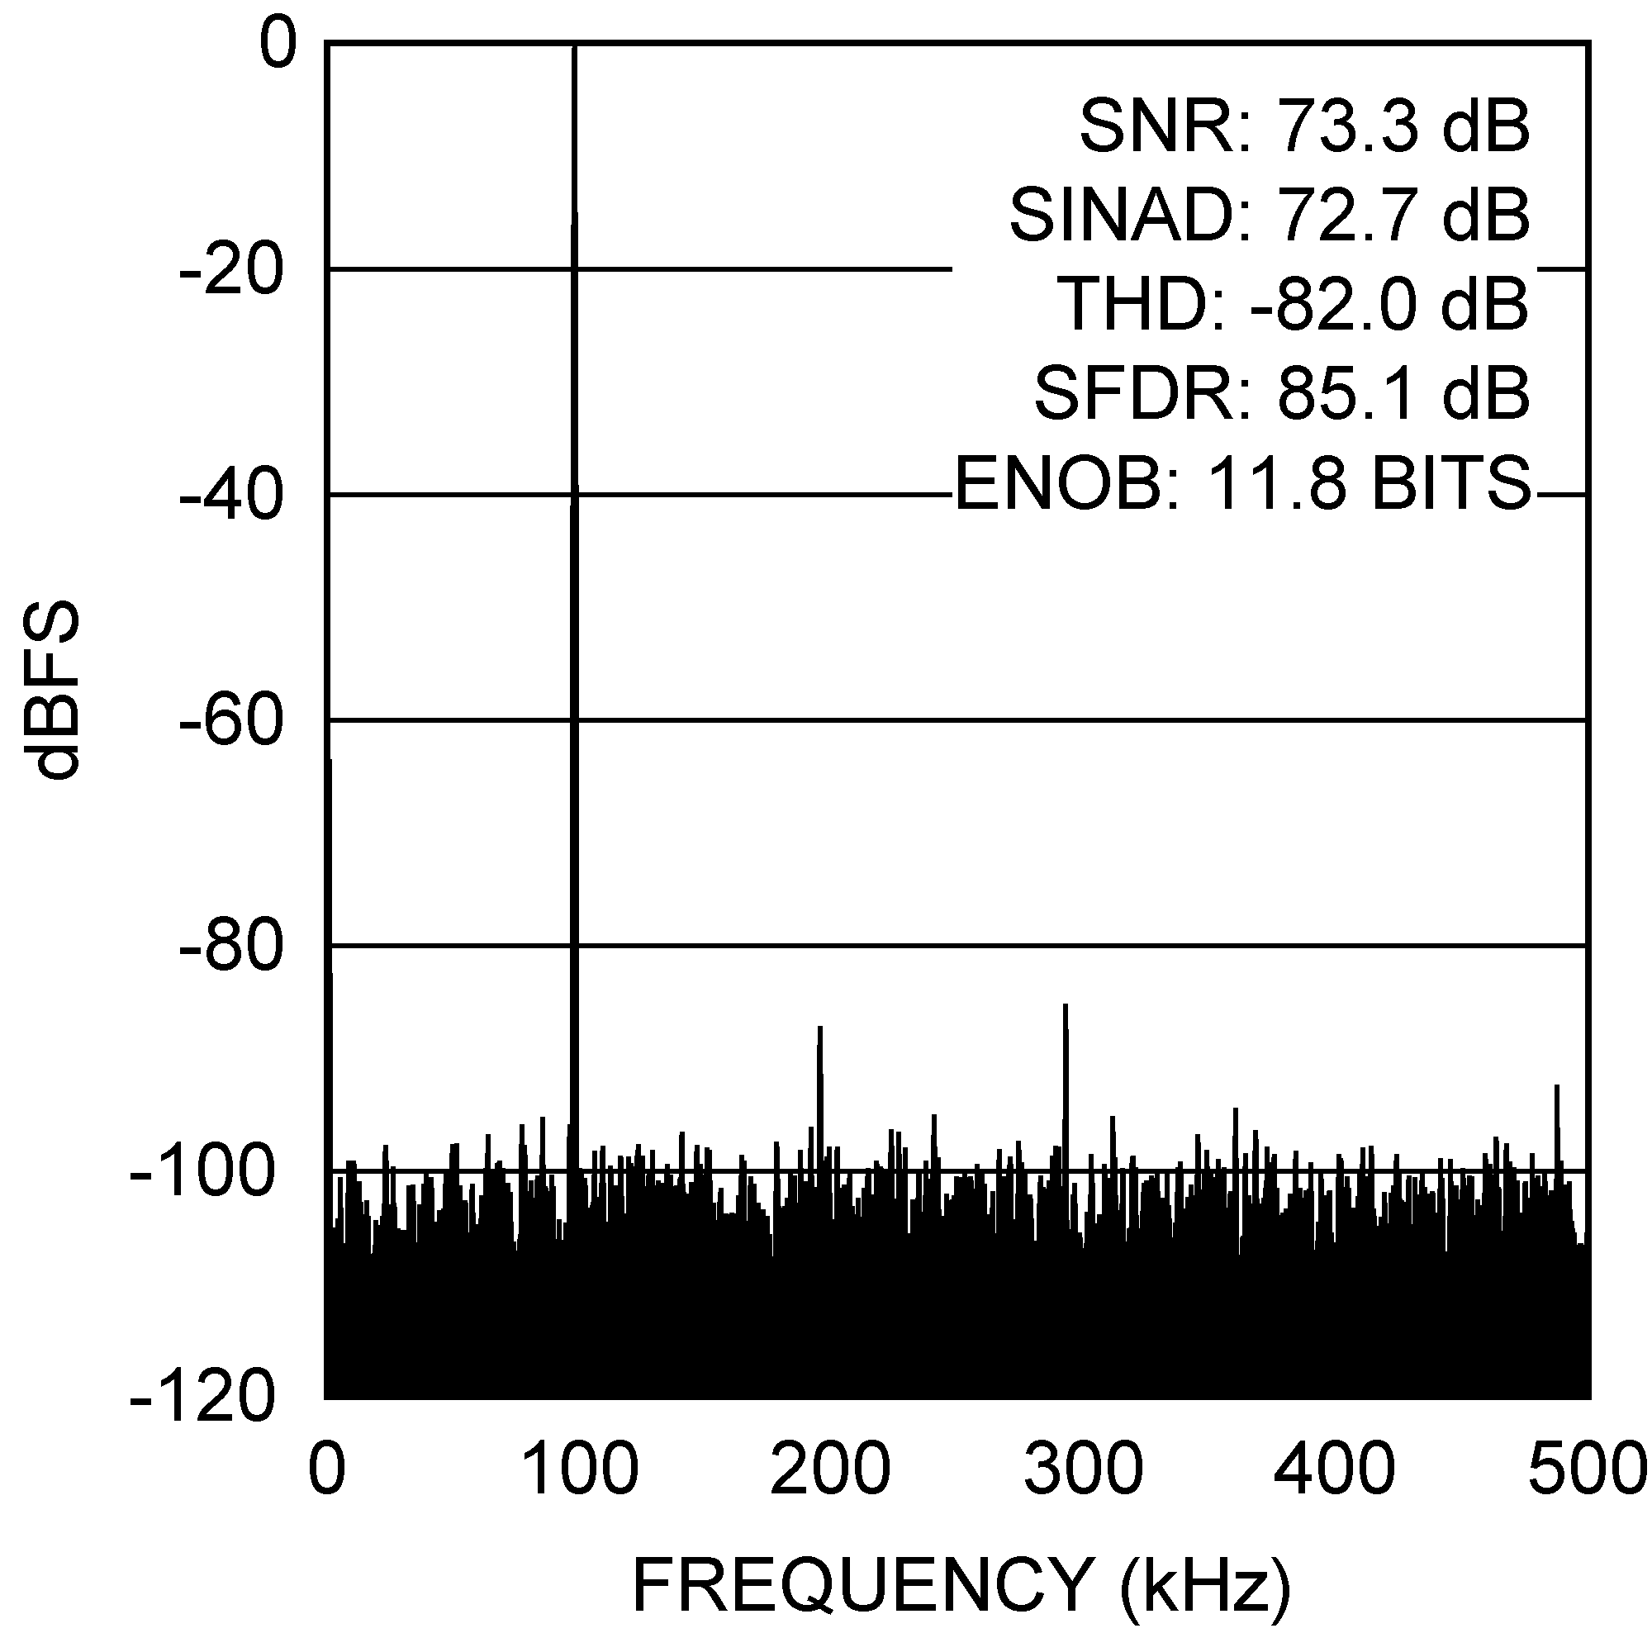
20110207 20110250

ADC121S101 THD vs. Input Frequency, 600 kSPS ADC121S101 THD vs. Input Frequency, 1 MSPS

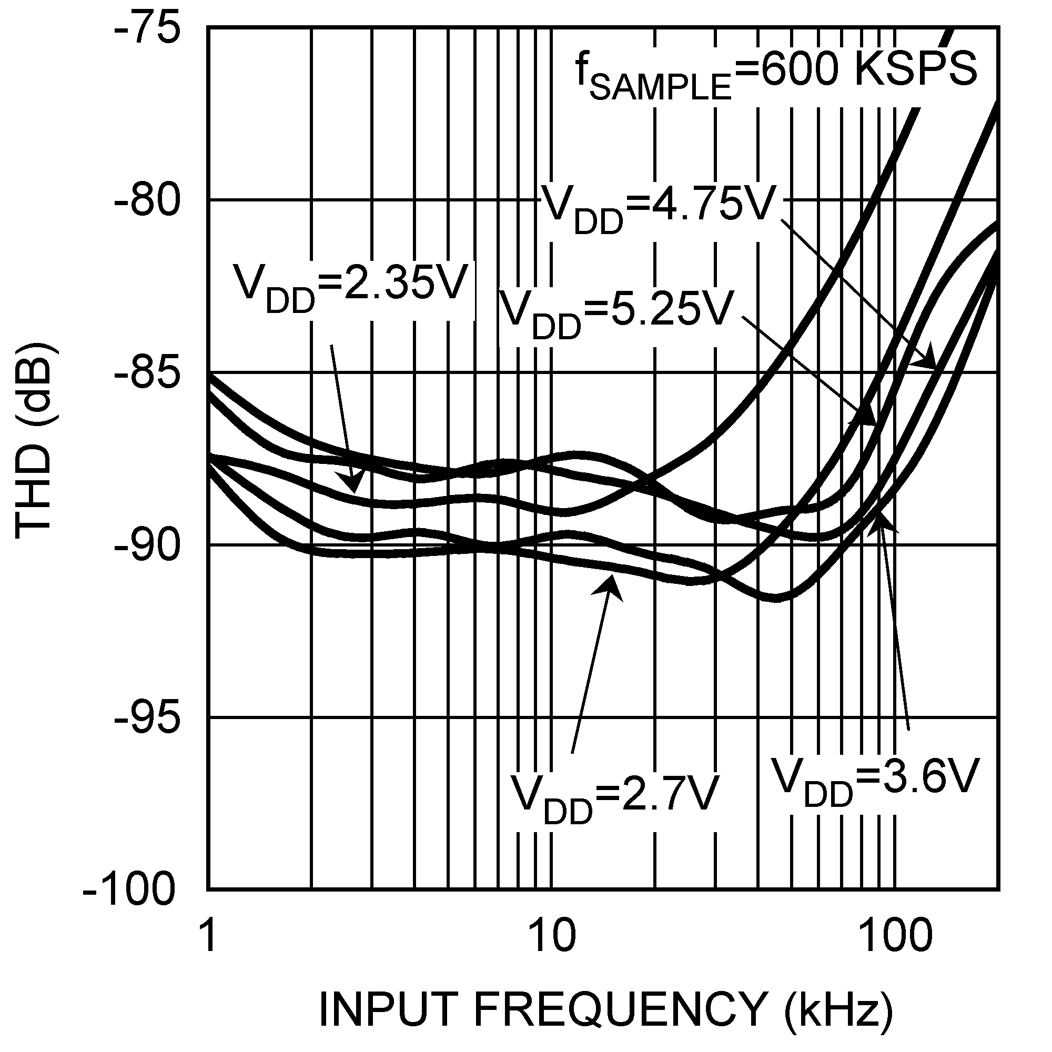
20110251 20110252

13 www.national.com

Typical Performance Characteristics TA = +25˚C, VDD = 3V, fSAMPLE = 1 MSPS, fSCLK = 20 MHz, fIN
ADC121S101/ADC101S101/ADC081S101
= 100 kHz unless otherwise stated. (Continued)

ADC121S101 SINAD vs. Input Frequency, 600 kSPS ADC121S101 SINAD vs. Input Frequency, 1 MSPS

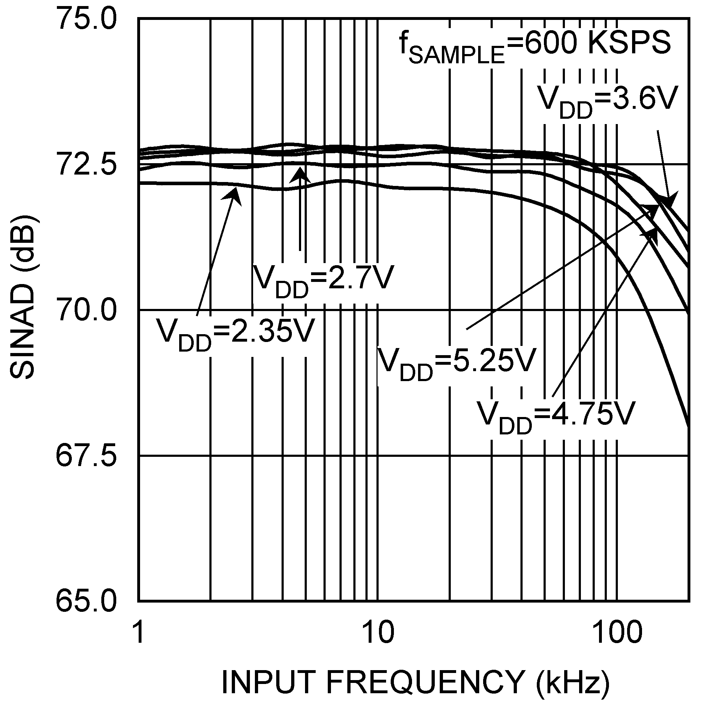
20110253 20110254

ADC121S101 SNR vs. fSCLK ADC121S101 SINAD vs. fSCLK
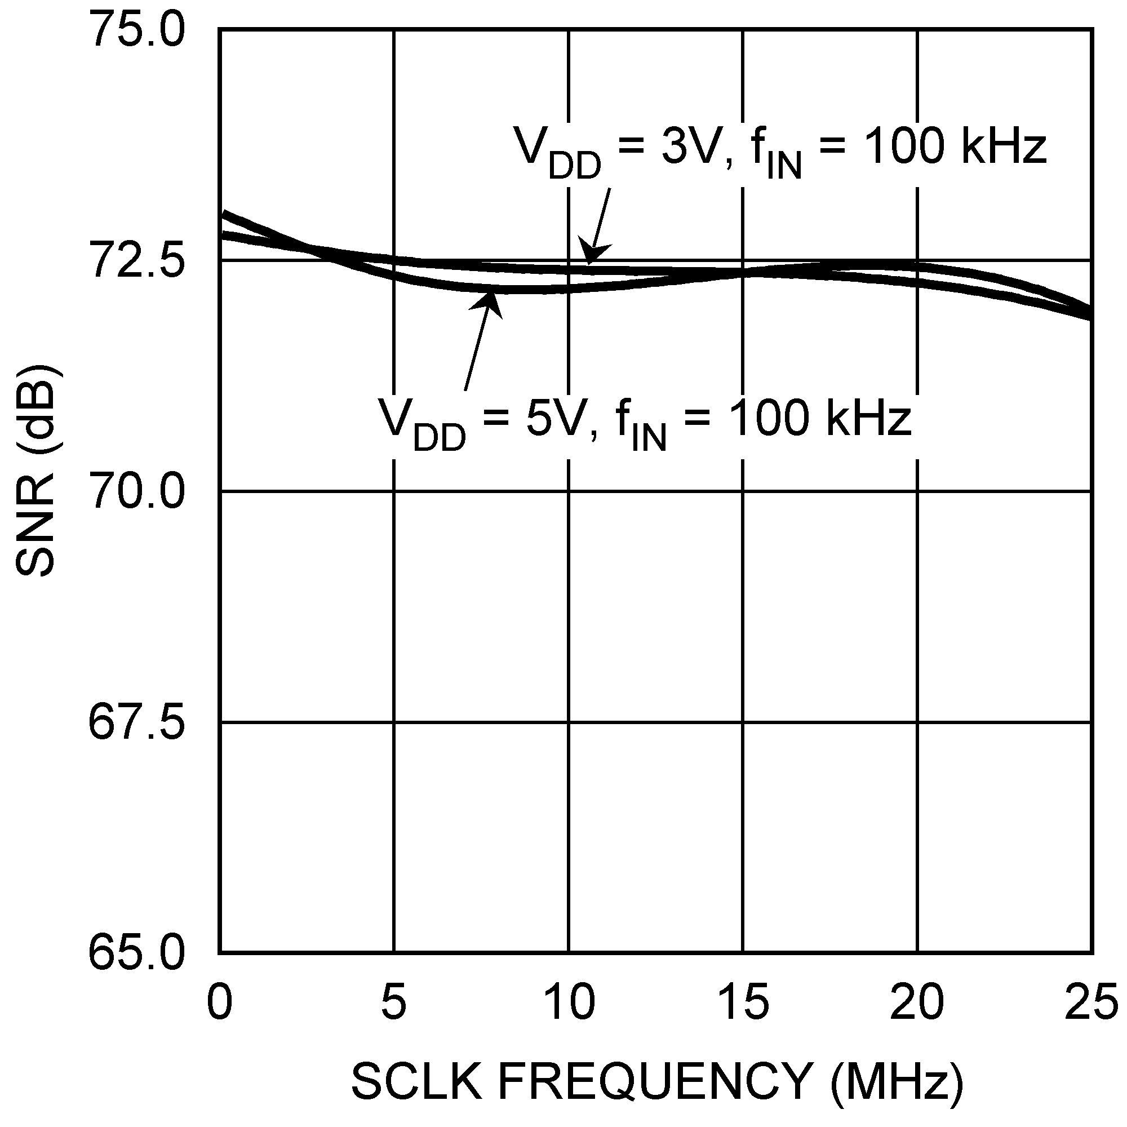
20110256 20110257

www.national.com 14

Typical Performance Characteristics TA = +25˚C, VDD = 3V, fSAMPLE = 1 MSPS, fSCLK = 20 MHz, fIN
ADC121S101/ADC101S101/ADC081S101
= 100 kHz unless otherwise stated. (Continued)

ADC101S101 DNL ADC101S101 INL

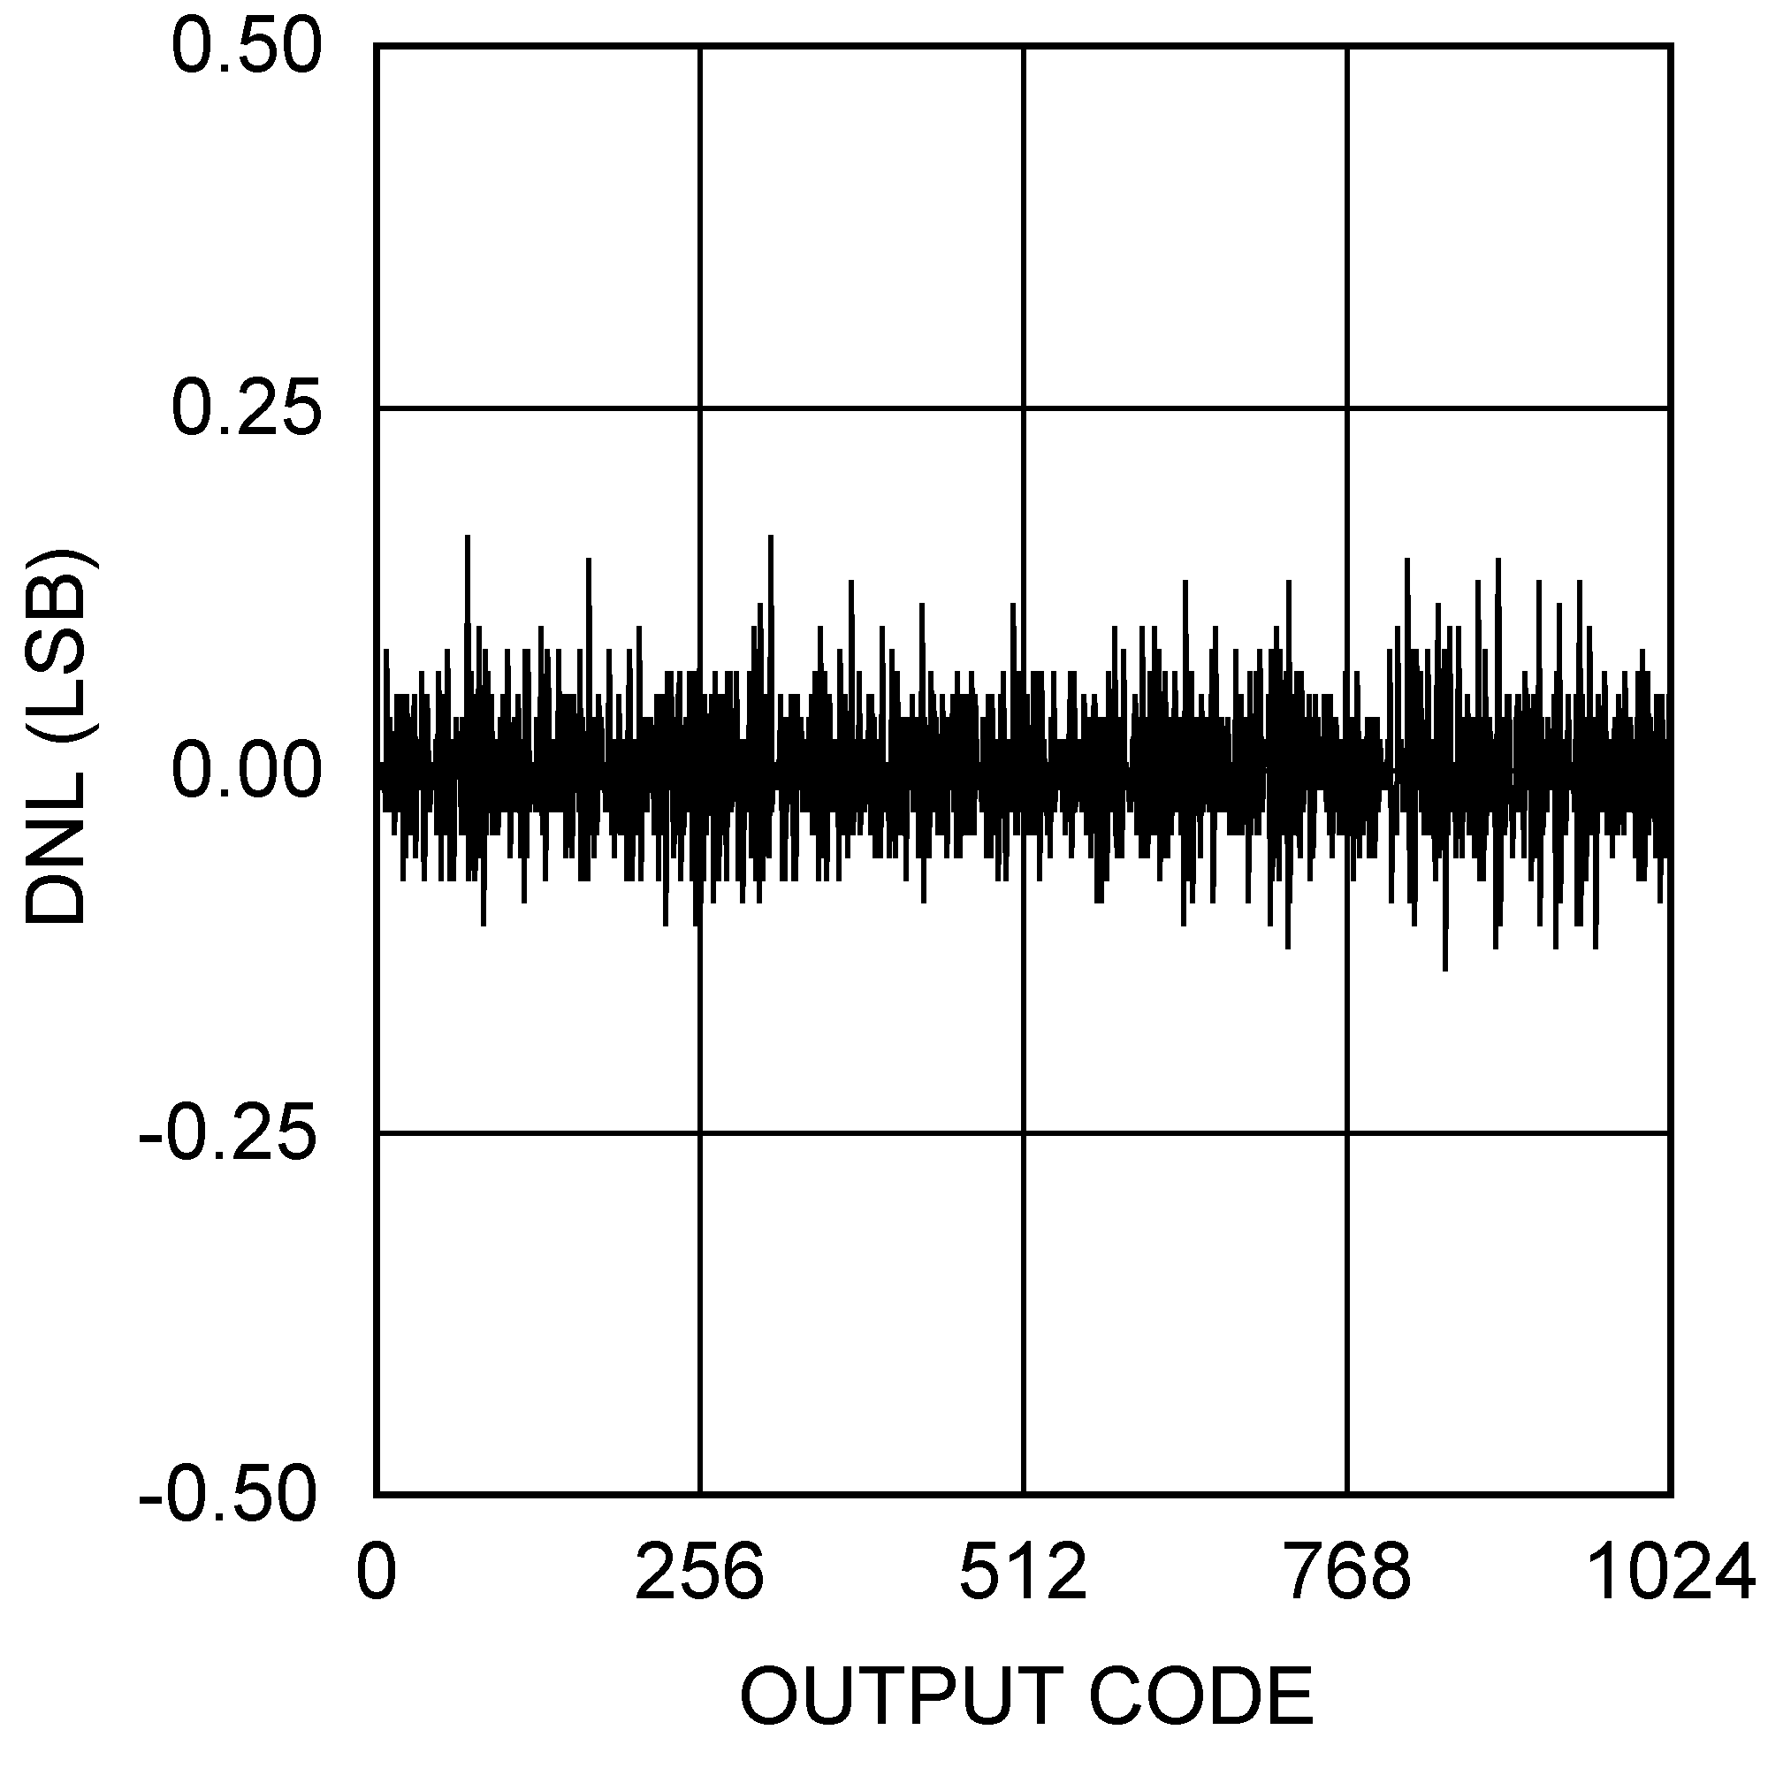
20110270 20110271

ADC101S101 Spectral Response @ 100 kHz Input ADC101S101 SNR vs. fSCLK
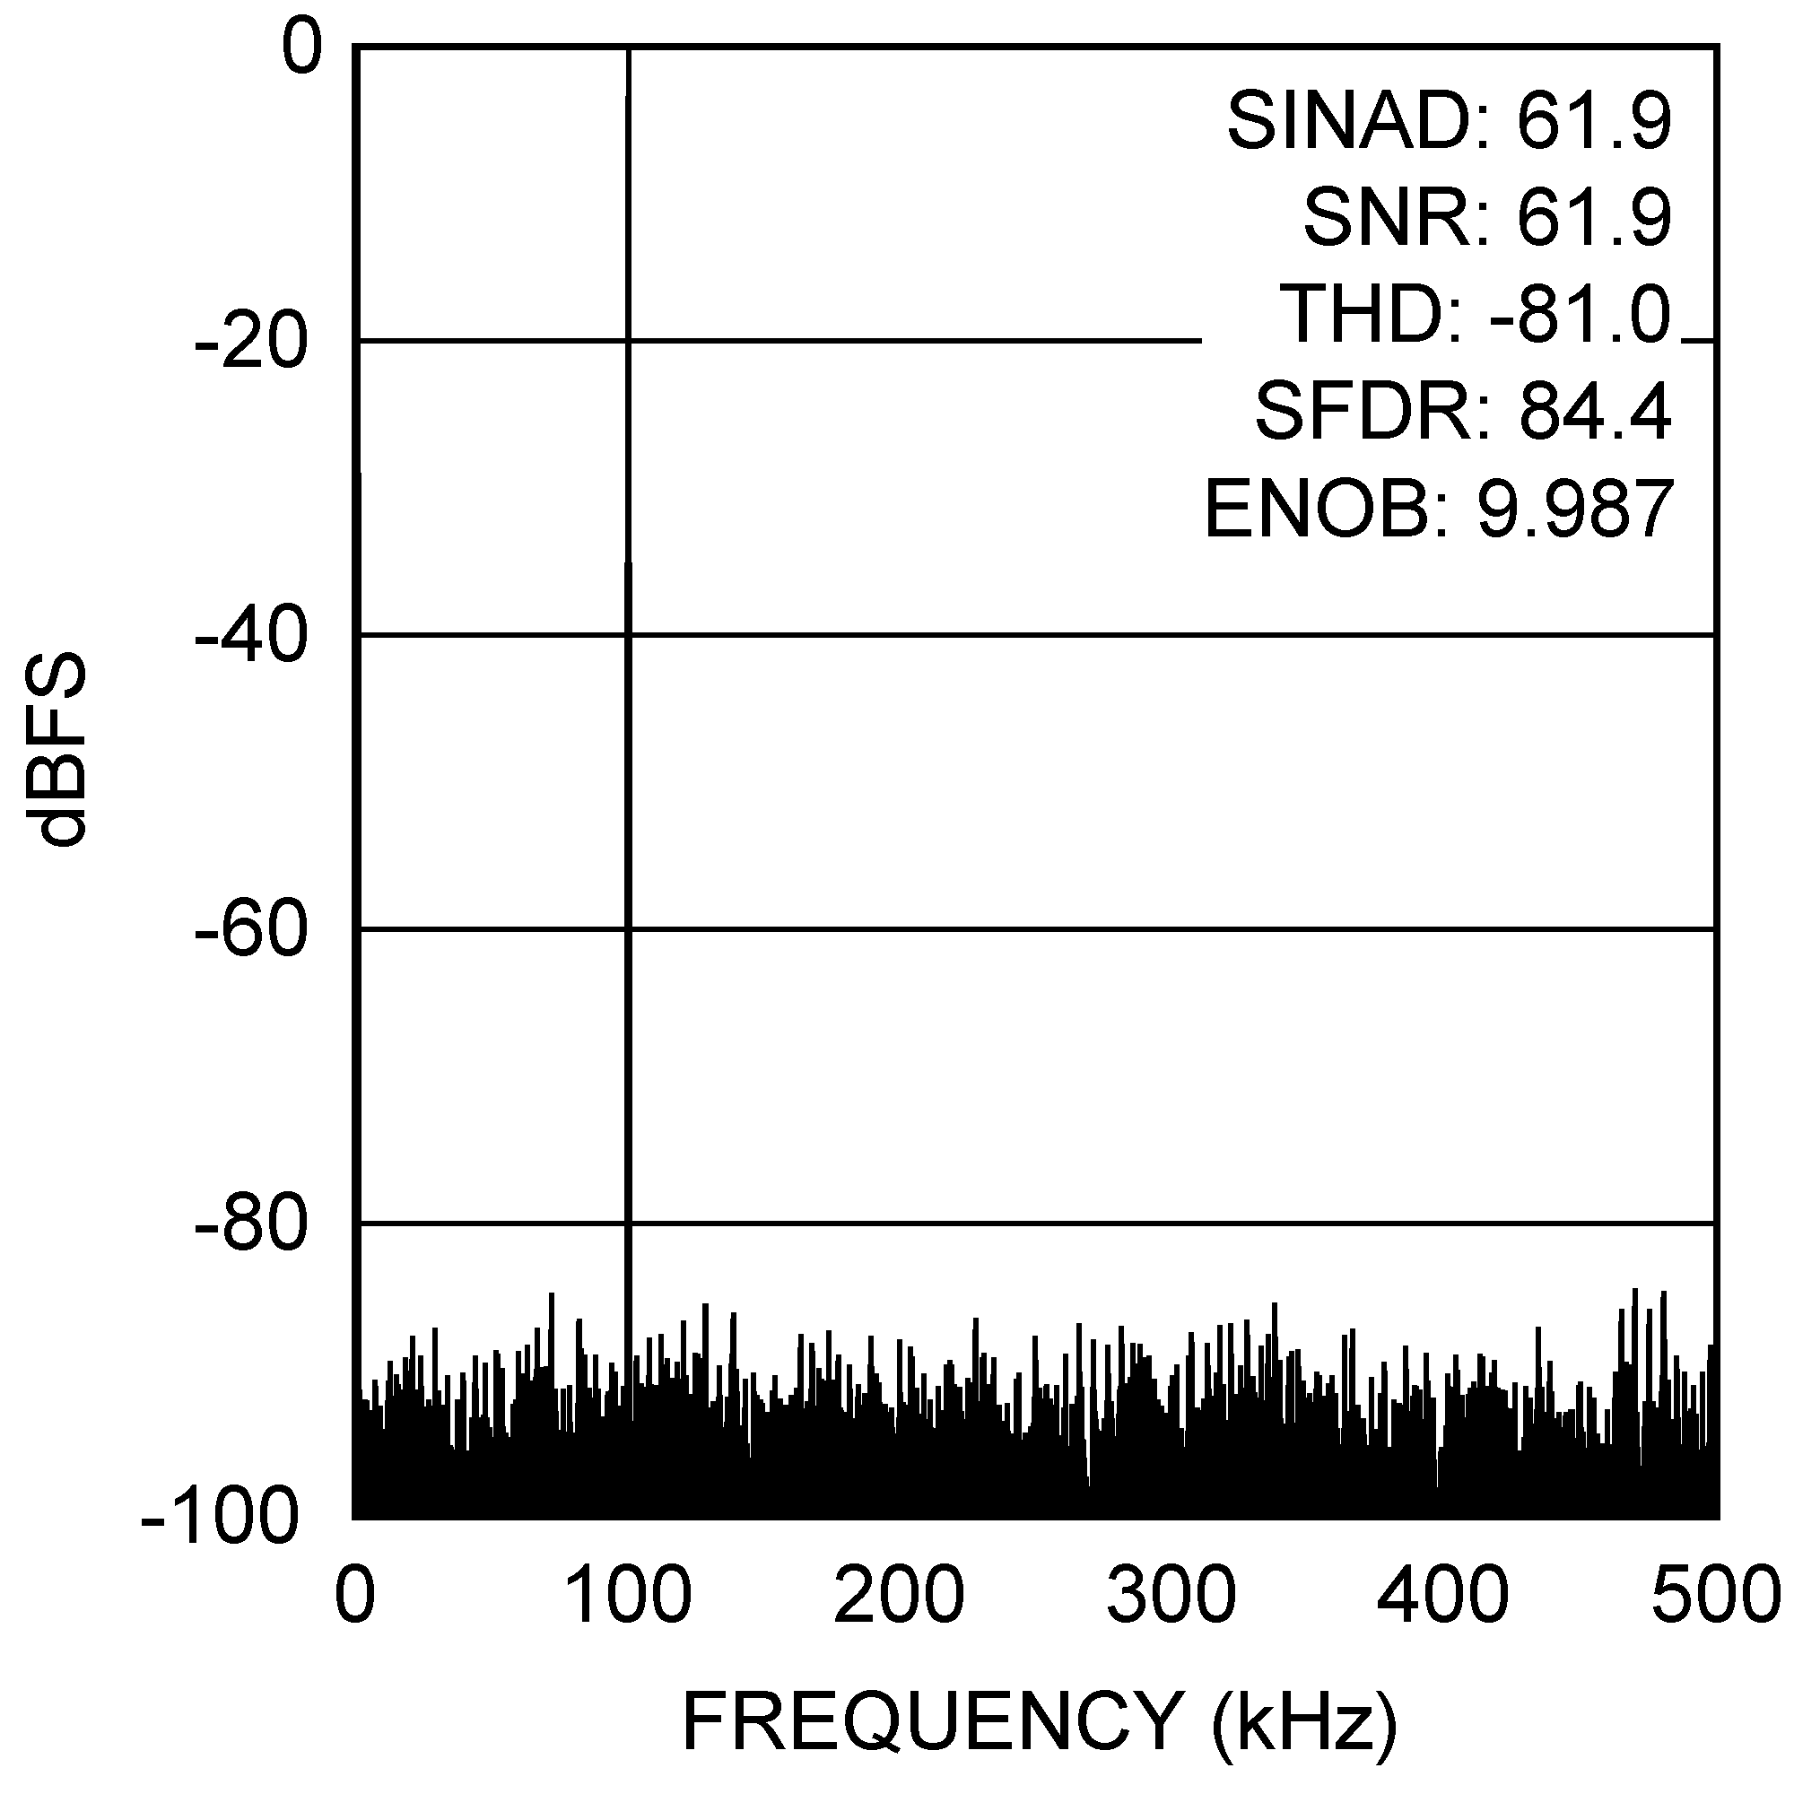

ADC101S101 SINAD vs. fSCLK
20110272 20110273
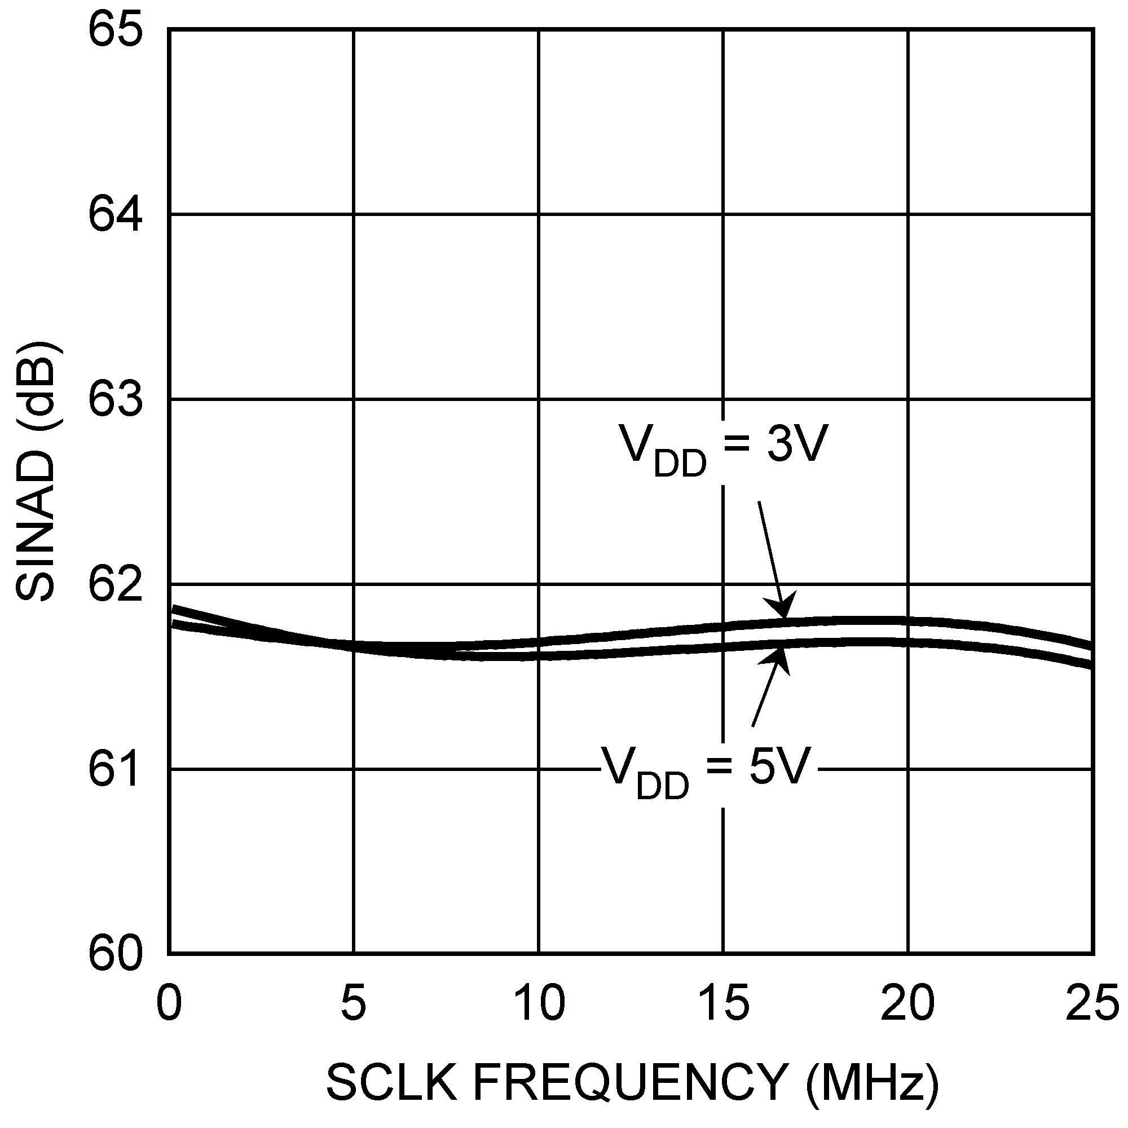
20110274

15 www.national.com

Typical Performance Characteristics TA = +25˚C, VDD = 3V, fSAMPLE = 1 MSPS, fSCLK = 20 MHz, fIN
ADC121S101/ADC101S101/ADC081S101
= 100 kHz unless otherwise stated. (Continued)

ADC081S101 DNL ADC081S101 INL

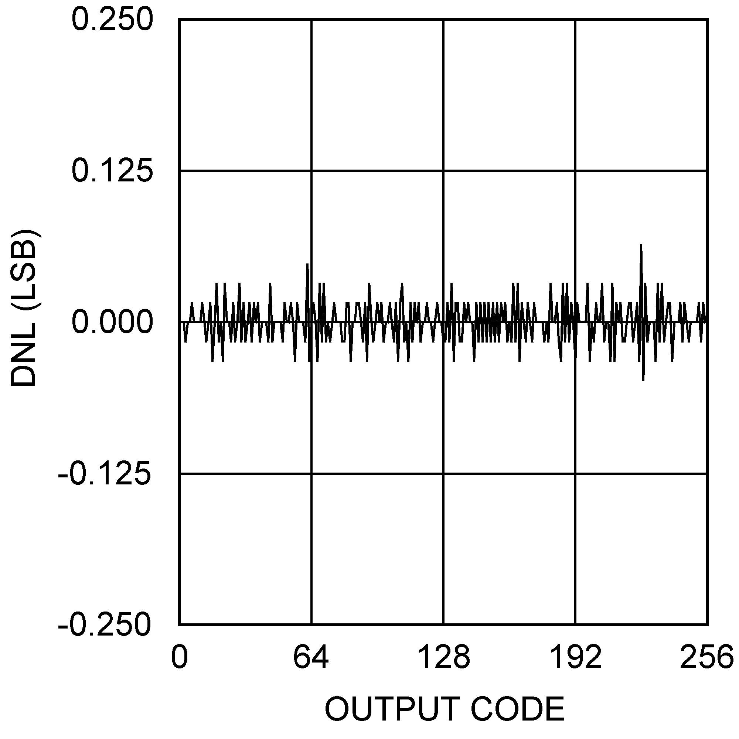
20110260 20110261

ADC081S101 Spectral Response @ 100 kHz Input ADC081S101 SNR vs. fSCLK
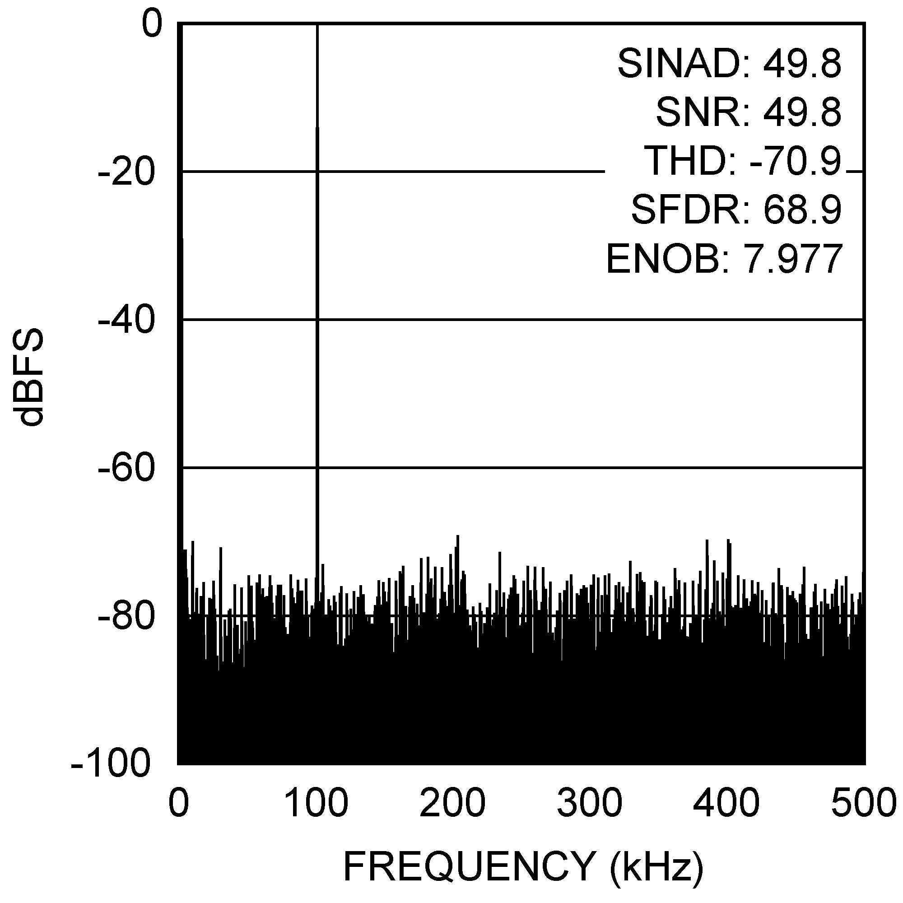
20110262 20110263

ADC081S101 SINAD vs. fSCLK Power Consumption vs. Throughput
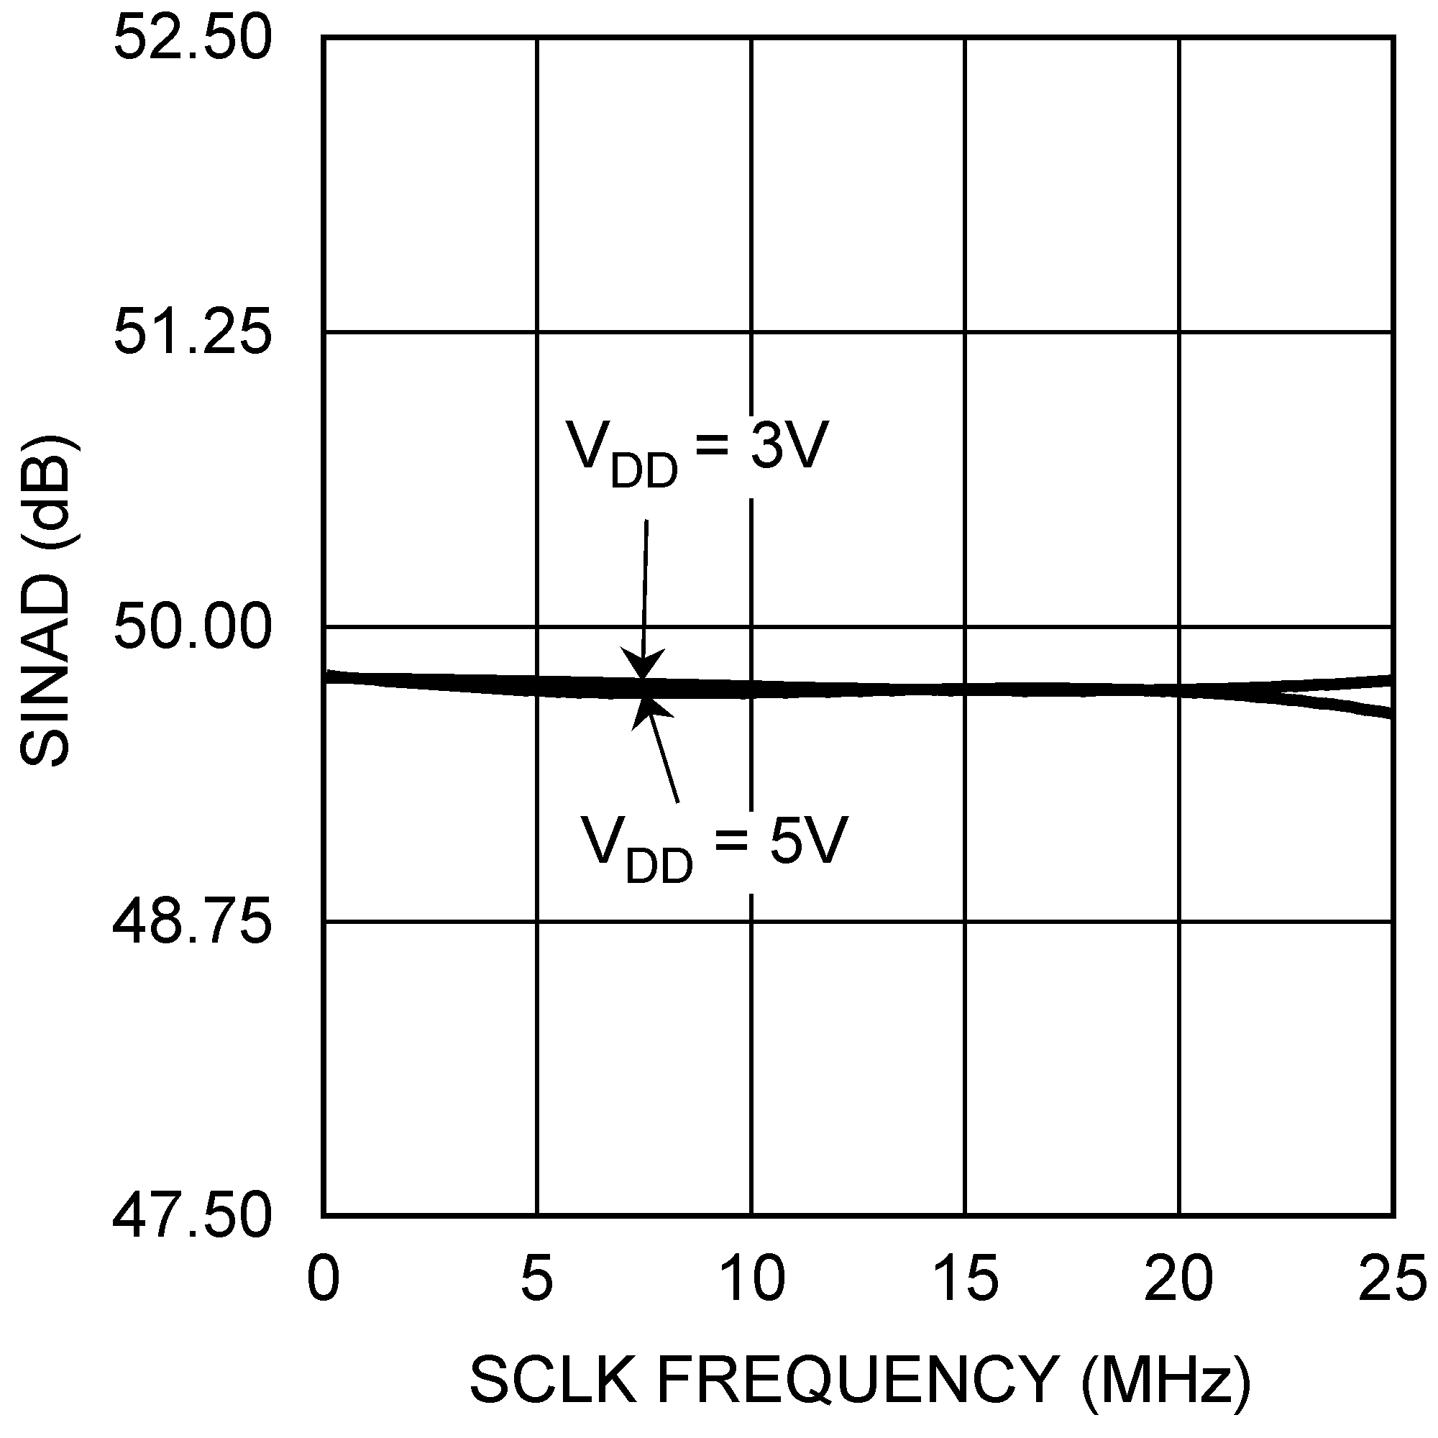
20110264 20110255

www.national.com 16

Applications Information

1.0 ADC121S101/101S101/081S101 OPERATION
The ADC121S101/101S101/081S101 are successive- approximation analog-to-digital converters designed around a charge-redistribution digital-to-analog converter. Simplified schematics of the ADC121S101/101S101/081S101 in both track and hold operation are shown in Figures 4 and 5, respectively. In Figure 4, the device is in track mode: switch SW1 connects the sampling capacitor to the input, and SW2 balances the comparator inputs. The device is in this state until CS is brought low, at which point the device moves to hold mode.
Figure 5 shows the device in hold mode: switch SW1 con- nects the sampling capacitor to ground, maintaining the sampled voltage, and switch SW2 unbalances the compara- tor. The control logic then instructs the charge-redistribution DAC to add or subtract fixed amounts of charge from the sampling capacitor until the comparator is balanced. When the comparator is balanced, the digital word supplied to the DAC is the digital representation of the analog input voltage. The device moves from hold mode to track mode on the 13th rising edge of SCLK.
ADC121S101/ADC101S101/ADC081S101

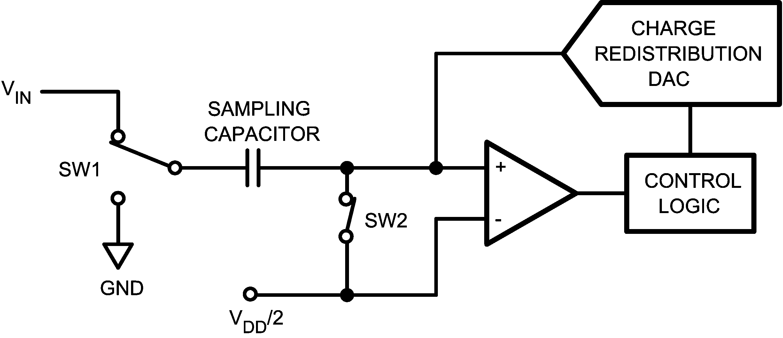
20110209

FIGURE 5. ADC121S101/101S101/081S101 in Track Mode

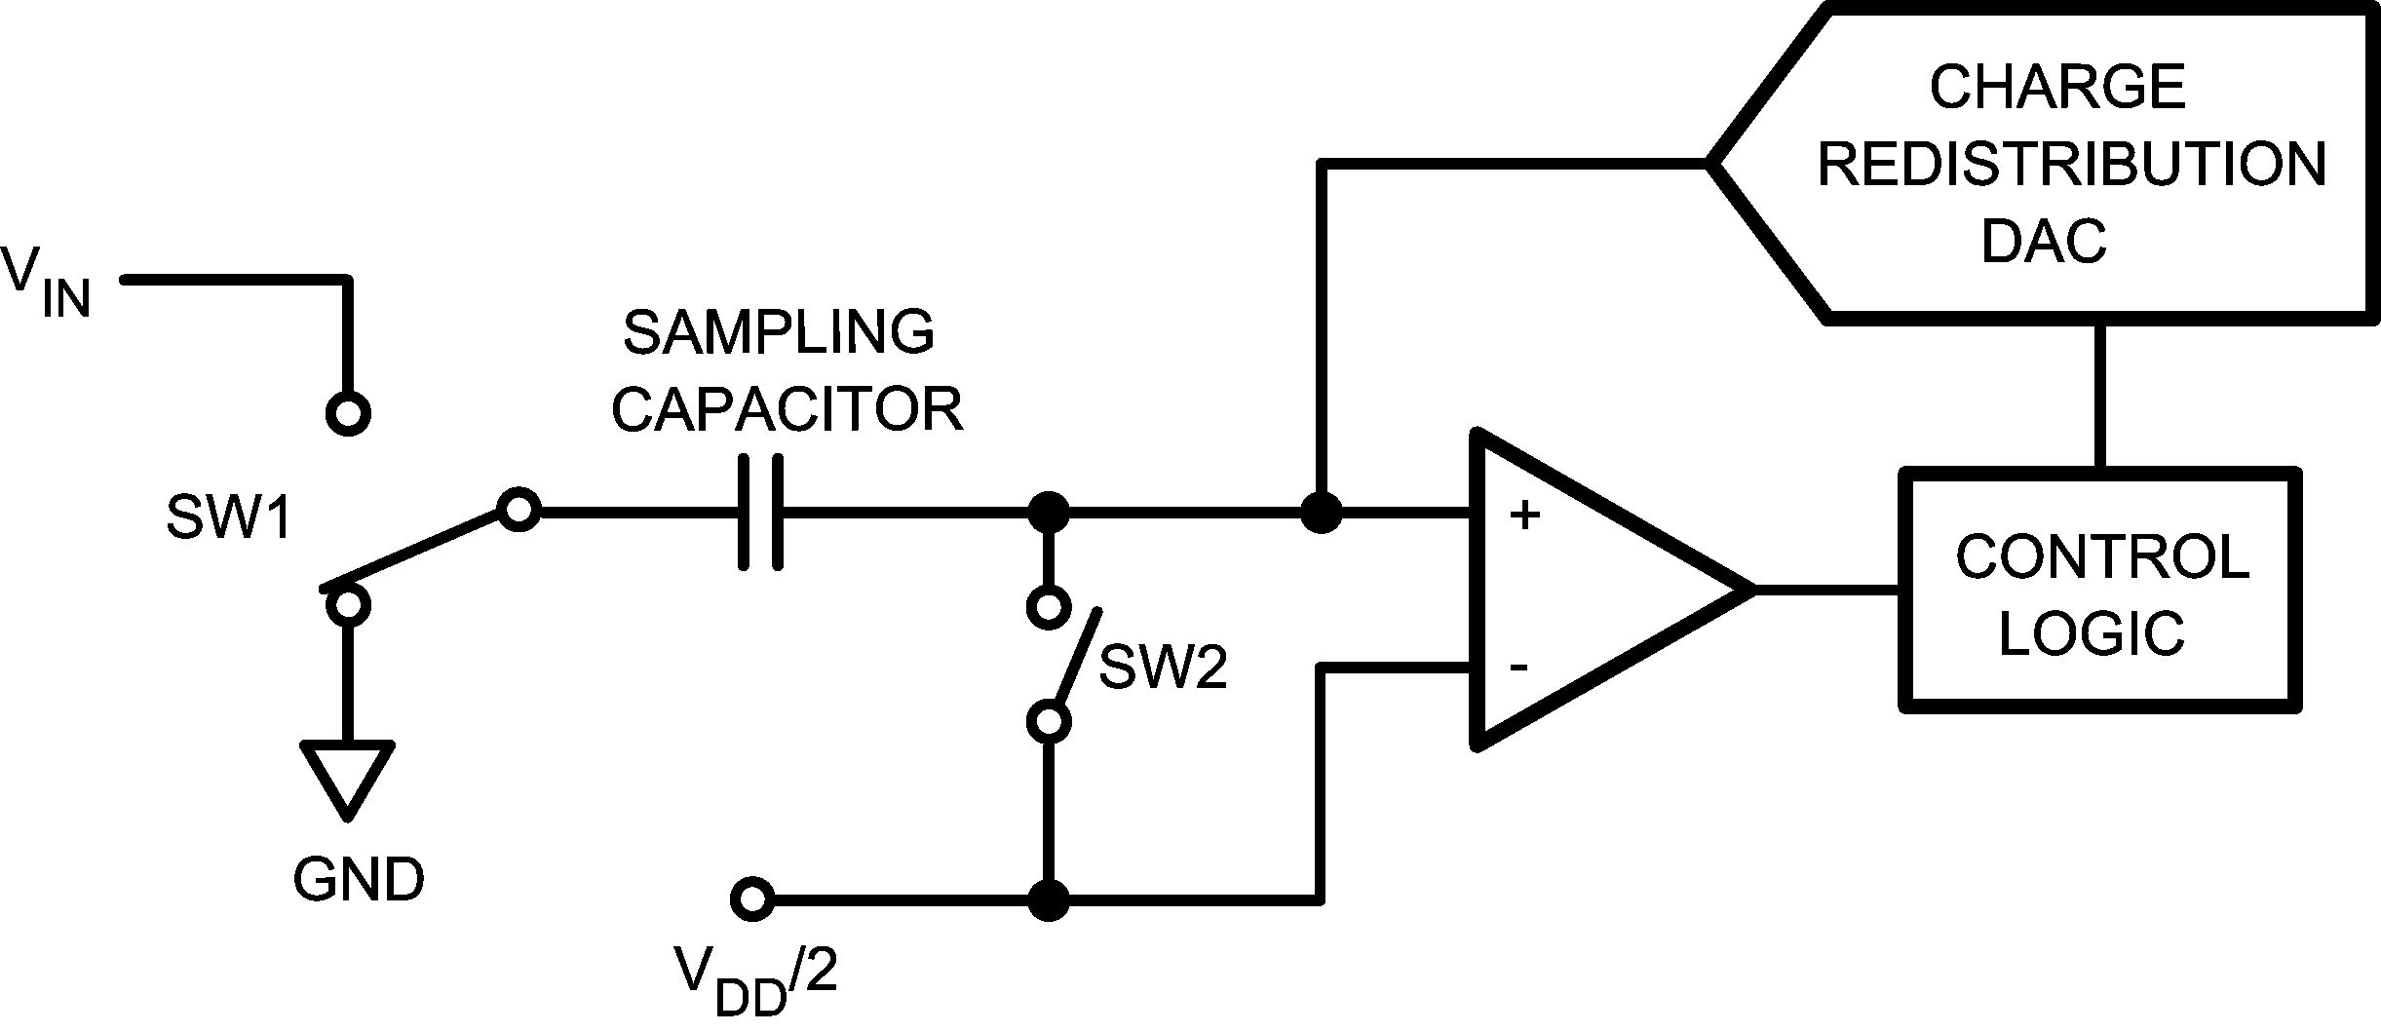
20110210

FIGURE 6. ADC121S101/101S101/081S101 in Hold Mode

2.0 USING THE ADC121S101/101S101/081S101
Serial interface timing diagrams for the ADC121S101/
101S101/081S101 are shown in Figures 1, 2, and 3. CS is chip select, which initiates conversions on the ADC121S101/
101S101/081S101 and frames the serial data transfers. SCLK (serial clock) controls both the conversion process and the timing of serial data. SDATA is the serial data out pin, where a conversion result is found as a serial data stream.
Basic operation of the ADC121S101/101S101/081S101 be- gins with CS going low, which initiates a conversion process and data transfer. Subsequent rising and falling edges of SCLK will be labelled with reference to the falling edge of CS; for example, "the third falling edge of SCLK" shall refer to the third falling edge of SCLK after CS goes low.
At the fall of CS, the SDATA pin comes out of TRI-STATE, and the converter moves from track mode to hold mode. The input signal is sampled and held for conversion on the falling edge of CS. The converter moves from hold mode to track
mode on the 13th rising edge of SCLK (see Figure 1, 2, or 3). The SDATA pin will be placed back into TRI-STATE after the
16th falling edge of SCLK, or at the rising edge of CS, whichever occurs first. After a conversion is completed, the quiet time tQUIET must be satisfied before bringing CS low again to begin another conversion.
Sixteen SCLK cycles are required to read a complete sample from the ADC121S101/101S101/081S101. The sample bits (including any leading or trailing zeroes) are clocked out on falling edges of SCLK, and are intended to be clocked in by a receiver on subsequent falling edges of SCLK. The ADC121S101/101S101/081S101 will produce three leading zero bits on SDATA, followed by twelve, ten, or eight data bits, most significant first. After the data bits, the ADC101S101 will clock out two trailing zeros, and the ADC081S101 will clock out four trailing zeros. The ADC121S101 will not clock out any trailing zeros; the least significant data bit will be valid on the 16th falling edge of SCLK.

17 www.national.com

Applications Information (Continued)
ADC121S101/ADC101S101/ADC081S101

If CS goes low before the rising edge of SCLK, an additional (fourth) zero bit may be captured by the next falling edge of SCLK.

3.0 ADC121S101/101S101/081S101 TRANSFER FUNCTION
The output format of the ADC121S101/101S101/081S101 is straight binary. Code transitions occur midway between suc-

cessive integer LSB values. The LSB widths for the ADC121S101 is VDD / 4096; for the ADC101S101 the LSB width is VDD / 1024; for the ADC081S101, the LSB width is VDD / 256. The ideal transfer characteristic for the ADC121S101 and ADC101S101 is shown in Figure 6, while the ideal transfer characteristic for the ADC081S101 is shown in Figure 7.

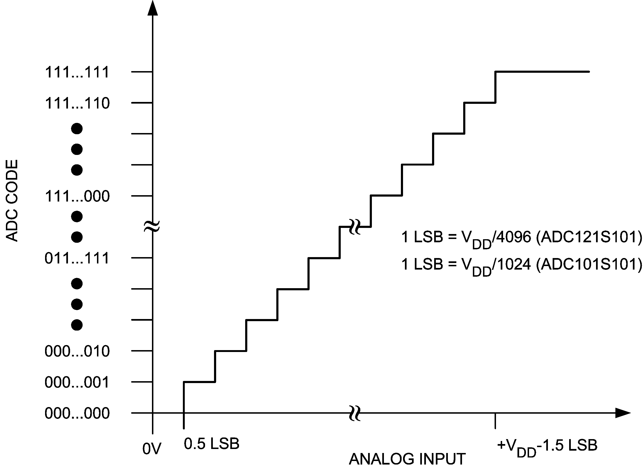
20110211

FIGURE 7. ADC121S101/101S101 Ideal Transfer Characteristic

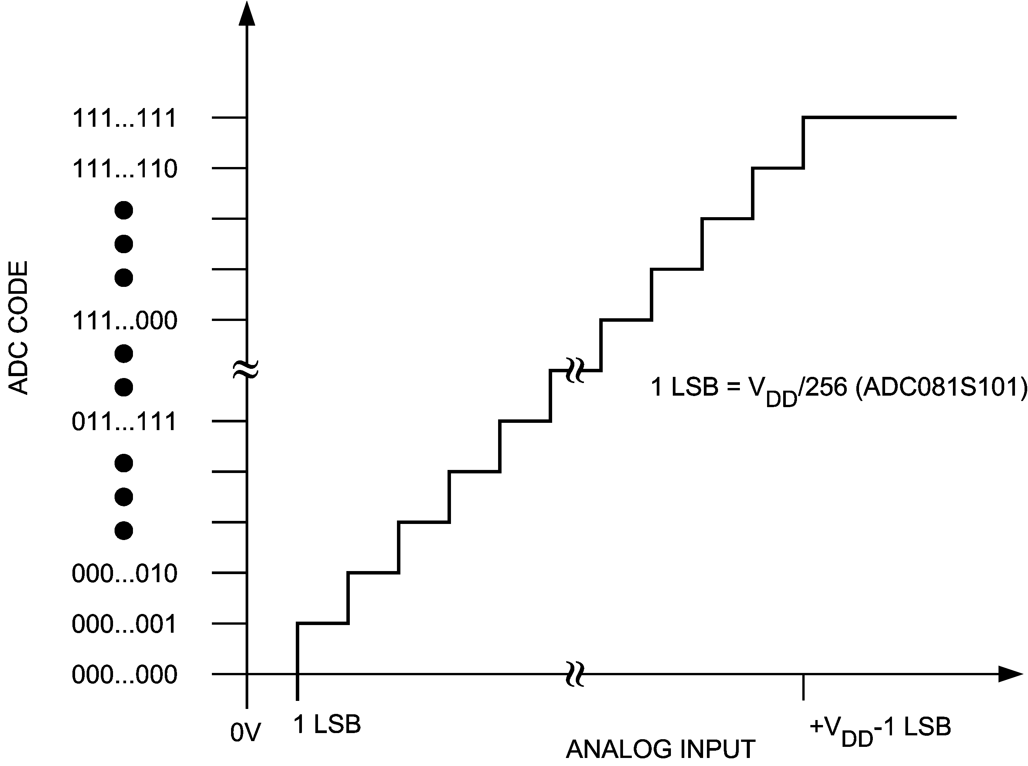
20110212

FIGURE 8. ADC081S101 Ideal Transfer Characteristic

www.national.com 18

Applications Information (Continued)

4.0 SAMPLE CIRCUIT

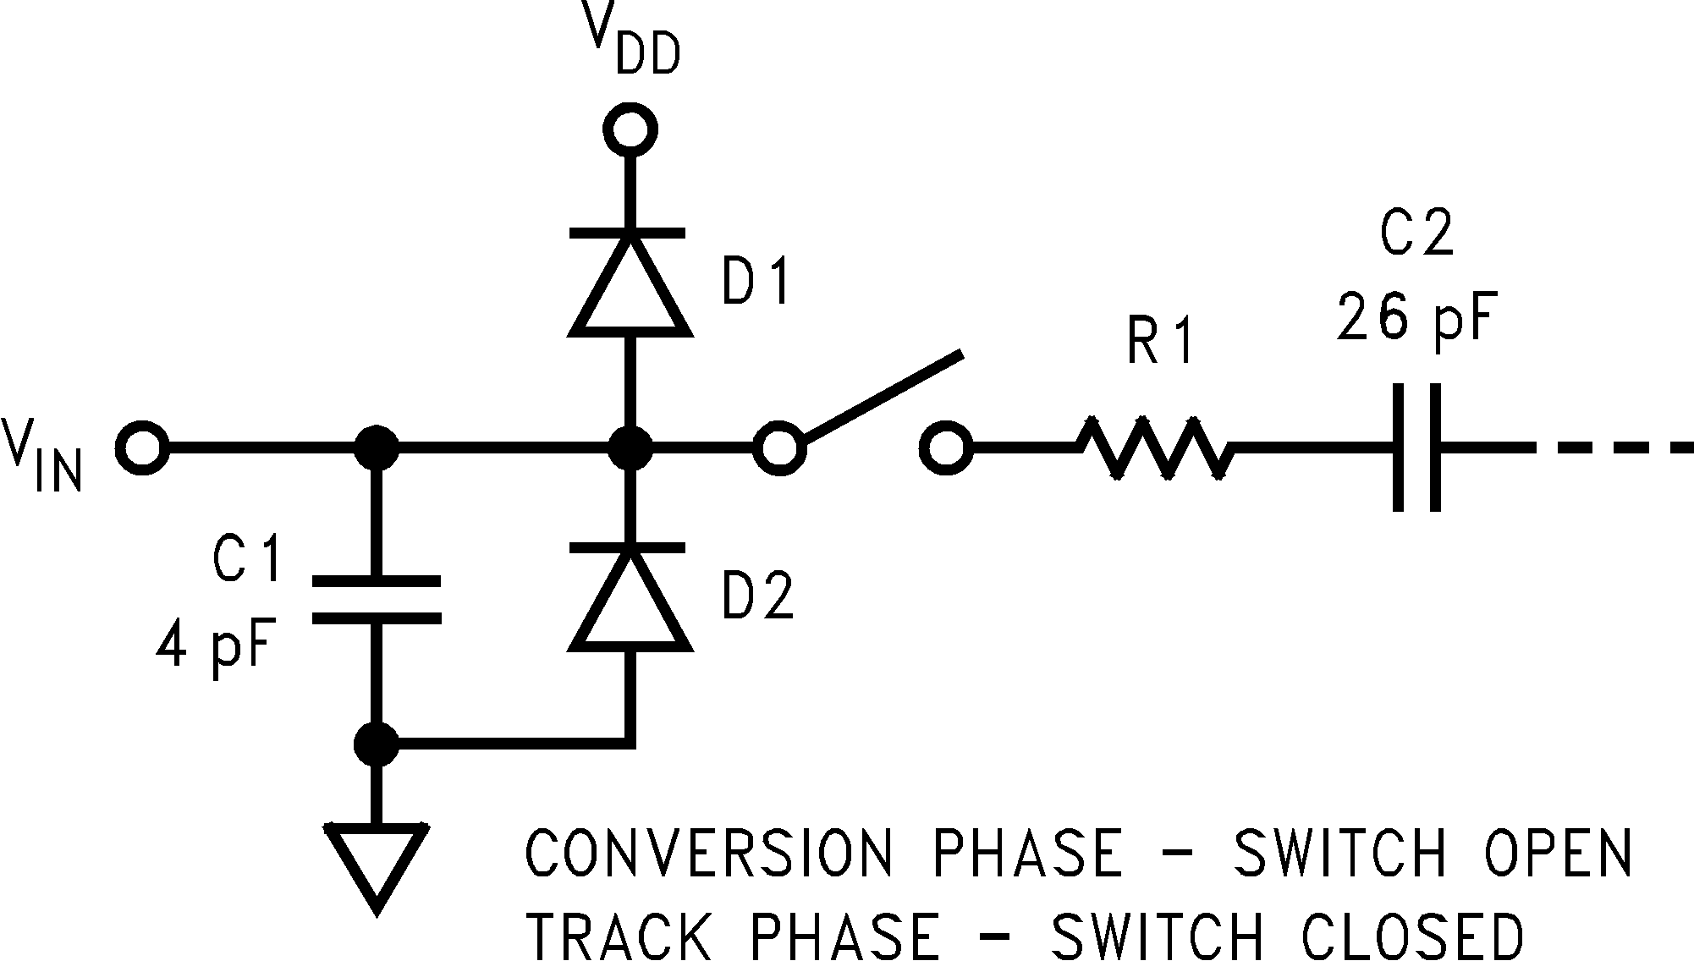
20110214

FIGURE 10. Equivalent Input Circuit

FIGURE 9. Sample Circuit

20110213
6.0 DIGITAL INPUTS AND OUTPUTS
The ADC121S101/101S101/081S101 digital inputs (SCLK and CS) are not limited by the same absolute maximum ratings as the analog inputs. The digital input pins are in- stead limited to +6.5V with respect to GND, regardless of VDD, the supply voltage. This allows the ADC121S101/
ADC121S101/ADC101S101/ADC081S101
101S101/081S101 to be interfaced with a wide range of logic
levels, independent of the supply voltage.

A typical application of the ADC121S101/101S101/081S101 is shown in Figure 8. The combined analog and digital supplies are provided in this example by the National LP2950 low-dropout voltage regulator, available in a variety of fixed and adjustable output voltages. The supply is by- passed with a capacitor network located close to the device. The three-wire interface is also shown connected to a micro- processor or DSP.

5.0 ANALOG INPUTS
An equivalent circuit for the ADC121S101/101S101/
081S101 input channel is shown in Figure 9. The diodes D1 and D2 provide ESD protection for the analog inputs. At no time should an analog input exceed VDD + 300 mV or GND
- 300 mV, as these ESD diodes will begin conducting current
into the substrate and affect ADC operation.
The capacitor C1 in Figure 9 typically has a value of 4 pF, and is mainly due to pin capacitance. The resistor R1 repre- sents the on resistance of the multiplexer and track / hold switch, and is typically 100 ohms. The capacitor C2 is the ADC121S101/101S101/081S101 sampling capacitor, and is typically 26 pF.
The sampling nature of the analog input causes input current pulses that result in voltage spikes at the input. The ADC121S101/101S101/081S101 will deliver best perfor- mance when driven by a low-impedance source to eliminate distortion caused by the charging of the sampling capaci- tance. In applications where dynamic performance is critical, the input might need to be driven with a low output- impedance amplifier. In addition, when using the ADC121S101/101S101/081S101 to sample AC signals, a band-pass or low-pass filter will reduce harmonics and noise and thus improve THD and SNR.
Note that, even though the digital inputs are tolerant of up to
+6.5V above GND, the digital outputs are only capable of driving VDD out. In addition, the digital input pins are not prone to latch-up; SCLK and CS may be asserted before VDD without any risk.

7.0 MODES OF OPERATION
The ADC121S101/101S101/081S101 has two possible modes of operation: normal mode, and shutdown mode. The ADC121S101/101S101/081S101 enters normal mode (and a conversion process is begun) when CS is pulled low. The device will enter shutdown mode if CS is pulled high before the tenth falling edge of SCLK after CS is pulled low, or will stay in normal mode if CS remains low. Once in shutdown mode, the device will stay there until CS is brought low again. By varying the ratio of time spent in the normal and shutdown modes, a system may trade-off throughput for power consumption.

8.0 NORMAL MODE
The best possible throughput is obtained by leaving the ADC121S101/101S101/081S101 in normal mode at all times, so there are no power-up delays. To keep the device in normal mode continuously, CS must be kept low until after the 10th falling edge of SCLK after the start of a conversion (remember that a conversion is initiated by bringing CS low).
If CS is brought high after the 10th falling edge, but before the 16th falling edge, the device will remain in normal mode, but the current conversion will be aborted, and SDATA will return to TRI-STATE (truncating the output word).
Sixteen SCLK cycles are required to read all of a conversion word from the device. After sixteen SCLK cycles have elapsed, CS may be idled either high or low until the next conversion. If CS is idled low, it must be brought high again before the start of the next conversion, which begins when CS is again brought low.
After sixteen SCLK cycles, SDATA returns to TRI-STATE. Another conversion may be started, after tQUIET has elapsed, by bringing CS low again.

19 www.national.com

Applications Information (Continued)
ADC121S101/ADC101S101/ADC081S101

9.0 SHUTDOWN MODE
Shutdown mode is appropriate for applications that either do not sample continuously, or are willing to trade throughput for power consumption. When the ADC121S101/101S101/
081S101 is in shutdown mode, all of the analog circuitry is turned off.
To enter shutdown mode, a conversion must be interrupted by bringing CS back high anytime between the second and

tenth falling edges of SCLK, as shown in Figure 10. Once CS has been brought high in this manner, the device will enter shutdown mode; the current conversion will be aborted and SDATA will enter TRI-STATE. If CS is brought high before the second falling edge of SCLK, the device will not change mode; this is to avoid accidentally changing mode as a result of noise on the CS line.

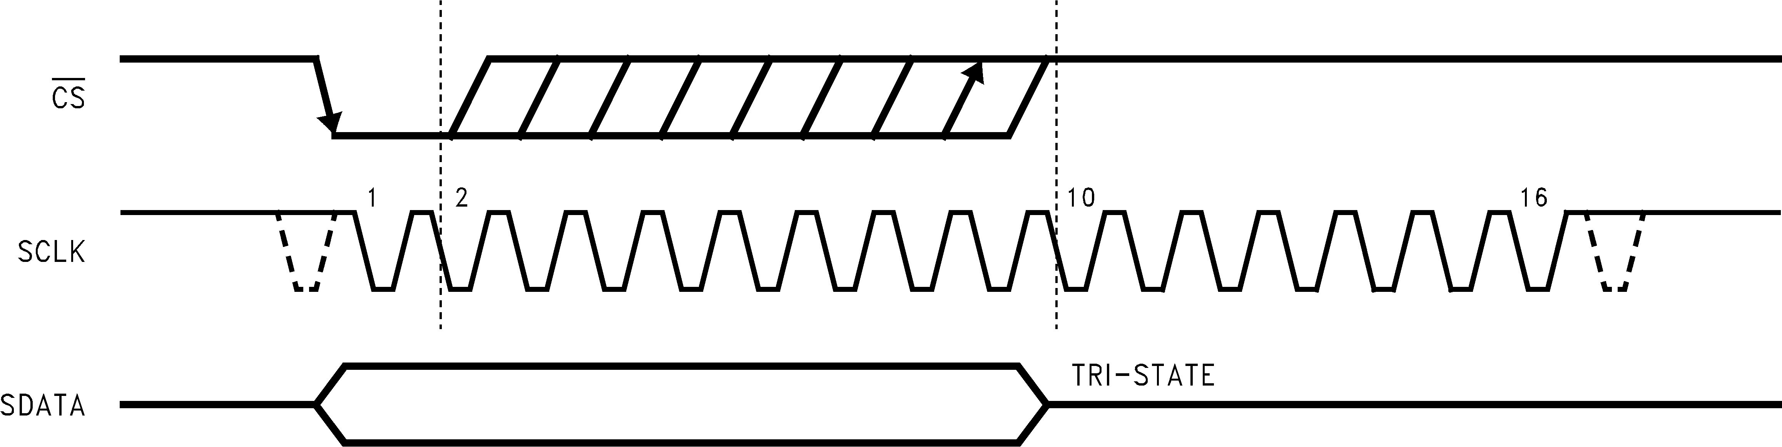
20110216

FIGURE 11. Entering Shutdown Mode

10.0 EXITING SHUTDOWN MODE

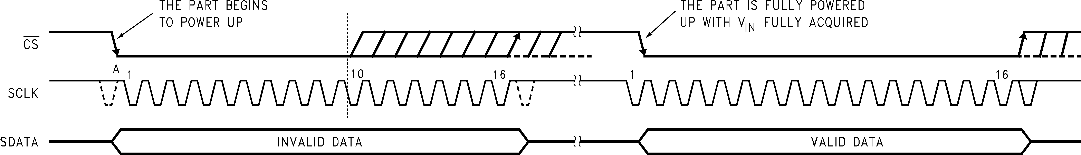
20110217

FIGURE 12. Entering Normal Mode

To exit shutdown mode, bring CS back low. Upon bringing CS low, the ADC121S101/101S101/081S101 will begin pow- ering up. Power up typically takes 1 µs. This microsecond of power-up delay results in the first conversion result being unusable. The second conversion performed after power-up, however, is valid, as shown in Figure 11.
If CS is brought back high before the 10th falling edge of SCLK, the device will return to shutdown mode. This is done to avoid accidentally entering normal mode as a result of noise on the CS line. To exit shutdown mode and remain in normal mode, CS must be kept low until after the 10th falling edge of SCLK. The ADC121S101/101S101/081S101 will be fully powered-up after 16 SCLK cycles.

11.0 POWER-UP TIMING
The ADC121S101/101S101/081S101 typically requires 1 µs to power up, either after first applying VDD, or after returning to normal mode from shutdown mode. This corresponds to one "dummy" conversion for any SCLK frequency within the specifications in this document. After this first dummy con- version, the ADC121S101/101S101/081S101 will perform conversions properly. Note that the tQUIET time must still be included between the first dummy conversion and the sec- ond valid conversion.
12.0 STARTUP MODE
When the VDD supply is first applied, the ADC121S101/
101S101/081S101 may power up in either of the two modes:
normal or shutdown. As such, one dummy conversion should be performed after start-up, exactly as described in Section 11.0. The part may then be placed into either normal mode or the shutdown mode, as described in Sections 8.0 and 9.0.

13.0 POWER MANAGEMENT
When the ADC121S101/101S101/081S101 is operated con- tinuously in normal mode, throughput up to 1 MSPS can be achieved. The user may trade throughput for power con- sumption by simply performing fewer conversions per unit time, and putting the ADC121S101/101S101/081S101 into shutdown mode between conversions. This method is not advantageous beyond 350 kSPS throughput.
A plot of maximum power consumption versus throughput is shown in Figure 12 below. To calculate the power consump- tion for a given throughput, remember that each time the part exits shutdown mode and enters normal mode, one dummy conversion is required. Generally, the user will put the part into normal mode, execute one dummy conversion followed by one valid conversion, and then put the part back into shutdown mode. When this is done, the fraction of time

www.national.com 20

Applications Information (Continued)

spent in normal mode may be calculated by multiplying the throughput (in samples per second) by 2 µs, the time taken to perform one dummy and one valid conversion. The power consumption can then be found by multiplying the fraction of time spent in normal mode by the normal mode power consumption figure. The power dissipated while the part is in shutdown mode is negligible.

For example, to calculate the power consumption at 300 kSPS with VDD = 5V, begin by calculating the fraction of time spent in normal mode: 300,000 samples/second·2 µs= 0.6, or 60%. The power consumption at 300 kSPS is then 60% of
ADC121S101/ADC101S101/ADC081S101
17.5 mW (the maximum power consumption at VDD = 5V) or
10.5 mW.

21 www.national.com

Physical Dimensions inches (millimeters) unless otherwise noted
ADC121S101/ADC101S101/ADC081S101

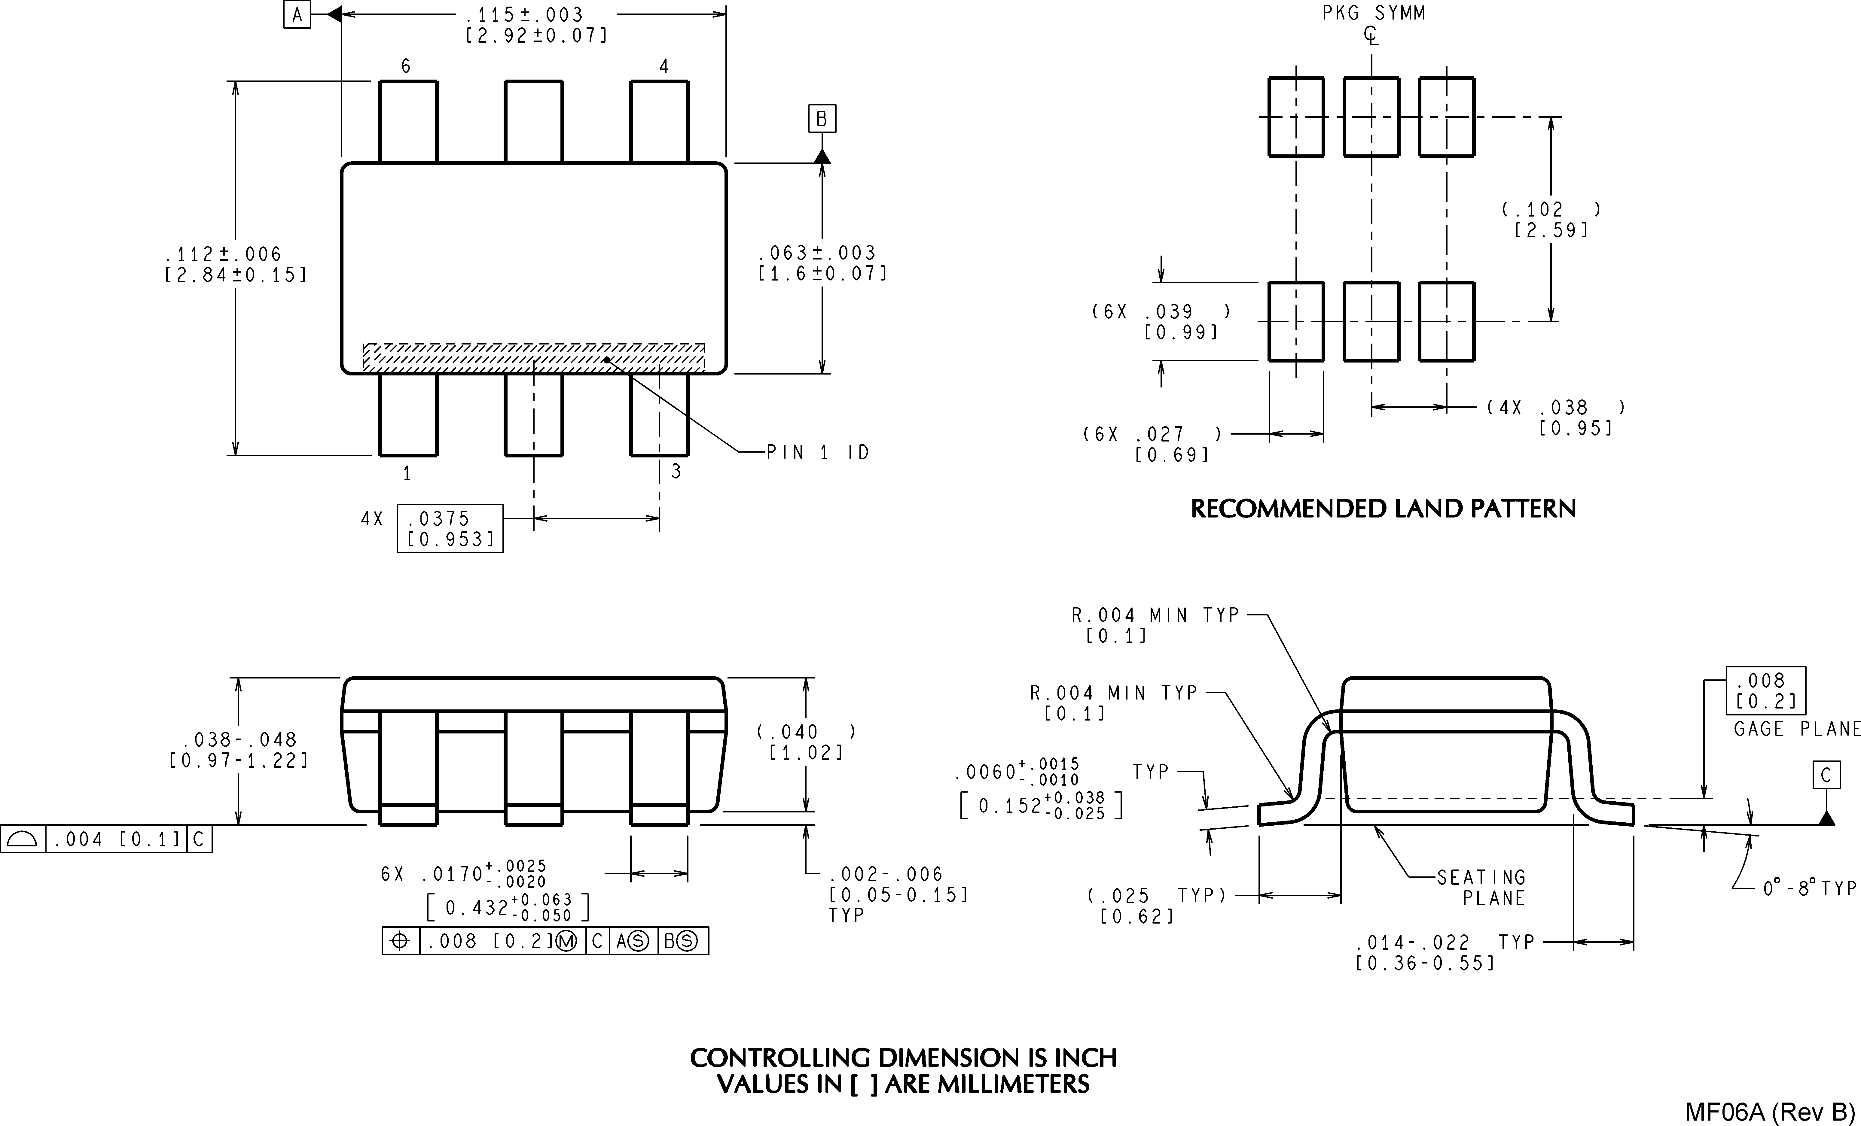

6-Lead SOT-23
Order Number ADC121S101CIMF, ADC121S101CIMFX, ADC101S101CIMF, ADC101S101CIMFX, ADC081S101CIMF or
ADC081S101CIMFX
NS Package Number MF06A

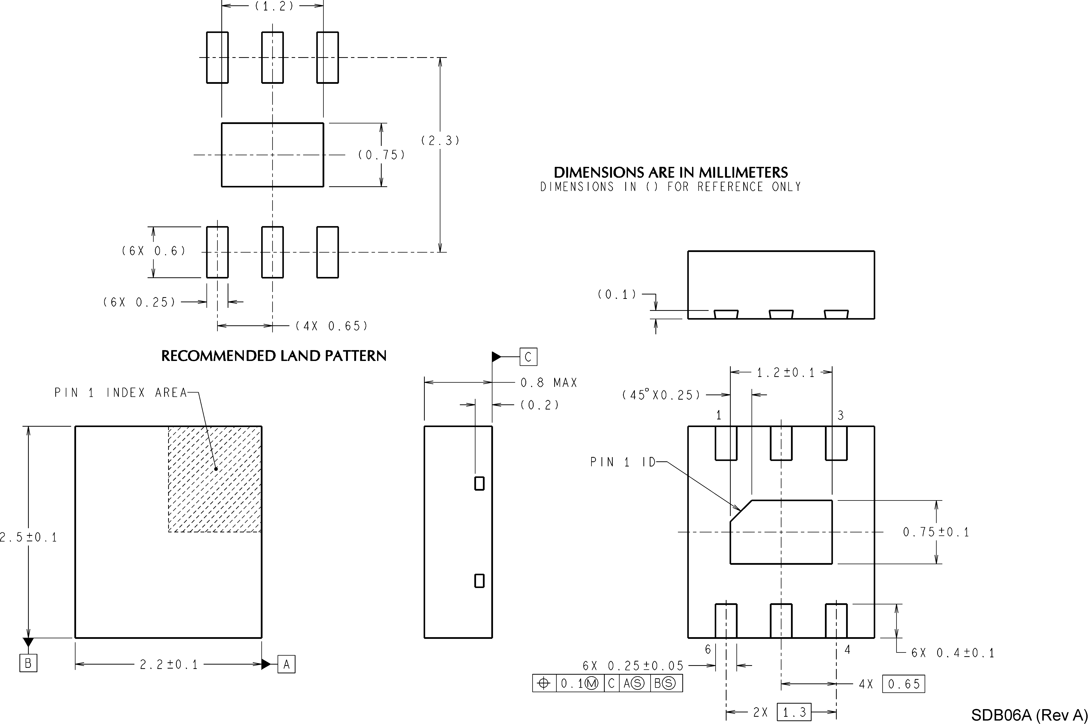

6-Lead LLP
Order Number ADC081S101CISD or ADC081S101CISDX NS Package Number SDB06A

www.national.com 22

ADC121S101/ADC101S101/ADC081S101 1MSPS, 12-/10-/8-Bit A/D Converters in SOT-23 & LLP
Notes
National does not assume any responsibility for use of any circuitry described, no circuit patent licenses are implied and National reserves the right at any time without notice to change said circuitry and specifications.
For the most current product information visit us at www.national.com.
LIFE SUPPORT POLICY
NATIONAL’S PRODUCTS ARE NOT AUTHORIZED FOR USE AS CRITICAL COMPONENTS IN LIFE SUPPORT DEVICES OR SYSTEMS WITHOUT THE EXPRESS WRITTEN APPROVAL OF THE PRESIDENT AND GENERAL COUNSEL OF NATIONAL SEMICONDUCTOR CORPORATION. As used herein:
1. Life support devices or systems are devices or systems 2. A critical component is any component of a life support which, (a) are intended for surgical implant into the body, or device or system whose failure to perform can be reasonably (b) support or sustain life, and whose failure to perform when expected to cause the failure of the life support device or properly used in accordance with instructions for use system, or to affect its safety or effectiveness.
provided in the labeling, can be reasonably expected to result in a significant injury to the user.
BANNED SUBSTANCE COMPLIANCE
National Semiconductor certifies that the products and packing materials meet the provisions of the Customer Products Stewardship Specification (CSP-9-111C2) and the Banned Substances and Materials of Interest Specification (CSP-9-111S2) and contain no ‘‘Banned Substances’’ as defined in CSP-9-111S2.
National Semiconductor National Semiconductor National Semiconductor National Semiconductor Americas Customer Europe Customer Support Center Asia Pacific Customer Japan Customer Support Center Support Center Fax: +49 (0) 180-530 85 86 Support Center Fax: 81-3-5639-7507
Email: new.feedback@nsc.com Email: europe.support@nsc.com Email: ap.support@nsc.com Email: jpn.feedback@nsc.com
Tel: 1-800-272-9959 Deutsch Tel: +49 (0) 69 9508 6208 Tel: 81-3-5639-7560
English Tel: +44 (0) 870 24 0 2171 www.national.com Français Tel: +33 (0) 1 41 91 8790

