June 1999
LM2574/LM2574HV SIMPLE SWITCHER 0.5A Step-Down Voltage Regulator

LM2574/LM2574HV
SIMPLE SWITCHER™ 0.5A Step-Down Voltage Regulator

General Description
The LM2574 series of regulators are monolithic integrated circuits that provide all the active functions for a step-down (buck) switching regulator, capable of driving a 0.5A load with excellent line and load regulation. These devices are available in fixed output voltages of 3.3V, 5V, 12V, 15V, and an adjustable output version.
Requiring a minimum number of external components, these regulators are simple to use and include internal frequency compensation and a fixed-frequency oscillator.
The LM2574 series offers a high-efficiency replacement for popular three-terminal linear regulators. Because of its high efficiency, the copper traces on the printed circuit board are normally the only heat sinking needed.
A standard series of inductors optimized for use with the LM2574 are available from several different manufacturers. This feature greatly simplifies the design of switch-mode power supplies.
Other features include a guaranteed ±4% tolerance on out- put voltage within specified input voltages and output load conditions, and ±10% on the oscillator frequency. External shutdown is included, featuring 50 µA (typical) standby cur- rent. The output switch includes cycle-by-cycle current limit- ing, as well as thermal shutdown for full protection under fault conditions.

Features
n 3.3V, 5V, 12V, 15V, and adjustable output versions
n Adjustable version output voltage range, 1.23V to 37V (57V for HV version) ±4% max over line and load conditions
n Guaranteed 0.5A output current
n Wide input voltage range, 40V, up to 60V for HV version
n Requires only 4 external components
n 52 kHz fixed frequency internal oscillator
n TTL shutdown capability, low power standby mode
n High efficiency
n Uses readily available standard inductors
n Thermal shutdown and current limit protection

Applications
n Simple high-efficiency step-down (buck) regulator
n Efficient pre-regulator for linear regulators
n On-card switching regulators
n Positive to negative converter (Buck-Boost)

Typical Application (Fixed Output Voltage Versions)

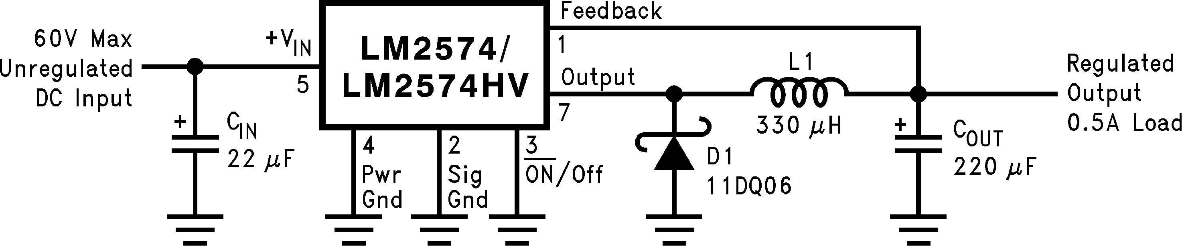

Note: Pin numbers are for 8-pin DIP package.
DS011394-1

Patent Pending
SIMPLE SWITCHER™ is a trademark of National Semiconductor Corporation

© 1999 National Semiconductor Corporation DS011394 www.national.com

Connection Diagrams

8-Lead DIP
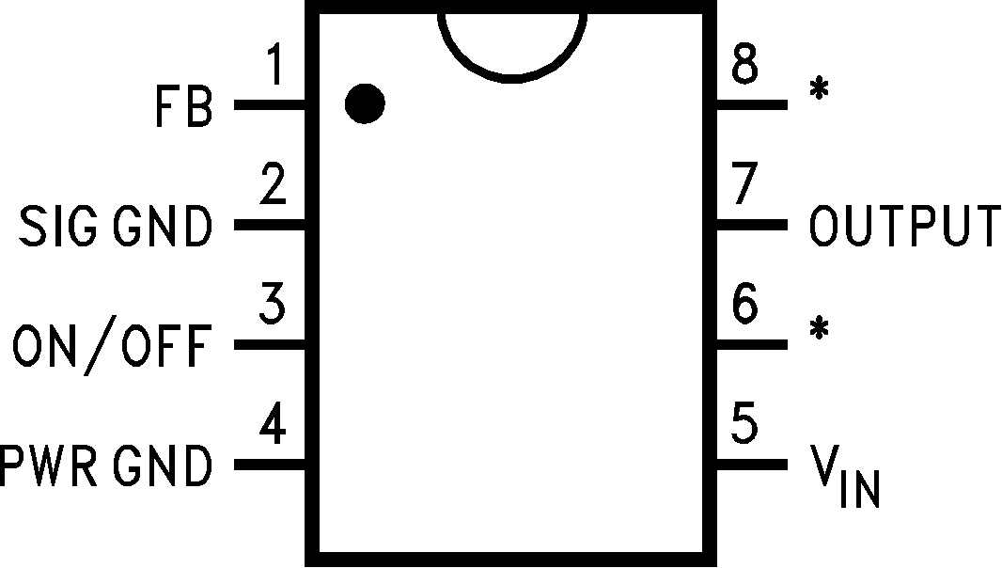
DS011394-2
* No internal connection, but should be soldered to PC board for best heat transfer.
14-Lead Wide
Surface Mount (WM)

Top View
Order Number LM2574-3.3HVN, LM2574HVN-5.0, LM2574HVN-12, LM2574HVN-15, LM2574HVN-ADJ,

Top View

DS011394-3

LM2574N-3.3, LM2574N-5.0, LM2574N-12,
LM2574N-15 or LM2574N-ADJ See NS Package Number N08A
Order Number LM2574HVM-3.3, LM2574HVM-5.0, LM2574HVM-12, LM2574HVM-15, LM2574HVM-ADJ, LM2574M-3.3 LM2574M-5.0, LM2574M-12,
LM2574M-15 or LM2574M-ADJ See NS Package Number M14B

www.national.com 2

Absolute Maximum Ratings (Note 1) Lead Temperature
If Military/Aerospace specified devices are required, (Soldering, 10 seconds) 260˚C please contact the National Semiconductor Sales Office/ Maximum Junction Temperature 150˚C Distributors for availability and specifications. Power Dissipation Internally Limited
Maximum Supply Voltage
LM2574 45V Operating Ratings
LM2574HV 63V Temperature Range
ON /OFF Pin Input Voltage −0.3V V +VIN LM2574/LM2574HV −40˚C TJ +125˚C Output Voltage to Ground Supply Voltage
(Steady State) −1V LM2574 40V Minimum ESD Rating LM2574HV 60V
(C = 100 pF, R = 1.5 k ) 2 kV
Storage Temperature Range −65˚C to +150˚C

LM2574-3.3, LM2574HV-3.3
Electrical Characteristics
Specifications with standard type face are for TJ = 25˚C, and those with boldface type apply over full Operating Tempera- ture Range.
Symbol | Parameter | Conditions | LM2574-3.3  LM2574HV-3.3 |  | Units  (Limits)
Symbol | Parameter | Conditions | Typ | Limit  (Note 2) | Units  (Limits)
SYSTEM PARAMETERS (Note 3) Test Circuit Figure 2
VOUT | Output Voltage | VIN = 12V, ILOAD = 100 mA | 3.3 | 3.234  3.366 | V V(Min) V(Max)
VOUT | Output Voltage  LM2574 | 4.75V VIN 40V, 0.1A ILOAD 0.5A | 3.3 | 3.168/3.135  3.432/3.465 | V V(Min) V(Max)
VOUT | Output Voltage  LM2574HV | 4.75V VIN 60V, 0.1A ILOAD 0.5A | 3.3 | 3.168/3.135  3.450/3.482 | V(Min) V(Max)
 | Efficiency | VIN = 12V, ILOAD = 0.5A | 72 |  | %
LM2574-5.0, LM2574HV-5.0
Electrical Characteristics
Specifications with standard type face are for TJ = 25˚C, and those with boldface type apply over full Operating Tempera- ture Range.
Symbol | Parameter | Conditions | LM2574-5.0  LM2574HV-5.0 |  | Units  (Limits)
Symbol | Parameter | Conditions | Typ | Limit  (Note 2) | Units  (Limits)
SYSTEM PARAMETERS (Note 3) Test Circuit Figure 2
VOUT | Output Voltage | VIN = 12V, ILOAD = 100 mA | 5 | 4.900  5.100 | V V(Min) V(Max)
VOUT | Output Voltage  LM2574 | 7V VIN 40V, 0.1A ILOAD 0.5A | 5 | 4.800/4.750  5.200/5.250 | V V(Min) V(Max)
VOUT | Output Voltage  LM2574HV | 7V VIN 60V, 0.1A ILOAD 0.5A | 5 | 4.800/4.750  5.225/5.275 | V(Min) V(Max)
 | Efficiency | VIN = 12V, ILOAD = 0.5A | 77 |  | %
3 www.national.com

LM2574-12, LM2574HV-12
Electrical Characteristics
Specifications with standard type face are for TJ = 25˚C, and those with boldface type apply over full Operating Tempera- ture Range.
Symbol | Parameter | Conditions | LM2574-12  LM2574HV-12 |  | Units  (Limits)
Symbol | Parameter | Conditions | Typ | Limit  (Note 2) | Units  (Limits)
SYSTEM PARAMETERS (Note 3) Test Circuit Figure 2
VOUT | Output Voltage | VIN = 25V, ILOAD = 100 mA | 12 | 11.76  12.24 | V V(Min) V(Max)
VOUT | Output Voltage  LM2574 | 15V VIN 40V, 0.1A ILOAD 0.5A | 12 | 11.52/11.40  12.48/12.60 | V V(Min) V(Max)
VOUT | Output Voltage  LM2574HV | 15V VIN 60V, 0.1A ILOAD 0.5A | 12 | 11.52/11.40  12.54/12.66 | V(Min) V(Max)
 | Efficiency | VIN = 15V, ILOAD = 0.5A | 88 |  | %
LM2574-15, LM2574HV-15
Electrical Characteristics
Specifications with standard type face are for TJ = 25˚C, and those with boldface type apply over full Operating Tempera- ture Range.
Symbol | Parameter | Conditions | LM2574-15  LM2574HV-15 |  | Units  (Limits)
Symbol | Parameter | Conditions | Typ | Limit  (Note 2) | Units  (Limits)
SYSTEM PARAMETERS (Note 3) Test Circuit Figure 2
VOUT | Output Voltage | VIN = 30V, ILOAD = 100 mA | 15 | 14.70  15.30 | V V(Min) V(Max)
VOUT | Output Voltage  LM2574 | 18V VIN 40V, 0.1A ILOAD 0.5A | 15 | 14.40/14.25  15.60/15.75 | V V(Min) V(Max)
VOUT | Output Voltage  LM2574HV | 18V VIN 60V, 0.1A ILOAD 0.5A | 15 | 14.40/14.25  15.68/15.83 | V(Min) V(Max)
 | Efficiency | VIN = 18V, ILOAD = 0.5A | 88 |  | %
LM2574-ADJ, LM2574HV-ADJ Electrical Characteristics
Specifications with standard type face are for TJ = 25˚C, and those with boldface type apply over full Operating Tempera- ture Range. Unless otherwise specified, VIN = 12V, ILOAD = 100 mA.
Symbol | Parameter | Conditions | LM2574-ADJ LM2574HV-ADJ |  | Units  (Limits)
Symbol | Parameter | Conditions | Typ | Limit  (Note 2) | Units  (Limits)
SYSTEM PARAMETERS (Note 3) Test Circuit Figure 2
VFB | Feedback Voltage | VIN = 12V, ILOAD = 100 mA | 1.230 | 1.217  1.243 | V V(Min) V(Max)
www.national.com 4

LM2574-ADJ, LM2574HV-ADJ Electrical Characteristics (Continued)

Specifications with standard type face are for TJ = 25˚C, and those with boldface type apply over full Operating Tempera- ture Range. Unless otherwise specified, VIN = 12V, ILOAD = 100 mA.
Symbol | Parameter | Conditions |  | LM2574-ADJ LM2574HV-ADJ |  | Units  (Limits)
Symbol | Parameter |  |  | Typ | Limit  (Note 2) | Units  (Limits)
SYSTEM PARAMETERS (Note 3) Test Circuit Figure 2
VFB | Feedback Voltage  LM2574 | 7V VIN 40V, 0.1A ILOAD 0.5A  VOUT Programmed for 5V. Circuit of Figure 2 |  | 1.230 | 1.193/1.180  1.267/1.280 | V V(Min) V(Max)
VFB | Feedback Voltage  LM2574HV | 7V VIN 60V, 0.1A ILOAD 0.5A  VOUT Programmed for 5V. Circuit of Figure 2 |  | 1.230 | 1.193/1.180  1.273/1.286 | V(Min) V(Max)
 | Efficiency | VIN = 12V, VOUT = 5V, ILOAD = 0.5A |  | 77 |  | %
All Output Voltage Versions
Electrical Characteristics
Specifications with standard type face are for TJ = 25˚C, and those with boldface type apply over full Operating Tempera- ture Range. Unless otherwise specified, VIN = 12V for the 3.3V, 5V, and Adjustable version, VIN = 25V for the 12V version, and VIN = 30V for the 15V version. ILOAD = 100 mA.
Symbol | Parameter |  | Conditions | LM2574-XX LM2574HV-XX |  | Units  (Limits)
Symbol |  |  | Conditions | Typ | Limit  (Note 2) | Units  (Limits)
DEVICE PARAMETERS
Ib | Feedback Bias  Current |  | Adjustable Version Only, VOUT = 5V | 50 | 100/500 | nA
fO | Oscillator Frequency |  | (see Note 10) | 52 | 47/42  58/63 | kHz kHz(Min) kHz(Max)
VSAT | Saturation Voltage |  | IOUT = 0.5A (Note 4) | 0.9 | 1.2/1.4 | V V(max)
DC | Max Duty Cycle  (ON) |  | (Note 5) | 98 | 93 | %  %(Min)
ICL | Current Limit |  | Peak Current, (Notes 4, 10) | 1.0 | 0.7/0.65  1.6/1.8 | A A(Min) A(Max)
IL | Output Leakage  Current |  | (Notes 6, 7) Output = 0V Output = −1V Output = −1V | 7.5 | 2  30 | mA(Max) mA mA(Max)
IQ | Quiescent Current |  | (Note 6) | 5 | 10 | mA  mA(Max)
ISTBY | Standby Quiescent  Current |  | ON /OFF Pin= 5V (OFF) | 50 | 200 | µA  µA(Max)
JA JA JA JA | Thermal Resistance |  | N Package, Junction to Ambient (Note 8) N Package, Junction to Ambient (Note 9) M Package, Junction to Ambient (Note 8) M Package, Junction to Ambient (Note 9) | 92  72  102  78 |  | ˚C/W
5 www.national.com

All Output Voltage Versions
Electrical Characteristics (Continued)

Specifications with standard type face are for TJ = 25˚C, and those with boldface type apply over full Operating Tempera- ture Range. Unless otherwise specified, VIN = 12V for the 3.3V, 5V, and Adjustable version, VIN = 25V for the 12V version, and VIN = 30V for the 15V version. ILOAD = 100 mA.
Symbol | Parameter | Conditions | LM2574-XX LM2574HV-XX |  | Units  (Limits)
Symbol | Parameter | Conditions | Typ | Limit  (Note 2) | Units  (Limits)
ON /OFF CONTROL Test Circuit Figure 2
VIH | ON /OFF Pin Logic  Input Level | VOUT = 0V | 1.4 | 2.2/2.4 | V(Min)
VIL | ON /OFF Pin Logic  Input Level | VOUT = Nominal Output Voltage | 1.2 | 1.0/0.8 | V(Max)
IH | ON /OFF Pin Input  Current | ON /OFF Pin = 5V (OFF) | 12 | 30 | µA  µA(Max)
IIL | ON /OFF Pin Input  Current | ON /OFF Pin = 0V (ON) | 0 | 10 | µA  µA(Max)
Note 1: Absolute Maximum Ratings indicate limits beyond which damage to the device may occur. Operating Ratings indicate conditions for which the device is in- tended to be functional, but do not guarantee specific performance limits. For guaranteed specifications and test conditions, see the Electrical Characteristics.
Note 2: All limits guaranteed at room temperature (Standard type face) and at temperature extremes (bold type face). All room temperature limits are 100% produc- tion tested. All limits at temperature extremes are guaranteed via correlation using standard Statistical Quality Control (SQC) methods. All limits are used to calculate Average Outgoing Quality Level.
Note 3: External components such as the catch diode, inductor, input and output capacitors can affect switching regulator system performance. When the LM2574 is used as shown in the Figure 2 test circuit, system performance will be as shown in system parameters section of Electrical Characteristics.
Note 4: Output pin sourcing current. No diode, inductor or capacitor connected to output pin.
Note 5: Feedback pin removed from output and connected to 0V.
Note 6: Feedback pin removed from output and connected to +12V for the Adjustable, 3.3V, and 5V versions, and +25V for the 12V and 15V versions, to force the output transistor OFF.
Note 7: VIN = 40V (60V for high voltage version).
Note 8: Junction to ambient thermal resistance with approximately 1 square inch of printed circuit board copper surrounding the leads. Additional copper area will lower thermal resistance further. See application hints in this data sheet and the thermal model in Switchers Made Simple software.
Note 9: Junction to ambient thermal resistance with approximately 4 square inches of 1 oz. (0.0014 in. thick) printed circuit board copper surrounding the leads. Ad- ditional copper area will lower thermal resistance further. (See Note 8.)
Note 10: The oscillator frequency reduces to approximately 18 kHz in the event of an output short or an overload which causes the regulated output voltage to drop approximately 40% from the nominal output voltage. This self protection feature lowers the average power dissipation of the IC by lowering the minimum duty cycle from 5% down to approximately 2%.

Typical Performance Characteristics (Circuit of Figure 2)

Normalized Output Voltage Line Regulation Dropout Voltage
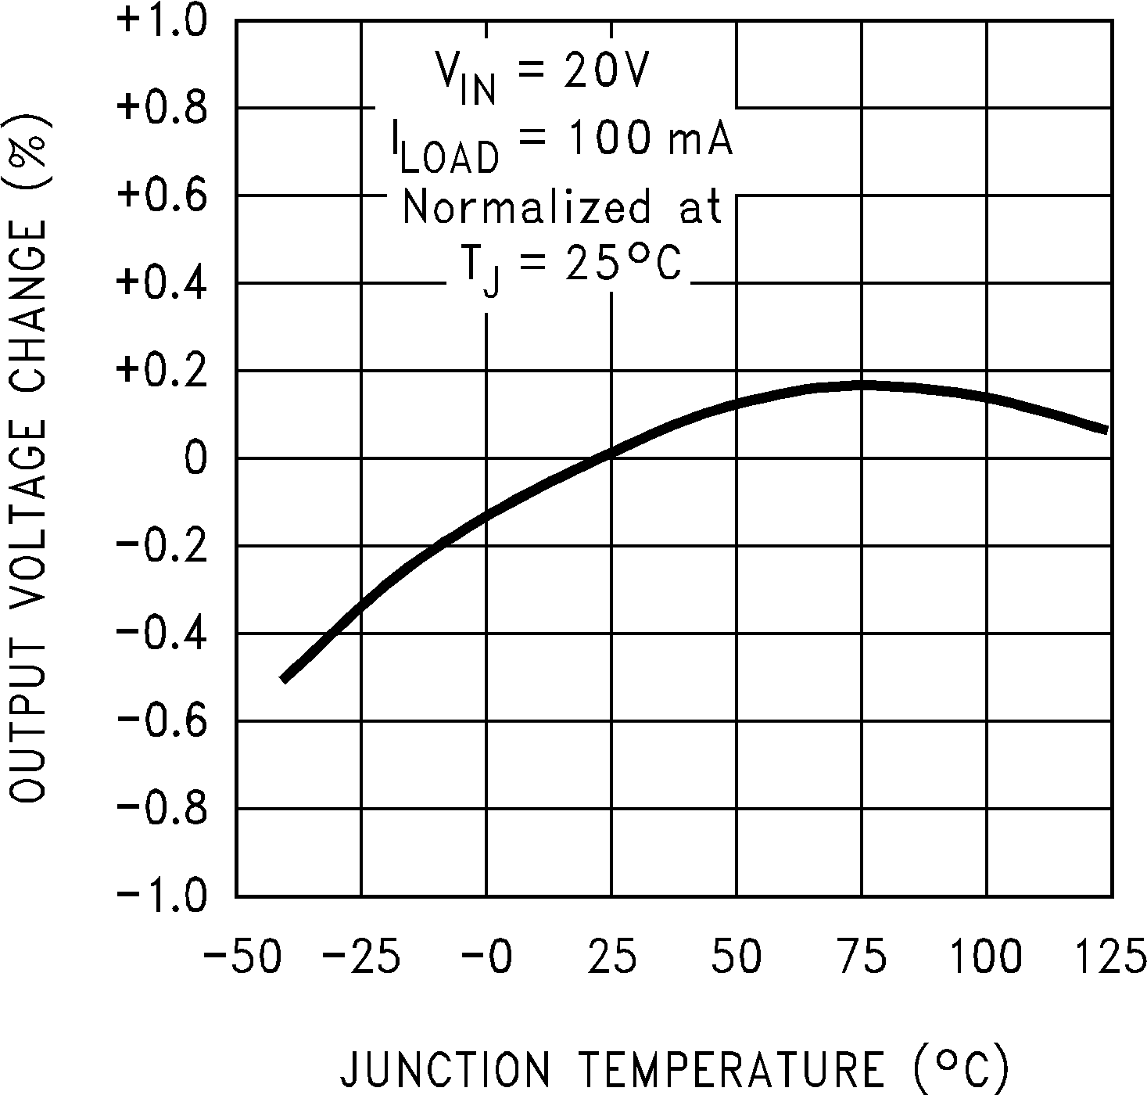
DS011394-27 DS011394-28 DS011394-29
www.national.com 6

Typical Performance Characteristics (Circuit of Figure 2) (Continued)

Current Limit

DS011394-30
Supply Current

DS011394-31
Standby
Quiescent Current

DS011394-32

Oscillator Frequency

DS011394-33
Switch Saturation
Voltage

DS011394-34
Efficiency

DS011394-35

Minimum Operating Voltage
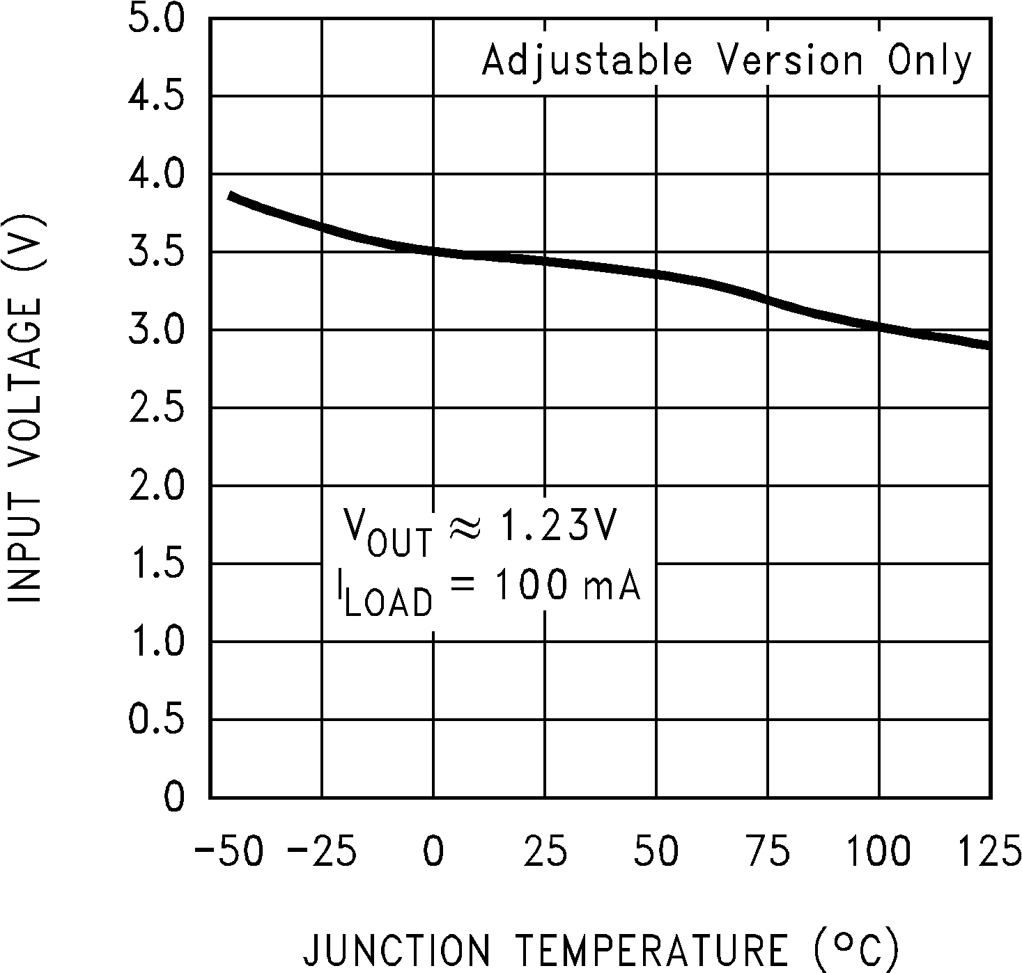
DS011394-36
Supply Current vs Duty Cycle

DS011394-37
Feedback Voltage vs Duty Cycle

DS011394-38

7 www.national.com

Typical Performance Characteristics (Circuit of Figure 2) (Continued)

Feedback
Pin Current

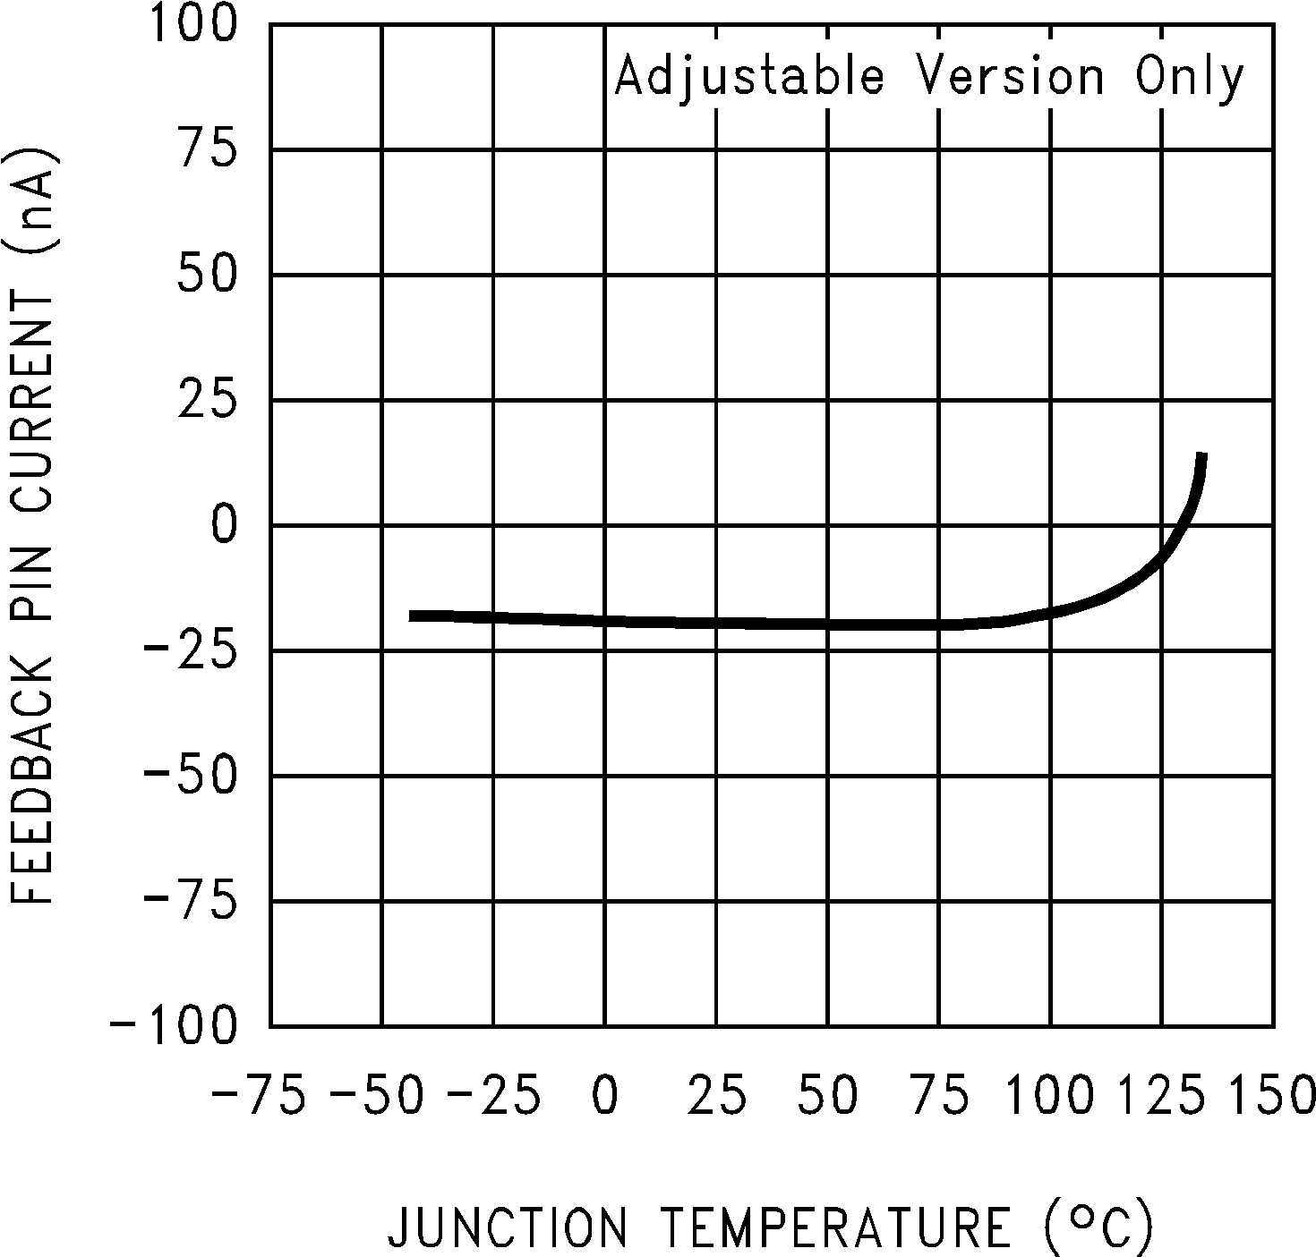
DS011394-39
Junction to Ambient
Thermal Resistance

DS011394-40

Continuous Mode Switching Waveforms
VOUT = 5V, 500 mA Load Current, L = 330 µH
Discontinuous Mode Switching Waveforms
VOUT = 5V, 100 mA Load Current, L = 100 µH

Notes:
A: Output Pin Voltage, 10V/div
B: Inductor Current, 0.2 A/div
C: Output Ripple Voltage, 20 mV/div, AC-Coupled
Horizontal Time Base: 5 µs/div
DS011394-6

Notes:
A: Output Pin Voltage, 10V/div
B: Inductor Current, 0.2 A/div
C: Output Ripple Voltage, 20 mV/div, AC-Coupled
Horizontal Time Base: 5 µs/div
DS011394-7

500 mA Load Transient Response for Continuous
Mode Operation. L = 330 µH, COUT = 300 µF
250 mA Load Transient Response for Discontinuous
Mode Operation. L = 68 µH, COUT = 470 µF

Notes:
A: Output Voltage, 50 mV/div. AC Coupled
B: 100 mA to 500 mA Load Pulse
Horizontal Time Base: 200 µs/div
DS011394-8

Notes:
A: Output Voltage, 50 mV/div. AC Coupled
B: 50 mA to 250 mA Load Pulse
Horizontal Time Base: 200 µs/div
DS011394-9

www.national.com 8

Block Diagram

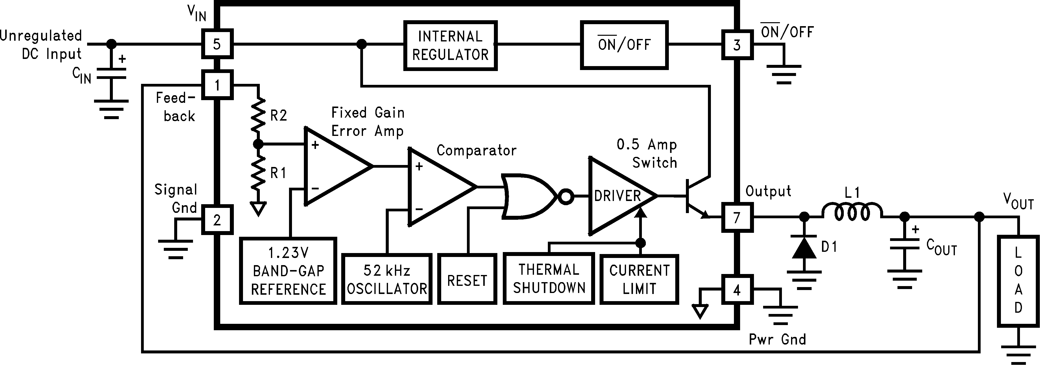

R1 = 1k
3.3V, R2 = 1.7k
5V, R2 = 3.1k
12V, R2 = 8.84k
15V, R2 = 11.3k
For Adj. Version
R1 = Open, R2 = 0
Note: Pin numbers are for the 8-pin DIP package.

FIGURE 1.
DS011394-10

9 www.national.com

Test Circuit and Layout Guidelines

Fixed Output Voltage Versions
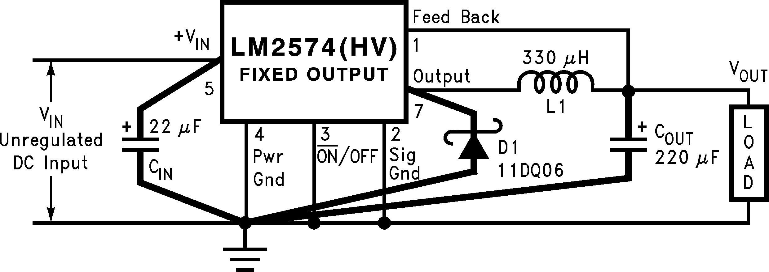

CIN — 22 µF, 75V
Aluminum Electrolytic
COUT — 220 µF, 25V
Aluminum Electrolytic
D1 — Schottky, 11DQ06
L1 — 330 µH, 52627
(for 5V in, 3.3V out, use
100 µH, RL-1284-100) R1 — 2k, 0.1%
R2 — 6.12k, 0.1%
DS011394-11

Adjustable Output Voltage Version

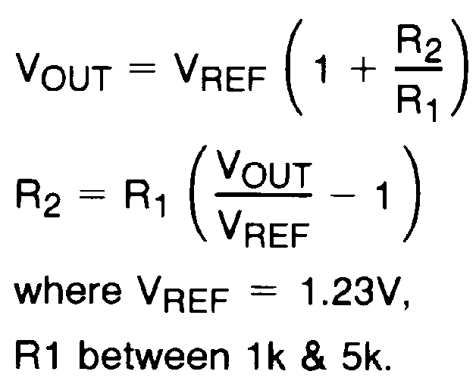
FIGURE 2.
As in any switching regulator, layout is very important. Rap- idly switching currents associated with wiring inductance generate voltage transients which can cause problems. For minimal inductance and ground loops, the length of the leads indicated by heavy lines should be kept as short as pos- sible. Single-point grounding (as indicated) or ground plane construction should be used for best results. When using the Adjustable version, physically locate the programming resis- tors near the regulator, to keep the sensitive feedback wiring short.

DS011394-12

www.national.com 10

Test Circuit and Layout Guidelines
U.S. Source
Note 1: Pulse Engineering, (619) 674-8100
P.O. Box 12236, San Diego, CA 92112

Note 2: Renco Electronics Inc., (516) 586-5566
60 Jeffryn Blvd. East, Deer Park, NY 11729
*Contact Manufacturer
European Source
Note 3: NPI/APC +44 (0) 634 290588
47 Riverside, Medway City Estate
Strood, Rochester, Kent ME2 4DP. UK

*Contact Manufacturer

(Continued)

Inductor  Value | Pulse Eng.  (Note 1) | Renco  (Note 2) | NPI  (Note 3)
68 µH  100 µH  150 µH  220 µH  330 µH  470 µH  680 µH  1000 µH  1500 µH  2200 µH | *  *  52625  52626  52627  52628  52629  52631  *  * | RL-1284-68-43  RL-1284-100-43  RL-1284-150-43  RL-1284-220-43  RL-1284-330-43  RL-1284-470-43  RL-1283-680-43  RL-1283-1000-43  RL-1283-1500-43  RL-1283-2200-43 | NP5915  NP5916  NP5917  NP5918/5919  NP5920/5921  NP5922  NP5923  *  *  *
FIGURE 3. Inductor Selection by
Manufacturer’s Part Number

11 www.national.com

LM2574 Series Buck Regulator Design Procedure
PROCEDURE (Fixed Output Voltage Versions) | EXAMPLE (Fixed Output Voltage Versions)
Given:  VOUT = Regulated Output Voltage (3.3V, 5V, 12V, or 15V) VIN(Max) = Maximum Input Voltage  ILOAD(Max) = Maximum Load Current  1. Inductor Selection (L1)  A. Select the correct Inductor value selection guide from Fig- ures 4, 5, 6, or Figure 7. (Output voltages of 3.3V, 5V, 12V or  15V respectively). For other output voltages, see the design procedure for the adjustable version.  B. From the inductor value selection guide, identify the induc- tance region intersected by VIN(Max) and ILOAD(Max).  C. Select an appropriate inductor from the table shown in Fig- ure 3. Part numbers are listed for three inductor manufactur- ers. The inductor chosen must be rated for operation at the LM2574 switching frequency (52 kHz) and for a current rating of 1.5 x ILOAD. For additional inductor information, see the in- ductor section in the Application Hints section of this data sheet.  2. Output Capacitor Selection (COUT)  A. The value of the output capacitor together with the inductor defines the dominate pole-pair of the switching regulator loop. For stable operation and an acceptable output ripple voltage, (approximately 1% of the output voltage) a value between  100 µF and 470 µF is recommended.  B. The capacitor’s voltage rating should be at least 1.5 times greater than the output voltage. For a 5V regulator, a rating of at least 8V is appropriate, and a 10V or 15V rating is recom- mended.  Higher voltage electrolytic capacitors generally have lower ESR numbers, and for this reason it may be necessary to se- lect a capacitor rated for a higher voltage than would normally be needed.  3. Catch Diode Selection (D1)  A. The catch-diode current rating must be at least 1.5 times greater than the maximum load current. Also, if the power supply design must withstand a continuous output short, the diode should have a current rating equal to the maximum cur- rent limit of the LM2574. The most stressful condition for this diode is an overload or shorted output condition.  B. The reverse voltage rating of the diode should be at least  1.25 times the maximum input voltage.  4. Input Capacitor (CIN)  An aluminum or tantalum electrolytic bypass capacitor located close to the regulator is needed for stable operation. | Given: VOUT = 5V VIN(Max) = 15V ILOAD(Max) = 0.4A  1. Inductor Selection (L1)  A. Use the selection guide shown in Figure 5.  B. From the selection guide, the inductance area intersected by the 15V line and 0.4A line is 330.  C. Inductor value required is 330 µH. From the table in Figure  3, choose Pulse Engineering PE-52627, Renco RL-1284-330, or NPI NP5920/5921.  2. Output Capacitor Selection (COUT)  A. COUT = 100 µF to 470 µF standard aluminum electrolytic.  B. Capacitor voltage rating = 20V.  3. Catch Diode Selection (D1)  A. For this example, a 1A current rating is adequate.  B. Use a 20V 1N5817 or SR102 Schottky diode, or any of the suggested fast-recovery diodes shown in Figure 9.  4. Input Capacitor (CIN)  A 22 µF aluminum electrolytic capacitor located near the input and ground pins provides sufficient bypassing.
www.national.com 12

LM2574 Series Buck Regulator Design Procedure (Continued)

INDUCTOR VALUE SELECTION GUIDES (For Continuous Mode Operation)

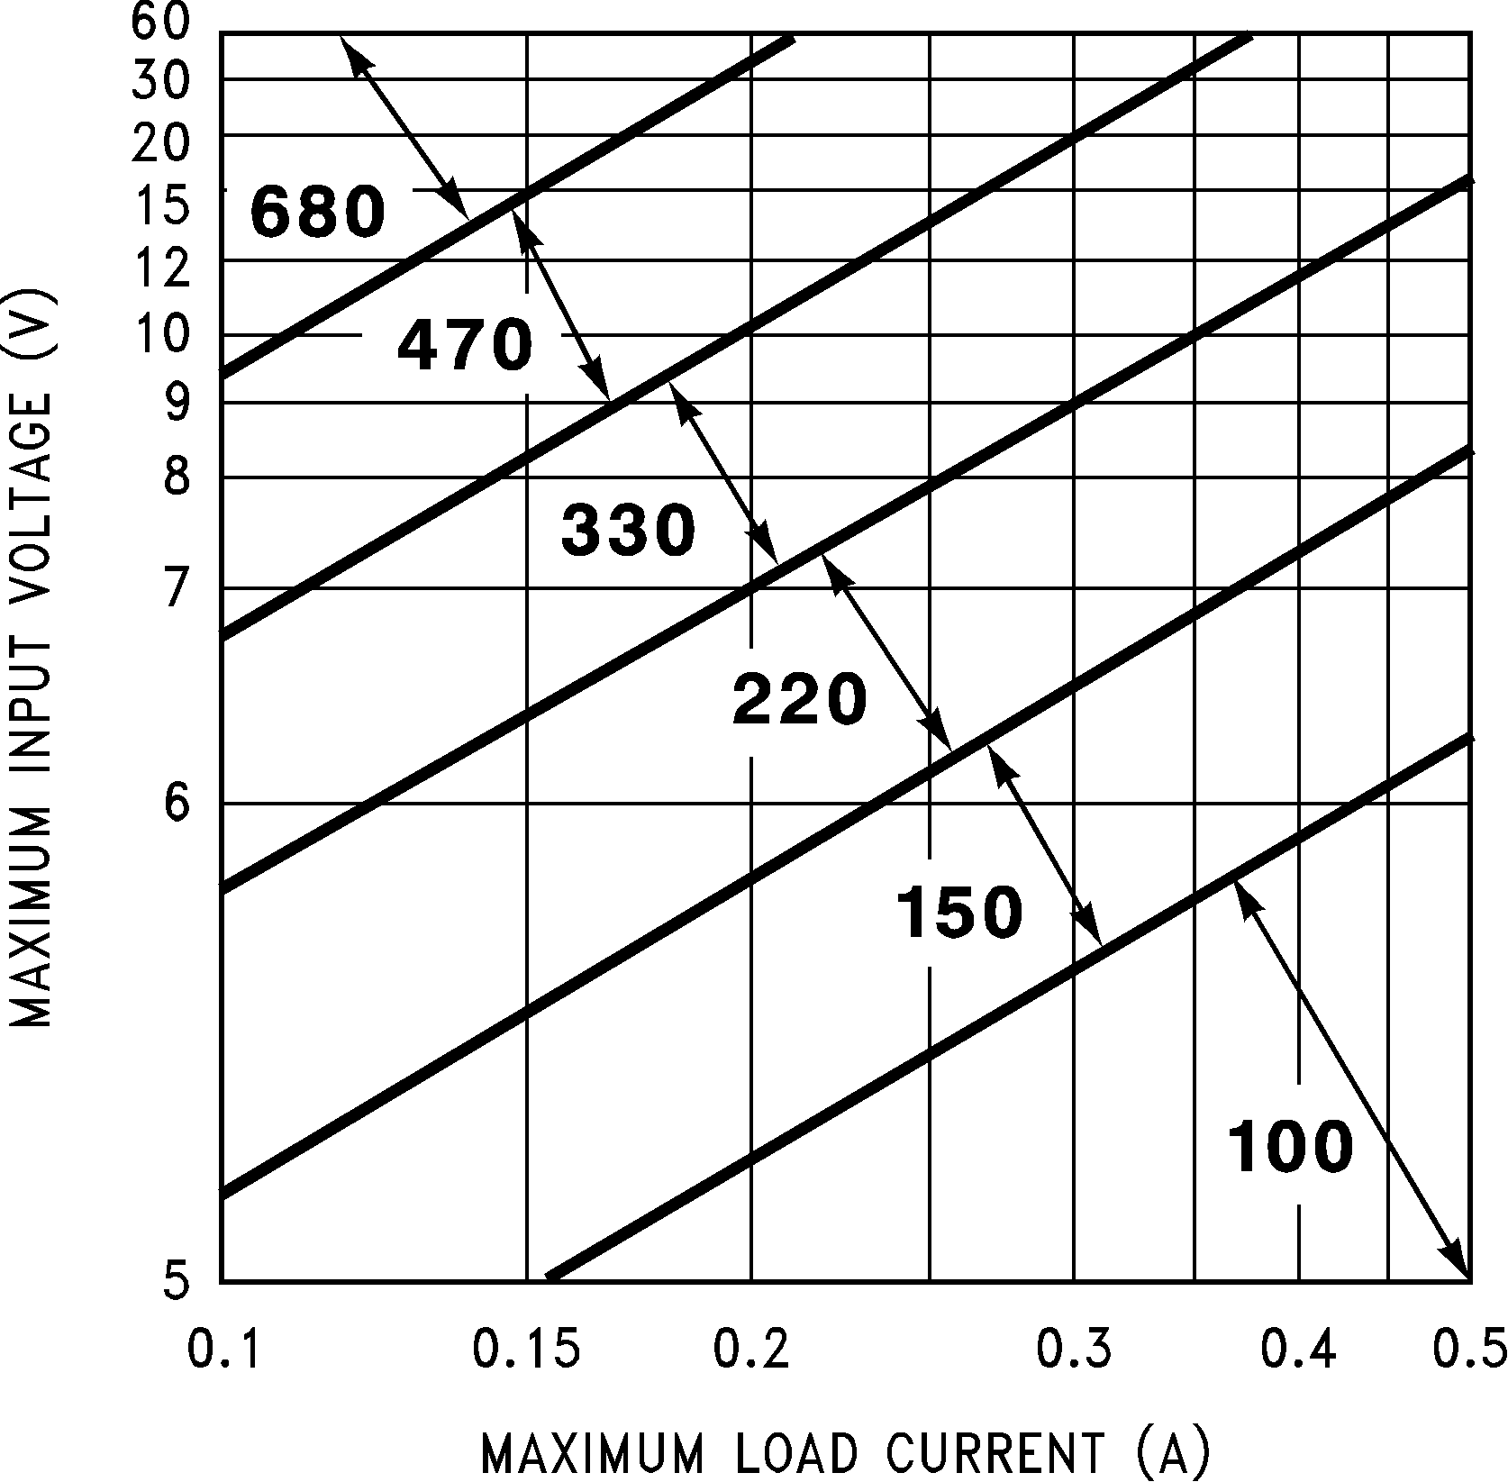

DS011394-26
FIGURE 4. LM2574HV-3.3 Inductor Selection Guide

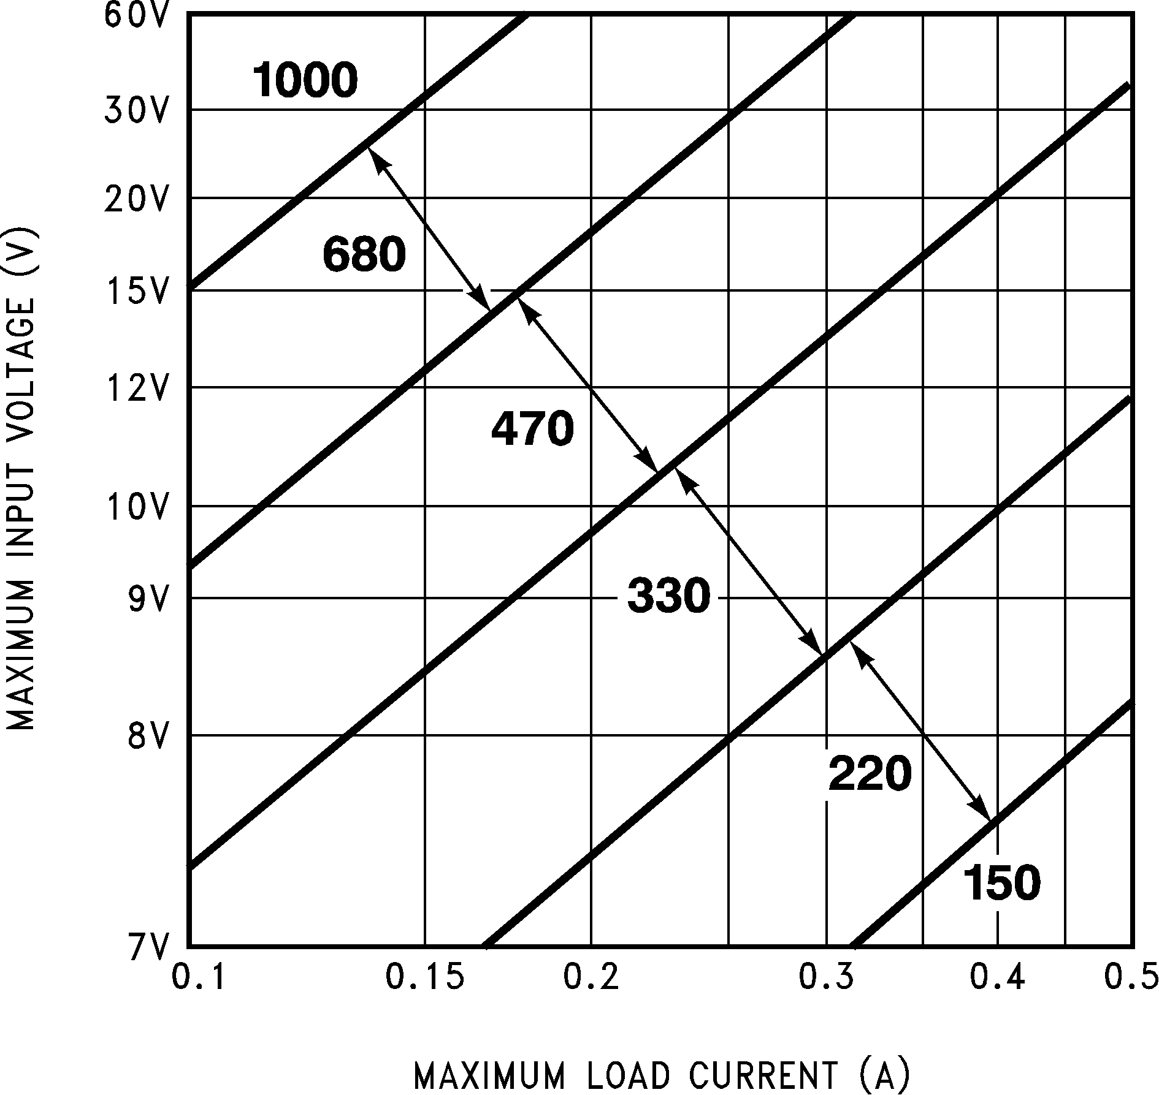
DS011394-13
FIGURE 5. LM2574HV-5.0 Inductor Selection Guide

DS011394-14
FIGURE 6. LM2574HV-12 Inductor Selection Guide

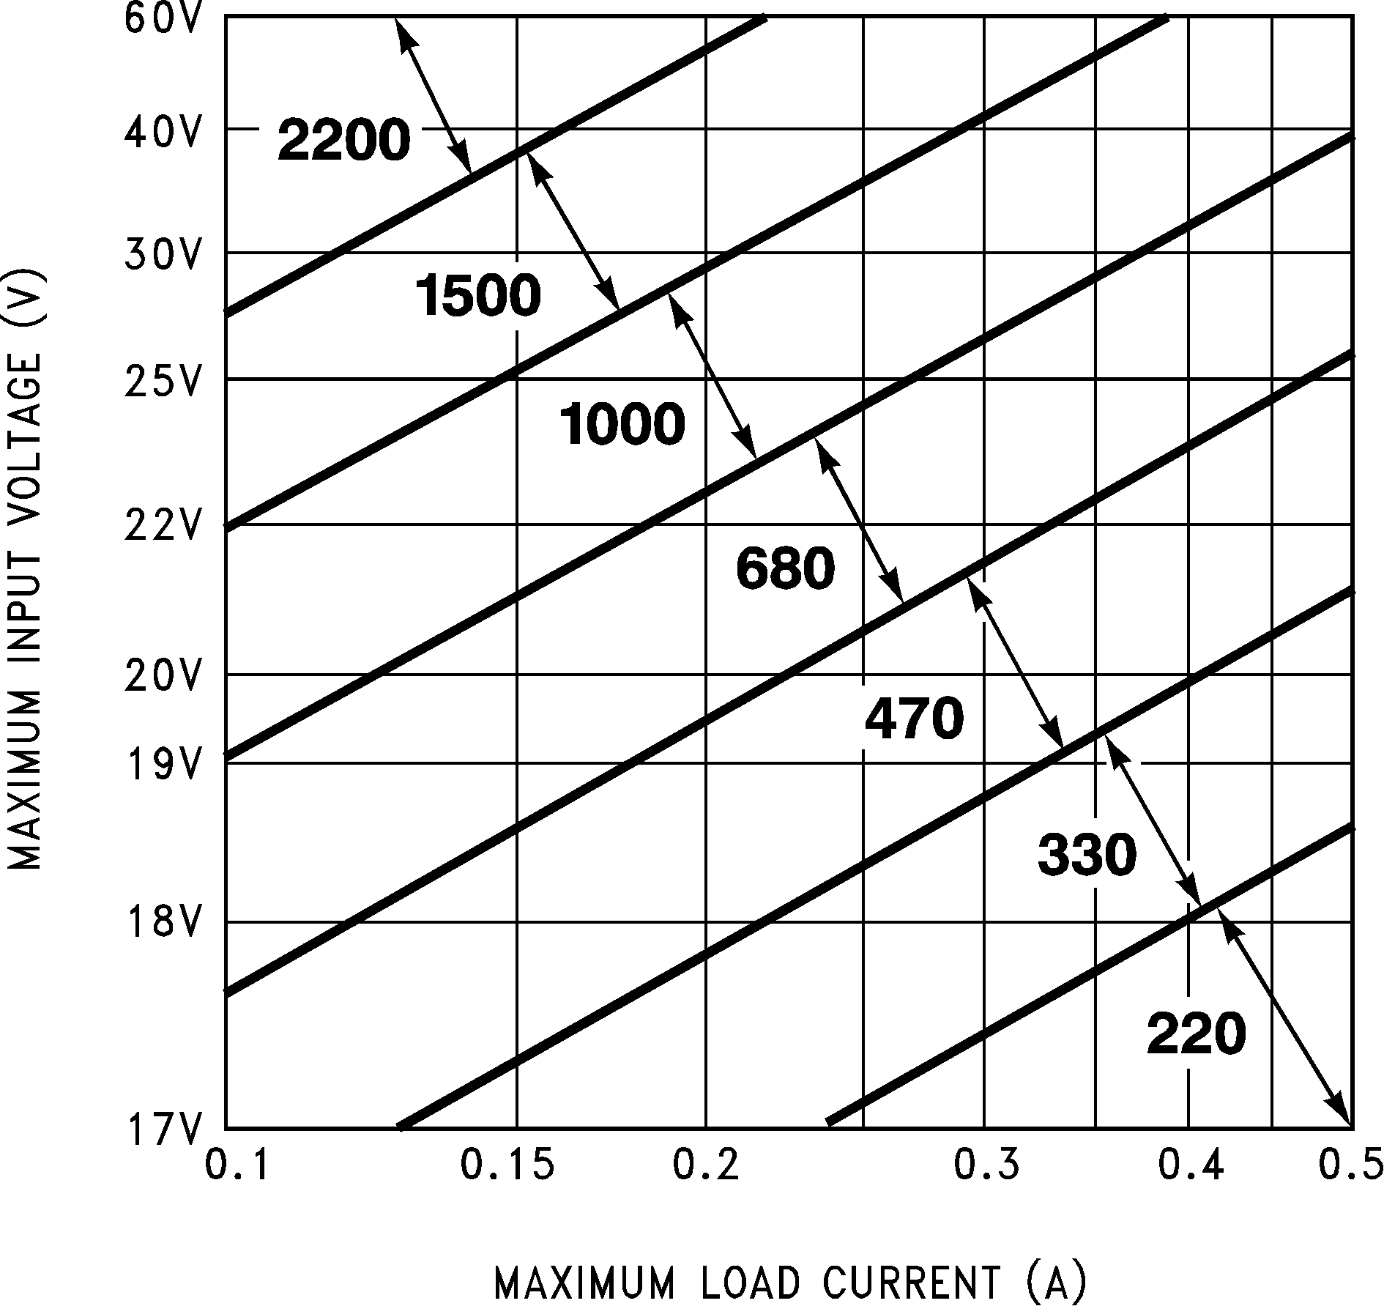
DS011394-15
FIGURE 7. LM2574HV-15 Inductor Selection Guide

13 www.national.com

LM2574 Series Buck Regulator Design Procedure (Continued)

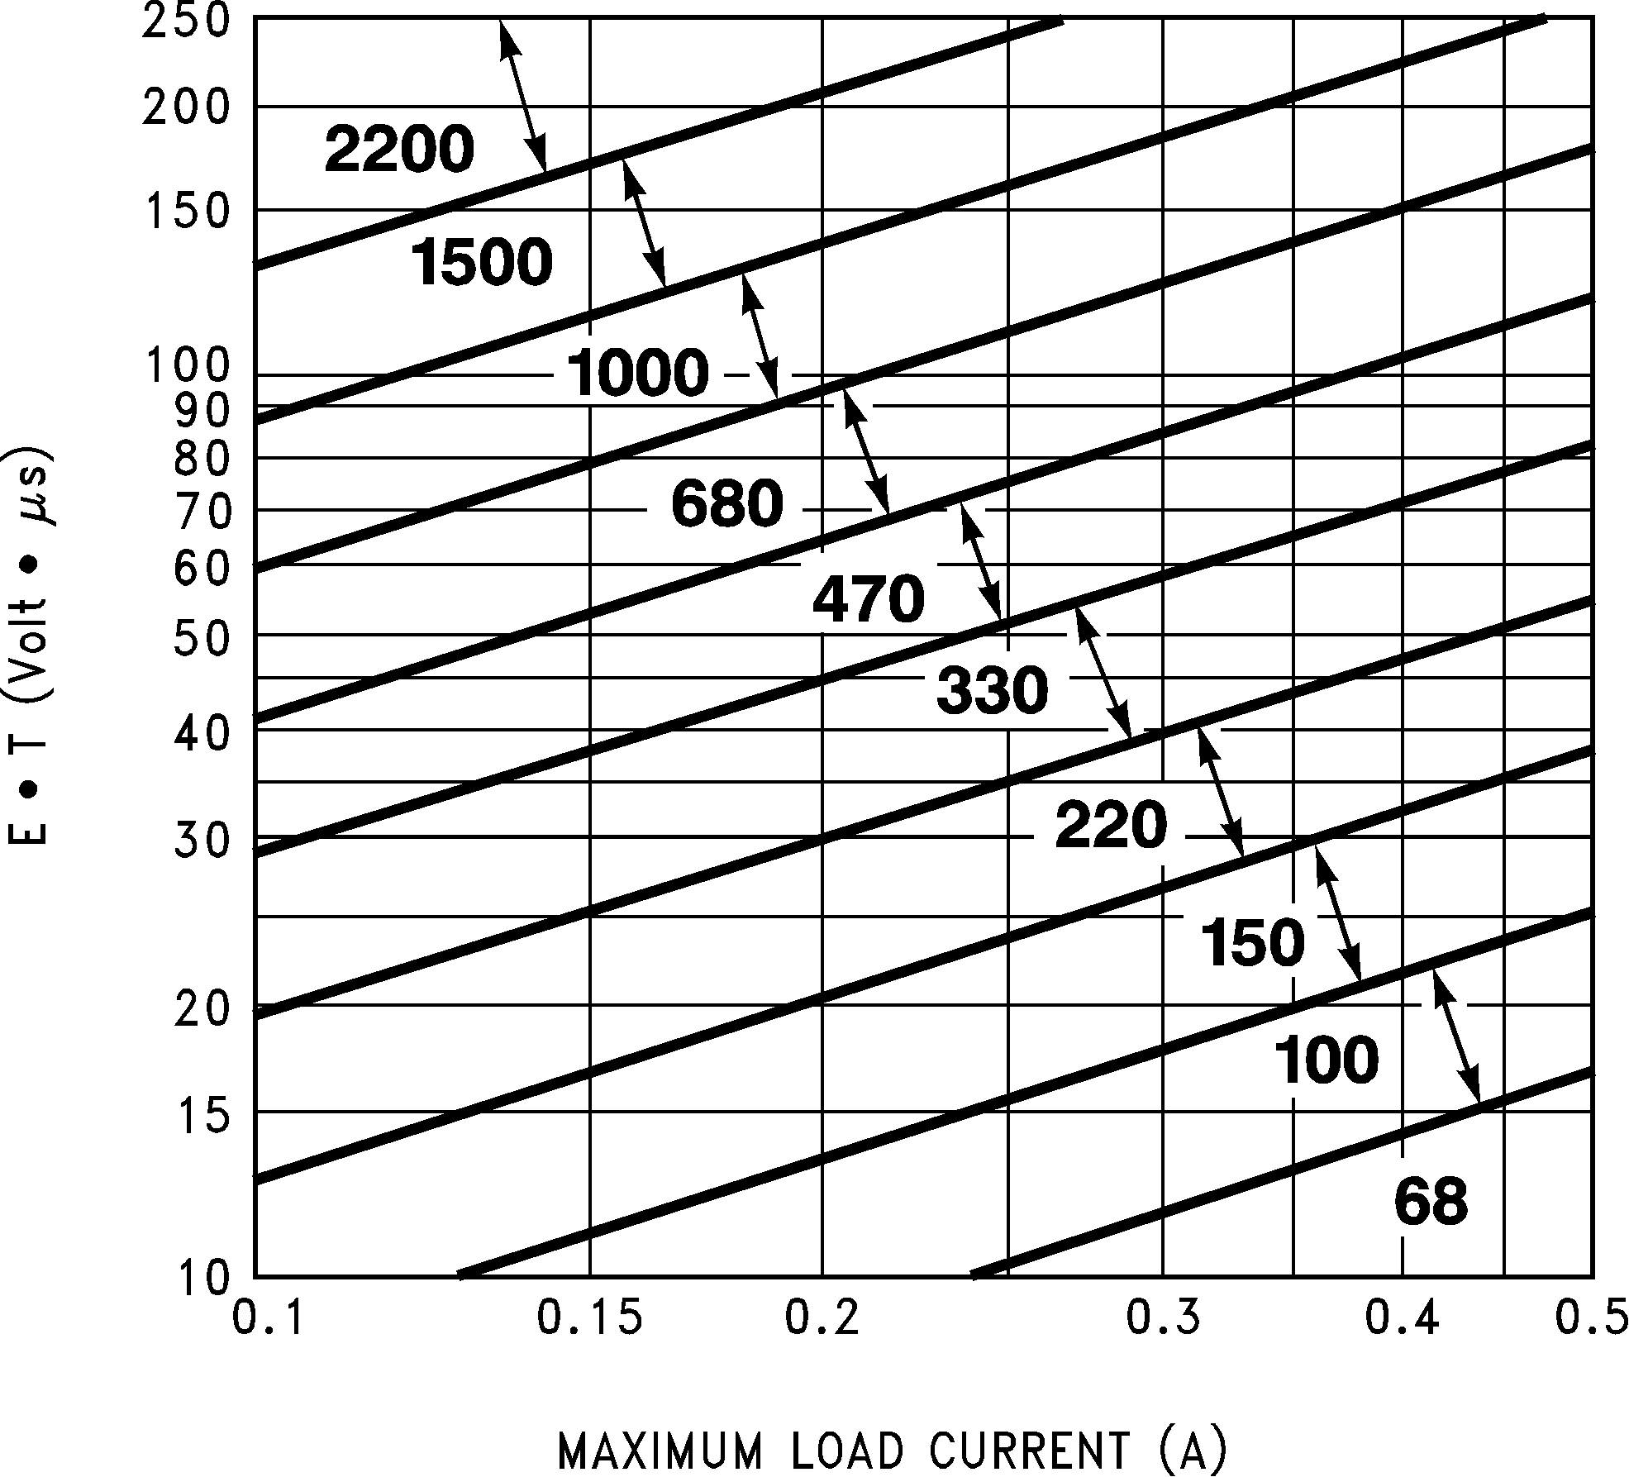
DS011394-16
FIGURE 8. LM2574HV-ADJ Inductor Selection Guide
PROCEDURE (Adjustable Output Voltage Versions) | EXAMPLE (Adjustable Output Voltage Versions)
Given:  VOUT = Regulated Output Voltage VIN(Max) = Maximum Input Voltage ILOAD(Max) = Maximum Load Current  F = Switching Frequency (Fixed at 52 kHz)  1. Programming Output Voltage (Selecting R1 and R2, as shown in Figure 2)  Use the following formula to select the appropriate resistor values.  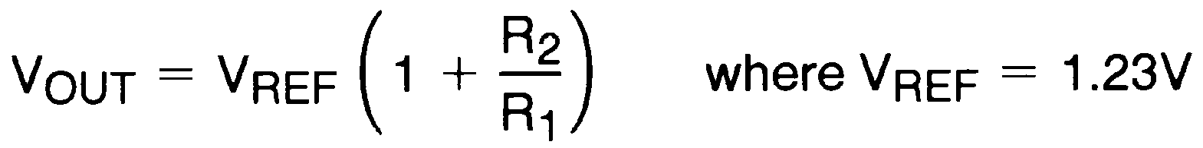  R1 can be between 1k and 5k. (For best temperature coeffi- cient and stability with time, use 1% metal film resistors)  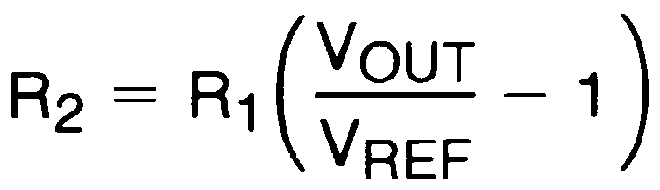  2. Inductor Selection (L1)  A. Calculate the inductor Volt • microsecond constant, E • T (V • µs), from the following formula:    B. Use the E • T value from the previous formula and match it with the E • T number on the vertical axis of the Inductor Value Selection Guide shown in Figure 8.  C. On the horizontal axis, select the maximum load current.  D. Identify the inductance region intersected by the E • T value and the maximum load current value, and note the in- ductor value for that region.  E. Select an appropriate inductor from the table shown in Fig- ure 3. Part numbers are listed for three inductor manufactur- ers. The inductor chosen must be rated for operation at the LM2574 switching frequency (52 kHz) and for a current rating of 1.5 x ILOAD. For additional inductor information, see the in- ductor section in the application hints section of this data sheet. | Given:  VOUT = 24V VIN(Max) = 40V ILOAD(Max) = 0.4A F = 52 kHz  1. Programming Output Voltage (Selecting R1 and R2)  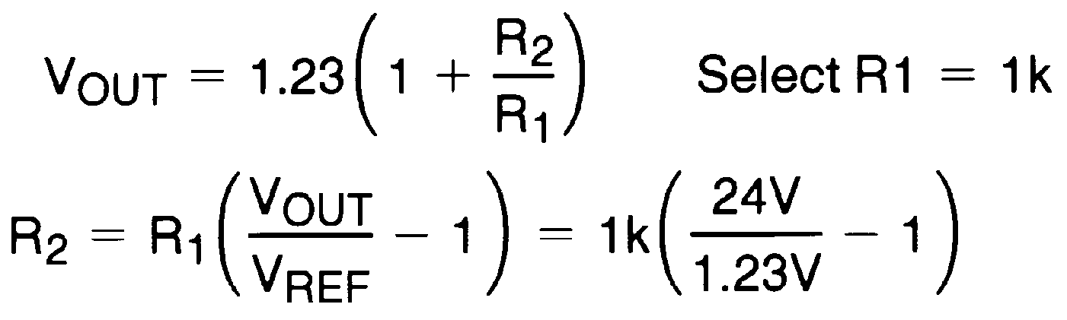  R2 = 1k (19.51−1) = 18.51k, closest 1% value is 18.7k  2. Inductor Selection (L1) A. Calculate E • T (V • µs)    B. E • T = 185 V • µs  C. ILOAD(Max) = 0.4A  D. Inductance Region = 1000  E. Inductor Value = 1000 µH Choose from Pulse Engineer- ing Part #PE-52631, or Renco Part #RL-1283-1000.
www.national.com 14

LM2574 Series Buck Regulator Design Procedure (Continued)
PROCEDURE (Adjustable Output Voltage Versions) | EXAMPLE (Adjustable Output Voltage Versions)
3. Output Capacitor Selection (COUT)  A. The value of the output capacitor together with the inductor defines the dominate pole-pair of the switching regulator loop. For stable operation, the capacitor must satisfy the following requirement:  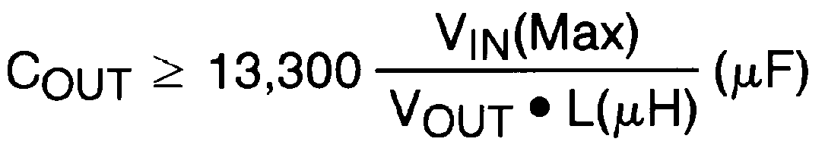  The above formula yields capacitor values between 5 µF and  1000 µF that will satisfy the loop requirements for stable op- eration. But to achieve an acceptable output ripple voltage, (approximately 1% of the output voltage) and transient re- sponse, the output capacitor may need to be several times larger than the above formula yields.  B. The capacitor’s voltage rating should be at last 1.5 times greater than the output voltage. For a 24V regulator, a rating of at least 35V is recommended.  Higher voltage electrolytic capacitors generally have lower ESR numbers, and for this reasion it may be necessary to se- lect a capacitor rate for a higher voltage than would normally be needed.  4. Catch Diode Selection (D1)  A. The catch-diode current rating must be at least 1.5 times greater than the maximum load current. Also, if the power supply design must withstand a continuous output short, the diode should have a current rating equal to the maximum cur- rent limit of the LM2574. The most stressful condition for this diode is an overload or shorted output condition. Suitable di- odes are shown in the selection guide of Figure 9.  B. The reverse voltage rating of the diode should be at least  1.25 times the maximum input voltage.  5. Input Capacitor (CIN)  An aluminum or tantalum electrolytic bypass capacitor located close to the regulator is needed for stable operation. | 3. Output Capacitor Selection (COUT)  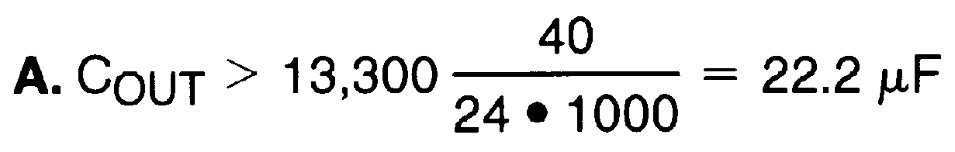  However, for acceptable output ripple voltage select  COUT 100 µF  COUT = 100 µF electrolytic capacitor  4. Catch Diode Selection (D1)  A. For this example, a 1A current rating is adequate.  B. Use a 50V MBR150 or 11DQ05 Schottky diode, or any of the suggested fast-recovery diodes in Figure 9.  5. Input Capacitor (CIN)  A 22 µF aluminum electrolytic capacitor located near the input and ground pins provides sufficient bypassing. See (Figure 9).  To further simplify the buck regulator design procedure, Na- tional Semiconductor is making available computer design software to be used with the Simple Switcher line of switching regulators. Switchers Made Simple (version 3.3) is available on a (31⁄2") diskette for IBM compatible computers from a Na- tional Semiconductor sales office in your area.
15 www.national.com

LM2574 Series Buck Regulator Design Procedure (Continued)

VR | 1 Amp Diodes
VR | Schottky | Fast Recovery
20V | 1N5817  SR102  MBR120P
30V | 1N5818  SR103  11DQ03  MBR130P  10JQ030 | The following diodes are all rated to  100V  11DF1  10JF1  MUR110  HER102
40V | 1N5819  SR104  11DQ04  11JQ04  MBR140P
50V | MBR150  SR105  11DQ05  11JQ05
60V | MBR160  SR106  11DQ06  11JQ06
90V | 11DQ09

Application Hints

INPUT CAPACITOR (CIN)
FIGURE 9. Diode Selection Guide
INDUCTOR SELECTION
All switching regulators have two basic modes of operation:
continuous and discontinuous. The difference between the

To maintain stability, the regulator input pin must be by- passed with at least a 22 µF electrolytic capacitor. The ca- pacitor’s leads must be kept short, and located near the regulator.
If the operating temperature range includes temperatures below −25˚C, the input capacitor value may need to be larger. With most electrolytic capacitors, the capacitance value decreases and the ESR increases with lower tempera- tures and age. Paralleling a ceramic or solid tantalum ca- pacitor will increase the regulator stability at cold tempera- tures. For maximum capacitor operating lifetime, the capacitor’s RMS ripple current rating should be greater than
two types relates to the inductor current, whether it is flowing
continuously, or if it drops to zero for a period of time in the normal switching cycle. Each mode has distinctively different operating characteristics, which can affect the regulator per- formance and requirements.
The LM2574 (or any of the Simple Switcher family) can be used for both continuous and discontinuous modes of opera- tion.
In many cases the preferred mode of operation is in the con- tinuous mode. It offers better load regulation, lower peak switch, inductor and diode currents, and can have lower out- put ripple voltage. But it does require relatively large inductor values to keep the inductor current flowing continuously, es- pecially at low output load currents.
To simplify the inductor selection process, an inductor selec- tion guide (nomograph) was designed (see Figure 4 through Figure 8). This guide assumes continuous mode operation, and selects an inductor that will allow a peak-to-peak induc- tor ripple current ( IIND) to be a certain percentage of the maximum design load current. In the LM2574 SIMPLE SWITCHER, the peak-to-peak inductor ripple current per- centage (of load current) is allowed to change as different design load currents are selected. By allowing the percent-
age of inductor ripple current to increase for lower current applications, the inductor size and value can be kept rela- tively low.

www.national.com 16

Application Hints (Continued)

INDUCTOR RIPPLE CURRENT
When the switcher is operating in the continuous mode, the inductor current waveform ranges from a triangular to a saw- tooth type of waveform (depending on the input voltage). For a given input voltage and output voltage, the peak-to-peak amplitude of this inductor current waveform remains con- stant. As the load current rises or falls, the entire sawtooth current waveform also rises or falls. The average DC value of this waveform is equal to the DC load current (in the buck regulator configuration).
If the load current drops to a low enough level, the bottom of the sawtooth current waveform will reach zero, and the switcher will change to a discontinuous mode of operation. This is a perfectly acceptable mode of operation. Any buck switching regulator (no matter how large the inductor value
the output ripple voltage can be calculated, or conversely, measuring the output ripple voltage and knowing the IIND, the ESR can be calculated.
From the previous example, the Peak-to-peak Inductor Ripple Current ( IIND) = 212 mA p-p. Once the IND value is known, the following three formulas can be used to calculate additional information about the switching regulator circuit:
1. Peak Inductor or peak switch current

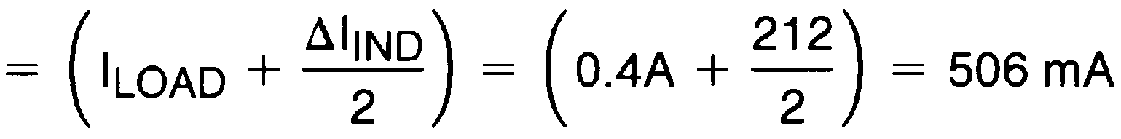
2. Minimum load current before the circuit becomes dis- continuous

is) will be forced to run discontinuous if the load current is
3. Output Ripple Voltage = ( I
) x (ESR of C )

light enough.
IND
OUT

The curve shown in Figure 10 illustrates how the peak-to- peak inductor ripple current ( IIND) is allowed to change as different maximum load currents are selected, and also how it changes as the operating point varies from the upper bor- der to the lower border within an inductance region (see In- ductor Selection guides).

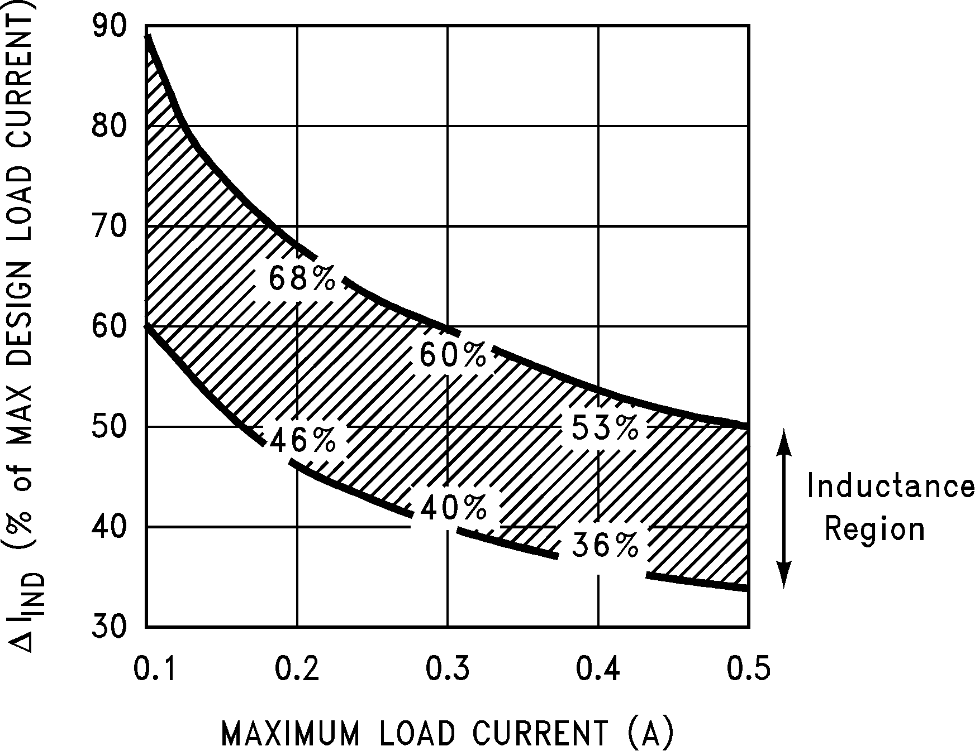
DS011394-18
FIGURE 10. Inductor Ripple Current ( IIND) Range Based on Selection Guides from Figure 4 through Figure 8.

Consider the following example: VOUT = 5V @ 0.4A
VIN = 10V minimum up to 20V maximum
The selection guide in Figure 5 shows that for a 0.4A load current, and an input voltage range between 10V and 20V, the inductance region selected by the guide is 330 µH. This value of inductance will allow a peak-to-peak inductor ripple current ( IIND) to flow that will be a percentage of the maxi- mum load current. For this inductor value, the IIND will also vary depending on the input voltage. As the input voltage in- creases to 20V, it approaches the upper border of the induc- tance region, and the inductor ripple current increases. Re- ferring to the curve in Figure 10, it can be seen that at the
0.4A load current level, and operating near the upper border of the 330 µH inductance region, the IIND will be 53% of
0.4A, or 212 mA p-p.
This IIND is important because from this number the peak inductor current rating can be determined, the minimum load current required before the circuit goes to discontinuous op- eration, and also, knowing the ESR of the output capacitor,
The selection guide chooses inductor values suitable for
continuous mode operation, but if the inductor value chosen is prohibitively high, the designer should investigate the pos- sibility of discontinuous operation. The computer design soft- ware Switchers Made Simple will provide all component values for discontinuous (as well as continuous) mode of op- eration.
Inductors are available in different styles such as pot core, toroid, E-frame, bobbin core, etc., as well as different core materials, such as ferrites and powdered iron. The least ex- pensive, the bobbin core type, consists of wire wrapped on a ferrite rod core. This type of construction makes for an inex- pensive inductor, but since the magnetic flux is not com- pletely contained within the core, it generates more electro- magnetic interference (EMI). This EMl can cause problems in sensitive circuits, or can give incorrect scope readings be- cause of induced voltages in the scope probe.
The inductors listed in the selection chart include powdered iron toroid for Pulse Engineering, and ferrite bobbin core for Renco.
An inductor should not be operated beyond its maximum rated current because it may saturate. When an inductor be- gins to saturate, the inductance decreases rapidly and the inductor begins to look mainly resistive (the DC resistance of the winding). This can cause the inductor current to rise very rapidly and will affect the energy storage capabilities of the inductor and could cause inductor overheating. Different in- ductor types have different saturation characteristics, and this should be kept in mind when selecting an inductor. The inductor manufacturers’ data sheets include current and en- ergy limits to avoid inductor saturation.

OUTPUT CAPACITOR
An output capacitor is required to filter the output voltage and is needed for loop stability. The capacitor should be located near the LM2574 using short pc board traces. Standard alu- minum electrolytics are usually adequate, but low ESR types are recommended for low output ripple voltage and good stability. The ESR of a capacitor depends on many factors, some which are: the value, the voltage rating, physical size and the type of construction. In general, low value or low voltage (less than 12V) electrolytic capacitors usually have higher ESR numbers.
The amount of output ripple voltage is primarily a function of the ESR (Equivalent Series Resistance) of the output ca-

17 www.national.com

Application Hints (Continued)

pacitor and the amplitude of the inductor ripple current ( IIND). See the section on inductor ripple current in Applica- tion Hints.
The lower capacitor values (100 µF- 330 µF) will allow typi- cally 50 mV to 150 mV of output ripple voltage, while larger- value capacitors will reduce the ripple to approximately
20 mV to 50 mV.
Output Ripple Voltage = ( IIND) (ESR of COUT)
To further reduce the output ripple voltage, several standard electrolytic capacitors may be paralleled, or a higher-grade capacitor may be used. Such capacitors are often called “high-frequency,” “low-inductance,” or “low-ESR.” These will reduce the output ripple to 10 mV or 20 mV. However, when operating in the continuous mode, reducing the ESR below
0.03 can cause instability in the regulator.
Tantalum capacitors can have a very low ESR, and should be carefully evaluated if it is the only output capacitor. Be- cause of their good low temperature characteristics, a tanta- lum can be used in parallel with aluminum electrolytics, with the tantalum making up 10% or 20% of the total capacitance.
The capacitor’s ripple current rating at 52 kHz should be at least 50% higher than the peak-to-peak inductor ripple cur- rent.

CATCH DIODE
Buck regulators require a diode to provide a return path for the inductor current when the switch is off. This diode should be located close to the LM2574 using short leads and short printed circuit traces.
Because of their fast switching speed and low forward volt- age drop, Schottky diodes provide the best efficiency, espe- cially in low output voltage switching regulators (less than
5V). Fast-Recovery, High-Efficiency, or Ultra-Fast Recovery diodes are also suitable, but some types with an abrupt turn- off characteristic may cause instability and EMI problems. A fast-recovery diode with soft recovery characteristics is a better choice. Standard 60 Hz diodes (e.g., 1N4001 or
1N5400, etc.) are also not suitable. See Figure 9 for Schot- tky and “soft” fast-recovery diode selection guide.

OUTPUT VOLTAGE RIPPLE AND TRANSIENTS
The output voltage of a switching power supply will contain a sawtooth ripple voltage at the switcher frequency, typically about 1% of the output voltage, and may also contain short voltage spikes at the peaks of the sawtooth waveform.
The output ripple voltage is due mainly to the inductor saw- tooth ripple current multiplied by the ESR of the output ca- pacitor. (See the inductor selection in the application hints.)
The voltage spikes are present because of the the fast switching action of the output switch, and the parasitic induc- tance of the output filter capacitor. To minimize these voltage spikes, special low inductance capacitors can be used, and their lead lengths must be kept short. Wiring inductance, stray capacitance, as well as the scope probe used to evalu- ate these transients, all contribute to the amplitude of these spikes.
An additional small LC filter (20 µH & 100 µF) can be added to the output (as shown in Figure 16 ) to further reduce the amount of output ripple and transients. A 10 x reduction in output ripple voltage and transients is possible with this filter.
FEEDBACK CONNECTION
The LM2574 (fixed voltage versions) feedback pin must be wired to the output voltage point of the switching power sup- ply. When using the adjustable version, physically locate both output voltage programming resistors near the LM2574 to avoid picking up unwanted noise. Avoid using resistors greater than 100 k because of the increased chance of noise pickup.

ON /OFF INPUT
For normal operation, the ON /OFF pin should be grounded or driven with a low-level TTL voltage (typically below 1.6V). To put the regulator into standby mode, drive this pin with a high-level TTL or CMOS signal. The ON /OFF pin can be safely pulled up to +VIN without a resistor in series with it. The ON /OFF pin should not be left open.

GROUNDING
The 8-pin molded DIP and the 14-pin surface mount pack- age have separate power and signal ground pins. Both ground pins should be soldered directly to wide printed cir- cuit board copper traces to assure low inductance connec- tions and good thermal properties.

THERMAL CONSIDERATIONS
The 8-pin DIP (N) package and the 14-pin Surface Mount (M) package are molded plastic packages with solid copper lead frames. The copper lead frame conducts the majority of the heat from the die, through the leads, to the printed circuit board copper, which acts as the heat sink. For best thermal performance, wide copper traces should be used, and all ground and unused pins should be soldered to generous amounts of printed circuit board copper, such as a ground plane. Large areas of copper provide the best transfer of heat (lower thermal resistance) to the surrounding air, and even double-sided or multilayer boards provide better heat paths to the surrounding air. Unless the power levels are small, using a socket for the 8-pin package is not recom- mended because of the additional thermal resistance it intro- duces, and the resultant higher junction temperature.
Because of the 0.5A current rating of the LM2574, the total package power dissipation for this switcher is quite low, ranging from approximately 0.1W up to 0.75W under varying conditions. In a carefully engineered printed circuit board, both the N and the M package can easily dissipate up to
0.75W, even at ambient temperatures of 60˚C, and still keep the maximum junction temperature below 125˚C.
A curve displaying thermal resistance vs. pc board area for the two packages is shown in the Typical Performance Char- acteristics curves section of this data sheet.
These thermal resistance numbers are approximate, and there can be many factors that will affect the final thermal re- sistance. Some of these factors include board size, shape, thickness, position, location, and board temperature. Other factors are, the area of printed circuit copper, copper thick- ness, trace width, multi-layer, single- or double-sided, and the amount of solder on the board. The effectiveness of the pc board to dissipate heat also depends on the size, number and spacing of other components on the board. Further- more, some of these components, such as the catch diode and inductor will generate some additional heat. Also, the thermal resistance decreases as the power level increases because of the increased air current activity at the higher power levels, and the lower surface to air resistance coeffi- cient at higher temperatures.

www.national.com 18

Application Hints (Continued)

The data sheet thermal resistance curves and the thermal model in Switchers Made Simple software (version 3.3) can estimate the maximum junction temperature based on operating conditions. ln addition, the junction temperature can be estimated in actual circuit operation by using the fol- lowing equation.
Tj = Tcu + ( j-cu x PD)
With the switcher operating under worst case conditions and all other components on the board in the intended enclosure, measure the copper temperature (Tcu ) near the IC. This can be done by temporarily soldering a small thermocouple to the pc board copper near the IC, or by holding a small ther- mocouple on the pc board copper using thermal grease for good thermal conduction.
The thermal resistance ( j-cu) for the two packages is:
j-cu = 42˚C/W for the N-8 package
j-cu = 52˚C/W for the M-14 package
The power dissipation (PD) for the IC could be measured, or it can be estimated by using the formula:

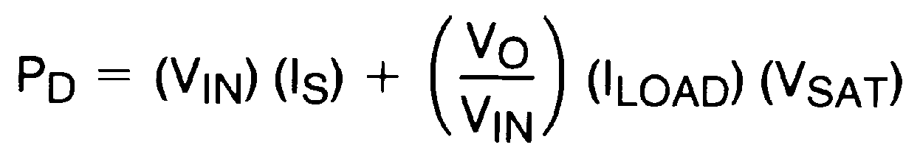
Where IS is obtained from the typical supply current curve (adjustable version use the supply current vs. duty cycle curve).

Additional Applications

INVERTING REGULATOR
Figure 11 shows a LM2574-12 in a buck-boost configuration to generate a negative 12V output from a positive input volt- age. This circuit bootstraps the regulator’s ground pin to the negative output voltage, then by grounding the feedback pin, the regulator senses the inverted output voltage and regu- lates it to −12V.

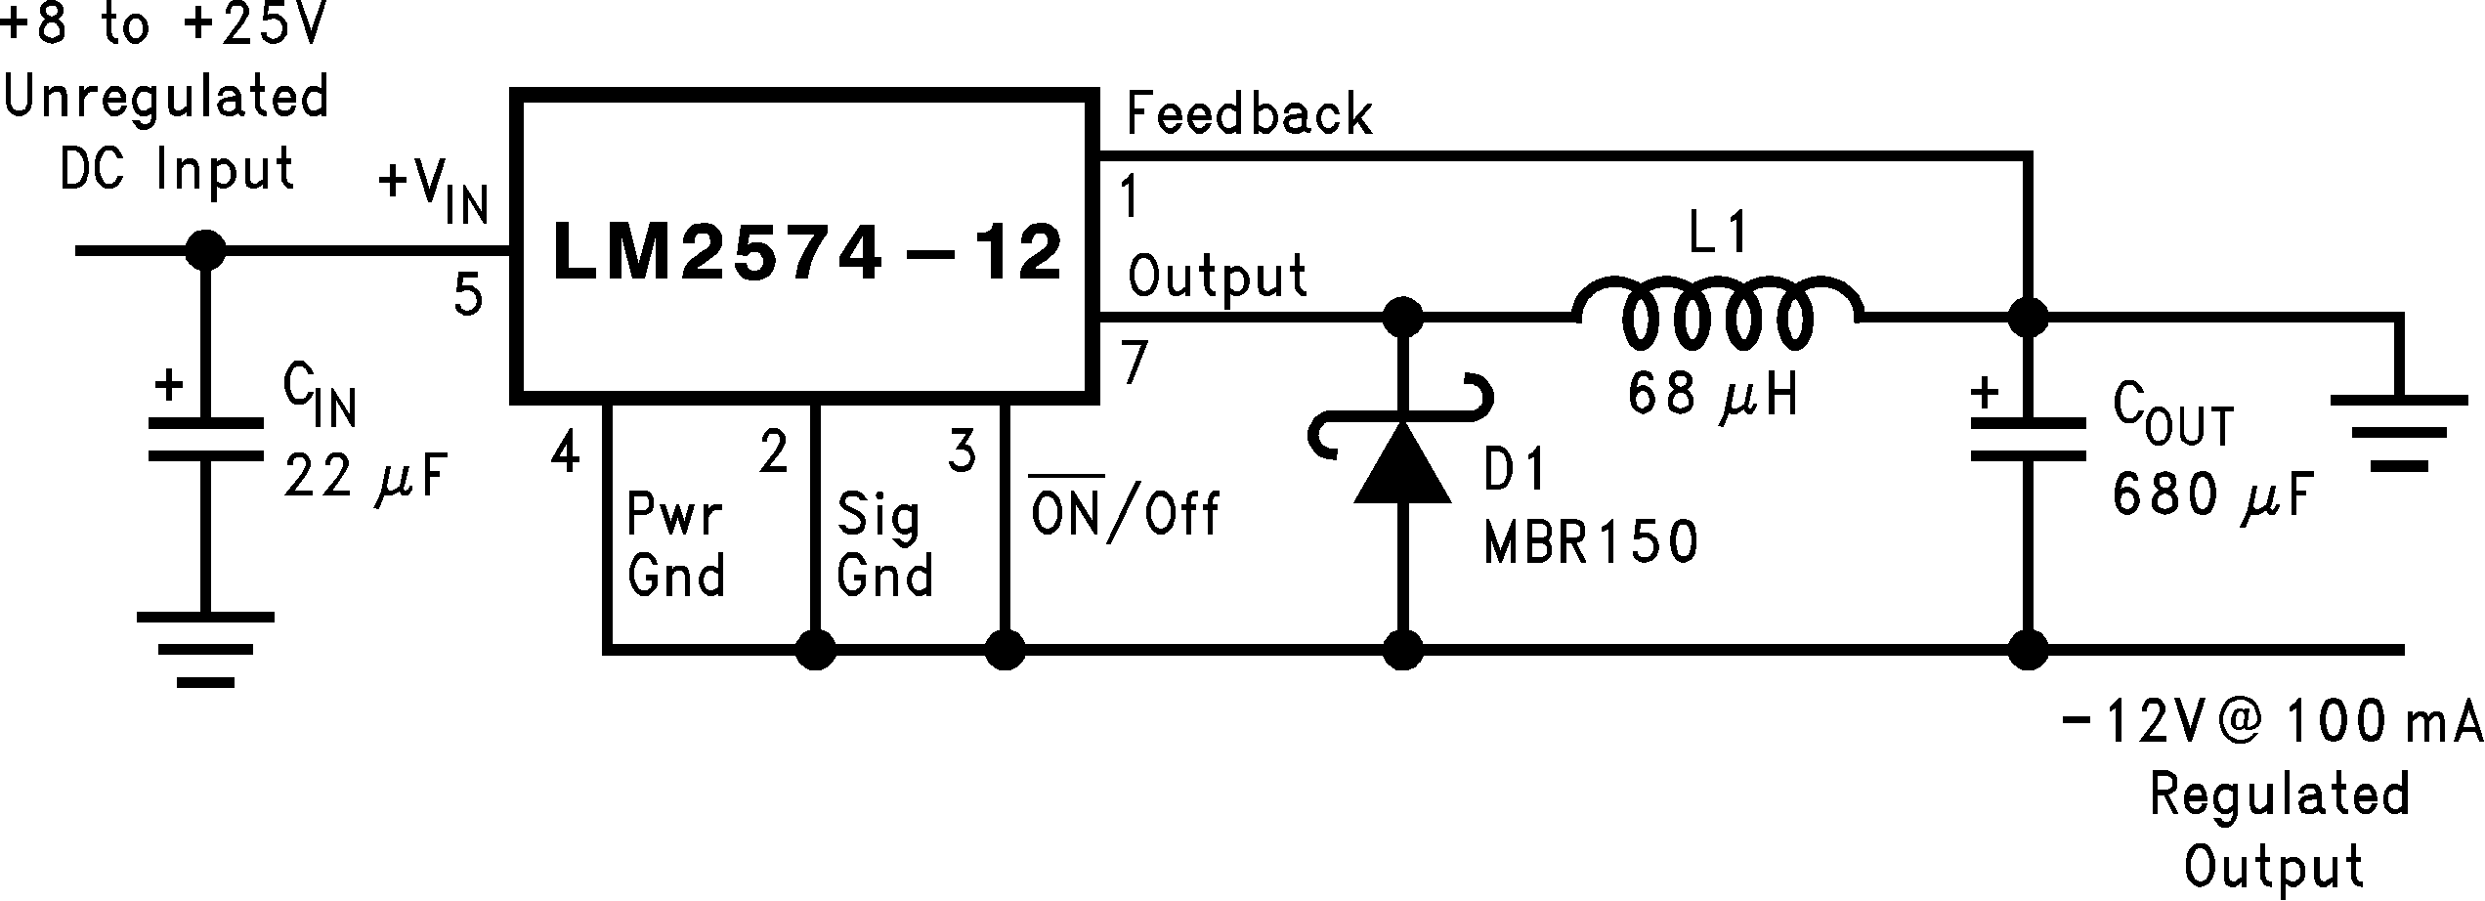

Note: Pin numbers are for the 8-pin DIP package.
FIGURE 11. Inverting Buck-Boost Develops −12V
DS011394-19

For an input voltage of 8V or more, the maximum available output current in this configuration is approximately 100 mA. At lighter loads, the minimum input voltage required drops to approximately 4.7V.
The switch currents in this buck-boost configuration are higher than in the standard buck-mode design, thus lowering the available output current. Also, the start-up input current of the buck-boost converter is higher than the standard buck- mode regulator, and this may overload an input power source with a current limit less than 0.6A. Using a delayed turn-on or an undervoltage lockout circuit (described in the next section) would allow the input voltage to rise to a high enough level before the switcher would be allowed to turn on.
Because of the structural differences between the buck and the buck-boost regulator topologies, the buck regulator de- sign procedure section can not be used to to select the in- ductor or the output capacitor. The recommended range of inductor values for the buck-boost design is between 68 µH and 220 µH, and the output capacitor values must be larger than what is normally required for buck designs. Low input voltages or high output currents require a large value output capacitor (in the thousands of micro Farads).
The peak inductor current, which is the same as the peak switch current, can be calculated from the following formula:
Where fosc = 52 kHz. Under normal continuous inductor cur- rent operating conditions, the minimum VIN represents the worst case. Select an inductor that is rated for the peak cur- rent anticipated.
Also, the maximum voltage appearing across the regulator is the absolute sum of the input and output voltage. For a −12V output, the maximum input voltage for the LM2574 is +28V, or +48V for the LM2574HV.
The Switchers Made Simple version 3.3) design software can be used to determine the feasibility of regulator designs using different topologies, different input-output parameters, different components, etc.

NEGATIVE BOOST REGULATOR
Another variation on the buck-boost topology is the negative boost configuration. The circuit in Figure 12 accepts an input voltage ranging from −5V to −12V and provides a regulated
−12V output. Input voltages greater than −12V will cause the output to rise above −12V, but will not damage the regulator.

19 www.national.com

Additional Applications (Continued)

Note: Pin numbers are for 8-pin DIP package.

DS011394-20

Note: Complete circuit not shown.
Note: Pin numbers are for 8-pin DIP package.
DS011394-21

FIGURE 12. Negative Boost
FIGURE 13. Undervoltage Lockout for Buck Circuit

Because of the boosting function of this type of regulator, the switch current is relatively high, especially at low input volt- ages. Output load current limitations are a result of the maxi- mum current rating of the switch. Also, boost regulators can not provide current limiting load protection in the event of a shorted load, so some other means (such as a fuse) may be necessary.

UNDERVOLTAGE LOCKOUT
In some applications it is desirable to keep the regulator off until the input voltage reaches a certain threshold. An under- voltage lockout circuit which accomplishes this task is shown in Figure 13 while Figure 14 shows the same circuit applied to a buck-boost configuration. These circuits keep the regu- lator off until the input voltage reaches a predetermined

Note: Complete circuit not shown (see Figure 11 ).
Note: Pin numbers are for 8-pin DIP package.

DS011394-22

level.
VTH VZ1 + 2VBE (Q1)
FIGURE 14. Undervoltage Lockout for Buck-Boost Circuit

DELAYED STARTUP
The ON /OFF pin can be used to provide a delayed startup feature as shown in Figure 15. With an input voltage of 20V and for the part values shown, the circuit provides approxi- mately 10 ms of delay time before the circuit begins switch- ing. Increasing the RC time constant can provide longer de- lay times. But excessively large RC time constants can cause problems with input voltages that are high in 60 Hz or
120 Hz ripple, by coupling the ripple into the ON /OFF pin. ADJUSTABLE OUTPUT, LOW-RIPPLE POWER SUPPLY A 500 mA power supply that features an adjustable output
voltage is shown in Figure 16. An additional L-C filter that re-
duces the output ripple by a factor of 10 or more is included in this circuit.

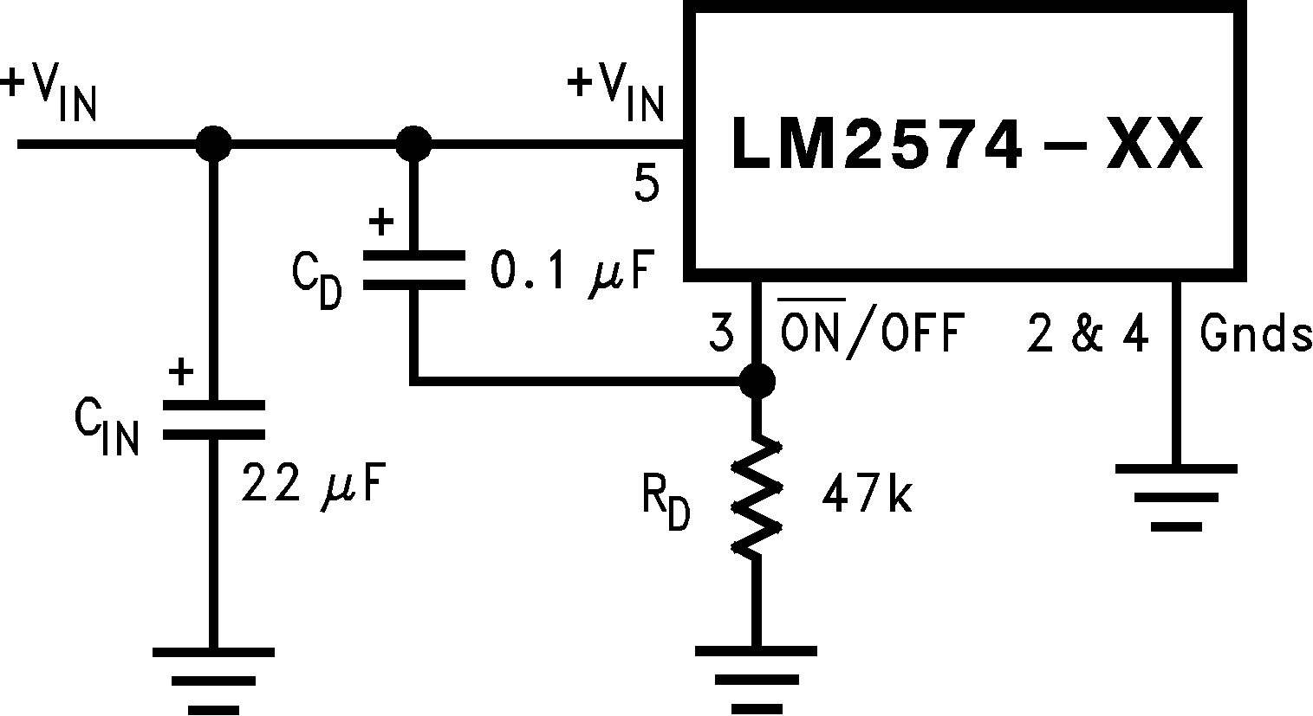

Note: Complete circuit not shown.
Note: Pin numbers are for 8-pin DIP package.
DS011394-23
FIGURE 15. Delayed Startup

www.national.com 20

Additional Applications (Continued)

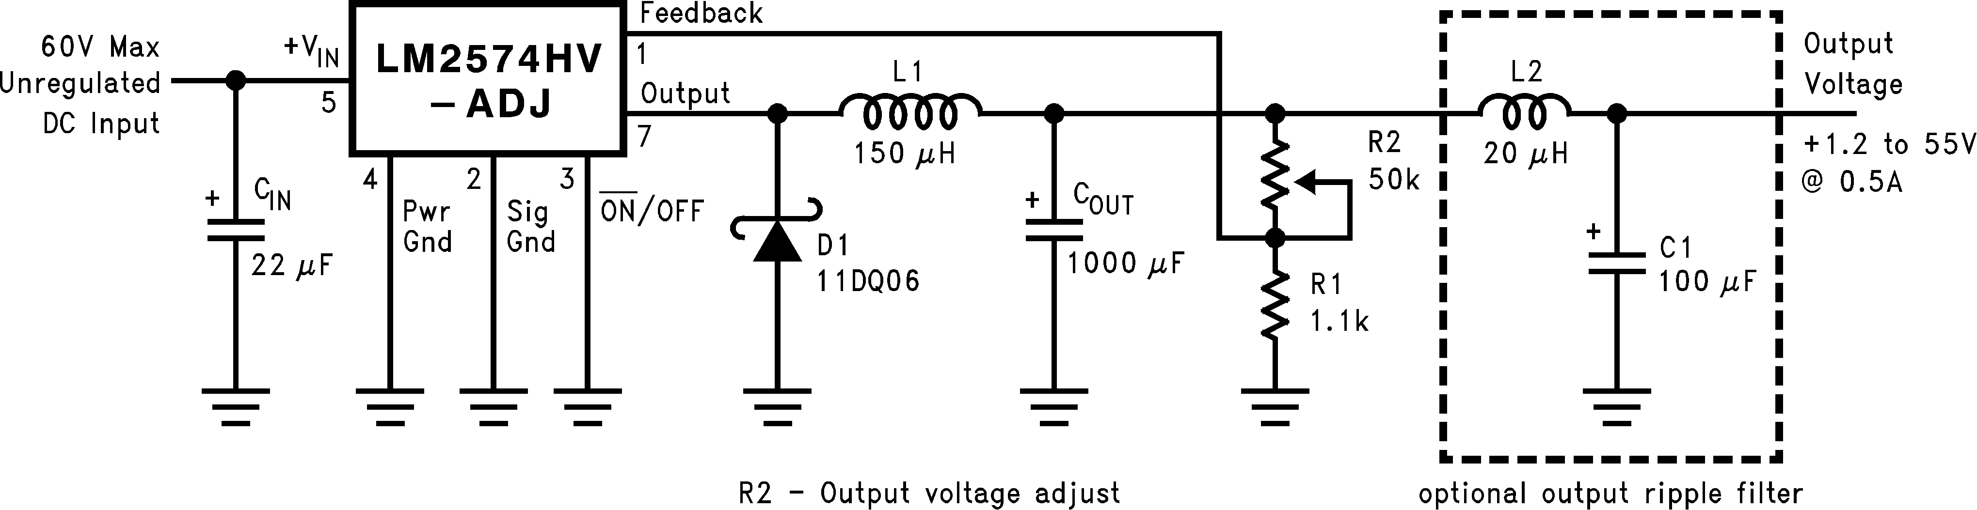

Note: Pin numbers are for 8-pin DIP package.

FIGURE 16. 1.2V to 55V Adjustable 500 mA Power Supply with Low Output Ripple
DS011394-24

Definition of Terms

BUCK REGULATOR
A switching regulator topology in which a higher voltage is converted to a lower voltage. Also known as a step-down switching regulator.

BUCK-BOOST REGULATOR
A switching regulator topology in which a positive voltage is converted to a negative voltage without a transformer.

DUTY CYCLE (D)
Ratio of the output switch’s on-time to the oscillator period.

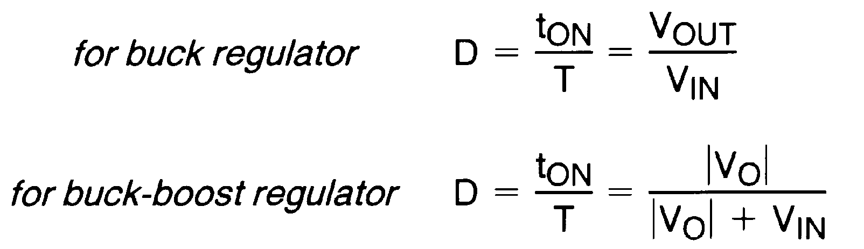

CATCH DIODE OR CURRENT STEERING DIODE
The diode which provides a return path for the load current
grade capacitors (“low-ESR”, “high-frequency”, or “low- inductance”) in the 100 µF–1000 µF range generally have ESR of less than 0.15 .

EQUIVALENT SERIES INDUCTANCE (ESL)
The pure inductance component of a capacitor (see Figure
17). The amount of inductance is determined to a large ex- tent on the capacitor’s construction. In a buck regulator, this unwanted inductance causes voltage spikes to appear on the output.

OUTPUT RIPPLE VOLTAGE
The AC component of the switching regulator’s output volt- age. It is usually dominated by the output capacitor’s ESR multiplied by the inductor’s ripple current ( IIND). The peak- to-peak value of this sawtooth ripple current can be deter- mined by reading the Inductor Ripple Current section of the Application hints.

CAPACITOR RIPPLE CURRENT
RMS value of the maximum allowable alternating current at which a capacitor can be operated continuously at a speci- fied temperature.

when the LM2574 switch is OFF.
STANDBY QUIESCENT CURRENT (I
STBY)

EFFICIENCY ( )
The proportion of input power actually delivered to the load.

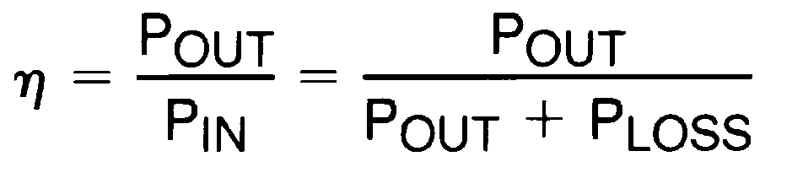

CAPACITOR EQUIVALENT SERIES RESISTANCE (ESR)
The purely resistive component of a real capacitor’s imped- ance (see Figure 17). It causes power loss resulting in ca- pacitor heating, which directly affects the capacitor’s operat- ing lifetime. When used as a switching regulator output filter, higher ESR values result in higher output ripple voltages.


DS011394-25
FIGURE 17. Simple Model of a Real Capacitor
Supply current required by the LM2574 when in the standby mode (ON/OFF pin is driven to TTL-high voltage, thus turn- ing the output switch OFF).

INDUCTOR RIPPLE CURRENT ( IIND)
The peak-to-peak value of the inductor current waveform, typically a sawtooth waveform when the regulator is operat- ing in the continuous mode (vs. discontinuous mode).

CONTINUOUS/DISCONTINUOUS MODE OPERATION
Relates to the inductor current. In the continuous mode, the inductor current is always flowing and never drops to zero, vs. the discontinuous mode, where the inductor current drops to zero for a period of time in the normal switching cycle.

Most standard aluminum electrolytic capacitors in the
100 µF–1000 µF range have 0.5 to 0.1 ESR. Higher-

21 www.national.com

Definition of Terms (Continued)

INDUCTOR SATURATION
The condition which exists when an inductor cannot hold any more magnetic flux. When an inductor saturates, the induc- tor appears less inductive and the resistive component domi- nates. Inductor current is then limited only by the DC resis- tance of the wire and the available source current.
OPERATING VOLT MICROSECOND CONSTANT (E•Top) The product (in VoIt•µs) of the voltage applied to the inductor and the time the voltage is applied. This E•Top constant is a
measure of the energy handling capability of an inductor and
is dependent upon the type of core, the core area, the num- ber of turns, and the duty cycle.

www.national.com 22

Physical Dimensions inches (millimeters) unless otherwise noted

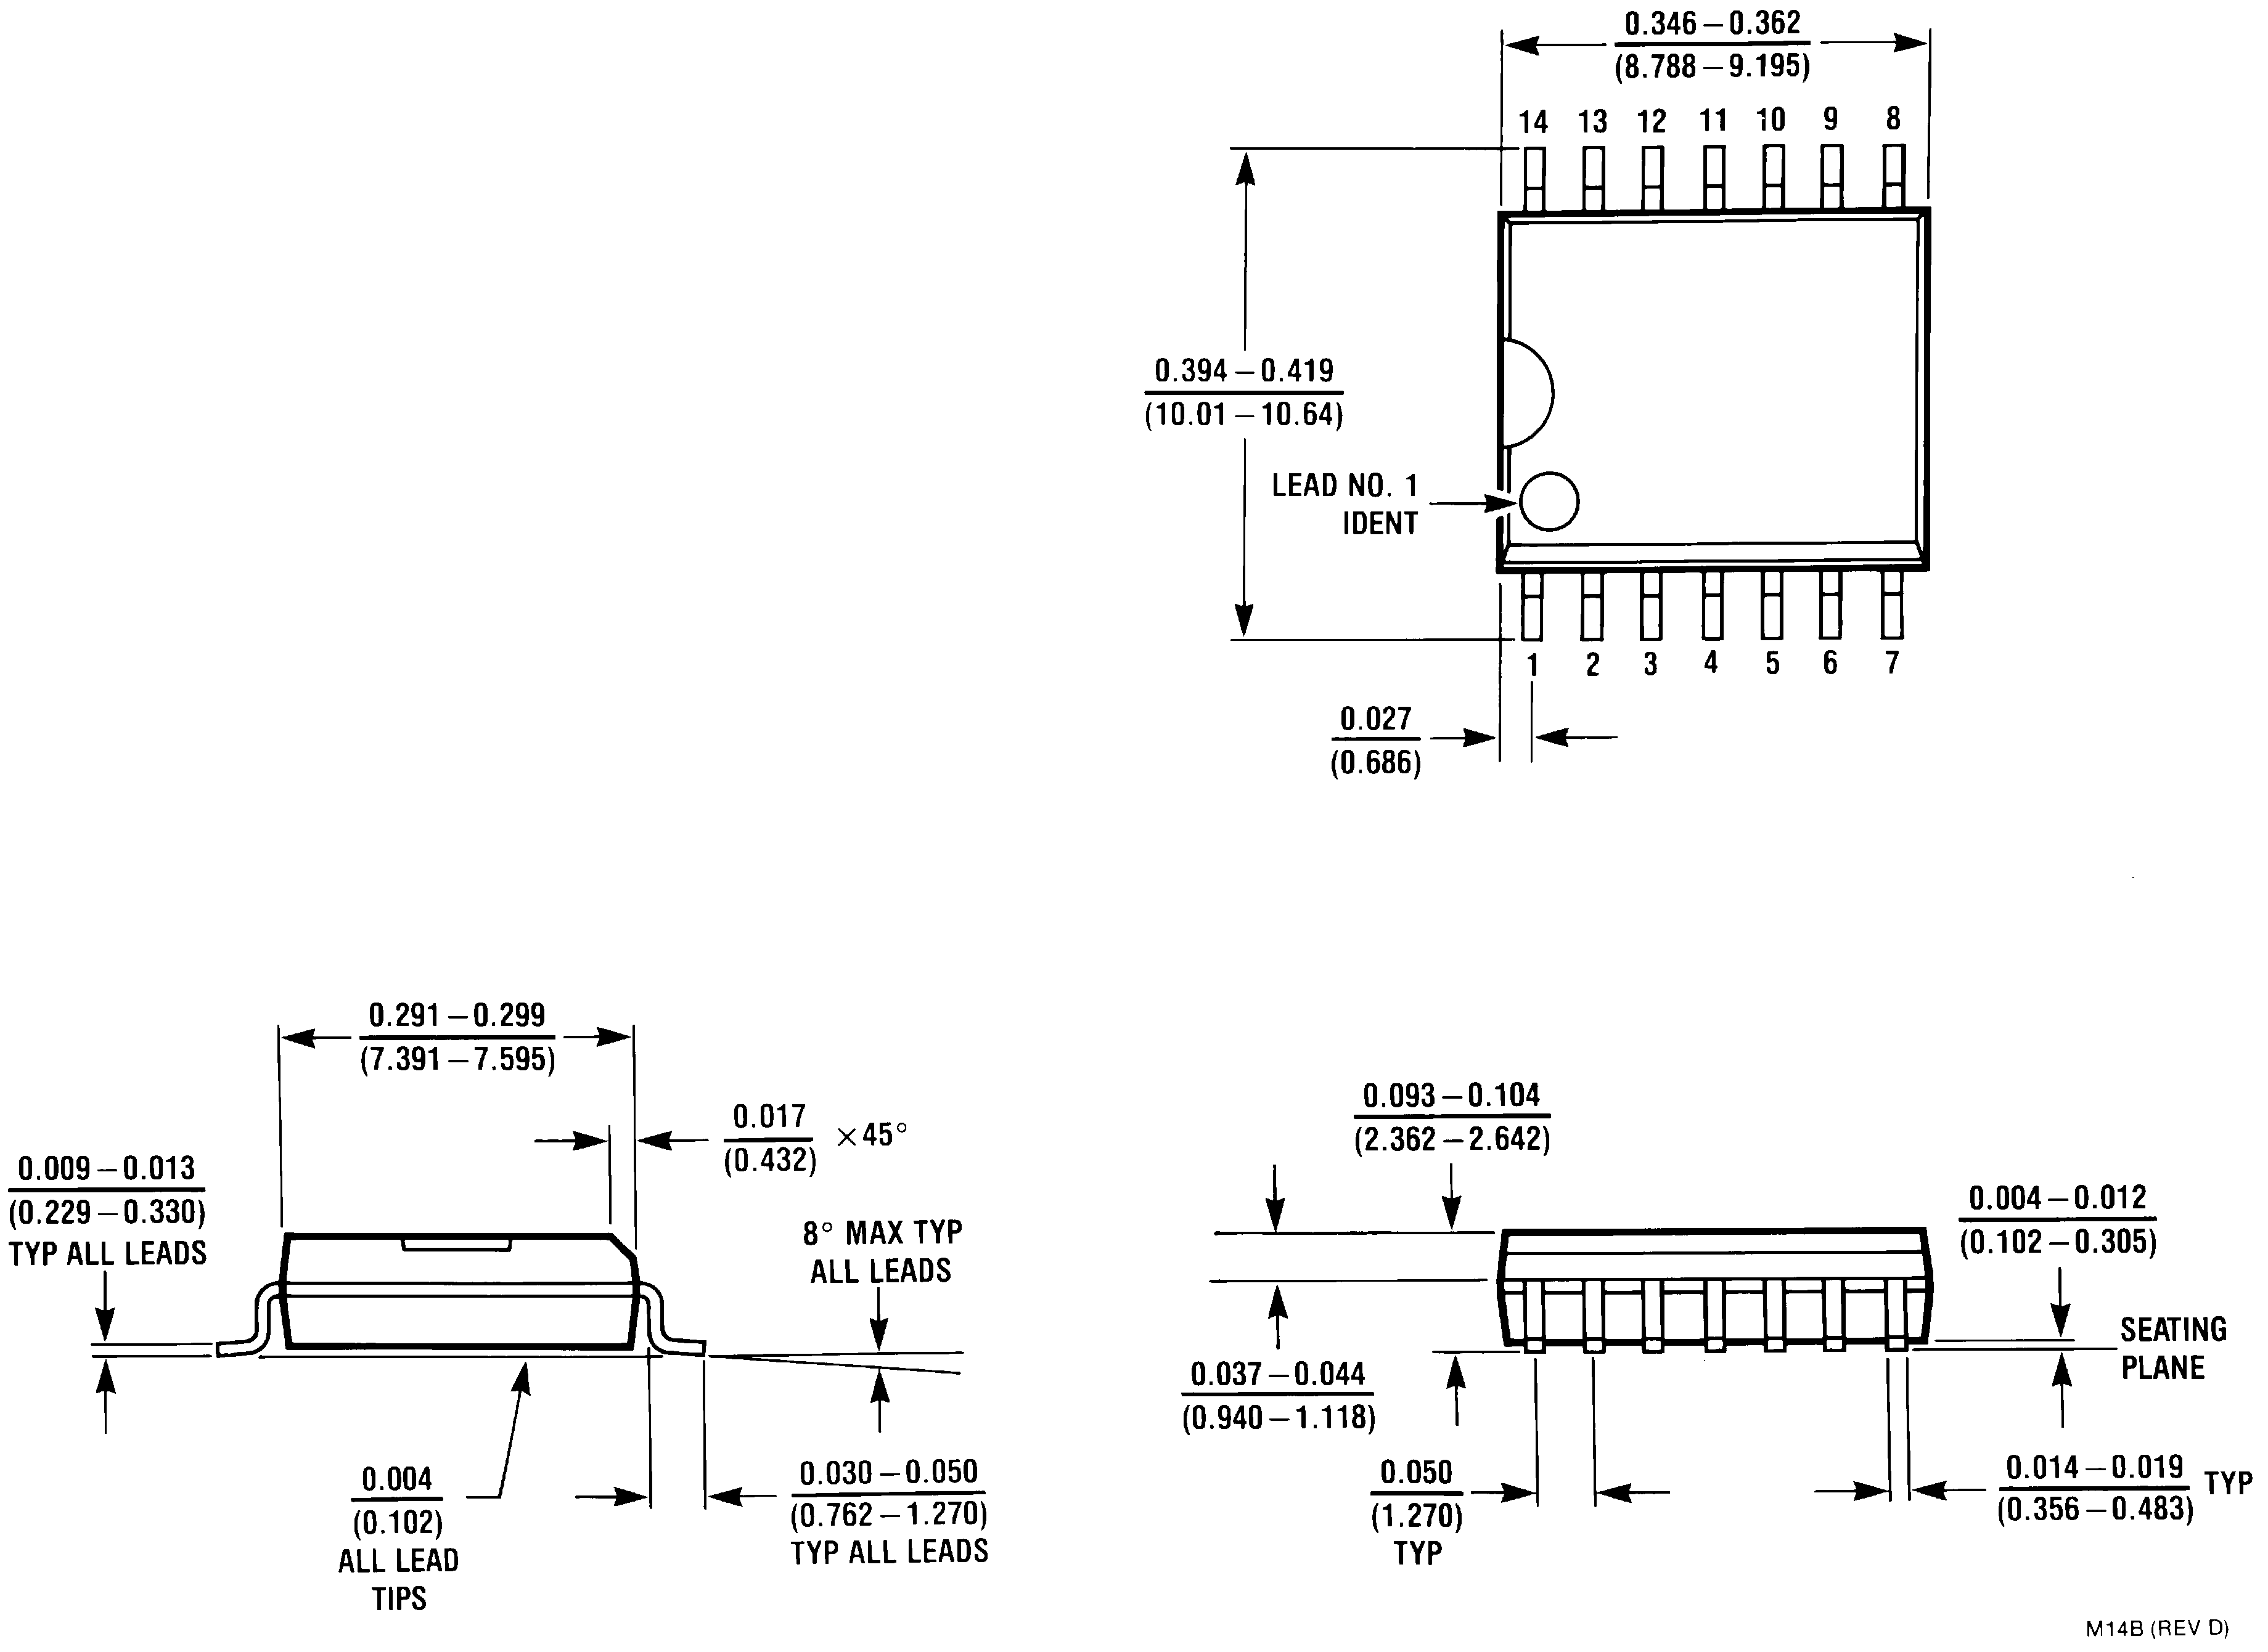
14-Lead Wide Surface Mount (WM)
Order Number LM2574M-3.3, LM2574HVM-3.3, LM2574M-5.0, LM2574HVM-5.0, LM2574M-12, LM2574HVM-12, LM2574M-15, LM2574HVM-15, LM2574M-ADJ or LM2574HVM-ADJ
NS Package Number M14B

23 www.national.com

Physical Dimensions inches (millimeters) unless otherwise noted (Continued)
LM2574/LM2574HV SIMPLE SWITCHER 0.5A Step-Down Voltage Regulator

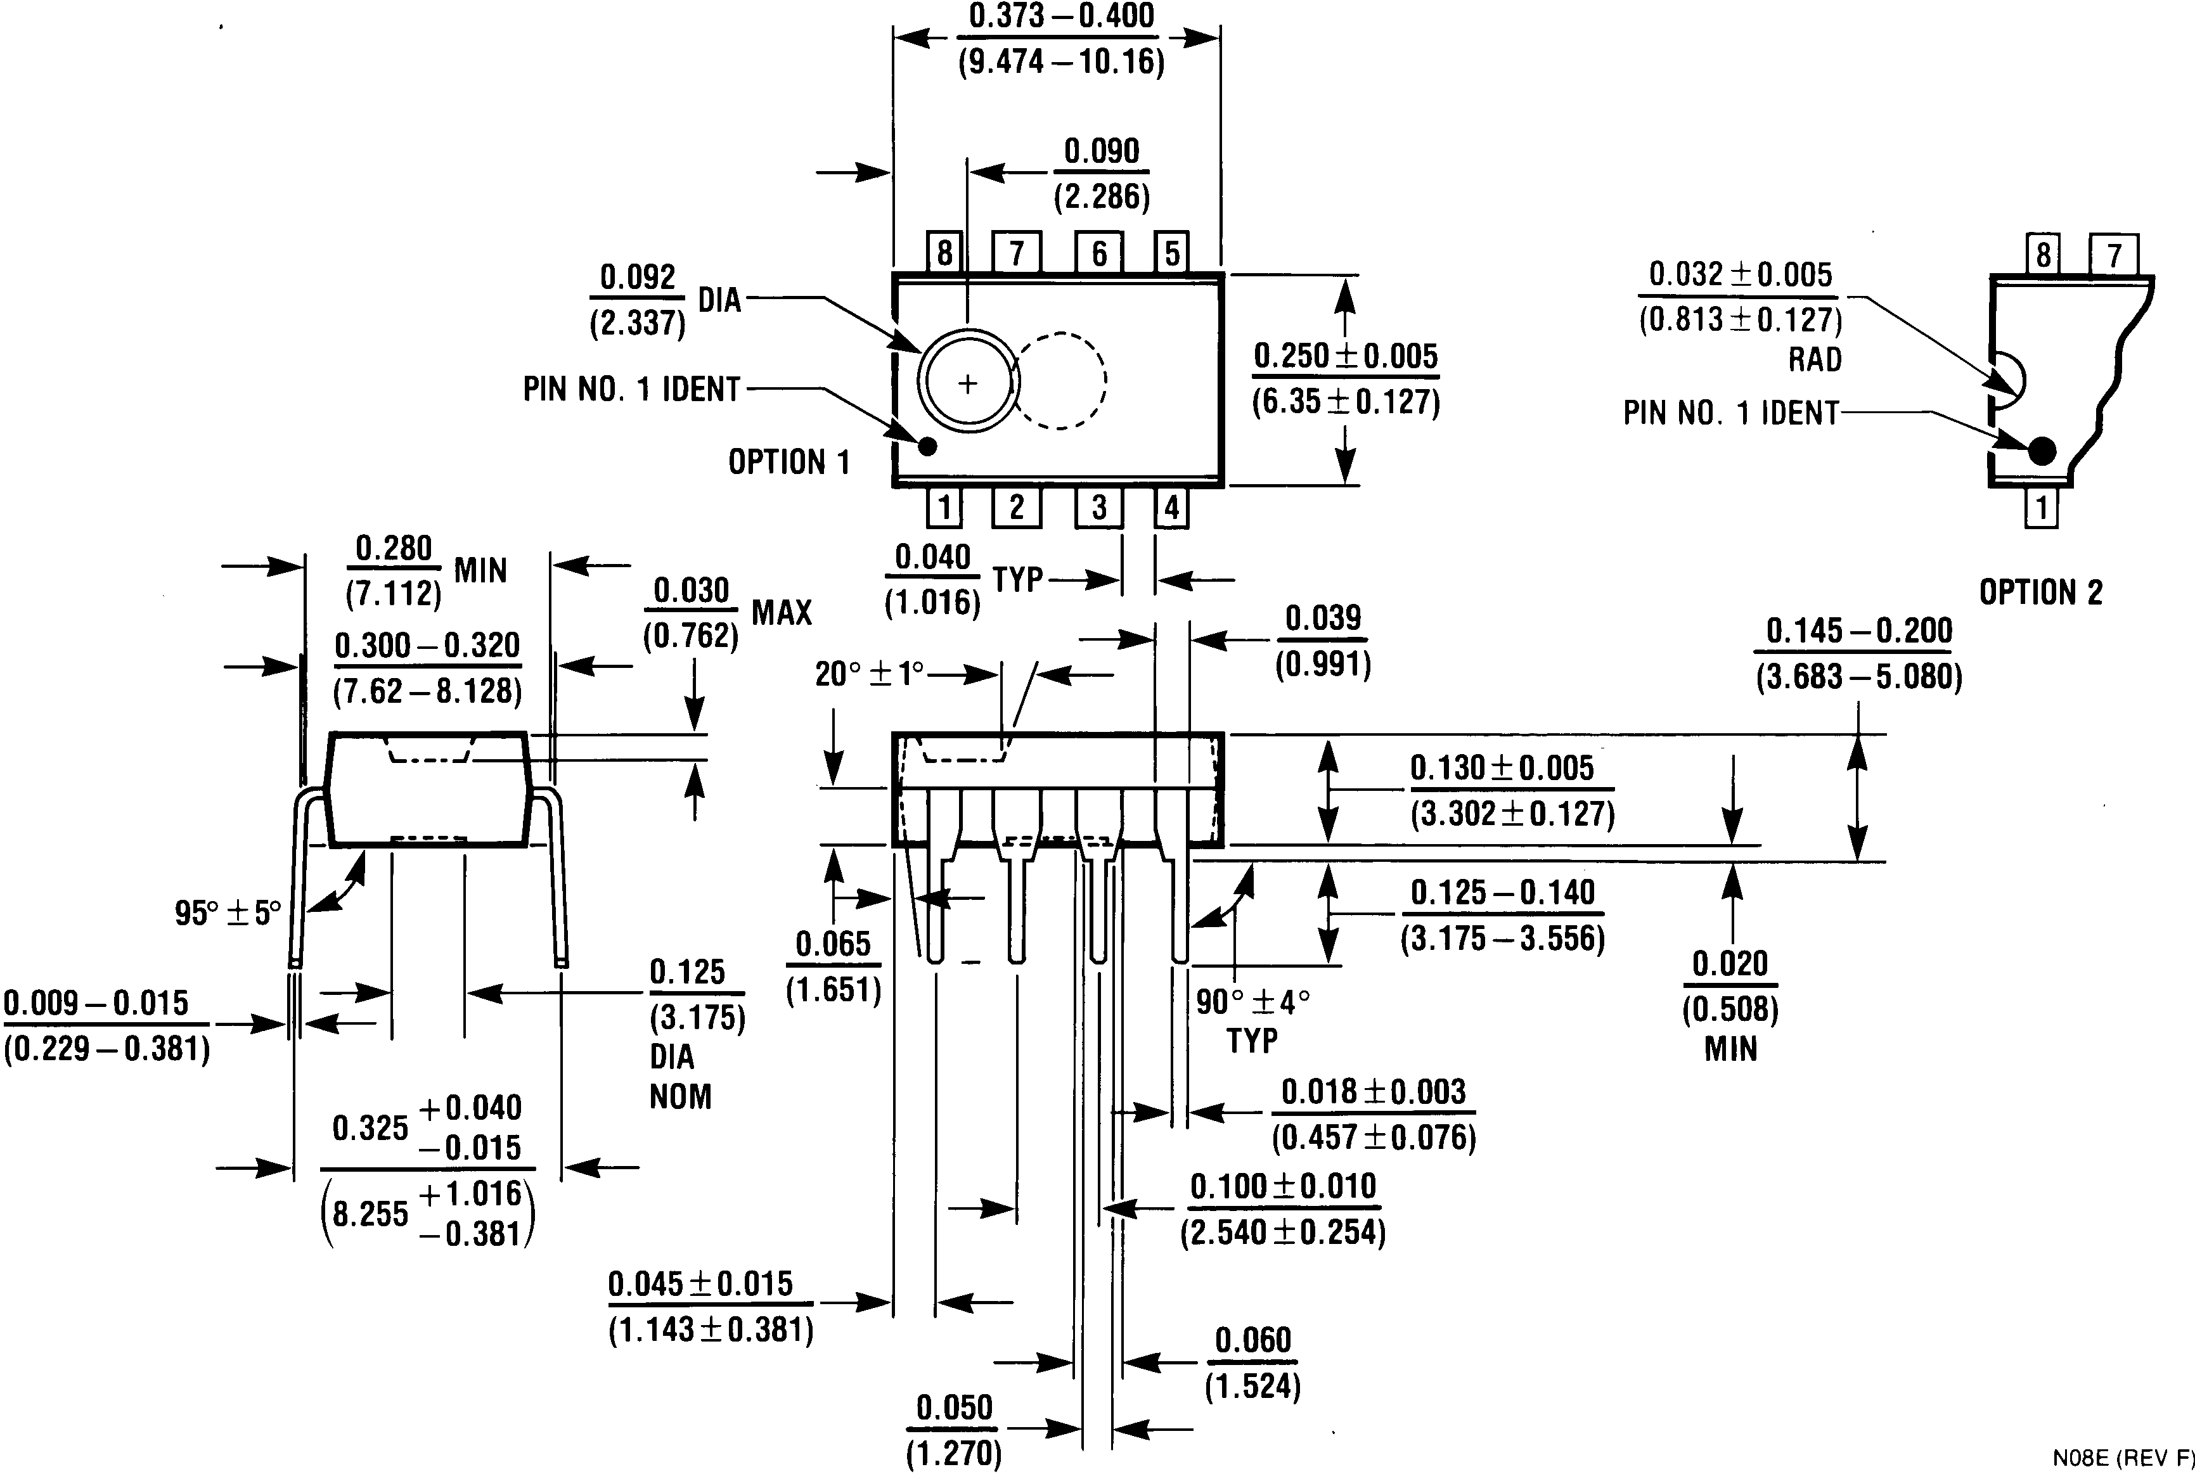
8-Lead DIP (N)
Order Number LM2574M-3.3, LM2574HVM-3.3, LM2574HVN-5.0, LM2574HVN-12, LM2574HVN-15, LM2574HVN-ADJ, LM2574N-5.0,
LM2574N-12, LM2574N-15 or LM2574N-ADJ NS Package Number N08A

LIFE SUPPORT POLICY

NATIONAL’S PRODUCTS ARE NOT AUTHORIZED FOR USE AS CRITICAL COMPONENTS IN LIFE SUPPORT DEVICES OR SYSTEMS WITHOUT THE EXPRESS WRITTEN APPROVAL OF THE PRESIDENT AND GENERAL COUNSEL OF NATIONAL SEMICONDUCTOR CORPORATION. As used herein:

1. Life support devices or systems are devices or systems which, (a) are intended for surgical implant into the body, or (b) support or sustain life, and whose failure to perform when properly used in accordance with instructions for use provided in the labeling, can be reasonably expected to result in a significant injury to the user.

2. A critical component is any component of a life support device or system whose failure to perform can be reasonably expected to cause the failure of the life support device or system, or to affect its safety or effectiveness.

National Semiconductor
Corporation
Americas
Tel: 1-800-272-9959
Fax: 1-800-737-7018
Email: support@nsc.com

www.national.com

National Semiconductor
Europe
Fax: +49 (0) 1 80-530 85 86
Email: europe.support@nsc.com
Deutsch Tel: +49 (0) 1 80-530 85 85
English Tel: +49 (0) 1 80-532 78 32
Français Tel: +49 (0) 1 80-532 93 58
Italiano Tel: +49 (0) 1 80-534 16 80

National Semiconductor Asia Pacific Customer Response Group
Tel: 65-2544466
Fax: 65-2504466
Email: sea.support@nsc.com

National Semiconductor
Japan Ltd.
Tel: 81-3-5639-7560
Fax: 81-3-5639-7507

National does not assume any responsibility for use of any circuitry described, no circuit patent licenses are implied and National reserves the right at any time without notice to change said circuitry and specifications.

