LP2985
June 15, 2009
LP2985 Micropower 150 mA Low-Noise Ultra Low-Dropout Regulator in SOT-23 and micro SMD Packages

Micropower 150 mA Low-Noise Ultra Low-Dropout
Regulator in SOT-23 and micro SMD Packages
Designed for Use with Very Low ESR Output Capacitors

General Description
The LP2985 is a 150 mA, fixed-output voltage regulator de- signed to provide ultra low-dropout and low noise in battery powered applications.
Using an optimized VIP® (Vertically Integrated PNP) process, the LP2985 delivers unequalled performance in all specifica- tions critical to battery-powered designs:
Dropout Voltage: Typically 300 mV @ 150 mA load, and
7 mV @ 1 mA load.
Ground Pin Current: Typically 850 µA @ 150 mA load, and
75 µA @ 1 mA load.
Enhanced Stability: The LP2985 is stable with output ca- pacitor ESR as low as 5 mΩ, which allows the use of ceramic capacitors on the output.
Sleep Mode: Less than 1 µA quiescent current when ON/OFF
pin is pulled low.
Smallest Possible Size: SOT-23 and micro SMD packages use absolute minimum board space.
Precision Output: 1% tolerance output voltages available (A
grade).
Low Noise: By adding a 10 nF bypass capacitor, output noise can be reduced to 30 µV (typical).
Multiple voltage options, from 2.5V to 5.0V, are available as standard products. Consult factory for custom voltages.
Features
■ Ultra low dropout voltage
■ Guaranteed 150 mA output current
■ Smallest possible size (SOT-23, micro SMD package)
■ Requires minimum external components
■ Stable with low-ESR output capacitor
■ <1 µA quiescent current when shut down
■ Low ground pin current at all loads
■ Output voltage accuracy 1% (A Grade)
■ High peak current capability
■ Wide supply voltage range (16V max)
■ Low ZOUT: 0.3Ω typical (10 Hz to 1 MHz)
■ Overtemperature/overcurrent protection
■ −40°C to +125°C junction temperature range
■ Custom voltages available

Applications
■ Cellular Phone
■ Palmtop/Laptop Computer
■ Personal Digital Assistant (PDA)
■ Camcorder, Personal Stereo, Camera

Block Diagram

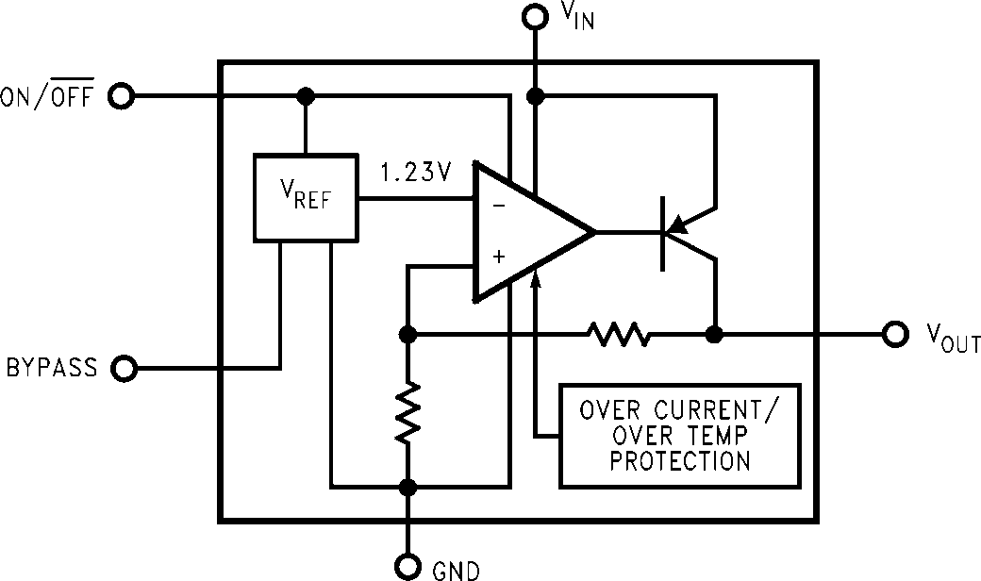

10014001

VIP® is a registered trademark of National Semiconductor Corporation.

© 2009 National Semiconductor Corporation 100140 www.national.com

Basic Application Circuit
LP2985

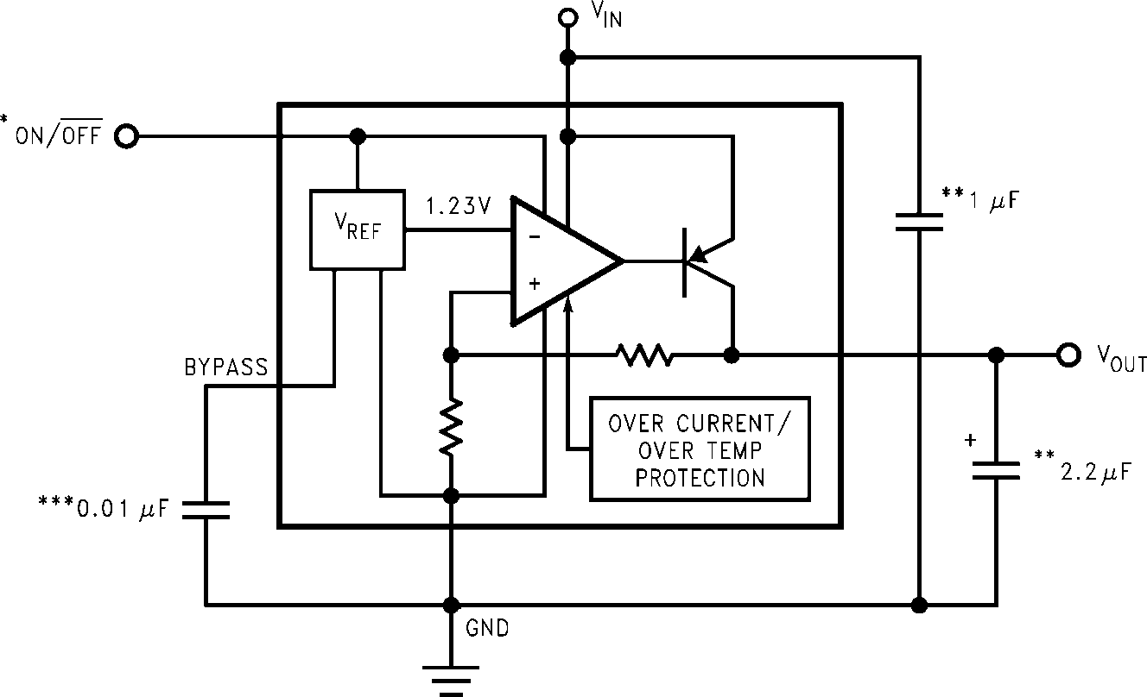

*ON/OFF input must be actively terminated. Tie to VIN if this function is not to be used.

10014002
**Minimum capacitance is shown to ensure stability (may be increased without limit). Ceramic capacitor required for output (see Application Hints).
***Reduces output noise (may be omitted if application is not noise critical). Use ceramic or film type with very low leakage current (see Application Hints).

Connection Diagrams

SOT-23, 5-Lead Small Outline Package (M5)
micro SMD, 5 Bump Package
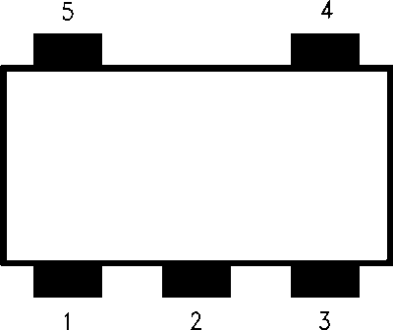

Top View

10014003

See NS Package Number MF05A

10014046
Note: The actual physical placement of the package marking will vary from part to part. Package marking contains date code and lot traceability information, and will vary considerably. Package marking does not correlate to device type.
Top View
See NS Package Numbers BPA05, TPA05, and TLA05

Pin Descriptions

Name Pin Number Function
VIN | SOT-23  1 | micro SMD  C3 | Input Voltage
GND | 2 | A1 | Common Ground (device substrate)
ON/OFF | 3 | A3 | Logic high enable input
BYPASS | 4 | B2 | Bypass capacitor for low noise operation
VOUT | 5 | C1 | Regulated output voltage

www.national.com 2

Ordering Information

TABLE 1. Package Marking and Ordering Information
LP2985

Output Voltage
(V)

Grade Order Information Package Marking Supplied as:
For output voltages ≤ 2.0V, refer to LP2985LV datasheet. SOT-23, 5-Lead Small Outline Package (M5)
LP2985AIM-2.5 LAUA 1000 Units on Tape and Reel

2.5

2.6
A
STD A
LP2985AIM5X-2.5 LAUA 3000 Units on Tape and Reel LP2985IM5-2.5 LAUB 1000 Units on Tape and Reel LP2985IM5X-2.5 LAUB 3000 Units on Tape and Reel LP2985AIM5-2.6 LCEA 1000 Units on Tape and Reel LP2985AIM5X-2.6 LCEA 3000 Units on Tape and Reel
STD LP2985AIM5–2.6 LCEB 1000 Units on Tape and Ree
LP2985AIM5-2.7 LALA 1000 Units on Tape and Reel

2.7

2.8

2.9

3.0

3.1

3.2

3.3

3.5

3.6
A
STD A STD A STD A STD A STD A STD A STD A STD A STD
LP2985AIM5X-2.7 LALA 3000 Units on Tape and Reel LP2985IM5-2.7 LALB 1000 Units on Tape and Reel LP2985IM5X-2.7 LALB 3000 Units on Tape and Reel LP2985AIM5-2.8 L0KA 1000 Units on Tape and Reel LP2985AIM5X-2.8 L0KA 3000 Units on Tape and Reel LP2985IM5-2.8 L0KB 1000 Units on Tape and Reel LP2985IM5X-2.8 L0KB 3000 Units on Tape and Reel LP2985AIM5-2.9 LAXA 1000 Units on Tape and Reel LP2985AIM5X-2.9 LAXA 3000 Units on Tape and Reel LP2985IM5-2.9 LAXB 1000 Units on Tape and Reel LP2985IM5X-2.9 LAXB 3000 Units on Tape and Reel LP2985AIM5-3.0 L0OA 1000 Units on Tape and Reel LP2985AIM5X-3.0 L0OA 3000 Units on Tape and Reel LP2985IM5-3.0 L0OB 1000 Units on Tape and Reel LP2985IM5X-3.0 L0OB 3000 Units on Tape and Reel LP2985AIM5-3.1 L0PA 1000 Units on Tape and Reel LP2985AIM5X-3.1 L0PA 3000 Units on Tape and Reel LP2985IM5-3.1 L0PB 1000 Units on Tape and Reel LP2985IM5X-3.1 L0PB 3000 Units on Tape and Reel LP2985AIM5-3.2 L0QA 1000 Units on Tape and Reel LP2985AIM5X-3.2 L0QA 3000 Units on Tape and Reel LP2985AIM5-3.2 L0QB 1000 Units on Tape and Reel LP2985IM5X-3.2 L0QB 3000 Units on Tape and Reel LP2985AIM5-3.3 L0RA 1000 Units on Tape and Reel LP2985AIM5X-3.3 L0RA 3000 Units on Tape and Reel LP2985IM5-3.3 L0RB 1000 Units on Tape and Reel LP2985IM5X-3.3 L0RB 3000 Units on Tape and Reel LP2985AIM5-3.5 LAIA 1000 Units on Tape and Reel LP2985AIM5X-3.5 LAIA 3000 Units on Tape and Reel LP2985IM5-3.5 LAIB 1000 Units on Tape and Reel LP2985IM5X-3.5 LAIB 3000 Units on Tape and Reel LP2985AIM5-3.6 L0SA 1000 Units on Tape and Reel LP2985AIM5X-3.6 L0SA 3000 Units on Tape and Reel LP2985IM5-3.6 L0SB 1000 Units on Tape and Reel LP2985IM5X-3.6 L0SB 3000 Units on Tape and Reel

3 www.national.com

Output Voltage
LP2985
(V)

3.8

Grade Order Information Package Marking Supplied as:

LP2985AIM5-3.8 L0YA 1000 Units on Tape and Reel
A
LP2985AIM5X-3.8 L0YA 3000 Units on Tape and Reel
LP2985IM5-3.8 L0YB 1000 Units on Tape and Reel
STD
LP2985IM5X-3.8 L0YB 3000 Units on Tape and Reel
LP2985AIM5-4.0 L0TA 1000 Units on Tape and Reel

4.0

4.5

5.0

5.7

6.1
A
STD A STD A STD A STD A STD
LP2985AIM5X-4.0 L0TA 3000 Units on Tape and Reel LP2985IM5-4.0 L0TB 1000 Units on Tape and Reel LP2985IM5X-4.0 L0TB 3000 Units on Tape and Reel LP2985AIM5-4.5 LA7A 1000 Units on Tape and Reel LP2985AIM5X-4.5 LA7A 3000 Units on Tape and Reel LP2985IM5X-4.5 LA7B 1000 Units on Tape and Reel LP2985IM5-4.5 LA7B 3000 Units on Tape and Reel LP2985AIM5-5.0 L0UA 1000 Units on Tape and Reel LP2985AIM5X-5.0 L0UA 3000 Units on Tape and Reel LP2985IM5-5.0 L0UB 1000 Units on Tape and Reel LP2985IM5X-5.0 L0UB 3000 Units on Tape and Reel LP2985AIM5-5.7 LKTA 1000 Units on Tape and Reel LP2985AIM5X-5.7 LKTA 3000 Units on Tape and Reel LP2985IM5-5.7 LKTB 1000 Units on Tape and Reel LP2985IM5X-5.7 LKTB 3000 Units on Tape and Reel LP2985AIM5-6.1 LF6A 1000 Units on Tape and Reel LP2985AIM5X-6.1 LF6A 3000 Units on Tape and Reel LP2985IM5-6.1 LF6B 1000 Units on Tape and Reel LP2985IM5X-6.1 LF6B 3000 Units on Tape and Reel
micro SMD, 5 Bump Package (BPA05 - 170 µm ball)
2.5 A LP2985AIBP-2.5 250 Units on Tape and Reel
LP2985AIBP-3.0 250 Units on Tape and Reel

3.0
A
LP2985AIBPX-3.0 3000 Units on Tape and Reel
STD LP2985IBP-3.0 250 Units on Tape and Reel
LP2985AIBP-5.0 250 Units on Tape and Reel

5.0
A
LP2985AIBPX-5.0 3000 Units on Tape and Reel
STD LP2985IBPX-5.0 3000 Units on Tape and Reel
micro SMD, 5 Bump Package (TPA05 - 170 µm ball)
LP2985AITP-2.5 250 Units on Tape and Reel

2.5
A
LP2985AITPX-2.5 3000 Units on Tape and Reel
STD LP2985ITP-2.5 250 Units on Tape and Reel
LP2985AITP-2.6 250 Units on Tape and Reel

2.6

2.7

2.8
A
STD A STD A STD
LP2985AITPX-2.6 3000 Units on Tape and Reel LP2985ITP-2.6 250 Units on Tape and Reel LP2985ITPX-2.6 3000 Units on Tape and Reel LP2985AITP-2.7 250 Units on Tape and Reel LP2985AITPX-2.7 3000 Units on Tape and Reel LP2985ITP-2.7 250 Units on Tape and Reel LP2985ITPX-2.7 3000 Units on Tape and Reel LP2985AITP-2.8 250 Units on Tape and Reel LP2985AITPX-2.8 3000 Units on Tape and Reel LP2985ITP-2.8 250 Units on Tape and Reel LP2985ITPX-2.8 3000 Units on Tape and Reel

www.national.com 4

Output Voltage
(V)

2.9

Grade Order Information Package Marking Supplied as:

LP2985AITP-2.9 250 Units on Tape and Reel
LP2985
A
LP2985AITPX-2.9 3000 Units on Tape and Reel
LP2985ITP-2.9 250 Units on Tape and Reel
STD
LP2985ITPX-2.9 3000 Units on Tape and Reel
LP2985AITP-3.0 250 Units on Tape and Reel

3.0

3.3

5.0
A
STD A STD A STD
LP2985AITPX-3.0 3000 Units on Tape and Reel LP2985ITP-3.0 250 Units on Tape and Reel LP2985ITPX-3.0 3000 Units on Tape and Reel LP2985AITP-3.3 250 Units on Tape and Reel LP2985AITPX-3.3 3000 Units on Tape and Reel LP2985ITP-3.3 250 Units on Tape and Reel LP2985ITPX-3.3 3000 Units on Tape and Reel LP2985AITP-5.0 250 Units on Tape and Reel LP2985AITPX-5.0 3000 Units on Tape and Reel LP2985ITP-5.0 250 Units on Tape and Reel LP2985ITPX-5.0 3000 Units on Tape and Reel
micro SMD, 5 Bump Package (TLA05 - 300 µm ball)
LP2985AITL-3.3 250 Units on Tape and Reel

3.3
A

STD
LP2985AITLX-3.3 3000 Units on Tape and Reel LP2985ITL-3.3 250 Units on Tape and Reel LP2985ITLX-3.3 3000 Units on Tape and Reel
micro SMD, 5 Bump Package (BLA05 - 300 µm ball)
3.3 A LP2985AIBLX-3.3 3000 Units on Tape and Reel

5 www.national.com

Absolute Maximum Ratings (Note 1) If Military/Aerospace specified devices are required, please contact the National Semiconductor Sales Office/
LP2985
Distributors for availability and specifications.

Storage Temperature Range −65°C to +150°C Operating Junction Temperature
Range −40°C to +125°C
Lead Temp. (Soldering, 5 sec.) 260°C ESD Rating (Note 2) 2 kV
Electrical Characteristics (Note 10)
Power Dissipation (Note 3) Internally Limited Input Supply Voltage (Survival) −0.3V to +16V Input Supply Voltage (Operating) 2.5V to +16V Shutdown Input Voltage (Survival) −0.3V to +16V Output Voltage (Survival, (Note 4)) −0.3V to +9V IOUT (Survival) Short Circuit
Protected
Input-Output Voltage (Survival, −0.3V to +16V
(Note 5))
Limits in standard typeface are for TJ = 25°C. and limits in boldface type apply over the full operating temperature range. Unless otherwise specified: VIN = VO(NOM) + 1V, IL = 1 mA, CIN = 1 µF, COUT = 4.7 µF, VON/OFF = 2V.
LP2985AI-X.X LP2985I-X.X

Symbol Parameter Conditions Typ
(Note 6) (Note 6)
Min Max Min Max
Units

ΔVO Output Voltage
IL = 1 mA −1.0 1.0 −1.5 1.5

Tolerance
1 mA ≤ IL
≤ 50 mA −1.5 1.5 −2.5 2.5
−2.5 2.5 −3.5 3.5

%VNOM

1 mA ≤ IL ≤ 150 mA −2.5 2.5 −3.0 3.0
−3.5 3.5 −4.0 4.0
Output Voltage VO(NOM)+1V ≤ VIN ≤ 16V 0.007 0.014 0.014
Line Regulation 0.032 0.032

%/V

VIN–VO Dropout Voltage
(Note 7)

IL = 0 1 3 3
5 5
IL = 1 mA 7 10 10
15 15
IL = 10 mA 40 60 60 mV
90 90
IL = 50 mA 120 150 150
225 225
IL = 150 mA 280 350 350
575 575
IGND Ground Pin Current IL = 0 65 95 95
125 125
IL = 1 mA 75 110 110
170 170
IL = 10 mA 120 220 220
400 400
µA IL = 50 mA 350 600 600
1000 1000
IL = 150 mA 850 1500 1500
2500 2500
VON/OFF < 0.3V 0.01 0.8 0.8
VON/OFF < 0.15V 0.05 2 2

VON/OFF ON/OFF Input Voltage
(Note 8)
High = O/P ON 1.4 1.6 1.6
V Low = O/P OFF 0.55 0.15 0.15
ION/OFF ON/OFF Input Current VON/OFF = 0 0.01 −2 −2
µA
VON/OFF = 5V 5 15 15

www.national.com 6

 |  |  |  | LP2985AI-X.X | LP2985I-X.X
Symbol | Parameter | Conditions | Typ | (Note 6) | (Note 6) | Units

en Output Noise BW = 300 Hz to 50 kHz,
Min Max Min Max
LP2985
Voltage (RMS) COUT = 10 µF 30 µV CBYPASS = 10 nF
Ripple Rejection f = 1 kHz, CBYPASS = 10 nF
IO(SC) | Short Circuit Current | RL = 0 (Steady State)
IO(PK) | Peak Output Current | (Note 9)  VOUT ≥ Vo(NOM) −5%

COUT
= 10 µF
45 dB

400 mA

350 mA

Note 1: “Absolute Maximum Ratings” indicate limits beyond which damage to the component may occur. Electrical specifications do not apply when operating the device outside of its rated operating conditions.
Note 2: The ESD rating of pins 3 and 4 for the SOT-23 package, or pins 5 and 2 for the micro SMD package, is 1 kV.
Note 3: The maximum allowable power dissipation is a function of the maximum junction temperature, TJ(MAX), the junction-to-ambient thermal resistance, θJ- A, and the ambient temperature, TA. The maximum allowable power dissipation at any ambient temperture is calculated using:

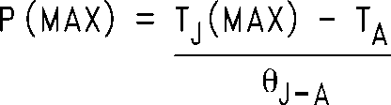

Where the value of θJ-A for the SOT-23 package is 220°C/W in a typical PC board mounting and the micro SMD package is 225°C/W. Exceeding the maximum allowable dissipation will cause excessive die temperature, and the regulator will go into thermal shutdown.
Note 4: For 12V option, output voltage survival: -0.3 to +16V. If used in a dual-supply system where the regulator load is returned to a negative supply, the LP2985 output must be diode-clamped to ground.
Note 5: The output PNP structure contains a diode between the VIN to VOUT terminals that is normally reverse-biased. Reversing the polarity from VIN to VOUT
will turn on this diode.
Note 6: Limits are 100% production tested at 25°C. Limits over the operating temperature range are guaranteed through correlation using Statistical Quality
Control (SQC) methods. The limits are used to calculate National's Average Outgoing Quality Level (AOQL).
Note 7: Dropout voltage is defined as the input to output differential at which the output voltage drops 100 mV below the value measured with a 1V differential.
Note 8: The ON/OFF input must be properly driven to prevent possible misoperation. For details, refer to Application Hints.
Note 9: The LP2985 has foldback current limiting which allows a high peak current when VOUT > 0.5V, and then reduces the maximum output current as VOUT is forced to ground (see Typical Performance Characteristics curves).
Note 10: Exposing the micro SMD device to direct sunlight will cause misoperation. See Application Hints for additional information.

7 www.national.com

Typical Performance Characteristics Unless otherwise specified: CIN = 1µF, COUT = 4.7µF, VIN = VOUT
(NOM) +1, TA = 25°C, ON/OFF pin is tied to VIN.
LP2985

VOUT vs Temperature

10014008
Short-Circuit Current

10014009

Short-Circuit Current

10014010
Short Circuit Current vs Output Voltage
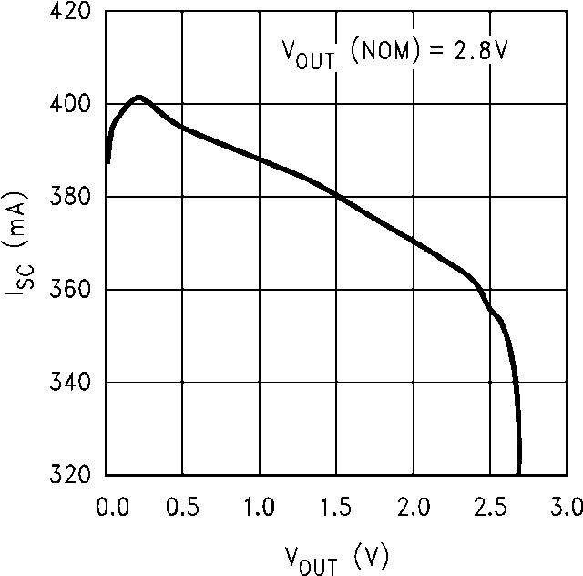

10014011

Ripple Rejection

10014013
Ripple Rejection

10014014

www.national.com 8

Ripple Rejection

10014015
Ripple Rejection
LP2985

10014016

Ripple Rejection

10014017
Ripple Rejection

10014018

Ripple Rejection

10014019
Ripple Rejection

10014023

9 www.national.com

Ripple Rejection
LP2985

10014022
Output Impedance vs Frequency
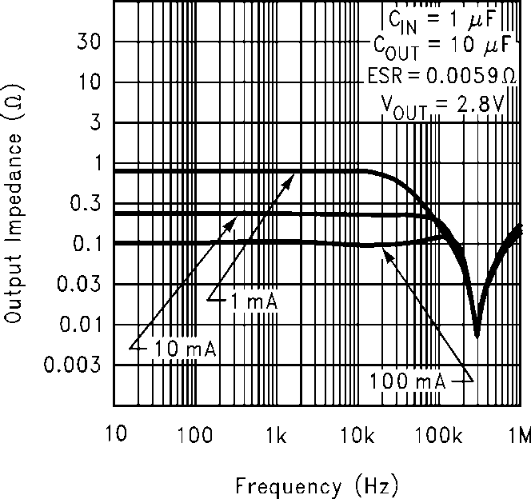

10014020

Output Impedance vs Frequency
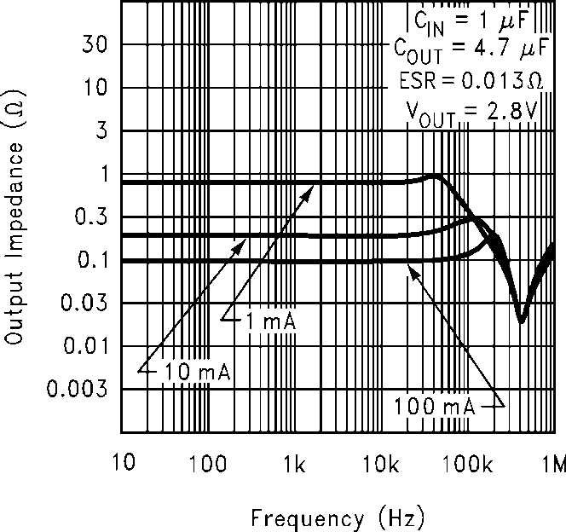

10014021
Output Noise Density

10014024

Output Noise Density

10014025
Ground Pin vs Load Current
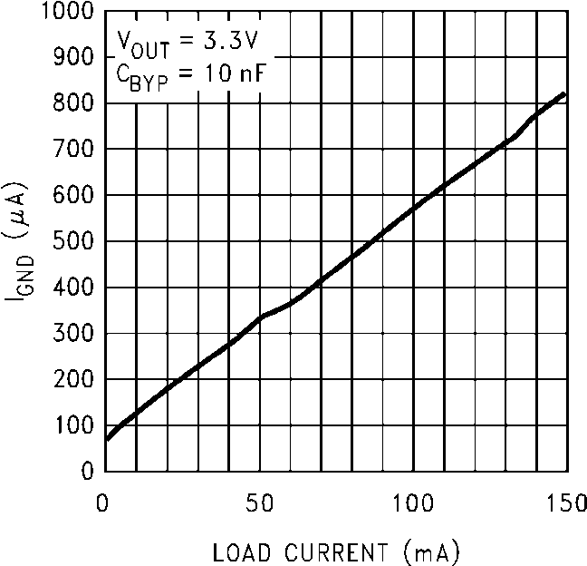

10014026

www.national.com 10

Dropout Voltage vs Temperature
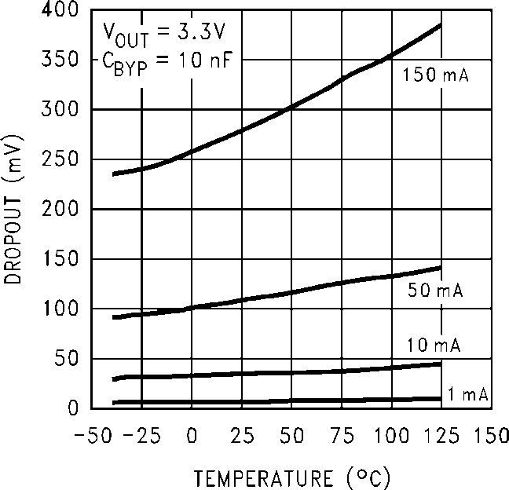

10014027
Input Current vs Pin
LP2985

10014029

GND Pin Current vs Temperature
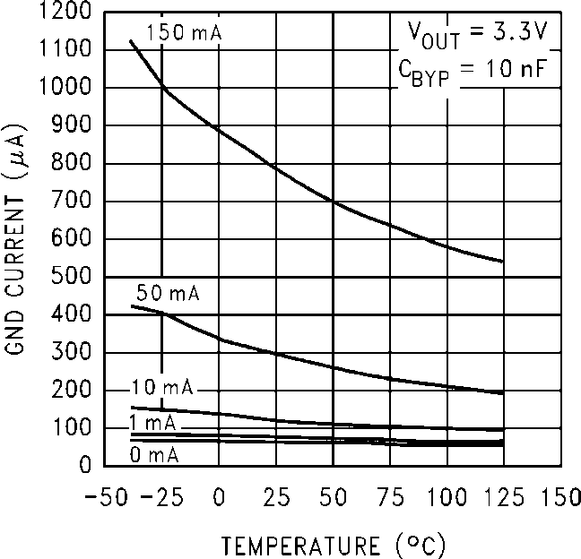

10014030
Instantaneous Short Circuit Current
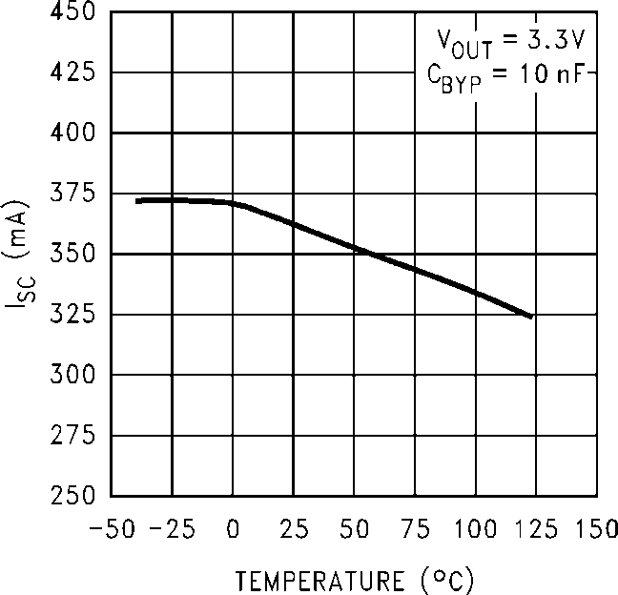

10014031

Load Transient Response

10014032
Load Transient Response

10014033

11 www.national.com

Load Transient Response
LP2985

10014034
Line Transient Response

10014035

Line Transient Response

10014036
Line Transient Response

10014037

Line Transient Response

10014038
Turn-On Time

10014039

www.national.com 12

Turn-On Time

10014040
Turn-On Time
LP2985

10014041

Turn-On Time

10014042

13 www.national.com

Application Hints
EXTERNAL CAPACITORS
LP2985
Like any low-dropout regulator, the LP2985 requires external capacitors for regulator stability. These capacitors must be correctly selected for good performance.

Input Capacitor
An input capacitor whose capacitance is ≥ 1 µF is required between the LP2985 input and ground (the amount of capac-
itance may be increased without limit).
This capacitor must be located a distance of not more than 1 cm from the input pin and returned to a clean analog ground. Any good quality ceramic, tantalum, or film capacitor may be used at the input.
Important: Tantalum capacitors can suffer catastrophic fail- ure due to surge current when connected to a low-impedance source of power (like a battery or very large capacitor). If a Tantalum capacitor is used at the input, it must be guaranteed by the manufacturer to have a surge current rating sufficient for the application.
There are no requirements for ESR on the input capacitor, but tolerance and temperature coefficient must be considered when selecting the capacitor to ensure the capacitance will
be ≥ 1 µF over the entire operating temperature range.

Output Capacitor
The LP2985 is designed specifically to work with ceramic out- put capacitors, utilizing circuitry which allows the regulator to be stable across the entire range of output current with an output capacitor whose ESR is as low as 5 mΩ. It may also be possible to use Tantalum or film capacitors at the output, but these are not as attractive for reasons of size and cost (see next section Capacitor Characteristics).
The output capacitor must meet the requirement for minimum amount of capacitance and also have an ESR (equivalent se- ries resistance) value which is within the stable range. Curves are provided which show the stable ESR range as a function of load current (see ESR graph below).

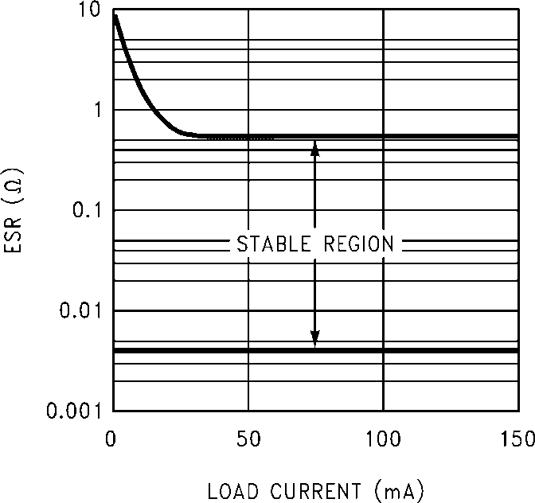

10014007
Important: The output capacitor must maintain its ESR within the stable region over the full operating temperature range of the application to assure stability.
The LP2985 requires a minimum of 2.2 µF on the output (out- put capacitor size can be increased without limit).
It is important to remember that capacitor tolerance and vari- ation with temperature must be taken into consideration when selecting an output capacitor so that the minimum required amount of output capacitance is provided over the full oper- ating temperature range. It should be noted that ceramic

capacitors can exhibit large changes in capacitance with tem- perature (see next section, Capacitor Characteristics).
The output capacitor must be located not more than 1 cm from the output pin and returned to a clean analog ground.

Noise Bypass Capacitor
Connecting a 10 nF capacitor to the Bypass pin significantly reduces noise on the regulator output. It should be noted that the capacitor is connected directly to a high-impedance circuit in the bandgap reference.
Because this circuit has only a few microamperes flowing in it, any significant loading on this node will cause a change in the regulated output voltage. For this reason, DC leakage current through the noise bypass capacitor must never ex- ceed 100 nA, and should be kept as low as possible for best output voltage accuracy.
The types of capacitors best suited for the noise bypass ca- pacitor are ceramic and film. High-quality ceramic capacitors with either NPO or COG dielectric typically have very low leakage. 10 nF polypropolene and polycarbonate film capac- itors are available in small surface-mount packages and typ- ically have extremely low leakage current.

CAPACITOR CHARACTERISTICS
The LP2985 was designed to work with ceramic capacitors on the output to take advantage of the benefits they offer: for capacitance values in the 2.2 µF to 4.7 µF range, ceramics are the least expensive and also have the lowest ESR values (which makes them best for eliminating high-frequency noise). The ESR of a typical 2.2 µF ceramic capacitor is in the range of 10 mΩ to 20 mΩ, which easily meets the ESR limits required for stability by the LP2985.
One disadvantage of ceramic capacitors is that their capaci- tance can vary with temperature. Most large value ceramic
capacitors (≥ 2.2 µF) are manufactured with the Z5U or Y5V
temperature characteristic, which results in the capacitance
dropping by more than 50% as the temperature goes from 25° C to 85°C.
This could cause problems if a 2.2 µF capacitor were used on the output since it will drop down to approximately 1 µF at high ambient temperatures (which could cause the LM2985 to os- cillate). If Z5U or Y5V capacitors are used on the output, a minimum capacitance value of 4.7 µF must be observed.
A better choice for temperature coefficient in ceramic capac- itors is X7R, which holds the capacitance within ±15%. Un- fortunately, the larger values of capacitance are not offered by all manufacturers in the X7R dielectric.

Tantalum
Tantalum capacitors are less desirable than ceramics for use as output capacitors because they are more expensive when comparing equivalent capacitance and voltage ratings in the
1 µF to 4.7 µF range.
Another important consideration is that Tantalum capacitors have higher ESR values than equivalent size ceramics. This means that while it may be possible to find a Tantalum ca- pacitor with an ESR value within the stable range, it would have to be larger in capacitance (which means bigger and more costly) than a ceramic capacitor with the same ESR value.
It should also be noted that the ESR of a typical Tantalum will increase about 2:1 as the temperature goes from 25°C down to −40°C, so some guard band must be allowed.

www.national.com 14

On/Off Input Operation
The LP2985 is shut off by driving the ON/OFF input low, and turned on by pulling it high. If this feature is not to be used, the ON/OFF input should be tied to VIN to keep the regulator output on at all times.
To assure proper operation, the signal source used to drive the ON/OFF input must be able to swing above and below the specified turn-on/turn-off voltage thresholds listed in the Elec- trical Characteristics section under VON/OFF. To prevent mis- operation, the turn-on (and turn-off) voltage signals applied to the ON/OFF input must have a slew rate which is
≥ 40 mV/µs.
Caution: the regulator output voltage can not be guaranteed if a slow-moving AC (or DC) signal is applied that is in the range between the specified turn-on and turn-off voltages list- ed under the electrical specification VON/OFF (see Electrical
Characteristics).

REVERSE INPUT-OUTPUT VOLTAGE
The PNP power transistor used as the pass element in the LP2985 has an inherent diode connected between the regu- lator output and input. During normal operation (where the input voltage is higher than the output) this diode is reverse- biased.
VIN to VOUT (cathode on VIN, anode on VOUT), to limit the re- verse voltage across the LP2985 to 0.3V (see Absolute Max- imum Ratings).
LP2985

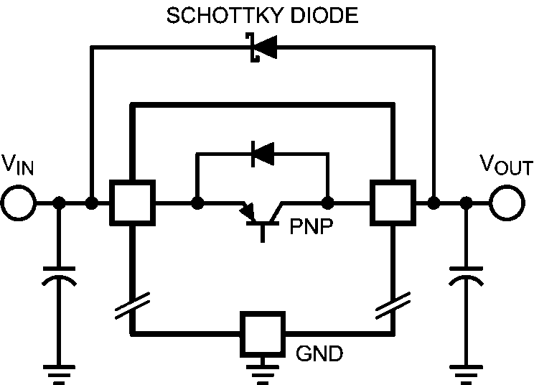

10014055

FIGURE 2. Reverse Current Protection

MICRO SMD MOUNTING
The micro SMD package requires specific mounting tech- niques which are detailed in National Semiconductor Appli- cation Note # 1112. Referring to the section Surface Mount Technology (SMT) Assembly Considerations, it should be noted that the pad style which must be used with the 5-pin package is the NSMD (non-solder mask defined) type.
For best results during assembly, alignment ordinals on the PC board may be used to facilitate placement of the micro SMD device.

FIGURE 1. Reverse Current Path

10014054

MICRO SMD LIGHT SENSITIVITY
Exposing the micro SMD device to direct sunlight will cause misoperation of the device. Light sources such as Halogen lamps can also affect electrical performance if brought near to the device.
The wavelenghts which have the most detrimental effect are reds and infra-reds, which means that the fluorescent lighting

However, if the output is pulled above the input, this diode will
turn ON and current will flow into the regulator output. In such cases, a parasitic SCR can latch which will allow a high cur- rent to flow into VIN (and out the ground pin), which can damage the part.
In any application where the output may be pulled above the input, an external Schottky diode must be connected from
used inside most buildings has very little effect on perfor- mance. A micro SMD test board was brought to within 1 cm of a fluorescent desk lamp and the effect on the regulated output voltage was negligible, showing a deviation of less than 0.1% from nominal.

15 www.national.com

Physical Dimensions inches (millimeters) unless otherwise noted
LP2985

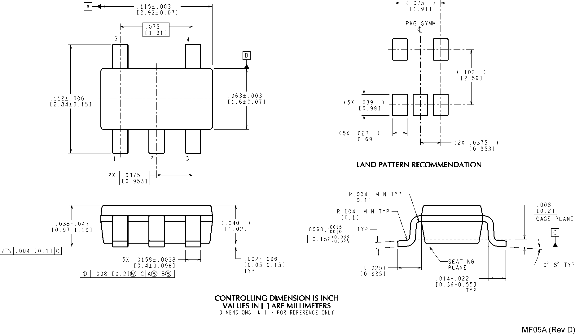
SOT-23, 5-Lead Small Outline Package (M5) NS Package Number MF05A.

www.national.com 16

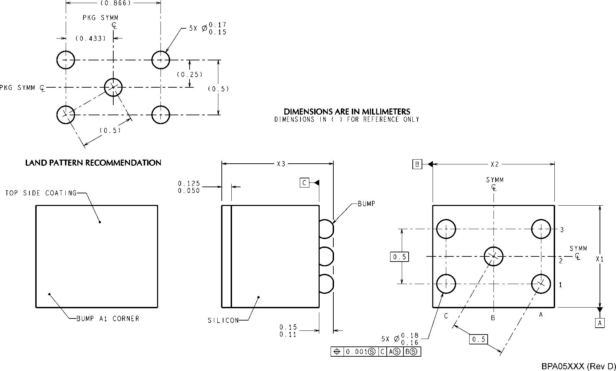
LP2985
NOTES: UNLESS OTHERWISE SPECIFIED
1. EPOXY COATING
2. 63Sn/37Pb EUTECTIC BUMP
3. RECOMMEND NON-SOLDER MASK DEFINED LANDING PAD.
4. PIN 1 IS ESTABLISHED BY LOWER LEFT CORNER WITH RESPECT TO TEXT ORIENTATION. REMAINING PINS ARE NUMBERED COUNTER CLOCK- WISE.
5. XXX IN DRAWING NUMBER REPRESENTS PACKAGE SIZE VARIATION WHERE X1 IS PACKAGE WIDTH, X2 IS PACKAGE LENGTH AND X3 IS PACK- AGE HEIGHT.
6.NO JEDEC REGISTRATION AS OF AUG.1999.
micro SMD, 5 Bump, Package (BPA05) NS Package Number BPA05A
The dimensions for X1, X2 and X3 are as given: X1 = 0.930 +/− 0.030mm
X2 = 1.107 +/− 0.030mm
X3 = 0.850 +/− 0.050mm

17 www.national.com

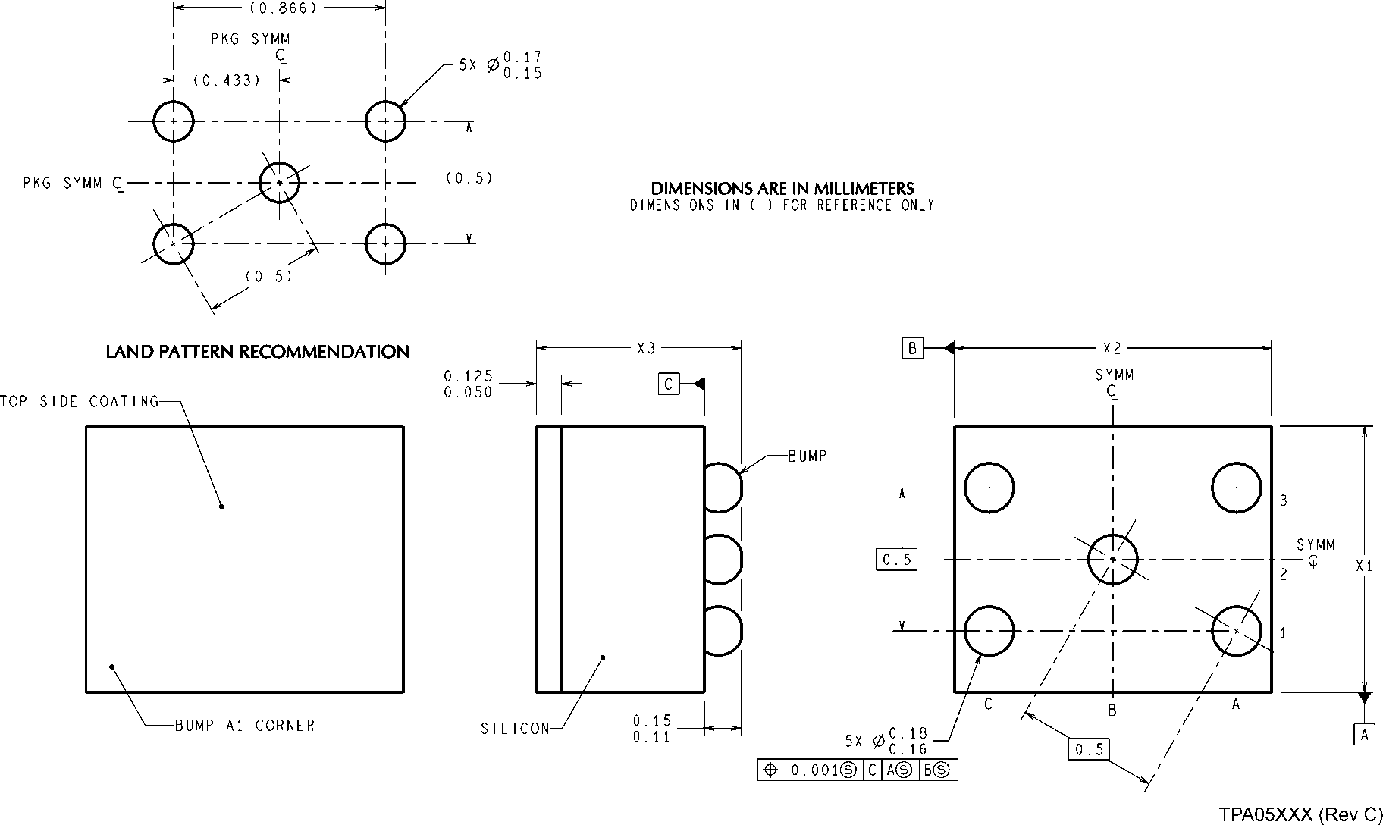
LP2985
NOTES: UNLESS OTHERWISE SPECIFIED
1. EPOXY COATING
2. 63Sn/37Pb EUTECTIC BUMP
3. RECOMMEND NON-SOLDER MASK DEFINED LANDING PAD.
4. PIN 1 IS ESTABLISHED BY LOWER LEFT CORNER WITH RESPECT TO TEXT ORIENTATION. REMAINING PINS ARE NUMBERED COUNTER CLOCK- WISE.
5. XXX IN DRAWING NUMBER REPRESENTS PACKAGE SIZE VARIATION WHERE X1 IS PACKAGE WIDTH, X2 IS PACKAGE LENGTH AND X3 IS PACK- AGE HEIGHT.
6.NO JEDEC REGISTRATION AS OF AUG.1999.
micro SMD, 5 Bump, Package (TPA05 - 170 µm ball) NS Package Number TPA05
The dimensions for X1, X2 and X3 are as given: X1 = 0.930 +/− 0.030mm
X2 = 1.107 +/− 0.030mm
X3 = 0.500 +/− 0.075mm

www.national.com 18

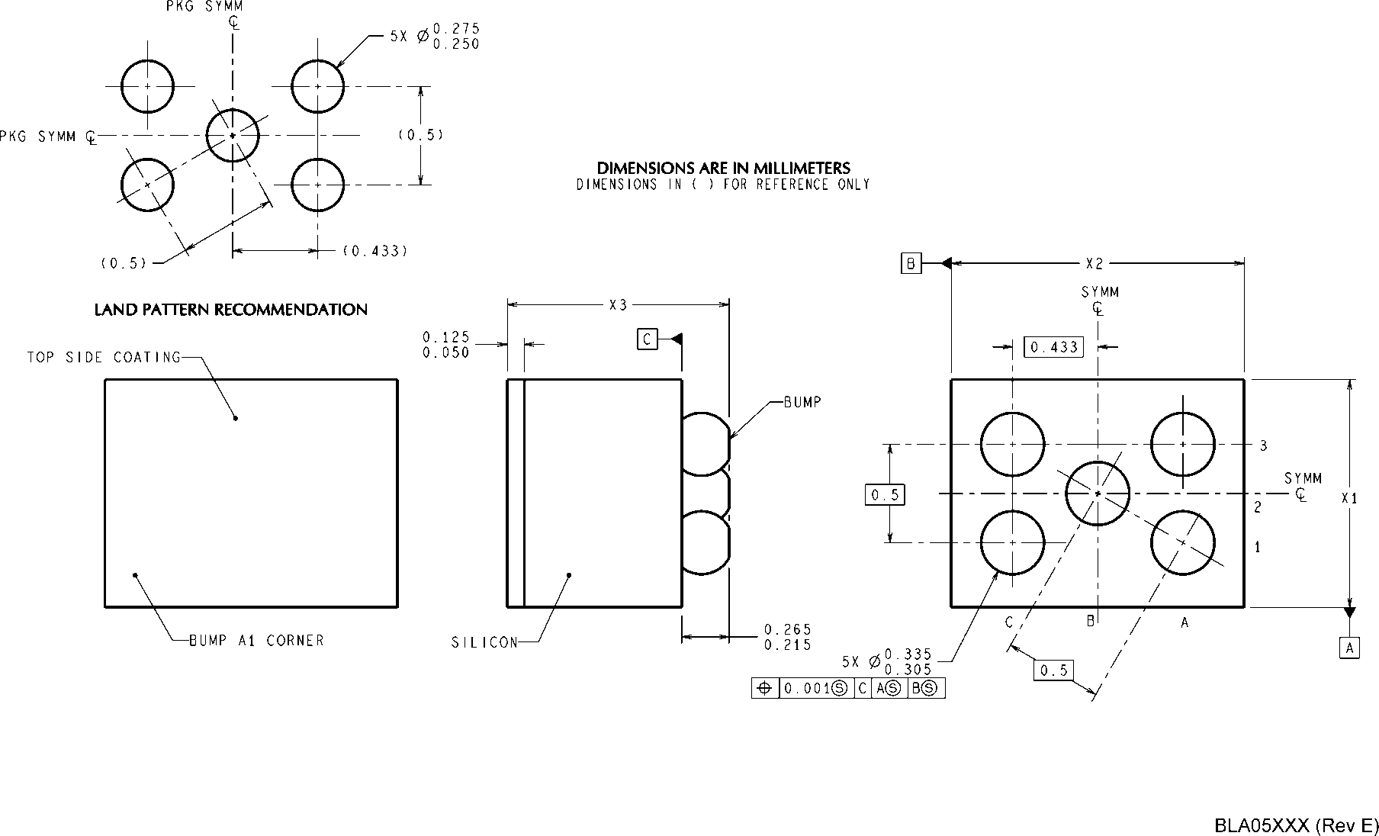
LP2985
NOTES: UNLESS OTHERWISE SPECIFIED
1. EPOXY COATING
2. 63Sn/37Pb EUTECTIC BUMP
3. RECOMMEND NON-SOLDER MASK DEFINED LANDING PAD.
4. PIN 1 IS ESTABLISHED BY LOWER LEFT CORNER WITH RESPECT TO TEXT ORIENTATION. REMAINING PINS ARE NUMBERED COUNTER CLOCK- WISE.
5. XXX IN DRAWING NUMBER REPRESENTS PACKAGE SIZE VARIATION WHERE X1 IS PACKAGE WIDTH, X2 IS PACKAGE LENGTH AND X3 IS PACK- AGE HEIGHT.
6. NO JEDEC REGISTRATION AS OF AUG.1999
micro SMD, 5 Bump, Package (BLA05 - 300 µm ball) NS Package Number BLA05A
The dimensions for X1, X2 and X3 are as given: X1 = 1.057 +/− 0.030mm
X2 = 1.412 +/− 0.030mm
X3 = 0.945 +/− 0.100mm

19 www.national.com

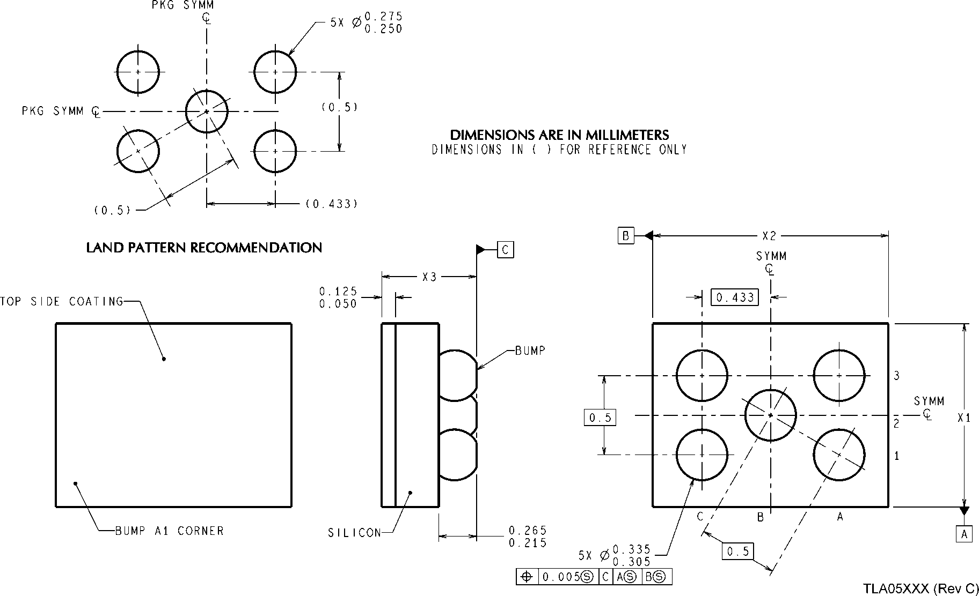
LP2985
NOTES: UNLESS OTHERWISE SPECIFIED
1. EPOXY COATING
2. 63Sn/37Pb EUTECTIC BUMP
3. RECOMMEND NON-SOLDER MASK DEFINED LANDING PAD.
4. PIN 1 IS ESTABLISHED BY LOWER LEFT CORNER WITH RESPECT TO TEXT ORIENTATION. REMAINING PINS ARE NUMBERED COUNTER CLOCK- WISE.
5. XXX IN DRAWING NUMBER REPRESENTS PACKAGE SIZE VARIATION WHERE X1 IS PACKAGE WIDTH, X2 IS PACKAGE LENGTH AND X3 IS PACK- AGE HEIGHT.
6.NO JEDEC REGISTRATION AS OF AUG.1999.
micro SMD, 5 Bump, Package (TLA05 - 300 µm ball) NS Package Number TLA05
The dimensions for X1, X2 and X3 are as given: X1 = 1.031 +/− 0.030mm
X2 = 1.412 +/− 0.030mm
X3 = 0.600 +/− 0.075mm

www.national.com 20

Notes
LP2985

21 www.national.com

Notes

For more National Semiconductor product information and proven design tools, visit the following Web sites at:

 | Products |  |  | Design Support
Amplifiers | www.national.com/amplifiers |  | WEBENCH® Tools | www.national.com/webench
Audio | www.national.com/audio |  | App Notes | www.national.com/appnotes
Clock and Timing | www.national.com/timing |  | Reference Designs | www.national.com/refdesigns
Data Converters | www.national.com/adc |  | Samples | www.national.com/samples
Interface | www.national.com/interface |  | Eval Boards | www.national.com/evalboards
LVDS | www.national.com/lvds |  | Packaging | www.national.com/packaging
Power Management | www.national.com/power |  | Green Compliance | www.national.com/quality/green
Switching Regulators |  | www.national.com/switchers | Distributors | www.national.com/contacts
LDOs |  | www.national.com/ldo | Quality and Reliability | www.national.com/quality
LED Lighting |  | www.national.com/led | Feedback/Support | www.national.com/feedback
Voltage Reference |  | www.national.com/vref | Design Made Easy | www.national.com/easy
PowerWise® Solutions www.national.com/powerwise Solutions www.national.com/solutions

Serial Digital Interface (SDI) www.national.com/sdi Mil/Aero www.national.com/milaero

Temperature Sensors www.national.com/tempsensors SolarMagic™ www.national.com/solarmagic

Wireless (PLL/VCO) www.national.com/wireless PowerWise® Design
University

www.national.com/training

THE CONTENTS OF THIS DOCUMENT ARE PROVIDED IN CONNECTION WITH NATIONAL SEMICONDUCTOR CORPORATION (“NATIONAL”) PRODUCTS. NATIONAL MAKES NO REPRESENTATIONS OR WARRANTIES WITH RESPECT TO THE ACCURACY OR COMPLETENESS OF THE CONTENTS OF THIS PUBLICATION AND RESERVES THE RIGHT TO MAKE CHANGES TO SPECIFICATIONS AND PRODUCT DESCRIPTIONS AT ANY TIME WITHOUT NOTICE. NO LICENSE, WHETHER EXPRESS, IMPLIED, ARISING BY ESTOPPEL OR OTHERWISE, TO ANY INTELLECTUAL PROPERTY RIGHTS IS GRANTED BY THIS DOCUMENT.
TESTING AND OTHER QUALITY CONTROLS ARE USED TO THE EXTENT NATIONAL DEEMS NECESSARY TO SUPPORT NATIONAL’S PRODUCT WARRANTY. EXCEPT WHERE MANDATED BY GOVERNMENT REQUIREMENTS, TESTING OF ALL PARAMETERS OF EACH PRODUCT IS NOT NECESSARILY PERFORMED. NATIONAL ASSUMES NO LIABILITY FOR APPLICATIONS ASSISTANCE OR BUYER PRODUCT DESIGN. BUYERS ARE RESPONSIBLE FOR THEIR PRODUCTS AND APPLICATIONS USING NATIONAL COMPONENTS. PRIOR TO USING OR DISTRIBUTING ANY PRODUCTS THAT INCLUDE NATIONAL COMPONENTS, BUYERS SHOULD PROVIDE ADEQUATE DESIGN, TESTING AND OPERATING SAFEGUARDS.
EXCEPT AS PROVIDED IN NATIONAL’S TERMS AND CONDITIONS OF SALE FOR SUCH PRODUCTS, NATIONAL ASSUMES NO LIABILITY WHATSOEVER, AND NATIONAL DISCLAIMS ANY EXPRESS OR IMPLIED WARRANTY RELATING TO THE SALE AND/OR USE OF NATIONAL PRODUCTS INCLUDING LIABILITY OR WARRANTIES RELATING TO FITNESS FOR A PARTICULAR PURPOSE, MERCHANTABILITY, OR INFRINGEMENT OF ANY PATENT, COPYRIGHT OR OTHER INTELLECTUAL PROPERTY RIGHT.

LIFE SUPPORT POLICY
NATIONAL’S PRODUCTS ARE NOT AUTHORIZED FOR USE AS CRITICAL COMPONENTS IN LIFE SUPPORT DEVICES OR SYSTEMS WITHOUT THE EXPRESS PRIOR WRITTEN APPROVAL OF THE CHIEF EXECUTIVE OFFICER AND GENERAL COUNSEL OF NATIONAL SEMICONDUCTOR CORPORATION. As used herein:
Life support devices or systems are devices which (a) are intended for surgical implant into the body, or (b) support or sustain life and whose failure to perform when properly used in accordance with instructions for use provided in the labeling can be reasonably expected to result in a significant injury to the user. A critical component is any component in a life support device or system whose failure to perform can be reasonably expected to cause the failure of the life support device or system or to affect its safety or effectiveness.

National Semiconductor and the National Semiconductor logo are registered trademarks of National Semiconductor Corporation. All other brand or product names may be trademarks or registered trademarks of their respective holders.
Copyright© 2009 National Semiconductor Corporation
For the most current product information visit us at www.national.com
LP2985 Micropower 150 mA Low-Noise Ultra Low-Dropout Regulator in SOT-23 and micro SMD Packages

National Semiconductor Americas Technical Support Center
Email: support@nsc.com
Tel: 1-800-272-9959

National Semiconductor Europe
Technical Support Center
Email: europe.support@nsc.com

National Semiconductor Asia Pacific Technical Support Center Email: ap.support@nsc.com

National Semiconductor Japan Technical Support Center Email: jpn.feedback@nsc.com

www.national.com

