

LP2995
DDR Termination Regulator
General Description
The LP2995 linear regulator is designed to meet the JEDEC SSTL-2 and SSTL-3 specifications for termination of DDR- SDRAM. The device contains a high-speed operational am- plifier to provide excellent response to load transients. The output stage prevents shoot through while delivering 1.5A continuous current and transient peaks up to 3A in the application as required for DDR-SDRAM termination. The
June 2006
LP2995 DDR Termination Regulator

Features
n Low output voltage offset
n Works with +5v, +3.3v and 2.5v rails
n Source and sink current
n Low external component count
n No external resistors required
n Linear topology
Available in SO-8, PSOP-8 or LLP-16 packages

LP2995 also incorporates a VSENSE pin to provide superior load regulation and a VREF output as a reference for the chipset and DDR DIMMS.
Patents Pending
n
n Low cost and easy to use

Applications
n DDR Termination Voltage
n SSTL-2
n SSTL-3

Typical Application Circuit

20039302

© 2006 National Semiconductor Corporation DS200393 www.national.com

Connection Diagrams

SO-8 (M08A) Package LQA- 16 Package

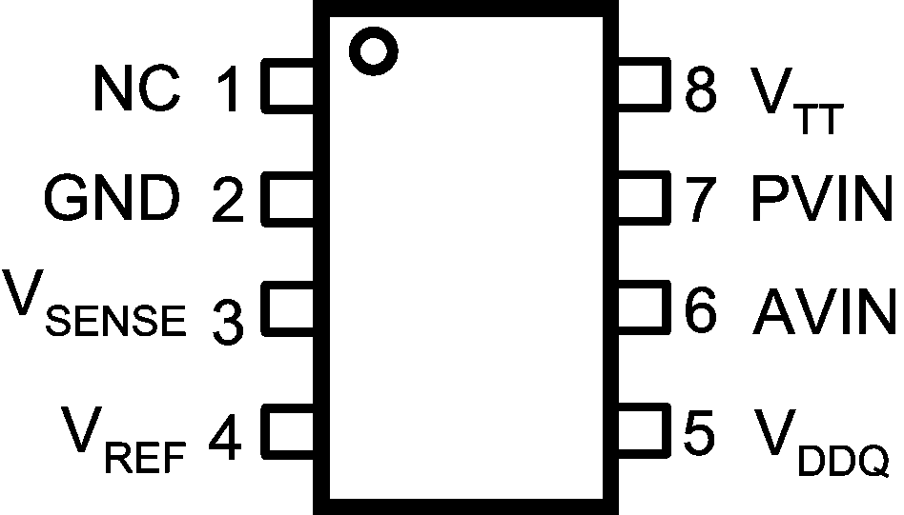
20039320
Top View

20039304
Top View

PSOP-8 (MRA08A) Package

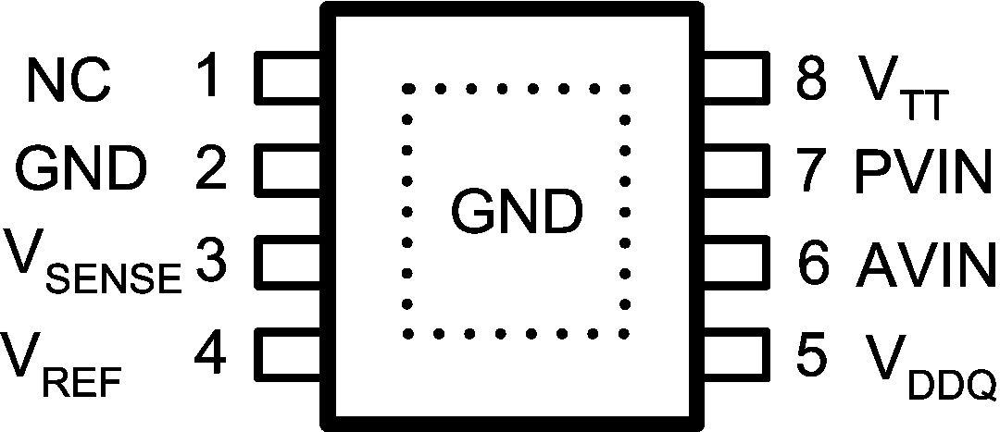
20039350
Top View

Pin Descriptions
SO-8 Pin or  PSOP-8 Pin | LLP Pin |  | Name |  | Function
1 | 1,3,4,6,9, 13,16 |  | NC |  | No internal connection. Can be used for vias.
2 | 2 |  | GND |  | Ground.
3 | 5 |  | VSENSE |  | Feedback pin for regulating VTT.
4 | 7 |  | VREF |  | Buffered internal reference voltage of  VDDQ/2.
5 | 8 |  | VDDQ |  | Input for internal reference equal to VDDQ/2.
6 | 10 |  | AVIN |  | Analog input pin.
7 | 11, 12 |  | PVIN |  | Power input pin.
8 | 14, 15 |  | VTT |  | Output voltage for connection to termination resistors.
 | EP |  | EP |  | Exposed pad thermal connection. Connect to soft Ground.
Ordering Information
Order Number |  | Package Type |  | NSC Package  Drawing |  | Supplied As
LP2995M |  | SO-8 |  | M08A |  | 95 Units per Rail
LP2995MX |  | SO-8 |  | M08A |  | 2500 Units Tape and Reel
LP2995MR |  | PSOP-8 |  | MRA08A |  | 95 Units per Rail
LP2995MRX |  | PSOP-8 |  | MRA08A |  | 2500 Units Tape and Reel
LP2995LQ |  | LLP-16 |  | LQA16A |  | 1000 Units Tape and Reel
LP2995LQX |  | LLP-16 |  | LQA16A |  | 4500 Units Tape and Reel

www.national.com 2
LP2995

Absolute Maximum Ratings (Note 1) LLP-16 Thermal Resistance (θJA) 51˚C/W
If Military/Aerospace specified devices are required, Lead Temperature (Soldering, 10 sec) 260˚C please contact the National Semiconductor Sales Office/ ESD Rating (Note 7) 1kV Distributors for availability and specifications.

PVIN, AVIN, VDDQ to GND −0.3V to +6V Operating Range
Storage Temp. Range −65˚C to +150˚C
Junction Temperature 150˚C Junction Temp. Range (Note 5) 0˚C to +125˚C PSOP-8 Thermal Resistance (θJA) 43˚C/W AVIN to GND 2.2V to 5.5V SO-8 Thermal Resistance (θJA) 151˚C/W PVIN to GND 2.2V to AVIN

Electrical Characteristics Specifications with standard typeface are for TJ = 25˚C and limits in boldface type apply over the full Operating Temperature Range (TJ = 0˚C to +125˚C). Unless otherwise specified,
AVIN = PVIN = 2.5V, VDDQ = 2.5V (Note 6).
Symbol | Parameter | Conditions | Min | Typ | Max | Units
VREF | VREF Voltage | IREF_OUT = 0mA | 1.21 | 1.235 | 1.26 | V
VOSVTT | VTT Output Voltage Offset | IOUT = 0A (Note 2) | −15  −20 | 0 | 15  20 | mV
∆VTT/VTT | Load Regulation  (Note 3) | IOUT = 0 to 1.5A |  | 0.5 |  | %
∆VTT/VTT | Load Regulation  (Note 3) | IOUT = 0 to −1.5A |  | −0.5 |  | %
ZVREF | VREF Output Impedance | IREF = −5µA to +5µA |  | 5 |  | kΩ
ZVDDQ | VDDQ Input Impedance |  |  | 100 |  | kΩ
Iq | Quiescent Current | IOUT = 0A (Note 4) |  | 250 | 400 | µA
Note 1: Absolute maximum ratings indicate limits beyond which damage to the device may occur. Operating range indicates conditions for which the device is intended to be functional, but does not guarantee specific performance limits. For guaranteed specifications and test conditions see Electrical Characteristics. The guaranteed specifications apply only for the test conditions listed. Some performance characteristics may degrade when the device is not operated under the listed test conditions.
Note 2: VTT offset is the voltage measurement defined as VTT subtracted from VREF. Note 3: Load regulation is tested by using a 10ms current pulse and measuring VTT. Note 4: Quiescent current defined as the current flow into AVIN.
Note 5: At elevated temperatures, devices must be derated based on thermal resistance. The device in the SO-8 package must be derated at θJA = 151˚ C/W
junction to ambient with no heat sink. The device in the LLP-16 must be derated at θJA = 51˚ C/W junction to ambient.
Note 6: Limits are 100% production tested at 25˚C. Limits over the operating temperature range are guaranteed through correlation using Statistical Quality Control
(SQC) methods. The limits are used to calculate National’s Average Outgoing Quality Level (AOQL).
Note 7: The human body model is a 100pF capacitor discharged through a 1.5kΩ resistor into each pin.

3 www.national.com
LP2995

Typical Performance Characteristics
LP2995

Iq vs VIN (25˚C) Iq vs Temperature ( VIN = 2.5V)
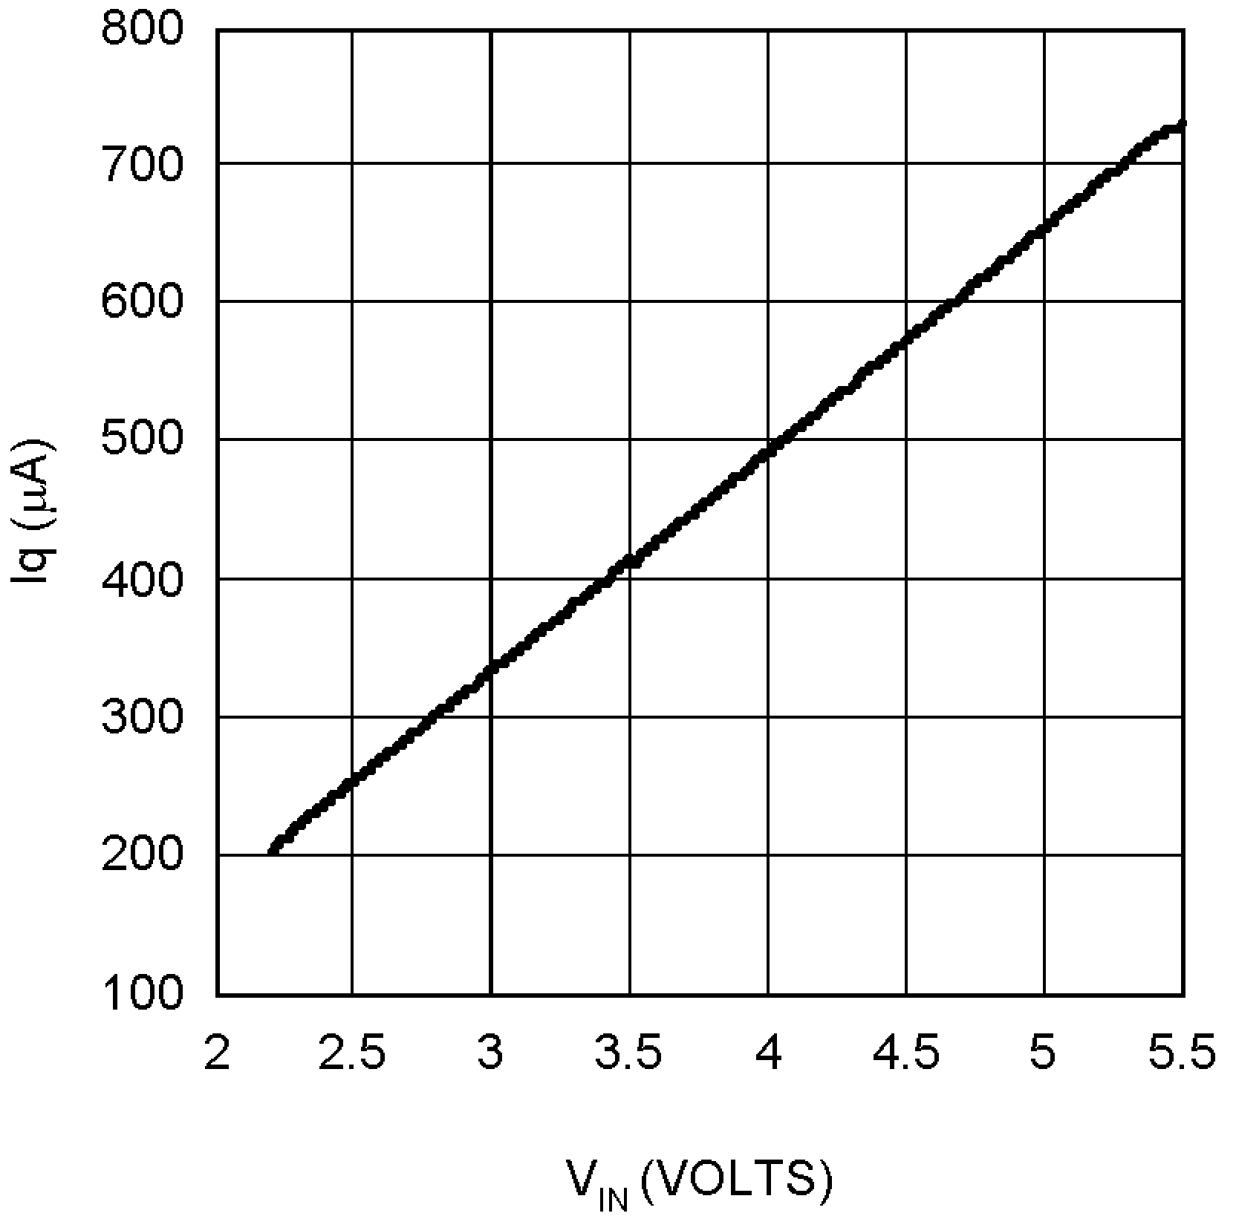
20039309 20039310

Iq vs VIN (0, 25, 85, and 125˚C) VREF vs IREF
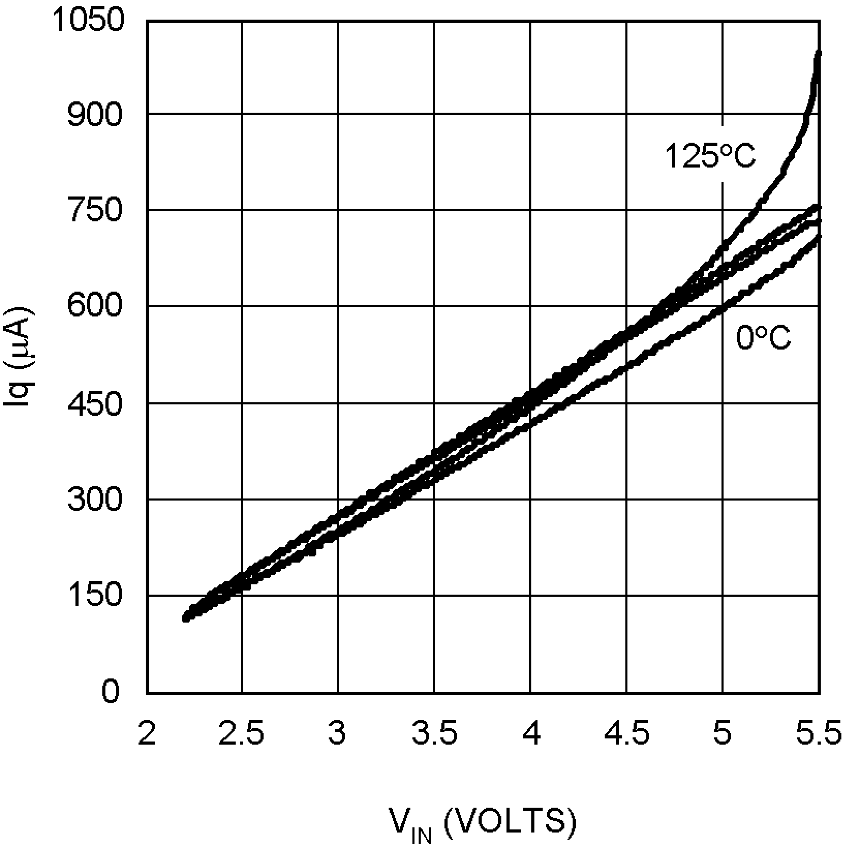
20039311 20039312

VREF vs Temperature (No Load) VTT vs IOUT (0, 25, 85, and 125˚C)
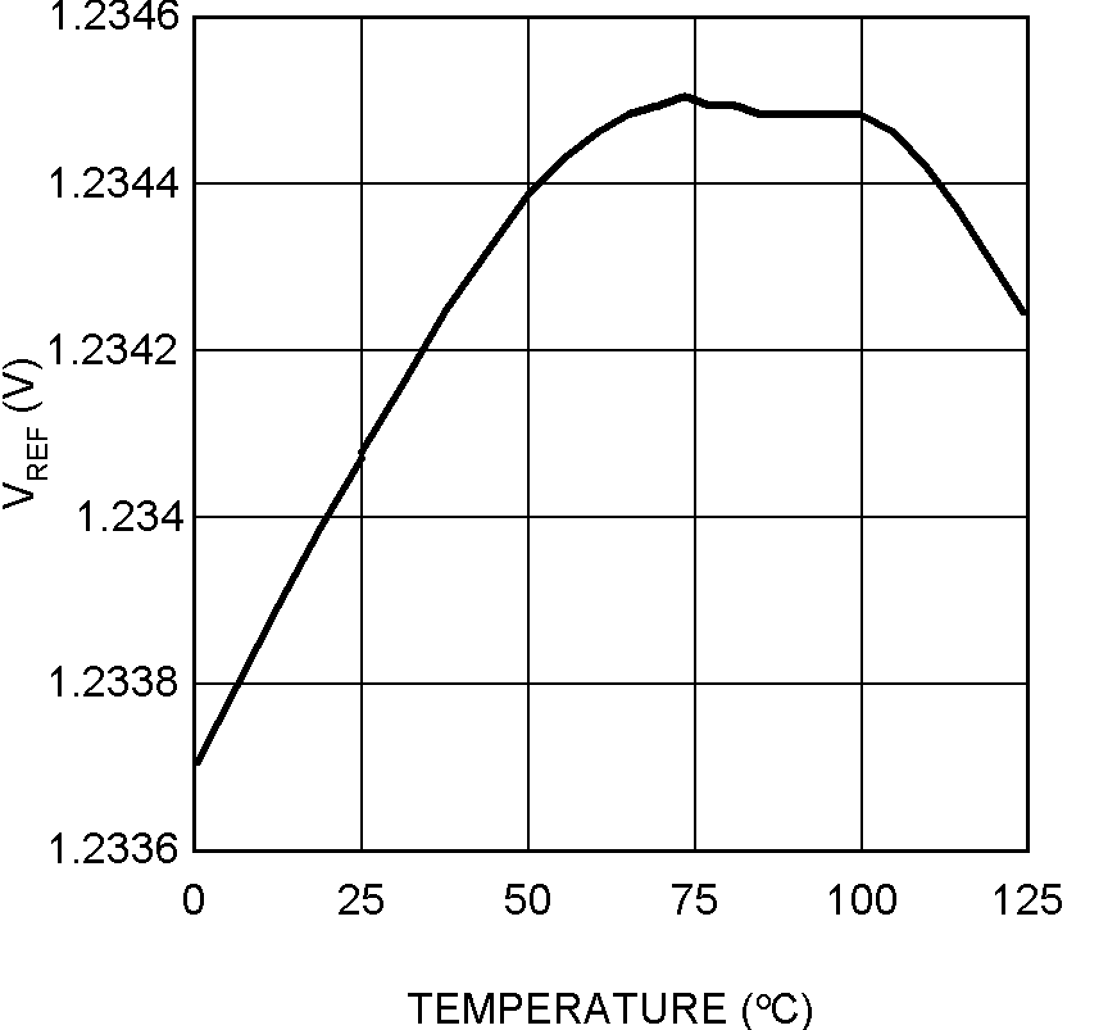
20039313 20039314

www.national.com 4

Typical Performance Characteristics (Continued)

VTT vs IOUT
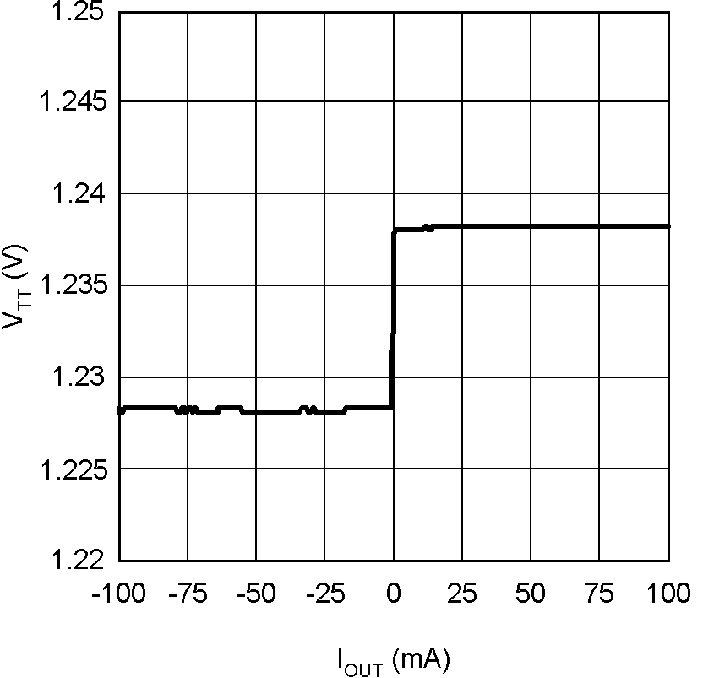
20039315

Maximum Output Current (Sinking) vs VIN
(VDDQ = 2.5)

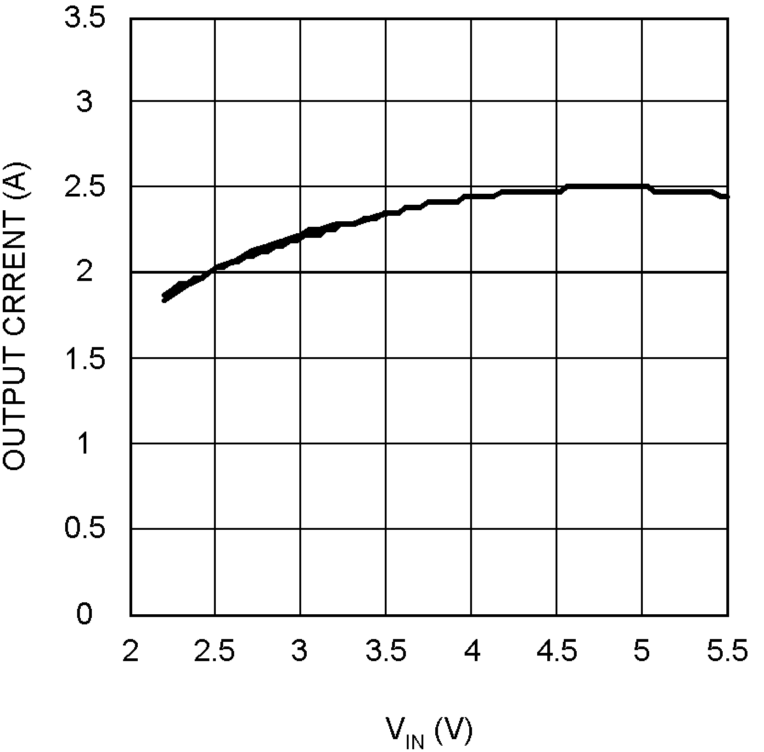
20039317
Maximum Output Current (Sourcing) vs VIN
LP2995
(VDDQ = 2.5)

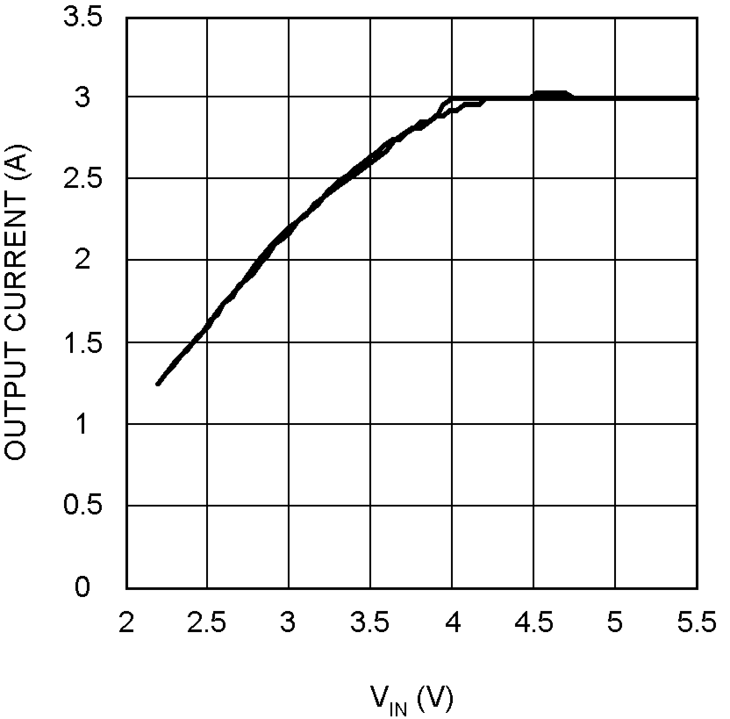
20039316

5 www.national.com

Block Diagram
LP2995

20039301

Description
The LP2995 is a linear bus termination regulator designed to meet the JEDEC requirements of SSTL-2 and SSTL-3. The LP2995 is capable of sinking and sourcing current at the output VTT, regulating the voltage to equal VDDQ / 2. A buffered reference voltage that also tracks VDDQ / 2 is generated on the VREF pin for providing a global reference to the DDR-SDRAM and Northbridge Chipset. VTT is designed to track the VREF voltage with a tight tolerance over the entire current range while preventing shoot through on the output stage.
Series Stub Termination Logic (SSTL) was created to im- prove signal integrity of the data transmission across the memory bus. This termination scheme is essential to prevent data error from signal reflections while transmitting at high frequencies encountered with DDR RAM. The most common form of termination is Class II single parallel termination. This involves using one Rs series resistor from the chipset to the memory and one Rt termination resistor. This implementa- tion can be seen below in Figure 1.

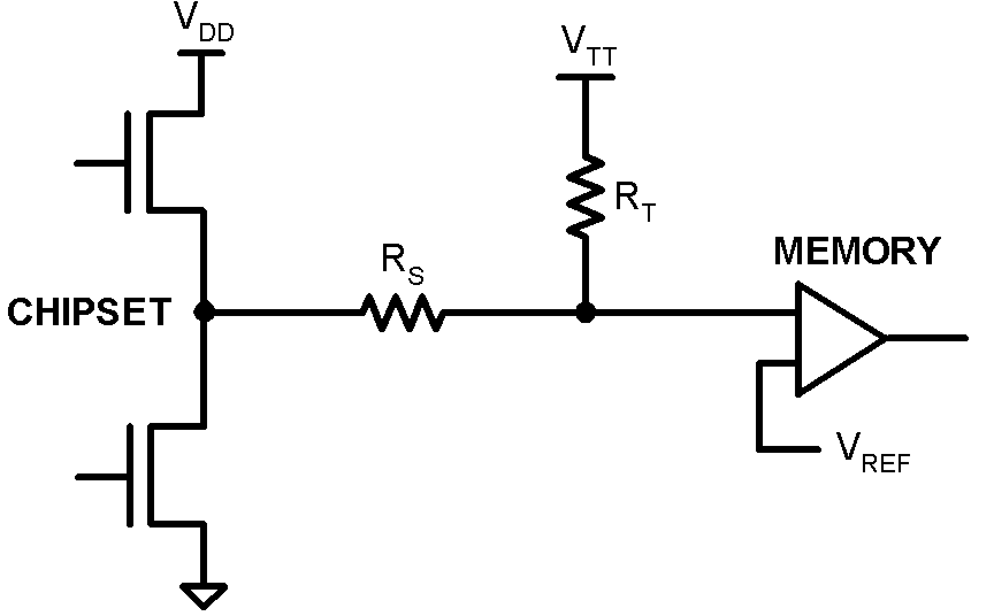
20039308

FIGURE 1.
Typical values for RS and RT are 25 Ohms although these can be changed to scale the current requirements from the LP2995. For determination of the current requirements of DDR-SDRAM termination please refer to the accompanying application notes.

www.national.com 6

Pin Descriptions

AVIN AND PVIN
AVIN and PVIN are the input supply pins for the LP2995. AVIN is used to supply all the internal control circuitry for the two op-amps and the output stage of VREF. PVIN is used exclusively to provide the rail voltage for the output stage on the power operational amplifier used to create VTT. For SSTL-2 applications AVIN and PVIN pins should be con- nected directly and tied to the 2.5V rail for optimal perfor- mance. This eliminates the need for bypassing the two sup- ply pins separately.

VDDQ
VDDQ is the input that is used to create the internal refer- ence voltage for regulating VTT and VREF. This voltage is generated by two internal 50kΩ resistors. This guarantees that VTT and VREF will track VDDQ / 2 precisely. The optimal implementation of VDDQ is as a remote sense for the refer- ence input. This can be achieved by connecting VDDQ directly to the 2.5V rail at the DIMM. This ensures that the reference voltage tracks the DDR memory rails precisely without a large voltage drop from the power lines. For SSTL-2 applications VDDQ will be a 2.5V signal, which will create a 1.25V reference voltage on VREF and a 1.25V termination voltage at VTT. For SSTL-3 applications it may be desirable to have a different scaling factor for creating the internal reference voltage besides 0.5. For instance a typical value that is commonly used is to have the reference voltage equal VDDQ*0.45. This can be achieved by placing a resis- tor in series with the VDDQ pin to effectively change the resistor divider.

VSENSE
The purpose of the sense pin is to provide improved remote load regulation. In most motherboard applications the termi- nation resistors will connect to VTT in a long plane. If the output voltage was regulated only at the output of the LP2995, then the long trace will cause a significant IR drop, resulting in a termination voltage lower at one end of the bus than the other. The VSENSE pin can be used to improve this performance, by connecting it to the middle of the bus. This will provide a better distribution across the entire termination bus.
Note: If remote load regulation is not used, then the VSENSE pin must still be connected to VTT.

VREF
VREF provides the buffered output of the internal reference voltage VDDQ / 2. This output should be used to provide the reference voltage for the Northbridge chipset and memory. Since these inputs are typically an extremely high imped- ance, there should be little current drawn from VREF. For improved performance, an output bypass capacitor can be used, located close to the pin, to help with noise. A ceramic capacitor in the range of 0.1 µF to 0.01 µF is recommended.

VTT
VTT is the regulated output that is used to terminate the bus resistors. It is capable of sinking and sourcing current while regulating the output precisely to VDDQ / 2. The LP2995 is designed to handle peak transient currents of up to ± 3A with a fast transient response. The maximum continuous current is a function of VIN and can be viewed in the TYPICAL PERFORMANCE CHARACTERISTICS section. If a tran- sient is expected to last above the maximum continuous
current rating for a significant amount of time then the output capacitor should be sized large enough to prevent an exces- sive voltage drop. Despite the fact that the LP2995 is de- signed to handle large transient output currents it is not capable of handling these for long durations, under all con- ditions. The reason for this is the standard packages are not able to thermally dissipate the heat as a result of the internal power loss. If large currents are required for longer dura- tions, then care should be taken to ensure that the maximum junction temperature is not exceeded. Proper thermal derat- ing should always be used (please refer to the Thermal Dissipation section).
LP2995

Component Selection

INPUT CAPACITOR
The LP2995 does not require a capacitor for input stability, but it is recommended for improved performance during large load transients to prevent the input rail from dropping. The input capacitor should be located as close as possible to the PVIN pin. Several recommendations exist dependent on the application required. A typical value recommended for AL electrolytic capacitors is 50 µF. Ceramic capacitors can also be used, a value in the range of 10 µF with X5R or better would be an ideal choice. The input capacitance can be reduced if the LP2995 is placed close to the bulk capaci- tance from the output of the 2.5V DC-DC converter.

OUTPUT CAPACITOR
The LP2995 has been designed to be insensitive of output capacitor size or ESR (Equivalent Series Resistance). This allows the flexibility to use any capacitor desired. The choice for output capacitor will be determined solely on the applica- tion and the requirements for load transient response of VTT. As a general recommendation the output capacitor should be sized above 100 µF with a low ESR for SSTL applications with DDR-SDRAM. The value of ESR should be determined by the maximum current spikes expected and the extent at which the output voltage is allowed to droop. Several capaci- tor options are available on the market and a few of these are highlighted below:
AL - It should be noted that many aluminum electrolytics only specify impedance at a frequency of 120 Hz, which indicates they have poor high frequency performance. Only aluminum electrolytics that have an impedance specified at a higher frequency (between 20 kHz and 100 kHz) should be used for the LP2995. To improve the ESR several AL electrolytics can be combined in parallel for an overall reduction. An important note to be aware of is the extent at which the ESR will change over temperature. Aluminum electrolytic capacitors can have their ESR rapidly increase at cold temperatures.
Ceramic - Ceramic capacitors typically have a low capaci- tance, in the range of 10 to 100 µF range, but they have excellent AC performance for bypassing noise because of very low ESR (typically less than 10 mΩ). However, some dielectric types do not have good capacitance characteris- tics as a function of voltage and temperature. Because of the typically low value of capacitance it is recommended to use ceramic capacitors in parallel with another capacitor such as an aluminum electrolytic. A dielectric of X5R or better is recommended for all ceramic capacitors.
Hybrid - Several hybrid capacitors such as OS-CON and SP are available from several manufacturers. These offer a large capacitance while maintaining a low ESR. These are

7 www.national.com

Component Selection (Continued)

the best solution when size and performance are critical, although their cost is typically higher than any other capaci- tor.
LP2995
Capacitor recommendations for different application circuits can be seen in the accompanying application notes with supporting evaluation boards.

Thermal Dissipation
Since the LP2995 is a linear regulator any current flow from VTT will result in internal power dissipation generating heat. To prevent damaging the part from exceeding the maximum allowable junction temperature, care should be taken to derate the part dependent on the maximum expected ambi- ent temperature and power dissipation. The maximum allow- able internal temperature rise (TRmax) can be calculated given the maximum ambient temperature (TAmax) of the application and the maximum allowable junction temperature (TJmax).

the DAP the θJA can be lowered significantly. Figure 3 shows the LLP thermal data when placed on a 4-layer JEDEC board with copper thickness of 0.5/1/1/0.5 oz. The number of vias, with a pitch of 1.27 mm, has been increased to the maximum of 4 where a θJA of 50.41˚C/W can be obtained. Via wall thickness for this calculation is 0.036 mm for 1oz. Copper.

TRmax = TJmax − TAmax
From this equation, the maximum power dissipation (PDmax)
of the part can be calculated:
PDmax = TRmax / θJA
The θJA of the LP2995 will be dependent on several vari- ables: the package used; the thickness of copper; the num- ber of vias and the airflow. For instance, the θJA of the SO-8 is 163˚C/W with the package mounted to a standard 8x4
2-layer board with 1oz. copper, no airflow, and 0.5W dissi- pation at room temperature. This value can be reduced to
151.2˚C/W by changing to a 3x4 board with 2 oz. copper that is the JEDEC standard. Figure 2 shows how the θJA varies with airflow for the two boards mentioned.

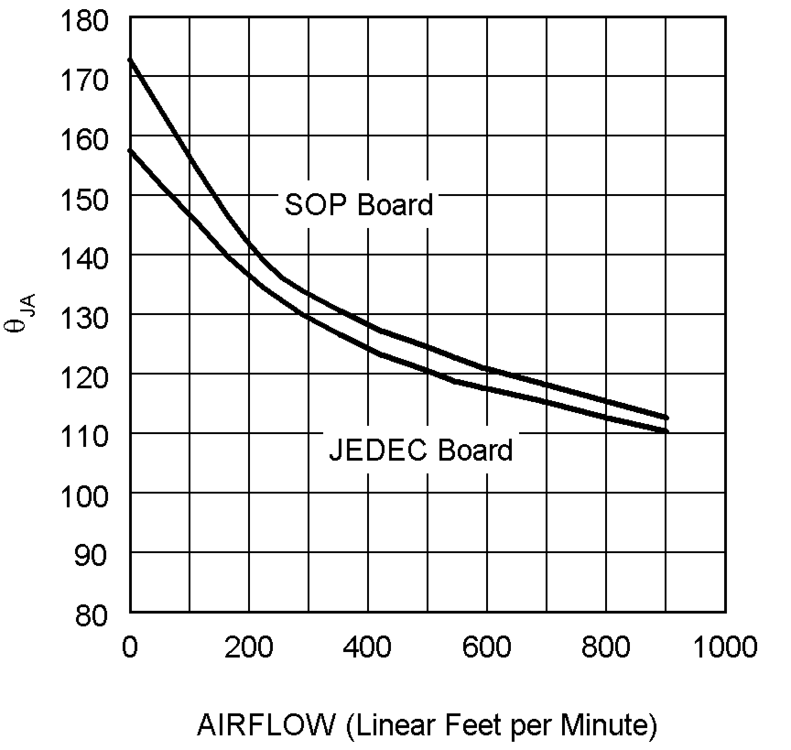
20039321

FIGURE 2. θJA vs Airflow (SO-8)

Layout is also extremely critical to maximize the output current with the LLP package. By simply placing vias under

20039322

FIGURE 3. LLP-16 θJA vs # of Vias (4 Layer JEDEC Board))

Additional improvements in lowering the θJA can also be achieved with a constant airflow across the package. Main- taining the same conditions as above and utilizing the 2x2 via array, Figure 4 shows how the θJA varies with airflow.

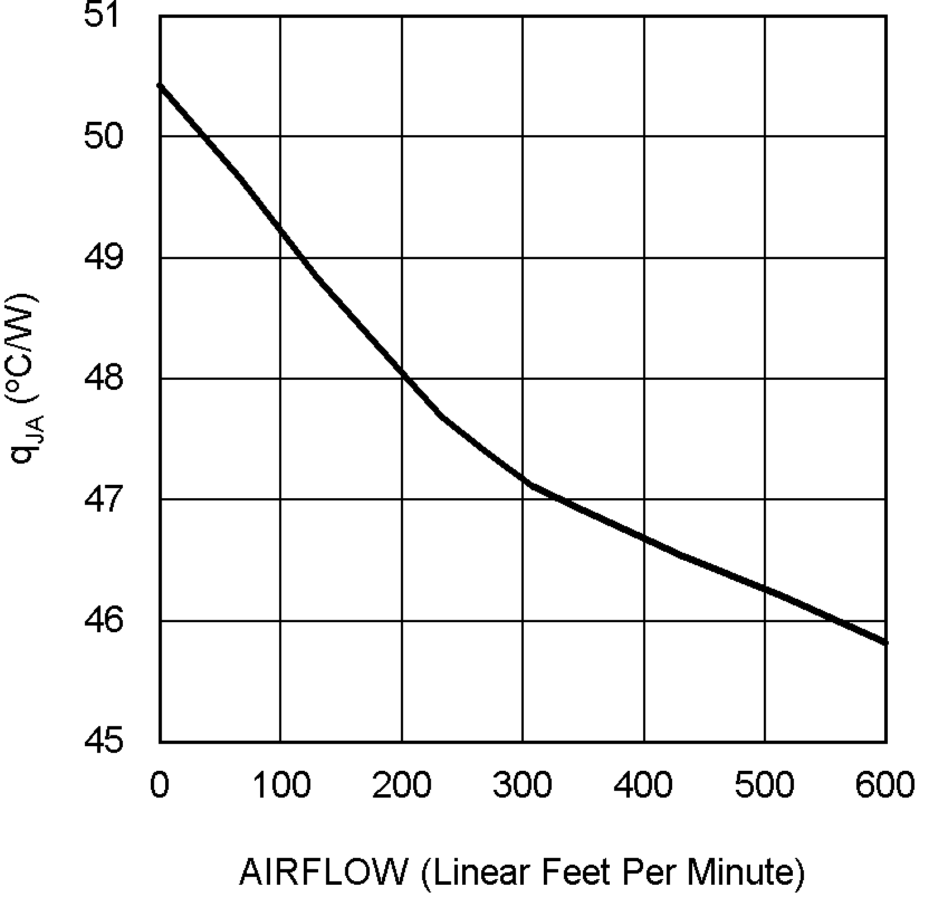
20039323

FIGURE 4. θJA vs Airflow Speed (JEDEC Board with 4
Vias)

www.national.com 8

Typical Application Circuits

The typical application circuit used for SSTL-2 termination schemes with DDR-SDRAM can be seen in Figure 5.

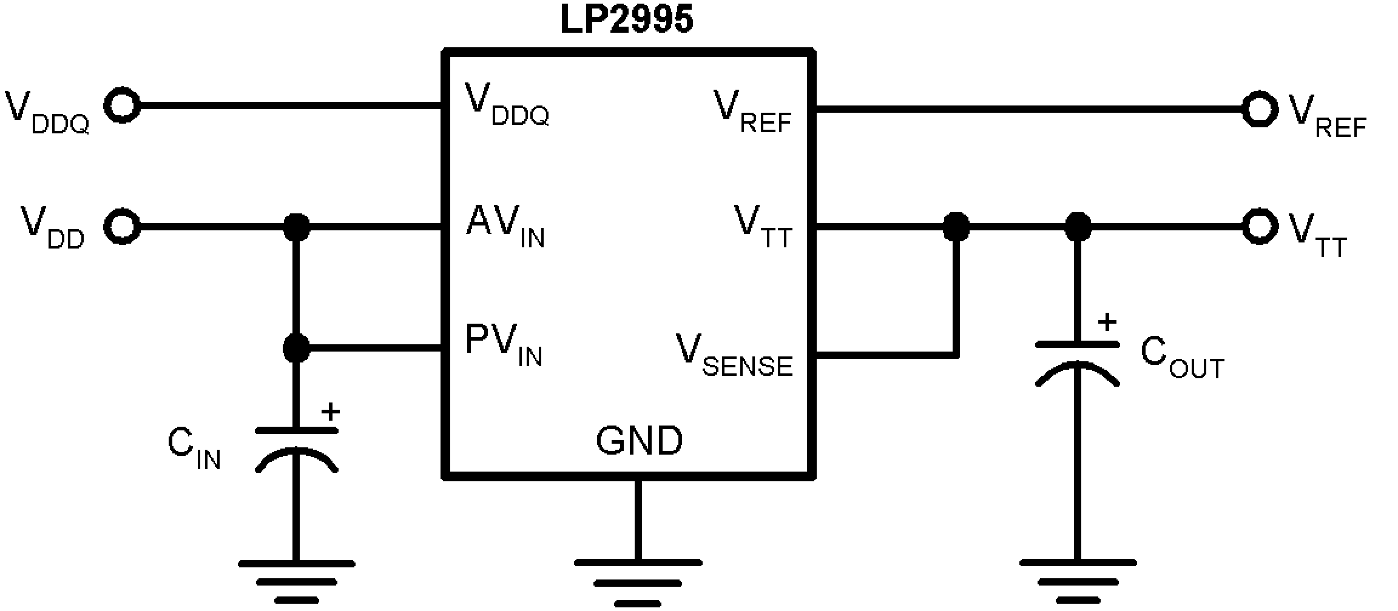
20039306

FIGURE 5. SSTL-2 Implementation

For SSTL-3 and other applications it may be desirable to change internal reference voltage scaling from VDDQ * 0.5. An external resistor in series with the VDDQ pin can be used to lower the reference voltage. Internally two 50 kΩ resistors
set the output VTT to be equal to VDDQ * 0.5. The addition of a 11.1 kΩ external resistor will change the internal reference voltage causing the two outputs to track VDDQ * 0.45. An implementation of this circuit can be seen in Figure 6.
LP2995

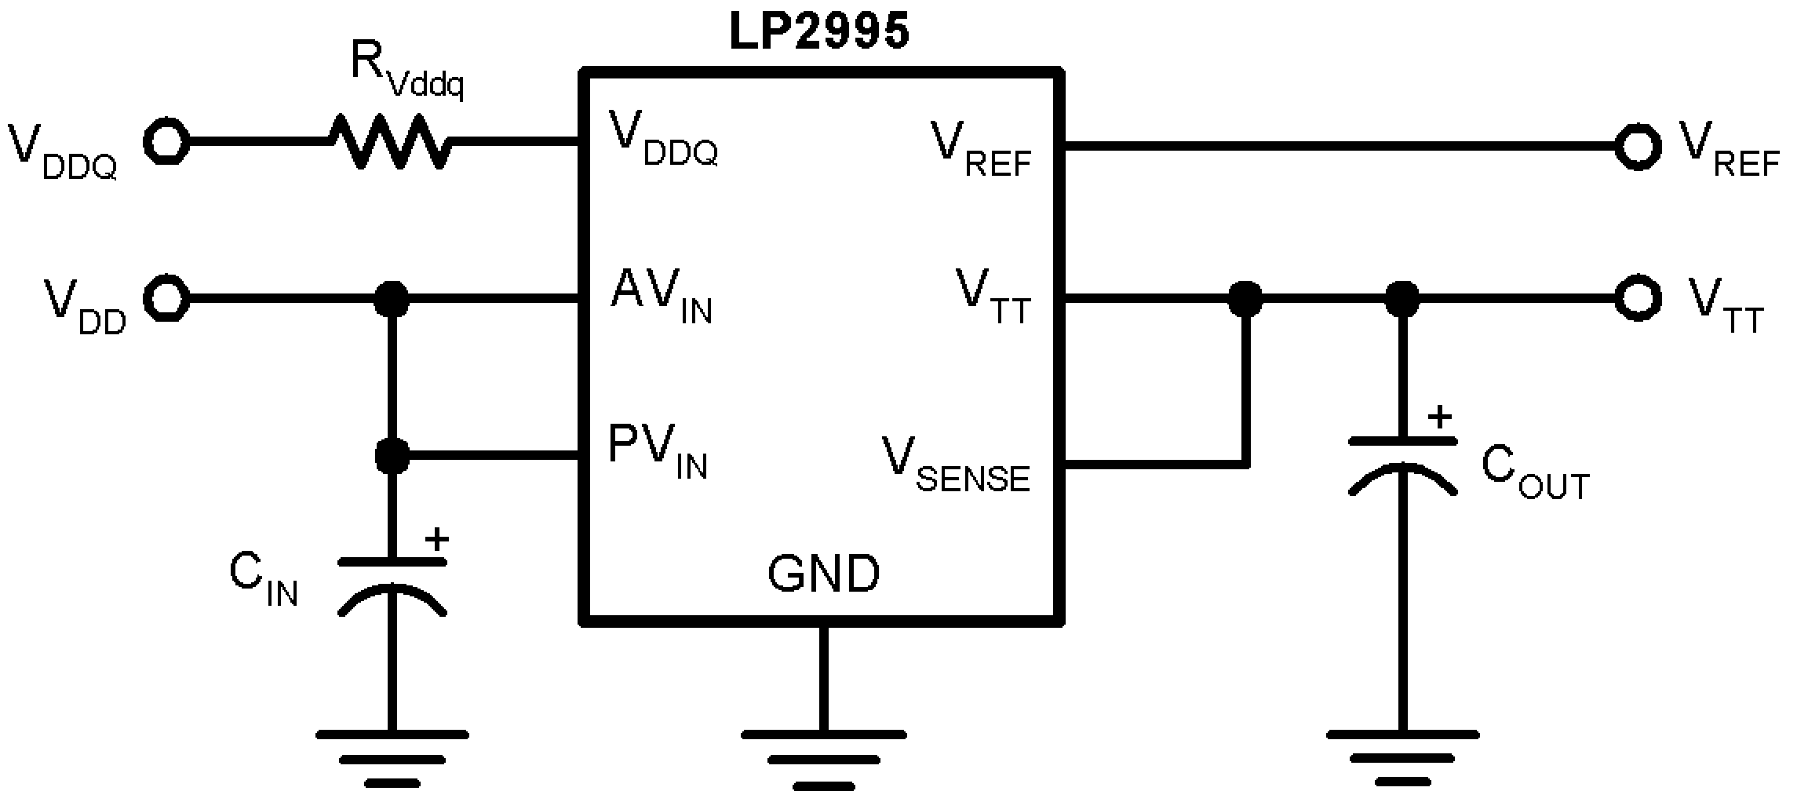
20039307

FIGURE 6. SSTL-3 Implementation

Another application that is sometimes required is to increase the VTT output voltage from the scaling factor of VDDQ * 0.5. This can be accomplished independently of VREF by using a
resistor divider network between VTT, VSENSE and Ground. An example of this circuit can be seen in Figure 7.

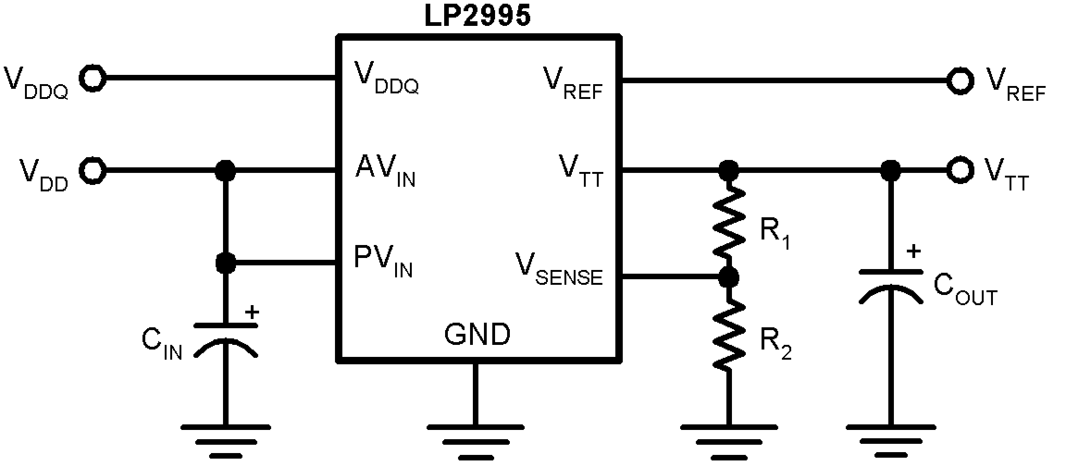
20039303

FIGURE 7.

9 www.national.com

PCB Layout Considerations
LP2995
1. AVIN and PVIN should be tied together for optimal per- formance. A local bypass capacitor should be placed as close as possible to the PVIN pin.
2. GND should be connected to a ground plane with mul- tiple vias for improved thermal performance.
3. VSENSE should be connected to the VTT termination bus at the point where regulation is required. For mother- board applications an ideal location would be at the
center of the termination bus.
4. VDDQ can be connected remotely to the VDDQ rail input at either the DIMM or the Chipset. This provides the most accurate point for creating the reference volt- age.
5. VREF should be bypassed with a 0.01 µF or 0.1 µF ceramic capacitor for improved performance. This ca- pacitor should be located as close as possible to the VREF pin.

www.national.com 10

Physical Dimensions inches (millimeters) unless otherwise noted

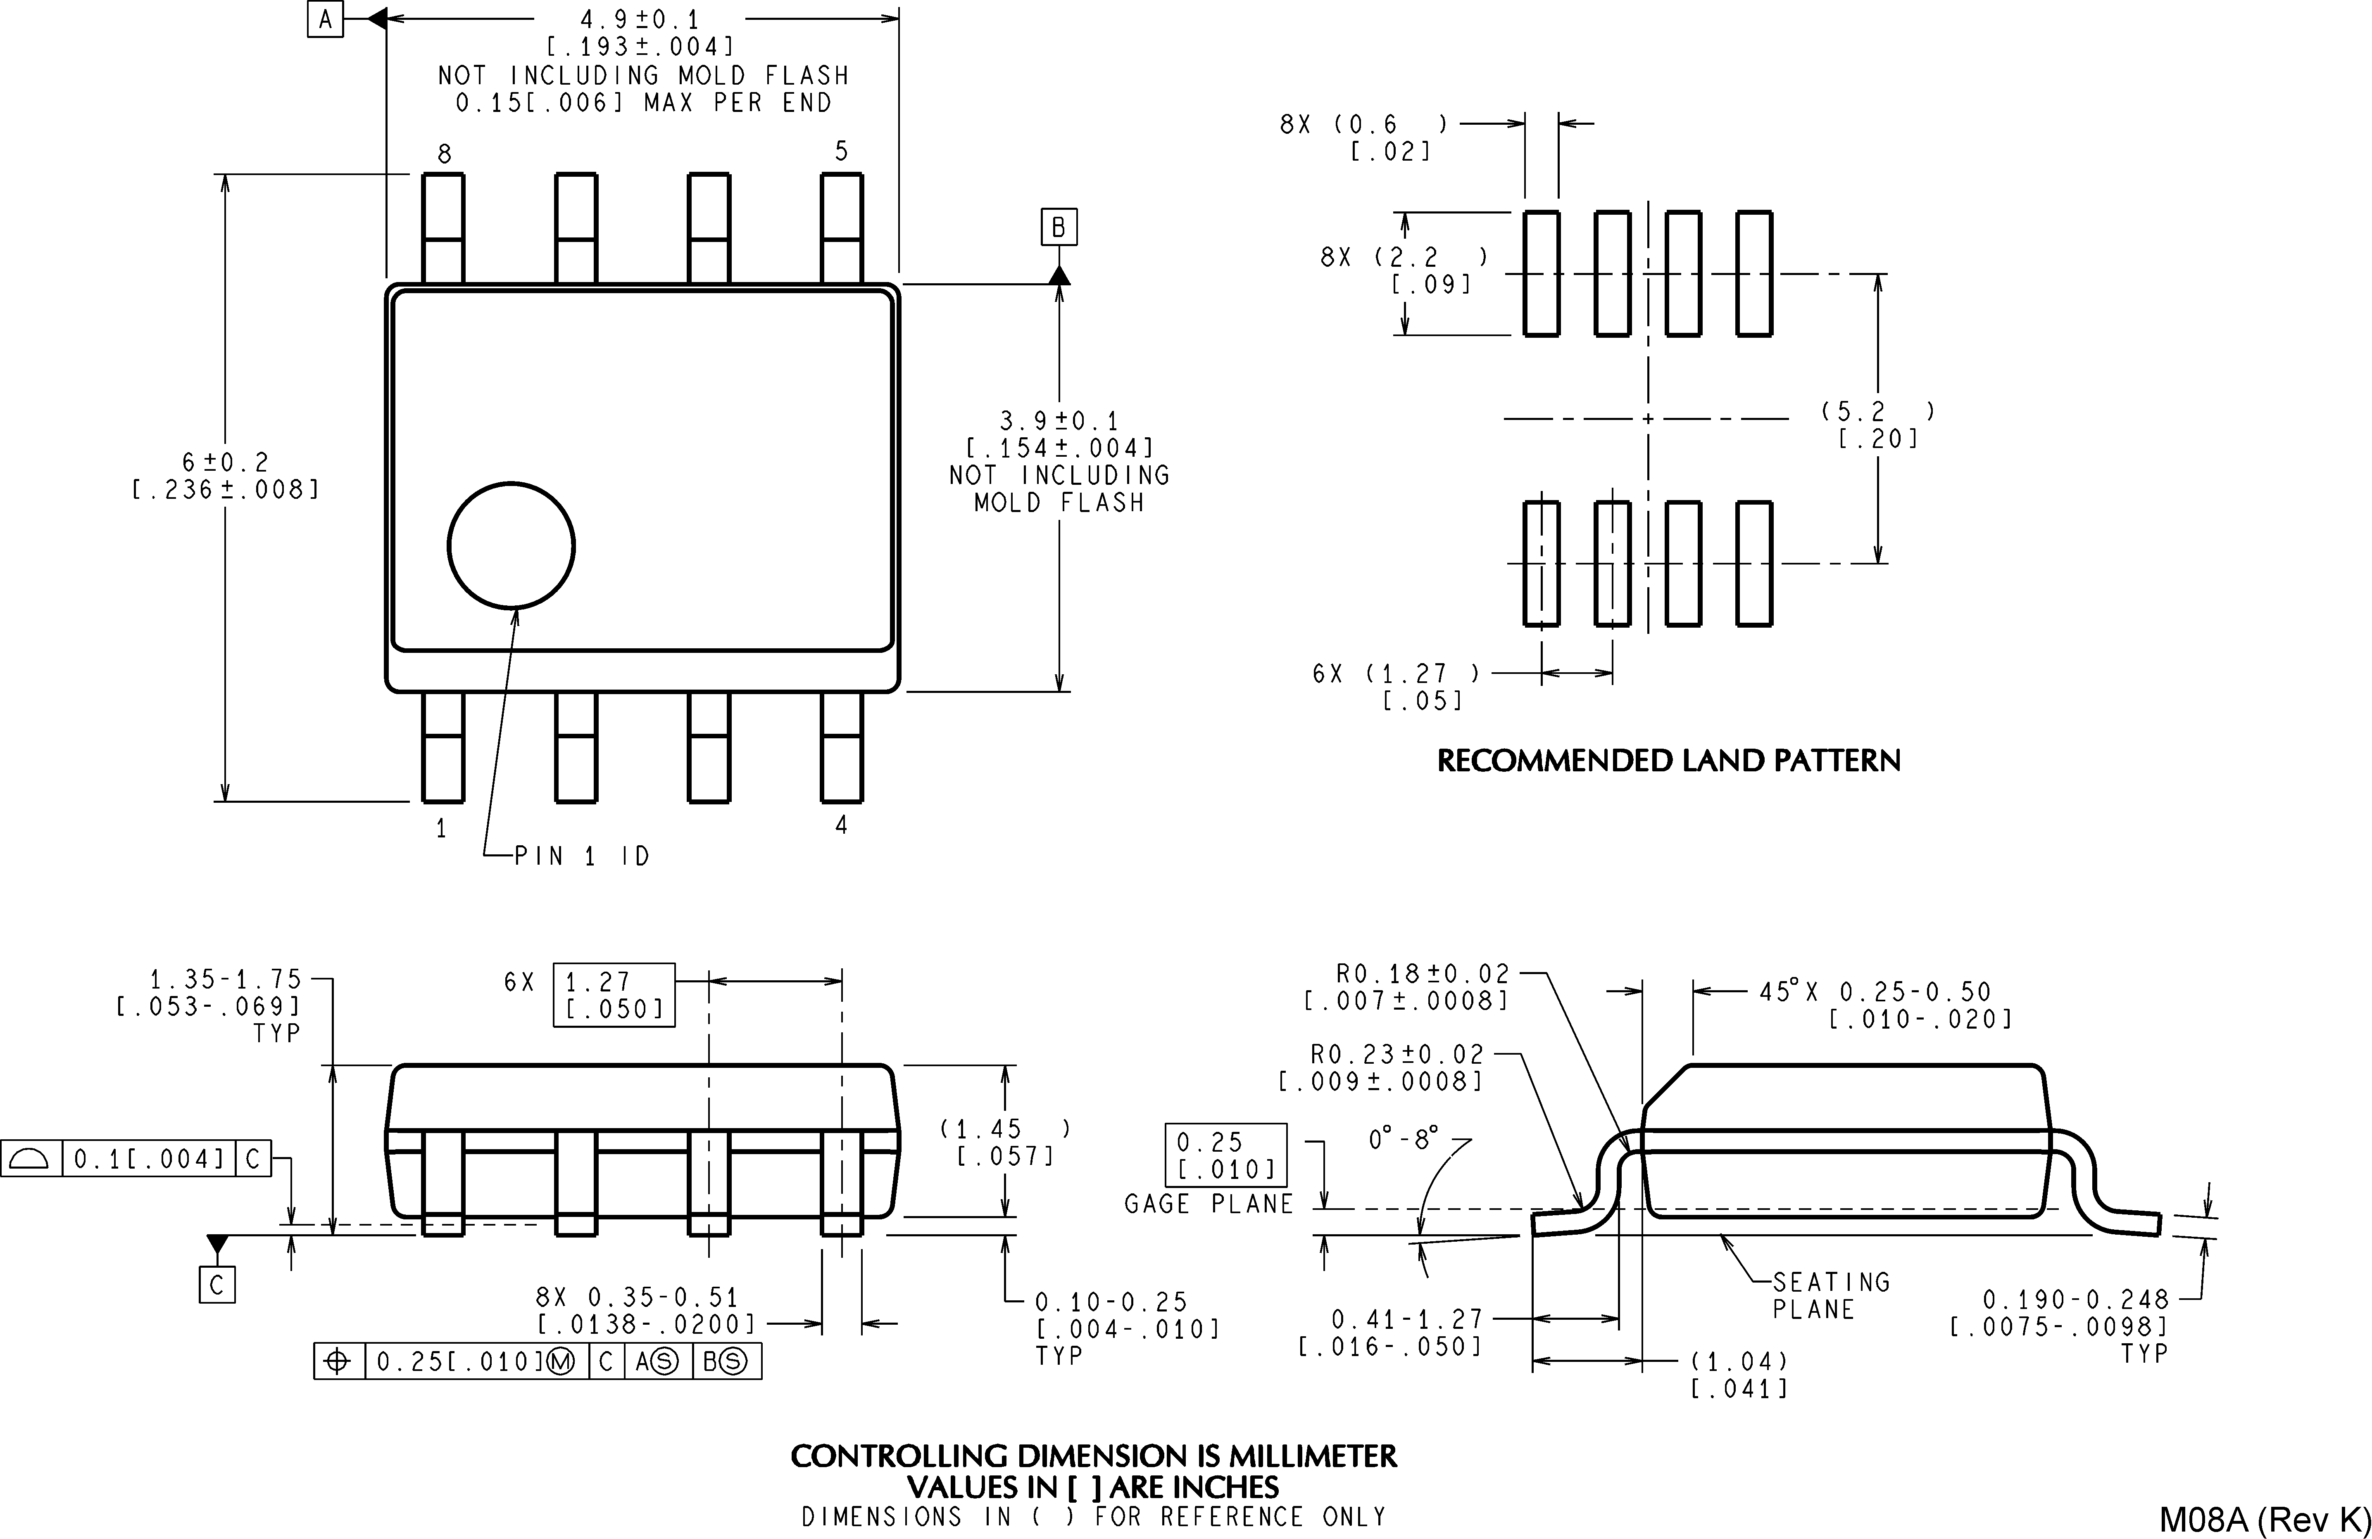
LP2995

8-Lead Small Outline Package (M8) NS Package Number M08A

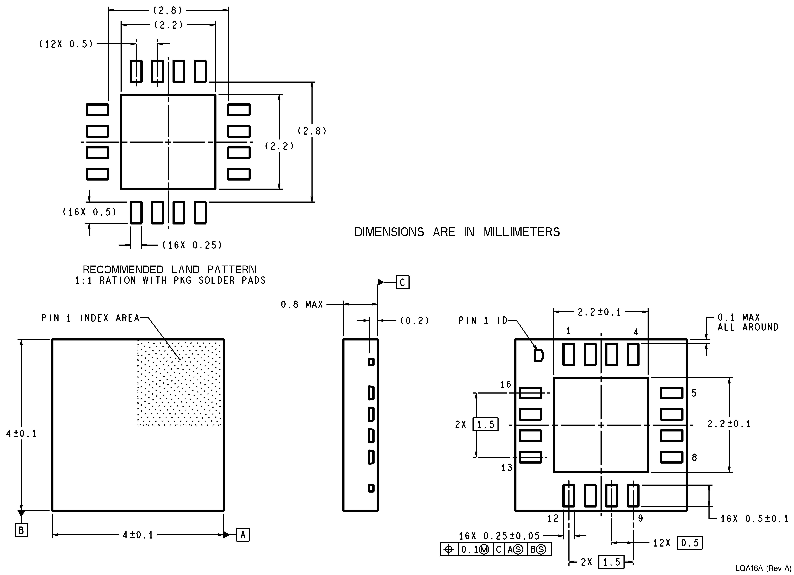

16-Lead LLP Package (LD) NS Package Number LQA16A

11 www.national.com

LP2995 DDR Termination Regulator
Physical Dimensions inches (millimeters) unless otherwise noted (Continued)

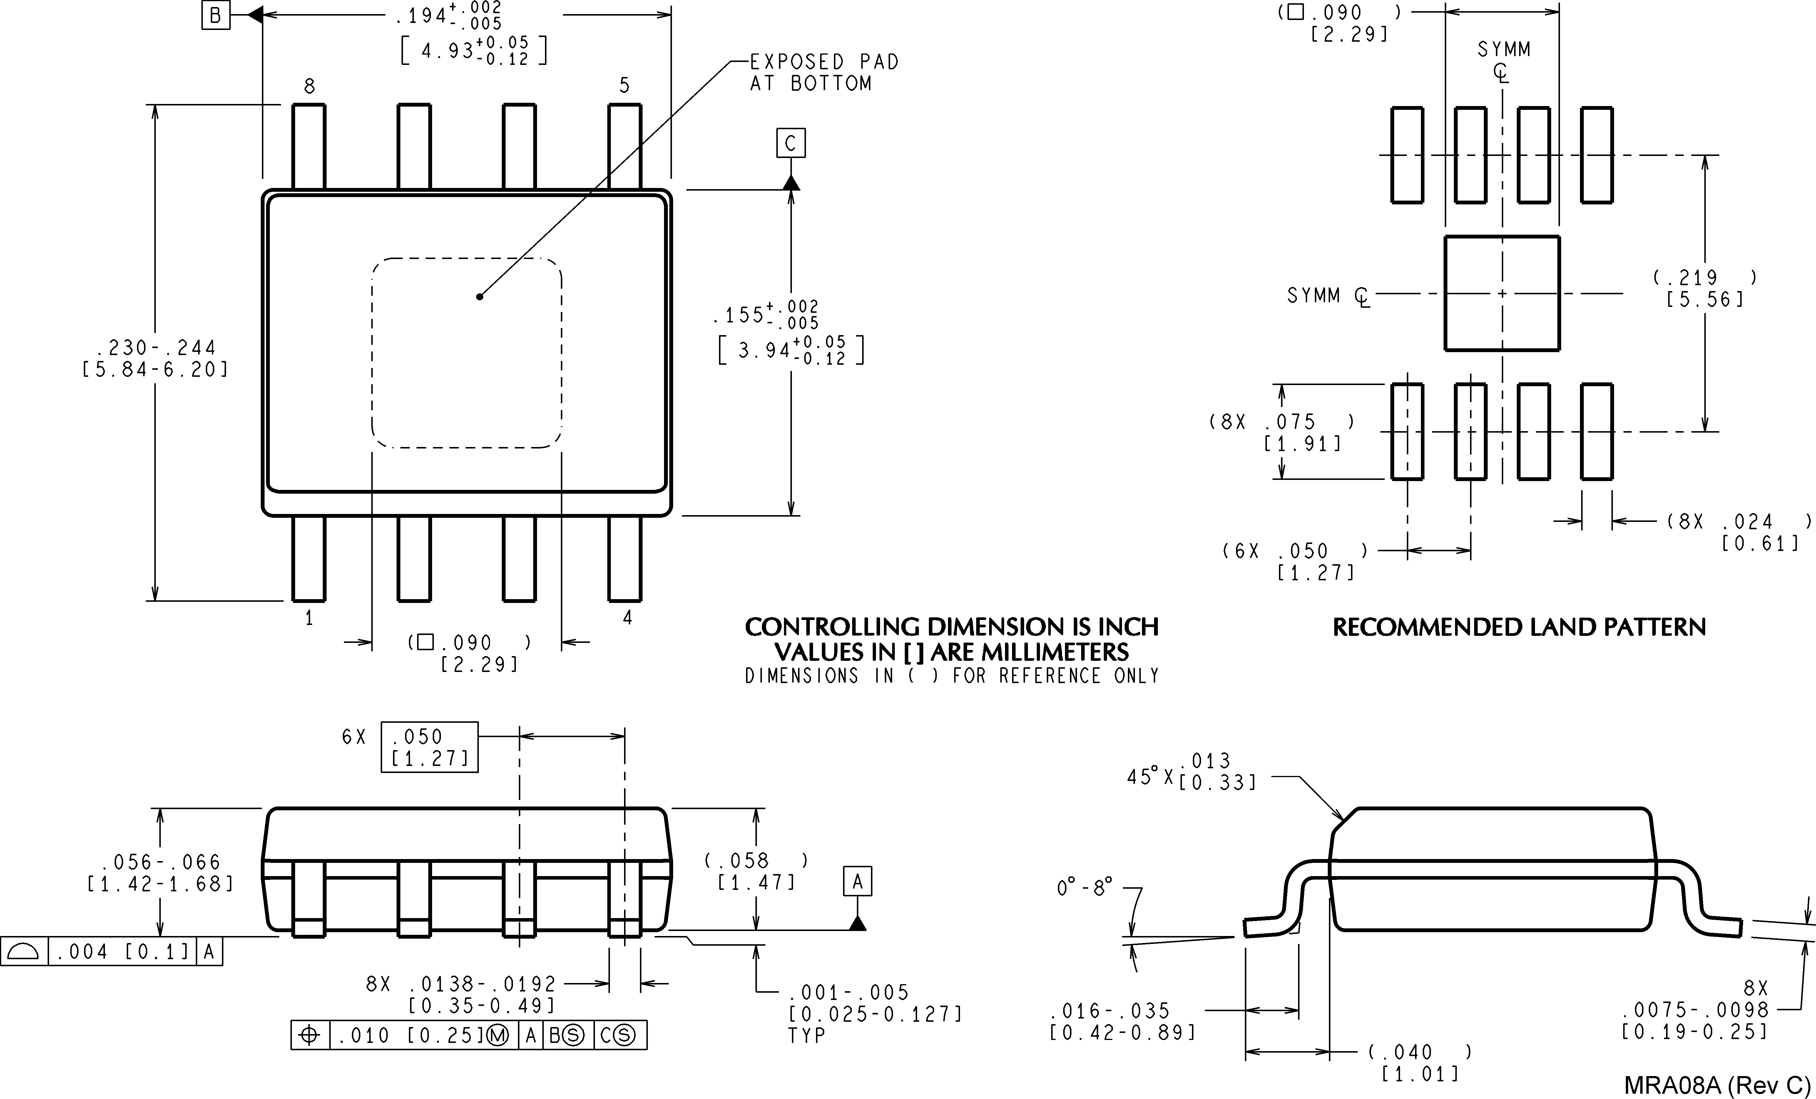

8-Lead PSOP Package (PSOP-8) NS Package Number MRA08A
National does not assume any responsibility for use of any circuitry described, no circuit patent licenses are implied and National reserves the right at any time without notice to change said circuitry and specifications.
For the most current product information visit us at www.national.com.
LIFE SUPPORT POLICY
NATIONAL’S PRODUCTS ARE NOT AUTHORIZED FOR USE AS CRITICAL COMPONENTS IN LIFE SUPPORT DEVICES OR SYSTEMS WITHOUT THE EXPRESS WRITTEN APPROVAL OF THE PRESIDENT AND GENERAL COUNSEL OF NATIONAL SEMICONDUCTOR CORPORATION. As used herein:
1. Life support devices or systems are devices or systems 2. A critical component is any component of a life support which, (a) are intended for surgical implant into the body, or device or system whose failure to perform can be reasonably (b) support or sustain life, and whose failure to perform when expected to cause the failure of the life support device or properly used in accordance with instructions for use system, or to affect its safety or effectiveness.
provided in the labeling, can be reasonably expected to result in a significant injury to the user.
BANNED SUBSTANCE COMPLIANCE
National Semiconductor follows the provisions of the Product Stewardship Guide for Customers (CSP-9-111C2) and Banned Substances and Materials of Interest Specification (CSP-9-111S2) for regulatory environmental compliance. Details may be found at: www.national.com/quality/green.
Lead free products are RoHS compliant.
National Semiconductor National Semiconductor National Semiconductor National Semiconductor Americas Customer Europe Customer Support Center Asia Pacific Customer Japan Customer Support Center Support Center Fax: +49 (0) 180-530 85 86 Support Center Fax: 81-3-5639-7507
Email: new.feedback@nsc.com Email: europe.support@nsc.com Email: ap.support@nsc.com Email: jpn.feedback@nsc.com
Tel: 1-800-272-9959 Deutsch Tel: +49 (0) 69 9508 6208 Tel: 81-3-5639-7560
English Tel: +44 (0) 870 24 0 2171 www.national.com Français Tel: +33 (0) 1 41 91 8790

