XC61C Series

Low Voltage Detectors (VDF= 0.8V～1.5V) Standard Voltage Detectors (VDF 1.6V～6.0V)

ETR0201_013a

■GENERAL DESCRIPTION
The XC61C series are highly precise, low power consumption voltage detectors, manufactured using CMOS and laser trimming technologies.
Detect voltage is extremely accurate with minimal temperature drift.
Both CMOS and N-channel open drain output configurations are available.

■APPLICATIONS
●Microprocessor reset circuitry
●Memory battery back-up circuits
●Power-on reset circuits
●Power failure detection
●System battery life and charge voltage monitors
■FEATURES
Highly Accurate : ± 2%
: ± 1%(Standard Voltage VD: 2.6V~5.0V)
Low Power Consumption : 0.7μA (TYP.) [VIN=1.5V] Detect Voltage Range : 0.8V ~ 6.0V in 0.1V increments Operating Voltage Range : 0.7V ~ 6.0V (Low Voltage)
0.7V～10.0V (Standard Voltage)
Detect Voltage Temperature Characteristics
: ±100ppm/℃ (TYP.)
Output Configuration : N-channel open drain or CMOS
Packages : SSOT-24
SOT-23
SOT-89
TO-92
Environmentally Friendly : EU RoHS Compliant, Pb Free

■TYPICAL APPLICATION CIRCUITS

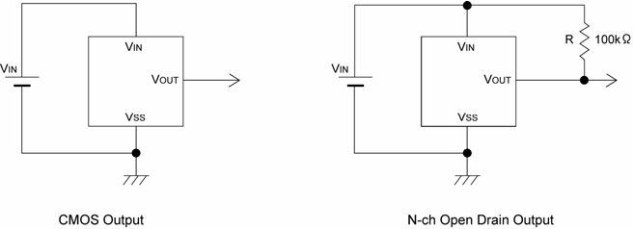

■TYPICAL PERFORMANCE CHARACTERISTICS

1/17

XC61C Series

■PIN CONFIGURATION

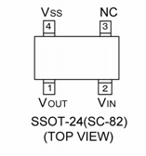

■PIN ASSIGNMENT
PIN NUMBER
 |  |  |  |  | PIN NAME | FUNCTION
SSOT-24 | SOT-23 | SOT-89 | TO-92 (T) | TO-92 (L) | PIN NAME | FUNCTION
2 | 3 | 2 | 2 | 1 | VIN | Supply Voltage
4 | 2 | 3 | 3 | 2 | VSS | Ground
1 | 1 | 1 | 1 | 3 | VOUT | Output
3 | - | - | - | - | NC | No Connection

■PRODUCT CLASSIFICATION
●Ordering Information
XC61C①②③④⑤⑥⑦-⑧(*1)

(SIDE VIEW) (SIDE VIEW)

DESIGNATOR | DESCRIPTION | SYMBOL | DESCRIPTION
① | Output Configuration | C | CMOS output
① | Output Configuration | N | N-ch open drain output
② ③ | Detect Voltage | 08 ~ 60 | e.g.0.9V → ②0, ③9
② ③ | Detect Voltage | 08 ~ 60 | e.g.1.5V → ②1, ③5
④ | Output Delay | 0 | No delay
⑤ | Detect Accuracy | 1 | Within ±1% (VDF(T)=2.6V~5.0V)
⑤ | Detect Accuracy | 2 | Within ±2%
⑥⑦-⑧ | Packages  (*2)  Taping Type | NR | SSOT-24 (SC-82)
⑥⑦-⑧ | Packages  (*2)  Taping Type | NR-G | SSOT-24 (SC-82) (Halogen & Antimony free)
⑥⑦-⑧ | Packages  (*2)  Taping Type | MR | SOT-23
⑥⑦-⑧ | Packages  (*2)  Taping Type | MR-G | SOT-23 (Halogen & Antimony free)
⑥⑦-⑧ | Packages  (*2)  Taping Type | PR | SOT-89
⑥⑦-⑧ | Packages  (*2)  Taping Type | PR-G | SOT-89 (Halogen & Antimony free)
⑥⑦-⑧ | Packages  (*2)  Taping Type | TH | TO-92 (Standard) Taping Type: Paper type
⑥⑦-⑧ | Packages  (*2)  Taping Type | TB | TO-92 (Standard) Taping Type: Bag
⑥⑦-⑧ | Packages  (*2)  Taping Type | LH | TO-92 (Custom pin configuration) Taping Type: Paper type  (Discontinued Product)
⑥⑦-⑧ | Packages  (*2)  Taping Type | LB | TO-92 (Custom pin configuration) Taping Type: Bag  (Discontinued Product)

(*1) The “-G” suffix indicates that the products are Halogen and Antimony free as well as being fully RoHS compliant.
(*2) The device orientation is fixed in its embossed tape pocket. For reverse orientation, please contact your local Torex sales office or representative. (Standard orientation: ⑥R-⑧, Reverse orientation: ⑥L-⑧)

2/17

XC61C
Series

■BLOCK DIAGRAMS

(1) CMOS Output (2) N-ch Open Drain Output

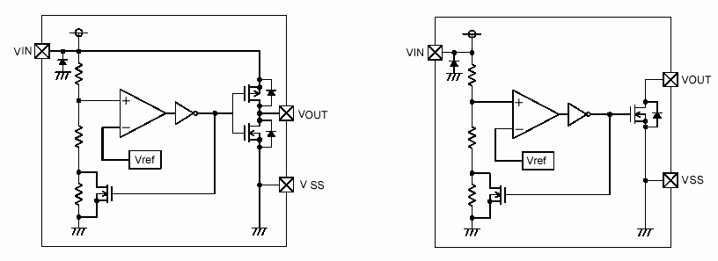

■ABSOLUTE MAXIMUM RATINGS

Ta = 25OC

PARAMETER |  |  | SYMBOL | RATINGS | UNITS
Input Voltage |  | *1 | VIN | 9.0 | V
 |  | *2 | VIN | 12.0 | V
Output Current |  |  | IOUT | 50 | mA
Output Voltage | CMOS |  | VOUT | VSS -0.3 ~ VIN +0.3 | V
Output Voltage | N-ch Open Drain Output *1 |  | VOUT | VSS -0.3 ~ 9.0 | V
Output Voltage | N-ch Open Drain Output *2 |  | VOUT | VSS -0.3 ~ 12.0 | V
Power Dissipation | SSOT-24 |  | Pd | 150 | mW
Power Dissipation | SOT-23 |  | Pd | 150 | mW
Power Dissipation | SOT-89 |  | Pd | 500 | mW
Power Dissipation | TO-92 |  | Pd | 300 | mW
Operating Temperature Range |  |  | Topr | -40～+85 | OC
Storage Temperature Range |  |  | Tstg | -40～+125 | OC

*1: Low voltage: VDF(T)=0.8V~1.5V
*2: Standard voltage: VDF(T)=1.6V~6.0V

3/17

XC61C Series

■ELECTRICAL CHARACTERISTICS

VDF (T) = 0.8V to 6.0V ± 2% VDF (T) = 2.6V to 5.0V ± 1%
PARAMETER | SYMBOL | CONDITIONS |  |  | MIN. | TYP. | MAX. | UNITS | CIRCUITS
Detect Voltage | VDF | VDF(T)=0.8V~1.5V *1  VDF(T)=1.6V~6.0V *2 |  |  | VDF(T)  x 0.98 | VDF(T) | VDF(T)  x 1.02 | V | 1
Detect Voltage | VDF | VDF(T)=2.6V~5.0V *2 |  |  | VDF(T)  x 0.99 | VDF(T) | VDF(T)  x 1.01 | V | 1
Hysteresis Range | VHYS |  |  |  | VDF  x 0.02 | VDF  x 0.05 | VDF  x 0.08 | V | 1
Supply Current | ISS | VIN = 1.5V |  |  | - | 0.7 | 2.3 | μA | 2
Supply Current | ISS | VIN = 2.0V |  |  | - | 0.8 | 2.7 | μA | 2
Supply Current | ISS | VIN = 3.0V |  |  | - | 0.9 | 3.0 | μA | 2
Supply Current | ISS | VIN = 4.0V |  |  | - | 1.0 | 3.2 | μA | 2
Supply Current | ISS | VIN = 5.0V |  |  | - | 1.1 | 3.6 | μA | 2
Operating Voltage *1 | VIN | VDF(T) = 0.8V to 1.5V |  |  | 0.7 | - | 6.0 | V | 1
Operating Voltage *2 | VIN | VDF(T) = 1.6V to 6.0V |  |  | 0.7 | - | 10.0 | V | 1
Output Current *1 | IOUT | N-ch VDS = 0.5V |  | VIN = 0.7V | 0.10 | 0.80 | - | mA | 3
Output Current *1 | IOUT |  |  | VIN = 1.0V | 0.85 | 2.70 | - | mA | 3
Output Current *1 | IOUT | CMOS, P-ch VDS = 2.1V VIN = 6.0V |  |  | - | -7.5 | -1.5 | mA | 4
Output Current *2 | IOUT | N-ch VDS = 0.5V |  | VIN = 1.0V | 1.0 | 2.2 | - | mA | 3
Output Current *2 | IOUT |  |  | VIN = 2.0V | 3.0 | 7.7 | - | mA | 3
Output Current *2 | IOUT |  |  | VIN = 3.0V | 5.0 | 10.1 | - | mA | 3
Output Current *2 | IOUT |  |  | VIN = 4.0V | 6.0 | 11.5 | - | mA | 3
Output Current *2 | IOUT |  |  | VIN = 5.0V | 7.0 | 13.0 | - | mA | 3
Output Current *2 | IOUT | CMOS, P-ch VDS = 2.1V VIN = 8.0V |  |  | - | -10.0 | -2.0 | mA | 4
Leak Current | Ileak | VIN=6.0V, VOUT=6.0V*1  VIN=10.0V, VOUT=10.0V*2 | CMOS |  | - | 10 | - | nA | 3
Leak Current | Ileak | VIN=6.0V, VOUT=6.0V*1  VIN=10.0V, VOUT=10.0V*2 | N-ch Open Drain |  | - | 10 | 100 | nA | 3
Temperature  Characteristics | ΔVDF  ΔTopr･VDF | -40℃ ≦ Topr ≦ 85℃ |  |  | - | ±100 | - | ppm/  ℃ | -
Delay Time  (VDR→VOUT inversion) | tDLY | Inverts from VDR to VOUT |  |  | - | 0.03 | 0.20 | ms | 5

NOTE:
*1: Low Voltage: VDF(T)=0.8V~1.5V
*2: Standard Voltage: VDF(T)=1.6V~6.0V VDF (T): Setting detect voltage
Release Voltage: VDR = VDF + VHYS

Ta=25℃

4/17

XC61C
Series

■OPERATIONAL EXPLANATION
(Especially prepared for CMOS output products)
① When input voltage (VIN) rises above detect voltage (VDF), output voltage (VOUT) will be equal to VIN. (A condition of high impedance exists with N-ch open drain output configurations.)
② When input voltage (VIN) falls below detect voltage (VDF), output voltage (VOUT) will be equal to the ground voltage
(VSS) level.
③ When input voltage (VIN) falls to a level below that of the minimum operating voltage (VMIN), output will become unstable. In this condition, VIN will equal the pulled-up output (should output be pulled-up.)
④ When input voltage (VIN) rises above the ground voltage (VSS) level, output will be unstable at levels below the
minimum operating voltage (VMIN). Between the VMIN and detect release voltage (VDR) levels, the ground voltage (VSS)
level will be maintained.
⑤ When input voltage (VIN) rises above detect release voltage (VDR), output voltage (VOUT) will be equal to VIN. (A condition of high impedance exists with N-ch open drain output configurations.)
⑥ The difference between VDR and VDF represents the hysteresis range.

●Timing Chart

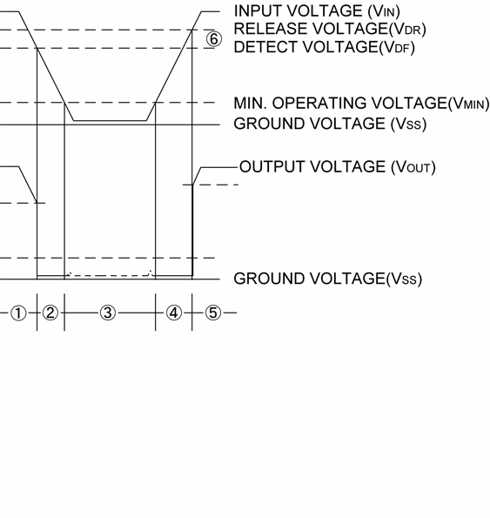

5/17

XC61C Series

■NOTES ON USE

1. Please use this IC within the stated maximum ratings. Operation beyond these limits may cause degrading or permanent damage to the device.
2. When a resistor is connected between the VIN pin and the input with CMOS output configurations, oscillation may occur as a result of voltage drops at RIN if load current (IOUT) exists. (refer to the Oscillation Description (1) below)
3. When a resistor is connected between the VIN pin and the input with CMOS output configurations, irrespective of N-ch
output configurations, oscillation may occur as a result of through current at the time of voltage release even if load current (IOUT) does not exist. (refer to the Oscillation Description (2) below )
4. With a resistor connected between the VIN pin and the input, detect and release voltage will rise as a result of the IC's supply current flowing through the VIN pin.
5. In order to stabilize the IC's operations, please ensure that VIN pin's input frequency's rise and fall times are more than several μ sec / V.
6. Please use N-ch open drains configuration, when a resistor RIN is connected between the VIN pin and power source.
In such cases, please ensure that RIN is less than 10kΩ and that C is more than 0.1μF.

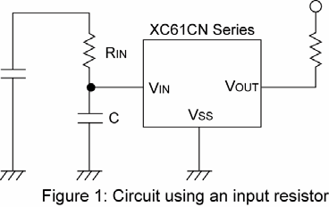

●Oscillation Description

(1) Output current oscillation with the CMOS output configuration
When the voltage applied at IN rises, release operations commence and the detector's output voltage increases. Load current (IOUT) will flow at RL. Because a voltage drop (RIN x IOUT) is produced at the RIN resistor, located between the input
(IN) and the VIN pin, the load current will flow via the IC's VIN pin. The voltage drop will also lead to a fall in the voltage level
at the VIN pin. When the VIN pin voltage level falls below the detect voltage level, detect operations will commence. Following detect operations, load current flow will cease and since voltage drop at RIN will disappear, the voltage level at the VIN pin will rise and release operations will begin over again.
Oscillation may occur with this " release - detect - release " repetition.
Further, this condition will also appear via means of a similar mechanism during detect operations.

(2) Oscillation as a result of through current
Since the XC61C series are CMOS IC S, through current will flow when the IC's internal circuit switching operates (during release and detect operations). Consequently, oscillation is liable to occur as a result of drops in voltage at the through
current's resistor (RIN) during release voltage operations. (refer to Figure 3)
Since hysteresis exists during detect operations, oscillation is unlikely to occur.

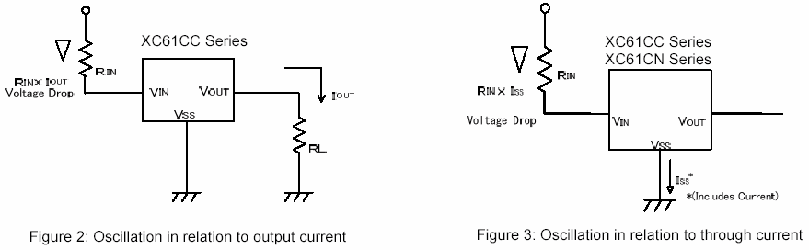

6/17

XC61C
Series

100kΩ*

7/17

XC61C Series

■TYPICAL PERFORMANCE CHARACTERISTICS
●Low Voltage

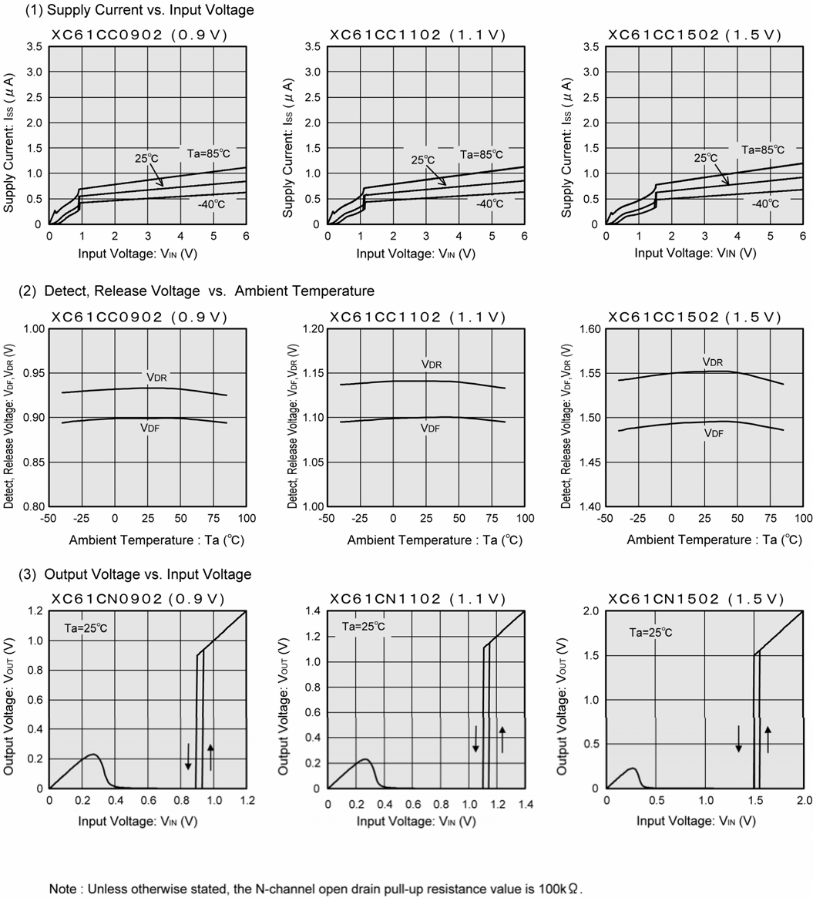

8/17

XC61C
Series

■TYPICAL PERFORMANCE CHARACTERISTICS (Continued)
●Low Voltage (Continued)

(4) N-ch Driver Output Current vs. VDS
ＸＣ６１ＣＣ０９０２ (０.９Ｖ)
1.4
Ta=25℃
1.2
Output Current: IOUT (mA)
VIN =0.8V
1.0

0.8

1.4

1.2
Output Current: IOUT (mA)

1.0

0.8

ＸＣ６１ＣＣ１１０２(１.１Ｖ)

Ta=25℃

VIN =0.8V

3.0

2.5
Output Current: IOUT (mA)

2.0

1.5

ＸＣ６１ＣＣ１１０２(１.１Ｖ)

Ta=25℃
VIN =1.0V

0.6

0.4

0.2
0.7V
0.6

0.4

0.2
0.7V

0.5

0
0 0.2 0.4 0.6 0.8 1.0
VDS (V)

0
0 0.2 0.4 0.6 0.8 1.0
VDS (V)

0
0 0.2 0.4 0.6 0.8 1.0
VDS (V)

1.4

1.2
Output Current: IOUT (mA)

1.0

0.8

0.6

0.4

0.2
ＸＣ６１ＣＣ１５０２(１.５Ｖ)

Ta=25℃

VIN =0.8V

0.7V

8.0
Output Current: IOUT (mA)

6.0

4.0

2.0
ＸＣ６１ＣＣ１５０２(１.５Ｖ)

Ta=25℃
VIN =1.4V

1.2V

1.0V

0
0 0.2 0.4 0.6 0.8 1.0
VDS (V)

0
0 0.2 0.4 0.6 0.8 1.0 1.2 1.4
VDS (V)

(5) N-ch Driver Output Current vs. Input Voltage
ＸＣ６１ＣＣ０９０２ (０.９Ｖ) ＸＣ６１ＣＣ１１０２ (１.１Ｖ) ＸＣ６１ＣＣ１５０２(１.５Ｖ)

2.5

2.0
Output Current: IOUT (mA)

1.5

VDS=0.5V
5.0

4.0
Output Current: IOUT (mA)

3.0

VDS=0.5V Ta=-40℃

25℃
10
VDS=0.5V
8
Output Current: IOUT (mA)

6

Ta=-40℃

25℃

1.0

0.5

0

Ta=85℃

25℃

-40℃
2.0

1.0

0
4
80℃
2

0

85℃

0 0.2 0.4 0.6 0.8 1.0
0 0.2 0.4 0.6 0.8 1.0 1.2
0 0.2 0.4 0.6 0.8 1.0 1.2 1.4 1.6
Input Voltage: VIN (V) Input Voltage: VIN (V) Input Voltage: VIN (V)

(6) P-ch Driver Output Current vs. Input Voltage
ＸＣ６１ＣＣ０９０２ (０.９Ｖ) ＸＣ６１ＣＣ１１０２ (１.１Ｖ)

ＸＣ６１ＣＣ１５０２(１.５Ｖ)

12
Ta= 25℃
10
Output Current: IOUT (mA)

VDS=2.1V
12
Ta= 25℃
10

VDS=2.1V
12
Ta= 25℃
10
Output Current: IOUT (mA)

VDS=2.1V

8 1.5V 8

1.5V 8

1.5V

6 1.0V 6
1.0V 6
1.0V

4 0.5V 4
0.5V 4

0.5V

2 2 2
Output Current: IOUT (mA)

0
0 1 2 3 4 5 6
0
0 1 2 3 4 5 6
0
0 1 2 3 4 5 6

Input Voltage: VIN (V) Input Voltage: VIN (V) Input Voltage: VIN (V)

9/17

XC61C Series

■TYPICAL PERFORMANCE CHARACTERISTICS (Continued)
●Standard Voltage

(1) Supply Current vs. Input Voltage
ＸＣ６１ＣＣ１８０２ (１.８Ｖ） ＸＣ６１ＣＣ２７０２ (２.７Ｖ)

3.5

3.0
Supply Current: ISS (μA)
3.5

3.0
Supply Current: ISS (μA)

2.5

2.0

1.5

1.0

0.5

2.5

2.0

1.5

1.0

0.5

25℃

Ta=85℃

-40℃

0
0 2 4 6 8 10
 |  | 25℃ |  | Ta=85℃
 |  |  |  |  | -40℃

Input Voltage: VIN (V)

0
0 2 4 6 8 10
Input Voltage: VIN (V)

3.5
ＸＣ６１ＣＣ３６０２ (３.６Ｖ) ＸＣ６１ＣＣ４５０２ (４.５Ｖ)
3.5

3.0
Supply Current: ISS (μA)

3.0
Supply Current: ISS (μA)

2.5

2.0

1.5

25℃

Ta=85℃

2.5

2.0

1.5

25℃

Ta=85℃

1.0

0.5

-40℃

1.0

0.5

-40℃

0
0 2 4 6 8 10
Input Voltage: VIN (V)

0
0 2 4 6 8 10
Input Voltage: VIN (V)

(2) Detect, Release Voltage vs. Ambient Temperature

1.90
Detect, Release Voltage: VDF, VDR (V)

ＸＣ６１ＣＣ１８０２ (１.８Ｖ) ＸＣ６１ＣＣ２７０２ (２.７Ｖ)
2.80
Detect, Release Voltage: VDF, VDR (V)

VDR

1.85

VDR

2.75

1.80

VDF
2.70

VDF

1.75
-50 -25 0 25 50 75 100
Ambient Temperature : Ta (℃)
2.65
-50 -25 0 25 50 75 100
Ambient Temperature : Ta (℃)

3.8
ＸＣ６１ＣＣ３６０２ (３.６Ｖ)

4.7
Detect, Release Voltage: VDF, VDR (V)
ＸＣ６１ＣＣ４５０２ (４.５Ｖ)

3.7

VDR

4.6
VDR

3.6

VDF
4.5

VDF

3.5
Detect, Release Voltage: VDF, VDR (V)
-50 -25 0 25 50 75 100
Ambient Temperature : Ta (℃)
4.4
-50 -25 0 25 50 75 100
Ambient Temperature : Ta (℃)

10/17

XC61C
Series

■TYPICAL PERFORMANCE CHARACTERISTICS (Continued)
●Standard Voltage (Continued)

(3) Output Voltage vs. Input Voltage

ＸＣ６１ＣＮ１８０２ （１.８V) ＸＣ６１ＣＮ２７０２ （２.７Ｖ)
2 3
Ta=25℃

Ta=25℃
Output Voltage: VOUT (V)

2
Output Voltage: VOUT (V)

1

1

0
0 1 2
Input Voltage: VIN (V)
0
0 1 2 3
Input Voltage: VIN (V)

ＸＣ６１ＣＮ３６０２ (３.６V)
4
Ta=25℃

3
Output Voltage: VOUT (V)
ＸＣ６１ＣＮ４５０２ (４.５V)
5
Ta=25℃
4

3
2
2

1
1
Output Voltage: VOUT (V)

0
0 1 2 3 4
0
0 1 2 3 4 5
Input Voltage: VIN (V) Input Voltage: VIN (V)

Note : The N-channell open draiin ppuullll uupp rreessiissttaannccee vvaalluuee iiss 110000kkΩ.Ω.

(4) N-ch Driver Output Current vs. VDS

ＸＣ６１ＣＣ１８０２ (１.８Ｖ) ＸＣ６１ＣＣ２７０２ (２.７V)
10 30

Ta=25℃
8
Output Current: IOUT (mA)
VIN =1.5V
Ta=25℃
25
Output Current: IOUT (mA)

VIN =2.5V

6

4
1.0V
2

0

20

15

10

5
1.0V
0

1.5V

2.0V

0 0.5 1.0 1.5 2.0
VDS (V)
0 0.5 1.0 1.5 2.0 2.5 3.0
VDS (V)

ＸＣ６１ＣＣ３６０２ (３.６Ｖ)
40

XC61CC4502 (4.5V)
ＸＣ６１XCＣ6Ｃ1C４C５45０0２2 ((4４.5V.５品V))
80
80 Ta=25℃

Ta=25℃

30
Output Current: IOUT (mA)

20

10

0

1.5V

VIN =3.0V

2.5V

2.0V
7700
Output Current: IOUT (mA)
6600
5500
4400
3300
2200

1100
00
Ta=25℃

VIN =4.0V

1.15.5VV
VIN =4.0V

33.5.5VV

3.03V.0V

2.52.V5V

2.20.V0V

0 0.5 1.0 1.5 2.0 2.5 3.0
VDS (V)
0 0.5 1.0 1.5 2.0 2.5 3.0 3.5 4.0
0 0.5 1.0 1.5 2.0 2.5 3.0 3.5 4.0
VDS (V)
VDS (V)

11/17

XC61C Series

■TYPICAL PERFORMANCE CHARACTERISTICS (Continued)
●Standard Voltage (Continued)

(4) N-ch Driver Output Current vs. VDS

1000

ＸＣ６１ＣＣ１８０２ (１.８V) ＸＣ６１ＣＣ２７０２ （２.７V)
1000

Ta=25℃
VIN =0.8V
Ta=25℃

800
Output Current: IOUT (μA)

800
Output Current: IOUT (μA)

VIN =0.8V

600

400

0.7V

600

400

0.7V

200

200

0
0 0.2 0.4 0.6 0.8 1.0

VDS (V)
0
0 0.2 0.4 0.6 0.8 1.0
VDS (V)

1000
ＸＣ６１ＣＣ３６０２ (３.６V) ＸＣ６１ＣＣ４５０２ (４.５V)
1000

800
Output Current: IOUT (μA)
Ta=25℃

VIN =0.8V

800
Output Current: IOUT (μA)
Ta=25℃

VIN =0.8V

600
600

400

0.7V
400
0.7V

200
200

0
0 0.2 0.4 0.6 0.8 1.0

VDS (V)
0
0 0.2 0.4 0.6 0.8 1.0

VDS (V)

(5) N-ch Driver Output Current vs. Input Voltage

ＸＣ６１ＣＣ１８０２ (１.８V) ＸＣ６１ＣＣ２７０２ (２.７V)
15 25

VDS=0.5V

10
Output Current: IOUT (mA)

Ta=-40℃

25℃
VDS=0.5V Ta=-40℃
20
Output Current: IOUT (mA)

25℃
15

5
85℃
10
85℃
5

0
0 0.5 1.0 1.5 2.0
0
0 0.5 1.0 1.5 2.0 2.5 3.0

Input Voltage: VIN (V) Input Voltage: VIN (V)

ＸＣ６１ＣＣ３６０２ (３.６V) ＸＣ６１ＣＣ４５０２ (４.５V)
30 40

VDS=0.5V
25
Output Current: IOUT (mA)

20

Ta=-40℃

25℃
VDS=0.5V

30
Output Current: IOUT (mA)

25℃
Ta=-40℃

15

10 85℃

5
20

10 85℃

0
0 1 2 3 4

Input Voltage: VIN (V)
0
0 1 2 3 4 5

Input Voltage: VIN (V)

12/17

XC61C
Series

■TYPICAL PERFORMANCE CHARACTERISTICS (Continued)
●Standard Voltage (Continued)

(6) P-ch Driver Output Current vs. Input Voltage

ＸＣ６１ＣＣ１８０２ (１.８V) ＸＣ６１ＣＣ２７０２ (２.７V)
15 15

VDS=2.1V

VDS=2.1V

1.5V
10 10
Output Current: IOUT (mA)
Output Current: IOUT (mA)
1.5V

1.0V
1.0V

0.5V
0.5V

0
0 2 4 6 8 10
0
0 2 4 6 8 10

Input Voltage: VIN (V) Input Voltage: VIN (V)

ＸＣ６１ＣＣ３６０２ (３.６V)
15
ＸＣ６１ＣＣ４５０２ (４.５V)
15

VDS=2.1V

VDS=2.1V

10 1.5V 10
Output Current: IOUT (mA)
Output Current: IOUT (mA)

1.0V
1.0V

0.5V
0.5V

0
0 2 4 6 8 10
0
0 2 4 6 8 10

Input Voltage: VIN (V)

Input Voltage: VIN (V)

13/17

XC61C Series

■PACKAGING INFORMATION
●SSOT-24 (SC-82) ●SOT-23



●SOT-89 ●TO-92

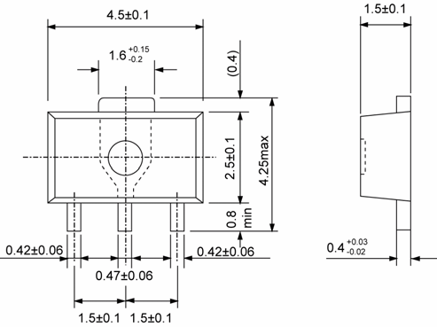

14/17

XC61C
Series

■MARKING RULE
● SSOT-24, SOT-23, SOT-89

① represents integer of detect voltage and
MARK | CONFIGURATION | VOLTAGE (V)
B | CMOS | 1.X
C | CMOS | 2.X
D | CMOS | 3.X
E | CMOS | 4.X
F | CMOS | 5.X
H | CMOS | 6.X

4 3 CMOS Output (XC61CC series)

① ② ④

1 2

3

① ② ③ ④

1 2
① ②
③ ④

N-Channel Open Drain Output (XC61CN series)

MARK | CONFIGURATION | VOLTAGE (V)
K | N-ch | 0.X
L | N-ch | 1.X
M | N-ch | 2.X
N | N-ch | 3.X
P | N-ch | 4.X
R | N-ch | 5.X
S | N-ch | 6.X

② represents decimal number of detect voltage
MARK | VOLTAGE (V) | MARK | VOLTAGE (V)
0 | X.0 | 5 | X.5
1 | X.1 | 6 | X.6
2 | X.2 | 7 | X.7
3 | X.3 | 8 | X.8
4 | X.4 | 9 | X.9

1 2 3

③ represents delay time
(Except for SSOT-24)

MARK | DELAY TIME | PRODUCT SERIES
3 | No Delay Time | XC61Cxxx0xxx

④ represents production lot number
Based on the internal standard. (G, I, J, O, Q, W excluded)

15/17

XC61C Series

■MARKING RULE (Continued)

●TO-92

① represents output configuration

MARK | OUTPUT CONFIGURATION
C | CMOS
N | N-ch

②, ③ represents detect voltage (ex.)

MARK |  | VOLTAGE (V)
② | ③ | VOLTAGE (V)
3 | 3 | 3.3
5 | 0 | 5.0
④ represents delay time
MARK | DELAY TIME
0 | No delay

⑤ represents detect voltage accuracy

MARK | DETECT VOLTAGE ACCURACY
1 | Within ± 1% (Semi-custom)
2 | Within ± 2%

⑥ represents a least significant digit of production year

MARK | PRODUCTION YEAR
5 | 2005
6 | 2006

⑦ represents production lot number
0 to 9, A to Z repeated. (G, I, J, O, Q, W excluded)
* No character inversion used.

16/17

XC61C
Series

1. The products and product specifications contained herein are subject to change without notice to improve performance characteristics. Consult us, or our representatives before use, to confirm that the information in this datasheet is up to date.
2. We assume no responsibility for any infringement of patents, patent rights, or other rights arising from the use of any information and circuitry in this datasheet.
3. Please ensure suitable shipping controls (including fail-safe designs and aging protection) are in force for equipment employing products listed in this datasheet.
4. The products in this datasheet are not developed, designed, or approved for use with such equipment whose failure of malfunction can be reasonably expected to directly endanger the life of, or cause significant injury to, the user.
(e.g. Atomic energy; aerospace; transport; combustion and associated safety equipment thereof.)
5. Please use the products listed in this datasheet within the specified ranges.

Should you wish to use the products under conditions exceeding the specifications, please consult us or our representatives.
6. We assume no responsibility for damage or loss due to abnormal use.
7. All rights reserved. No part of this datasheet may be copied or reproduced without the prior permission of TOREX SEMICONDUCTOR LTD.

17/17

