DS1401
Front-Panel iButton Holder

www.maxim-ic.com

FEATURES
A convenient interface for iButtons®

Can be used with any DS9097-series COM
port adapter

Provides four iButton ports (one port used for button cable connection)

iButtons can be inserted in any combination

>10000 insertion/withdrawal cycles with no performance degradation

Fastens to any convenient location

Comes with double-sided adhesive tape for mounting

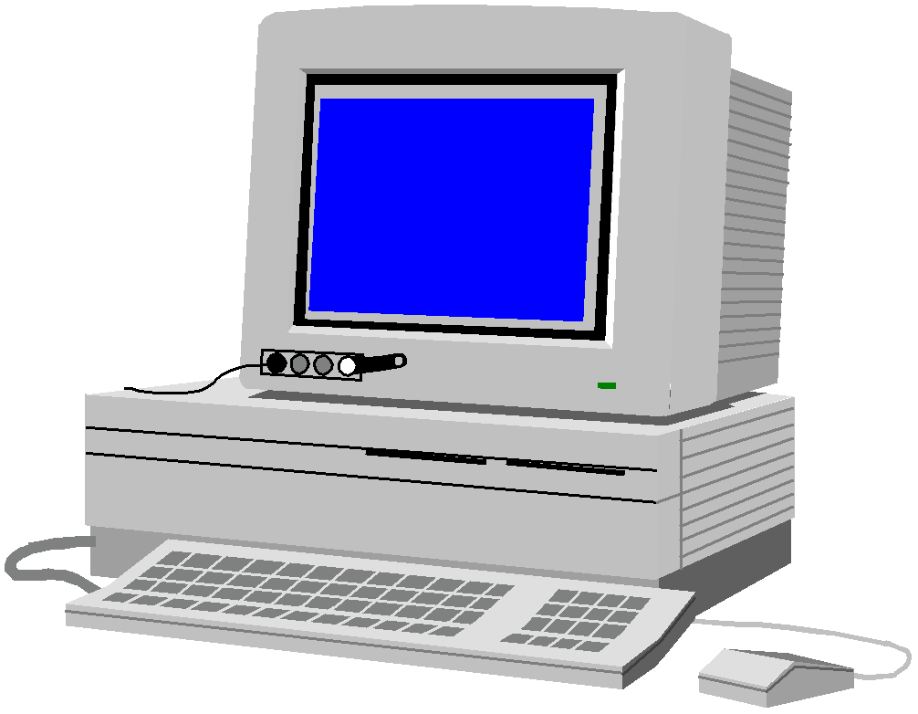

ORDERING INFORMATION
DS1401-04 Four-button version, as shown
in the picture

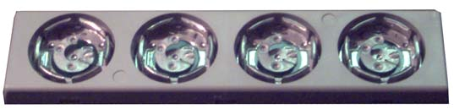
DS1401-04

DESCRIPTION
iButtons can be conveniently accessed using the DS1401 Front Panel iButton Holder and DS1402
MicroLAN cables.

The DS1401 is connected to the computer using a DS1402BR8 MicroLAN Cable and a Dallas COM Port
Adapter. It mounts to any surface (top of tower computer, CRT, keyboard).

The DS1401 supports Dallas’ MicroLAN architecture, allowing iButtons to be inserted into Button ports in any combination. Each device’s unique 64-bit ID makes location detection automatic.

The DS1401 uses DS9100A and DS9100B Touch-and-Hold Probe Stampings for ground and data contact, respectively. These stampings are designed for F5 MicroCans® and dwelled contact.

iButton and MicroCan are registered trademarks of Dallas Semiconductor.

1 of 1 070302

