DS1402D-0XX
iButton Probe Component Parts

www.maxim-ic.com

Features
Spring-Mounted iButton® Reader
Momentary Contact for Both F3 and F5 Style iButtons or Dwelled Contact for F5 Only
Convenient Tactile Feedback System for Dwelled iButton Contact

Mounting Pad Layout

.82in

Ground
.080in

Data

.46in

General Description
The four component parts that are used to construct the Blue-Dot iButton reader found in the DS1402D-DR8 and DS1402D-DB8 are described here. Diagrams 1 through 4 show the individual part dimensions. This document also describes how to assemble the Blue-Dot given the sub-parts listed in Table 1. The Blue-Dot can be assembled in the three easy steps described in the Assembly Instructions section.

Table 1. DS1402D Parts Listing
Reference | Part | Description | Ordering Information
A | DS1402D-011 | Small Blue Insert | DS1402D-11
B | DS1402D-010 | Small Data Contact Spring | DS1402D-10
C | DS1402D-003 | Large Blue Support | DS1402D-3
D | DS1402D-017 | Large Ground Contact | DS1402D-17
 | DS1402D-041 | Subassembly of A-D | DS1402D-41

iButton is a registered trademark of Dallas Semiconductor. Blue-Dot is a trademark of Dallas Semiconductor.

Diagram 1. DS1402D-003

Diagram 2. DS1402D-010

Diagram 3. DS1402D-011

Diagram 4. DS1402D-017
Assembly Instructions
1. Insert the end of the Data Spring (B) wire at the large coil end, into the slot at the top of the Data Button (A). Twist the spring clockwise into the slot until the end of the wire at the small coil end lines up with the edge of the slot in the Button.

A

B

2. Place the Data Button (A) with the Data Spring (B), assembled, into the Contact Support (C).

D

The Contact (D) loop fits around the side of the notch with the larger radii.
3. Compress the Data Spring (B) into the center of the Data Button (A) and slide the Contact (D) onto the Contact
Support (C). Check that the Data Button (A) is free to move up and down through the Contact (D).

Slot in Button (A) to line up with notch in Contact Support (C).
C

End of wire to line up with notch in Contact Support
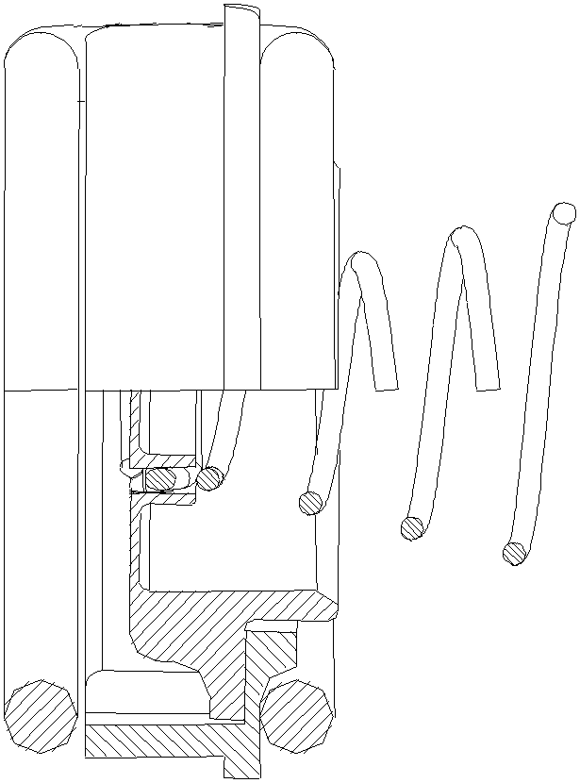

XY
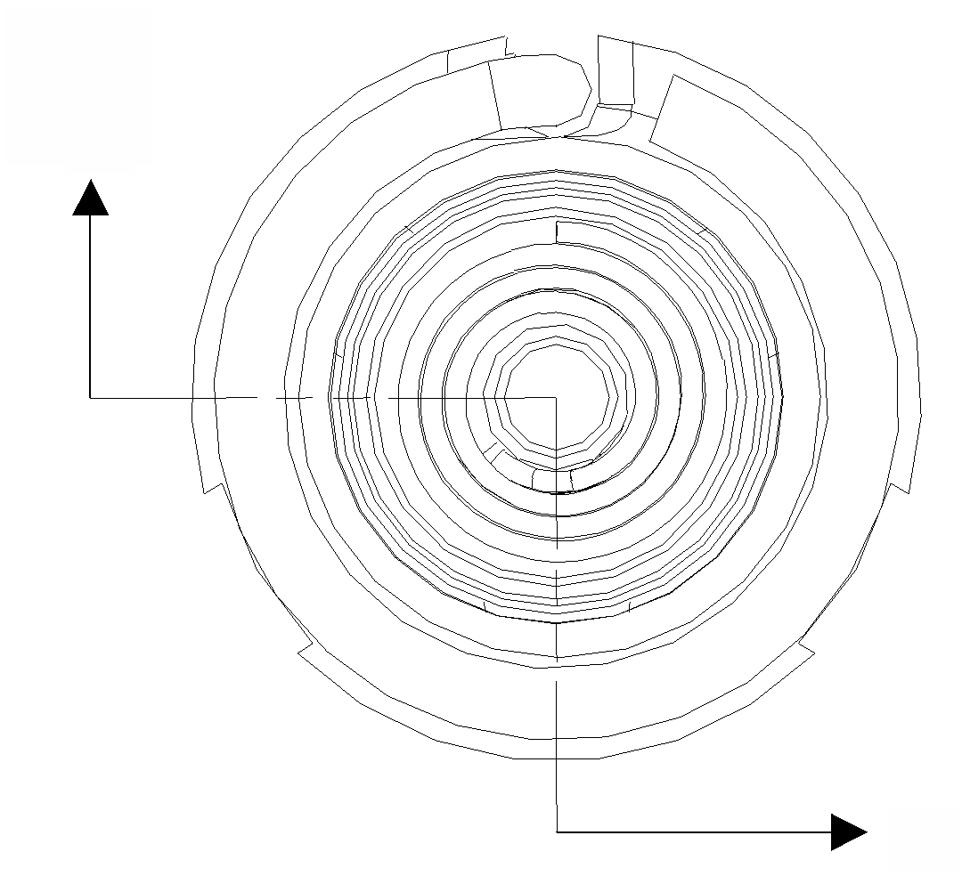

XY
Overview

Here is an assembly picture of the overview of steps listed above.

See Assembly Instructions

A

Option: Can be twisted in at the last step of assembly.

B

C

D
Insert into Contact D

Assembled Parts

