Rev 1; 9/06

Addressable Digital Potentiometer

General Description
The DS1805 addressable digital potentiometer contains a single 256-position digitally controlled potentiometer. Device control is achieved through a 2-wire serial inter- face. Device addressing is provided through three address inputs that allow up to eight devices on a sin- gle 2-wire bus. The exact wiper position of the poten- tiometer can be written or read. The DS1805 is available in 16-pin SO and 14-pin TSSOP packages. The device is available in three standard resistance val- ues: 10kΩ, 50kΩ, and 100kΩ. The DS1805 is specified over the industrial temperature range. The DS1805 provides a low-cost alternative for designs based on the DS1803, but require only a single potentiometer.
Features
♦ 3V or 5V Operation
♦  ♦ | Low Power Consumption  One Digitally Controlled, 256-Position
 | Potentiometer
♦ | Compatible with DS1803-Based Designs
♦ | 14-Pin TSSOP (173mil) and 16-Pin SO (150mil) Available for Surface-Mount Applications
♦ | Three Address Inputs
♦ | Serial 2-Wire Bus
♦ | Operating Temperature Range

Applications

CCFL Inverters
PDAs and Cell Phones Portable Electronics Multimedia Products
Instrumentation and Industrial Controls
Industrial: -40°C to +85°C
♦ Standard Resistance Values

DS1805-010: 10kΩ DS1805-050*: 50kΩ DS1805-100*: 100kΩ

Pin Configurations Ordering Information

TOP VIEW

H1 1

L1 2

W1 3

A2 4

A1 5

A0 6

GND 7

DS1805E
14 VCC

13 N.C.

12 N.C.

11 N.C.

10 N.C.

9 SDA

8 SCL
H1 1

N.C. 2

L1 3

W1 4

A2 5

A1 6

A0 7

GND 8

DS1805Z
16 VCC

15 N.C.

14 N.C.

13 N.C.

12 N.C.
PART TEMP RANGE PIN-PACKAGE RESISTANCE (KΩ)
DS1805E-010 -40°C to +85°C 14 TSSOP (173mil) 10
DS1805E-050* -40°C to +85°C 14 TSSOP (173mil) 50
DS1805E-100* -40°C to +85°C 14 TSSOP (173mil) 100
DS1805Z-010 -40°C to +85°C 16 SO (150mil) 10
DS1805Z-050* -40°C to +85°C 16 SO (150mil) 50
DS1805Z-100* -40°C to +85°C 16 SO (150mil) 100

11 N.C.

10 SDA

9 SCL

Add “/T&R” for tape-and-reel orders.
*Future product.

14 TSSOP (173mil)
DS1805

16 SO (150mil)

ABSOLUTE MAXIMUM RATINGS
Voltage on Any Pin Relative to Ground .................-0.5V to +6.0V Operating Temperature Range ...........................-40°C to +85°C

Storage Temperature Range .............................-55°C to +125°C Soldering Temperature ............................................See IPC/JEDEC J-STD-020A Specification

Stresses beyond those listed under “Absolute Maximum Ratings” may cause permanent damage to the device. These are stress ratings only, and functional operation of the device at these or any other conditions beyond those indicated in the operational sections of the specifications is not implied. Exposure to absolute maximum rating conditions for extended periods may affect device reliability.
DS1805

RECOMMENDED DC OPERATING CONDITIONS
(TA = -40°C to +85°C)

PARAMETER | SYMBOL | CONDITIONS | MIN TYP MAX | UNITS
Supply Voltage | VCC | (Note 1) | 2.7 5.5 | V
Resistor Inputs | L, H, W | (Note 1) | -0.3 VCC +  0.3 | V

DC ELECTRICAL CHARACTERISTICS
(VCC = 2.7V to 5.5V, TA = -40°C to +85°C.)

PARAMETER | SYMBOL | CONDITIONS | MIN TYP MAX | UNITS
Supply Current Active | ICC | (Note 2) | 200 | µA
Input Leakage | IIL |  | -1 +1 | µA
Wiper Resistance | RW |  | 400 1000 | Ω
Wiper Current | IW |  | 1 | mA
Input Logic 1 | VIH |  | 0.7VCC VCC +  0.3 | V
Input Logic 0 | VIL |  | GND - 0.3VCC  0.3 | V
Input Logic Levels A0, A1, A2 (Note 3) |  | Input logic 1 | 0.7VCC VCC +  0.3 | V
Input Logic Levels A0, A1, A2 (Note 3) |  | Input logic 0 | GND - 0.25V C C  0.3 | V
Input Current each I/O Pin  (Note 4) |  | 0.4V < VI/O < 0.9VCC | -10 +10 | µA
Standby Current | ISTBY | (Note 5) | 20 40 | µA
Low-Level Output Voltage | VOL1 | 3mA sink current | 0 0.4 | V
Low-Level Output Voltage | VOL2 | 6mA sink current | 0 0.6 | V
I/O Capacitance | CI/0 |  | 10 | pF
Pulse Width of Spikes that Must be Suppressed by the Input Filter | tSP | Fast mode | 0 50 | ns

DS1805

ANALOG RESISTOR CHARACTERISTICS
(VCC = 2.7V to 5.5V, TA = -40°C to +85°C)

PARAMETER | SYMBOL | CONDITIONS | MIN TYP MAX | UNITS
End-to-End Resistor Tolerance |  | (Note 6) | -20 +20 | %
Absolute Linearity |  | (Note 7) | -0.75 +0.75 | LSB
Relative Linearity |  | (Note 8) | -0.3 +0.3 | LSB
-3dB Cutoff Frequency | fCUTOFF | (Note 9) |  | Hz
Ratiometric Temperature Coefficient |  |  | 8 | ppm/°C
End-to-End Temperature Coefficient |  |  | 550 | ppm/°C
Capacitance | CI |  | 5 | pF

AC ELECTRICAL CHARACTERISTICS
(VCC = 2.7V to 5.5V, TA = -40°C to +85°C)

PARAMETER | SYMBOL | CONDITIONS | MIN TYP MAX | UNITS
SCL Clock Frequency (Note 10) | fSCL | Fast mode | 0 400 | kHz
SCL Clock Frequency (Note 10) | fSCL | Standard mode | 0 100 | kHz
Bus Free Time Between STOP  and START Condition (Note 10) | tBUF | Fast mode | 1.3 | µs
Bus Free Time Between STOP  and START Condition (Note 10) | tBUF | Standard mode | 4.7 | µs
Hold Time (Repeated) START Condition (Notes 10, 11) | tHD:STA | Fast mode | 0.6 | µs
Hold Time (Repeated) START Condition (Notes 10, 11) | tHD:STA | Standard mode | 4.0 | µs
Low Period of SCL Clock  (Note 10) | tLOW | Fast mode | 1.3 | µs
Low Period of SCL Clock  (Note 10) | tLOW | Standard mode | 4.7 | µs
High Period of SCL Clock  (Note 10) | tHIGH | Fast mode | 0.6 | µs
High Period of SCL Clock  (Note 10) | tHIGH | Standard mode | 4.0 | µs
Data Hold Time  (Notes 10, 12, 13) | tHD:DAT | Fast mode | 0 0.9 | µs
Data Hold Time  (Notes 10, 12, 13) | tHD:DAT | Standard mode | 0 0.9 | µs
Data Setup Time  (Note 10) | tSU:DAT | Fast mode | 100 | ns
Data Setup Time  (Note 10) | tSU:DAT | Standard mode | 250 | ns
Rise Time of Both SDA and SCL Signals (Notes 10, 14) | tR | Fast mode | 20 + 0.1CB 300 | ns
Rise Time of Both SDA and SCL Signals (Notes 10, 14) | tR | Standard mode | 20 + 0.1CB 1000 | ns
Fall Time of Both SDA and SCL Signals (Notes 10, 14) | tF | Fast mode | 20 + 0.1CB 300 | ns
Fall Time of Both SDA and SCL Signals (Notes 10, 14) | tF | Standard mode | 20 + 0.1CB 300 | ns
Setup Time for STOP Condition  (Note 10) | tSU:STO | Fast mode | 0.6 | µs
Setup Time for STOP Condition  (Note 10) | tSU:STO | Standard mode | 4.0 | µs
Capacitive Load for Each Bus  Line (Note 14) | CB |  | 400 | pF

DS1805

AC ELECTRICAL CHARACTERISTICS
(VCC = 2.7V to 5.5V, TA = -40°C to +85°C)

Note 1: All voltages are referenced to ground.
Note 2: ICC specified with SDA pin open. SCL = 400kHz clock rate.
Note 3: Address inputs A0, A1, and A2 should be connected to either VCC or GND, depending on the desired address selections.
Note 4: I/O pins of fast mode devices must not obstruct the SDA and SCL lines if VCC is switched off.
Note 5: ISTBY specified with SDA = SCL = VCC = 5.0V.
Note 6: Valid at +25°C only.
Note 7: Absolute linearity is used to determine wiper voltage versus expected voltage as determined by wiper position.
Note 8: Relative linearity is used to determine the change in voltage between successive tap positions.
Note 9: -3dB cutoff frequency characteristics for the DS1805 depend on potentiometer total resistance: DS1805-010, 1MHz; DS1805-50, 200kHz; DS1805-100, 100kHz.
Note 10: A fast mode device can be used in a standard mode system, but the requirement tSU:DAT > 250ns must then be met. This will automatically be the case if the device does not stretch the low period of the SCL signal. If such a device does stretch
the LOW period of the SCL signal, it must output the next data bit to the SDA line tRMAX + tSU:DAT = 1000ns + 250ns =
1250ns before the SCL line is released.
Note 11: After this period, the first clock pulse is generated.
Note 12: The maximum tHD:DAT has only to be met if the device does not stretch the low period (tLOW) of the SCL signal.
Note 13: A device must internally provide a hold time of at least 300ns for the SDA signal (referred to the VIHMIN of the SCL signal)
in order to bridge the undefined region of the falling edge of SCL.
Note 14: CB—total capacitance of one bus line in picofarads, timing referenced to (0.9)(VCC) and (0.1)(VCC).

Typical Operating Characteristics
(VCC = 5.0V, TA = +25°C, unless otherwise noted.)

SUPPLY CURRENT
vs. TEMPERATURE
30

25

15

10
SUPPLY CURRENT (µA)

5

W-L RESISTANCE
vs. WIPER SETTING

10
DS1805 toc01

8
W-L RESISTANCE (kΩ)

6

4

2

350
DS1805 toc02

300

250

200

150

100
WIPER RESISTANCE (Ω)

50

WIPER RESISTANCE vs. WIPER VOLTAGE (10kΩ)

VCC = 5V
DS1805 toc03

VCC = 3V
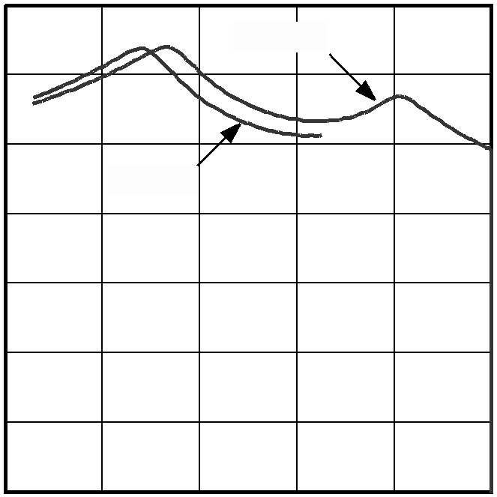

0
-40
VCC = 5V
VCC = 3V

-20 0

20 40

60 80

0
0 25 50
10kΩ POTENTIOMETER

75 100 125 150 175 200 225 250

0
0 1 2 3 4 5

TEMPERATURE (°C)
WIPER SETTING
WIPER VOLTAGE (V)

VOLTAGE DIVIDER PERCENT CHANGE (FROM +25°C) vs. TEMPERATURE

END-TO-END RESISTANCE TEMPERATURE

ACTIVE SUPPLY CURRENT
DS1805 toc06

0.06

0.04

0.02

0

-0.02
% CHANGE (FROM +25°C)

WIPER = BFh

WIPER = 3Fh
DS1805 toc04

WIPER = 7Fh
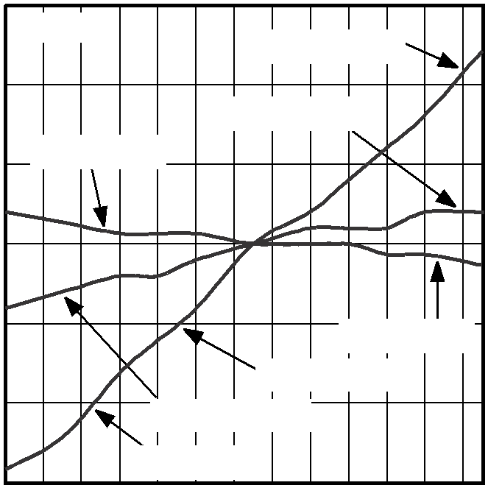

WIPER = BFh
TC = 8.1ppm/°C

5 50
SDA = VCC
A0, A1, A2, L1 = GND W1, H1 = NO CONNECT

DS1805 toc05
4 45
END-TO-END RESISTANCE % CHANGE
3 40
2 35
10kΩ, WORST CASE
1 30
0 25
ACTIVE SUPPLY CURRENT (µA)
-1 20
-2 15
-3 TC = 530ppm/°C 10

-0.04

-0.06
TC = 1.3ppm/°C
-4 5
-5 0

-40
-20 0
20 40 60 80
-40
-20 0 20
40 60 80
0 100
200
300
400

TEMPERATURE (°C)
TEMPERATURE (°C)
SCL FREQUENCY (kHz)

0.18

0.16

0.14
ABSOLUTE LINEARITY (LSB)

0.12

0.10

0.08

0.06

0.04

0.02

0
VOLTAGE-DIVIDER ABSOLUTE LINEARITY
vs. WIPER SETTING (10kΩ)
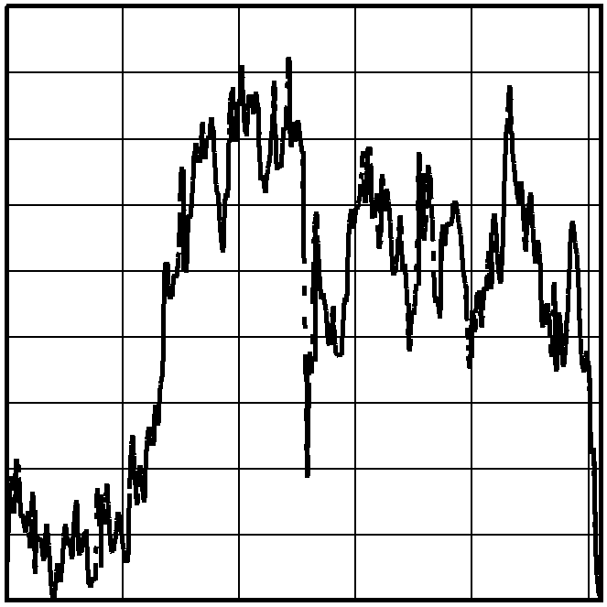

DS1805 toc07

0.06
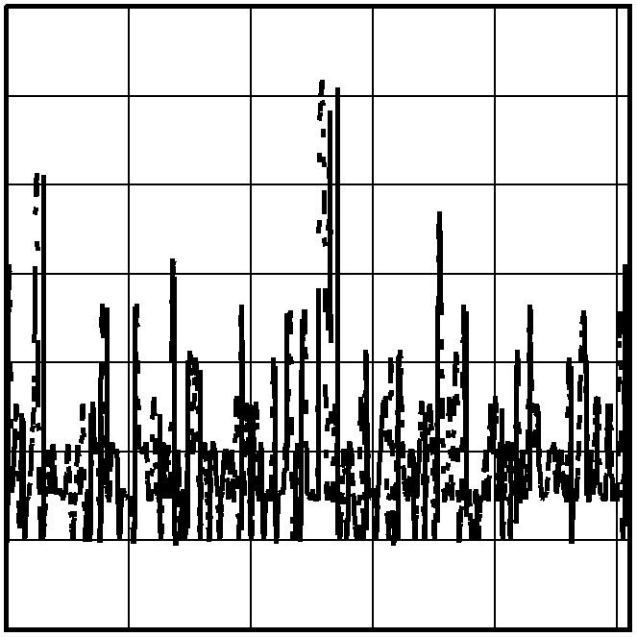

0.05

0.04

0.03

0.02

0.01
RELATIVE LINEARITY (LSB)

0

-0.01
VOLTAGE-DIVIDER RELATIVE LINEARITY
vs. WIPER SETTING (10kΩ)
DS1805 toc08

0 50 100
150
200
250
0 50
100
150
200
250

WIPER SETTING
DS1805
WIPER SETTING

L1 POTENTIOMETER-1 H1

256-TO-1 MULTIPLEXER

SRAM

REG-0 (8-BIT REGISTER)

WIPER-1 (8-BIT REGISTER) W1

SCL  SDA |  | COMMAND/ CONTROL UNIT
2-WIRE SERIAL INTERFACE
DEVICE ADDRESS SELECTION |  | A0
DEVICE ADDRESS SELECTION |  | A1
DEVICE ADDRESS SELECTION |  | A2

Figure 1. Functional Diagram
DS1805

Pin Description
PIN |  | NAME | FUNCTION
TSSOP | SO | NAME | FUNCTION
1 | 1 | H1 | High End of  Potentiometer
2 | 3 | L1 | Low End of  Potentiometer
3 | 4 | W1 | Wiper Terminal of  Potentiometer
6, 5, 4 | 7, 6, 5 | A0, A1, A2 | Address Select Inputs
7 | 8 | GND | Ground
8 | 9 | SCL | Serial Clock Input
9 | 10 | SDA | Serial Data I/O
10–13 | 2, 11–15 | N.C. | No Connection
14 | 16 | VCC | 3V/5V Power-Supply  Input

Detailed Description
The DS1805 addressable digital potentiometer contains a single 256-position digitally controlled potentiometer. Device control is achieved through a 2-wire serial inter- face. Device addressing is provided through three address inputs that allow up to eight devices on a single
2-wire bus. The exact wiper position of the potentiometer can be written or read. The DS1805 is available in 16-pin SO and 14-pin TSSOP packages. The device is available in three standard resistance values: 10kΩ, 50kΩ, and
100kΩ. The DS1805 specified over the industrial temper- ature range. The DS1805 is provides a low-cost alterna- tive for designs based on the DS1803, but require only a single potentiometer.
Device Operation
The DS1805 is an addressable, digitally controlled device that has a single 256-position potentiometer. Figure 1 shows a block diagram of the part. Communication and control of the device is accom- plished through a 2-wire serial interface that has SDA and SDL signals. Device addressing is attained using the device chip-select inputs A0, A1, and A2.

SDA

MSB

SLAVE ADDRESS

R/W DIRECTION BIT

ACKNOWLEDGEMENT SIGNAL FROM RECEIVER

ACKNOWLEDGEMENT SIGNAL FROM RECEIVER

SCL

1 2 6 7 8 9 1 2

3–7 8 9

START CONDITION

ACK

REPEATED IF MORE BYTES ARE TRANSFERED

ACK

STOP CONDITION OR REPEATED START CONDITION

Figure 2. 2-Wire Data Transfer Overview

The potentiometer is composed of a 256-position resis- tor array. Two 8-bit registers are provided to ensure compatibility with DS1803-based designs. Register-0 is a general-purpose SRAM byte, while register-1 is assigned to the potentiometer and is used to set the wiper position on the resistor array. The wiper terminal is multiplexed to one of 256 positions on the resistor array based on its corresponding 8-bit register value. The high- est wiper setting, FFh, is 1 LSB away from H1 (resistor
DS1805
255), while the lowest setting, 00h, connects to L1.
The DS1805 is a volatile device that does not maintain the position of the wiper during power-down or loss of power. On power-up, the wiper position is set to 00h (the low-end terminal). The user can then set the wiper value to a desired position.
Communication with the DS1805 takes place over the
2-wire serial interface consisting of the bidirectional data terminal, SDA, and the serial clock input, SCL. Complete details of the 2-wire interface are discussed in the 2-Wire Serial Data Bus section.
The 2-wire interface and address inputs A0, A1, and A2 allow operation of up to eight devices in a bus topology, with A0, A1, and A2 being the address of the device.

Application Considerations
The DS1805 is offered in three standard resistor values:
10kΩ, 50kΩ, and 100kΩ. The resolution of the poten- tiometer is defined as RTOT/256, where RTOT is the total resistor value of the potentiometer. The DS1805 is designed to operate using 3V or 5V power supplies over
the industrial (-40°C to +85°C) temperature range. Maximum input signal levels across the potentiometer cannot exceed the operating power supply of the device.
2-Wire Serial Data Bus
The DS1805 supports a bidirectional 2-wire bus and data transmission protocol. A device that sends data on the bus is called a transmitter, and a device receiving data is called a receiver. The device that controls the message is called a master. The devices that are con- trolled by the master are slaves. The bus must be con- trolled by a master device that generates the serial clock (SCL), controls the bus access, and generates the START and STOP conditions. The DS1805 operates as a slave on the 2-wire bus. Connections to the bus are made through the open-drain I/O lines, SDA and SCL.
The following bus protocol has been defined (Figure 2):
• Data transfer can be initiated only when the bus is not busy.
• During data transfer, the data line must remain sta- ble whenever the clock line is high. Changes in the data line while the clock line is high will be interpret- ed as control signals.
Accordingly, the following bus conditions have been defined:
Bus not busy: Both data and clock lines remain high.
Start data transfer: A change in the state of the data line from high to low while the clock is high defines a START condition.

Stop data transfer: A change in the state of the data line from low to high while the clock line is high defines the STOP condition.
Data valid: The state of the data line represents valid data when, after a START condition, the data line is sta- ble for the duration of the high period of the clock signal. The data on the line must be changed during the low period of the clock signal. There is one clock pulse per bit of data. Figure 2 details how data transfer is accom- plished on the 2-wire bus. Depending upon the state of the R/W bit, two types of data transfer are possible.
Each data transfer is initiated with a START condition

MSB
0 1 0 1 A2 A1 A0 R/W

DEVICE IDENTIFIER

DEVICE ADDRESS

LSB

and terminated with a STOP condition. The number of data bytes transferred between START and STOP con- ditions is not limited and is determined by the master device. The information is transferred byte-wise and each receiver acknowledges with a ninth bit.
DS1805
Within the bus specifications a regular mode (100kHz clock rate) and a fast mode (400kHz clock rate) are defined. The DS1805 works in both modes.
Acknowledge: Each receiving device, when addressed, is obliged to generate an acknowledge after the recep- tion of each byte. The master device must generate an extra clock pulse that is associated with this acknowl- edge bit.
A device that acknowledges must pull down the SDA line during the acknowledge clock pulse in such a way that the SDA line is stable low during the high period of the acknowledge-related clock pulse. Of course, setup and hold times must be taken into account. A master must signal an end of data to the slave by not generat- ing an acknowledge bit on the last byte that has been clocked out of the slave. In this case, the slave must leave the data line high to enable the master to gener- ate the STOP condition.
Data transfer from a master transmitter to a slave receiver: The first byte transmitted by the master is the control byte (slave address). Next follows a number of data bytes. The slave returns an acknowledge bit after each received byte.
Data transfer from a slave transmitter to a master receiver: The first byte (the slave address) is transmit- ted by the master. The slave then returns an acknowl- edge bit. Next follows a number of data bytes transmitted by the slave to the master. The master returns an acknowledge bit after all received bytes other than the last byte. At the end of the last received byte, a ‘not acknowledge’ is returned.
The master device generates all of the serial clock pulses and the START and STOP conditions. A transfer

Figure 3. Control Byte

is ended with a STOP condition or with a repeated START condition. Since a repeated START condition is also the beginning of the next serial transfer, the bus will not be released.
The DS1805 can operate in the following two modes:
Slave receiver mode: Serial data and clock are received through SDA and SCL. After each byte is received, an acknowledge bit is transmitted. START and STOP conditions are recognized as the beginning and end of a serial transfer. Address recognition is performed by hardware after reception of the slave address and direction bit.
Slave transmitter mode: The first byte is received and handled as in the slave receiver mode. However, in this mode the direction bit will indicate that the transfer direction is reversed. Serial data is transmitted on SDA by the DS1805 while the serial clock is input on SCL. START and STOP conditions are recognized as the beginning and end of a serial transfer.
Slave Address
A control byte is the first byte received following the START condition from the master device. The control byte consists of a four-bit control code; for the DS1805, this is set as 0101 binary for read/write operations. The next three bits of the control byte are the device select bits (A2, A1, A0). They are used by the master device to select which of eight devices are to be accessed. The select bits are the three least significant bits (LSB) of the slave address. Additionally, A2, A1, and A0 can be changed any time during a powered condition of the part. The last bit of the control byte (R/W) defines the operation to be performed. When set to a one, a read operation is selected; when set to a zero a write opera- tion is selected. Figure 3 shows the control byte struc- ture for the DS1805.

Following the START condition, the DS1805 monitors the SDA bus checking the device type identifier being transmitted. Upon receiving the 0101 address code and appropriate device select bits, the slave device outputs an acknowledge signal on the SDA line.
Command and Protocol
The DS1805’s command and protocol structure of the DS1805 allows the user to read or write to both the scratchpad and potentiometer registers. Figures 4 and
5 show the command structures for the part. Potentiometer data values and control and command values are always transmitted most significant bit (MSB) first. During communications, the receiving unit always generates the acknowledge.

Reading the DS1805
As shown in Figure 4, the DS1805 provides one read- command operation. This operation allows the user to read both potentiometers. Specifically, the R/W bit of the control byte is set equal to a one for a read operation. Communication to read the DS1805 begins with a START condition that is issued by the master device. The control byte from the master device follows the START condition. Once the control byte has been received by the DS1805, the part responds with an acknowledge. The read/write bit of the control byte as stated should be set equal to one for reading the DS1805.
When the master has received the acknowledge from the DS1805, the master can then begin to receive poten- tiometer wiper data. The value of the register-0 wiper position will be the first returned from the DS1805. Once the eight bits of the register-0 wiper position have been transmitted, the master needs to issue an acknowledge, unless it is the only byte to be read, in which case the master issues a not acknowledge. If desired, the master can stop the communication transfer at this point by issu- ing the STOP condition. However, if the value of the potentiometer-1 wiper position value is needed, commu-
Table 1. 2-Wire Command Words

COMMAND | COMMAND VALUE
Write Register-0 | 101010 01
Write Potentiometer-1 Register | 101010 10
Write Both Registers | 101011 11

nication transfer can continue by clocking the remaining eight bits of the potentiometer-1 value, followed by a not acknowledge. Final communication transfer is terminated by issuing the STOP command. Figure 4 shows the flow of the read operation.

Writing to the DS1805
Figure 5 shows a data flow diagram for writing the DS1805. The DS1805 has three write-command opera- tions. These include write reg-0, write pot-1, and write reg-0/pot-1. The write reg-0 command allows the user to write the value of scratchpad register-0 and as an option the value of potentiometer-1. The write-1 command allows the user to write the value of potentiometer-1 only. The last write command, write-0/1, allows the user to write both registers to the same value with one command and one data value being issued.
All the write operations begin with a START condition. Following the START condition, the master device issues the control byte. The read/write bit of the control byte is set to zero for writing the DS1805. Once the control byte has been issued and the master receives the acknowl- edgment from the DS1805, the command byte is trans- mitted to the DS1805. As mentioned above, there exist three write operations that can be used with the DS1805. Figure 5 and Table 1 show the binary value of each write command.

Package Information
For the latest package outline information, go to
www.maxim-ic.com/packages.

OPTIONAL

MSB
 |  |  |  |  |  |  |  | ACK
0 1 0 1 A2 A1 A0 1 |  |  |  |  |  |  |  | ACK

START

CONTROL BYTE

LSB MSB

DATA BYTE

LSB MSB

DATA BYTE

LSB
NACK
STOP

DS1805
REG-0 POT-1
ACK

R/W = 1

Figure 4. 2-Wire Read Protocols

REGISTER-0

MSB
START

CONTROL BYTE

LSB MSB
 |  |  |  |  |  |  |  | ACK
1 0 1 0 1 0 0 1 |  |  |  |  |  |  |  | ACK

COMMAND BYTE

LSB MSB

DATA BYTE

LSB
ACK
OPTIONAL

MSB

DATA BYTE

LSB
ACK
STOP

REG-0
POT-1

R/W = 0
 |  |  |  |  |  |  |  | ACK
0 1 0 1 A2 A1 A0 0 |  |  |  |  |  |  |  | ACK

WRITE POT-1

MSB
START

CONTROL BYTE

LSB MSB
 |  |  |  |  |  |  |  | ACK
1 0 1 0 1 0 1 0 |  |  |  |  |  |  |  | ACK

COMMAND BYTE

LSB MSB
 |  |  |  |  |  |  |  | ACK
POT-1 |  |  |  |  |  |  |  | ACK

DATA BYTE

LSB
STOP

 |  |  |  |  |  |  |  | ACK
0 1 0 1 A2 A1 A0 0 |  |  |  |  |  |  |  | ACK
R/W = 0

WRITE REGISTER-0 AND POT-1 (SAME VALUE)

MSB
START
CONTROL BYTE

LSB MSB
 |  |  |  |  |  |  |  | ACK
1 0 1 0 1 1 1 1 |  |  |  |  |  |  |  | ACK

COMMAND BYTE

LSB MSB
 |  |  |  |  |  |  |  | ACK
REG-0/POT-1 VALUE |  |  |  |  |  |  |  | ACK

DATA BYTE

LSB
STOP

 |  |  |  |  |  |  |  | ACK
0 1 0 1 A2 A1 A0 0 |  |  |  |  |  |  |  | ACK
R/W = 0

Figure 5. 2-Wire Write Protocols

SDA

tBUF

tLOW

tR tF

tHD:STA
tSP

SCL

STOP START

tHD:STA

tHD:DAT

tHIGH

tSU:DAT REPEATED START

tSU:STA

tSU:STO

Figure 6. Timing Diagram

Revision History
Pages changed at Rev1: 9, 10
Package Information
For the latest package outline information, go to
www.maxim-ic.com/DallasPackInfo.

DS1805

Maxim cannot assume responsibility for use of any circuitry other than circuitry entirely embodied in a Maxim product. No circuit patent licenses are implied. Maxim reserves the right to change the circuitry and specifications without notice at any time.

10 Maxim Integrated Products, 120 San Gabriel Drive, Sunnyvale, CA 94086 408-737-7600

© 2002 Maxim Integrated Products Printed USA is a registered trademark of Maxim Integrated Products.

