DS9092R
iButtonTM Port

FEATURES


ﾧ Empty stainless steel F5 MicroCan with opening in rear and solder tabs
ﾧ Acts as a touch contact for remotely located
1-WireTM devices
ﾧ Together with DS2404S-C01 makes complex
functions involving microcontrollers behave as if they were iButtons
ﾧ DS9092R for DS9100-based iButton probes
ﾧ DS9092RG grooved version for Blue Dot
Receptors

ORDERING INFORMATION
DS9092R Tabbed F5 MicroCan
DS9092RG Tabbed F5 MicroCan with groove

DS9092R Tabbed MicroCan
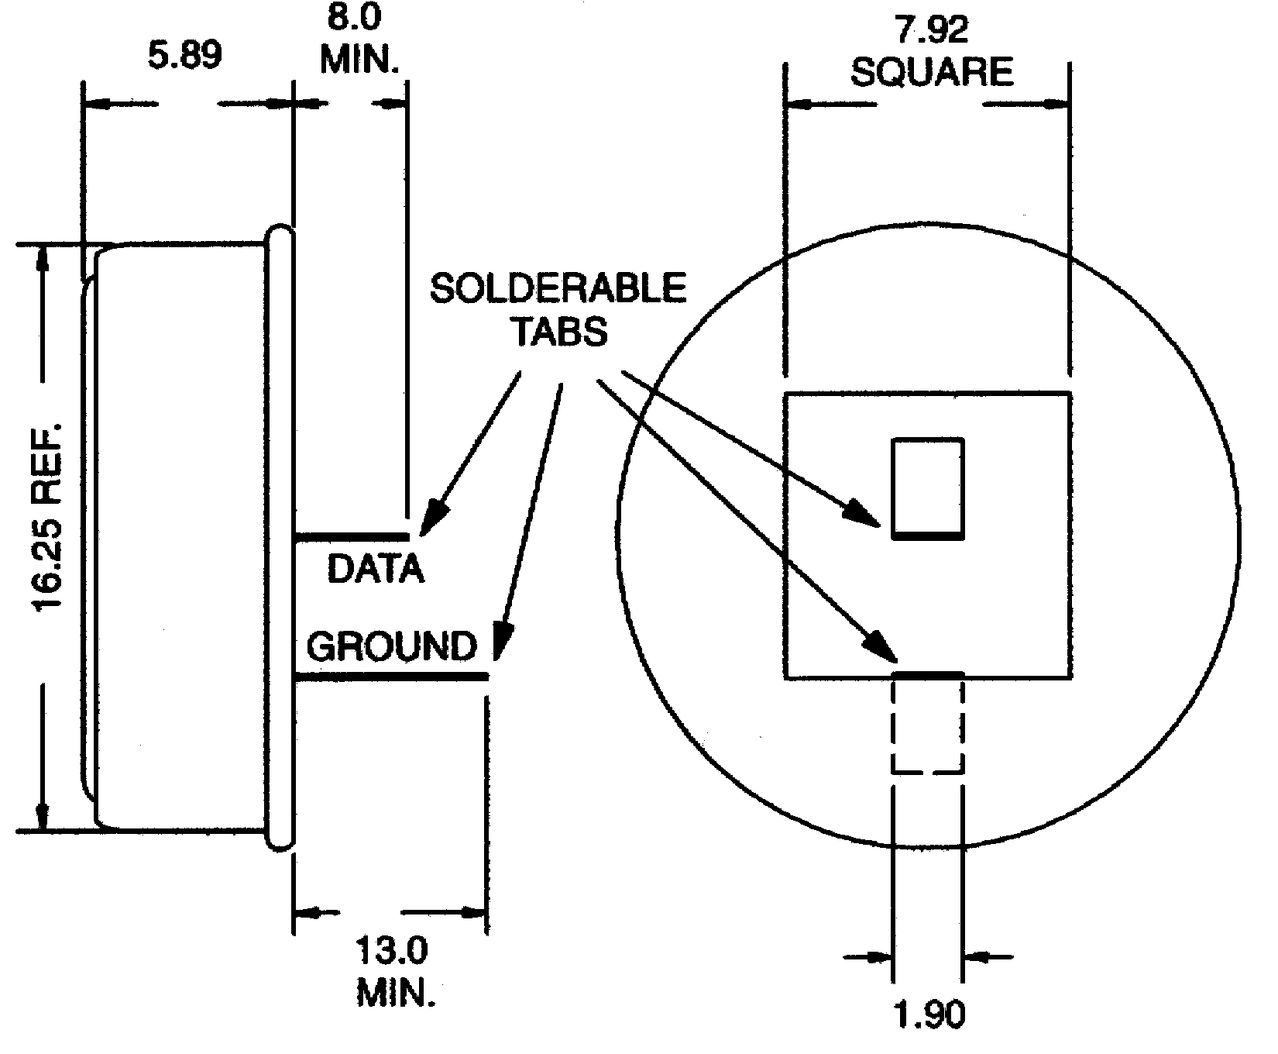

APPLICATION

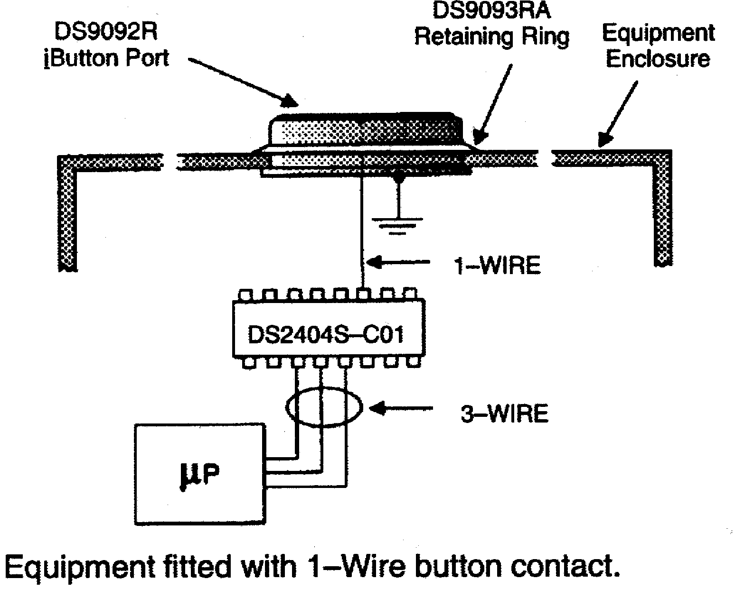

DS9092RG Tabbed MicroCan with
Groove

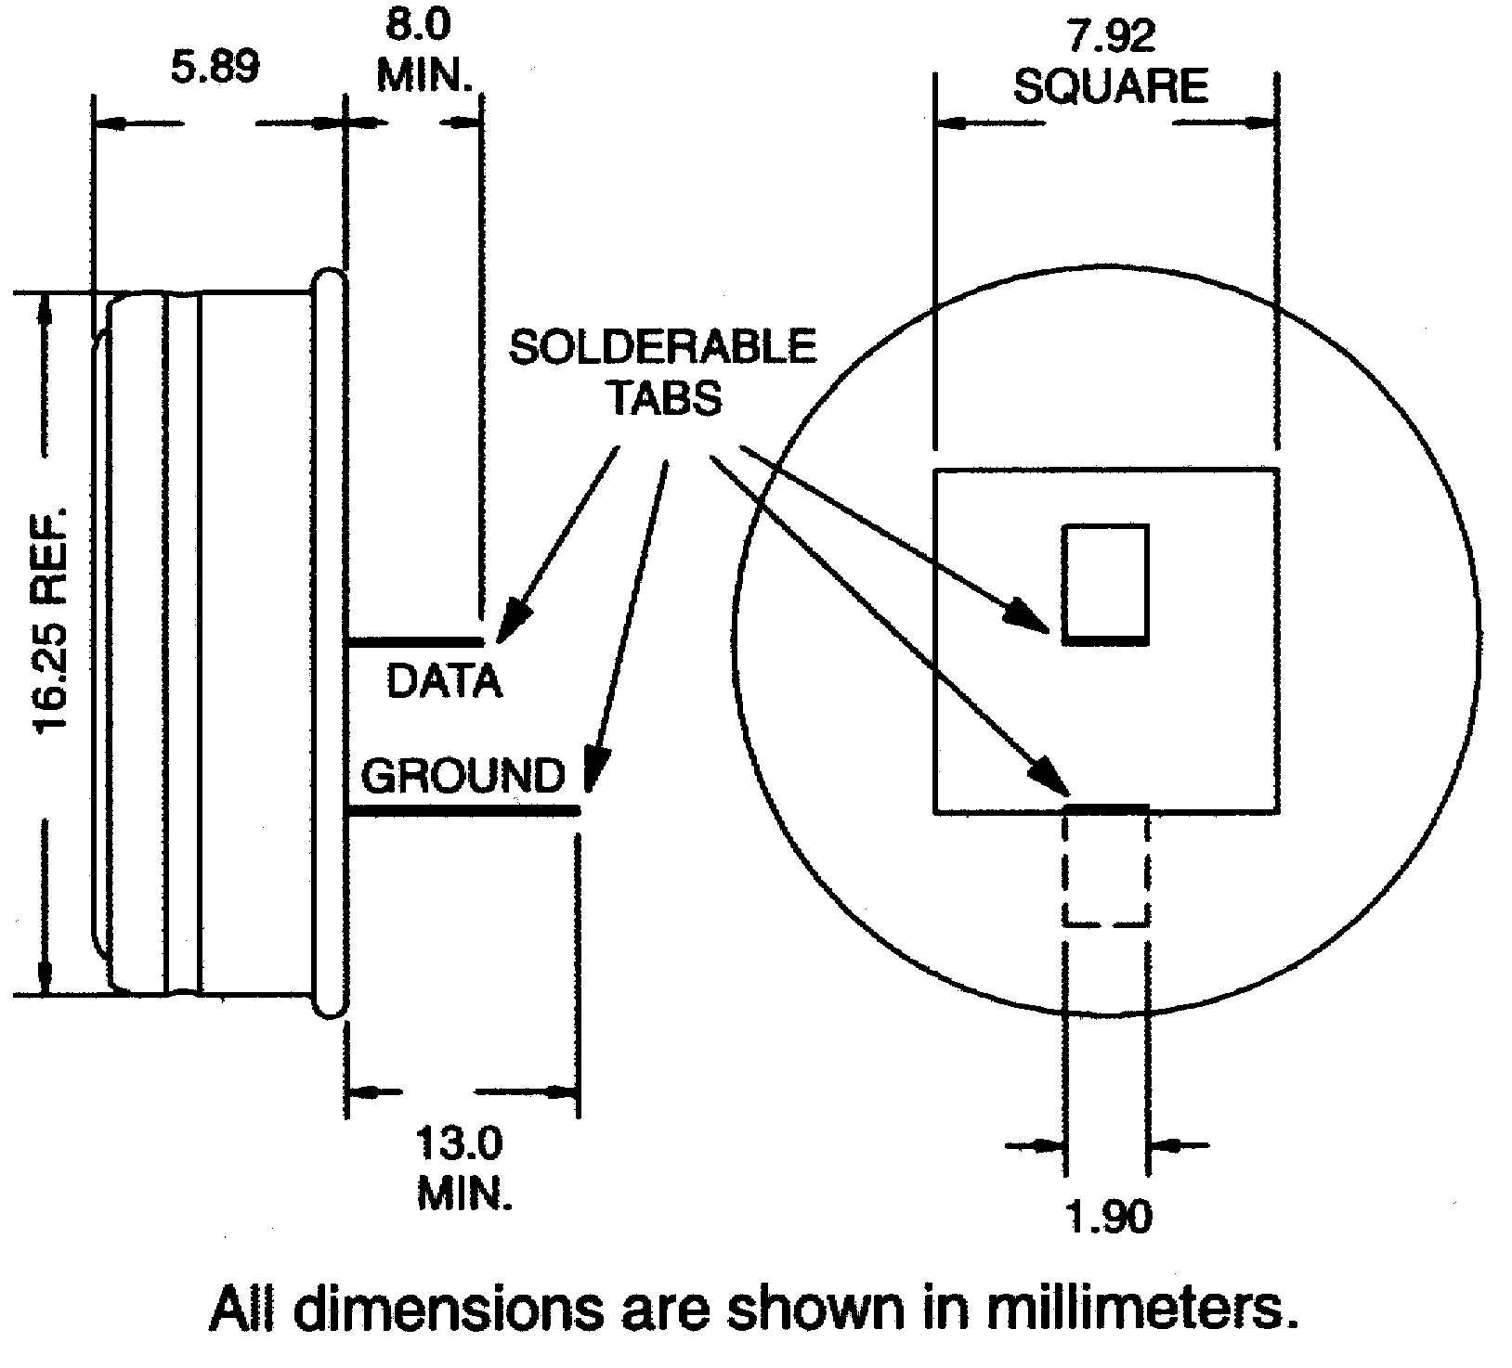

DESCRIPTION
The DS9092R iButton Port provides the electrical contact necessary for mating remotely located iButtons or other 1-Wire MicroLAN devices with reader/writers. The iButton port is available with groove (DS9092RG) and without (DS9092R). For applications where only a touch contact is needed either version will perform well. For dwelled-contact applications the DS9092R (without groove) is the preferred choice for use with the DS1402BP/DS1402RP MicroLAN cables. The grooved DS9092RG works best with the DS1402D-type cables featuring a Blue Dot Receptor.

1 of 1 102199

