DS9106 iButtonTM Halo

FEATURES


ﾧ Slides over iButton and highlights with a color

ﾧ Color-coded tab accepts transparent computer generated label

ﾧ Improves the visibility of the iButton for quick sighting

ﾧ Available in six bright colors

ﾧ 20 mm (DS9106S) and 60 mm (DS9106L)
usable tail length for legends

ﾧ Uses DS9096P adhesive pads for securing the tail

ﾧ 1000 labels per bag

DESCRIPTION
iBUTTON HALO TYPES DS9106L

DS9106S
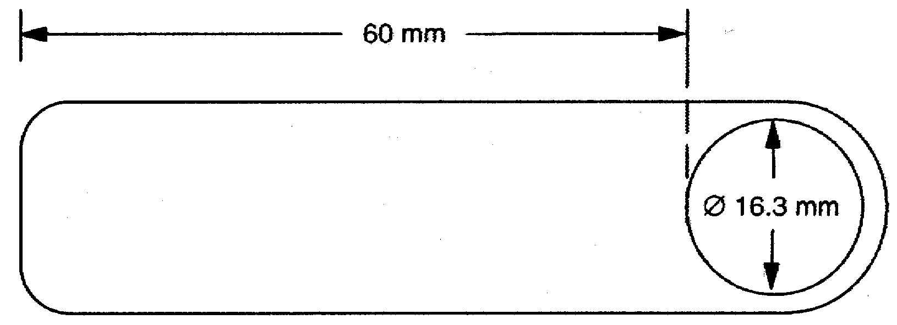

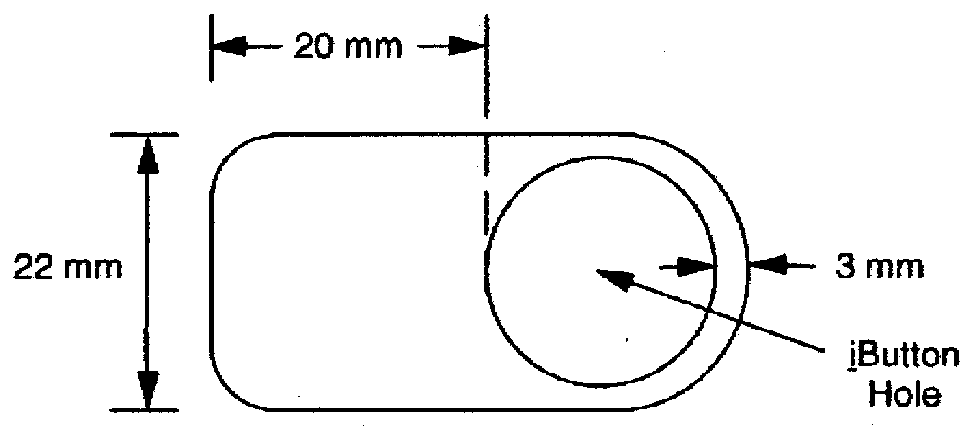

ORDERING INFORMATION
DS9106S-PK iButton Halo, Pink 20 mm DS9106S-OG iButton Halo, Orange 20 mm DS9106S-GN iButton Halo, Green 20 mm DS9106S-YL iButton Halo, Yellow 20 mm DS9106S-BL iButton Halo, Blue 20 mm DS9106S-WH iButton Halo, White 20 mm DS9106L-PK iButton Halo, Pink 60 mm DS9106L-OG iButton Halo, Orange 60 mm DS9106L-GN iButton Halo, Green 60 mm DS9106L-YL iButton Halo, Yellow 60 mm DS9106L-BL iButton Halo, Blue 60 mm DS9106L-WH iButton Halo, White 60 mm

The DS9106 iButton Halos are 0.25 mm, thin vinyl highlighters that slide over an iButton that is to be labeled with text, picture or numeric information. The halo is retained by a friction fit to the iButton it is pressed onto and one or two DS9096P double-sided adhesive pads.

The halo itself is blank. Readable graphics are added using commercially available label printers such as the P-Touch series of products from BROTHER and the VARITRONICS EasyStepTM Label Printers. These manufacturers also offer software support for IBM and MAC compatible computers.

For best visibility and contrast, the labels should be printed black on transparent film. With their adhesive backing, they then mount on the fluorescent-colored iButton Halo.

1 of 1 102199

