19-1735; Rev 0; 7/01

1.5µA IQ, Step-Up DC-DC Converters in Thin SOT23-5

General Description
The MAX1722/MAX1723/MAX1724 compact, high-effi- ciency, step-up DC-DC converters are available in tiny, 5- pin thin SOT23 packages. They feature an extremely low
1.5µA quiescent supply current to ensure the highest pos- sible light-load efficiency. Optimized for operation from one to two alkaline or nickel-metal-hydride (NiMH) cells, or a single Li+ cell, these devices are ideal for applications where extremely low quiescent current and ultra-small size are critical.
Built-in synchronous rectification significantly improves efficiency and reduces size and cost by eliminating the need for an external Schottky diode. All three devices fea- ture a 0.5Ω N-channel power switch. The MAX1722/ MAX1724 also feature proprietary noise-reduction circuitry, which suppresses electromagnetic interference (EMI) caused by the inductor in many step-up applications. The family offers different combinations of fixed or adjustable outputs, shutdown, and EMI reduction (see Selector Guide).

Applications
Features
♦ Up to 90% Efficiency
♦ No External Diode or FETs Needed
♦ 1.5µA Quiescent Supply Current
♦ 0.1µA Logic-Controlled Shutdown
♦ ±1% Output Voltage Accuracy
♦ Fixed Output Voltage (MAX1724) or Adjustable
Output Voltage (MAX1722/MAX1723)
♦ Up to 150mA Output Current
♦ 0.8V to 5.5V Input Voltage Range
♦ 0.91V Guaranteed Startup (MAX1722/MAX1724)
♦ Internal EMI Suppression (MAX1722/MAX1724)
♦ Thin SOT23-5 Package (1.1mm max Height)
Ordering Information
PART TEMP. RANGE PIN- TOP PACKAGE MARK
MAX1722EZK-T -40°C to +85°C 5 SOT23 ADQF
MAX1723EZK-T -40°C to +85°C 5 SOT23 ADQG
MAX1724EZK27-T -40°C to +85°C 5 SOT23 ADQH
MAX1724EZK30-T -40°C to +85°C 5 SOT23 ADQI
MAX1724EZK33-T -40°C to +85°C 5 SOT23 ADQJ
MAX1724EZK50-T -40°C to +85°C 5 SOT23 ADQK

Pagers
Remote Controls
Remote Wireless
Transmitters
Personal
Medical Devices
Digital Still Cameras

Single-Cell Battery- Powered Devices
Low-Power Hand-Held
Instruments
MP3 Players
Personal Digital
Assistants (PDA)

Selector Guide
PART | OUTPUT (V) | SHDN | LX DAMPING
MAX1722EZK | Adjustable | No | Yes
MAX1723EZK | Adjustable | Yes | No
MAX1724EZK27 | Fixed 2.7 | Yes | Yes
MAX1724EZK30 | Fixed 3.0 | Yes | Yes
MAX1724EZK33 | Fixed 3.3 | Yes | Yes
MAX1724EZK50 | Fixed 5.0 | Yes | Yes

Typical Operating Circuit

10μH
Pin Configurations

TOP VIEW
IN

BATT

1 5 LX

MAX1724

OUT

OUT

GND 2
MAX1722

OFF
SHDN

GND

UP TO 150mA

FB 3 4

OUT

MAX1722/MAX1723/MAX1724
THIN SOT23-5

Pin Configurations are continued at end of data sheet.

Maxim Integrated Products 1

ABSOLUTE MAXIMUM RATINGS
OUT, SHDN, BATT, LX to GND ................................-0.3V to +6V FB to GND ................................................-0.3V to (VOUT + 0.3V) OUT, LX Current.......................................................................1A Continuous Power Dissipation (TA = +70°C)
5-Pin Thin SOT23 (derate 7.1mW/°C above +70°C) ...571mW

Operating Temperature Range ...........................-40°C to +85°C Junction Temperature ......................................................+150°C Storage Temperature Range .............................-65°C to +150°C Lead Temperature (soldering, 10s) ................................ +300°C

MAX1722/MAX1723/MAX1724

Stresses beyond those listed under “Absolute Maximum Ratings” may cause permanent damage to the device. These are stress ratings only, and functional operation of the device at these or any other conditions beyond those indicated in the operational sections of the specifications is not implied. Exposure to absolute maximum rating conditions for extended periods may affect device reliability.

ELECTRICAL CHARACTERISTICS
(VBATT = 1.2V, VOUT = 3.3V (MAX1722/MAX1723), VOUT = VOUT(NOM) (MAX1724), SHDN = OUT, RL = ∞, TA = 0°C to +85°C, unless otherwise noted. Typical values are at TA = +25°C.) (Note 1)

PARAMETER | SYMBOL | CONDITIONS |  | MIN TYP MAX | UNITS
Minimum Input Voltage |  | MAX1722/MAX1724 |  | 0.8 | V
Operating Input Voltage | VIN | TA = +25°C | MAX1722/MAX1724 | 0.91 5.5 | V
Operating Input Voltage | VIN | TA = +25°C | MAX1723 (Note 2) | 1.2 5.5 | V
Minimum Startup Input Voltage |  | TA = +25°C, RL = 3kΩ | MAX1722/MAX1724 | 0.83 0.91 | V
Minimum Startup Input Voltage |  | TA = +25°C, RL = 3kΩ | MAX1723 (Note 2) | 0.87 1.2 | V
Output Voltage | VOUT | MAX1724EZK27 | TA = +25°C | 2.673 2.7 2.727 | V
Output Voltage | VOUT | MAX1724EZK27 | TA = 0°C to +85°C | 2.633 2.767 | V
Output Voltage | VOUT | MAX1724EZK30 | TA = +25°C | 2.970 3.0 3.030 | V
Output Voltage | VOUT | MAX1724EZK30 | TA = 0°C to +85°C | 2.925 3.075 | V
Output Voltage | VOUT | MAX1724EZK33 | TA = +25°C | 3.267 3.3 3.333 | V
Output Voltage | VOUT | MAX1724EZK33 | TA = 0°C to +85°C | 3.218 3.383 | V
Output Voltage | VOUT | MAX1724EZK50 | TA = +25°C | 4.950 5.0 5.050 | V
Output Voltage | VOUT | MAX1724EZK50 | TA = 0°C to +85°C | 4.875 5.125 | V
Output Voltage Range | VOUT | MAX1722/MAX1723 |  | 2 5.5 | V
Feedback Voltage | VFB | MAX1722/MAX1723 | TA = +25°C | 1.223 1.235 1.247 | V
Feedback Voltage | VFB | MAX1722/MAX1723 | TA = 0°C to +85°C | 1.210 1.260 | V
Feedback Bias Current | IFB | MAX1722/MAX1723 | TA = +25°C | 1.5 20 | nA
Feedback Bias Current | IFB | MAX1722/MAX1723 | TA = +85°C | 2.2 | nA
N-Channel On-Resistance | RDS(ON) | VOUT forced to 3.3V |  | 0.5 1.0 | Ω
P-Channel On-Resistance | RDS(ON) | VOUT forced to 3.3V |  | 1.0 2.0 | Ω
N-Channel Switch Current Limit | ILIM | VOUT forced to 3.3V |  | 400 500 600 | mA
Switch Maximum On-Time | tON |  |  | 3.5 5 6.5 | µs
Synchronous Rectifier Zero- Crossing Current |  | VOUT forced to 3.3V |  | 5 20 35 | mA
Quiescent Current into OUT |  | (Notes 3, 4) |  | 1.5 3.6 | µA
Shutdown Current into OUT |  | MAX1723/MAX1724 (Notes 3, 4) | TA = +25°C | 0.01 0.5 | µA
Shutdown Current into OUT |  | MAX1723/MAX1724 (Notes 3, 4) | TA = +85°C | 0.1 | µA
Quiescent Current into BATT |  | MAX1722/MAX1724 (Note 4) | TA = +25°C | 0.001 0.5 | µA
Quiescent Current into BATT |  | MAX1722/MAX1724 (Note 4) | TA = +85°C | 0.01 | µA

MAX1722/MAX1723/MAX1724

ELECTRICAL CHARACTERISTICS (continued)
(VBATT = 1.2V, VOUT = 3.3V (MAX1722/MAX1723), VOUT = VOUT(NOM) (MAX1724), SHDN = OUT, RL = ∞, TA = 0°C to +85°C, unless otherwise noted. Typical values are at TA = +25°C.) (Note 1)

PARAMETER | SYMBOL | CONDITIONS |  | MIN TYP MAX | UNITS
Shutdown Current into BATT |  | MAX1724 (Note 4) | TA = +25°C | 0.001 0.5 | µA
Shutdown Current into BATT |  | MAX1724 (Note 4) | TA = +85°C | 0.01 | µA
SHDN Voltage Threshold | VIL | MAX1723/MAX1724 |  | 75 400 | mV
SHDN Voltage Threshold | VIH | MAX1723/MAX1724 |  | 500 800 | mV
SHDN Input Bias Current |  | MAX1723/MAX1724, VSHDN = 5.5V | TA = +25°C | 2 100 | nA
SHDN Input Bias Current |  | MAX1723/MAX1724, VSHDN = 5.5V | TA = +85°C | 7 | nA

ELECTRICAL CHARACTERISTICS
(VBATT = 1.2V, VOUT = 3.3V (MAX1722/MAX1723), VOUT = VOUT(NOM) (MAX1724), SHDN = OUT, RL = ∞, TA = -40°C to +85°C, unless otherwise noted.) (Note 1)

PARAMETER | SYMBOL | CONDITIONS | MIN TYP MAX | UNITS
Output Voltage | VOUT | MAX1724EZK27 | 2.633 2.767 | V
Output Voltage | VOUT | MAX1724EZK30 | 2.925 3.075 | V
Output Voltage | VOUT | MAX1724EZK33 | 3.218 3.383 | V
Output Voltage | VOUT | MAX1724EZK50 | 4.875 5.125 | V
Output Voltage Range | VOUT | MAX1722/MAX1723 | 2 5.5 | V
Feedback Voltage | VFB | MAX1722/MAX1723 | 1.200 1.270 | V
N-Channel On-Resistance | RDS(ON) | VOUT forced to 3.3V | 1.0 | Ω
P-Channel On-Resistance | RDS(ON) | VOUT forced to 3.3V | 2.0 | Ω
N-Channel Switch Current Limit | ILIM | VOUT forced to 3.3V | 400 620 | mA
Switch Maximum On-Time | tON |  | 3.5 6.5 | µs
Synchronous Rectifier Zero- Crossing Current |  | VOUT forced to 3.3V | 5 35 | mA
Quiescent Current into OUT |  | (Notes 3,4) | 3.6 | µA
SHDN Voltage Threshold | VIL | MAX1723/MAX1724 | 75 | mV
SHDN Voltage Threshold | VIH | MAX1723/MAX1724 | 800 | mV

Note 1: Limits are 100% production tested at TA = +25°C. Limits over the operating temperature range are guaranteed by design.
Note 2: Guaranteed with the addition of a Schottky MBR0520L external diode between LX and OUT when using the MAX1723 with only one cell, and assumes a 0.3V voltage drop across the Schottky diode (see Figure 3).
Note 3: Supply current is measured with an ammeter between the output and OUT pin. This current correlates directly with actual battery supply current, but is reduced in value according to the step-up ratio and efficiency.
Note 4: VOUT forced to the following conditions to inhibit switching: VOUT = 1.05 ✕ VOUT(NOM) (MAX1724), VOUT = 3.465V
(MAX1722/MAX1723).

Typical Operating Characteristics (Figure 3 (MAX1723), Figure 7 (MAX1722), Figure 8 (MAX1724), VBATT = VIN = 1.5V, L = 10µH, CIN = 10µF, COUT = 10µF, TA = +25°C, unless otherwise noted.)

100
EFFICIENCY vs. LOAD CURRENT (VOUT = 5.0V)

VIN = 3.3V VIN = 4.0V VIN = 2.0V
MAX1722 toc01

100
EFFICIENCY vs. LOAD CURRENT (VOUT = 3.3V)

VIN = 2.5V
MAX1722 toc02

100
EFFICIENCY vs. LOAD CURRENT (VOUT = 2.5V)

90 90 VIN = 2.0V

80 80
90

80 VIN = 1.5V

VIN = 2.0V
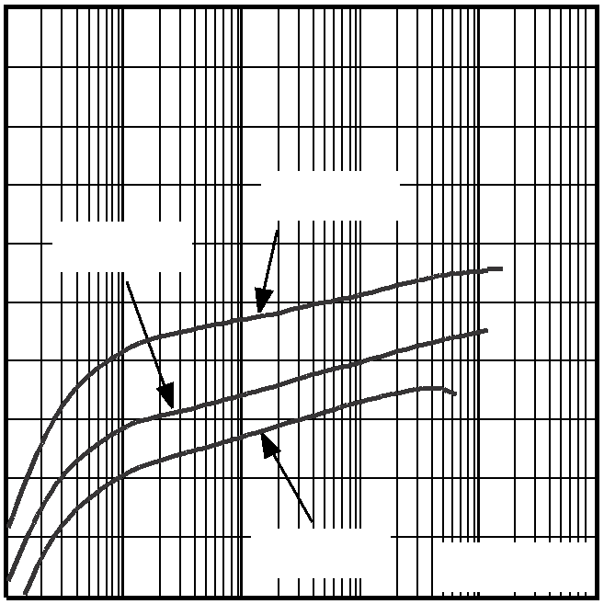

MAX1722 toc03

70 70 70
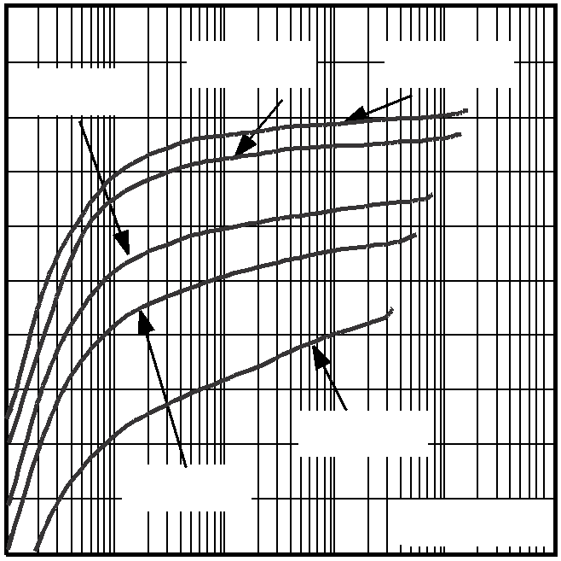

EFFICIENCY (%)
EFFICIENCY (%)

60 VIN = 1.0V

L = DO1606
50
60

VIN = 1.5V
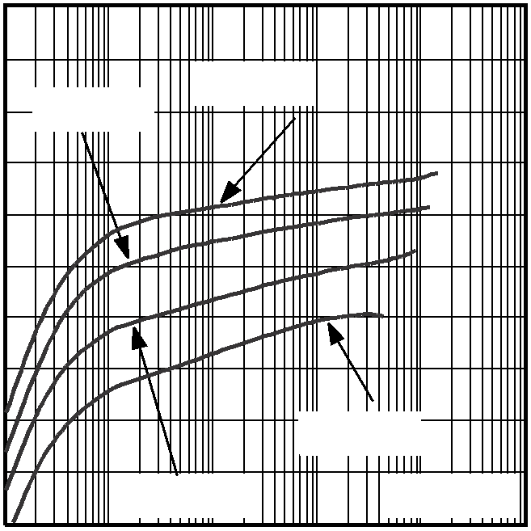

50

VIN
= 1.0V 60

L = DO1606
50

VIN = 1.0V L = DO1606

200

160

120

80

40

0
0.01 0.1 1 10 100 1000
LOAD CURRENT (mA)
MAXIMUM OUTPUT CURRENT
MAX1722 toc04
vs. INPUT VOLTAGE

2.4

2.2

2.0
STARTUP VOLTAGE (V)

1.8

1.6

1.4

1.2

1.0

0.8

0.6
0.01 0.1 1 10 100 1000
LOAD CURRENT (mA)
STARTUP VOLTAGE
vs. LOAD CURRENT

RESISTIVE LOAD VOUT = 5.0V
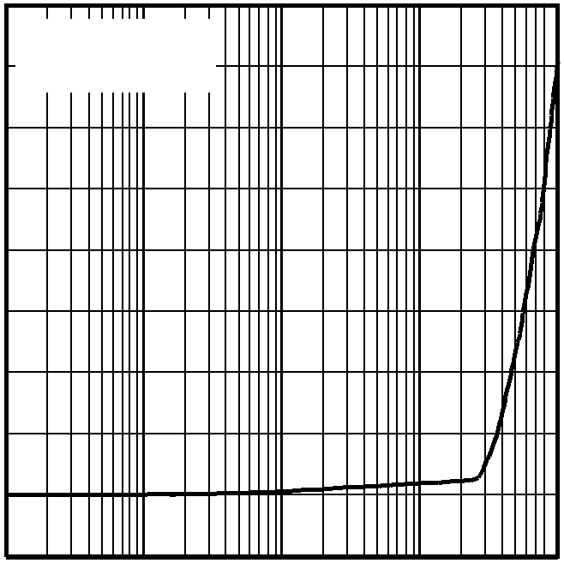

0.01 0.1 1 10 100 1000
LOAD CURRENT (mA)
QUIESCENT CURRENT INTO OUT
vs. OUTPUT VOLTAGE
2.0
MAX1722 toc05
1.8 NO LOAD
MAX1722 toc06
1.6
1.4
QUIESCENT CURRENT (μA)
1.2
1.0
0.8
0.6
0.4
0.2
0

0 1 2
VOUT = 2.5V
VOUT = 5.0V
VOUT = 3.3V

3 4 5
0.01 0.1 1
10 100
1.0
1.5
2.0 2.5 3.0
3.5 4.0 4.5 5.0 5.5

INPUT VOLTAGE (V)
LOAD CURRENT (mA)
OUTPUT VOLTAGE (V)

1.2
STARTUP VOLTAGE vs.
TEMPERATURE
MAX1722 toc07

SWITCHING WAVEFORMS

1.0

0.8

0.6

0.4
STARTUP VOLTAGE (V)

0.2
NO LOAD

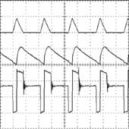
ILX
500mA/div
MAX1722 toc08

VOUT
50mV/div

VLX
2V/div

0
-40

-15 10

35 60 85

1μs/div

TEMPERATURE (°C)
MAX1722/MAX1723/MAX1724
EFFICIENCY (%)
IOUT(MAX) (mA)
IOUT = 50mA, VOUT = 5.0V, VIN = 3.3V

Typical Operating Characteristics (continued) (Figure 3 (MAX1723), Figure 7 (MAX1722), Figure 8 (MAX1724), VBATT = VIN = 1.5V, L = 10µH, CIN = 10µF, COUT = 10µF, TA = +25°C, unless otherwise noted.)
MAX1722 toc09
MAX1722 toc10

LOAD-TRANSIENT RESPONSE
SHUTDOWN RESPONSE

3.3V

50mA

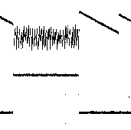
0
5V VOUT
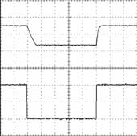
A 2V/div

0

2V

B VSHDN
1V/div
0

A: VOUT, 50mV/div
B: IOUT, 20mA/div
200μs/div
1ms/div
VIN = 3.3V, VOUT = 5.0V, ROUT = 100Ω

0.8
SHUTDOWN INPUT THRESHOLD
vs. TEMPERATURE
MAX1722 toc11

MAX1722/MAX1723/MAX1724
0.7

0.6

0.5

0.4

0.3

0.2
SHUTDOWN THRESHOLD (mV)

0.1

0
-40 -15 10 35 60 85
RISING EDGE
FALLING EDGE

TEMPERATURE (°C)
Pin Description

PIN |  |  | NAME | FUNCTION
MAX1722 | MAX1723 | MAX1724 | NAME | FUNCTION
1 | — | 1 | BATT | Battery Input and Damping Switch Connection
— | 1 | 3 | SHDN | Shutdown Input. Drive high for normal operation. Drive low for shutdown.
2 | 2 | 2 | GND | Ground
3 | 3 | — | FB | Feedback Input to Set Output Voltage. Use a resistor-divider network to adjust the output voltage. See Setting the Output Voltage section.
4 | 4 | 4 | OUT | Power Output. OUT also provides bootstrap power to the IC.
5 | 5 | 5 | LX | Internal N-channel MOSFET Switch Drain and P-Channel Synchronous  Rectifier Drain

OUT

MAX1723

STARTUP CIRCUITRY
ZERO- CROSSING DETECTOR

P

SHDN

CONTROL LOGIC

DRIVER LX

FB

ERROR
COMPARATOR N

1.235V REFERENCE
CURRENT LIMIT

GND

Figure 1. MAX1723 Simplified Functional Diagram

Detailed Description
MAX1722/MAX1723/MAX1724
The MAX1722/MAX1723/MAX1724 compact, high-effi- ciency, step-up DC-DC converters are guaranteed to start up with voltages as low as 0.91V and operate with an input voltage down to 0.8V. Consuming only 1.5µA of quiescent current, these devices include a built-in syn- chronous rectifier that reduces cost by eliminating the need for an external diode and improves overall efficien- cy by minimizing losses in the circuit (see Synchronous Rectification section). The MAX1722/MAX1724 feature a clamp circuit that reduces EMI due to inductor ringing. The MAX1723/MAX1724 feature an active-low shutdown that reduces quiescent supply current to 0.1µA. The MAX1722/MAX1723 have an adjustable output voltage, while the MAX1724 is available with four fixed-output voltage options (see Selector Guide). Figure 1 is the MAX1723 simplified functional diagram and Figure 2 is the MAX1724 simplified functional diagram.

PFM Control Scheme A forced discontinuous, current-limited, pulse-frequency- modulation (PFM) control scheme is a key feature of the
MAX1722/MAX1723/MAX1724. This scheme provides ultra-low quiescent current and high efficiency over a wide output current range. There is no oscillator; the inductor current is limited by the 0.5A N-channel cur- rent limit or by the 5µs switch maximum on-time. Following each on cycle, the inductor current must ramp to zero before another cycle may start. When the error comparator senses that the output has fallen below the regulation threshold, another cycle begins.

Synchronous Rectification The internal synchronous rectifier eliminates the need for an external Schottky diode, thus reducing cost and board space. While the inductor discharges, the P- channel MOSFET turns on and shunts the MOSFET body diode. As a result, the rectifier voltage drop is sig- nificantly reduced, improving efficiency without the addition of external components.

Low-Voltage Startup Circuit The MAX1722/MAX1723/MAX1724 contain a low-volt- age startup circuit to control DC-DC operation until the output voltage exceeds 1.5V (typ). The minimum start-

BATT
DAMPING SWITCH

OUT

MAX1724

STARTUP CIRCUITRY

ZERO- CROSSING DETECTOR

R2
P

SHDN

CONTROL LOGIC

DRIVER LX

ERROR
COMPARATOR N

R1

1.235V REFERENCE

CURRENT LIMIT

GND

Figure 2. MAX1724 Simplified Functional Diagram

1.2V TO VOUT

10μF

SHDN

10μH

LX OUT

D1
VOUT = 3.6V

R2
lacks a BATT pin; therefore, this circuit is powered through the OUT pin. Adding a Schottky diode in paral- lel with the P-channel synchronous rectifier allows for startup voltages as low as 1.2V for the MAX1723 (Figure 3). The external Schottky diode is not needed for input voltages greater than 1.8V. Once started, the output maintains the load as the battery voltage decreases below the startup voltage.

MAX1723

GND FB

Figure 3. MAX1723 Single-Cell Operation
2.37MΩ

R1
1.24MΩ
10μF

Shutdown (MAX1723/MAX1724) The MAX1723/MAX1724 enter shutdown when the SHDN pin is driven low. During shutdown, the body diode of the P-channel MOSFET allows current to flow from the battery to the output. VOUT falls to approxi- mately VIN - 0.6V and LX remains high impedance. Shutdown can be pulled as high as 6V, regardless of the voltage at BATT or OUT. For normal operation, con-

up voltage is a function of load current (see Typical
MAX1722/MAX1723/MAX1724
Operating Characteristics). This circuit is powered from the BATT pin for the MAX1722/MAX1724, guaranteeing startup at input voltages as low as 0.91V. The MAX1723
nect SHDN to the input.

VOUT

VIN

MAX1722
MAX1724

PDRV

OUT

P

BATT

TIMING CIRCUIT
DAMPING SWITCH

DAMP

LX

NDRV N

GND

Figure 4. Simplified Diagram of Damping Switch

1V/div
1V/div

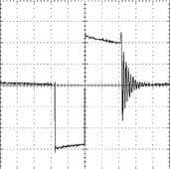
1μs/div

Figure 5. LX Ringing Without Damping Switch (MAX1723)
1μs/div

Figure 6. LX Ringing With Damping Switch (MAX1722/MAX1724)

BATT/Damping Switch
(MAX1722/MAX1724) The MAX1722/MAX1724 include an internal damping switch (Figure 4) to minimize ringing at LX and reduce EMI. When the energy in the inductor is insufficient to supply current to the output, the capacitance and inductance at LX form a resonant circuit that causes ringing. The damping switch supplies a path to quickly dissipate this energy, suppressing the ringing at LX. This does not reduce the output ripple, but does
Design Procedure

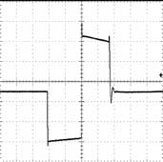
Setting the Output Voltage
(MAX1722/MAX1723) The output voltage can be adjusted from 2V to 5.5V using external resistors R1 and R2 (Figure 7). Since FB leakage is 20nA (max), select feedback resistor R1 in the 100kΩ to 1MΩ range. Calculate R2 as follows:

⎛ VOUT ⎞

reduce EMI with minimal impact on efficiency. Figures
MAX1722/MAX1723/MAX1724
5 and 6 show the LX node voltage waveform without and with the damping switch, respectively.
R2 =

where VFB = 1.235V.
R1 ⎜
⎝
VFB
− 1
⎠

INPUT
0.8V TO VOUT 10μH
For maximum output current, choose the inductor value so that the controller reaches the current-limit before the maximum on-time is triggered:

VBATT tON(MAX)

10μF
BATT
LX

OUT
OUTPUT
2V TO 5.5V
L <
ILIM

MAX1722

R2 10μF
where the maximum on-time is typically 5µs, and the current limit (ILIM) is typically 500mA (see Electrical Characteristics table).

FB

R1
GND

For larger inductor values, determine the peak inductor current (IPEAK) by:

Figure 7. Adjustable Output Circuit

Inductor Selection

INPUT

IPEAK

VBATT tON(MAX)
=
L

The control scheme of the MAX1722/MAX1723/ MAX1724 permits flexibility in choosing an inductor. A
0.8V TO VOUT 10μH

10µH inductor value performs well in most applications. Smaller inductance values typically offer smaller physi- cal size for a given series resistance, allowing the smallest overall circuit dimensions. Circuits using larger inductance values may start up at lower battery volt- ages, provide higher efficiency, and exhibit less ripple,
C1
10μF
BATT

MAX1724
LX OUT

OUTPUT VOUT (NOM)

C2
10μF

but they may reduce the maximum output current. This
ON

occurs when the inductance is sufficiently large to pre- vent the maximum current limit (ILIM) from being reached before the maximum on-time (tON(MAX)) expires.
OFF
SHDN

GND

Table 1. Suggested Inductors and
Suppliers
MANUFACTURER | INDUCTOR | PHONE WEBSITE
Coilcraft | DO1608 Series  DO1606 Series | 847-639-2361 www.coilcraft.com
Murata | LQH4C Series | 770-436-1300 www.murata.com
Sumida | CDRH4D18 Series CR32 Series CMD4D06 Series | 847-545-6700 www.sumida.com
Sumitomo/  Daidoo Electronics | CXLD140 Series | +81 (06) 6355-5733 www.daidoo.co.jp
Toko | 3DF Type  D412F Type | 847-297-0070 www.toko.com

Figure 8. MAX1724 Standard Application Circuit

The inductor’s incremental saturation current rating should be greater than the peak switching current. However, it is generally acceptable to bias the inductor into saturation by as much as 20%, although this will slightly reduce effi- ciency. Table 1 lists suggested inductors and suppliers.

Maximum Output Current The maximum output current depends on the peak induc- tor current, the input voltage, the output voltage, and the overall efficiency (η):

1
I = I
⎛ VBATT ⎞ η

⎜ ⎟

OUT(MAX)
MAX1722/MAX1723/MAX1724
2 PEAK ⎝ VOUT ⎠

Table 2. Suggested Surface-Mount Capacitors and Manufacturers (C1 and C2)

MANUFACTURER | CAPACITOR VALUE | DESCRIPTION | PHONE WEBSITE
AVX | 1∝F to 10∝F | X7R Ceramic | 843-448-9411 www.avxcorp.com
AVX | 10∝F to 330∝F | TAJ Tantalum Series  TPS Tantalum Series | 843-448-9411 www.avxcorp.com
Kemet | 1∝F to 22∝F | X5R/X7R Ceramic | 864-963-6300 www.kemet.com
Kemet | 10∝F to 330∝F | T494 Tantalum Series | 864-963-6300 www.kemet.com
Kemet | 68∝F to 330∝F | T520 Tantalum Series | 864-963-6300 www.kemet.com
Sanyo | 33∝F to 330∝F | TPC Polymer Series | 408-749-9714 www.secc.co.jp
Taiyo Yuden | 33∝F to 330∝F | X5R/X7R Ceramic | 800-368-2496 www.t-yuden.org
TDK | 1∝F to 10∝F | X7R Ceramic | 847-803-6100 www.tdk.com
Vishay Sprague | 10∝F to 330∝F | 594D Tantalum Series  595D Tantalum Series | 203-452-5664 www.vishay.com

For most applications, the peak inductor current equals the current limit. However, for applications using large inductor values or low input voltages, the maximum on- time limits the peak inductor current (see Inductor Selection section).

Capacitor Selection Choose input and output capacitors to supply the input and output peak currents with acceptable voltage rip- ple. The input filter capacitor (CIN) reduces peak cur- rents drawn from the battery and improves efficiency. Low equivalent series resistance (ESR) capacitors are recommended. Ceramic capacitors have the lowest ESR, but low ESR tantalum or polymer capacitors offer a good balance between cost and performance.
Output voltage ripple has two components: variations in the charge stored in the output capacitor with each LX pulse, and the voltage drop across the capacitor’s ESR caused by the current into and out of the capaci- tor:

VRIPPLE = VRIPPLE(C) + VRIPPLE(ESR)
VRIPPLE(ESR) ≈ IPEAK RESR(COUT)
where IPEAK is the peak inductor current (see Inductor Selection section). For ceramic capacitors, the output voltage ripple is typically dominated by VRIPPLE(C). For example, a 10µF ceramic capacitor and a 10µH induc- tor typically provide 75mV of output ripple when step- ping up from 3.3V to 5V at 50mA. Low input-to-output voltage differences (i.e. two cells to 3.3V) require high- er output capacitor values.
Capacitance and ESR variation of temperature should be considered for best performance in applications with wide operating temperature ranges. Table 2 lists suggested capacitors and suppliers.

PC Board Layout Considerations
Careful PC board layout is important for minimizing ground bounce and noise. Keep the IC’s GND pin and the ground leads of the input and output capacitors less than 0.2in (5mm) apart using a ground plane. In addition, keep all connections to FB (MAX1722/MAX1723 only) and LX as short as possible.

Chip Information
TRANSISTOR COUNT: 863

1 ⎛ L
V ≈
⎞
(I - I )

RIPPLE(C)
2 ⎜ V
- V C
⎟ PEAK2
OUT2

⎝ ( OUT BATT )
MAX1722/MAX1723/MAX1724
OUT ⎠

Pin Configurations (continued)

TOP VIEW

SHDN
1 5 LX
BATT
1 5 LX

GND 2
MAX1723

GND 2
MAX1724

FB 3 4
OUT
SHDN
3 4 OUT

THIN SOT23-5
THIN SOT23-5

MAX1722/MAX1723/MAX1724

Package Information
THIN SOT23.EPS

MAX1722/MAX1723/MAX1724

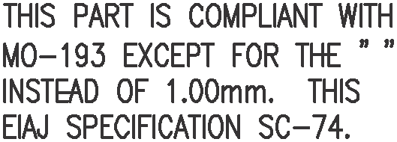
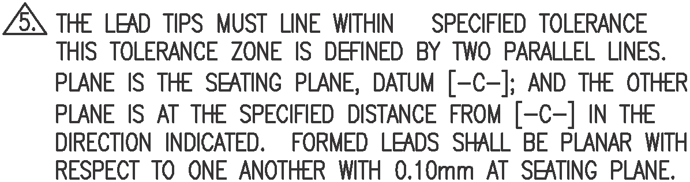

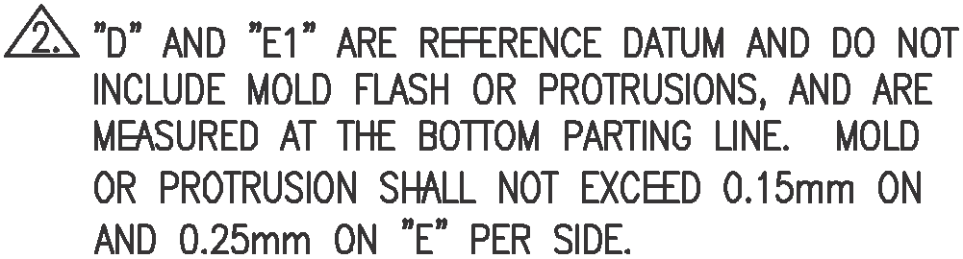
Maxim cannot assume responsibility for use of any circuitry other than circuitry entirely embodied in a Maxim product. No circuit patent licenses are implied. Maxim reserves the right to change the circuitry and specifications without notice at any time.

12 Maxim Integrated Products, 120 San Gabriel Drive, Sunnyvale, CA 94086 408-737-7600

© 2001 Maxim Integrated Products Printed USA is a registered trademark of Maxim Integrated Products.

