19-0461; Rev 2; 4/97

400MHz, Ultra-Low-Distortion Op Amps

General Description
The MAX4108/MAX4109/MAX4308/MAX4309 op amps combine ultra-high-speed performance with ultra-low- distortion operation. The MAX4108 is compensated for unity-gain stability; the MAX4109, MAX4308, and MAX4309 are compensated for minimum closed-loop gains (AVCL) of 2V/V, 5V/V, and 10V/V, respectively.
The MAX4108 delivers a 400MHz unity-gain bandwidth with a 1200V/µs slew rate. An ultra-low-distortion design provides an unprecedented spurious-free dynamic range of -93dBc (MAX4108) at 5MHz (VOUT = 2Vp-p, RL
= 100Ω), making these amplifiers ideal for high-perfor- mance RF signal processing.
These high-speed op amps feature a wide output volt- age swing and a high-current output-drive capability of
90mA.

Applications
High-Speed ADC/DAC Preamp RGB and Composite Video High-Performance Receivers Pulse/RF Amplifier
Active Filters
Ultrasound
Broadcast and High-Definition TV
Features
♦ High Speed:
400MHz Unity-Gain Bandwidth (MAX4108)
225MHz -3dB Bandwidth (AVCL = +2, MAX4109)
220MHz -3dB Bandwidth (AVCL = +5, MAX4308)
200MHz -3dB Bandwidth (AVCL = +10, MAX4309)
♦ 1200V/µs Slew Rate
♦ Excellent Spurious-Free Dynamic Range:
-93dBc at fC = 5MHz (MAX4108)
-90dBc at fC = 5MHz (MAX4109)
♦ 100MHz 0.1dB Gain Flatness (MAX4108)
♦ High Full-Power Bandwidth: 300MHz
(MAX4108, VO = 2Vp-p)
♦ High Output Drive: 90mA
♦ Output Short-Circuit Protected
♦ Low Differential Gain/Phase: 0.004%/0.008°

Ordering Information
PART TEMP. RANGE PIN-PACKAGE
MAX4108ESA -40°C to +85°C 8 SO
MAX4109ESA -40°C to +85°C 8 SO
MAX4308ESA -40°C to +85°C 8 SO
MAX4309ESA -40°C to +85°C 8 SO

Typical Application Circuit
Pin Configuration

300 300

TOP VIEW

53.6 *

300

MAX4109

10
12-BIT ADC

N.C. IN-
MAX4108
MAX4109
MAX4308
MAX4309
1 | MAX4108  MAX4109  MAX4308  MAX4309 | 8
2 | MAX4108  MAX4109  MAX4308  MAX4309 | 7
3 | MAX4108  MAX4109  MAX4308  MAX4309 | 6
4 | MAX4108  MAX4109  MAX4308  MAX4309 | 5

IN+

VCC

VCC

OUT

60 *

300

* USED TO MATCH A 50
SOURCE IMPEDANCE
VEE
VEE

SO

MAX4108/MAX4109/MAX4308/MAX4309

DIFFERENCE AMPLIFIER/ADC PREAMPLIFIER

ABSOLUTE MAXIMUM RATINGS
Supply Voltage (VCC to VEE) ..................................................12V Voltage on Any Pin to Ground or
Any Other Pin ..............................(VEE - 0.3V) to (VCC + 0.3V) Short-Circuit Duration (OUT to GND) .........................Continuous Continuous Power Dissipation (TA = +70°C)
SO (derate 5.88mW/°C above +70°C) ........................471mW

Operating Temperature Range ...........................-40°C to +85°C Storage Temperature Range .............................-65°C to +150°C Junction Temperature ......................................................+150°C Lead Temperature (soldering, 10sec) .............................+300°C

MAX4108/MAX4109/MAX4308/MAX4309
Stresses beyond those listed under “Absolute Maximum Ratings” may cause permanent damage to the device. These are stress ratings only, and functional operation of the device at these or any other conditions beyond those indicated in the operational sections of the specifications is not implied. Exposure to absolute maximum rating conditions for extended periods may affect device reliability.

ELECTRICAL CHARACTERISTICS
(VCC = +5V, VEE = -5V, TA = TMIN to TMAX, typical values are at TA = +25°C, unless otherwise noted.)

PARAMETER | SYMBOL | CONDITIONS |  | MIN TYP MAX | UNITS
DC SPECIFICATIONS (RL = ∞)
Input Offset Voltage | VOS | VOUT = 0V |  | 1 8 | mV
Input Offset Voltage Drift | TCVOS | VOUT = 0V |  | 13 | µV/°C
Input Bias Current | IB | VOUT = 0V, VIN = -VOS |  | 12 34 | µA
Input Offset Current | IOS | VOUT = 0V, VIN = -VOS |  | 0.05 2.5 | µA
Common-Mode Input  Resistance | RINCM | Either input |  | 1.5 | MΩ
Common-Mode Input  Capacitance | CINCM | Either input |  | 1 | pF
Input Voltage Noise | en | f = 10kHz |  | 6 | nV/√Hz
Integrated Voltage Noise | EnRMS | fB = 1MHz to 100MHz |  | 75 | µVRMS
Input Current Noise | in | f = 10kHz |  | 2 | pA/√Hz
Integrated Current Noise | In | fB = 1MHz to 100MHz |  | 25 | nARMS
Common-Mode Input Voltage | VCM |  |  | -2.5 2.5 | V
Common-Mode Rejection | CMR | VCM = ±2.5V |  | 70 100 | dB
Power-Supply Rejection | PSR | VS = ±4.5V to ±5.5V |  | 70 90 | dB
Open-Loop Voltage Gain | AOL | VOUT = ±2.0V, VCM = 0V, RL = 100Ω |  | 70 100 | dB
Quiescent Supply Current | IS | VIN = 0V |  | 20 27 | mA
Output Voltage Swing | VOUT | RL = ∞ |  | 2.5 to 2.9 to  -3.1 -3.8 | V
Output Voltage Swing | VOUT | RL = 100Ω |  | 2.5 to 2.7 to  -3.1 -3.7 | V
Output Current Drive | IOUT | RL = 33Ω, TA = 0°C to +85°C |  | 65 90 | mA
Short-Circuit Output Current | ISC | Short to ground |  | 100 | mA
AC SPECIFICATIONS (RL = 100 | Ω)
-3dB Bandwidth | BW-3dB | VOUT ≤ 0.1VRMS | MAX4108 | 400 | MHz
-3dB Bandwidth | BW-3dB | VOUT ≤ 0.1VRMS | MAX4109 | 225 | MHz
-3dB Bandwidth | BW-3dB | VOUT ≤ 0.1VRMS | MAX4308 | 220 | MHz
-3dB Bandwidth | BW-3dB |  | MAX4309 | 200 | MHz

MAX4108/MAX4109/MAX4308/MAX4309

ELECTRICAL CHARACTERISTICS (continued)
(VCC = +5V, VEE = -5V, TA = TMIN to TMAX, typical values are at TA = +25°C, unless otherwise noted.)

e
PARAMETER | SYMBOL | CONDITIONS |  | MIN TYP MAX | UNITS
AC SPECIFICATIONS (RL = 100 | Ω) (continu | d)
Full-Power Bandwidth | FPBW | VOUT = 2Vp-p | MAX4108 | 300 | MHz
Full-Power Bandwidth | FPBW | VOUT = 2Vp-p | MAX4109 | 200 | MHz
Full-Power Bandwidth | FPBW | VOUT = 2Vp-p | MAX4308 | 190 | MHz
Full-Power Bandwidth | FPBW | VOUT = 2Vp-p | MAX4309 | 130 | MHz
0.1dB Gain Flatness | BW0.1dB | MAX4108, AVCL = +1 |  | 100 | MHz
0.1dB Gain Flatness | BW0.1dB | MAX4109, AVCL = +2 |  | 25 | MHz
0.1dB Gain Flatness | BW0.1dB | MAX4308, AVCL = +5 |  | 100 | MHz
0.1dB Gain Flatness | BW0.1dB | MAX4309, AVCL = +10 |  | 30 | MHz
Slew Rate | SR | -2V ≤ VOUT ≤ 2V |  | 1200 | V/µs
Settling Time | tS | -1V ≤ VOUT ≤ 1V | To 0.1% | 8 | ns
Settling Time | tS | -1V ≤ VOUT ≤ 1V | To 0.01% | 12 | ns
Rise/Fall Times | tR, tF | 10% to 90% | -2V ≤ VOUT  ≤ 2V | 3 | ns
Rise/Fall Times | tR, tF | 10% to 90% | -50mV ≤ VOUT  ≤ 50mV | 2 | ns
Differential Gain | DG | f = 3.58MHz, RL = 150Ω |  | 0.004 | %
Differential Phase | DP | f = 3.58MHz, RL = 150Ω |  | 0.008 | degrees
Input Capacitance | CIN |  |  | 2 | pF
Output Resistance | ROUT | f = 10MHz |  | 1 | Ω
Spurious-Free Dynamic Range | SFDR | MAX4108,  VOUT = 2Vp-p, AVCL = +1 | fC = 5MHz, RL = 100Ω | -93 | dBc
Spurious-Free Dynamic Range | SFDR | MAX4108,  VOUT = 2Vp-p, AVCL = +1 | fC = 20MHz, RL = 100Ω | -81 | dBc
Spurious-Free Dynamic Range | SFDR | MAX4109,  VOUT = 2Vp-p, AVCL = +2 | fC = 5MHz, RL = 100Ω | -90 | dBc
Spurious-Free Dynamic Range | SFDR | MAX4109,  VOUT = 2Vp-p, AVCL = +2 | fC = 20MHz, RL = 100Ω | -80 | dBc
Spurious-Free Dynamic Range | SFDR | MAX4308,  VOUT = 2Vp-p, AVCL = +5 | fC = 5MHz, RL = 100Ω | -83 | dBc
Spurious-Free Dynamic Range | SFDR | MAX4308,  VOUT = 2Vp-p, AVCL = +5 | fC = 20MHz, RL = 100Ω | -80 | dBc
Spurious-Free Dynamic Range | SFDR | MAX4309,  VOUT = 2Vp-p, AVCL = +10 | fC = 5MHz, RL = 100Ω | -83
Spurious-Free Dynamic Range | SFDR | MAX4309,  VOUT = 2Vp-p, AVCL = +10 | fC = 20MHz, RL = 100Ω | -80
Third-Order Intercept | IP3 | fC = 10MHz | MAX4108 | 39 | dBm
Third-Order Intercept | IP3 | fC = 10MHz | MAX4109 | 36 | dBm
Third-Order Intercept | IP3 | fC = 10MHz | MAX4308 | 46 | dBm
Third-Order Intercept | IP3 | fC = 10MHz | MAX4309 | 43 | dBm

Typical Operating Characteristics
(VCC = +5V, VEE = -5V, RL = 100Ω, TA = +25°C, unless otherwise noted.)

MAX4108
SMALL-SIGNAL GAIN vs. FREQUENCY
2
1 VOUT 100mVp-p AVCL = +1
0
NORMALIZED GAIN (dB)
-1
-2
AVCL = +2
-3
-4

-5
-6
-7

-8

MAX4108
LARGE-SIGNAL GAIN vs. FREQUENCY
MAX4108/9-B
4
VOUT = 2Vp-p
3 AVCL = +1
MAX4108/9-A
2
1
0

-1
-2
GAIN (dB)

-3
-4
-5

-6

MAX4109
SMALL-SIGNAL GAIN vs. FREQUENCY
2
1 VOUT 100mVp-p A = +2
MAX4108/9-C
VCL
0
NORMALIZED GAIN (dB)
-1
-2
-3
AVCL = +5
-4
-5
-6
-7
-8

0.1 1 10 100 1000
FREQUENCY (MHz)
0.1 1 10 100 1000
FREQUENCY (MHz)
0.1 1
10
FREQUENCY (MHz)
MAX4308/9 TOCE
100 1000

MAX4109
LARGE-SIGNAL GAIN vs. FREQUENCY
MAX4108/9-D
2
MAX4308
SMALL-SIGNAL GAIN vs. FREQUENCY
4
MAX4309
SMALL-SIGNAL GAIN vs. FREQUENCY
MAX4308/9 TOCF
4

1 VOUT = 2Vp-p
AVCL = +2
0
NORMALIZED GAIN (dB)
-1
-2
-3
-4
-5
-6
-7
-8
3 VOUT 100mVp-p
AVCL = +5
2
1
0
-1
-2
-3
NORMALIZED GAIN (dB)
-4
-5
-6
3 VOUT 100mVp-p
2
1
0
-1
-2
-3
NORMALIZED GAIN (dB)
-4
-5
-6

AVCL = +10

AVCL = +20
MAX4108/9-i

1 10
100 1000
0.1 1
10 100
1000
0.1 1
10 100
1000

FREQUENCY (MHz)
FREQUENCY (MHz)
FREQUENCY (MHz)

MAX4308/MAX4309
LARGE-SIGNAL GAIN vs. FREQUENCY
4

-40
MAX4108
HARMONIC DISTORTION vs. FREQUENCY
MAX4108/9-H
MAX4109
HARMONIC DISTORTION vs. FREQUENCY
10

3 VOUT = 2Vp-p
2
1
0
-1
-2
-3
NORMALIZED GAIN (dB)
-4
-5
-6

MAX4309
AVCL = +10

MAX4308
MAX4308/9 TOCG
AVCL = +5

-50

-60

-70

-80

-90
HARMONIC DISTORTION (dBc)

-100

-110
VOUT = 2Vp-p
AVCL = +1

2ND HARMONIC

3RD HARMONIC

-10
HARMONIC DISTORTION (dBc)

-30

-50

-70

-90

-110
VOUT = 2Vp-p
AVCL = +2

2ND HARMONIC

3RD HARMONIC

0.1
MAX4108/MAX4109/MAX4308/MAX4309
1 10 100
FREQUENCY (MHz)
1000
0.1
1 10
FREQUENCY (MHz)
100
0.1
1 10
FREQUENCY (MHz)
100

Typical Operating Characteristics (continued)
(VCC = +5V, VEE = -5V, RL = 100Ω, TA = +25°C, unless otherwise noted.)

-20

-30

-50

-60

-70

-80

-90

-100
MAX4308/MAX4309
HARMONIC DISTORTION vs.FREQUENCY

VOUT = 2Vp-p
MAX4308: AVCL = +5
MAX4309: AVCL = +10

3RD HARMONIC

-30
MAX4108/09 TOCJ

-40
HARMONIC DISTORTION (dBc)

-50

-60

-80

-90

-100
MAX4108
HARMONIC DISTORTION vs. LOAD
MAX4108/9-K

AVCL = +1
VOUT = 2Vp-p
fO = 20MHz

2ND HARMONIC

3RD HARMONIC

-30

-40

-50
HARMONIC DISTORTION (dBc)

-60

-80

-90

-100
MAX4108/9-N
MAX4109
HARMONIC DISTORTION vs. LOAD

AVCL = +2
MAX4108/9-L
VOUT = 2Vp-p
fO = 20MHz

2ND HARMONIC

3RD HARMONIC

0.1 1
10 100 10
100
1000 10
100
1000

FREQUENCY (MHz)
RESISTIVE LOAD ( )
RESISTIVE LOAD ( )

MAX4308/MAX4309
HARMONIC DISTORTION vs. LOAD
MAX4108/09 TOCM
MAX4108
HARMONIC DISTORTION vs. OUTPUT SWING
MAX4109
HARMONIC DISTORTION vs. OUTPUT SWING

-30

-50

-60

VOUT = 2Vp-p fO = 5MHz
MAX4308: AVCL = +5

-40
HARMONIC DISTORTION (dBc)

-50

-60

AVCL = +1
VOUT = 2Vp-p
fO = 20MHz

-40
HARMONIC DISTORTION (dBc)

-50

-60

AVCL = +2
VOUT = 2Vp-p
MAX4108/9-O
fO = 20MHz

-70

-80

2ND HARMONIC

-80

2ND HARMONIC

-80

2ND HARMONIC

-100

10 100 1000

-100

0.1
3RD HARMONIC

1 10

-100

0.1
3RD HARMONIC

1 10

-20

-30

-40

-50

-60

-80

-90

-100
RESISTIVE LOAD ( )

MAX4308/MAX4309
HARMONIC DISTORTION
vs. OUTPUT SWING

VOUT = 2Vp-p fO = 5MHz
MAX4308: AVCL = +5
MAX4309: AVCL = +10

2ND HARMONIC

3RD HARMONIC
OUTPUT SWING (Vp-p)
MAX4109
TWO-TONE THIRD-ORDER INTERCEPT
MAX4108/9-Q
vs. FREQUENCY
45
MAX4108/09 TOCP

40

35
THIRD-ORDER INTERCEPT (dBm)

30

25

20

15

10

100

10
VOLTAGE NOISE (nV Hz)

1
OUTPUT SWING (Vp-p)

INPUT VOLTAGE NOISE
MAX4108/9-TOCR
vs. FREQUENCY

0.1 1 10 1
10 100
1 10
100 1k
10k 100k 1M

RESISTIVE LOAD ( )
MAX4108/MAX4109/MAX4308/MAX4309
HARMONIC DISTORTION (dBc)
HARMONIC DISTORTION (dBc)
HARMONIC DISTORTION (dBc)
FREQUENCY (MHz)
FREQUENCY (Hz)

Typical Operating Characteristics (continued)
(VCC = +5V, VEE = -5V, RL = 100Ω, TA = +25°C, unless otherwise noted.)

0.004
0.002

MAX4108
DIFFERENTIAL GAIN AND PHASE (RL = 150 )

AVCL = +1V
MAX4108/9-S

0.008
0.006

MAX4108
DIFFERENTIAL GAIN AND PHASE (RL = 75 )

AVCL = +1V

0.004
AVCL = +2V

0.002

MAX4109
MAX4108/9-T
DIFFERENTIAL GAIN AND PHASE (RL = 150 )
MAX4108/9-U

0.000
-0.002
-0.004
DIFF GAIN (%)
0.004
0.002
0.000
-0.002
DIFF GAIN (%)
0.000
-0.002
-0.004
DIFF GAIN (%)

0.004
0.002
0.000
-0.002
-0.004
DIFF PHASE (deg)

0

AVCL = +1V

IRE

100

0.006
0.004
0.002
0.000
-0.002
DIFF PHASE (deg)

0

AVCL = +1V

IRE

100

0.002
DIFF PHASE (deg)
0.000
-0.002
-0.004
-0.006

0

AVCL = +2V

IRE

100

0
IRE

100 0
AVCL = +2V

IRE

100

0
IRE

100
MAX4108/9-X

0.006
0.004
0.002
0.000
-0.002
DIFF GAIN (%)
MAX4109
DIFFERENTIAL GAIN AND PHASE (RL = 75 )
MAX4108/9-V

0.002
0.000
-0.002
-0.004
-0.006
DIFF GAIN (%)
MAX4308
DIFFERENTIAL GAIN AND PHASE (RL = 150 )
MAX4108/9-W

AVCL = +5V

0.004
0.002
0.000
-0.002
-0.004
DIFF GAIN (%)
MAX4309
DIFFERENTIAL GAIN AND PHASE (RL = 150 )

AVCL = +10V

0.006
0.004
0.002
0.000
-0.002
DIFF PHASE (deg)

0

AVCL = +2V

0

IRE

IRE
MAX4108

100

100

0.004
0.002
0.000
-0.002
-0.004
DIFF PHASE (deg)

0

AVCL = +5V

0

IRE

IRE
MAX4108

100

100

0.002
0.000
-0.002
-0.004
-0.006
-0.008
-0.010
DIFF PHASE (deg)

0

AVCL = +10V

0

IRE

IRE
MAX4108

100

100

SMALL-SIGNAL PULSE RESPONSE
(AVCL = +1)
MAX4108/9-Y
SMALL-SIGNAL PULSE RESPONSE (AVCL = +2)
MAX4108/9-Z
LARGE-SIGNAL PULSE RESPONSE (AVCL = +1)
MAX4108/9-AA

MAX4108/MAX4109/MAX4308/MAX4309

IN
VOLTAGE (20mV/div)

OUT
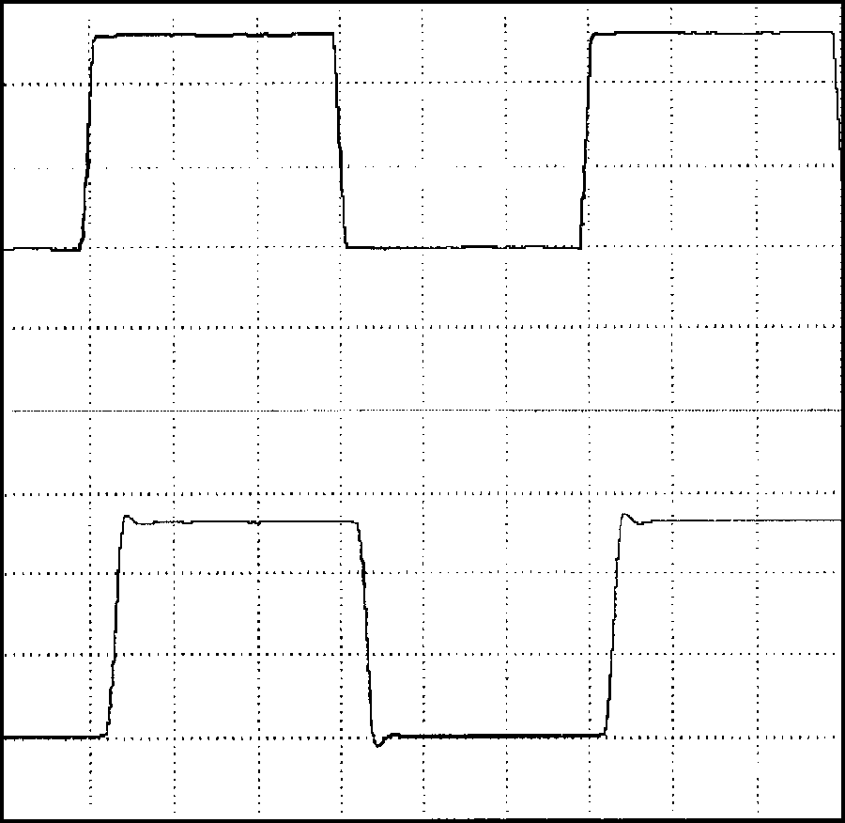
TIME (10ns/div)

GND

GND

IN
VOLTAGE (10mV/div)

OUT
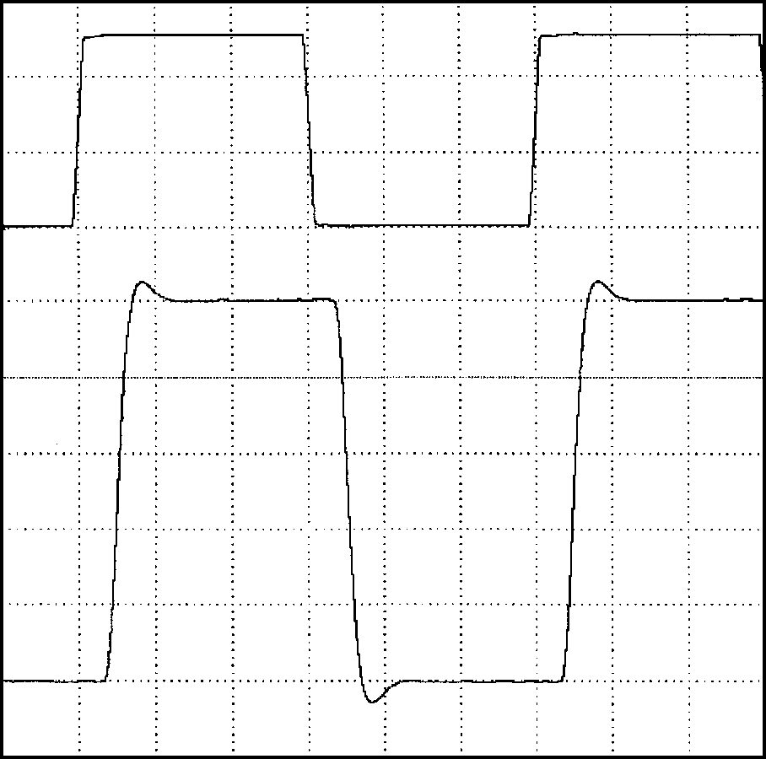
TIME (10ns/div)

GND

GND

IN
VOLTAGE (500mV/div)

OUT
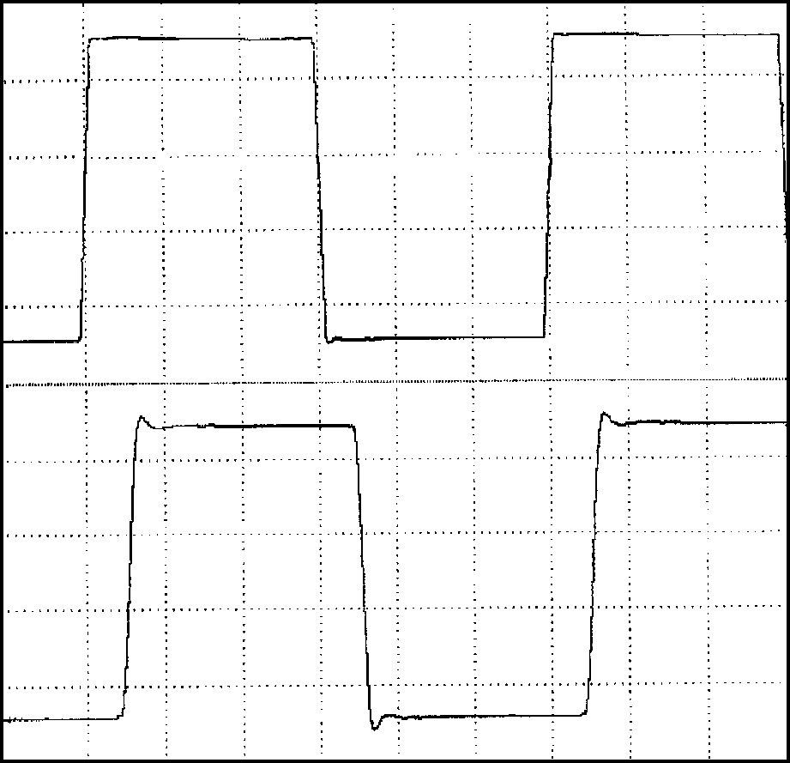
TIME (10ns/div)

GND

GND

Typical Operating Characteristics (continued)
(VCC = +5V, VEE = -5V, RL = 100Ω, TA = +25°C, unless otherwise noted.)

MAX4108
LARGE-SIGNAL PULSE RESPONSE (AVCL = +2)
MAX4108/9-BB

MAX4109
SMALL-SIGNAL PULSE RESPONSE (AVCL = +2)
MAX4108/9-CC
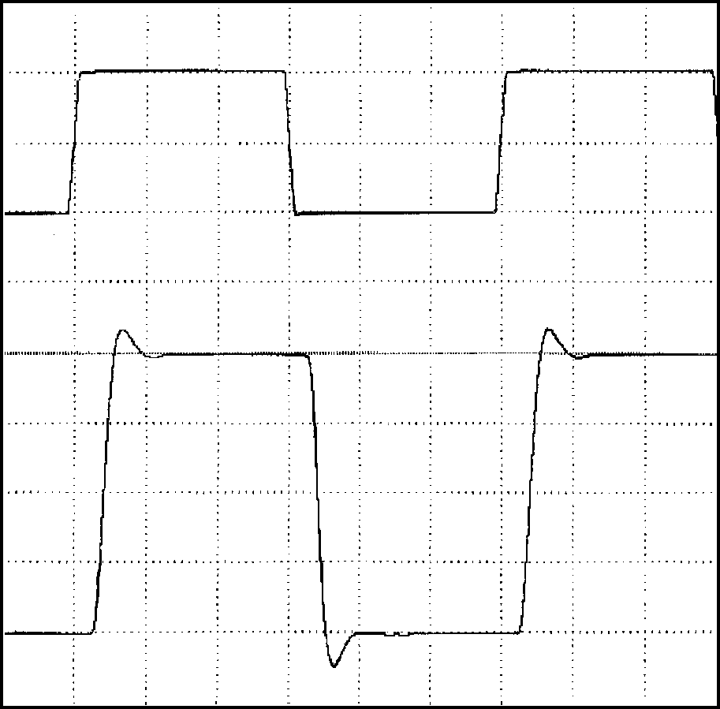

MAX4109
LARGE-SIGNAL PULSE RESPONSE (AVCL = +2)
MAX4108/9-DD

IN
VOLTAGE (500mV/div)

OUT
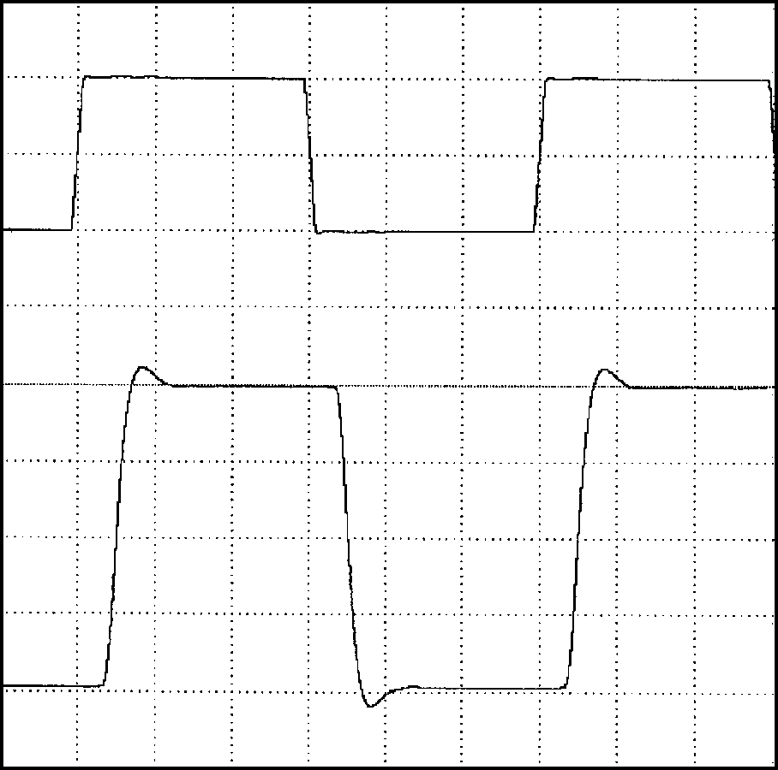
TIME (10ns/div)

GND

GND

IN
VOLTAGE (10mV/div)

OUT

TIME (10ns/div)

GND

GND
VOLTAGE (500mV/div)

IN

OUT
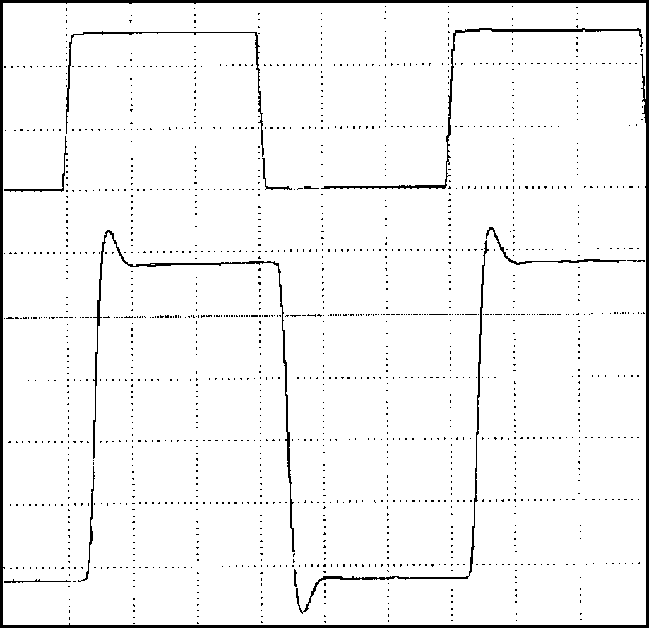
TIME (10ns/div)

GND

GND

MAX4308
SMALL-SIGNAL PULSE RESPONSE (AVCL = +5)
MAX4108/9EE
MAX4308
LARGE-SIGNAL PULSE RESPONSE (AVCL = +5)
MAX4108/9FF
MAX4309
SMALL-SIGNAL PULSE RESPONSE (AVCL = +10)
MAX4108/9GG

IN
VOLTAGE (100mV/div)

OUT
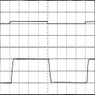
TIME (10ns/div)

GND

GND

IN
VOLTAGE (1V/div)

OUT
TIME (10ns/div)

GND
VOLTAGE (25mV/div)

GND

IN

OUT
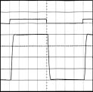
TIME (10ns/div)

GND

GND

MAX4309
SMALL-SIGNAL PULSE RESPONSE (AVCL = +20)
MAX4108/9HH
MAX4309
LARGE-SIGNAL PULSE RESPONSE (AVCL = +10)
MAX4108/9ii
MAX4309
LARGE-SIGNAL PULSE RESPONSE (AVCL = +20)
MAX4108/9JJ

MAX4108/MAX4109/MAX4308/MAX4309

IN
VOLTAGE (25mV/div)

OUT
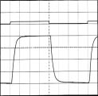

TIME (10ns/div)

GND

GND
VOLTAGE (500mV/div)

IN

OUT
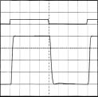

TIME (10ns/div)

GND

GND
VOLTAGE (500mV/div)

IN

OUT
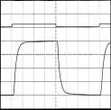
TIME (10ns/div)

GND

GND

Typical Operating Characteristics (continued)
(VCC = +5V, VEE = -5V, RL = 100Ω, TA = +25°C, unless otherwise noted.)

100

90
80
70
60

50
40

30
20
10

0
POWER-SUPPLY REJECTION
vs. FREQUENCY

MAX4108/MAX4308

MAX4109/ MAX4309

0.2 1 10 100 1000
FREQUENCY (MHz)

110
MAX4108/9-KK

100
COMMON-MODE REJECTION (dB)
90
80
70

60
50

40
30
20

10
COMMON-MODE REJECTION
vs. FREQUENCY
MAX4108/9-LL

MAX4108/MAX4308

MAX4109/ MAX4309

0.1 1 10 100 1000
FREQUENCY (MHz)

1000

100
OUTPUT IMPEDANCE ( )

10

1

0.1
CLOSED-LOOP OUTPUT IMPEDANCE
vs. FREQUENCY
MAX4108/9-MM

0.1 1 10 100 1000
FREQUENCY (MHz)

4.0

3.5

3.0

2.5

2.0

1.5

1.0

0.5

0
OUTPUT SWING
vs. LOAD RESISTANCE

2.0
MAX4108/9-NN

1.8

1.6

1.4

1.2

1.0
VOLTAGE (mV)

0.8

0.6

0.4
INPUT OFFSET VOLTAGE
vs. TEMPERATURE
MAX4108/9-OO
INPUT BIAS CURRENT
vs. TEMPERATURE
MAX4108/9-PP
25

23
21
19
CURRENT (µA)
17

15
13
11
9
7

5

10 30

50 70
90 110 130 150
-75
-50
-25 0
25 50
75 100 125
-75
-50
-25 0
25 50
75 100 125

LOAD RESISTANCE ( )
TEMPERATURE (°C)
TEMPERATURE (°C)

0.100

0.080

0.060

0.040

0.020
INPUT OFFSET CURRENT
vs. TEMPERATURE

30
MAX4108/9-QQ
POSITIVE SUPPLY CURRENT
NEGATIVE SUPPLY CURRENT

20

10
CURRENT (mA)

0

-10

-20

-30
POWER-SUPPLY CURRENT
vs. TEMPERATURE

5.0
4.0
3.0
MAX4108/9-RR

2.0
OUTPUT SWING (V)
1.0

0.0
-1.0
-2.0

-3.0
-4.0
-5.0
OUTPUT SWING
vs. TEMPERATURE

RL =
MAX4108/9-SS
RL = 100

RL = 100

RL =

-75

-50
-25 0
25 50
75 100 125
-75
-50
-25 0
25 50
75 100 125
-75
-50
-25 0
25 50
75 100 125

TEMPERATURE (°C)
MAX4108/MAX4109/MAX4308/MAX4309
CURRENT (µA)
OUTPUT SWING (VPEAK)
POWER-SUPPLY REJECTION (dB)
TEMPERATURE (°C)
TEMPERATURE (°C)

Pin Description

PIN | NAME | FUNCTION
1 | N.C. | No Connection. Not internally connected.
2 | IN- | Inverting Input
3 | IN+ | Noninverting Input
4, 5 | VEE | Negative Power Supply, connect to -5VDC.
6 | OUT | Amplifier Output
7, 8 | VCC | Positive Power Supply, connect to +5VDC.

Detailed Description

Choosing Resistor Values
Unity-Gain Configuration The MAX4108 is internally compensated for unity gain. When configured for unity gain, the device requires a small resistor in series with the feedback path. This resistor improves the AC response by reducing the Q of the tank circuit, which is formed by parasitic feed- back inductance and capacitance.
Inverting and Noninverting Configurations The values of the gain-setting feedback and input resis- tors are important design considerations. Large resistor values will increase voltage noise, and will interact with the amplifier’s input and PC board capacitance to gen- erate undesirable poles and zeros, which can decrease bandwidth or cause oscillations. For example, a nonin- verting gain of +2, using 1kΩ resistors combined with
2pF of input capacitance and 0.5pF of board capaci- tance, will cause a feedback pole at 128MHz. If this pole is within the anticipated amplifier bandwidth, it will jeopardize stability. Reducing these 1kΩ resistors to
100Ω will extend the pole frequency to 1.28GHz, but could limit output swing by adding 200Ω in parallel with the amplifier’s load. Clearly, the selection of resistor val- ues must be tailored to the specific application.
MAX4108/9-1B
The MAX4108/MAX4109/MAX4308/MAX4309 are ultra- low-distortion, high-bandwidth op amps. The output distortion will be degraded as the total load resistance seen by the amplifier decreases. To minimize distortion products, keep the input and gain-setting resistors rela- tively large. A 500Ω feedback resistor combined with an appropriate input resistor to set the gain will provide excellent AC performance without significantly increas- ing distortion.
MAX4108
MAX4308
MAX4109/MAX4309

RG RF 25

20
ISOLATION RESISTANCE ( )

VIN
PART | RF ( ) | RG ( ) | GAIN (V/V)
MAX4108 | 24 |  | 1
MAX4109 | 500 | 500 | 2
MAX4308 | 500 | 125 | 5
MAX4309 | 500 | 56 | 10

RS
15

CL RL
10

5

0
10 40 70 100 130 160
CAPACITANCE (pF)

190

220

Figure 1a. Using an Isolation Resistor for High Capacitive
MAX4108/MAX4109/MAX4308/MAX4309
Loads
Figure 1b. Optimal Isolation Resistor (RS) vs. Capacitive Load

Driving Capacitive Loads The MAX4108/MAX4109/MAX4308/MAX4309 are opti- mized for AC performance. They are not designed to drive highly reactive loads. Reactive loads will decrease phase margin and may produce excessive ringing and oscillation. Figure 1a shows a circuit that
eliminates this problem, and Figure 1b is a graph of the optimal isolation resistor (RS) vs. capacitive load. Figures 2a–2d show how a capacitive load causes excessive peaking of the amplifier’s bandwidth if the capacitive load is not isolated (RS) from the amplifier. A small isolation resistor (usually 15Ω to 22Ω) placed

12
10 RS = 0
AVCL = +1 CL = 15pF
MAX4108/9-2A
8
CLOSED-LOOP GAIN (dB)
CLOSED-LOOP GAIN (dB)
6 CL = 10pF
4
2

0
-2
CL = 5pF
-4
-6
-8
20
18 RS = 0
AVCL = +2
16

14
12
10
8

6
4
2
0

CL = 15pF
MAX4108/9-2B

CL = 10pF

CL = 5pF

0.1 1
10
FREQUENCY (MHz)
100
1000
0.1 1
10
FREQUENCY (MHz)
100
1000

Figure 2a. MAX4108 Response vs. Capacitive Load—No
Resistive (RS) Isolation (circuit shown in Figure 1a)
Figure 2b. MAX4109 Response vs. Capacitive Load—No
Resistive (RS) Isolation (circuit shown in Figure 1a)

4
3 RS = 0
AVCL = +5
2
1
0
-1

-2
-3
NORMALIZED GAIN (dB)

-4
-5
-6

CL = 15pF
MAX4108/9-2C

CL = 10pF CL = 5pF
4
3 RS = 0
AVCL = +10
MAX4108/9-2D
2
1
0
NORMALIZED GAIN (dB)
-1

-2
-3

-4
-5
-6

CL = 15pF

CL = 5pF

CL = 10pF

0.1 1
10
FREQUENCY (MHz)
100
1000
0.1 1
10
FREQUENCY (MHz)
100
1000

Figure 2c. MAX4308 Response vs. Capacitive Load—No
MAX4108/MAX4109/MAX4308/MAX4309
Resistive (RS) Isolation (circuit shown in Figure 1a)
Figure 2d. MAX4309 Response vs. Capacitive Load—No
Resistive (RS) Isolation (circuit shown in Figure 1a)

before the reactive load prevents ringing and oscilla- tion. At higher capacitive loads, AC performance will be controlled by the interaction of the load capacitance and isolation resistor. Figures 3a–3c show the effect of an isolation resistor on the MAX4108/MAX4109/ MAX4308/MAX4309 closed-loop response.
Coaxial cable and other transmission lines are easily driven when terminated at both ends with their charac- teristic impedance. When driving back-terminated transmission lines, the capacitance of the transmission line is essentially eliminated.

ADC Input Buffers Input buffer amplifiers can be a source of significant errors in high-speed ADC applications. The input buffer is usually required to rapidly charge and discharge the ADC’s input, which is often capacitive (see the section

11
10 CL = 10pF AVCL = +2
9

8
CLOSED-LOOP GAIN (dB)
7
6

5

4
3

2
1
0.1 1

RS = 15

10

RS = 8.2
MAX4108/9-3B

100

1000

Driving Capacitive Loads). In addition, a high-speed ADC’s input impedance often changes very rapidly during the conversion cycle, requiring an amplifier with very low output impedance at high frequencies to main- tain measurement accuracy. The combination of high speed, fast slew rate, low noise, and a low and stable distortion over load makes the MAX4108/MAX4109/ MAX4308/MAX4309 ideally suited for use as buffer amplifiers in high-speed ADC applications.
MAX4108/9-3A
FREQUENCY (MHz)

Figure 3b. MAX4308 Response vs. Capacitive Load with
Resistive (RS) Isolation (circuit shown in Figure 1a)

12
10 CL = 10pF AVCL = +1
8
CLOSED-LOOP GAIN (dB)
6
4
2

0

-2
-4
-6
-8
0.1 1

RS = 10

RS = 22

RS = 30

10 100

1000
4
3 CL = 10pF AV = +5
MAX4108/9-3C
2

1
NORMALIZED GAIN (dB)
0
-1
RS = 8.2
-2 RS = 15
-3 RS = 47
-4
-5
-6
0.1 1 10

100

1000

FREQUENCY (MHz)
FREQUENCY (MHz)

Figure 3a. MAX4108 Response vs. Capacitive Load with
MAX4108/MAX4109/MAX4308/MAX4309
Resistive (RS) Isolation (circuit shown in Figure 1a)
Figure 3c. MAX4108/MAX4309 Response vs. Capacitive Load with Resistive (RS) Isolation (circuit shown in Figure 1a)

MAX4108/MAX4109/MAX4308/MAX4309

Chip Information

TRANSISTOR COUNT: 57
SUBSTRATE CONNECTED TO VEE

SOICN.EPS

Package Information

Maxim cannot assume responsibility for use of any circuitry other than circuitry entirely embodied in a Maxim product. No circuit patent licenses are implied. Maxim reserves the right to change the circuitry and specifications without notice at any time.

12 Maxim Integrated Products, 120 San Gabriel Drive, Sunnyvale, CA 94086 (408) 737-7600

© 1997 Maxim Integrated Products Printed USA is a registered trademark of Maxim Integrated Products.

